* HTML vs HTML5
  + HTML5 is the latest version of HyperText Markup Language, which supports multimedia, tags and elements, improved document markups and new APIs.

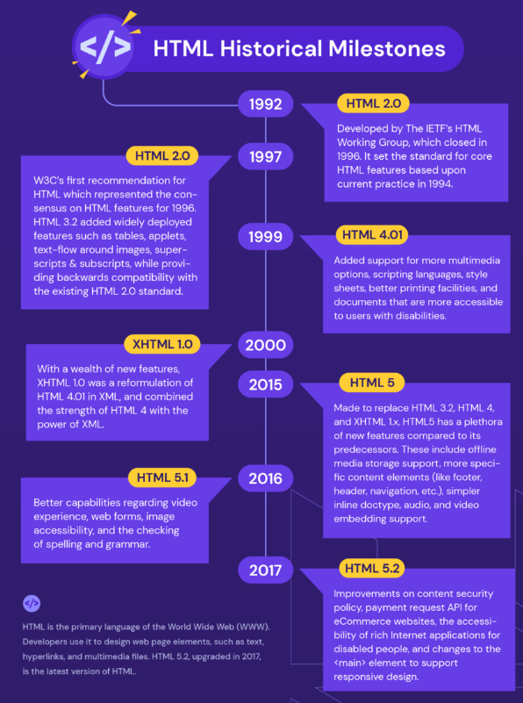

Figure

* The HTML <blockquote> element defines a section that is quoted from another source.

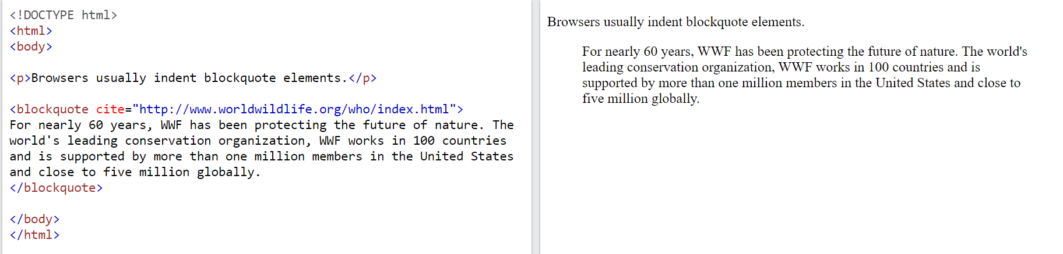

Figure

* The HTML <q> tag defines a short quotation.

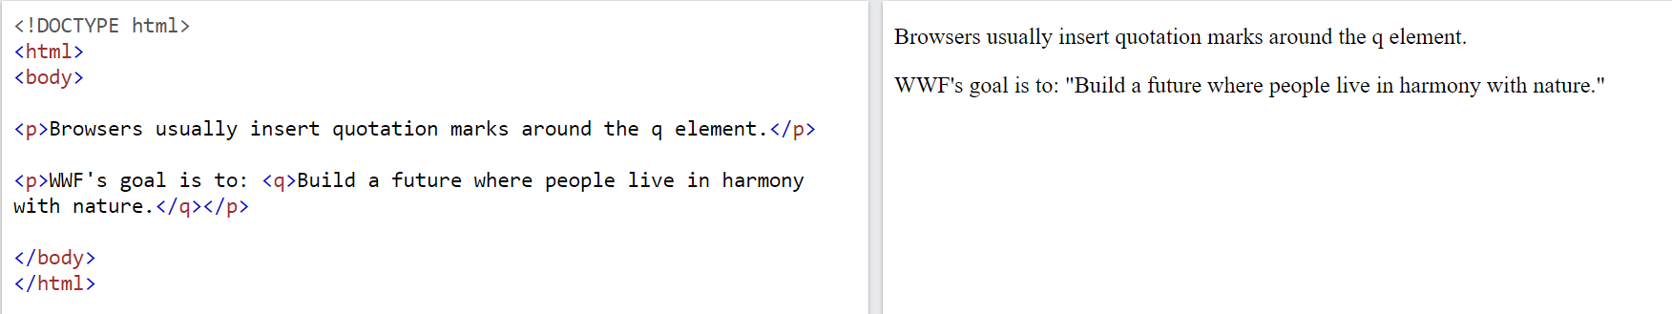

Figure

* The HTML <cite> tag defines the title of a creative work (e.g. a book, a poem, a song, a movie, a painting, a sculpture, etc.).

**Note:** A person's name is not the title of a work. The text in the <cite> element usually renders in *italic*.

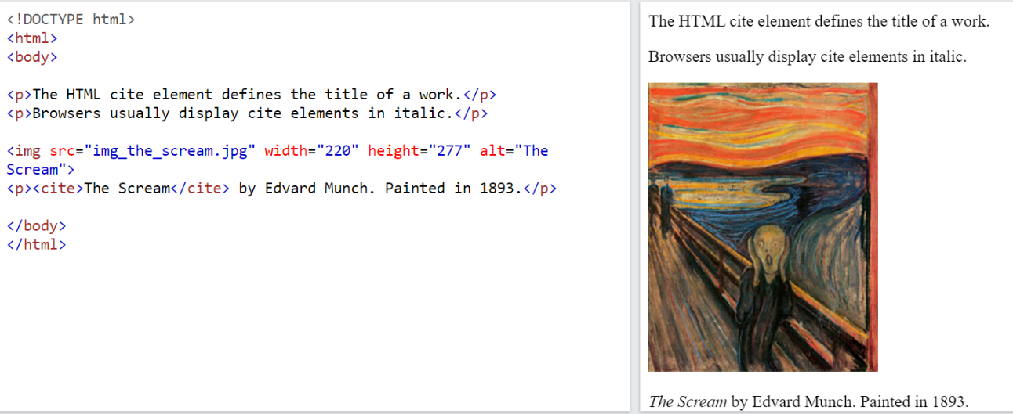

Figure

* BDO stands for Bi-Directional Override. The HTML <bdo> tag is used to override the current text direction

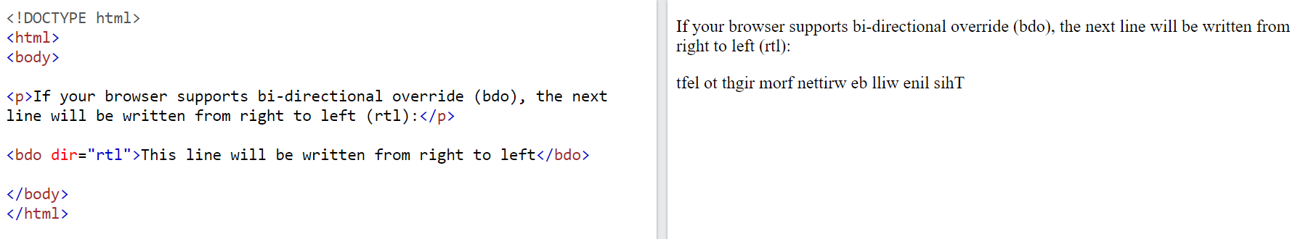

Figure

* <dd> A description list, with terms and descriptions.

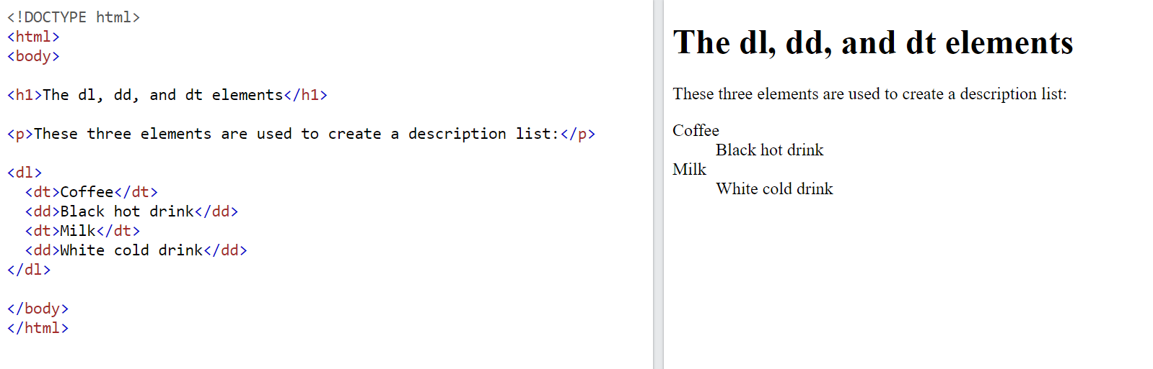

Figure

* Use a <figure> element to mark up a photo in a document, and a <figcaption> element define a caption for the photo.

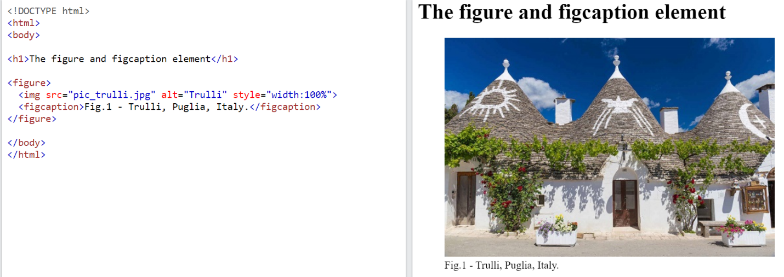

Figure

* <code> HTML contains several elements for defining user input and computer code.

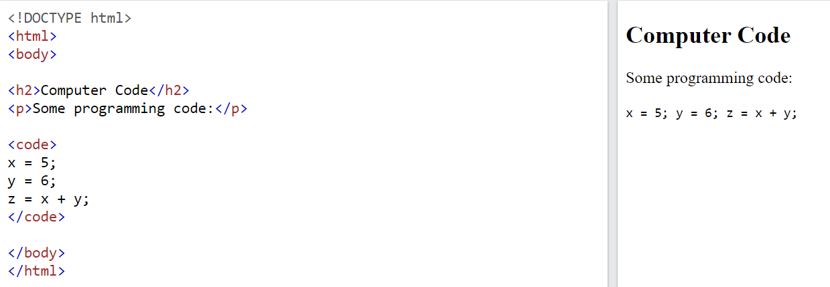

Figure

* Reserved characters in HTML must be replaced with character entities.

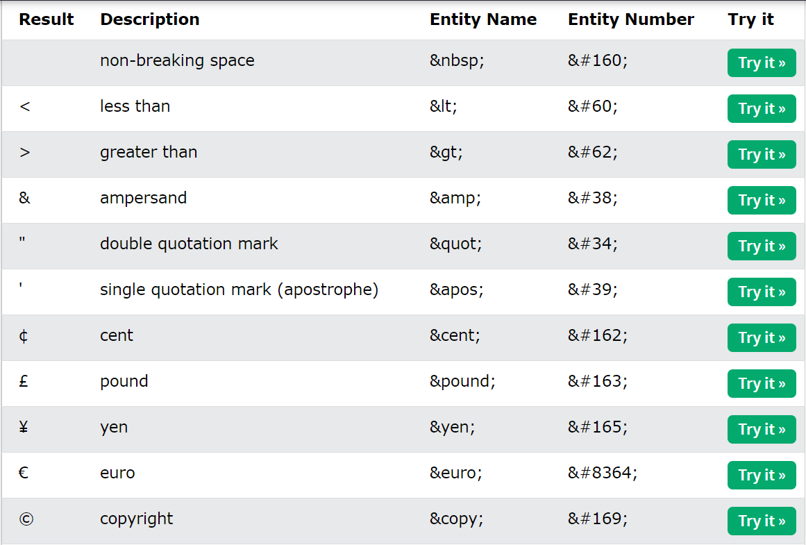

Figure

* XHTML was developed to make HTML more extensible and flexible to work with other data formats (such as XML). In addition, browsers ignore errors in HTML pages, and try to display the website even if it has some errors in the markup. So XHTML comes with a much stricter error handling.