**CSS vs SCSS vs SASSS**

Css determine how a document, usually written in HTML, is presented i.e. displayed to the user. At the present, there are galore of CSS preprocessors available. A CSS preprocessor is a program that allows generation CSS from a different syntax. SASS and SCSS are two of the most popular CSS preprocessors.

Here is the declaration example codes.

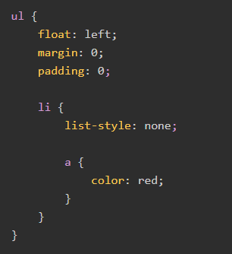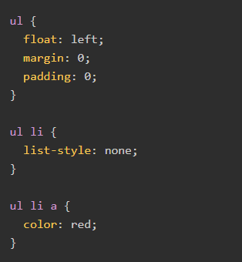

**SCSS**

**CSS**

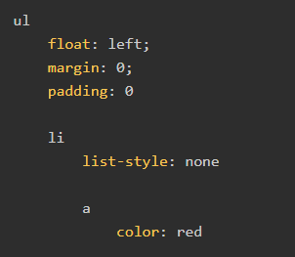

**SASS**

**How to use SASS?**

We can import any CSS/SASS file this way;

import “design.sass”

Also, we can import multiple files by separating them with a comma;

@import “design.scss”,”about.css”;

**NOTE!**

We can easily import CSS files in the sass file. But it is forbidden not to include the .css extension in the import statement.

But the saas team discourages the use of the @import Rule. Sass team encourages the use of @use rule instead which is available in dart sass.

**CSS REFERANCE**

.intro : selects all elements with class= “intro”.

#LastName : select the element with id=”LastName”.

h1,p : slsects all <h1> elements and all <p> elements.

ul ~ table : selects all <table> elements that are sibling of <ul> element.

[id$=ess] : selects all elements with an id attribute value ending with “ess”.

[id|=my] : selects all elements with an id attribute value equal to “my” or starting with “my” followed by hyphen (-).

[id^=L] : selects all elements with an id attribute value starting with the letter “L”.

[title~=beatiful] : selects all elements with a title attribute value containing the word “beatiful”.

:checked : selects all checked from elements.

p::first-letter : slects the first letter of all <p> elements.

tr:nth-last-child(1) : select all <li> elements that are the first child their parent, counting from the last child.

**CSS PROPERTİES**

animation: binding an animation to a <div> element, using the shorthand property.

backdrop-filter: The backdrop-filter property is used a apply a graphical effect to the area behind an element.

background-blend-mode: This property sets how an elements background images should blend with each other and with the elements background color. (darken,lighten…)

background-clip: This propert sets whether an elements background extends underneath its border box, padding box or content box.

column-fill: This property controls how an elements contents are balanced when broken into columns.

column-gap: This property sets the size of the gap between an elements columns

column-rule: This property sets the width, style and color of the line draw between columns in a multi-column layout.

hyphens: This property defines whether hyphenation is allowed to create more soft wrap opportunities within a line of text.

image-rendering: This property specifies the type of algorithm to be used for image scaling

mix-blend-mode: This property sets how an elements content should blend with the content of he elements parent and the elements background.

perspective: This property determines the distance between the z = 0 plane and the user in order to give a 3D-positioned element some perspective.

text-emphasis: This property applies emphasis marks to text

unicode-bidi: This property is used together with the direction property to set or return whether the next should be overridden to support muktiple languages in the same document.

user-select: This property controls whether the user can select text. This does not have any effect on content loaded as part of a browsers user interface except in textboxes.

z-index: This property sets the z-order of a positioned element and its descendants or flex items. Overlapping elements with a larger z-index cover those with smaller one.