**Callback**

Where callbacks really shine are in asynchronous functions, where one function has to wait for another function (like waiting for a file to load).

Usings:

Right: myCalculator(5, 5, myDisplayer);

Wrong: ;

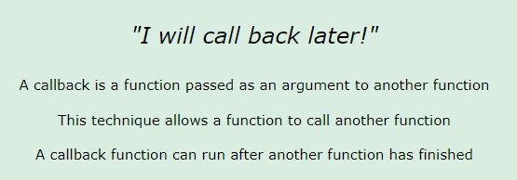

**Asynchronous**

Asynchronous using similar to Callback functions.

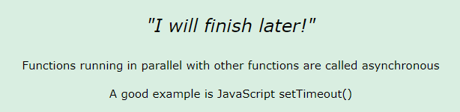

**Promises**

We can not access the Promise properties state and result. We must use a Promise method to handle promises.

Promise.then() takes two arguments, a callback for success and another for failure. Both are optional, so you can add a callback for success or failure only.

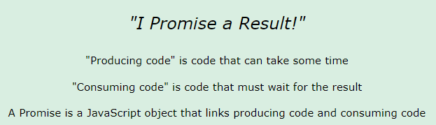

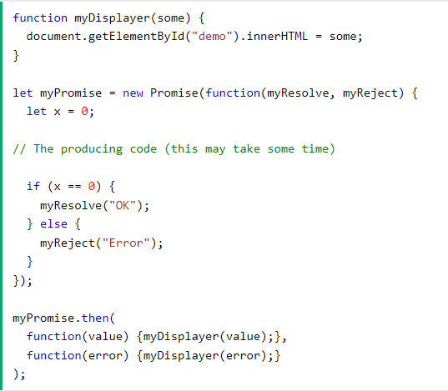

**Asyn/Await**

Generally using Asynchronous methods.

