**Creating an NPM Package For React Native**

Let's consolidate the subject by creating a sample project and publishing it on NPM. Let's run the following commands in order to create a new npm project by creating an empty folder.

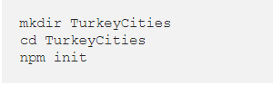

Let's add the following provinces by creating the index.js file of the project directory.

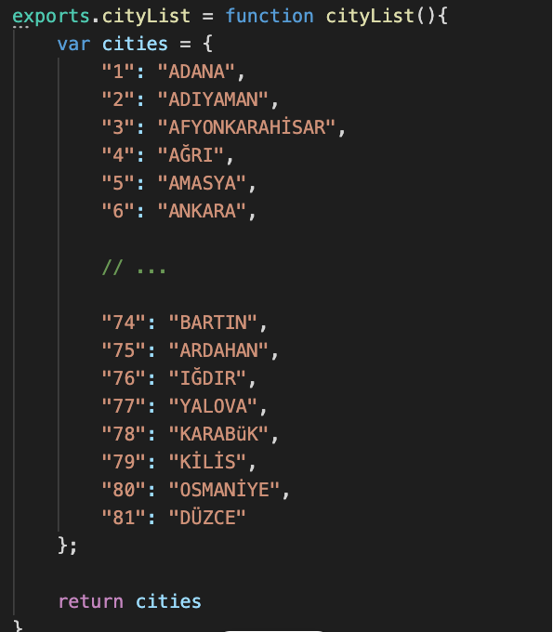

Now let's publish the module we wrote. First, let's open a free account on npmjs.com and then login with the following command.

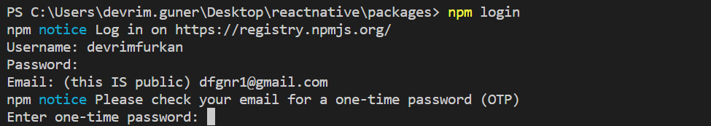

After this command, it will ask you for username, password and email information, and after entering this information, your login process will be completed.

Now, let's go to the project directory via cmd and run the publish command.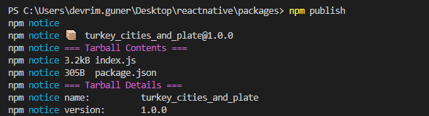

You can see the package when you go to your profile from npmjs.com

