**REACT NAVIGATION**

**Installing;**

|  |
| --- |
| * npm install @react-navigation/native |

|  |
| --- |
| * npm install react-native-screens react-native-safe-area-context |

If you're on a Mac and developing for iOS, you need to install the pods (via Cocoapods) to complete the linking.

|  |
| --- |
| * npx pod-install ios |

react-native-screens package requires one additional configuration step to properly work on Android devices. Edit MainActivity.java file which is located in android/app/src/main/java/<your package name>/MainActivity.java.

|  |
| --- |
| * @Override protected void onCreate(Bundle savedInstanceState) {  super.onCreate(null); } |

Add the following code to the body of MainActivity class:

and make sure to add an import statement at the top of this file:

|  |
| --- |
| * import android.os.Bundle; |

And finally we need to do it for stacking navigation;

|  |
| --- |
| * npm install @react-navigation/native-stack |

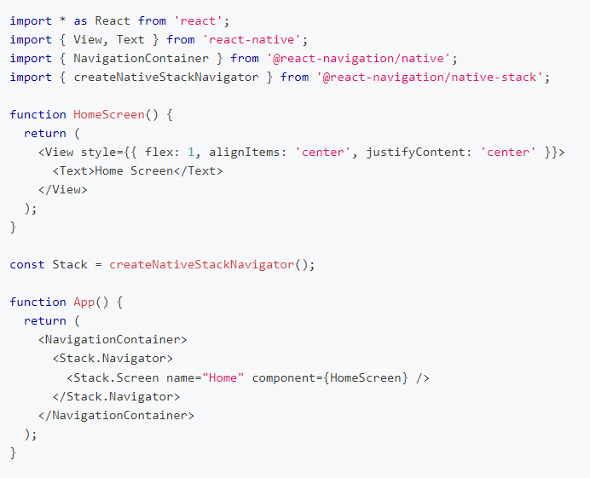Here is example project;