# **ADVENTUREWORKS ETL- MICROSERVICES:**

## (OPEN DATABASE IN LOCAL AZURE DATA STUDIO)

Note: used 2019 version (link:   
<https://learn.microsoft.com/en-us/sql/samples/adventureworks-install-configure?view=sql-server-ver16&tabs=data-studio>  
)

## Create Two New Table inside the Database **note**: unnecessary columns from SalesOrderHeader (rowguid, modifieddate, and comment) and Customer (rowguid, modifieddate, passwordhash, and passwordsalt) were not created therefore it was not necessary to delete them again (Step F is achieved here) ScreenShot-1 (Create new Table for TransformedSalesOrderHeader)

ScreenShot-2 (Create a new Table for (TransformedCustomer)   
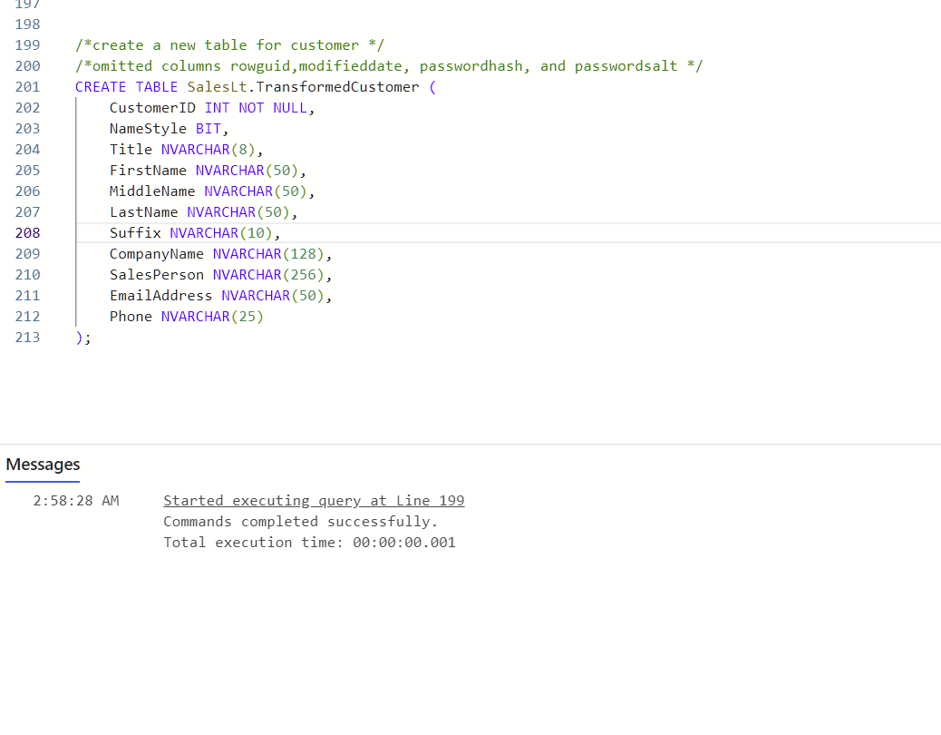

## Change the column name from status to ‘OrderStatus’ note: This step is step G in original, but it was done after new table ‘TransformedSalesOrderHead’ table was created

1. Sink Data from Original Tables to New Tables   
   **screenshot-1: From ‘SalesOrderHeader’ to ‘TransformedSalesOrderHeader’**  
     
   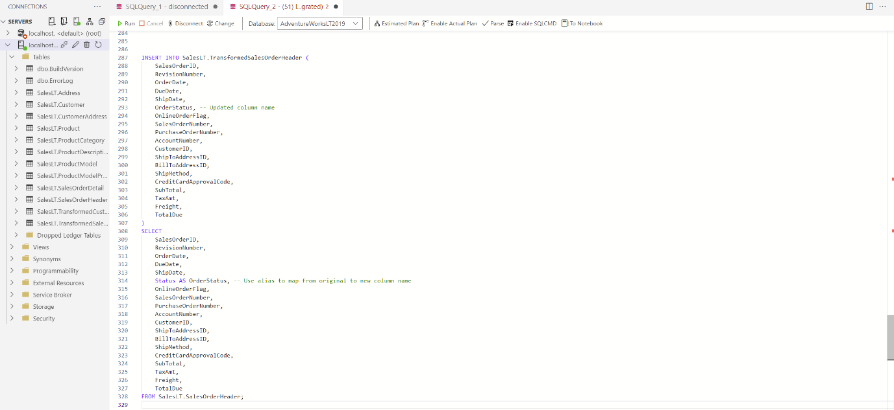  
     
   **screenshot-2: Data successfully sinks in ‘TransformedSalesOrderHeader’ table   
   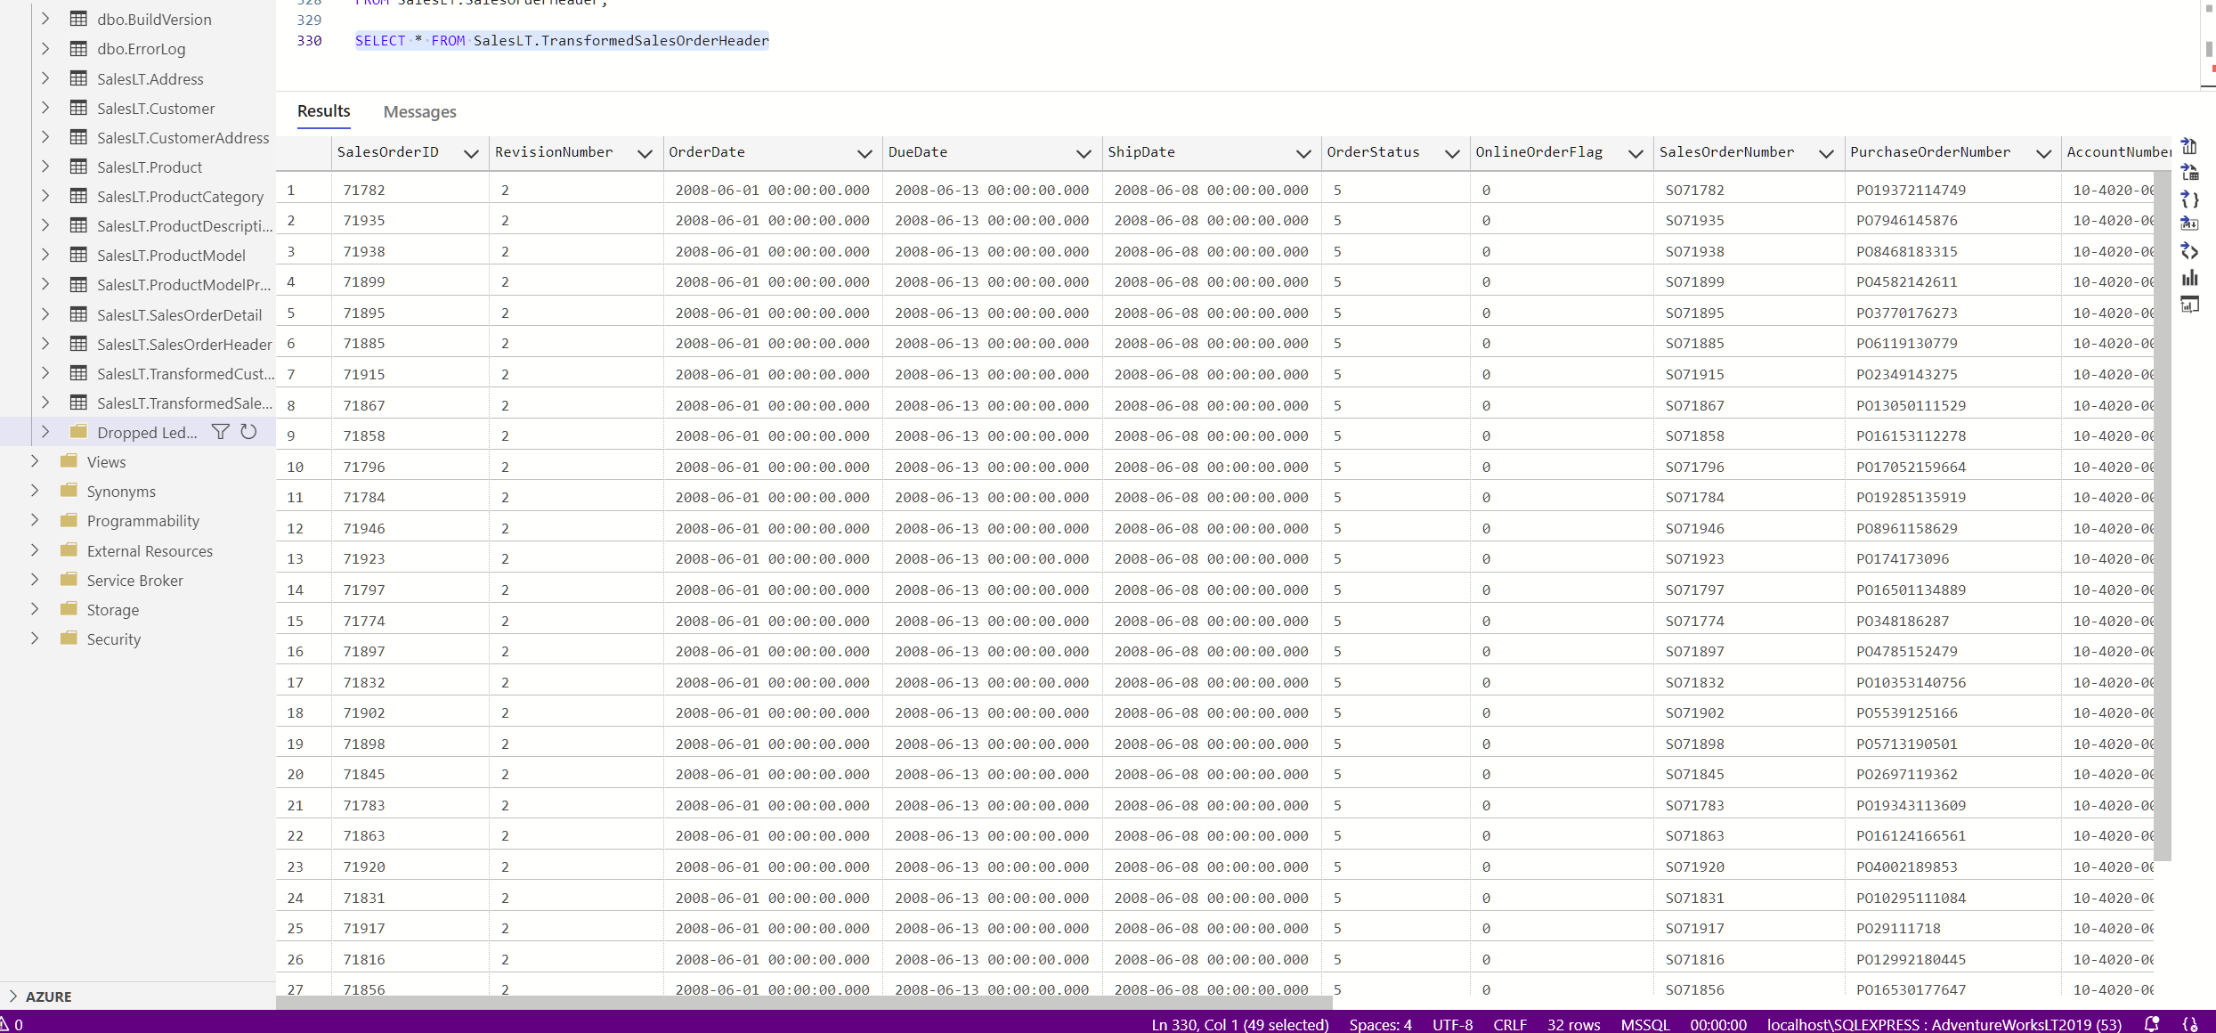**

Screenshot-3: From ‘Customer’ to ‘TransformedCustomer’   
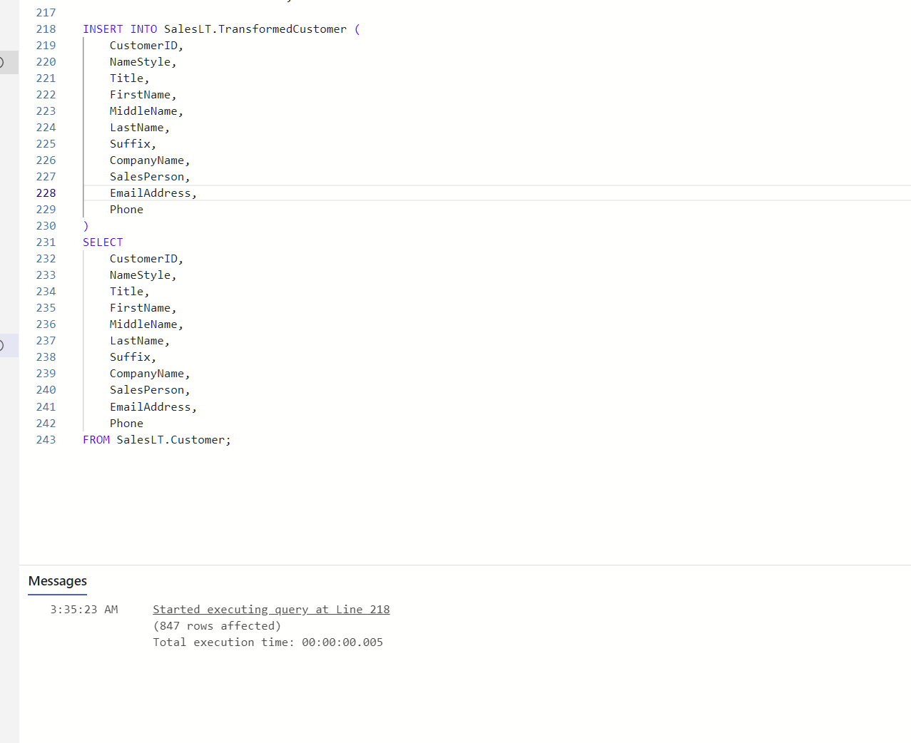

Screenshot-4: Data sinks successfully in ‘TransformedCustomer’ Table   
(note: query 243)  
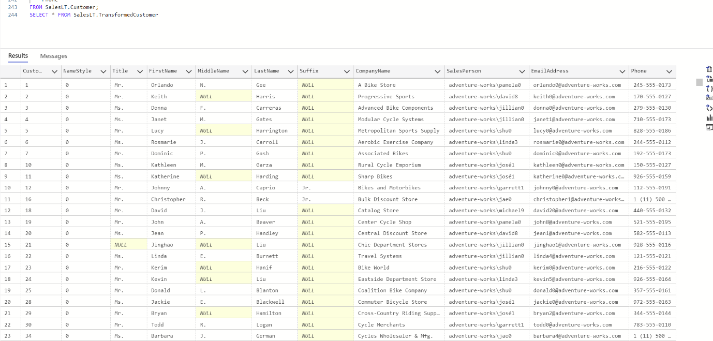

## Open ‘AdventureWorksLT2019’ Database with PowerBI Software

## Open new Tables with PowerBI Software **screenshot-1: new ‘SalesLT.TransformedCustomer’ Table before Transform Data**

Note: see empty and null values before transform

**Screenshot-2: new ‘SalesLT.****TransformedSalesOrderHeader’ Table before Transform Data  
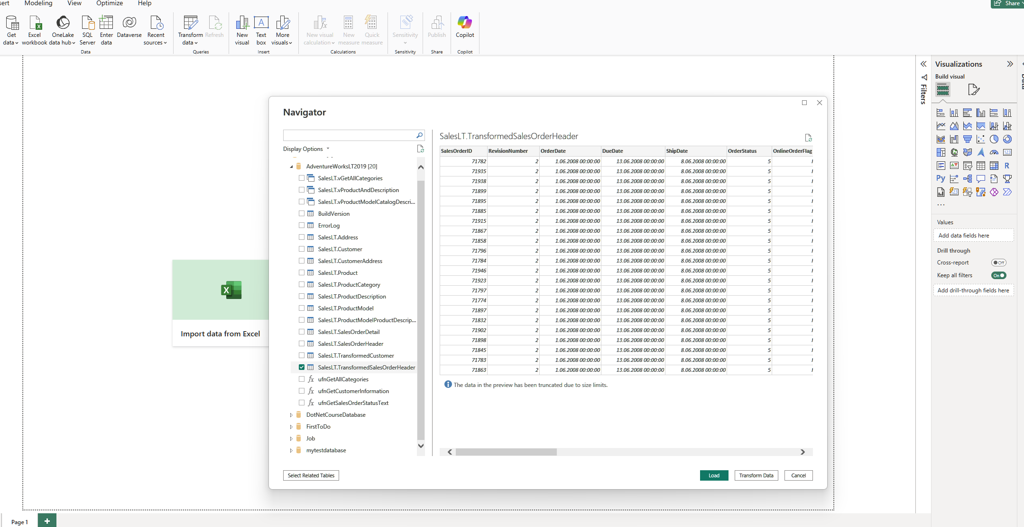**

## Make Sure You don’t have any duplicates/blank rows Screenshot-1: duplicated and blank rows are removed from new ‘SalesLT.TransformedCustomer’ Table (see right side of photo under applied steps)

Screenshot-2: duplicated and blank rows are removed from new ‘SalesLT.TransformedSalesOrderHeader’ table.  
  
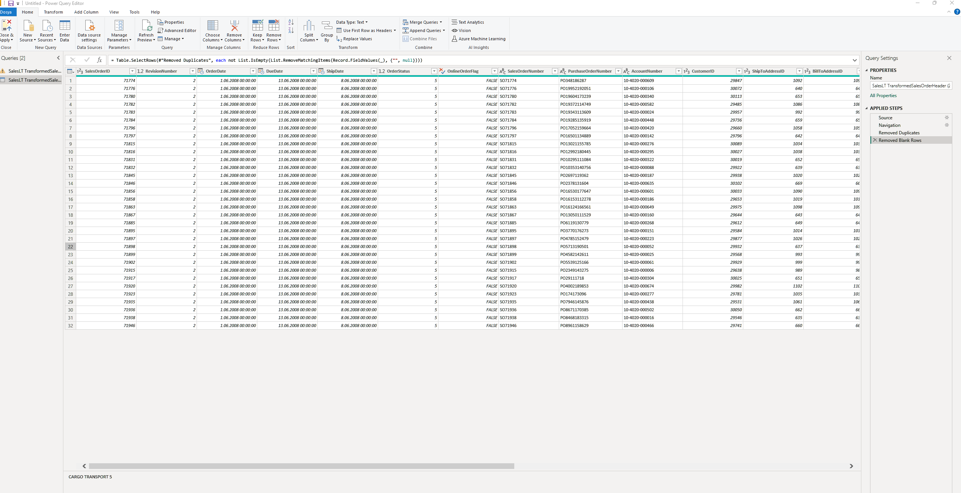

## Handle Null Data in Columns

Screenshot-1: ‘SalesLT.TransformedCustomer’ Table before replacing “null” to “no information”  
  
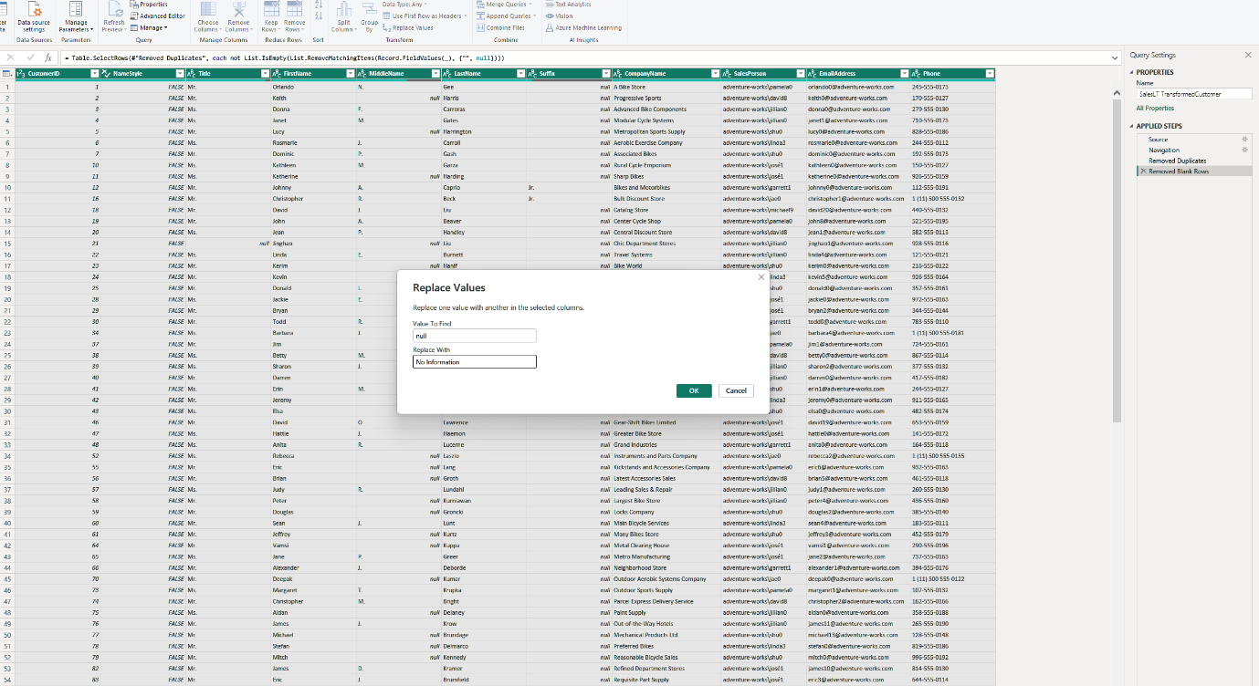

Screenshot-2: “SalesLT.TransformedSalesOrderHeader” Table before replacing “null” to “no information”   
  
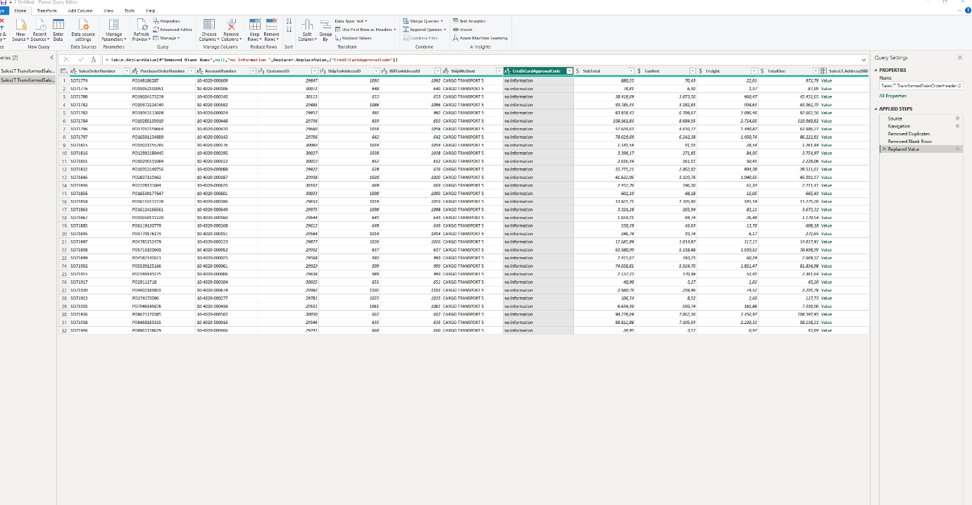

Screenshot-3: ‘SalesLT.TransformedCustomer’ with ‘no information’   
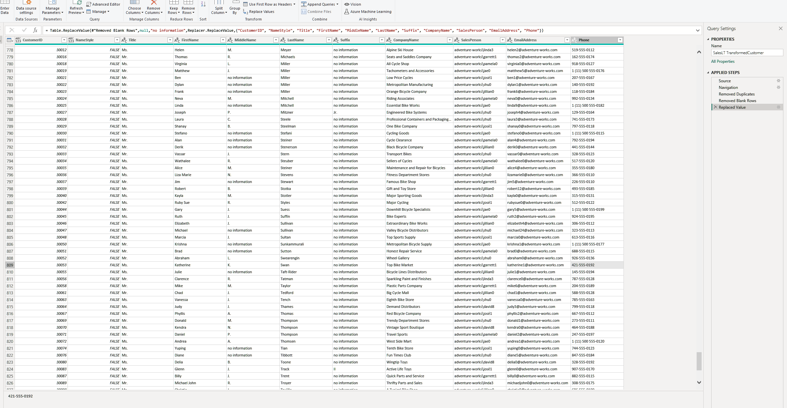

## LOAD DATA INTO POWER BI

Screenshot1: Transformed Customer in Power BI   
  
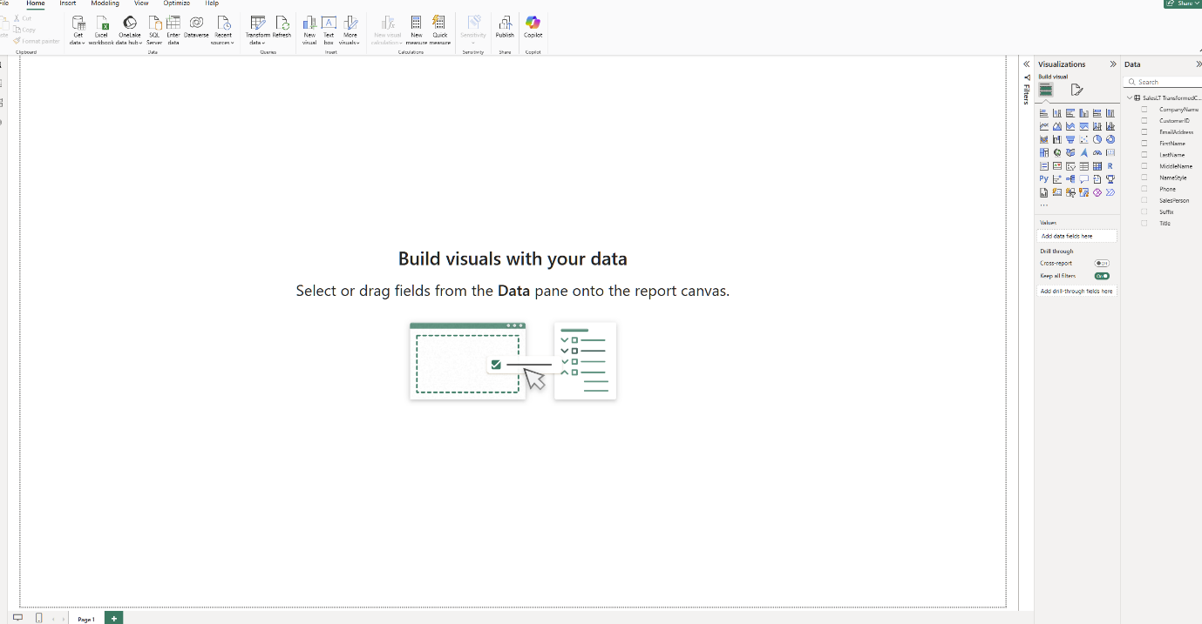

Screenshot2: Transformed SalesOrderHeader in Power BI

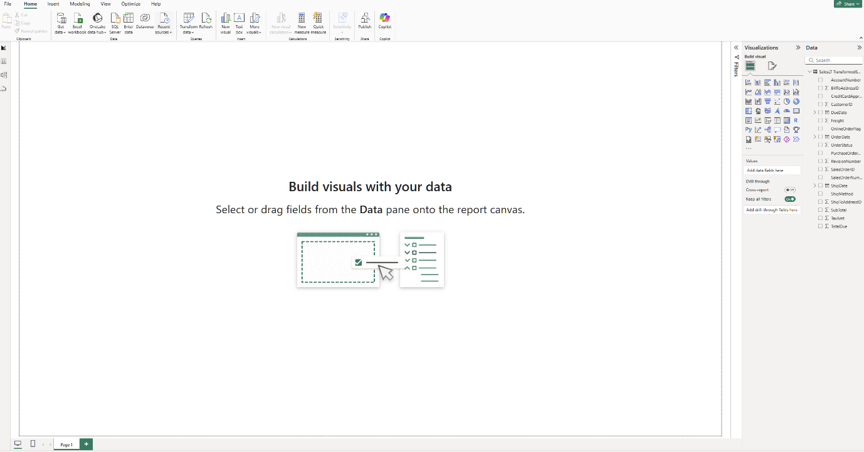

**Answers for the questions and screenshots of the PowerBI Visualisation to be placed below:**

## How many rows with no information exist in the Suffix column? (part2queryL)

**Answer:   
799 rows with ‘no information’**

**Screenshot of PowerBI Visualisation:   
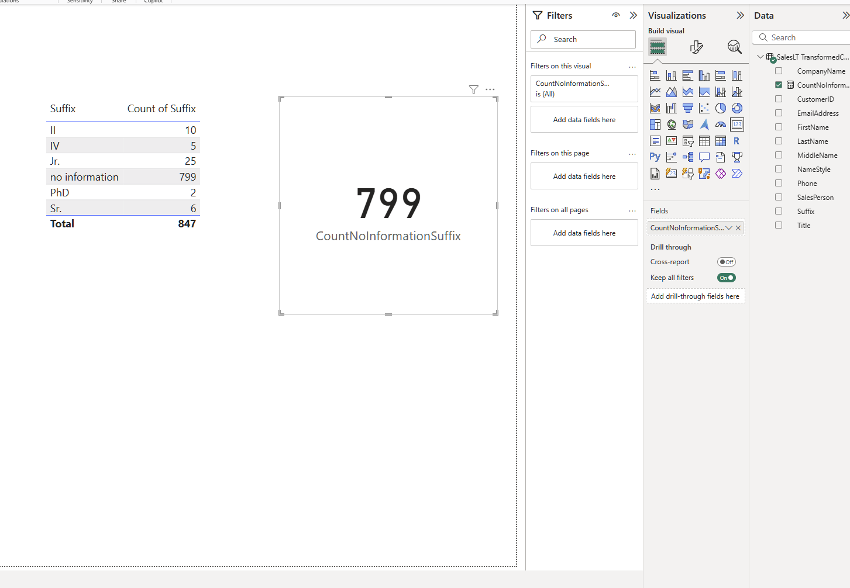**

## How many rows with no information exist in Middlename column? (part2queryM)

**Answer:   
343 rows with “no information”**

**Screenshot of PowerBI Visualisation:**

## 

## What is the total TaxAmt that was paid?

**Answer:   
69.234,6997 or (69,23K)  
  
(part2queryN)**

**Screenshot of PowerBI Visualisation:   
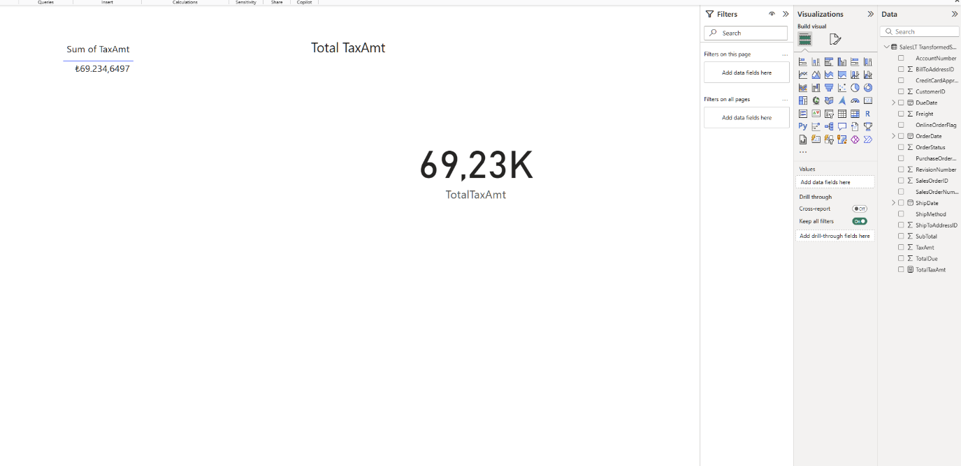**

## Which account number paid the most taxes?

**Answer:   
account number: 10-4020-000448   
paid: 8.684,9465   
  
part2query0**

**Screenshot of PowerBI Visualisation:** 