Gluu Cluster Manager Tutorial

Purpose
The purpose of this document is to create a two node Gluu Server cluster with Gluu Cluster Manager. I am not going to give technical details, for technical information see https://gluu.org/docs/cm/

Gluu Cluster Manager
Gluu Cluster Manager (we will refer as GCM) is a web based Open Source Software that aims to create and manage your Gluu Server clusters. It also allows you to monitor various system and ldap status with graphics. You can download latest version from github repository: https://github.com/GluuFederation/cluster-mgr

Prerequisites
In this tutorial we will create two node Gluu Server cluster. We need two machine (I will use Virtual Box VMs) for nodes and a load balancer. Since GCM manages servers remotely via SSH, we also need a machine for GCM. My VM hosts are as follows:
Name | FQN Hostname | IP Address | OS Type | minRAM | Usage
CM | cm.mygluu.org | 198.168.56.150 | Ubuntu 16 | 1GB | GCM will be installed on this machine
LB | lb.mygluu.org | 192.168.56.200 | Ubuntu 16 | 1GB | This machine will be used as a load balancer
GS1 | gs1.mygluu.org | 192.168.56.201 | Ubuntu 16 | 4GB | Gluu Server Node1
GS2 | gs2.mygluu.org | 192.168.56.202 | Ubuntu 16 | 4GB | Gluu Server Node2

Each machine has the following entries in /etc/hosts file:
192.168.56.150 cm.mygluu.org
192.168.56.200 lb.mygluu.org
192.168.56.201 gs1.mygluu.org
192.168.56.202 gs2.mygluu.org

When we finish our setup, we will have the following structure:
GS1
LB
GS2
CM
client-1
client-2
client-n
...

For this tutorial we have no firewall protecting any of our servers. For ports please see https://gluu.org/docs/cm/installation/#ports

Prepare Vms (if you don’t have)
To have these VMs, I created a fresh Virtual Box Machine with 1GB Ram and installed Ubuntu 16.04 LTS. I changed network type of Adapter 1 to Host-only adapter, so that my desktop and each server can communicate via private network.
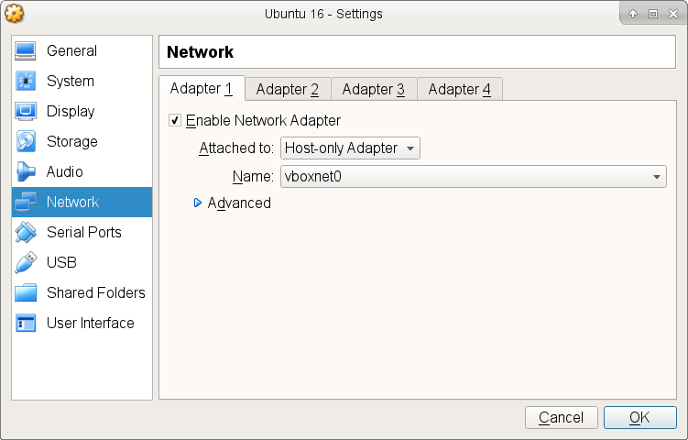
I cloned this VM four times and labeled accordingly. You can use Linked Clone to disk save space:
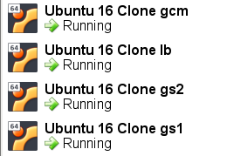
I changed RAM size of GS1 and GS2 to 4GB before preceding. Since my Vms need internet access and I configured them Host-only network, I need my desktop to NAT these Vms. On my deskptop computer I executed these two commands:
root@debian:~# sysctl -w net.ipv4.ip_forward=1
root@debian:~# sudo iptables -t nat -A POSTROUTING -o wlo1 -j MASQUERADE

My desktop is reaching internet via Wifi and my Wifi adapter is wlo1. I booted up each machine and write these to /etc/network/interfaces
auto enp0s3
iface enp0s3 inet static
address 192.168.56.150
netmask 255.255.255.0
network 192.168.56.0
broadcast 192.168.56.255
gateway 192.168.56.1
dns-nameservers 192.168.1.1

Chenge address for each machine accordignly. I also set up hostname:
echo “cm” > /etc/hostname

Then reboot machine to get new setting enabled.

Create User foo
I create user named foo on all servers. As an example login to LB as root and create user:
root@lb:~# adduser foo
Adding user `foo' ...
Adding new group `foo' (1001) ...
Adding new user `foo' (1001) with group `foo' ...
Creating home directory `/home/foo' ...
Copying files from `/etc/skel' ...
Enter new UNIX password:
Retype new UNIX password:
passwd: password updated successfully
Changing the user information for foo
Enter the new value, or press ENTER for the default
Full Name []:
Room Number []:
Work Phone []:
Home Phone []:
Other []:
Is the information correct? [Y/n] y

Generate SSH Public Key on CM
GCM will manage all servers via ssh without password. So we need an ssh public key created on CM and distribute to LB, GCS1 and GCS2.
Login to CM as foo and create ssh public key:
foo@cm:~$ ssh-keygen -t rsa
Generating public/private rsa key pair.
Enter file in which to save the key (/home/foo/.ssh/id_rsa):
Created directory '/home/foo/.ssh'.
Enter passphrase (empty for no passphrase):
Enter same passphrase again:
Your identification has been saved in /home/foo/.ssh/id_rsa.
Your public key has been saved in /home/foo/.ssh/id_rsa.pub.
The key fingerprint is:
SHA256:qDi+YD/tN5MU8xudNyAxi6MRsnCEl3nEvrSebQhDt+0 foo@cm
The key's randomart image is:
+---[RSA 2048]----+
| o.=. |
| o * + o |
| + = . . + |
| o = * o . |
| . o O S o o |
| + * o o o o |
|..o * * . o . . |
|.o.o = E . |
| ooo.o o |
+----[SHA256]-----+

I did not provided passphrase, if you do GCM will ask you before making ssh to the servers.
Since user foo needs some modifications on GCM, it should be able to execute sudo command without password, so login GCM as root and execute the following command:
root@cm:~# echo "foo ALL=(ALL) NOPASSWD:ALL" >> /etc/sudoers

Copy Public Key of CM to Other Servers
Login CM as root and copy public key to other servers:
foo@cm:~$ scp /home/foo/.ssh/id_rsa.pub foo@lb.mygluu.org:/tmp
foo@cm:~$ scp /home/foo/.ssh/id_rsa.pub foo@gs1.mygluu.org:/tmp
foo@cm:~$ scp /home/foo/.ssh/id_rsa.pub foo@gs2.mygluu.org:/tmp

Add Public Key of CM to authorized_keys on Other Servers
Add public key of CM to /root/.ssh/authorized_keys on LB, GS1 and GS2. For example login to LB as root and:
root@lb:~# mkdir -p /root/.ssh/
root@lb:~# chmod 700 /root/.ssh/
root@lb:~# cat /tmp/id_rsa.pub >> /root/.ssh/authorized_keys

Test on CM if foo can login to GS1 via ssh without password:
foo@cm:~$ ssh root@gs1.mygluu.org
Welcome to Ubuntu 16.04.5 LTS (GNU/Linux 4.4.0-131-generic x86_64)

* Documentation: https://help.ubuntu.com
* Management: https://landscape.canonical.com
* Support: https://ubuntu.com/advantage

121 packages can be updated.
90 updates are security updates..

Install Gluu Cluster Manager
After preparation of servers, time is come to installation of GCM. Login to CM as root and install dependencies with:
root@cm:~# apt-get update
root@cm:~# apt-get install python-pip python-dev libffi-dev libssl-dev python-ldap redis-server default-jre
root@cm:~# pip install --upgrade setuptools influxdb psutil
Them install GCM:
root@cm:~# pip install clustermgr

We don’t recommend you to run GCM as root, so login as foo and start GCM:
foo@cm:~$ clustermgr-cli start

If you want to stop GCM, you can run this command:
$ clustermgr-cli stop

For security reasons GCM will only listen localhost:5000, to be able to use GCM we need to make ssh port forwarding from Desktop computer. On your desktop computer execute the following command:
mbaser@debian:~$ ssh -L 5000:localhost:5000 foo@cm.mygluu.org
foo@cm.mygluu.org's password:

GCM will display errors most of the time. If you have something unexpected, please see log files under /home/foo/.clustermgr/logs

Signup Cluster Manager
On your desktop computer, open browser (Firefox or Chrome) and navigate to http://localhost:5000
The first step is signup GCM. Signup will be performed only once. Choose a username and a password. I chose gcmuser

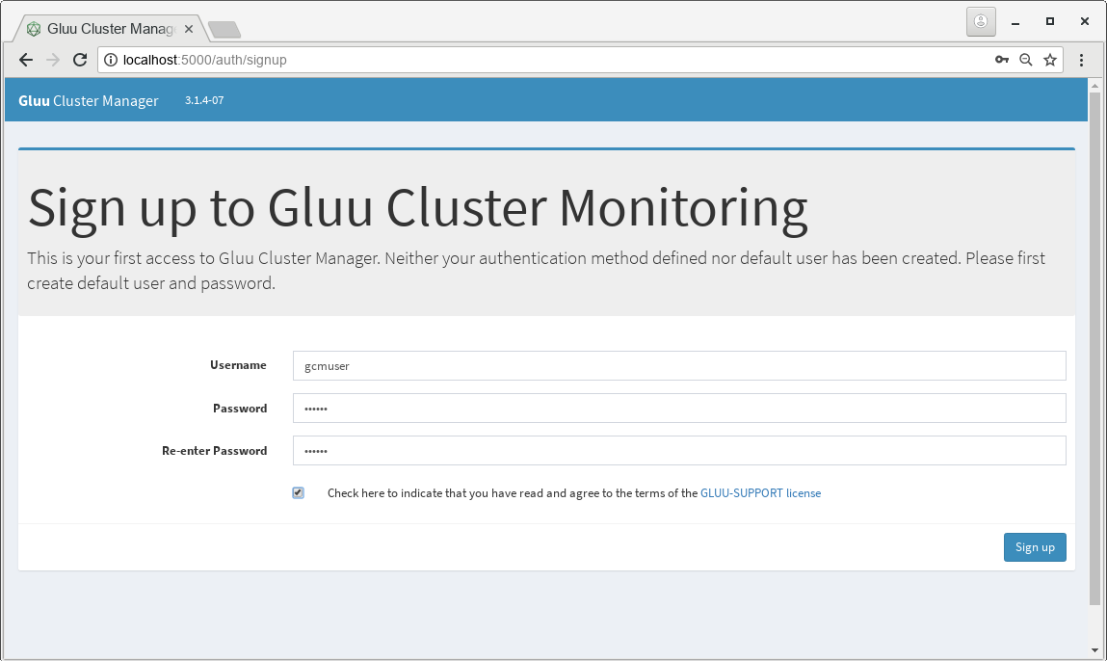
On subsequent visits to GCM, you will use this username and password. In case you forget username or password, you can delete /home/foo/.clustermgr/auth.ini file. Not other settings/configurations will be damaged by deleting this file.

Configure Application
Second step is to choose, clustering type. Since we are going to create a new cluster with two nodes, I choose Create a New Gluu Server Cluster. After hitting this button, we will be directed to Application Settings. On this page we need to enter these values:
Replication Manager Password: This password will be used GCM to set replication between opendj servers and mostly you won’t use this password yourself. Choose a strong password.
Load Balancer Hostname: In our case it is lb.mygluu.org
Load Balancer IP Address: In our case it is 192.168.56.200
We also checked Add IP Addresses and hostnames to /etc/hosts file on each server
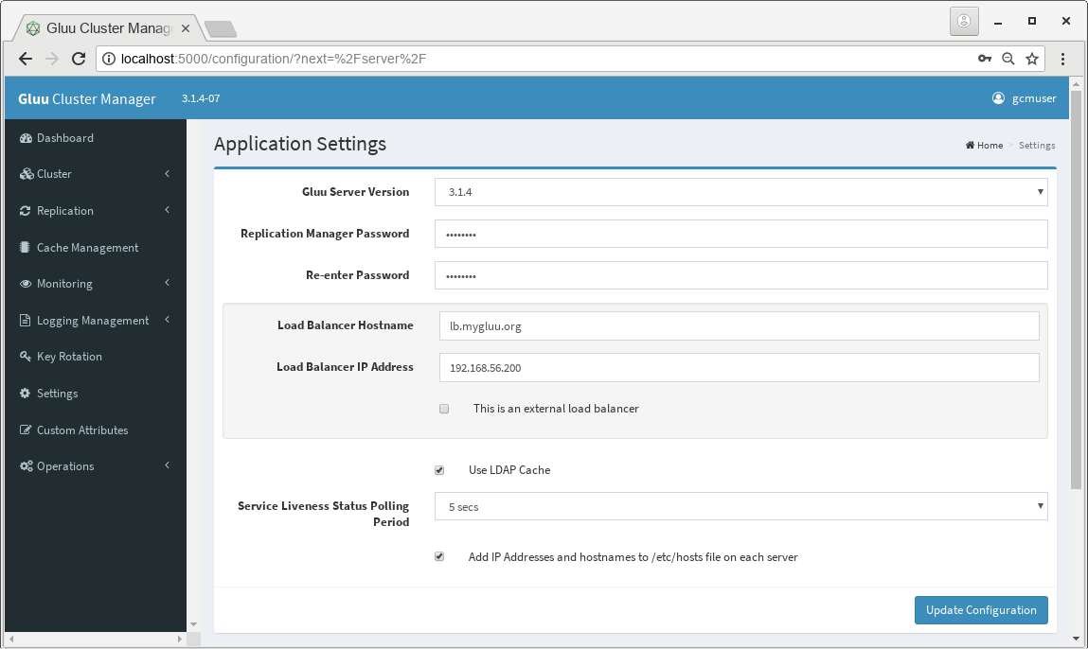
Since we are going to use LDAP Cache, we left this option checked. If you prefer redis cache, please unchecked it. In that case, you should configure caches on Cache Management menu after LDAP replication is configured.
Next step is to Add Primary Server.
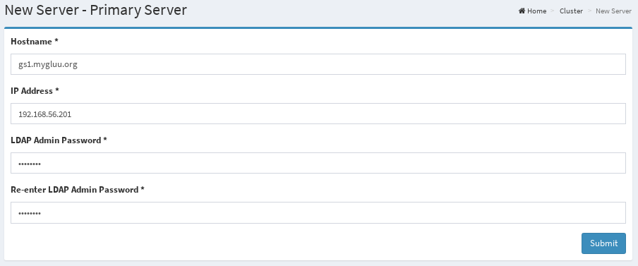
Add second server as follows
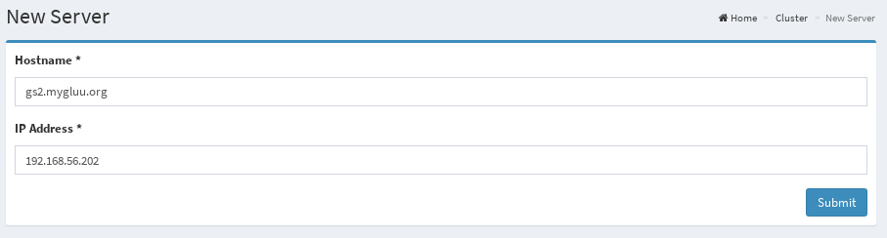
Your Dashboard should be look like as following figure. At any time you can add new Gluu Server node to your cluster so that you can enlarge cluster horizontally.
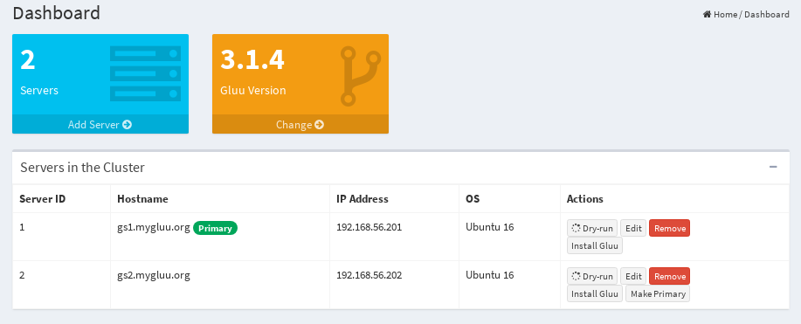
The Dashboard will also display health status of major Gluu components (LDAP, oxauth and identity) after installation.
We can install Gluu Servers by clicking Install Gluu button. First we should install primary server. When click, it will be asked some trivial info for creating ssl certificates, license agreements and Gluu Server Components to be installed. Click Submit button, after over-viewing setup properties, hit Install Gluu Server button.
Gluu Server will be installed and configured so that it can work in cluster:
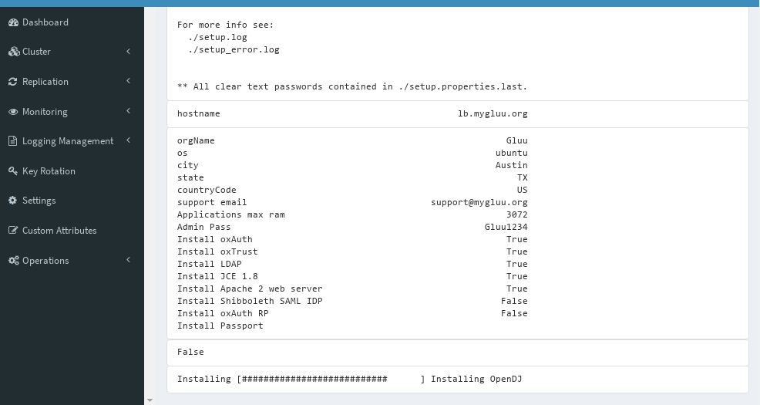
Note that hostname will be set to lb.mygluu.org, all nodes hostname will be set to load balancer’s hostname, since the world will interact only with load balancer. After installation of all servers is finished, all status should be green in Service Liveness Status column on Dashboard.

Install NGINX
Nginx server will be installed on load balancer (LB). To install nginx choose Cluster > Install Nginx from the left menu.
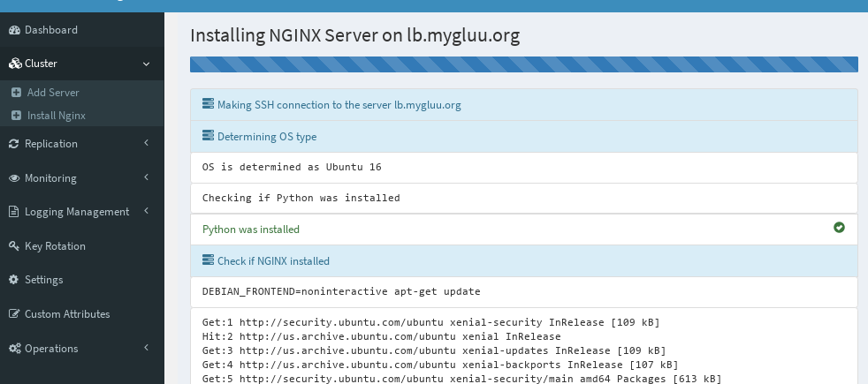
After installation of Nginx finished, hit Go to LDAP Replication button

Enable Replication
If you hit the green button after nginx, you will jump to replication page. Alternatively you can reach this page by Replication > LDAP from the left menu. Hit Deploy All button. This will configure ldap replication on all servers and will make configurations on each server so that they become a node of cluster. After configuration of replication finished, GCM will display status of replication:
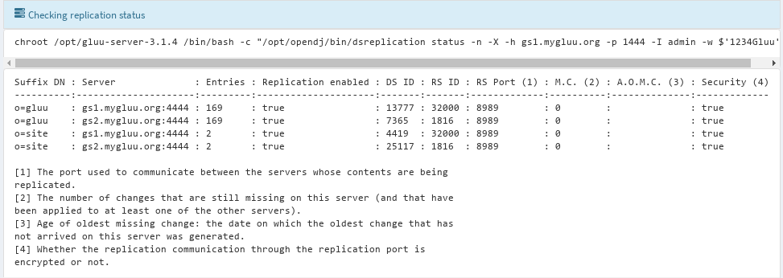
On the page, if you can see Entires matches across the server and all is zero on M.C. column, then replication is good.
This is the final step for creating Gluu Server Cluster. You can test if your cluster is working. For this I follow these steps:
1) Stop one of the Gluu Servers. I choose to stop GS2, so login as root and:
# /etc/init.d/gluu-server-3.1.4 stop
2) Login to Gluu UI via LB (lb.mygluu.org) with browser and add a test person: testuser
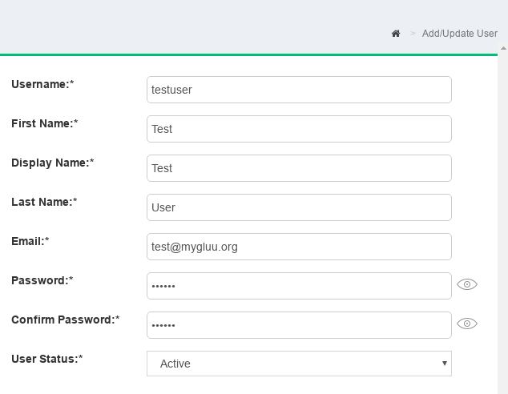
Since GS2 is not working while you are adding person, this person is created on GS1
3) Start Gluu Server on GS2:
# root@lb:~# /etc/init.d/gluu-server-3.1.4 start
4) After a few seconds, stop Gluu Server on GS1:
# /etc/init.d/gluu-server-3.1.4 stop
5) Then login Gluu UI with testuser via LB (lb.mygluu.org). If login is successful you are lucky.
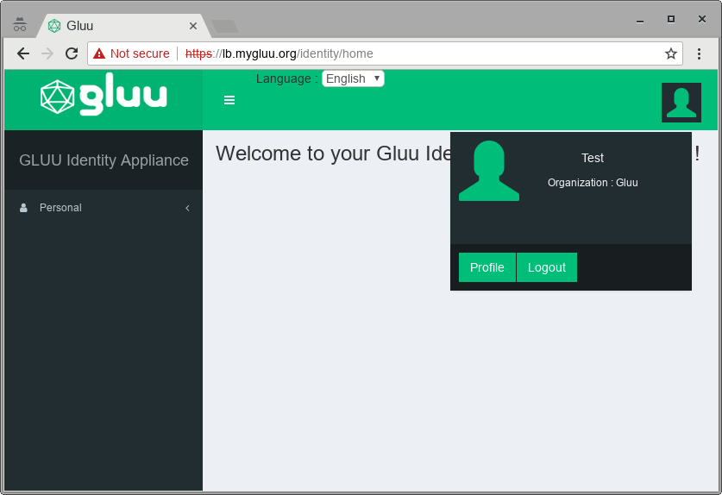
Since GS1 is not working, your are logged in GS2 which was not working while you are creating testuser. So cluster is working successfully.
Before going to optional configurations please start Gluu Server on GS1:
# root@lb:~# /etc/init.d/gluu-server-3.1.4 start

Monitoring (optional)
GCM can be used for monitoring your servers in the cluster. To setup monitoring, click Monitoring > Install Monitoring from the left menu. In the upcoming page, hit Install Monitoring button. You may get the following error, don’t worry it won’t break things:
An error occurrued while executing pip install pyDes: /usr/local/lib/python2.7/dist-packages/pip/_vendor/requests/__init__.py:83: RequestsDependencyWarning: Old version of cryptography ([1, 2, 3]) may cause slowdown. warnings.warn(warning, RequestsDependencyWarning) DEPRECATION: Python 2.7 will reach the end of its life on January 1st, 2020. Please upgrade your Python as Python 2.7 won't be maintained after that date. A future version of pip will drop support for Python 2.7.

After finishing first step, click Configure Local Server button. After 5 minutes of completion monitoring setup, you will be able to see the following in Monitoring dashboard.
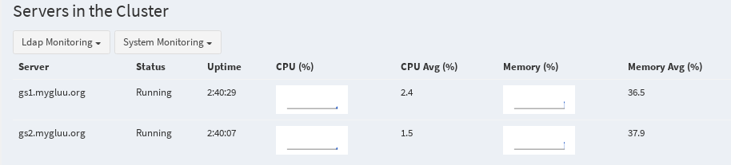

Cache Management (Optional)
Although LDAP CacheManagement is easy to configure and works well, it makes high load on LDAP replication. Therefore many admins prefer redis cache management. To configure redis cache management, go Setting on the left menu and unchecked Use LDAP Cache. After this you will see Cache Management on the left menu. Click on it and hit Setup Cache button. Complete 3 steps.

