Rohit Sai

00162939| Batch 16 ‘C’

Computing Project

Level 5 Diploma in Computing

E-mail: websrohit@gmail.com

Softwarica College of IT & E-Commerce

Kathmandu, Nepal

April 9, 2017

**Project Proposal on E-Gig nepal**

**Contents**

Introduction: 2

1.1. List of main Features: 3

1.2. Aims: 3

1.3. Objectives: 3

1.4. Development Methods: 4

Project Plan: 6

2.1. Work Breakdown Structure (WBS): 6

2.2. Time Estimate: 7

2.3. Milestone: 7

2.4. Schedule: 8

Risk Management: 9

Configuration Management: 10

Conclusion: 12

References: 13

# Introduction:

**E-Gig Nepal** is an online site which will be developed to solve the current problems of searching the gigs/musical shows browsing different sites and Facebook pages. Different gigs are promoted and viewed in different pages and sites currently which makes the fans or music lovers hard to find the gigs they are interested in and find the details about it. So many fans are currently in search of the single platform or the site which they can use to find all the gigs that will be happening in the country.

Also, the organizers of these kinds of musical shows/gigs gets promoted for their events and maximum audience for the shows will be reached with the help of this site. Currently the organizers, needed to pay certain amount according to the type of event they were going to conduct to many promoters or event planners. But with this site, the organizers will be able to promote their event through this page without any cost. The organizers can post their event details in this site freely.

The audiences having different taste in music can get information about their bands/artists and their background information. They can search their bands/artists for the genres they are interested in. The information about the band/artists can be searched or found in the site manually. The audiences can also search the gigs with respect to their interested genres. The gigs can also be searched with the venue where it is happening. If you want to know which event/gig is happening in which date, it can also be searched using the date in which you want to get the list of the gigs. The audiences can view all the gigs that will be happening in Nepal and are posted by Organizers or admin of the site.

For the promotion of the event, the organizers should have registered in the site and should have a valid E-Mail and Contact Details. After the successful registration, the organizers should login to the site. The organizer can also edit their profiles by logging in. After logging in the organizers can post their events in the site. The posted details of the event/gig should be genuine. The gigs/shows the organizers have posted in the site will be showed when gigs are searched whereas bands profiles are viewed & posted by the admin of the site. The admin of the page can also post the events or gigs happening.

## List of main Features:

* To search the gigs/ shows happening & their complete details.
* To search their artist/ bands details which are recorded in the site.
* To register the organizer’s account at the site & edit their profiles.
* To post or promote the details of their event for free in the site.
* To create different accounts for the band members, organizers and the audiences.
* To edit their registered accounts.
* To Login the existing account and promote the gig of the organizers.
* To read or get information of all the bands/ artist by the audiences.
* To get information of all the gigs / shows happening in the country.
* To get the links to book the tickets by the audiences if available.

## Aims:

* To build a website / web application for listing or collecting all the details of the gigs/ events that will be happening in Nepal.
* To build a site for listing the details of all the bands and artists of Nepal in a single site.
* To build a site for promoting the events/ gigs of the organizers of Nepal.
* To promote the Nepali Music to International platform.

## Objectives:

* To gather information about the Nepali bands.
* To gather information about the Organizers of the Nepal.
* To design a website that is targeted for Nepali music lover audiences and organizers.
* To develop a website that can show the gig or events details and band details.
* To test a website so that no any error occurs while searching the gigs and band profiles.
* To test a website so that all the included functions perform well.
* To document all the processes taken while developing the website and explain what we have made.
* To submit the final made project to the client with the documentation.

## Development Methods:

For the development of this project I choose Waterfall Model with object oriented methodology. In this Model, the process of the development is followed serially one after another. I choose waterfall model with object oriented method because of following reasons:

* The time of the project is very limited.
* The project is to be performed by an individual.
* Requirements are already stated and are unlikely to change.
* The project can be re-used at future.

The waterfall model consists of various serial steps. They are stated as follows:

* Idea/Planning
* Analysis
* Design
* Development/Implementation
* Test/Maintenance

**Figure: Waterfall Cycle**

In the waterfall model, the steps are followed serially from Planning, Analysis to Testing and Implementation as shown above. The steps are only done after completing one after another. This method is choose for this particular project with the following reasons:

* The E-Gig Nepal already has all the requirements collected that are needed to develop the project i.e. all the required modules and contents are clear.
* This project is solely owned by me, so there is less chance of change in requirements.
* This project is further planned to expand to android application so OOP is followed so that codes can be re-used.
* This project is college based and has a limited time to complete.

# Project Plan:

In this part of the document, all project scopes & milestones are defined. We also identify the work breakdown structure. We also set & agree the targeted delivery dates of the system. (Method123.com, 2017) We break our project plan into 4 areas as listed below:

## 2.1. Work Breakdown Structure (WBS):

WBS is the process of dividing the whole complex projects into small and simple manageable tasks. We break down the complete project into little chunks of different tasks which makes the project easy to manage. (www.tutorialspoint.com,2017) The WBS is presented in a diagram. The WBS for this project is presented below:

**Figure: WBS for E-Gig Nepal**

## 2.2. Time Estimate:

In this phase, we estimate all the activities and the time that can take to complete. The below shows the time estimation for this project.

|  |  |  |
| --- | --- | --- |
| **S.No.** | **Activity** | **Time** |
| 1. | Project Proposal | 1 day |
| **2.** | **Analysis Specification** | **14 days** |
| **2.1** | **Requirements** | **8 days** |
| 2.1.1 | Bands Analysis | 4 days |
| 2.1.2 | Organizers Analysis | 4 days |
| 2.2 | Use Case | 3 days |
| 2.3 | Architecture | 3 days |
| **3.** | **Design Specification** | **31 days** |
| **3.1** | **Structural** | **25 days** |
| 3.1.1 | Primary Navigations | 10 days |
| 3.1.2 | Contents for Band and Gigs | 15 days |
| 3.2 | Behavior | 6 days |
| 4. | Implementation | 21 days |
| **5.** | **Testing** | **6 days** |
| 5.1 | Functionality Testing | 2 days |
| 5.2 | Usability Testing | 2 days |
| 5.3 | Interface Testing | 2 days |
| 6. | Reporting | 20 days |
|  | **Total Days** | **93 days** |

**Table: Time Estimate**

## 2.3. Milestone:

In this phase, we assign milestone and the date to complete the milestone. The table below shows the milestones for this project.

|  |  |  |
| --- | --- | --- |
| **S.N.** | **Milestone** | **Date** |
| 1. | Project Proposal | 9th April 2017 |
| 2. | Analysis Specification | 23rd April 2017 |
| 3. | Design Specification | 24th May 2017 |
| 4. | Implementation | 14th June 2017 |
| 5. | Project Submission | 11th July 2017 |

**Table: Milestone**

## 2.4. Schedule:

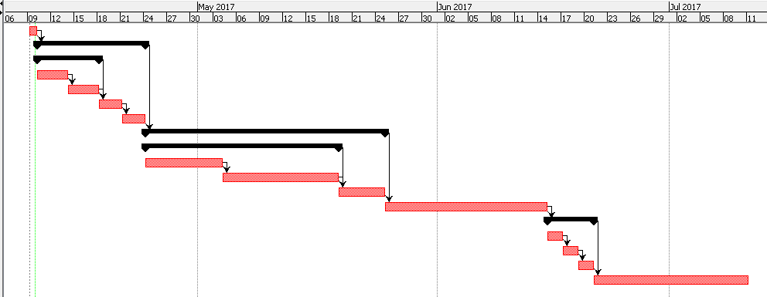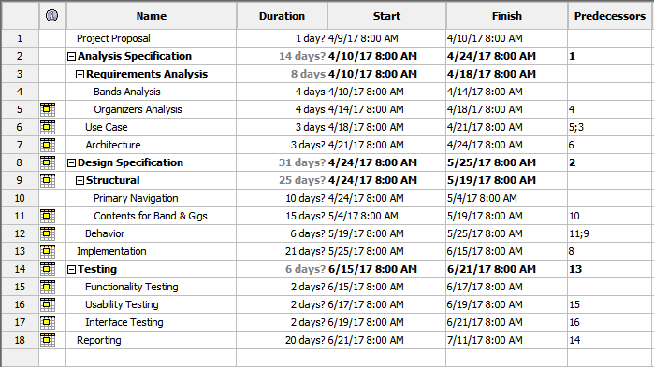

**Figure: Gantt Chart**

# Risk Management:

Some of the risk listed for the projects with their types is:

* Event Driven Risk
  + Laptop Damage
  + Drive may get formatted
* Long Term or Chronic Risk
  + Low Budget Estimation
  + Faster Milestone Estimation
  + Sudden Growth of Requirement (www.castsoftware.com,2017)
* Technical Risk
  + Designs may not work well as a change in browser
  + Software used for designing like Dreamweaver may not respond
* Non-Technical Risk
  + Developer may get ill
  + Natural disasters may occur

Table below shows the above listed risk, their consequences, likelihood, impact and action that can be taken to solve it:

|  |  |  |  |  |
| --- | --- | --- | --- | --- |
| **Risk** | **Likelihood** | **Consequences** | **Impact** | **Action** |
| Laptop Damage | 2 | 4 | 8 | Make sure to check the laptop properly before starting project |
| Drive may get formatted | 2 | 4 | 8 | Make a proper back up of day to day work |
| Low Budget Estimation | 3 | 4 | 12 | Make a proper cost estimation |
| Faster Milestone Estimation | 3 | 3 | 9 | Make a proper time calculation |
| Sudden growth of Requirement | 3 | 4 | 12 | Make sure to collect all the requirement properly |
| Design may not work well as change in browser | 3 | 2 | 6 | Make sure to support multi browser and accessible |
| Software used during development may not respond | 3 | 2 | 6 | Installation of multiple software for the development should be done |
| Developer may get ill | 1 | 5 | 5 | Make sure to stay safe and eat healthy |
| Natural disasters may occur | 1 | 5 | 5 | Make sure to have a proper back up |

**Table: Risk Management**

# Configuration Management:

Configuration management system is required to make a proper co-ordination between the related files in the project including documentation. It is also used to make a version control of the system. For the configuration management, I have planned to make a directory structure which will be seen as below:

**E_GigNepal**

Documentation

00162939_RohitSai_Proposal.docx

00162939_RohitSai_Proposal.pdf

Project

fonts

img

index.php

database

js

css

Version/BackUp

Project1

Project2

Project3

ProjectN

Diagrams

Use Case

ER-Diagram

Gantt Chart

**Figure: Configuration Management**

For the configuration system, I have made four different folders to store Documentation, Project, Version and BackUp/Version control respectively. In the documentation folder, I will be storing all the files related to documentation including project proposal. For now, I have two files ‘00162939_RohitSai_Proposal.docx’ and ‘00162939_RohitSai_Proposal.pdf’. In the project folder, I will be storing all the files required for developing the system. I have made folders like fonts, img, database, js and css where different fonts that will be used will be stored, images for the site that will be used will be stored, database related SQL files, javascripts files, css files will be stored respectively. index.php will be main file inside project folder. Inside the diagram folder, all the required diagrams like Use Case, Gantt Chart, ER-Diagram for the project will be stored. Whereas in Version/BackUp folder the project folder will be backed up as a change with the folder name Project1, Project2 and so on.

# Conclusion:

Finally, the proposal for the project that will be developed is at the end. The system proposed will be made on web based application to make an ease for users to search the gigs and shows and promote their gigs. The system will also help the users to know about their favourite artist or band. The details of the gig will be provided. The proposed application won’t have map services for which location the gig will be happening and direct booking to the tickets. Only link to book the ticket will be provided. Further improved version of this will be developed with maps and direct ticket booking and payment system. Also, mobile android app for this system are planned for future. For this system, all the information is provided in this document from project scope, planning, features, aims and objectives. Work breakdown structure with milestones, time estimation and schedule is also presented above. Also, the risk management and configuration management is explained above. The configuration management helps the version controlling and back up of the files and folder.

# References:

Method123.com. (2017). Project Plan - Project Planning. [online] Available at: http://www.method123.com/project-plan.php [Accessed 4 Apr. 2017].

www.tutorialspoint.com. (2017). Work Breakdown Structure. [online] Available at: https://www.tutorialspoint.com/management_concepts/work_breakdown_structure.htm [Accessed 4 Apr. 2017].

www.castsoftware.com. (2017). Risk Management in Software Development. [online] Available at: http://www.castsoftware.com/research-labs/risk-management-in-software-development-and-software-engineering-projects [Accessed 5th Apr. 2017].