Task 1

Charles Babbage, (26 December 1791 – 18 October 1871) an English [polymath](http://en.wikipedia.org/wiki/Polymath), was considered the father of the computer. He was a mathematician, philosopher, inventor and mechanical engineer. However, Charles Babbage was and is best known for his theories and concepts about computers that can be programmed. He invented the first mechanical computer, although they weren’t completed due to lack of funds and clashes of personality with the Astronomer Royal. His machines were very crude and mechanical, but their basic architecture was similar to computers we use in the modern era. The data and program memory were separated and were to be put into the machine in the form of [punched cards](http://en.wikipedia.org/wiki/Punched_card); the operations carried out by the machine was instruction-based, the control unit checked the validity of conditions, and the machine had separate input and output units. The machine used printers, curve plotters and the bells as forms of output. The memory was capable of holding 1,000 numbers of 40 decimal digits. The machine relied on its own internal procedures, which were stored in the form of pegs inserted into rotating drums called "barrels"; this was used to carry out more complex instructions the user's program might specify. Three types of punch cards were used: for arithmetical operations, for numerical constants, and to load and store operations. Each type of card required a separate card reader. Charles Babbage also mechanized arithmetic calculations.

Reference:

* <http://en.wikipedia.org/wiki/Charles_Babbage>
* <http://en.wikipedia.org/wiki/Analytical_Engine>

Task 2

Mary's Tasty French Toast

* Combine 2 slightly beaten eggs with 1 tsp vanilla extract, ½ tsp cinnamon, 1 cup milk
* Dip 6 slices of bread in mixture
* Fry in small amount of butter until golden brown
* Serve bread with maple syrup, sugar, or oregon grape jelly

The 5 problems that I can detect as to why this fails as an algorithm would be as follows:-

1. How much is slightly beaten? For how long should the eggs be beaten to be considered slightly beaten? Beat eggs with what, fork or egg beater?
2. “Dip 6 slices of bread in mixture”. Which mixture? Is it the one with the eggs or some other mixture?
3. Fry what in small amount of butter? How much is a small amount of butter?
4. Fry in small amount of butter until what is golden brown? The bread or the butter?
5. I could serve bread with maple syrup, sugar, or oregon grape jelly, but whatever happened to the French toasts?

For us it’s fairly obvious what the recipe expects us to do, but a programmable robot would have no clue. It’ll keep asking itself the questions I mentioned above. Hence the recipe is a failure as an algorithm.

Task 3

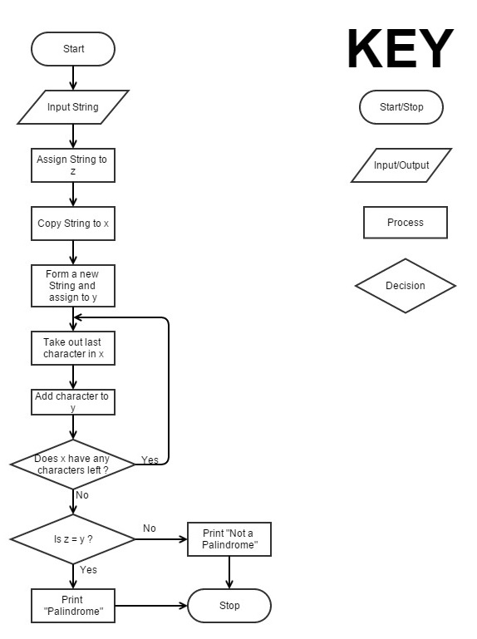

Start

Input String

Assign String to z

Copy String to x

Repeat till x has no characters

Take out last Character in x

Add character to y

Is z=y?

If yes then print “Palindrome”

Else print “Not a Palindrome”

Stop

Task 4

Happy Birthday Alan

00101001

Alan Turing’s age would be 29 in Hexadecimal



-45

61

-83

211

1101 0011

61

0011 1101

61



00101011

Not Possible

11100000

00001110