Modernising Clearihue’s Lighting System

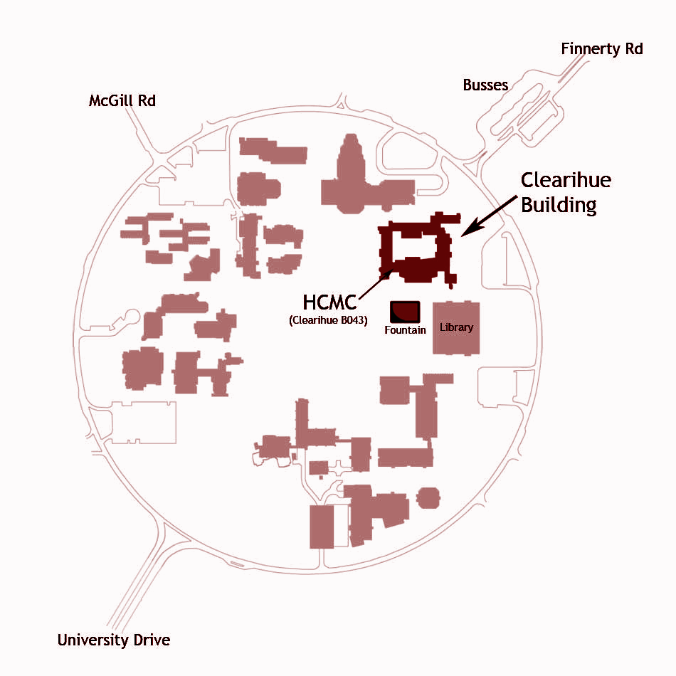

Helping the University of Victoria in accomplishing sustainability goals

**For :**

David Adams, Facilities Management Energy Manager at The University of Victoria

**December 04, 2016**

**By :**

Devroop Banerjee

Alina Chin

Peter Kihaile

Thomas Watkin

**Devroop Banerjee**

2551, Sinclair Rd

Stibbard Residence

Victoria BC V8N 1B7

Canada

**David Adams**

Facilities Management Energy Manager

University of Victoria

PO Box 1700 STN CSC

Victoria BC V8W 2Y2

Canada

**November 28, 2016,**

**Dear Mr. Adams**,

Following will be my report for an investigation into energy savings measures for the Clearihue building on the main University of Victoria campus. Your stated sustainability goal was to reduce UVic’s overall energy consumption by 8% by 2019. After reading through the data you provided, it became clear that Clearihue was one of the most energy consuming buildings on campus, using 2,341,506 kWh, or $187,320 in 2015. Some of this usage is warranted. A teaching environment needs adequate lighting and heating. Students occasionally use the facilities outside teaching hours for private study. Many aspects of the consumption, such as lights left on while not in use and fluorescent lighting, for two examples, are easily remedied wastes of power over the course of the year. This report aims to fix this. Specifically, the investigation looks into the lighting systems of Clearihue: how can energy be saved by automating light controls to turn off when not in use, where can energy be saved by changing the type of lighting in the building, and what will the benefits of these savings be? This came with a number of ancillary investigations that were pursued, such as looking into the percentage of the building’s power usage that lighting uses, the current patterns of power saving methods in the building, and the efficiency of the current bulbs and lighting systems.

The solution to this problem comes in two parts. First and foremost, the CFLs need to be replaced by LEDs. Secondly, a majority of the lights in Clearihue need to be switched off in the evenings, unless activated by sensors. This would save approximately $8,400.00 per annum from just one building. Finally, adding an occupancy sensor to each room would supplement the second part of the solution mentioned above. A wide scale implementation of these solutions throughout campus would surely help UVic with its goal to reduce overall electricity usage by 8% by 2019. Hence, my research and calculations have led me to believe that an implementation of this idea is an absolute necessity.

Please feel free to contact me in case of any queries so that I could clarify them personally. My contact information is provided below.

Sincerely,

**Devroop Banerjee**

Devroop Banerjee

2nd year Computer Science student

University of Victoria

Ph: +1 778 922 6643

[indroneil20@gmail.com](mailto:indroneil20@gmail.com)

Table of Contents

**Executive Summary** **5**

**1.** **Introduction** **5**

**2.** **Methods** **6**

2.1. General Research **7**

2.2. Surveys of Students and Faculty **7**

2.3. Observational Studies (Site Surveys) **8**

**3.** **Results** **8**

3.1. General Research **8**

3.2. Survey Results **11**

3.3. Discussion **12**

**4.** **Conclusion** **13**

**5.** **Recommendations** **13**

**6.** **References** **14**

**7.** **Appendices** **14**

1. Recorder’s Document 1 **14**
2. Recorder’s Document 2 **16**
3. Recorder’s Document 3 **18**
4. Recorder’s Document 4 **19**
5. Recorder’s Document 5 **20**
6. Survey Results **20**
7. Individual work logs **23**
8. Team work log **26**

List of Tables and Figures

**Table 1. Number of Light Fixtures in Clearihue Building . . . . . . . . . . . . . . . . . . . . . . . . . 9**

**Figure 1. Electricity Savings per hour of operation . . . . . . . . . . . . . . . . . . . . . . . . . . . . . . .11**

**Figure 2. Payback Period . . . . . . . . . . . . . . . . . . . . . . . . . . . . . . . . . . . . . . . . . . . . . . . . . . . 11**

**Figure 3. Survey - Classes Taken in Clearihue - Winter Term 2016 . . . . . . . . . . . . . . . . . .21**

**Figure 4. Survey - Hours Spent in Clearihue Per Week - Winter Term 2016 . . . . . . . . . . . 21**

**Figure 5. Survey - Main Time of Day Using Clearihue - Winter Term 2016 . . . . . . . . . . . 22**

**Figure 6. Survey - Lights Turned Off Upon Leaving - Winter Term 2016 . . . . . . . . . . . . .22**

**Figure 7. Survey - Clearihue Light Management Satisfaction - Winter Term 2016 . . . . . .23**

# Executive Summary

To help UVic achieve its energy reduction goals, we researched the feasibility of energy reduction in the Clearihue building through upgrading to LED lighting and reducing the building’s hours of operation. Through the data provided by David Adams and our survey of the Clearihue building, we obtained estimates on the power usage of Clearihue’s lighting system. Using our estimates, we calculated the power savings of Clearihue by switching to LEDs. Our results showed that within a year and a half, the switch to T8 Fluorescent Tube LED replacements would have paid for themselves in energy savings. In addition, we investigated the usefulness of reduced lighting and building schedules. We recommend immediately performing the upgrade from fluorescent to LED lighting in Clearihue, followed by further research and/or user surveys on limiting the building use after hours, which may additionally save significant energy costs for UVic.

# **Introduction**

This report investigates the feasibility of reducing Clearihue building’s electricity usage through replacing the current lighting system with LEDs and reducing the building hours. Clearihue is one of the top 10 highest consumers of electricity among the campus buildings. In keeping with UVic’s goal to reduce power consumption by 8% by 2019 [1], it would be logical to switch over to Light Emitting Diodes (LEDs).

UVic’s current lighting system is a prime example of inefficiency. Currently, the Clearihue building uses fluorescent lights (CFLs) in all of its rooms, which consumes $15,610 per month. Additionally, CFLs have a short lifespan, which means they need to be replaced more frequently compared to LEDs, adding to UVic’s list of expenses.

To determine how feasible, eco-friendly and cost-effective it would be to replace the CFLs with LEDs, we used a variety of methods to collect and analyze our data: general research, surveys from students, observational studies of the building, and administrative resources. We also inspected whether installing LED lights would actually help UVic achieve its goal to reduce on-campus electricity consumption by 8% by 2019.

# **Methods**

Our team used general research, surveys from students, observational studies of the building, and administrative resources in order to investigate the feasibility of our proposal.

## General Research

In this stage, we collected raw data about Clearihue’s energy usage. We referred primarily to information about buildings’ power expenditure provided by David Adams [1] and UVic[3]. To estimate the amount of light fixtures in the building, we performed a visual inspection of the building’s hallways and classrooms on selected floors, combined with viewing Clearihue’s layout map. From there, we tallied up the number of rooms per floor, multiplied that number by the average number of light fixtures per room, and then added that to the number of light fixtures in the hallways.

## Surveys of Students and Faculty

In order to acquire general information regarding people’s use of the building, we asked a sample of 20 students about their occupancy patterns in Clearihue. In our experience, computer science and engineering students don’t have many classes in Clearihue, oftentimes having at most one course a year in the building. Due to that, we tried primarily to include students that are from the humanities departments in this survey. We used two questions to ascertain that those surveyed used the building enough to obtain usable responses. The next two questions were used to judge the busiest times and whether students changed behavior in regards to switching the lights on/off, based on what time of the day they are in the building. The last is an opinion question, to see how the students feel about the current system.

## Observational Studies (Site Surveys)

To complement our surveys targeted at faculty and students, we also conducted a survey of Clearihue itself and observed occupancy patterns at different times of the day. Our observations were carried out primarily in classrooms, so during our studies, usage patterns for the office lights were somewhat overlooked. We expected professors to be more considerate about conserving energy by switching the lights off.

# **Results**

## General Research

From our analysis of Clearihue’s floorplan, we estimate that the building has 1373 fluorescent lighting fixtures (see Table 1 below). From our background research, Clearihue used 2.34M kWh of electricity, or about $187k/year, in 2015 [3].

**Table 1**

**Number of Light Fixtures in Clearihue Building**

|  |  |  |  |
| --- | --- | --- | --- |
| **Room Type** | **Average # of Fixtures** | **# of Units** | **Fixtures (Subtotal)** |
| Classroom | 36 | 20 | 720 |
| Hallway (per floor) | 134 | 3 | 402 |
| Office (single) | 1 | 251 | 251 |
|  |  | **Fixtures (Total)** | **1373** |

Occupancy sensors have not been installed in Clearihue [2]. However, we found that in February 2015, UVic instated a reduced corridor lighting schedule for the building: general space lighting were put on programmed relays [5]. The reduced lighting schedule aimed to reduce the operating hours of the lights in some areas:

* Corridor Lighting runs from 5:00 am to 1:00 am
* Office Corridors runs from 5:00 am to 7:00 pm
* First Flr. Classrooms run from 5:00 am to 10:00 pm [5]

According to Adams [2], Clearihue uses standard 32W T8 fluorescent tubes in its light fixtures. Assuming that the lights operate for 16 hours per day on average, Clearihue’s lighting system consumes 703 kWh per day, or 257586 kWh per year. This translates to a cost of about $21k per year, using the 2015 average cost of electricity ($0.08/kWh) [3].

15W LED tube lights [2] can replace Clearihue’s existing fluorescent lights without requiring the fixtures to be modified. (Our visual inspection found at least one “high-tech” classroom whose lights were LED tubes; however, according to Adams, UVic has not performed any systemic upgrade to the lighting in Clearihue [2], so our analysis assumes that virtually all lights are still fluorescent lights.) Performing this upgrade would reduce the energy consumption rate of the building by 23.3 kW. While research was not conclusive, an average price on wholesale lighting websites (minimum orders of 100 pieces) showed an average price of $7 per T8 bulb [7], using the kind that connect directly into the existing T8 Fluorescent slot without adjustment. For 1373 units, that gives a supply cost for upgrades of $9611. We did not, however, gather installation costs for changing the bulbs. It was assumed this could be a side project for existing campus management. If we disregard the installation costs, it would take 5157 hours of 100% building light use to start seeing payback. If we use a more realistic 66% light usage, then we get 7736 hours of use before finishing the payback period. If we assume 16 hours of this reduced light usage per day, then that gives a payback period of only 484 days. (see Fig. 2).

savings (kW) = (32 - 15)W/unit * 1373 units = 23.3 kW

**Fig. 1: Electricity savings per hour of operation**

payback period (h) = $9611 / (23.3 kW * $0.08/kWh) = 5157 h

5157 h / (⅔) = 7736 h

7736 h / 16 h = 484 days

**Fig. 2: Payback Period**

In addition, we also investigated reducing the hours of operation by closing the building during off hours. If Clearihue is closed before 5:00AM and after 7:00PM, then (assuming fluorescent lights and a 16 h/day baseline) UVic would save 32073 kWh annually.

## Survey Results

As previously mentioned, we attempted to get responses from students that were active in the building, so the fact that most (90%) have 2+ classes and most (80%) spend 4+ hours in the building serves us very well. Finding out that the vast majority of students were busiest in the building before the evening was of no surprise. When we inquired further, we found that 6 of the respondents who said they were busiest during the morning or afternoon also either study late or take night classes in Clearihue, which is good as we can get broader responses. The responses to turning off lights when leaving classrooms had a clear division between the morning/afternoon groups and the evening ones. All of those that took night classes or studied late said “yes” to turning off lights. All of the “no” responses came strictly from users that aren’t regularly in the building after 5 p.m.

## **Discussion**

From our building survey and research, we found that Clearihue’s current lighting system makes up about 11% of the building’s total electricity consumption. LED replacement addresses the need to modernize Clearihue’s lighting system very well. Because LED tubes can be installed into existing T8 fixtures without any modifications, they are an excellent solution with a lowered installation cost and other benefits such as a 10-year lifespan and a lack of mercury compared to fluorescents.

Since the majority of Clearihue users we surveyed use the building before 5 p.m., reducing the entire building’s hours seems feasible. At the least, a reduced usage plan for the building, limiting to one floor of one wing to those outside the faculty, could allow a strong reduction in energy while still providing some study areas, especially considering that 15% of our survey responses reported using the building in these off-hours. Given the clear results on how quickly the LED replacements complete their payback period, combined with their almost doubled lifespan, which we didn’t even account for, LED seems an obvious choice for implementation. Finally, since respondents are split on whether Clearihue’s current lighting policy is satisfactory, we anticipate that changing the policy will result in a similarly mixed response.

# **Conclusion**

Clearihue is one of the oldest buildings on campus, and it’s obvious that the building’s technology is lagging behind when compared to newly built or renovated buildings. In Clearihue, it is necessary for a large portion of lights to be on throughout the day, so the lights used should be as energy efficient and cost effective as possible. CFLs are not eco-friendly and carry high repair costs when compared to LEDs. A move towards LEDs would be of great benefit to Clearihue, UVic, and UVic’s goals as stated in the Sustainability Action Plan.

# **Recommendations**

The lightbulbs throughout Clearihue should be immediately replaced with T8 Fluorescent LED replacements; the sooner the change is made, the sooner the payback period can be attained, and the sooner UVic closes in on its energy reduction platform. Due to the limitations of our resources and time, we were not able to perform a more extensive survey. We obtained hopeful results in investigating a reduction in building hours, but we currently do not have a concrete answer with our data. We recommend that a more extensive survey of building users, combined with a feasibility report for things such as reduced building usage (in areas and hours of availability) be performed.

# **References**

1. D. Adams, “ENGR 240 – Problem Statement,” Univ. Victoria, 2016.
2. D. Adams, “RE: ENGR 240 project additional questions,” 2016.
3. D. Adams, “UVic Monthly Energy Consumption for 2015 by Building,” 2016.
4. “Integrated Energy Masterplan,” Univ. Victoria, Victoria, 11-1309- M01, 2011.
5. L. Kao, “Retrocommissioning Final Report,” Univ. Victoria, Victoria, 2015.
6. “Sustainability Action Plan,” Campus Planning & Sustainability, Univ. Victoria, Victoria, 2014.
7. “T8 1.2M LED Fluorescent Replacements,” DH Gate. 2016.

# **Appendices**

## Recorder’s Document 1

**Minutes - Nov. 7**

**Meeting Date:** November 7, 2016 **Recorder:** Alina

**Group members present:** Alina, Devroop, Peter

**Roles assigned:** Leader - Devroop

Timekeeper - Peter

Facilitator - Alina

**Agenda item: Meeting outside of class time**

**Discussion:**

Where and when to meet in person.

**Decision:**

Apart from online collaboration, we’ll prefer to meet in the ECS group study rooms.

**Agenda item: Attendance**

**Discussion:**

Bylaw for group members’ attendance.

**Decision:**

Group members should try to attend regularly (i.e., every meeting).

**Agenda item: Missing meetings**

**Discussion:**

What we should do if someone doesn’t attend a meeting (both the absent person and the rest of the group members).

**Decision:**

The absent person should notify another group member. The rest of the group will:

1. Note it down
2. Update them about what was done
3. Let them know how they can contribute to the upcoming tasks
4. Adjust the timeline, if necessary

**Agenda item: Project topic**

**Discussion:**

Which proposal to work on for the final project.

**Decision:**

We will make a decision based on the data sent by David Adams.

**Agenda item: Team goal**

**Discussion:**

What our team wants to accomplish and learn from doing this project.

**Decision:**

We have come to the conclusions that our goals are as follows:

1. Learn to write a clean, effective technical report.
2. Learn to write in a clean, concise, and effective manner in general.
3. Learn to work well in a group.
4. Learn how to edit each other’s writing.
5. Get a good grade on this assignment.

**Tasks:**

1. Finish Exercise 6 and submit - Devroop
2. Update Thom on what we discussed - Alina

**Date of next meeting:** Nov. 14, 2016

## Recorder’s Document 2

**Minutes - Nov. 17**

**Meeting Date:** November 17, 2016 **Recorder:** Alina

**Group members present:** Alina, Peter, Thom

**Roles assigned:** Leader - Peter

Timekeeper - Thom

Facilitator - Alina

**Agenda item: Report topic**

**Discussion:**

We need to choose a proposal to implement based on the potential effectiveness and the amount of data needed to research it.

**Decision:**

Since David Adams’ answers are about campus buildings, we decided to go forward with the *Clearihue proposal* by Thom and Alina.

**Agenda item: Milestone 3 (due Sun.)**

**Discussion:**

Milestone 3 is the revised Background and Need Statement from our chosen proposal (see Coursespaces).

**Decision:**

Alina will refine and add IEEE citations to Background and Need Statement from Thom and Alina’s proposal.

**Agenda item: Progress report (presentation) (due Mon.)**

**Discussion:**

The progress report is an 8-10 min. presentation (see Coursespaces).

**Decision:**

We’ll work on it online, since everyone in the group is busy over the weekend.

1. Start filling in sections for Final Report using the Word template & proposal.
2. Base slides off the report using the Powerpoint template (see Coursespaces for presentation structure).
3. Decide who will present which slides.

**Agenda item: Work completed**

**Discussion:**

How to perform additional research to answer (some of) our research questions.

**Decision:**

* David Adams sent some data on campus buildings (posted on Coursespaces).
* Go to Clearihue in person and count the lights, etc. and extrapolate based on number of classrooms per floor
* Email UVic for floorplan, computer lab policies, etc.

**Tasks:**

1. Finish Milestone 3 and hand in - Alina
2. Gather info from Clearihue in person - everyone
3. Work on report & slides using info from David Adams etc. - everyone

**Date of next meeting: Monday, Nov. 21**

## Recorder’s Document 3

**Minutes - Nov. 23**

**Meeting Date:** November 23, 2016 **Recorder:** Peter

**Group members present:** Alina, Peter, Thom, Devroop

**Roles assigned:** Leader - Peter

Timekeeper - Thom

Facilitator - Alina

**Agenda item: making up ground for previously missed meetings**

**Discussion:**

Missed 2 or 3 team meetings due to a large portion (2+) members of the group being out of classes due to illness and personal issues. Need to make up ground since we were already behind to begin with

**Decision:**

The missed meetings weren’t too big of a deal because everyone still collected data or did other productive work for the group outside of class time. While all meetings should be attended by all members of the group, we got lucky in that this didn’t have too big of a negative effect on where we’re at.

**Agenda item: Carrying out surveys (of people)**

**Discussion:**

Surveys still need to be distributed and have their responses tallied.

**Decision:**

Should be completed before next class (Nov 25). We’re all pretty busy at this point of the year and distributing 20 surveys and then gathering all of the figures may take a bit longer than we expect. Nov 25 is a tentative date, but we do not expect to be done much later than that.

**Agenda item: Carrying out surveys (of the building)**

**Discussion:**

Completed our observational studies of Clearihue and its occupancy patterns. Now what needs to be done is for us to bring all of our information together, analyze it, and then see in what direction the evidence points to.

**Decision:**

This will definitely be completed before next class. Since we all already have our observational reports, this is just a matter of analysis.

**Tasks:**

1. Prepare for the final report

## Recorder’s Document 4

**Minutes - Nov. 24**

**Meeting Date:** November 24, 2016 **Recorder:** Alina

**Group members present:** Alina, Peter, Thom, Devroop

**Roles assigned:** Leader - Peter

Timekeeper - Thom

Facilitator - Alina

**Agenda item: Cover letter**

**Discussion:**

The cover letter assignment is due this Sunday.

**Decision:**

We will all work on the cover letter using Google Docs.

**Agenda item: Work logs**

**Discussion:**

Most of us forgot about keeping work logs, which we need to submit in the appendices of the final report.

**Decision:**

We can each do a backdated work log of Nov. 23’s work, and continue to keep individual logs.

**Tasks:**

1. Work on cover letter - everyone
2. Backdated minutes for Nov. 23 meeting - Peter

## Recorder’s Document 5

**Minutes - Dec 1**

**Meeting Date:** December 1, 2016 **Recorder:** Peter

**Group members present:** Alina, Peter, Devroop

**Roles assigned:** Leader - Alina

Timekeeper - Peter

Facilitator - Devroop

**Agenda item: revision of rough draft**

**Discussion:**

We need to look over the draft and make sure all requirements are included. Make sure that all graphs, figures, etc. in the report are consistent with the actual values we have. Read it over once per person to avoid avoidable error like grammar mistakes and mis-numbered graphs.

**Decision:**

We will all need to read the rough draft over before Tuesday. Since exam week is starting, we weren’t able to hit the original deadline but will definitely make it to Tuesday.

**Tasks:**

1. Revise the rough draft.
2. Submit FINAL team report with all requirements.

## Survey Results

1. **How many classes do you have in the Clearihue building per week?**

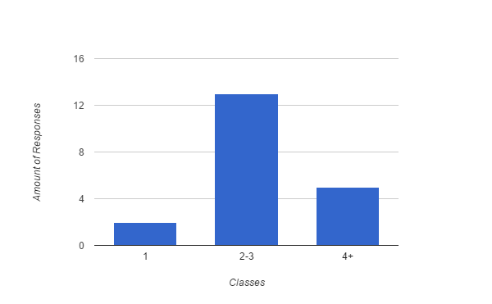

**Fig. 3: Survey - Classes Taken in Clearihue - Winter Term 2016**

1. **How much time do you spend in Clearihue per week?**

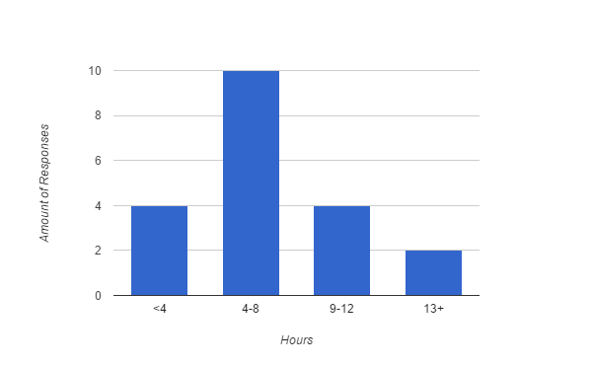 **Fig. 4: Survey - Hours Spent in Clearihue Per Week - Winter Term 2016**

1. **At what time of the day are you usually in the Clearihue building? (Morning is 7 a.m. to 12:59 p.m., Afternoon is 1 p.m. to 4:59 p.m., Evening is anything later than 5:00 p.m.).**

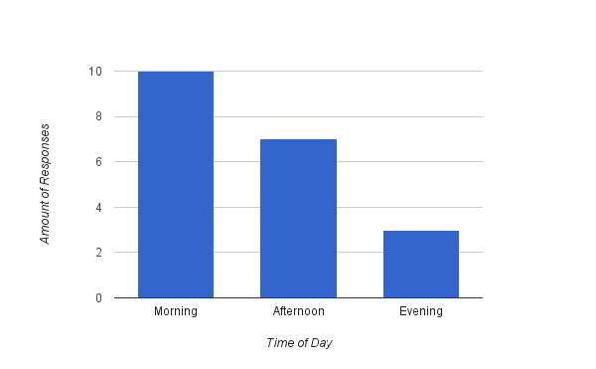 **Fig. 5: Survey - Main Time of Day Using Clearihue - Winter Term 2016**

1. **Do you turn lights off when you are the last to leave a classroom?**

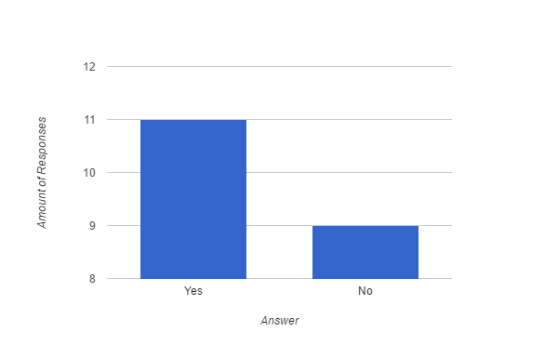 **Fig. 6: Survey - Lights Turned Off Upon Leaving - Winter Term 2016**

1. **Do you feel that Clearihue’s current management system for lights work sufficiently?**

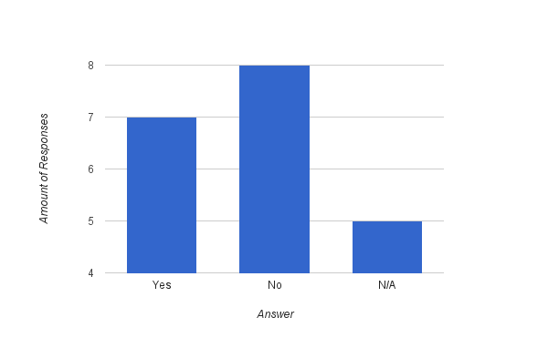 **Fig. 7: Survey - Clearihue Light Management Satisfaction - Winter Term 2016**

## Individual work logs

|  |  |  |
| --- | --- | --- |
| **Name** | Devroop Banerjee | **Project**:  Team report |
| **Signature** | *Devroop Banerjee* |
| **Work Log** | | |
| |  |  |  |  | | --- | --- | --- | --- | | **Date** | **Work completed** | **Time** | **Total hrs** | | Throughout November | Observation of occupancy patterns | Various | 4 | | Nov 17 | Refinement of problem statement | 12pm - 1pm | 1 | | Nov 20 | Prepared powerpoint | 12pm - 1:30 | 1.5 | | Dec 1 | Draft of introduction, results, references pages. | Various | 4 | | Dec 5 | Revision and formatting of team report | 4pm - 8pm | 4 | | | |

|  |  |  |
| --- | --- | --- |
| **Name** | Alina Chin | **Project**:  Team report |
| **Signature** | *Alina Chin* |
| **Work Log** | | |
| |  |  |  |  | | --- | --- | --- | --- | | **Date** | **Work completed** | **Time** | **Total hrs** | | Throughout November | Recorder’s logs, organization of team meetings | Various | 3 | | Nov 17 | Collection and analysis of administrative resources | Various | 2.5 | | Nov 20 | Prepared Powerpoint | 12pm - 1:30pm | 1.5 | | Dec 4 | Draft of exec summary, result, and appendices pages | Various | 6 | | Dec 6 | Revision of team report | 3pm - 5:30pm | 2.5 | | | |

|  |  |  |
| --- | --- | --- |
| **Name** | Peter Kihaile | **Project**:  Team report |
| **Signature** | *Peter Kihaile* |
| **Work Log** | | |
| |  |  |  |  | | --- | --- | --- | --- | | **Date** | **Work completed** | **Time** | **Total hrs** | | Throughout November | Observation of occupancy patterns & general research | Various | 3 | | Nov 25 | Distributing, collecting, and analyzing surveys | Various | 3 | | Dec 3 | Draft of methods, results, and conclusion section of report | Various | 4.5 | | Dec 5 | Revision of team report | 5pm - 7:30pm | 2.5 | | | |

|  |  |  |
| --- | --- | --- |
| **Name** | Thom Watkin | **Project**:  Team report |
| **Signature** | Thom Watkin |
| **Work Log** | | |
| |  |  |  |  | | --- | --- | --- | --- | | **Date** | **Work completed** | **Time** | **Total hrs** | | Nov 17 | Collection of data regarding lights (current amount in Clearihue, power usage, etc.) | 12pm - 4pm | 4 | | Nov 29 | Compilation and research of recommendations for Clearihue lighting | 1pm - 4pm | 3.5 | | Dec 2 | Draft of results, recommendations, and references pages | Various | 4 | | Dec 6 | Revision of team report | 3pm - 5:30pm | 2.5 | | | |

## Team work log

|  |  |  |
| --- | --- | --- |
| **Name** | **Tasks** | **Total hrs** |
| Devroop Banerjee | Created templates for both the powerpoint and team report; observed Clearihue occupancy patterns; refined problem statement; helped in preparation of the powerpoint; rehearsed for powerpoint presentation; drafted introduction, helped in draft of results and references pages; formatted final team report; helped in revision of final team report. | 14.5 hrs |
| Alina Chin | Organized team, team meetings, and recorder’s logs; collected and analyzed administrative resources; helped in preparation of powerpoint; rehearsed for powerpoint presentation; drafted executive summary and appendices pages of report, helped draft results section; helped in final revisions of team report. | 15.5 hrs |
| Peter Kihaile | Observed occupancy patterns; distributed, collected, followed up on, and analyzed surveys; rehearsed for powerpoint presentation; drafted methods and conclusion sections of report, and helped to draft results section; helped in final revision of team report; prepared team logs. | 13 hrs |
| Thom Watkin | Collected data regarding lights i.e. cost, eco-friendliness, when lights go off in Clearihue, etc.; compiled and researched pertinent recommendations; drafted recommendations page of report, helped draft results and references sections; helped in final revision of team report. | 14 hrs |