**SENG 310 - Assignment 1**

**Devroop Banerjee**

**V00837868**

**Note: My responses are based on my observations of the Spotify Premium app on an Android platform. Spotify’s functionalities vary between devices and platforms.**

**Part 1:**

1. Provide a high level description of the **conceptual model**used by the selected music streaming software service. You should provide and refer to some **screenshots** of the software you chose to critique in your description.

* Spotify is a mix between Netflix, a regular music player, and Instagram. It uses album art to indicate playlists which is a virtual representation of vinyl records (default album art is a vinyl record). Like Netflix/YouTube, Spotify provides its users with music recommendations, based on searches and listening history. Finally, like Instagram, the users are able to follow other users and artists. Spotify’s underlying concept is to bring something innovative to the user where the latter can listen to, organize, search, and save music while staying up to date with what the user’s peers and the world are listening to without the hassle of downloading music from the internet or the drawback of music files using up the device’s memory.

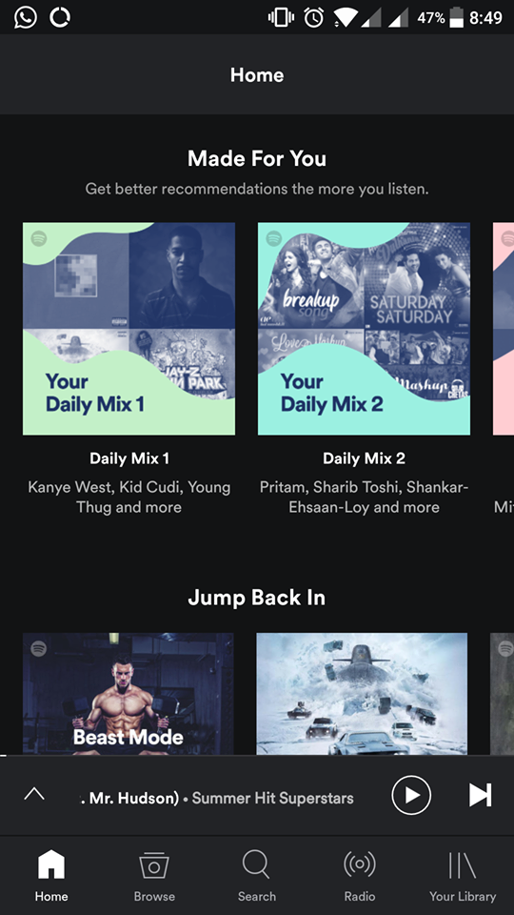 

1. Which key **metaphors**and **analogies** are used by this software?

* Like mentioned earlier, Spotify uses album art to represent playlists implying that the songs are the tracks on a virtual vinyl record. Its overall look and feel is that of any music player with the usual play/pause buttons, progress bar, etc. The fact that these features stay consistent between the in-app player, home screen widget, lock screen widget and looks very similar to any other music player’s widgets clearly shows the key function of this app…playing music. Considering most smartphone owners know how to navigate around a music player, this key analogy helps the user comprehend Spotify’s functionalities instantly.

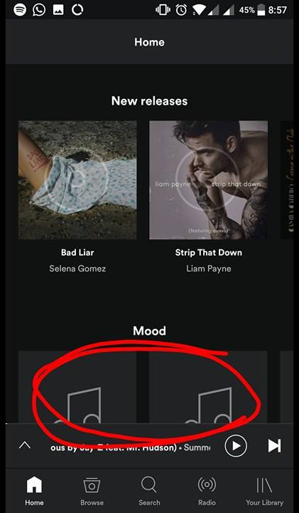 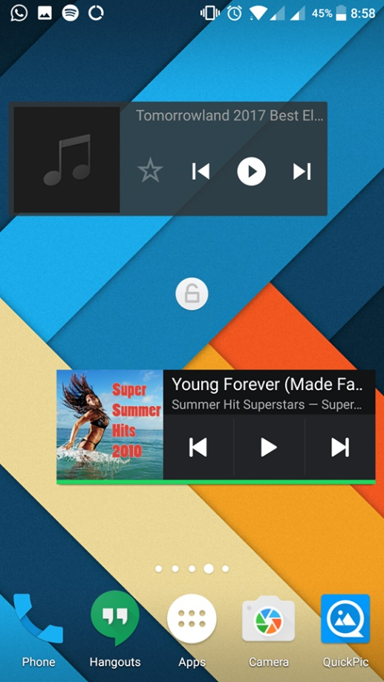

1. What are the main **task domain objects**you can create and manipulate, and which **attributes** do these objects have?  (To answer this, you need to consider which tasks the user wishes to perform)

* The main task domain objects would be the library, account, playlists, search tab. Library has various options such as playlists, stations, settings. Account has information on the user such as playlists, followers, following. Playlists have songs and options to manipulate the playlists. Search tab has a search bar and search history.

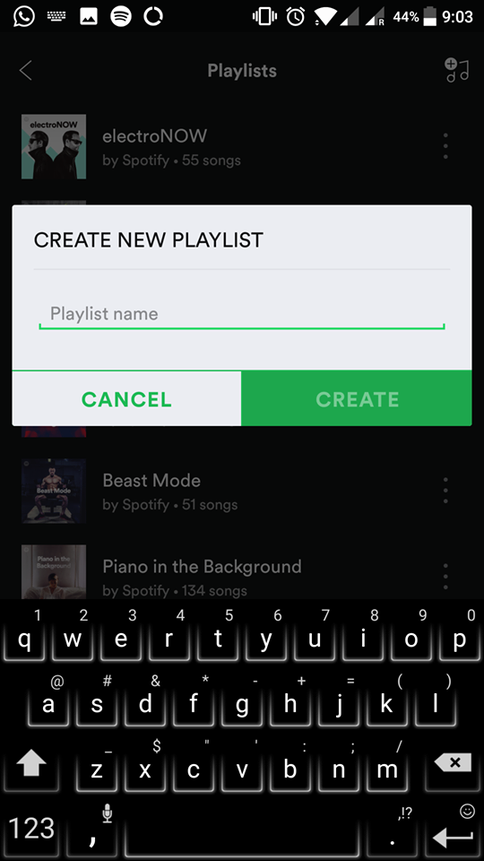 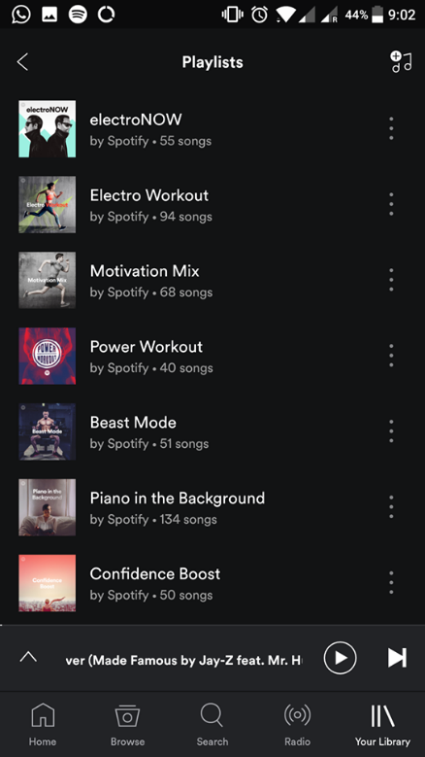 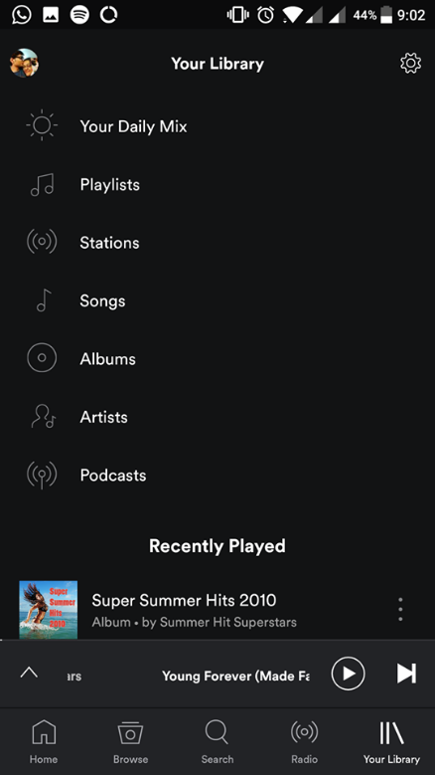

1. What kinds of **relationships** exist between the conceptual model objects?

* Some model objects have a parent-child relationship where one object might be included in another object (songs in playlist). Some model objects are related by the type of objects they are (different songs are the same type of object). Other models such as search and library not directly related. Overall, the conceptual model objects are related in some way or the other.

1. What kinds of**operations**are available for you to create and manipulate the domain objects, object relationships and object attributes?

* The library, account and playlists can be created, modified and deleted. The search tab can be used to look for other playlists, songs, albums etc, which can then be played/saved.

**Part 2:**

1. Can you easily determine the **function of the system**? How?

* Yes, the function of the system can be easily determined mostly due to its layout which is familiar to that of other music players. Spotify is ridden with intuitive signifiers which helps the user explore and understand its functionalities.

1. Can you easily tell what **actions are possible**? How?

* Yes. Spotify uses symbols which are known to most people such as the play button, or the 3 dots which lead to an options pop-up. It also uses self-explanatory keywords such as “search” in the search bar.

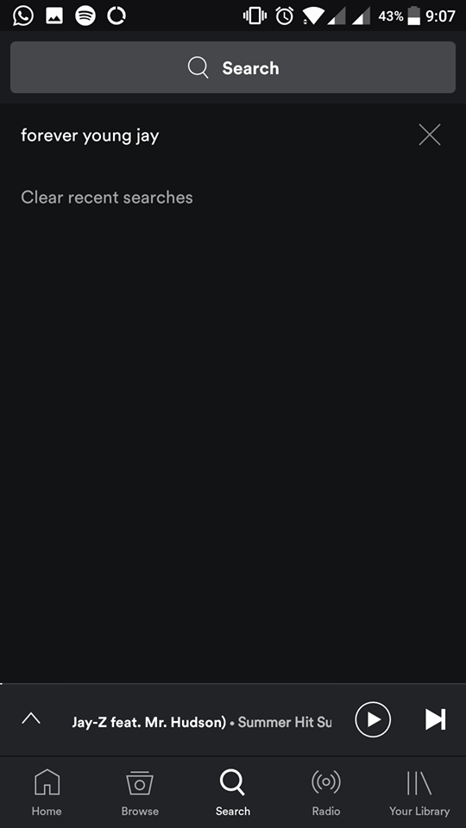

1. Can you determine the **mapping from intention to physical movement**? How?

* Yes. The pages scroll up and down depending on how the user scrolls. Similarly, tracks can be changed with a swipe to the right or left to go to the previous or next track respectively. The mapping is good on the most part as it has good button placement and the functionality of each tab or button is easily comprehendible.

1. Can you easily **perform the action(s)**? How?

* Yes. Most of the actions a user wishes to perform, are only a few taps away. Spotify uses a sufficient amount of labels and tags to guide the user, and groups actions with similar functionalities together, for ease of access.

1. Can you easily tell if the **system is in a desired state(s)**? How?

* Yes. If the music is playing, the music can be heard and the play symbol changes to a pause symbol. If shuffle or repeat is turned on, the symbols are coloured green instead of the usual white. When searching for music, results show up immediately and change as the user keeps typing, which implies that it’s searching our query correctly. If Spotify is running, it shows up in the notification bar.

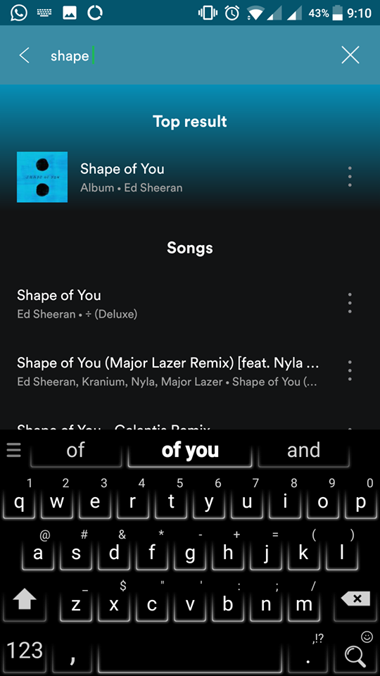

1. Can you easily determine **mapping from system state to interpretation**? How?

* Yes. The change in the play/pause button is a good mapping from system state to interpretation.

1. Can you always tell what **state the system is in**? How?

* Yes. There are multiple visual and audial cues to determine the state. The notification bar and widget hints about the system’s state (the play/pause button change based on the state). The widget is “blank” when Spotify isn’t running.

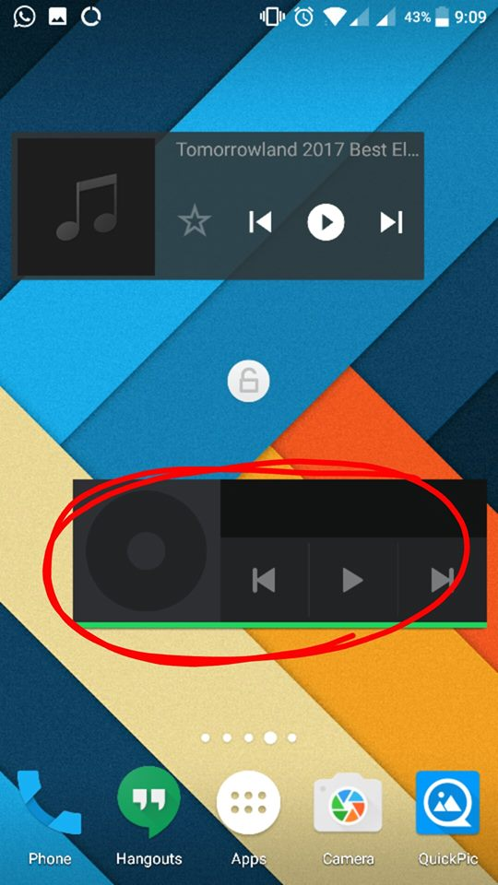

1. Overall, do you think this software suffers from the Gulf of**Execution**and/or the Gulf of **Evaluation?**Please explain

* No, it doesn’t suffer from either. As an app on touchscreen phone, it is clear that tapping on various button carry out different tasks. It is also really easy to determine whether an operation has been performed or not because everything is visual and/or audial. Changing songs changes the album art, the name of the song, the background colour, takes the user from the playlist page to the music player page, etc. Even if the user is lost in the app, he/she can simply tap on the minimized player at the bottom of the app, allowing the user to return to the most important functionality of the app…playing music.

**Part 3:**

1. Overall, do you think the software offers a good **conceptual model**?  If not, how could it be improved?

* Yes. Spotify does offer a good conceptual model. Its limitations and capabilities are clearly understandable.

1. Does the system offer good **Discoverability**, in terms of helping the user figure out how to use it? How? Could this be improved, and if so, how?

* Yes, Spotify offers good discoverability. The most important actions which can be performed are implemented as tabs, at the bottom of every page. The only thing which puzzled me a little was putting the settings button under “your library”. Personally, I think settings should’ve gotten its own tab.

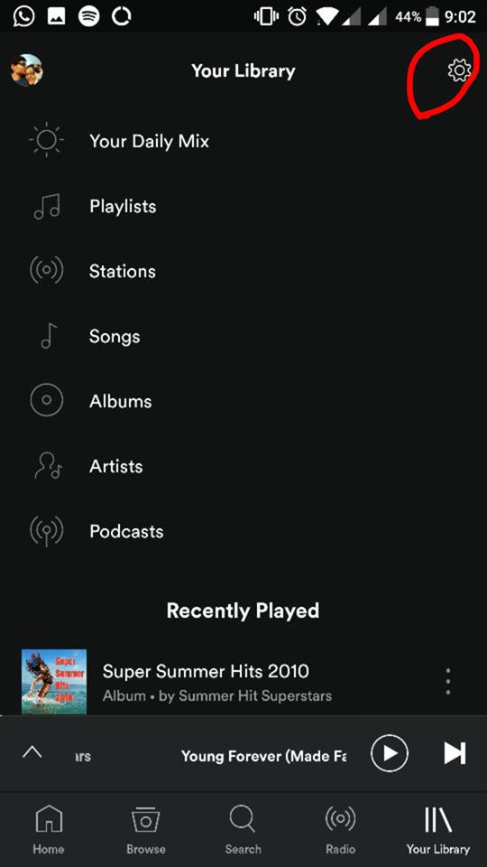

1. How does the system make use of **Mappings**?  Does it make use of appropriate mappings?  If not, how could they be improved?

* Yes, Spotify makes good use of mapping. I couldn’t find any buttons whose functionality I didn’t understand upon a quick glance.

1. Does the system give appropriate **feedback** to the user about the actions the users can make? How?  If not, how could it be improved?

* Yes. There are pop ups when adding/removing music from library. There are other visual clues such as a playlist appearing when created or “no results found for ….” when it can’t find something.

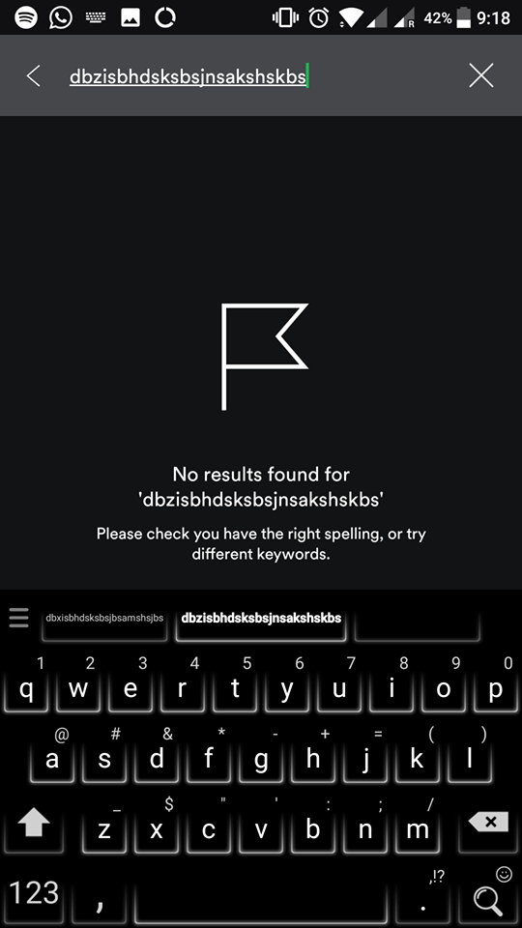 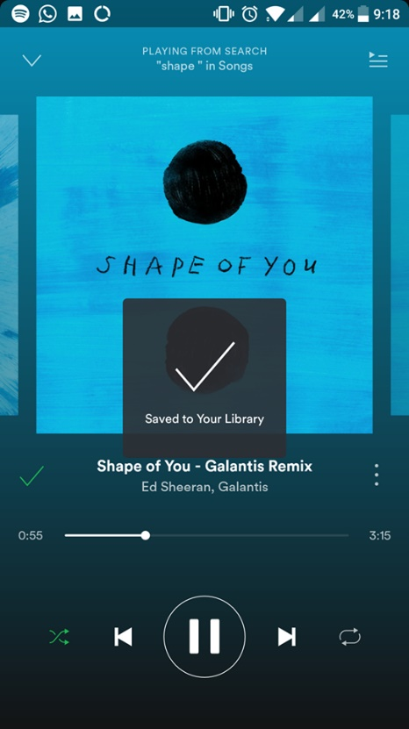 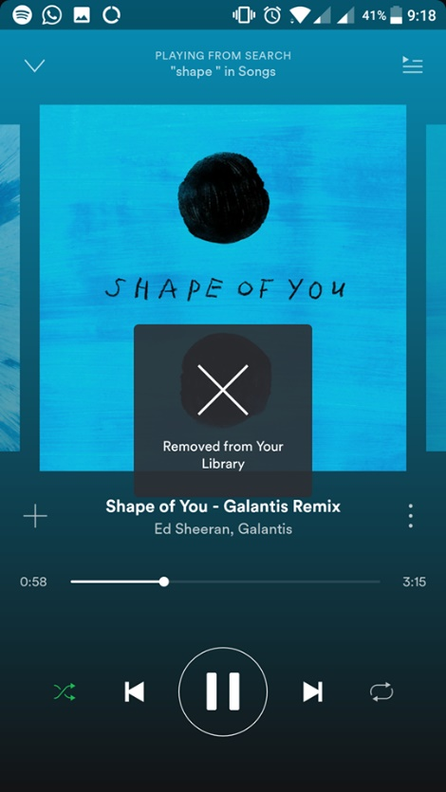

1. Does the system leverage **signifiers**in its design? How? Please give two examples of signifiers and the **perceived affordances** they make visible.

* Yes. The shuffle, repeat, previous, next, play/pause buttons are good signifiers. Their perceived affordances include manipulating what the user’s listening to (change/pause/resume tracks). Another signifier would be the different tabs, especially the browse tab. It has a picture of an album tilted forward, clearly indicating that the user would be able to browse through albums if this tab is used.

