Speed Test Project Report
Course | CS 568 Contemporary Topics in Networking
Instructor | Ali C. Begen
Project | Project 1: Speed Testing
Team members | Uğurcan Yılmaz, Damla Şahin
Website | speedtest.ugurcanyilmaz.com
Server | AWS EC2 t3.micro, Europe (Stockholm), eu-north-1

This report explains how we built a website that measures ping, download speed and upload speed, how we put it on the internet, and how we improved its accuracy step by step.

1. How the test works
The project has two parts. The client is a web page (index.html, app.js, style.css) that runs in the browser and does the measuring. The server is a small Go program (main.go) that uses only Go's standard library and has three endpoints:
Endpoint | What it does
/ping | Answers immediately with an empty response
/download?size=N | Sends N bytes of random data
/upload | Receives data, throws it away, replies with the number of bytes received
When the user clicks Begin Speed Test, the browser runs three tests in this order.

1.1 Ping
The browser sends a request to /ping and measures the time until the answer arrives, using performance.now(). This is the round-trip time.
- The first request is sent but not counted, because it also has to open the connection (TCP and TLS handshakes), which makes it slower.
- Then 10 more requests are sent one after another.
- The result is the lowest of the 10 times, in milliseconds. The lowest value is the closest to the real network delay, because the other values include random waiting in the browser or the network.

1.2 Download speed
The browser downloads random data from /download. We use random bytes so that nothing between the server and the browser can compress them and make the result look faster.
- The bytes are counted while they arrive, piece by piece, with the Fetch API's stream reader. So we know the progress at any moment, not only when a file is finished.
- The first object is small (100 KB). If an object finishes in less than 250 ms, the next one is twice as big, up to 8 MB. This way a slow connection does not wait for huge objects, and a fast connection does not waste time on tiny ones.
- Every 250 ms we calculate the speed over the last 1 second:
speed (Mbps) = (bytes × 8) ÷ (time in ms × 1000)
- The first second is ignored, because TCP starts slowly and the speed is still rising.
- The test stops when the last 4 speed readings are within 10% of each other (the speed is stable), or after 8 seconds at most. Transfers that are still running are then cancelled, so no extra data is wasted.
- The final result is the average of those last 4 readings.

1.3 Upload speed
Upload works the same way as download, but the browser sends random data to /upload. We use XMLHttpRequest here instead of fetch, because only XMLHttpRequest reports upload progress (upload.onprogress). The random data is created in the browser with crypto.getRandomValues().

1.4 What the page shows
The page shows ping (ms), download and upload speed (Mbps), the amount of data downloaded and uploaded (MB), and at the end the total time and total data used.

2. First results on a local PC
We first ran the server on our own PC with go run . and opened http://localhost:8080 in the browser on the same PC.
Run | Ping (ms) | Download (Mbps) | Upload (Mbps) | Data used (MB)
Local PC | 0.5 | 5312.3 | 5754.4 | 2409.40
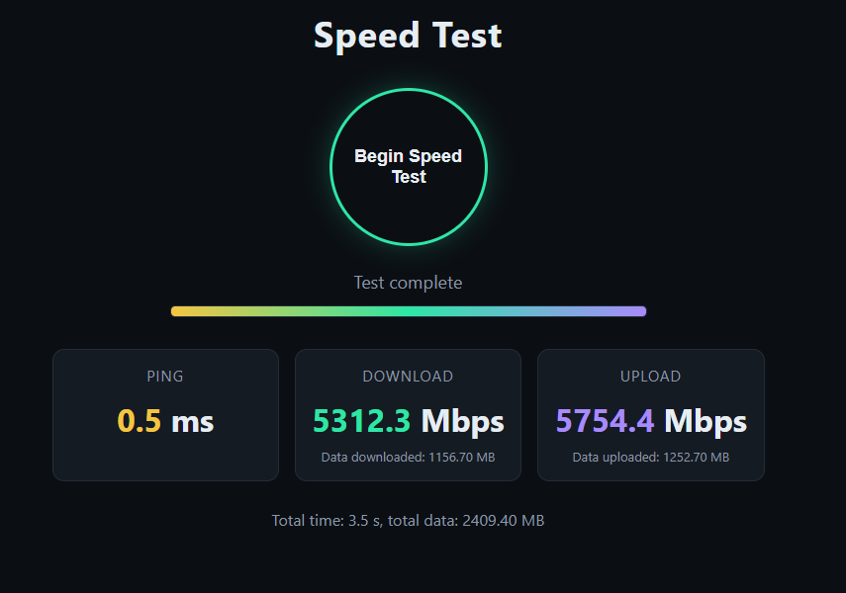
Figure 1: Our speed test running on the local PC (localhost): 0.5 ms ping, 5312.3 Mbps download and 5754.4 Mbps upload. These are not real internet speeds.
The results were very high because several thousand Mbps and a ping of 1 to 2 ms, much more than our internet connection can do. These results are not real. When the browser and the server are on the same computer, the data never goes through a network cable, Wi-Fi or our internet provider. It is only copied inside the computer's memory, so we were measuring the speed of the PC, not the internet.
The local test was still useful because it showed that the page, the three tests and the server endpoints work. To measure a real internet connection, the server had to run somewhere else on the internet.

3. Putting the site on the internet
We rented a small Linux server on Amazon Web Services (AWS) and made the site available at https://speedtest.ugurcanyilmaz.com. A visitor's request goes through these steps:
- The browser asks Cloudflare DNS for the address of speedtest.ugurcanyilmaz.com and gets the IP address of our AWS server.
- The browser connects directly to the AWS server.
- Caddy on the server handles HTTPS and passes each request to our Go program.
- The Go program answers on port 8080 (the page, /ping, /download, /upload).

3.1 AWS server (EC2)
Setting | Value
Region | Europe (Stockholm), eu-north-1
Instance type | t3.micro (2 vCPU, 1 GB memory)
Operating system | Ubuntu Server LTS
Open ports | 22 (SSH), 80 (HTTP), 443 (HTTPS)
IP address | Elastic IP (fixed address that does not change when the server restarts)
We connected to the server in the browser with EC2 Instance Connect, installed Git, Go and Caddy, downloaded our code from GitHub and built it with “go build .” To keep the program running all the time, also after a restart, we made it a systemd service.
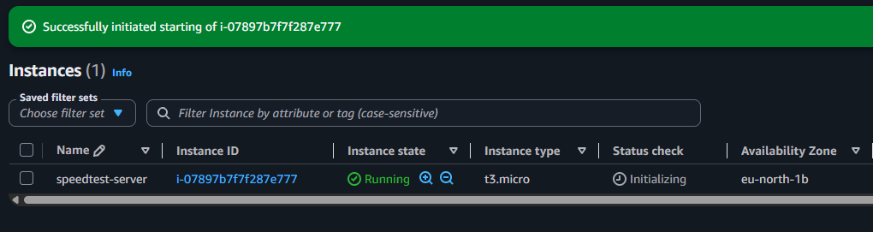
Figure 2: The EC2 instance list in the AWS console. speedtest-server is running as a t3.micro in availability zone eu-north-1b (Stockholm).
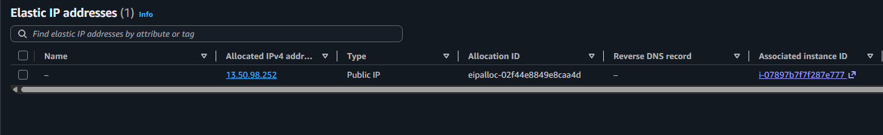
Figure 3: The Elastic IP address 13.50.98.252, associated with our EC2 instance.
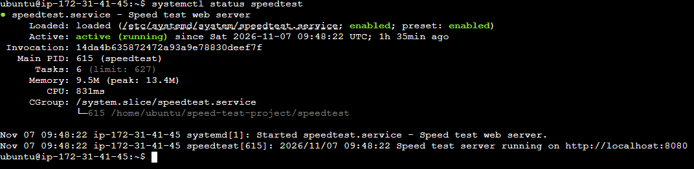
Figure 4: The output of systemctl status speedtest on the server. The service is active (running) and the Go program listens on port 8080.

3.2 DNS record on ugurcanyilmaz.com
Our domain ugurcanyilmaz.com is managed in Cloudflare. We added one record:
Type | Name | Content | Proxy status
A | speedtest | our Elastic IP | DNS only
We chose DNS only on purpose. With Cloudflare's proxy turned on, all traffic would go through Cloudflare's servers, and we would measure the ping and speed to Cloudflare instead of to our own server.
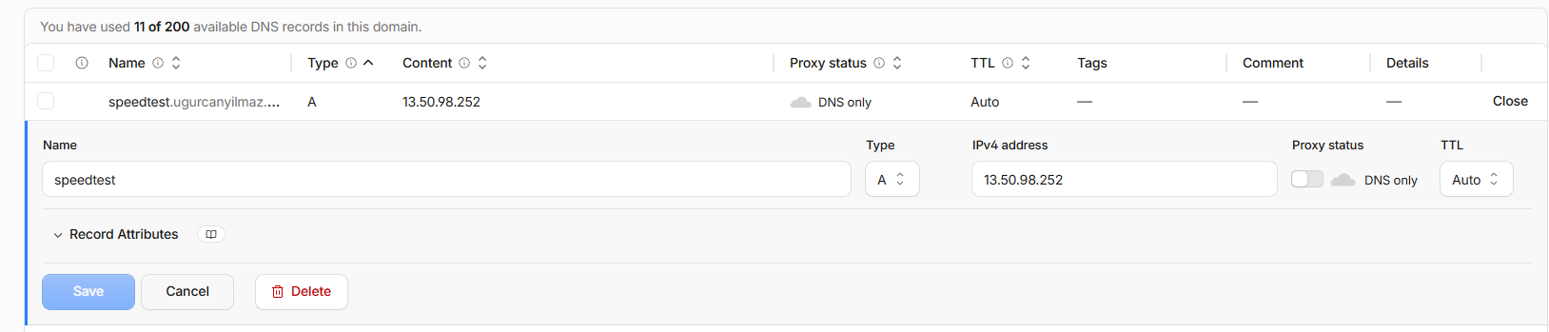
Figure 5: The Cloudflare DNS record: type A, name speedtest, pointing to 13.50.98.252, with proxy status DNS only.

3.3 HTTPS with Caddy
Caddy is a web server that gets a free HTTPS certificate from Let's Encrypt automatically and renews it by itself. Our configuration only tells Caddy to pass all requests for our domain to the Go program:
speedtest.ugurcanyilmaz.com {
reverse_proxy localhost:8080
}
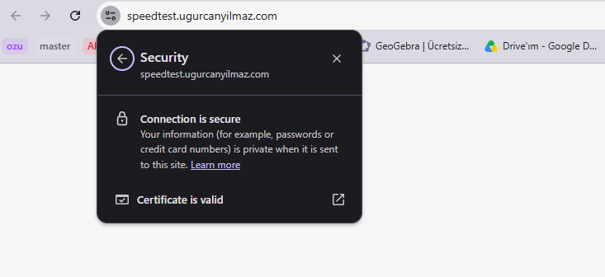
Figure 6: Chrome's security panel for speedtest.ugurcanyilmaz.com, showing "Connection is secure" and "Certificate is valid".

4. First results on the AWS server
On the AWS server, the first version used one connection: one download or upload at a time. All tests were done from the same laptop and network, connected to TurkNet in Istanbul (about 1 Gbps).
Test | Ping (ms) | Download (Mbps) | Upload (Mbps) | Data used (MB) | Time (s)
Our test, run 1 | 54.5 | 133.5 | 131.8 | 59.16 | 5.2
Our test, run 2 | 53.6 | 110.4 | 136.4 | 86.42 | 8.0
Our test, run 3 | 53.2 | 93.8 | 136.2 | 96.32 | 7.4
Ookla Speedtest, Istanbul server | 2 | 928.42 | 941.83 | not provided by Ookla | not provided by Ookla
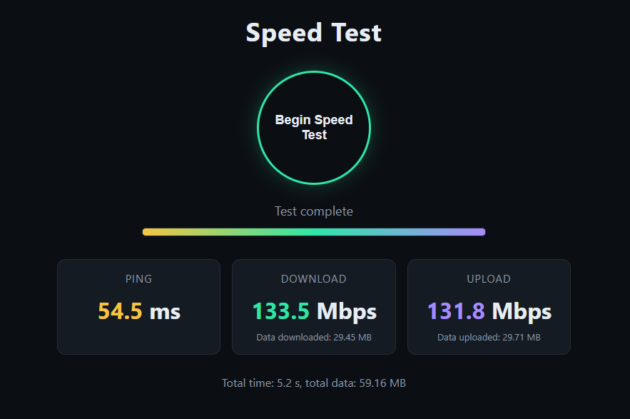
Figure 7: Our first test on the AWS server with 1 connection (run 1): 54.5 ms ping, 133.5 Mbps download and 131.8 Mbps upload, using 59.16 MB in 5.2 s.
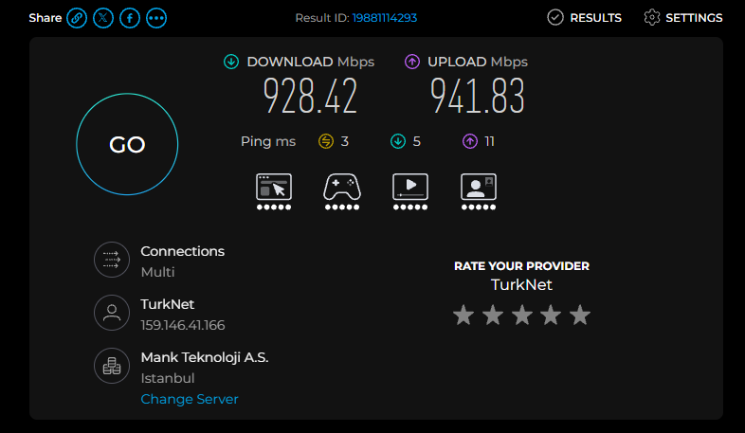
Figure 8: Ookla Speedtest to a server in Istanbul (Mank Teknoloji A.S.): 3 ms ping, 928.42 Mbps download and 941.83 Mbps upload.
Our results were much lower than Ookla's. Part of the difference is that the two tests did not use servers in the same place: Ookla chose a server in Istanbul (3 ms ping), while our server is in Stockholm, about 54 ms away. To compare fairly, we found the Ookla server closest to our AWS server by running Ookla's command-line tool on the AWS server itself. It choose AltusHost B. V., Stockholm with a latency of only 2.97 ms, so from then on we compared against that server.
We ran these commands on the AWS server:
cd ~
curl -sLO https://install.speedtest.net/app/cli/ookla-speedtest-1.2.0-linux-x86_64.tgz
tar xzf ookla-speedtest-1.2.0-linux-x86_64.tgz speedtest
./speedtest --accept-license --accept-gdpr
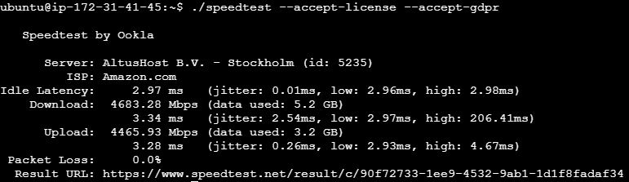
Figure 9: Ookla's command-line tool running on the AWS server. It chose AltusHost B.V., Stockholm, with 2.97 ms latency.

4.1 Comparison with the closest Ookla server
We then ran Ookla Speedtest in the browser with the server set to AltusHost B.V., Stockholm (Change Server), so both tests measured to the same city.
Test | Ping (ms) | Download (Mbps) | Upload (Mbps) | Data used (MB) | Time (s)
Our test (average of 3 runs) | 53.76 | 112.56 | 134.8 | 80.6 | 6.9
Ookla Speedtest, AltusHost B.V. Stockholm | 55 | 340.09 | 898.75 | not provided by Ookla | not provided by Ookla
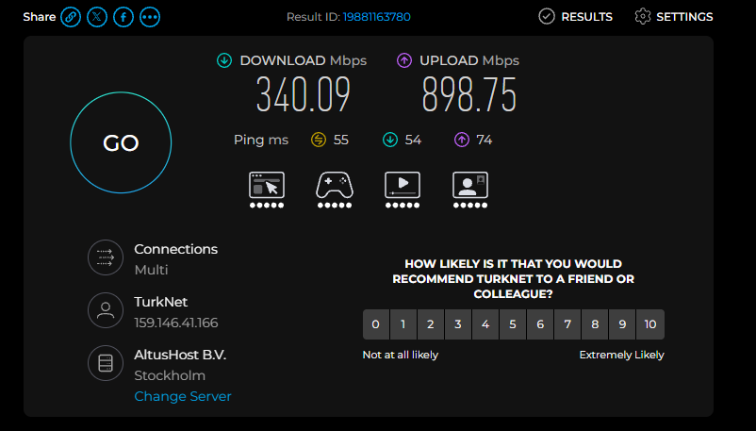
Figure 10: Ookla Speedtest from our PC to AltusHost B.V., Stockholm: 55 ms ping, 340.09 Mbps download and 898.75 Mbps upload.
With both tests going to Stockholm, the server location no longer explains the difference.

5. Trying multiple connections
While reading about how other speed tests work, we found that Ookla Speedtest uses several TCP connections at the same time. A study comparing Ookla with M-Lab's NDT7 test explains that Ookla starts using multiple connections when the round-trip time is above 20 ms and uses up to eight connections at high latency, and concludes that "a speed test tool that uses multiple TCP connections or runs for a longer duration will report higher speeds under high latency" [1]. Our ping to the server is about 54 ms, so this applied to us.
We changed the client so that several transfers run at the same time. Each one downloads (or uploads) objects one after another, and the speed is calculated from the total bytes of all of them. The number of connections can be chosen in the address bar, for example /?connections=4, so we could test different values without changing the code.
Test (HTTP/2 on, default server settings) | Ping (ms) | Download (Mbps) | Upload (Mbps) | Data used (MB) | Time (s)
1 connection (average of section 4) | 53.76 | 112.56 | 134.8 | 80.6 | 6.9
4 connections | 54.1 | 109.1 | 158.3 | 61.51 | 4.9
6 connections | 54.0 | 110.2 | 159.6 | 63.20 | 4.9
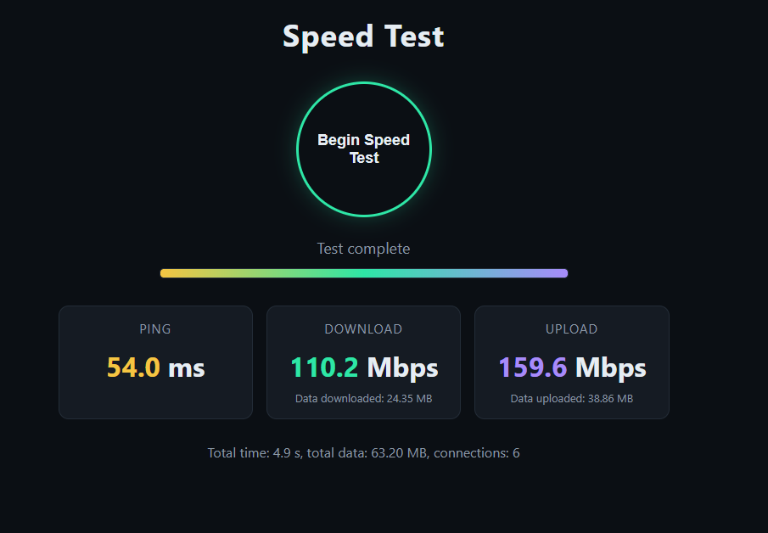
Figure 11: Our test with 6 connections while HTTP/2 was still on: 54.0 ms ping, 110.2 Mbps download and 159.6 Mbps upload.
The speed did not improve with more connections. Download and upload stayed around 140 Mbps, while our line can do about 1 Gbps. Download and upload were also almost exactly the same number, which looked like a fixed limit somewhere rather than the real speed of the line. So we started looking for the reason.

6. Finding the problem
We searched online for the reason and found three things that could limit our speed. We changed them one at a time and ran the test after each change, so we could see the effect of each one. Every result below is the average of 3 runs.

6.1 HTTP/2 puts all transfers into one connection
In Chrome's developer tools (Network tab, Protocol column) we saw that our requests used h2, which is HTTP/2. Caddy turns on HTTP/2 by default. The HTTP/2 standard says a client should not open more than one HTTP/2 connection to the same server [2, section 9.1]. So our "parallel" transfers were not really parallel because the browser sent them all through one connection.
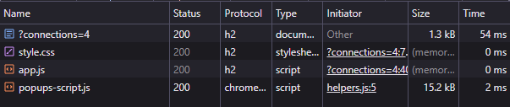
Figure 12: Chrome DevTools, Network tab. The page and its files use protocol h2 (HTTP/2).
HTTP/2 also has its own flow control. The standard warns that if the window is smaller than the bandwidth-delay product, the "receive throughput will be limited by HTTP/2 flow control" [2, section 5.2.3]. In Go's source code, which Caddy is built with, the server's receive buffer per connection defaults to 1 MB [3]. With 1 MB in flight and about 60 ms round-trip time, the maximum is:
(1,048,576 × 8 bits) ÷ 0.059 s ≈ 142 Mbps
This is almost exactly our measured speeds. An article on HTTP/2 performance also explains that "HTTP/2 opens a single TCP connection, and the TCP protocol reduces the TCP window size each time there is loss/congestion" [4].
What we changed: we turned off HTTP/2 in Caddy with the protocols option [5], so the browser uses HTTP/1.1 and opens a separate TCP connection for each transfer:
{
servers {
protocols h1
}
}
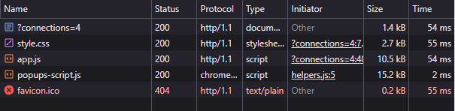
Figure 13: Chrome DevTools, Network tab, after turning off HTTP/2. The protocol is now http/1.1.
Results after 6.1 (HTTP/1.1):
Test | Ping (ms) | Download (Mbps) | Upload (Mbps) | Data used (MB) | Time (s)
1 connection | 54.3 | 94.5 | 443.1 | 190.20 | 6.9
4 connections | 53.9 | 305.4 | 986.9 | 403.45 | 6.6
6 connections | 54.3 | 347.5 | 814.8 | 431.71 | 6.6

6.2 BBR congestion control
Linux uses the CUBIC congestion control algorithm by default. CUBIC sees every lost packet as a sign of congestion and slows down. BBR, developed at Google, instead measures the bottleneck bandwidth and the round-trip time and tries to keep the connection near the bandwidth-delay product. Its authors report 2 to 25 times higher throughput than CUBIC in Google's network [6]. BBR should be used together with the fq queueing method, as noted by ESnet [7].
What we changed (file /etc/sysctl.d/98-bbr.conf on the server):
net.core.default_qdisc = fq
net.ipv4.tcp_congestion_control = bbr
Figure 14: sysctl shows that BBR is now the congestion control on the server.
Results after 6.2 (HTTP/1.1, BBR):
Test | Ping (ms) | Download (Mbps) | Upload (Mbps) | Data used (MB) | Time (s)
1 connection | 56.9 | 255.0 | 430.2 | 171.83 | 5.9
4 connections | 55.8 | 548.9 | 841.8 | 412.62 | 6.4
6 connections | 53.7 | 704.9 | 870.0 | 634.91 | 8.4

6.3 Bigger TCP buffers
To keep a fast connection full over a long distance, a lot of data must be "in flight" at the same time. For a 1 Gbps line and 62 ms round-trip time:
1,000 Mbps × 0.062 s = 62 Mbit ≈ 7.75 MB
ESnet, the US research network, explains that the default maximum Linux TCP buffers are too small for fast, long paths and recommends raising them [7]. We used their 32 MB autotuning limit. We also turned off tcp_slow_start_after_idle. By default Linux resets the congestion window "after an idle period" [8], which slows a connection down again between two transfers.
What we changed (file /etc/sysctl.d/99-buffers.conf on the server):
net.core.rmem_max = 33554432
net.core.wmem_max = 33554432
net.ipv4.tcp_rmem = 4096 131072 33554432
net.ipv4.tcp_wmem = 4096 65536 33554432
net.ipv4.tcp_slow_start_after_idle = 0
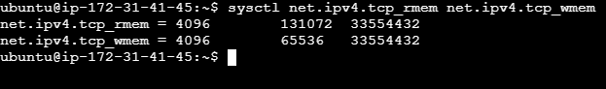
Figure 15: sysctl shows the new TCP buffer limits. The maximum of tcp_rmem and tcp_wmem is now 33554432 bytes (32 MB).
Results after 6.3 (HTTP/1.1, BBR, bigger buffers):
Test | Ping (ms) | Download (Mbps) | Upload (Mbps) | Data used (MB) | Time (s)
1 connection | 54.8 | 504.3 | 569.1 | 306.11 | 7.3
4 connections | 53.5 | 663.2 | 870.8 | 351.73 | 5.9
6 connections | 53.7 | 709.2 | 924.3 | 442.48 | 6.6

7. Results after the fixes
After turning off HTTP/2 and turning on BBR and bigger buffers, multiple connections made a large difference. With 6 connections the speed went from about 140 Mbps to 727 Mbps download and 855 Mbps upload. We chose 6 connections because browsers open at most 6 HTTP/1.1 connections to one website, so more connections would only wait in a queue.
Test (HTTP/1.1, BBR, big buffers) | Ping (ms) | Download (Mbps) | Upload (Mbps) | Data used (MB) | Time (s)
1 connection | 54.8 | 504.3 | 569.1 | 306.11 | 7.3
2 connections | 54.6 | 477.6 | 868.3 | 337.02 | 6.4
4 connections | 53.5 | 663.2 | 870.8 | 351.73 | 5.9
6 connections | 55.9 | 727.3 | 854.7 | 574.45 | 7.6
Ookla Speedtest, AltusHost B.V. Stockholm | 56 | 244.16 | 836.22 | - | -
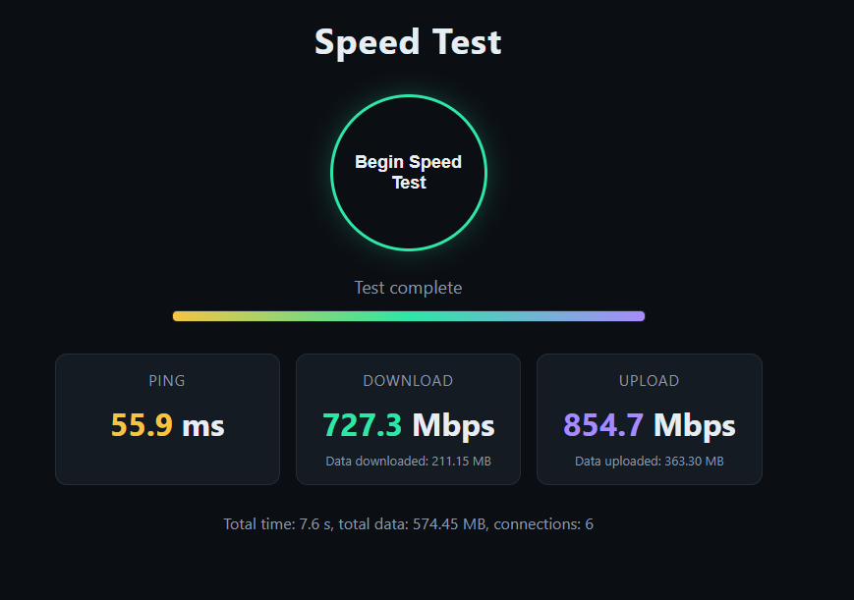
Figure 16: Our test after all three changes, with 6 connections: 55.9 ms ping, 727.3 Mbps download and 854.7 Mbps upload, using 574.45 MB in 7.6 s.
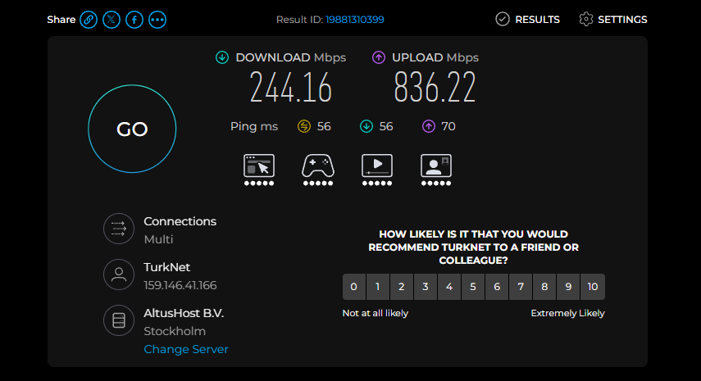
Figure 17: Ookla Speedtest to AltusHost B.V., Stockholm, run at the same time: 56 ms ping, 244.16 Mbps download and 836.22 Mbps upload.
Our ping and upload are close to Ookla's (55.9 vs 56 ms, 854 vs 836 Mbps). Our download is higher than Ookla's. We think this is because the two tests take different routes. Our data goes from TurkNet to Amazon's network, while Ookla's goes from TurkNet to AltusHost B.V.. Both results are below our line speed of about 1 Gbps, so our result is possible.
To check that our numbers are real, we watched the network card's speed in Windows Resource Monitor while our test was running.
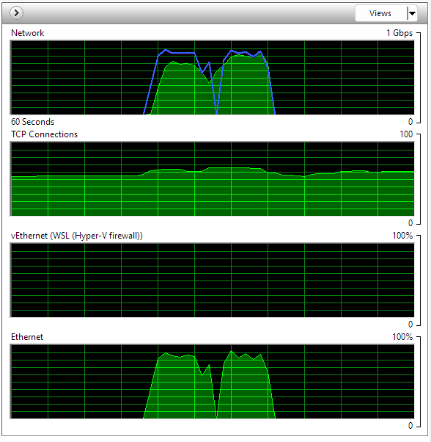
Figure 18: Windows Resource Monitor during our test. The network graph rises close to the 1 Gbps line twice: first during the download, then during the upload.

Summary
Step | Change | Connections | Download (Mbps) | Upload (Mbps)
1 | First version on AWS (section 4) | 1 | 112.6 | 134.8
2 | Multiple connections, HTTP/2 still on (section 5) | 6 | 110.2 | 159.6
3 | HTTP/2 turned off (6.1) | 6 | 347.5 | 814.8
4 | BBR turned on (6.2) | 6 | 704.9 | 870.0
5 | Bigger TCP buffers (6.3) | 6 | 709.2 | 924.3
The biggest lesson was that parallel connections only help when they are separate connections. With HTTP/2 they all shared one connection with a 1 MB limit, which held both download and upload at about 140 Mbps.

Sources
- K. MacMillan, T. Mangla, J. Saxon, N. P. Marwell, N. Feamster, "A Comparative Analysis of Ookla Speedtest and Measurement Labs Network Diagnostic Test (NDT7)", Proc. ACM Meas. Anal. Comput. Syst. 7(1), 2023.
- IETF, RFC 9113: HTTP/2, 2022. Sections 5.2.3 and 9.1.
- The Go Authors, net/http/internal/http2/config.go (Go source code).
- O'Reilly, "Will HTTP/2 make my site faster?"
- Caddy Documentation, "Global options (Caddyfile)": servers, protocols, caddyserver.com.
- N. Cardwell et al., "BBR: Congestion-based congestion control", ACM Queue, 2016, as summarized by A. Colyer, The Morning Paper.
- ESnet, Linux Tuning, fasterdata.es.net.
- The Linux Kernel documentation, "IP Sysctl": tcp_slow_start_after_idle, docs.kernel.org.

