BATCH 11 – Ghost Vehicle Detection in Fog Using Pressure-Wave Sensing Before Visual Detection
PROCEDURE :

Configuring Keil IDE for TM4C123G :

- Open Keil µVision 5
- Setting up New Project in Keil IDE :
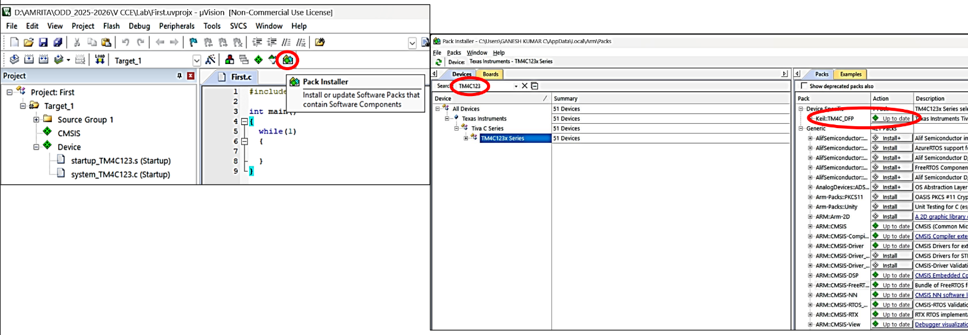
Click Pack Installer Icon → In Search Type TM4C123 → Click on TM4C123x Series → Install Device Specific pack and make sure it is up to date

- Project –> New µVision Project
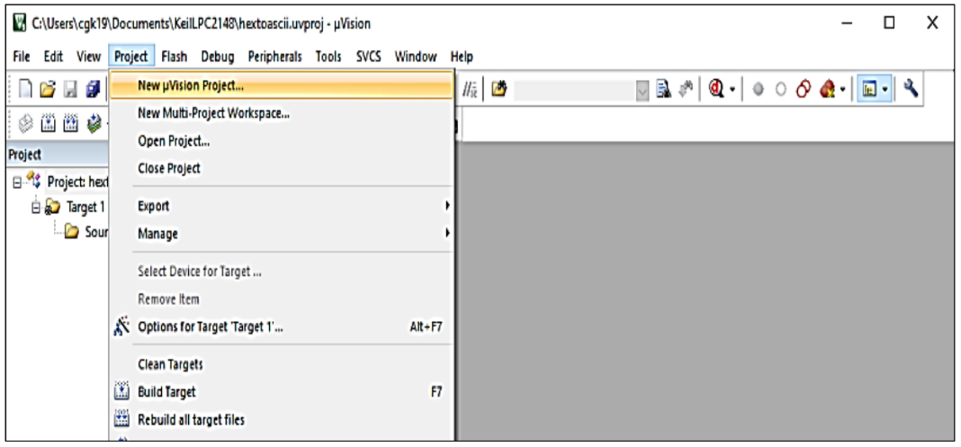

- Create a folder for new project & provide a filename & click save

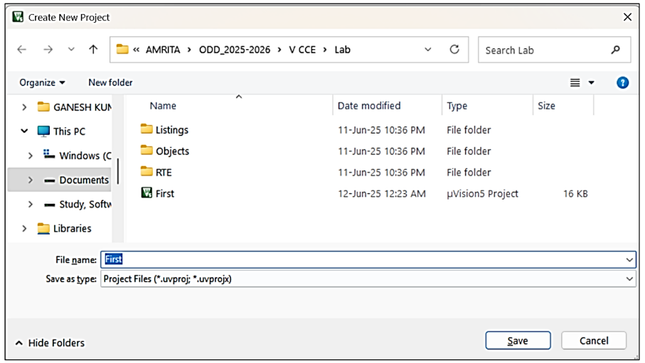

In dropdown select Software Packs
➢ Search for TM4C123GH6PM
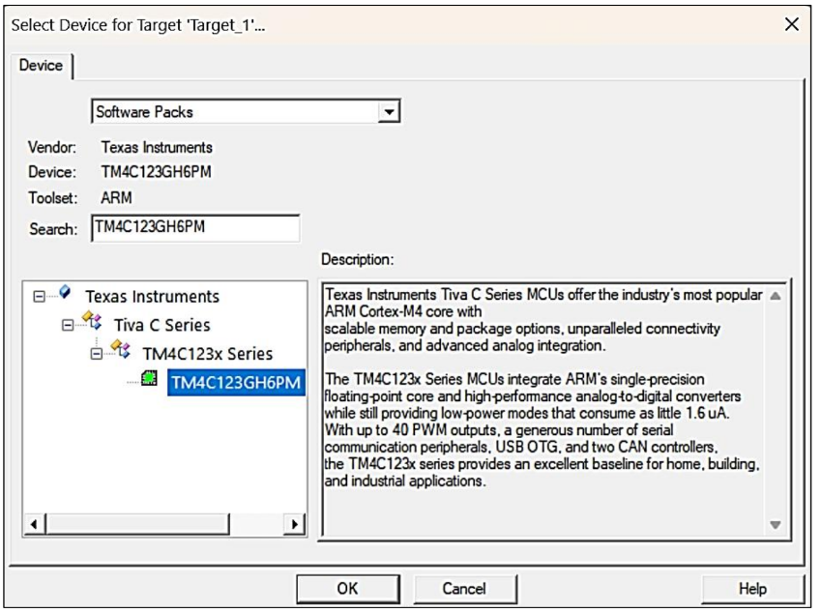
➢ Select the TM4C123GH6PM and click OK

- In Manage Run-Time Environment → Choose CMSIS (CORE) and Device (Startup) → Click Ok
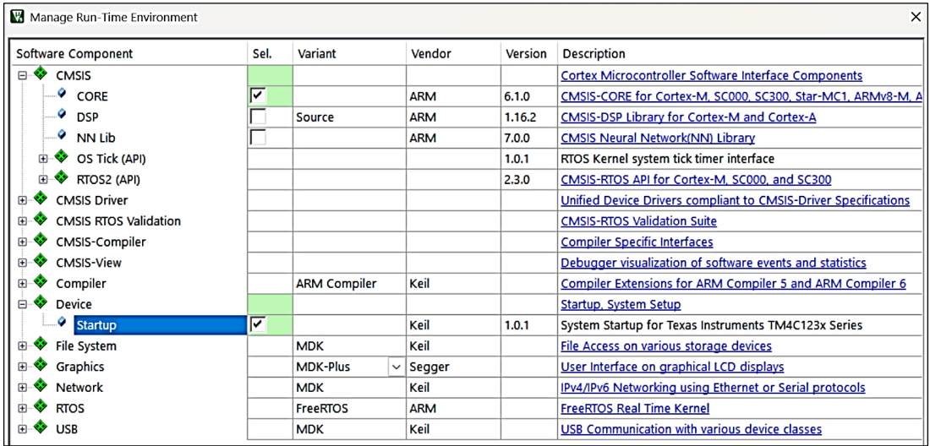

- New Project is been created
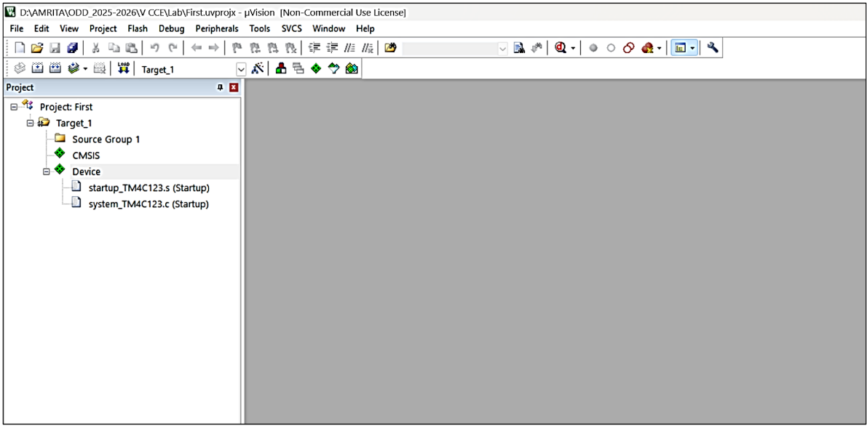

- Right click on Source Group 1
- Click Add New item to Group “Source Group 1”
- Select C File (.c) & provide a name (without any extension)
- Finally click Add

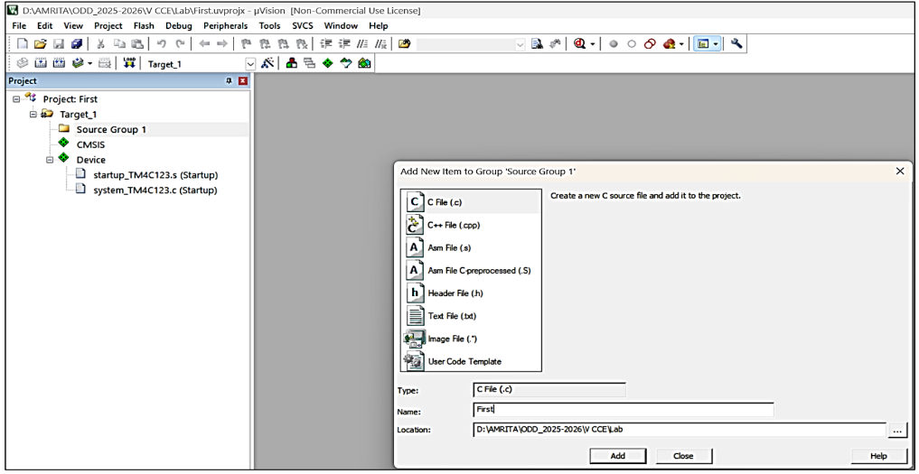

- C File added to Source Group 1
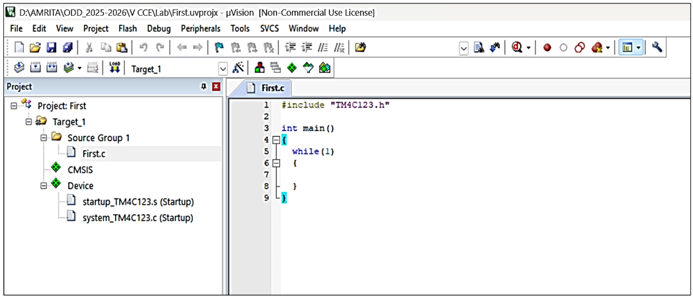
- Type program in the Editing Window

Step 1 — System initialisation (runs once at power-up)
On reset, main() initialises every peripheral in sequence: the buzzer is set up and immediately forced off (Buzzer_Init(); Buzzer_Off();), followed by the 3-channel ADC, I2C0, the OLED, the LED, and finally the ultrasonic driver. This ordering matters — the buzzer is silenced before any other peripheral can generate a false trigger during startup.
Step 2 — Startup screen (one-time, ~1.5 seconds)
The OLED is cleared and two lines of static text are written: "GHOST VEHICLE" on row 0 and "FUSION MODE" on row 1. A 1500ms delay holds this screen so the observer has time to confirm the display and firmware are alive before live data begins.
Step 3 — Enter the continuous monitoring loop
The firmware enters an infinite while(1) loop that repeats every ~150ms. Each iteration performs the same five actions in order:
- Acquire acoustic data — ADC0_ReadAll() triggers ADC0's sample sequencer, which samples all three microphone channels (Front, Back-Right, Back-Left) in one hardware-triggered sequence and returns their raw 12-bit values.
- Compute the acoustic level — GetDirection() scans the three values and returns the maximum, used purely as a corroborating "SND" display value.
- Acquire the distance reading — Ultrasonic_GetDistanceCM() fires a 10µs trigger pulse, times the returned echo pulse via Timer0, and converts it to centimetres (or returns the 0xFFFF sentinel if no echo arrives within the timeout).
- Classify and update the OLED — the screen is cleared and redrawn with three lines: DIST: (the distance in cm, or "NOECHO"), SND: (the acoustic level), and a status line from GetStatusText() — one of MONITORING, CAR DETECTED, APPROACHING, or CRITICAL, depending on which distance band the reading falls into.
- Drive the alert outputs — UpdateAlerts() is called with the same distance value and sets the LED and buzzer GPIO pins according to the three-tier logic (off above 30cm, LED-only above 10cm, LED+buzzer below 10cm).
Step 4 — Repeat indefinitely
After a 150ms delay, the loop returns to Step 3.1, so the observer sees the OLED refresh, and the LED/buzzer respond, roughly 6–7 times per second — fast enough to feel continuous, without flooding the I2C bus with unnecessary redraw traffic.
