Medico Gpt

RAJATAVA GHOSH SAPTARSHI CHATTOPADHYAY

TECHNOLOGIES USED

* Python
* Scikit Learn
* Panda
* Numpy
* Seaborn
* HTML
* CSS
* JAVA SCRIPT
* GitHub

**ABSTRACT**

Introducing a revolutionary medical chatbot leveraging the **Gpt Model**. This innovative AI companion guides users through health concerns with empathetic conversations, offering personalized advice and information. Harnessing advanced **natural language processing**, it ensures a user-friendly interface for addressing medical queries, bridging the gap between technology and healthcare.

**INTRODUCTION**

**Diabetes is a chronic medical condition affecting millions worldwide, and early detection plays a crucial role in effective management. This hackathon project aims to develop an efficient and accurate diabetes detection model by harnessing the power of Python-based libraries and technologies. The integration of machine learning algorithms with a user-friendly interface enhances accessibility for both practitioners and individuals seeking to assess their diabetes risk.**

**Flow Chart**

Using HTML to make the skeleton of the interface

Enter Pregnancy , Glucose count , BP , Skin Thickness , insulin level , BMI , Diabetes Pedigree Function & Age .

API INTEGRATION

**<------------------->**

JavaScript used for API integration and calling .

CSS is implemented to the HTML to add some animation and colour .

Data Preprocessing & applying diff. algorithms and checking the best scores .

Calling different algorithm through sklearn with use of python & Cborn helps to explore data from the dataset.

**ADDITIONAL CODING**

As we are unable to deploy the **hugging face** due to lack of deep knowledge in the field of **neural network** , we can try by getting a dataset in the form of PDF , DOC , or txt file we can fine tune the **open.ai** Gpt model using hugging face’s transformer library to generate response about diabetes remedies .

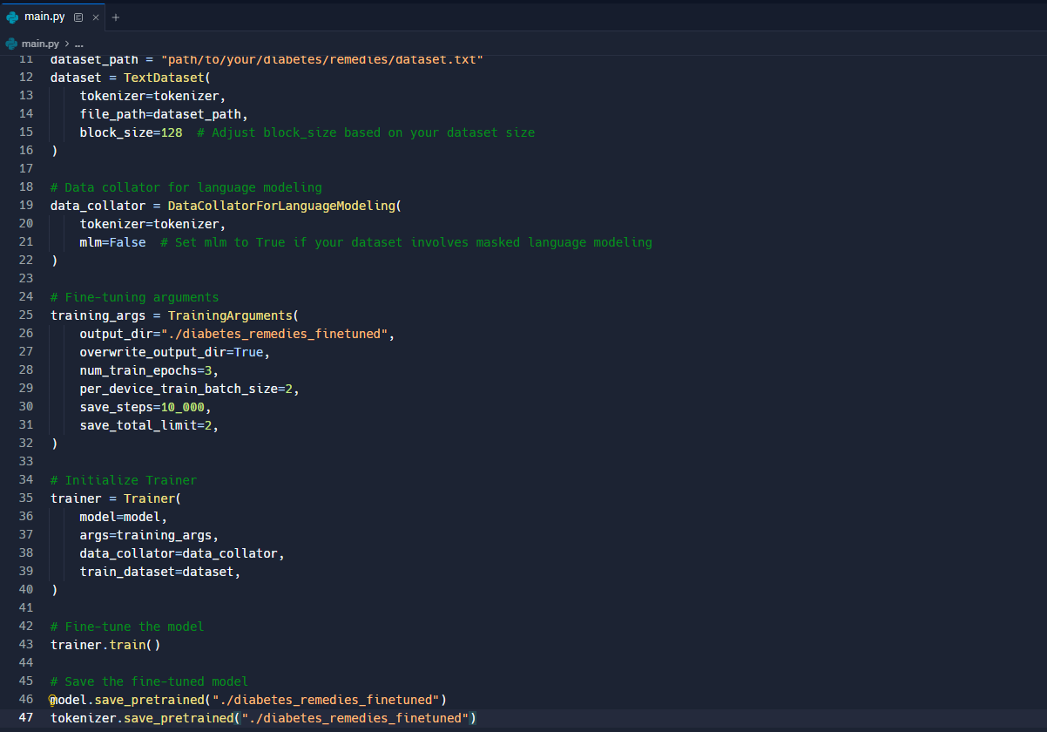

*IMG : SNIPPET FOR FINE TUNING open.ai Gpt MODEL*

**INSTRUCTION**

**USING ML MODEL:**

* **Open the medicogpt.py**
* **Install the required libraries – sklearn,pandas,numpy,seaborn(Optional for VScode or offline IDE)**
* **Run the code**
* **Enter desired Values  
  *The input will be in 0 & 1 , where 0 indicates negative for diabetes and 1 indicates positive\***

**As there can be complications in running the code we are providing the link for our code space**

* https://www.kaggle.com/code/rajatavaghosh/notebook40b5191710

**CHATBOT :**

* **Open the folder Chatbot**
* **Double click on index.html**
* **After the page loads, click on the comment icon**
* https://github.com/devsappy/chatbothackathon.i

**CONCLUSION**

Myself Rajatava Ghosh and Saptarshi Chattopadhyay are delighted to participate in the Hackathon AI ARENA 2.0 on MERCER METTL . We learnt a lots of techs and libraries which were useful to upskill ourself. We used a wide range of online materials and majority were done through Kaggle which is the important part of our MedicoGpt, that is building the model. We are expecting to explore a broader side through our project . Not only sticking to diabetes we can predict Cancer , Thyroid , Liver cirrhosis ect which are commonly searched topics on the web world.