1. **EC2 Instance**

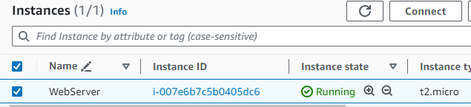

1. **Classic Load Balancer**

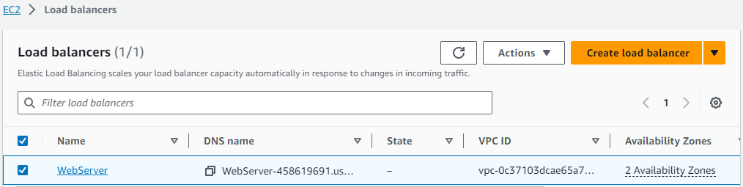

1. **EC2 as Target**

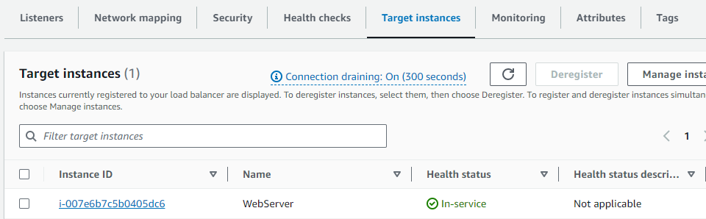

1. **SNS TOPIC**

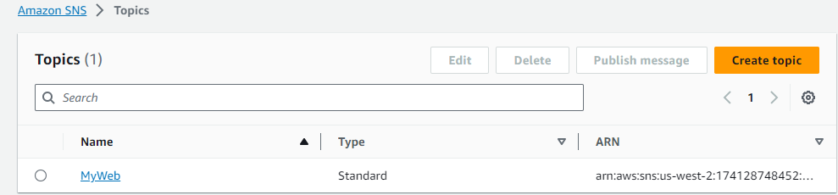

1. **Email subscription**

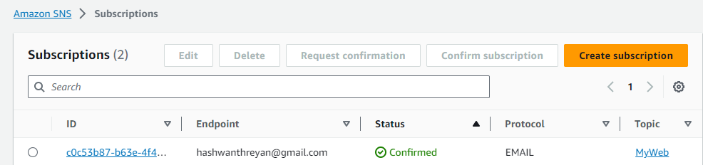

1. **Lambda Function**

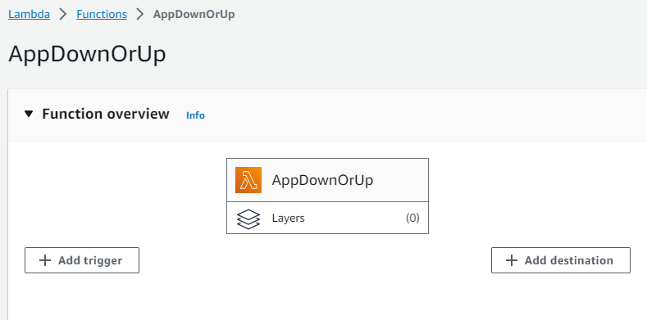

1. **Email Alert when URL is Down**

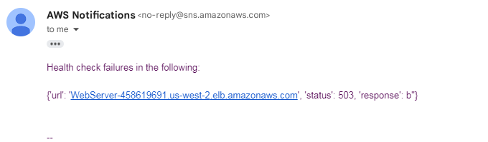

1. **Email Alert when URL is UP**

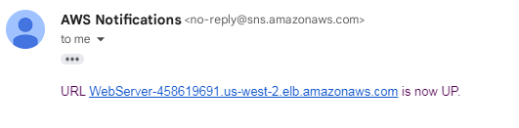

1. **Code**

