**A**

**Mini project**

**(KCS554)**

**ON**

**RESTURANT MANAGEMENT SYSTEM**

Acknowledgment

I would like to express my special thanks of gratitude to my teacher

**Mrs. Shivani Varshney** who gave me the golden opportunity to do this wonderful project on the topic “RESTURANT MANAGEMENT SYSTEM” , which also helped me in doing a lot of research and I came to know about so many new things.

I am really thankful to them.

Secondly, I would also like to thank my brother (Mr.Sandeep Prabhat Saxena) who helped me a lot in finalizing this project within limited time frame.

I am making this project not only for marks but to also increase my knowledge.

THANKS AGAIN TO ALL WHO HELPED ME

Introduction

My project is about Web Development ( Topic :- Resturant Management System Designing ). Languages used in my project are HTML5 (Hyper-Text Markup Lnguage 5) , CSS3 (Cascading Style Sheets 3) , Bootsrap , JS ( Java Sript) and JS Library jquery . “I have choosen this project ( Web designing and development ). Because only of Market or Companies choice , as there is a vast scop of web development , so many companies are hiring employes on Web Devlopment that’s I have choosen it “.

In my project , I have clearly shown the designing of a Resturant type website , all the things are same according with zomato , swiggy etc . various designing techniques are used using CSS3 and Bootstrap . As , we all know CSS stands for Cascading Style Sheet . This Style Sheets allows us to show or design wonderful effects on pages . So many Animations and movements or designed using this approach . Now, the Role of Bootstrap is to provide responsiveness in all Machines like , if we design a product for any company . so bootstrap will allow us to make it responsive or supposive for any devices. Now , the role of HTML is , to connect all other Designing or Development platforms to the page of Website , that will showed up on the screen .

Now , JS stands for Java Script , it is a Scripted language , on it provides various types of functioning like Animation , Scrolling , Movements , Special effect s , some backend support etc . Now , I’LL use JS to design a Star Rating System that will help to Review the website .

I have also try to use plugins some other links that will make website more attractive .

Objectives

Various companies in todays market are demanding web designing and development that why I have choosen this field. My project is about a website that deals with the fulfillment of designing and development of website as I’ll choosen topic Resturant Management System for the completion of mini project.

In this project I’ll used HTML(Hyper-Text Markup Language) , CSS(Cascading Style Sheets) , JS(Java Script) , Bootstrap etc.

Based on the problems stated above, the objectives of the project are :

* To develop online odering and reserving system in restaurant.
* To develop use interface for online restaurant management system.
* To provide online menu information for customer.
* Increase sales and productivity by knowing the status of all restocking and special orders.
* Get better prices from vendors by ordering smarter , leveraging detailed purchase history.
* Increase profitability by eliminating unnecessary and wasteful purchases.
* Increase efficiency through detailed reporting.

FEASIBILITY STUDY

The objective of feasibility study is to determine whether or not the proposed system is feasible. The feasibility is determined in terms of three aspects. These are:

* Technical Feasibility

In this, one has to test whether the system can be developed using existing technology or not. We have used Visual Basic as front-end and MS ACCESS as back-end. It is evident that necessary hardware and software are available for development and implementation of proposed system We acquired the technical knowledge of working in Visual Basic language, and then only we have started designing our project

* Economical feasibility:

As a part of this, the costs and benefits associated with the proposed system are compared and the project is economically feasible only if tangible and intangible benefits outweigh the cost. The cost for proposed Resturant management system is outweighing the cost and efforts involved in maintaining the registers, books. files and generation of various reports The system also reduces the administrative and technical staff to do various jobs that single software can do. So, this system is economically feasible.

* Legal Feasibility:

Legal feasibility determines whether the proposed system conflicts with legal requirements, eg, the Data Protection Act. It will be done by some legal advisors.

System requirements

* Sublime Text.
* MS word.
* Abobe photoshop.
* Operating System.

Hardware requirements

* A keyboard/mouse.
* A monitor to display the content.

Features

* A user friendly.
* Attractive.
* Colorful.

Language and software tool used

* Language : HTML , CSS , BOOTSTRAP , JS.
* Operating System: Windows 10.

PROJECT CODE

<html>

<head>

<title>Dev Resturant</title>

</head>

**Code for design elements using css.**

<style>

body{

font-family: latha; color : green;background: linear-gradient(rgba(0,0,0,0.65),rgba(0,0,0,0.65),rgba(0,0,0,0.38),rgba(0,0,0,0)) ,url(create-food-website.jpg) no-repeat; background-size:cover; }

.list{ width: 900px; float:right; }

.list ul li{width: 120px; float: left; margin: 10px auto; text-align: center;}

.list ul li a{text-decoration: none; color: white;font-size: 30px;}

.list ul li:hover{background-color: dark gray; }

.list ul li a:hover{color: green; }

.list1{ width: 900px; float: center; }

.list1 ul li{width: 120px; float: left; margin:10px 0px auto; text-align: center;}

.list1 ul li a{text-decoration: none; color: black; font-size: 30px}

.list1 ul li:hover{background-color: dark gray; }

.list1 ul li a:hover{color: green; }

.side{width: 300px; height: 539px; background-color: black; opacity: 0.9; padding: 55px;}

.side h2{ text-align: center;text-transform: uppercase; font-size: 30px;}

.side h1{text-align: justify; color: darkgrey; font-weight: normal; margin: 40px auto}

.side h3{ text-align: center;text-transform: uppercase; font-size: 30px; margin: 80px auto;}

.choice form , input[type = "button"]{background-color: black; color: white; padding: 10px; margin: -14px auto; padding-left: 50px; padding-right: 50px;text-align: center;font-size: 20px}

form , input[type = "button"]:hover{background-color: green; border: none; border-radius: 100px;}

.main{ width 900px; background: white; margin-top: 100px;}

.us{font-size: 40px;text-align: center;text-decoration: underline;}

.paragraph{font-size: 30px; background:url(create-food-website.jpg)no-repeat; background-position: left 1000px bottom 10px; }

.aboutus1{font-size: 30px ;display: flex; margin: 0px 100px;}

.aboutus2{font-size: 30px ;display: flex; margin: 0px 100px;}

.main2{ width 900px; background: white; margin-top: 100px;}

.items1{font-size: 30px ;display: flex;}

.items1 i p{font-size: 40px;text-align: center;}

.row h2{font-size: 50px; text-align: center;text-decoration: underline;}

.row p{font-size:30px; text-align: center;}

.btn, input[type = "button"]{ color: white; padding: 10px; margin: -14px auto; padding-left: 50px; padding-right: 50px;text-align: center;}

.btn , input[type = "button"]:hover{background-color: green; border: none; border-radius: 100px;font-size: 20px;}

.footer-social-icons{ width: 100%; height: auto; margin: auto;}

.footer-social-icons ul{ margin: 0px; padding: 0px; text-align: center;}

.footer-social-icons ul li{ display: inline-block; width: 50px; height: 50px; margin: 0px 10px; border-radius: 100%; background:green;}

.footer-social-icons ul li a{ color: white; font-size: 25px; display: block;}

.footer-social-icons ul li a i{line-height: 50px;}

.footer-social-icons ul li a:hover{color: lightgreen; }

.footer-menu-one{width: 100%; height: auto; margin: auto; margin-top: 20px;}

.footer-menu-one ul{ margin: 0px; padding: 0px; text-align: center;}

.footer-menu-one ul li{display: inline-block; margin: 0px 15px;}

.footer-menu-one ul li a{font-family: arial;font-size: 20px;font-weight: 600;color: white;text-transform: uppercase;letter-spacing: 1px;}

a{text-decoration: none; outline: none;}

.footer-menu-one ul li a:hover{color: green ;}

.footer-bottom{ width: 100%; height: auto; margin: auto;background: green;}

.footer-bottom p{ font-family: arial; font-size: 30px; text-align: center; color: white; font-weight: 600; letter-spacing: 1px;}

.footer-bottom p a{ color: white;}

.footer-bottom p a:hover{color:lightgreen;}

.rateus h2{font-size: 30px;margin: 100px;}

</style>

**Code for desuign elements and set using html.**

<body>

<div class = "list">

<ul type ="none">

<li><a href="second.html">home</a></li>

<li><a href="#about">about us</a></li>

<li><a href="#menu">menu</a></li>

<li><a href="second2.html">dishes</a></li>

<li><a href="#">contact</a></li>

<li><a href="login.html">Log in</a></li>

<li><a href="#">sign in</a></li>

</ul>

</div>

<div class="side">

<h2>Welcome </h2>

<h1>We deliver good quality food with great service to our customers. </h1>

<h3>by DEV SAXENA</h3>

<div class="choice">

<form action="#menu" method="post">

<input type="button" value="view menu"></form>

</div>

</div>

<section id="about" class="main">

<div class = "list1">

<ul type ="none">

<li><a href="second.html">home</a></li>

<li><a href="#about">about us</a></li>

<li><a href="#menu">menu</a></li>

<li><a href="second2.html">dishes</a></li>

<li><a href="#">contact</a></li>

<li><a href="login.html">Log in</a></li>

<li><a href="#">sign in</a></li>

</ul>

</div>

<div class="us">

<h1><br>about us</h1>

</div>

<div class="aboutus1">

<article class="about">

<div class="text">

<img src="i1.jpg" style="image" >

<h2 class="subtitle">Drinks</h2>

<p class="info"> All types of drink are avilable in my resturant</p>

</div>

</article>

<article class="about">

<div class="text" >

<img src="i2.jpg" style="image">

<h2 class="subtitle">Healthy Food</h2>

<p class="info"> All types of healthy food are avilable in my resturant</p>

</div>

</article>

<article class="about">

<div class="text">

<img src="i3.jpg" style="image">

<h2 class="subtitle">Organic Food</h2>

<p class="info"> All types of Organic food are avilable in my resturant</p>

</div>

</article>

</div>

<div class="aboutus2">

<article class="about">

<div class="text">

<img src="i4.jpg" style="image">

<h2 class="subtitle">Fast Food</h2>

<p class="info"> All types of Fast food are avilable in my resturant</p>

</div>

</article>

<article class="about">

<div class="text">

<img src="i5.jpg" style="image">

<h2 class="subtitle">Non vegetarian food</h2>

<p class="info"> All types of Non vegitarian food are avilable in my resturant</p>

</div>

</article>

<article class="about">

<div class="text">

<img src="i6.jpg" style="image">

<h2 class="subtitle">Hot and Spicy</h2>

<p class="info"> All types of hot and spicy are avilable in my resturant</p>

</div>

</article>

</div>

</section>

<section id="menu" class="main2">

<div class = "list1">

<ul type ="none">

<li><a href="second.html">home</a></li>

<li><a href="#about">about us</a></li>

<li><a href="#menu">menu</a></li>

<li><a href="second2.html">dishes</a></li>

<li><a href="#">contact</a></li>

<li><a href="login.html">Log in</a></li>

<li><a href="#">sign in</a></li>

</ul>

</div>

<div class="row">

<h2 ><br>Restaurant Services</h2>

<p>Services provided by us are interesting and Delicious in Taste</p>

</div>

<div class="items1">

<div class="items">

<img src="4i.jpg" style="padding:20px 60px; border-radius: 50%;">

<i><p class="text-center">Breakfast</p></i>

<center><a class="btn " href="#">Check-In</a></center>

</div>

<div class="items">

<img src="5i.jpg" style="padding: 20px 60px;border-radius: 50%;">

<i><p class="text-center">Lunch</p></i>

<center><a class="btn " href="#">Check-In</a></center>

</div>

<div class="items">

<img src="7i.jpg" style="padding: 20px 60px;border-radius: 50%;">

<i><p class="text-center">Dinner</p></i>

<center><a class="btn " href="#">Check-In</a></center>

</div>

</div>

<div class="rateus">

<center><h2> We,Hope you guys enjoy our services so now its time to rate us.....</h2>

<img src="we.png">

</center>

<center><button type="button" class="btn " data-toggle="modal" data-target="#myModal">Rate Us</button></center>

<div class="modal fade" id="myModal" role="dialog">

<div class="modal-dialog">

<div class="modal-content">

<div class="modal-header">

<button type="button" class="close" data-dismiss="modal">&times;</button>

<h4 class="modal-title">Rate Us.</h4>

</div>

</section>

<link rel="stylesheet" href="https://cdnjs.cloudflare.com/ajax/libs/font-awesome/4.7.0/css/font-awesome.min.css">

<div class="footer-social-icons">

<ul>

<li><a href="https://www.facebook.com/" target="blank"><i class="fa fa-facebook"></i></a></li>

<li><a href="https://www.google.co.in/" target="blank"><i class="fa fa-google"></i></a></li>

<li><a href="https://twitter.com/" target="blank"><i class="fa fa-twitter"></i></a></li>

<li><a href="" target="blank"><i class="fa fa-instagram"></i></a></li>

</ul>

</div>

<div class="footer-menu-one">

<ul>

<li><a href=#about>About</a></li>

<li><a href="contacts.html">Contact Us</a></li>

<li><a href="second2.html">Items</a></li>

</ul>

</div>

<div class="footer-bottom">

<p>Design And Developed By<a href="#"> DEV SAXENA</a></p>

</div>

</body>

</html>

**Code for design next window(items).**

* **Using css.**

.us{font-size:40px;text-align: center;padding-right: 100px;color:green;text-decoration: underline;}

.dish1{font-size: 20px ;display: flex;margin: 0px 100px;}

.dish2{font-size: 20px ;display: flex;margin: 0px 100px}

.card{ background-color:#fff; flex: 1;margin: 0 10px;}

.card .img{height: 200px; width: 100%;}

.card .img img{height: 100%; width: 100%; object-fit: cover;}

.card .content{padding:10px 20px}

.card .content .title{ font-size: 25px ;font-weight: 600;}

.card .content .sub-title{ font-size: 20px; font-weight: 600; color: green; line-height: 20px;}

.card .content p{text-align: justify; margin: 10px 0;}

.card .content .btn{display: block; text-align: left; margin: 10px 0;}

.card .content .btn button{background-color: green; color: white; border:none; outline: none; font-size: 17px; padding: 5px 8px; border-radius: 5px;cursor: pointer; transition: 0.2s;}

.card .content .btn button:hover{ transform: scale(0.9);}

* **Using html**

<div class="img"><img src="7i.jpg"></div>

<div class="content">

<div class="title">Burger</div><section id="dish" class="dishes">

<div class="us">

<h1><br>Items</h1>

</div>

<div class="dish1">

<div class="card">

<div class="img"><img src="7i.jpg"></div>

<div class="content">

<div class="title">Burger</div>

<div class="sub-title">Order Now</div>

<div class="btn">

<button>Add-To-Cart</button>

</div>

</div>

</div>

**OUTPUT**

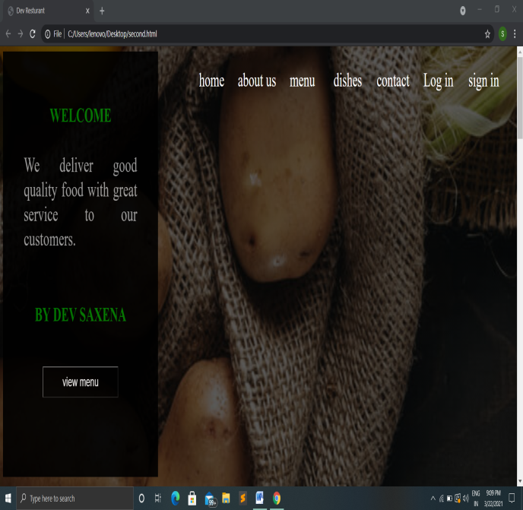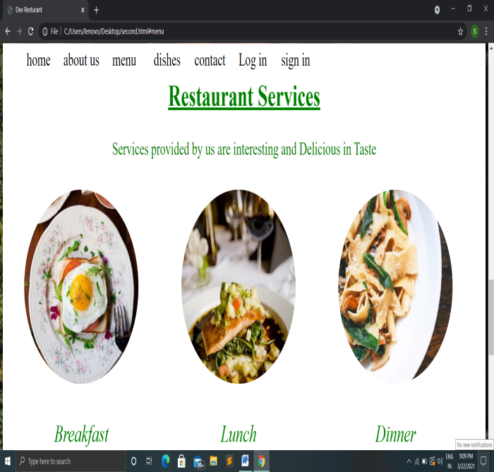

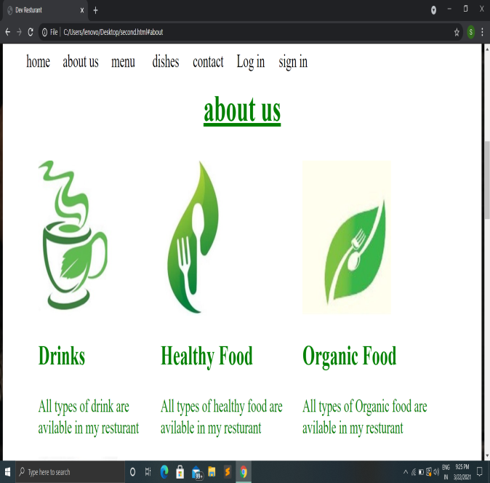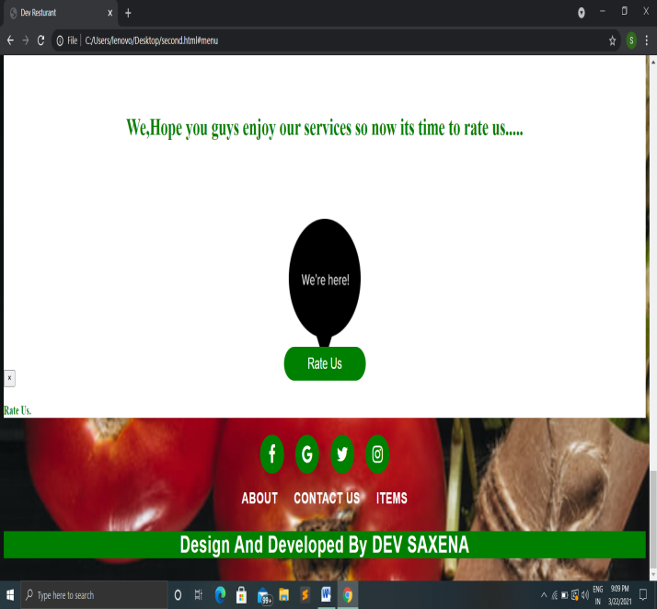

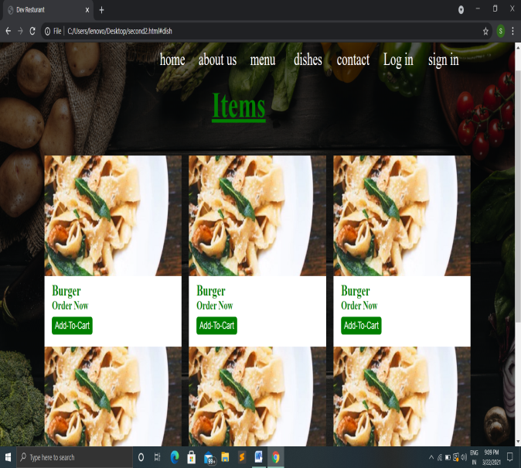

Summary

“Online Restaurant Management System" is a web application. This system is developed to automate day to day activity of a restaurant. Restaurant is a kind of business that serves people all over world with ready made food. This system is developed to provide service facility to restaurant and also to the customer. This restaurant management system can be used by employees in a restaurant to handle the clients, their orders and can help them easily find free tables or place orders. The services that are provided is food ordering and reservation table management by the customer through the system online, customer information management and waiter information management, menu information management and report. The restaurant menu is organized by categories (appetizers, soups, salads, entrees, sides and drinks) of menu items. Main objective build the system this is to provide ordering and reservation service by online to the customer. Each menu item has a name, price and associated recipe. A recipe for a menu item has a chef, preparation instruction sand associated ingredients. With this system online, ordering and reservation management will become easier and systematic to replace traditional system where are still using paper. To resister a meal online, the customer has to become a member first then he can access the later part of the site. this project to facilitate customer for make online ordering and reservation. The option of becoming member was only an attempt to avoid (to some extent) placing the fake bookings.

A Mini project on

Resturant Management System

*A PROJECT REPORT*

**Submitted to**

**Dr. ABDUL KALAM TECHNICAL UNIVERSITY,LUCKNOW**

*By*

**DEV SAXENA**

**Roll no. 1834010010**

*In partial fulfillment for the award of the degree of*

**BACHELOR OF TECHNOLOGY**

**IN**

**COMPUTER SCIENCE AND ENGINEERING**

**5 SEMESTER**



**DEPARTMENT OF COMPUTER SCIENCE AND ENGINEERING**

**VIVEKANANDA COLLEGE OF ENGINEERING AND TECHNOLOGY COLLEGE,ALIGARH**

**March 2021**