Lab Setup Steps:

  - Set IP address on PC to 172.16.200.2/30.
  - PC should be on the same LAN ad E0 on BB1.
  - Set MC Hammer to server
  - Set correct network interface on MC Hammer
  - Set three multicast groups, first group = 224.1.1.2
  - Start multicast hammer on PC
  - Packet sniffer on 172.16.255.230/25 will be able to detect the multicast traffic
  - Second PC running MC hammer as a receiver on 172.16.255.230/25, you can also use OpenBSD box interface dc1 172.16.255.254/25

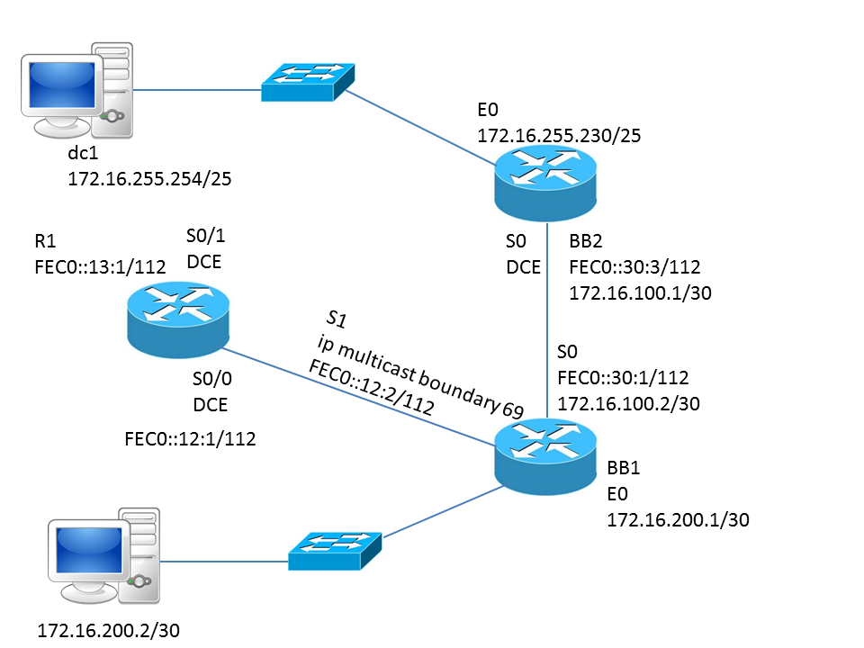

Debugging Commands:

show ip multicast int s0
show ip igmp groups
show ip igmp membership
show ip mroute sparse

debug ip mpacket detail
debug ip mcache 224.1.1.2

BB1 (cisco 2501)
ip multicast-routing
ipv6 unicast-routing
ipv6 cef
!
!
!
interface Loopback0
ip address 10.1.2.1 255.255.255.0
ipv6 address FEC0::2:1/112
!
interface Ethernet0
ip address 172.16.200.1 255.255.255.252
ip pim sparse-dense-mode
ip igmp join-group 224.1.1.2
ip igmp join-group 224.1.1.3
ip igmp join-group 224.1.1.4
!
interface Serial0
ip address 172.16.100.1 255.255.255.252
ip pim sparse-dense-mode
ip igmp join-group 224.1.1.2
ip igmp join-group 224.1.1.3
ip igmp join-group 224.1.1.4
ipv6 address FEC0::30:1/112
clockrate 64000
interface Serial1
no ip address
ip multicast boundary 69
ipv6 address FEC0::13:3/112
ipv6 address FE80::2 link-local
!
ip pim rp-address 172.16.100.1 2
!
logging origin-id hostname
logging 172.16.255.254
access-list 2 permit 224.0.1.40
access-list 2 permit 224.1.1.2
access-list 2 permit 224.1.1.3
access-list 2 permit 224.1.1.4
access-list 69 deny 239.0.0.0 0.255.255.255
access-list 69 permit 224.0.0.0 15.255.255.255

BB2 (cisco 2501)
ip multicast-routing
ipv6 unicast-routing
ipv6 cef
!
!
!
interface Loopback0
ip address 10.1.3.1 255.255.255.0
ipv6 address FEC0::3:1/112
!
interface Ethernet0
ip address 172.16.255.230 255.255.255.128
ip pim sparse-dense-mode
ip igmp join-group 224.1.1.2
ip igmp join-group 224.1.1.3
ip igmp join-group 224.1.1.4
!
interface Serial0
ip address 172.16.100.2 255.255.255.252
ip pim sparse-dense-mode
ip igmp join-group 224.1.1.2
ip igmp join-group 224.1.1.3
ip igmp join-group 224.1.1.4
ipv6 address FEC0::30:3/112
interface Serial1
no ip address
ip multicast boundary 69
ipv6 address FEC0::12:2/112
!
ip http server
ip classless
!
ip pim rp-address 172.16.100.1
!
logging origin-id hostname
logging 172.16.255.254
access-list 69 deny 239.0.0.0 0.255.255.255
access-list 69 permit 224.0.0.0 15.255.255.255

R1 (Cisco 2610)
clock timezone CST -6
clock summer-time CDT recurring
no aaa new-model
ip subnet-zero
ip cef
ip multicast-routing
ip audit po max-events 100
ipv6 unicast-routing
ipv6 cef
interface Loopback0
ip address 10.1.1.1 255.255.255.0
ipv6 address FEC0::1:1/112
!
interface Serial0/1
ip address 8.1.0.2 255.255.0.0
ip pim sparse-mode
ip igmp join-group 239.42.42.42
ipv6 address FEC0::13:1/112
ipv6 address FE80::1 link-local
clock rate 64000
ip pim rp-address 10.1.23.2
!
logging origin-id hostname
logging 172.16.255.254
access-list 69 deny 239.0.0.0 0.255.255.255
access-list 69 permit 224.0.0.0 15.255.255.255

