Azure Traffic Testing

This document describes what is needed to test traffic in Azure. YES it is OK to use a Microsoft operating system for testing. The goal is to simulate one or more "back end" servers running in a VNet in Azure. Easiest is probably a simple WWW server w/port 80 open.

In the following diagram, the “Example Spoke” 1 and 2 show the temporary test infrastructure described in this document.

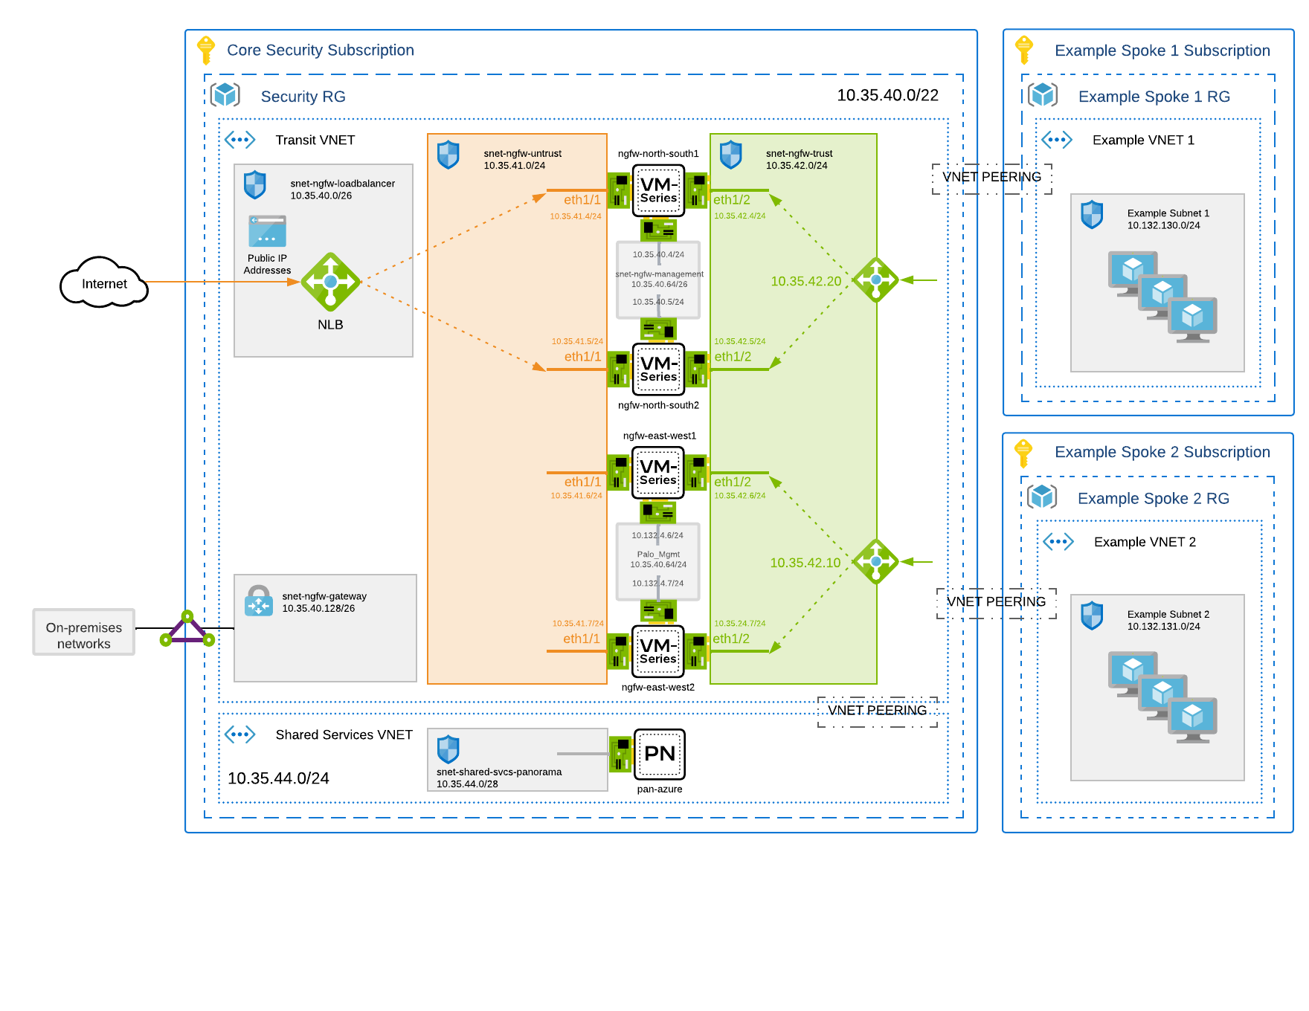

Outbound Traffic Testing

The web server should be able to make some request for a service on the public Internet. For example, get a software update, get time from an NTP server, etc.

Traffic will originate from an Azure based virtual machine destined for the public Internet. The following temporary infra is recommended:
- (1) Resource Group
- (1) Virtual Network (VNet)
- (1) Subnet
- (1) Linux Virtual Machine
- (1) Public IP (PiP)

Inbound Traffic Testing

From the "public internet" we want to send a request to get a web page from the "server" in the Azure environment. The test is successful if the host gets back a simple web page.

Traffic will originate from the public Internet with the goal of reaching an example application server in Azure. The following temporary infra is recommended:
- (1) Resource Group
- (1) Virtual Network (VNet)
- (1) Subnet
- (1) Linux Virtual Machine
- (1) Public IP (PiP)

East-West Traffic Testing

Traffic that originates in the Azure subscription that is destined for another network/host in the same subscription, or another subscription owned by the same organization is known as "East-West". For East-West testing, the following temporary infra is recommended:
- (1) Resource Group
- (2) Virtual Network (VNet)
- (2) Subnet
- (2) Linux Virtual Machine

Cleanup
Once the testing is completed, the test resources should be removed from the Azure environment. If these resources are not removed, you will continue to be billed for them.

- Deleting a Resource Group will remove all the temporary test infra as well.

