Date | Modification
9/22/03 | Initial Draft

Configuration Projects

This list should include hardware and software configuration projects. Projects should be documented and posted on web site whenever possible.

Entertainment box

Computer connected to stereo to play MP3’s. This box could also be connected to television if it has a DVD player. Users should be able to telnet or use web interface to log in and play music. Could run Linux, but requires a large hard disk.

VPN

Can net BIOS be routed for the VPN?

Make the net meeting server permanent

Password synchronization

Figure out a way to synchronize passwords between Samba, Windows, Linux, and BSD.

Unix passwd sync option in samba (broken?)

Set up commodore and play some games

Apple talk LAN segments

Token ring

Set up cluster

Make another OpenBSD box

It would be nice to have one of these around just for learning and comparison purposes.

ATM

Put the ATM backbone up full time. ATM could replace the current FDDI infrastructure.

Web Cam
Set up a 24 hour web cam in the work area using the USB camera.

System back ups

The goal is to create a reliable network backup process. Basically need one box with a huge drive or set of drives that we can dump stuff to.

Hardware
Back up server could have DDS2 or DDS3 tape drive off ebay.com. One box (even a P2) could have 4 +200GB drives, which should be more than enough.

Software
There is a package called BRU that could work for a lights out backup system.

Process and Policy
What should be backed up?
(baby pictures, all other pictures, web pages, databases, home directories)

There should be weekly lights-out backups at around 3am, maybe on Monday or Tuesday nights.

Web site

Proxy
- fix the error pages on the squid cache
-new version of squid
- custom error page

Additions

make the urban drink list available
-add different kinds of searches
-add/drop drinks

Genealogy

Start a genealogy web page.

Software Projects

syscheck.pl

- date bug
- version
- get opts.

find/parse firewall logs

trouble ticketing

Books Wanted

http://www.ultrapassword.com/club17/index.php

Need TALL bookshelves.

Computer/Networking Hardware Wanted

Serial terminal server

It would be nice to have one of these to put in the rack with the routers and switches. Look into the possibility of building one.

Sun Cobalt Qube 3 Appliance

Network printer

8mm video recorder and player

This one is not such a hot item anymore since the video camera will play the older 8mm tapes.

Sony model EVO-520 portable 8MM VCR
SONY EV-A60 8mm Video Rec/Player

Infrastructure Upgrades

Rack and cable management:

The kind of hardware needed is 19" racks, pans (cantilever shelves), feet, rack mount computer cases.

http://www.server-rack-online.com/server-rack-information.html

Server cabinets would be nice, but they are very expensive. These can be on wheels and don’t need to be drilled into the floor.

To hold the networking equipment, use relay racks, 96” tall if possible (8 feet). Should have EIA spacing (10-32). A "Rack Unit" is equal to 1.75" in height. To calculate the internal useable space of a rack enclosure you would simply multiply the total amount of Rack Units by 1.75". For example, a 44U rack enclosure would have 77" of internal usable space (44 x 1.75).

http://www.rackframe.com/index.html
http://www.iscdfw.com/onlinecatalog/racks/steel_relay_racks2.htm

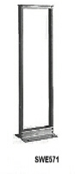
Figure 1; Relay rack

LAN furniture can be used to hold servers and possibly one operator position. With all the servers concentrated in one area, a KVM can be used so only one monitor, keyboard and mouse are necessary.

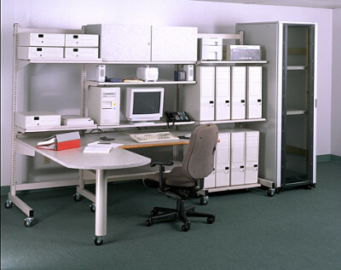
Figure 2: LAN furniture

CAT-5 panel inserts.

CAT-5 wall jacks. Can be installed in walls and terminated at a frame. The pinout can be changed on the backend.

Furniture
Will need terminals for one mac, laura, frank windows, frank linux, and guest, for a total of 5 if possible.

Power

Is DC power an option?

Cooling

Fire Detection and Prevention

Workbench
http://www.mf-direct-benches.com/KnockdownSeries/K_Series.htm

There should also be a cart to push stuff around on.

Tool Storage
Rollbox?

Physical Security

inventory all equipment (started in computers.xls)
- take pictures
- record serial numbers

Other

Write a Book About #fubaria
"life in a chat room"
-people
-bots
-takeovers
-timeline
-meetings
=projects

