PRACTICAL 1

AIM: Configuring Android Development Environment.

THEORY:

Android Studio Configuration

* Android Studio is the official Integrated Development Environment (IDE) for Android app development. Based on the powerful code editor and developer tools from IntelliJ IDEA , Android Studio offers even more features that enhance your productivity when building Android apps.

**Installation**

1. To download the Android Studio, visit the official Android Studio website in your web browser.
2. Click on the "Download Android Studio" option.

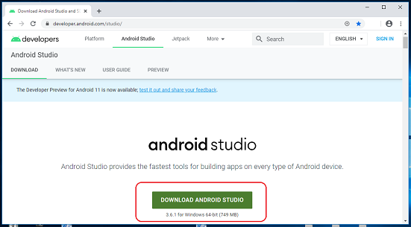

1. Double-click on the downloaded "Android Studio-ide.exe" file.
2. "Android Studio Setup" will appear on the screen and click "Next" to proceed.
3. Select the components that you want to install and click on the "Next" button.
4. Now, browse the location where you want to install the Android Studio and click "Next" to proceed.

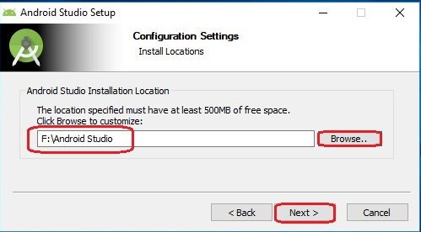

1. Choose a start menu folder for the "Android Studio" shortcut and click the "Install" button to proceed.
2. After the successful completion of the installation, click on the "Next" button.

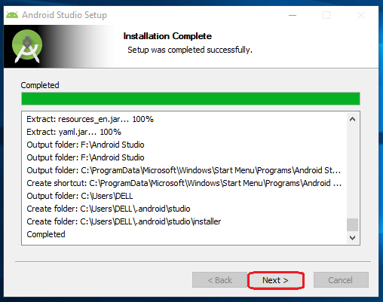

1. Click on the "Finish" button to proceed.

Select the appropriate download option. Standard will install the most common settings and options for you. Click "Next" to proceed.

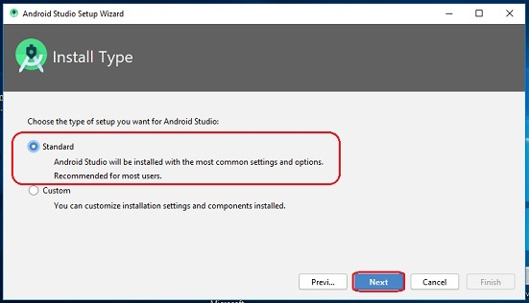

Now, click on the "Finish" button to download all the SDK components.