Snapshots:

1. PyCharm Database

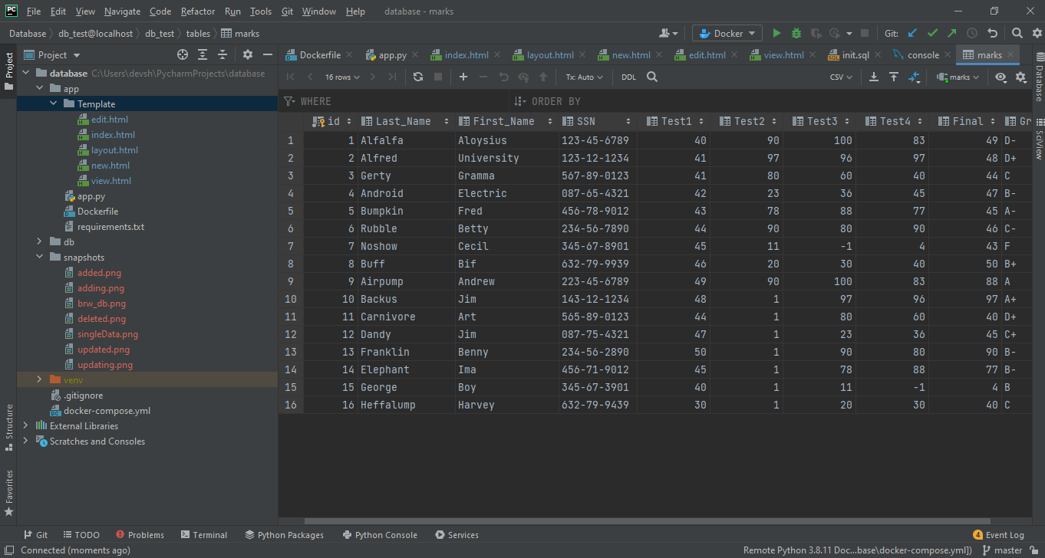

B) Data shown in the browser Homepage

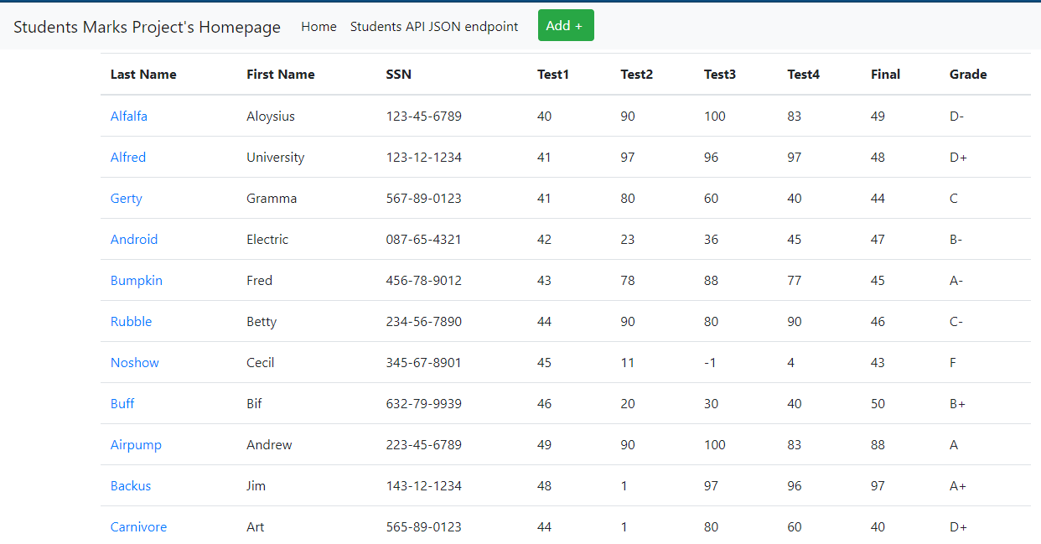

C) Single data shown in the browser

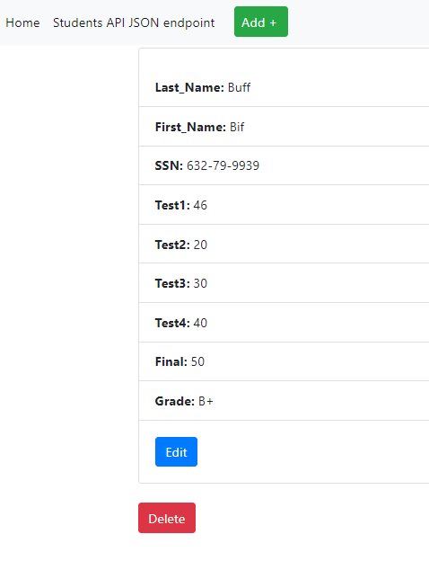

D-1) Adding New Data

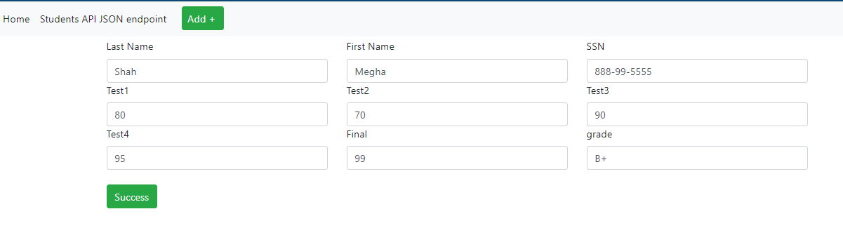

D-2) New Data Added

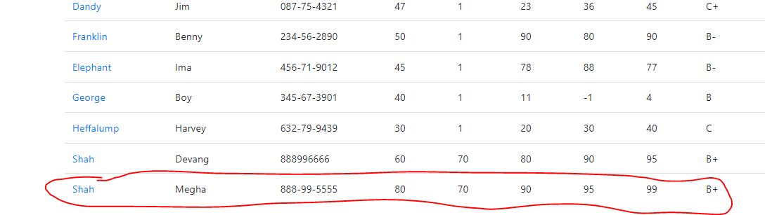

E-1) Updating

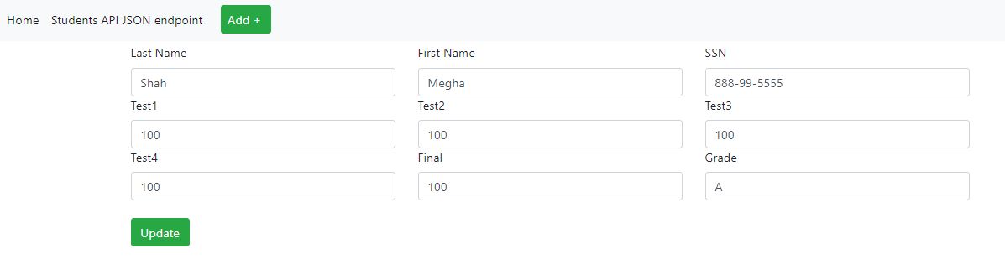

E-2) Updated

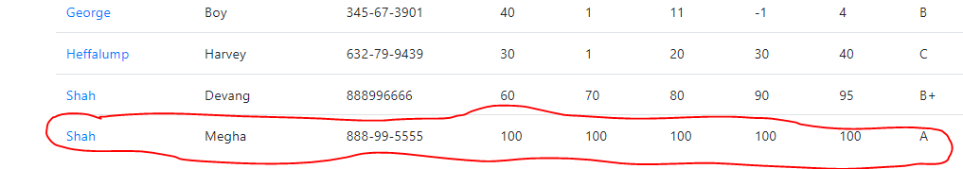

F) Deleted

