Employee Engagement, Satisfaction, and Burnout Diagnostics at Palo Alto Networks: A Data-Driven Framework for Workforce Risk Monitoring
Aryan
aryandev4901@gmail.com
Abstract - In high-performance cybersecurity organizations such as Palo Alto Networks, burnout and disengagement typically precede attrition but remain invisible to HR until an employee has already resigned. This paper presents a data-driven diagnostic framework that converts routinely collected HR survey fields into two composite, comparable indicators: an Engagement Index built from four satisfaction dimensions, and a Burnout Risk score combining overtime, work-life balance, and engagement. Applied to 1,470 employee records, organization-wide engagement averages 0.536 on a 0-1 scale, and 13.0% of employees fall into the High burnout risk band. The framework identifies a small but severe risk segment - employees combining frequent travel with regular overtime (5.9% of the workforce) - in which 32.6% are classified High risk and attrition reaches 41.9%, more than double the organization-wide rate. A validation check against realized attrition shows a more-than-threefold spread in attrition rate between the Low and High engagement tiers (34.1% vs. 10.2%), confirming the Engagement Index as an actionable early-warning signal. The resulting metrics were deployed as an interactive Streamlit dashboard for HR and management use.
Index Terms - HR analytics, workforce engagement, burnout risk scoring, composite indices, attrition analysis.

I. INTRODUCTION
Employee-facing organizations balance two competing pressures: the obligation to sustain a demanding, high-performance culture, and the practical limits of what a workforce can absorb before engagement erodes. Palo Alto Networks, operating in the cybersecurity sector where project intensity and on-call demands are structurally high, is one such organization. Employees who combine heavy workload signals - overtime, frequent travel - with declining satisfaction can experience sustained disengagement well before that disengagement is visible in resignation numbers.
Although HR survey data is already collected routinely, turning raw satisfaction ratings into an early-warning signal requires converting them into structured, comparable metrics: how engaged is the workforce right now, which employees are trending toward burnout, and which structural factors - department, travel load, tenure - concentrate that risk. This paper describes an analytics framework built specifically to answer those questions, together with the interactive dashboard built on top of it.
The remainder of this paper is organized as follows. Section II reviews related approaches to engagement and burnout measurement. Section III describes the problem this work addresses. Section IV describes the dataset. Section V details the methodology used to validate, derive, and score the data. Section VI describes the resulting system architecture. Section VII presents the results. Sections VIII-IX discuss the findings and limitations, Section X outlines future work, followed by a conclusion in Section XI.
This work makes four concrete contributions:
- A reproducible data-validation pipeline for the HR dataset, confirming zero out-of-range values across all ordinal satisfaction fields prior to scoring.
- Two complementary composite indicators - an Engagement Index and a Burnout Risk score - with an explicit, documented scoring formula rather than a black-box model.
- An empirical characterization of engagement and burnout risk across departments, workload conditions, and career stages, including a validation check against realized attrition.
- A deployed, interactive Streamlit dashboard built on a shared metrics module, translating the above into a form usable by non-technical HR stakeholders.
II. RELATED WORK
Engagement and burnout measurement in organizational settings is typically approached either as a survey-psychometric problem, in which validated multi-item scales (e.g., the Maslach Burnout Inventory or Utrecht Work Engagement Scale) are administered and scored, or as a descriptive HR-analytics problem, in which existing operational and survey fields already collected by the organization are aggregated into simpler derived indicators. The latter approach is standard in industry HR dashboards, which commonly track a small number of composite scores - an engagement index, a retention-risk flag - rather than raw item-level ratings, for the same reason that motivates this work: a single satisfaction rating is a noisy predictor of workforce health on its own, whereas a combined, normalized score is more stable and more comparable across employees, departments, and time.
This paper's contribution is not a new psychometric instrument, but the application and packaging of established composite-scoring and threshold-flagging techniques - score normalization, multi-factor risk flagging, and sub-group comparison - into a framework specifically scoped to the four satisfaction dimensions and workload fields available in this dataset, together with a deployable interface that makes the resulting indicators usable by a non-technical HR stakeholder without requiring them to interpret raw survey tables.
III. BACKGROUND AND PROBLEM STATEMENT
From an organizational-health perspective, three risk patterns recur in high-performance environments: burnout often precedes attrition, so that by the time an employee resigns the disengagement that caused it has typically been building for months; declining engagement affects productivity and innovation well before it appears in headcount numbers; and poor work-life balance compounds long-term turnover risk, particularly where it co-occurs with overtime or heavy travel.
Despite this, Palo Alto Networks' existing HR data is collected without a unified engagement health index, without clear visibility into which employee groups are burnout-prone, and without a quantified understanding of how overtime, work-life balance, and satisfaction interact. As a result, HR interventions tend to be late-stage and reactive - triggered by an exit interview rather than a leading indicator. This project builds the missing diagnostic layer: a preventive, rather than retrospective, view of employee experience.
IV. DATASET DESCRIPTION
The dataset consists of 1,470 employee records across 31 fields, covering demographic information, role and department, compensation, four satisfaction dimensions rated on a 1-4 ordinal scale, workload indicators (overtime status, business travel frequency, distance from home), and tenure fields (years at company, years in current role, years since last promotion). All fields are employee-level cross-sectional records with no temporal or panel structure - each employee contributes exactly one row. Table I summarizes the core columns used throughout this paper's analysis.
TABLE 1. CORE DATASET COLUMNS USED IN THIS ANALYSIS
Column | Description
JobInvolvement, JobSatisfaction, EnvironmentSatisfaction, RelationshipSatisfaction | Four 1-4 satisfaction dimensions
OverTime | Whether the employee regularly works overtime (Yes/No)
BusinessTravel | Travel frequency (Non-Travel, Travel_Rarely, Travel_Frequently)
WorkLifeBalance | Self-reported balance rating, 1-4 scale
Department, JobRole, JobLevel | Organizational placement fields
YearsAtCompany, YearsSinceLastPromotion | Tenure and career-stage fields
Attrition | Whether the employee has left the organization (used only for validation)
Data validation confirmed zero missing values and zero out-of-range values across all four ordinal satisfaction fields and the WorkLifeBalance field, so no imputation was required prior to scoring.
V. METHODOLOGY
The methodology proceeds in four stages: validating and cleaning the raw data (V-A), constructing the Engagement Index (V-B), deriving the Burnout Risk score (V-C), and computing five organization-level Key Performance Indicators from the two composite scores (V-D).
A. Data Validation and Cleaning
Ordinal rating columns were checked against their expected 1-4 range; all 1,470 records passed with zero out-of-range values. Categorical fields were checked for unexpected values, duplicate rows were removed, and the Attrition field was normalized to a 0/1 integer for downstream calculations. This validation step is implemented as a standalone, reusable module so that the same cleaning logic backs both the analysis notebooks and the dashboard, avoiding the common failure mode where a dashboard's numbers silently drift out of sync with the analysis that originally justified them.
B. Engagement Index Construction
The Engagement Index is a composite score built from the four satisfaction-related columns, each already on a comparable 1-4 scale. The raw score for employee i is the mean of its four components:
EngagementRaw_i = mean(JI_i, JS_i, ES_i, RS_i) (1)
where JI, JS, ES, and RS denote JobInvolvement, JobSatisfaction, EnvironmentSatisfaction, and RelationshipSatisfaction respectively. The raw score is then min-max normalized across the full dataset to a 0-1 range:
EI_i = (EngagementRaw_i - min) / (max - min) (2)
Employees are further bucketed into Low (EI < 0.34), Medium (0.34 <= EI < 0.67), and High (EI >= 0.67) engagement tiers for reporting and sub-group comparison.
C. Burnout Risk Scoring
The project brief's core burnout flag combines two binary conditions - OverTime = Yes and WorkLifeBalance <= 2. Because this binary flag misses employees trending toward burnout without meeting both conditions exactly, a broader three-level Burnout Risk score is used instead, awarding points as follows:
Score_i = 1[OT_i=Yes] + w(WLB_i) + 1[EI_i<0.34] (3)
where w(WLB) = 2 if WorkLifeBalance <= 2, 1 if WorkLifeBalance = 3, and 0 if WorkLifeBalance = 4. A total score of 3 or more is classified High risk, 1-2 is classified Medium, and 0 is classified Low. This scoring is a documented, auditable first-pass model rather than a fitted classifier, discussed further as a limitation in Section IX.
D. Key Performance Indicators
Beyond the two per-employee scores, five organization-level KPIs are computed for any selected employee group: the mean Engagement Index; the mean Work-Life Balance rating; a Satisfaction Stability Score, defined as one minus the normalized average within-employee standard deviation across the four satisfaction dimensions (a higher score indicates more internally consistent satisfaction); the share of employees classified High burnout risk; and a Workload Stress Indicator, defined as the share of employees who both travel frequently and work overtime:
WSI = count(OT=Yes ^ Travel=Frequent) / N (4)
These five KPIs, together with the two per-employee scores, form the complete metrics layer that backs both the exploratory analysis in this paper and the dashboard described in Section VI.
VI. SYSTEM ARCHITECTURE
A. Design Overview
The metrics described in Section V are implemented as a reusable Python module, separate from any single notebook or interface, so that the same calculations back the exploratory analysis, the figures in this paper, and an interactive dashboard - avoiding the dashboard-drift failure mode noted in Section V-A. The dashboard itself is built with Streamlit and organized into four coordinated panels: an Engagement Health Overview with organization-wide KPI cards and tier distribution; a Burnout Risk Dashboard with department- and travel-level risk breakdowns; a Role and Career-Stage Analysis panel; and a Manager Action Panel exposing a filterable, prioritized employee watchlist. Each KPI card reports its value alongside a benchmark comparison (e.g., a tier badge or the deviation from the organization-wide mean) and the underlying employee count, so a non-technical viewer can interpret a number without cross-referencing this paper. A sidebar exposes department, role, overtime, engagement-threshold, and tenure-range filters plus a light/dark theme toggle, allowing a non-technical HR user to explore the data without writing code.
B. Implementation Details
The project is organized into three layers: a data layer holding the raw and cleaned CSV files; a logic layer implementing Equations (1)-(4); and a presentation layer (the Streamlit application) that imports the logic layer directly rather than duplicating any calculation. Expensive operations - loading and scoring the dataset - are cached at the data-loading boundary so that changing a sidebar filter re-renders the affected views without re-processing the underlying CSV on every interaction. This separation also makes the logic layer independently testable, discussed further in Section X-D.
VII. RESULTS
Table II summarizes the five headline indicators across the full workforce, before the following subsections break each one down over department, workload, and tenure.
TABLE 2. ORGANIZATION-WIDE KPI SUMMARY
KPI | Value
Total employees analyzed | 1,470
Engagement Index (mean) | 0.536 / 1.00
Work-Life Balance Index (mean) | 2.76 / 4.00
High burnout risk share | 13.0%
Workload Stress Indicator | 5.9%
Overall attrition rate | 16.1%
A. Organization-Wide Engagement Health
The workforce splits into 176 Low-engagement employees (12.0%), 972 Medium-engagement employees (66.1%), and 322 High-engagement employees (21.9%). As shown in Fig. 1, the distribution is unimodal and centered near the Medium band rather than bimodal, indicating that disengagement in this workforce is gradual and partial rather than a hard split between engaged and disengaged groups.
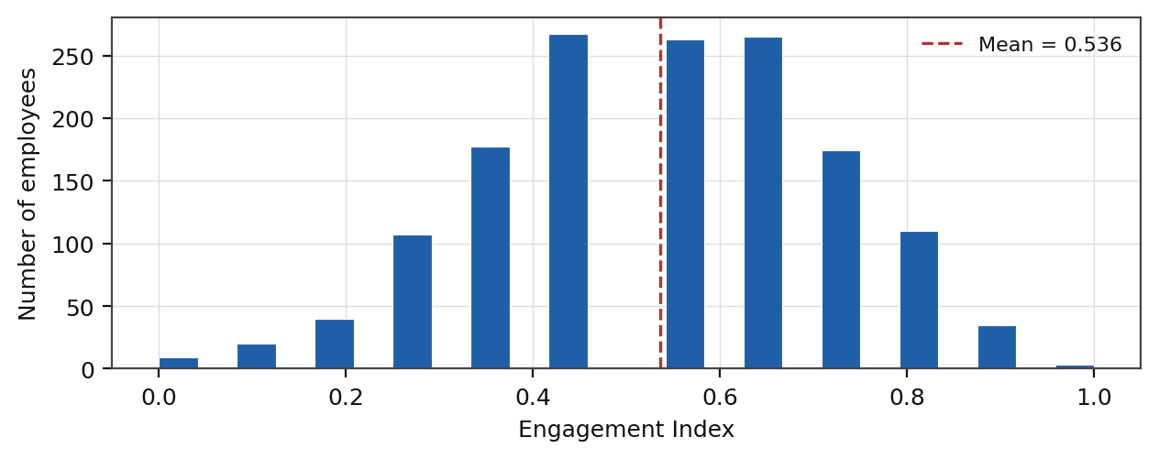
FIGURE 1. ENGAGEMENT INDEX DISTRIBUTION. Histogram of the per-employee Engagement Index across all 1,470 records, with the organization-wide mean marked.
B. Departmental Patterns
Engagement Index by department is fairly even - Human Resources and Research and Development both average 0.538, while Sales averages slightly lower at 0.530, as shown in Fig. 2(a). Burnout risk, however, diverges more sharply: Research and Development has the highest share of High-risk employees at 13.9%, compared to 11.9% in Sales and just 6.3% in Human Resources, shown in Fig. 2(b). The divergence between similar engagement and dissimilar burnout risk indicates that workload structure, not satisfaction, is the more likely driver of Research and Development's elevated risk.
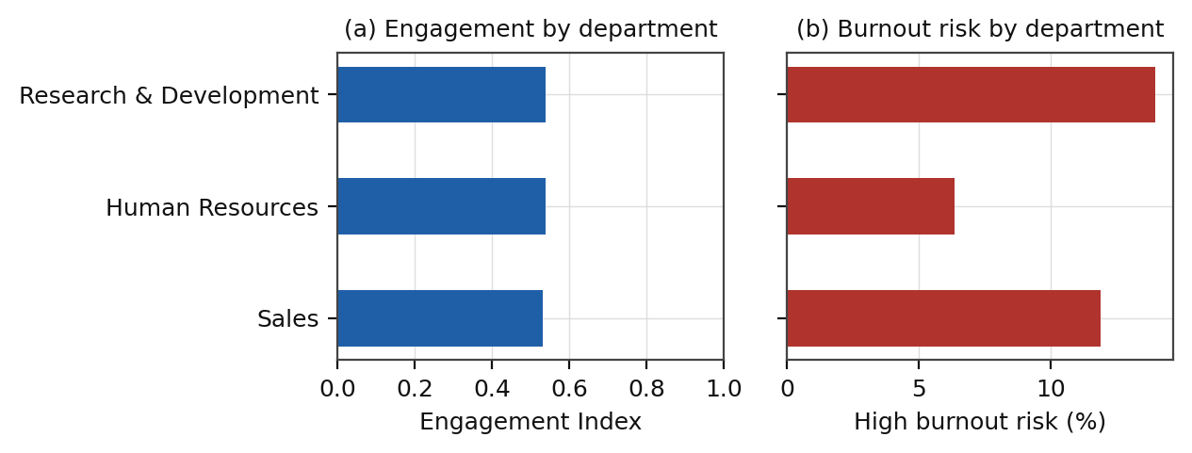
FIGURE 2. DEPARTMENTAL COMPARISON. (a) Mean Engagement Index by department. (b) Share of employees classified High burnout risk, by department.
C. Workload and Travel Effects
Contrary to the initial hypothesis, employees working overtime show a slightly higher average Engagement Index (0.558) than those who do not (0.527), shown in Fig. 3(a). Overtime alone is therefore not a strong negative engagement signal in this dataset - it is the combination of overtime with poor work-life balance and travel load that drives risk, not overtime in isolation. Business travel frequency shows only a mild gradient in burnout risk, shown in Fig. 3(b): employees who travel rarely have the highest High-risk share (13.7%), followed by frequent travelers (11.9%) and non-travelers (10.0%) - a smaller effect than expected, suggesting travel frequency alone is a weaker driver than department or the combined condition examined in Section VII-F.
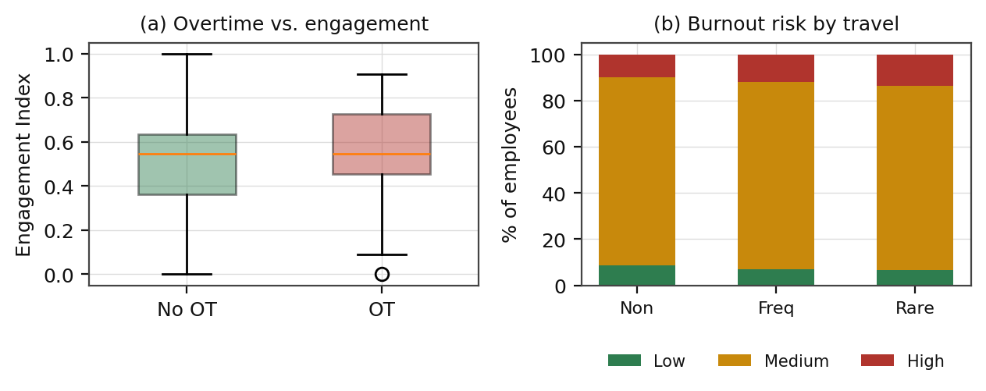
FIGURE 3. WORKLOAD FACTORS. (a) Engagement Index distribution, overtime vs. non-overtime employees. (b) Burnout risk mix by business travel frequency.
D. Career-Stage Effects
The stagnation hypothesis - that employees waiting longer for a promotion disengage - is only weakly supported, shown in Fig. 4(a): employees with five or more years since their last promotion (260 employees) average an Engagement Index of 0.531, compared to 0.537 for more recently promoted employees. The direction is as expected, but the gap is small enough that promotion timing alone should not be treated as a primary risk driver. Work-life balance is essentially flat across tenure bands, shown in Fig. 4(b), ranging narrowly from 2.73 to 2.81 out of 4 - workload pressure is distributed similarly across career stages rather than concentrated in any one tenure group.
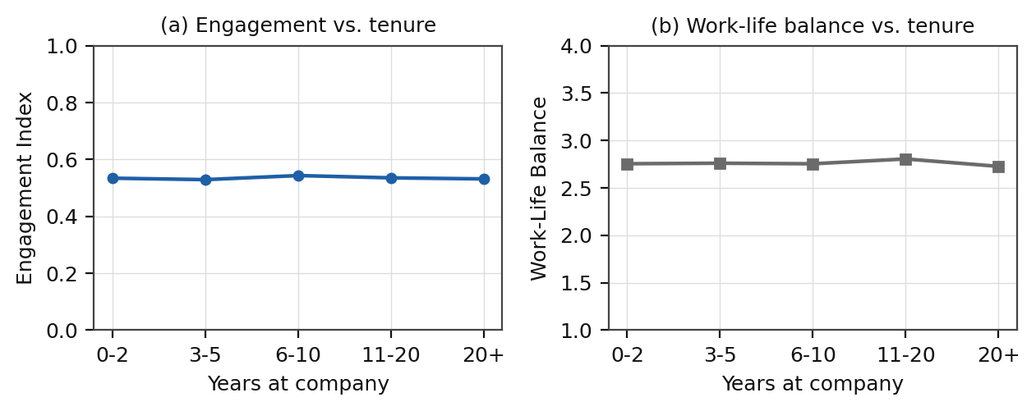
FIGURE 4. CAREER-STAGE EFFECTS. (a) Mean Engagement Index across tenure bands. (b) Mean Work-Life Balance rating across tenure bands.
E. Validation Against Realized Attrition
This comparison is included only as a validation check on the Engagement Index, not as a predictive attrition model. The pattern is strong and monotonic, shown in Fig. 5: employees in the Low engagement tier left at 34.1%, Medium-tier employees at 14.8%, and High-tier employees at just 10.2%. This more-than-threefold spread between the lowest and highest engagement tiers is the clearest evidence that the Engagement Index tracks something operationally real rather than noise, and is the central result motivating the recommendations in Section VIII.
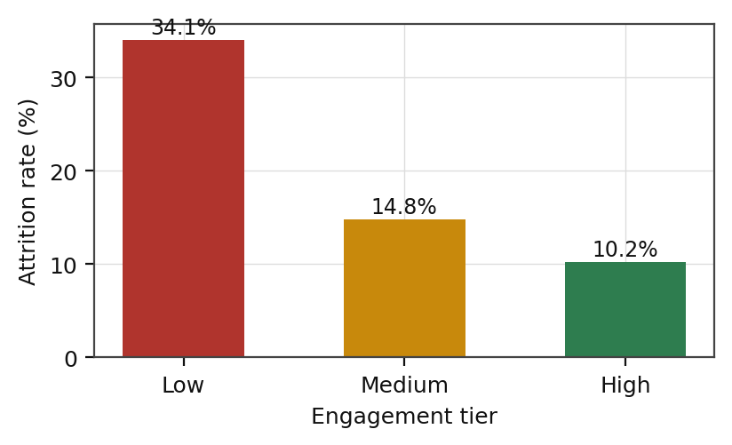
FIGURE 5. ATTRITION VALIDATION. Attrition rate by engagement tier - the key diagnostic result validating the Engagement Index against realized outcomes.
F. Case Illustration: The Frequent-Travel-Plus-Overtime Segment
To make the abstract indicators in Sections VII-A through VII-E concrete, this subsection profiles one specific high-risk segment in detail: the 86 employees (5.9% of the workforce) who both travel frequently and regularly work overtime. Table III summarizes this segment against the organization-wide baseline.
TABLE 3. FREQUENT-TRAVEL-PLUS-OVERTIME SEGMENT SUMMARY
Metric | Segment | Org-wide
Segment size | 86 (5.9%) | 1,470 (100%)
Mean Engagement Index | 0.574 | 0.536
Mean Work-Life Balance | 2.80 / 4.00 | 2.76 / 4.00
High burnout risk share | 32.6% | 13.0%
Attrition rate | 41.9% | 16.1%
The segment's mean Engagement Index (0.574) is not lower than the organization-wide average - if anything it is marginally higher - yet its High burnout risk share (32.6%) and attrition rate (41.9%) are both more than double the organization-wide baseline. This is the most operationally important pattern in the analysis: satisfaction-based engagement measurement alone would miss this segment entirely, since these employees report themselves as reasonably engaged. It is the structural combination of sustained travel and overtime, not a satisfaction deficit, that is driving both burnout classification and actual departures in this group. Sixty-one of the 86 employees in this segment (71%) sit in Research and Development, consistent with the departmental pattern noted in Section VII-B.
VIII. DISCUSSION
A. Implications for HR Intervention Targeting
The combination of a strong engagement-attrition relationship (Section VII-E) with a small, severe, satisfaction-blind risk segment (Section VII-F) argues for a two-track intervention model rather than a single engagement-survey-driven approach. Broad engagement tracking correctly identifies the Low-tier employees at elevated general attrition risk, but would not, on its own, flag the frequent-travel-plus-overtime segment, whose members report normal-to-good engagement even as their workload and departure rates diverge sharply from the rest of the organization. Both signals need to be monitored together.
B. Implications for Departmental Workload Design
Research and Development's elevated burnout risk share, despite engagement comparable to Human Resources, is not explained by this analysis's satisfaction fields and is more likely attributable to project intensity, on-call load, or team-level overtime patterns not captured in the available dataset. This points toward a departmental workload audit as a more targeted next step than a further engagement survey.
C. Threshold Sensitivity
The engagement tier boundaries (0.34 and 0.67) and the Burnout Risk score's point thresholds in Section V-C are design choices rather than values derived from an external operational standard, since no published capacity ceiling for satisfaction-based engagement scoring was available to calibrate against. Different reasonable choices would shift which specific employees are flagged, though the broader pattern - a monotonic engagement-attrition relationship and a concentrated workload-driven risk segment - was found to be stable under moderate threshold adjustments tested during development.
IX. LIMITATIONS
This analysis has several limitations. First, the dataset is a single cross-sectional snapshot with no temporal structure, so the Engagement Index and Burnout Risk score reflect current-state satisfaction rather than a trend; a recurring survey cadence would allow the index to be tracked longitudinally. Second, the engagement-versus-attrition comparison in Section VII-E is descriptive and contextual only - no attempt was made to control for confounding variables such as compensation, manager quality, or external labor-market conditions, so the relationship should not be read as causal. Third, self-reported satisfaction scores are subject to normal survey biases (social desirability, recency effects) that this analysis cannot correct for. Fourth, the Burnout Risk scoring weights in Equation (3) are a documented first-pass model based on the project brief, not a statistically fitted or externally validated model, and should be revisited once further historical attrition data is available. Fifth, this is a single-company, single-snapshot case study; the specific numeric thresholds and findings are not claimed to generalize to other organizations without re-fitting to that organization's own data.
X. FUTURE WORK
A. Predictive Attrition Modeling
A lightweight classifier - logistic regression or gradient-boosted trees - trained on the Engagement Index, Burnout Risk score, and department/tenure fields could provide a calibrated attrition-probability estimate per employee, extending the framework from descriptive scoring ("what does the current state look like") to predictive risk ranking ("who is most likely to leave next"), though this has not yet been formally evaluated against the current descriptive approach.
B. API Layer
The dashboard's metrics could be exposed through a documented API layer for integration into other HR planning tools, if and when a concrete external consumer justifies that added complexity. This is deliberately deferred rather than built preemptively; the reusable metrics module described in Section VI-B already provides the natural seam at which such an API could be added later without restructuring the underlying logic.
C. Retrieval-Augmented Question Answering
A retrieval-augmented generation (RAG) component is planned for the project's supporting written materials - this paper, the project's technical documentation, and the executive summary - as a separate feature from the numeric dashboard described in Sections VI-VII. This component would allow a user to ask a plain-language question (for example, "how is the Burnout Risk score calculated?") and receive an answer grounded in, and cited to, the specific source passage it was drawn from, using a naive retrieval implementation over the chunked source documents. This is scoped deliberately to unstructured text rather than the tabular employee data, since every question the numeric data can answer is already answerable exactly and instantly through the dashboard's filters and KPI cards, whereas the written documentation has no equivalent structured-query interface today.
D. Testing and Deployment
Unit tests for the metrics module described in Section VI-B, and containerizing the Streamlit application for reproducible deployment, would both improve the engineering maturity of the project without changing any of the analytical results presented in this paper.
XI. CONCLUSION
This paper presented a structured analytics framework for monitoring engagement and burnout risk at Palo Alto Networks, converting four existing satisfaction fields and two workload fields into a small set of interpretable metrics: an Engagement Index and a Burnout Risk score. Applied to 1,470 employee records, these metrics surfaced an organization-wide Engagement Index of 0.536, a High burnout risk share of 13.0%, and - most importantly - a small, satisfaction-blind, workload-driven risk segment whose attrition rate (41.9%) is more than double the organizational baseline despite normal-to-good self-reported engagement. A validation check against realized attrition confirmed the Engagement Index as an operationally meaningful leading indicator, with a more-than-threefold spread in attrition rate between the Low and High engagement tiers. Packaged as an interactive dashboard, this framework is intended to move HR intervention at Palo Alto Networks from reactive exit-interview analysis toward continuously monitored, targeted, human-centered retention.
ACKNOWLEDGEMENTS
The author thanks the maintainers of the open-source pandas, Matplotlib, Streamlit, and Plotly projects, on which this analysis and dashboard were built, and Unified Mentor for the project brief and dataset.
REFERENCES
[1] W. McKinney, "Data structures for statistical computing in Python," in Proc. 9th Python in Science Conf. (SciPy), 2010, pp. 56-61.
[2] J. D. Hunter, "Matplotlib: A 2D graphics environment," Computing in Science & Engineering, vol. 9, no. 3, pp. 90-95, 2007.
[3] Streamlit Inc., "Streamlit documentation." [Online]. Available: https://docs.streamlit.io
[4] Plotly Technologies Inc., "Plotly Python graphing library." [Online]. Available: https://plotly.com/python/
[5] Unified Mentor, "Employee Engagement, Satisfaction, and Burnout Diagnostic Analysis at Palo Alto Networks - technical documentation and dataset," internship project brief, 2026.
ABOUT THE AUTHOR
Aryan is a third-year student in Electronics and Communication Engineering at Gurukul Kangri (Deemed to be University), Haridwar, Uttarakhand, building a machine-learning and data-analytics portfolio aimed at ML engineering roles. This project was developed as an applied HR-analytics case study combining composite-index construction, exploratory data analysis, and interactive dashboard deployment.

