PES University, Bengaluru · Software Engineering Mini-Project
Team E16 – Section E
Traffic Management System (Simulation)
Software Requirements Specification (IEEE 830)
Document ID | SRS-TMS-1.0
Version / Date | 1.0 / 29 September 2026
Deliverable | Mini-Project Part 1
Builds on | Phase 1 SRS (Team-E16)
Team Members
Name | SRN
Likhith T Bommisetty | PES1UG24CS249
Devashruth M | PES1UG24CS251
Manish Bala | PES1UG24CS263
Manoj PS | PES1UG24CS265
Contents

1 Introduction
This SRS follows the structure of IEEE Std 830-1998 / ISO/IEC/IEEE 29148. It refines the team's Phase 1 requirements list (R1–R10, FR1–FR7, NFR1–NFR6) into clear, measurable, testable requirements and adds the use-case model and security section. Priority: M Must, S Should. Verification: T Test, D Demonstration, I Inspection, A Analysis.

1.1 Purpose
To specify the functional, non-functional and security requirements of the Traffic Management System (Simulation) so that the team, the instructor and testers share one unambiguous baseline for design (Part 3), testing (Part 2) and implementation in later phases.

1.2 Scope
The system is a single-machine C/C++ console application that simulates vehicle arrival and departure at road intersections using queue data structures, manages traffic-signal timing, prioritises emergency vehicles, monitors congestion and produces traffic reports. In scope: simulation engine, signal control, emergency priority, congestion monitoring, reports, configuration, user accounts and role-based access. Out of scope: connection to real traffic hardware or sensors, GUI/web front end, multi-machine or networked operation, real map data.

1.3 Definitions, Acronyms and Abbreviations
Term | Meaning
Tick | One simulated second; the smallest time step of the simulation engine.
Lane | A single approach queue at an intersection holding waiting vehicles in FIFO order.
Cycle / green / yellow | One full sequence of signal phases; green duration is operator-set, yellow is fixed at 3 s.
Emergency vehicle | Ambulance, fire or police vehicle flagged as priority; served ahead of normal traffic.
Congestion level | Low (< 5 vehicles queued), Moderate (5–14), High (≥ 15); thresholds configurable.
Throughput | Vehicles departed per simulated minute.
Average wait time | Mean simulated seconds between a vehicle's arrival and departure.
Operator / Administrator / Commuter | The three user classes defined in §2.3.
RBAC | Role-based access control.

1.4 References
- Team E16, Phase 1 – Software Requirements Specification (problem statement, feasibility, R1–R10, use cases).
- IEEE Std 830-1998; ISO/IEC/IEEE 29148:2018.
- SEI CERT C++ Coding Standard; OWASP ASVS 4.0 (authentication and input validation).

1.5 Overview
§2 describes the product context; §3 gives the use-case model and the specific requirements (functional, non-functional, security); §4 traces Phase 1 requirements to this SRS and to use cases.

2 Overall Description

2.1 Product Perspective
A new, standalone application. It has no external interfaces other than the local console and the local file system (user store, configuration, audit log, exported reports). It replaces fixed-time signal planning by allowing operators to observe congestion and adjust timing in a simulated environment.

2.2 Product Functions
- Simulate vehicle arrivals and departures per lane with FIFO queues.
- Set and adjust signal timing per intersection; optional adaptive extension of green time.
- Display live signal state and congestion per lane and intersection.
- Detect and prioritise emergency vehicles.
- Configure system parameters and manage intersections.
- Generate and export traffic reports.
- Manage user accounts and enforce role-based, authenticated access.

2.3 User Classes and Characteristics
Actor | Description | Access
Traffic Operator | Runs the simulation, monitors signals, adjusts timing, handles emergency priority, generates reports. Basic computer skills. | Login required
System Administrator | Manages user accounts, system-wide parameters and intersections. | Login required; highest privileges
Commuter | Read-only end user who views congestion status and completed reports. | No login; read-only view

2.4 Operating Environment
C++17 compiled with g++ 11 or later (GCC/MinGW-w64); runs on Ubuntu 22.04 and Windows 11 in a text console; no external hardware.

2.5 Design and Implementation Constraints
- Implementation language: C/C++ with standard-library or hand-written queue data structures (Phase 1 decision).
- Only free/open-source tools (zero licensing cost).
- Persistent data stored in local files; no database server.
- Must be modular so Phases 2–5 can deliver iteratively.

2.6 Assumptions and Dependencies
- One simulated second (tick) is processed per real second in real-time mode; a fast mode may run faster.
- Vehicle arrivals follow a configurable rate using a seeded pseudo-random generator.
- The operator's machine clock is correct (used for lockout and session timeouts).
- Each vehicle needs 2 simulated seconds to cross the stop line while its signal is green.

2.7 Feasibility Summary
Technical, economic, operational and schedule feasibility were established in Phase 1: queue-based simulation is implementable in C/C++ without hardware, tools are free, the console UI suits an operator, and the modular scope fits Phases 2–5.

3 Specific Requirements

3.1 External Interface Requirements
Interface | Description
User interface | Text console: menu-driven screens, a live dashboard (per-lane queue length, signal state, congestion level) and a read-only Commuter view.
Software | Standard C++17 library; local files users.dat, config.ini, audit.log and reports/*.csv|txt.
Hardware / communications | None. Single-process, single-machine; no network access.

3.2 Use Case Model
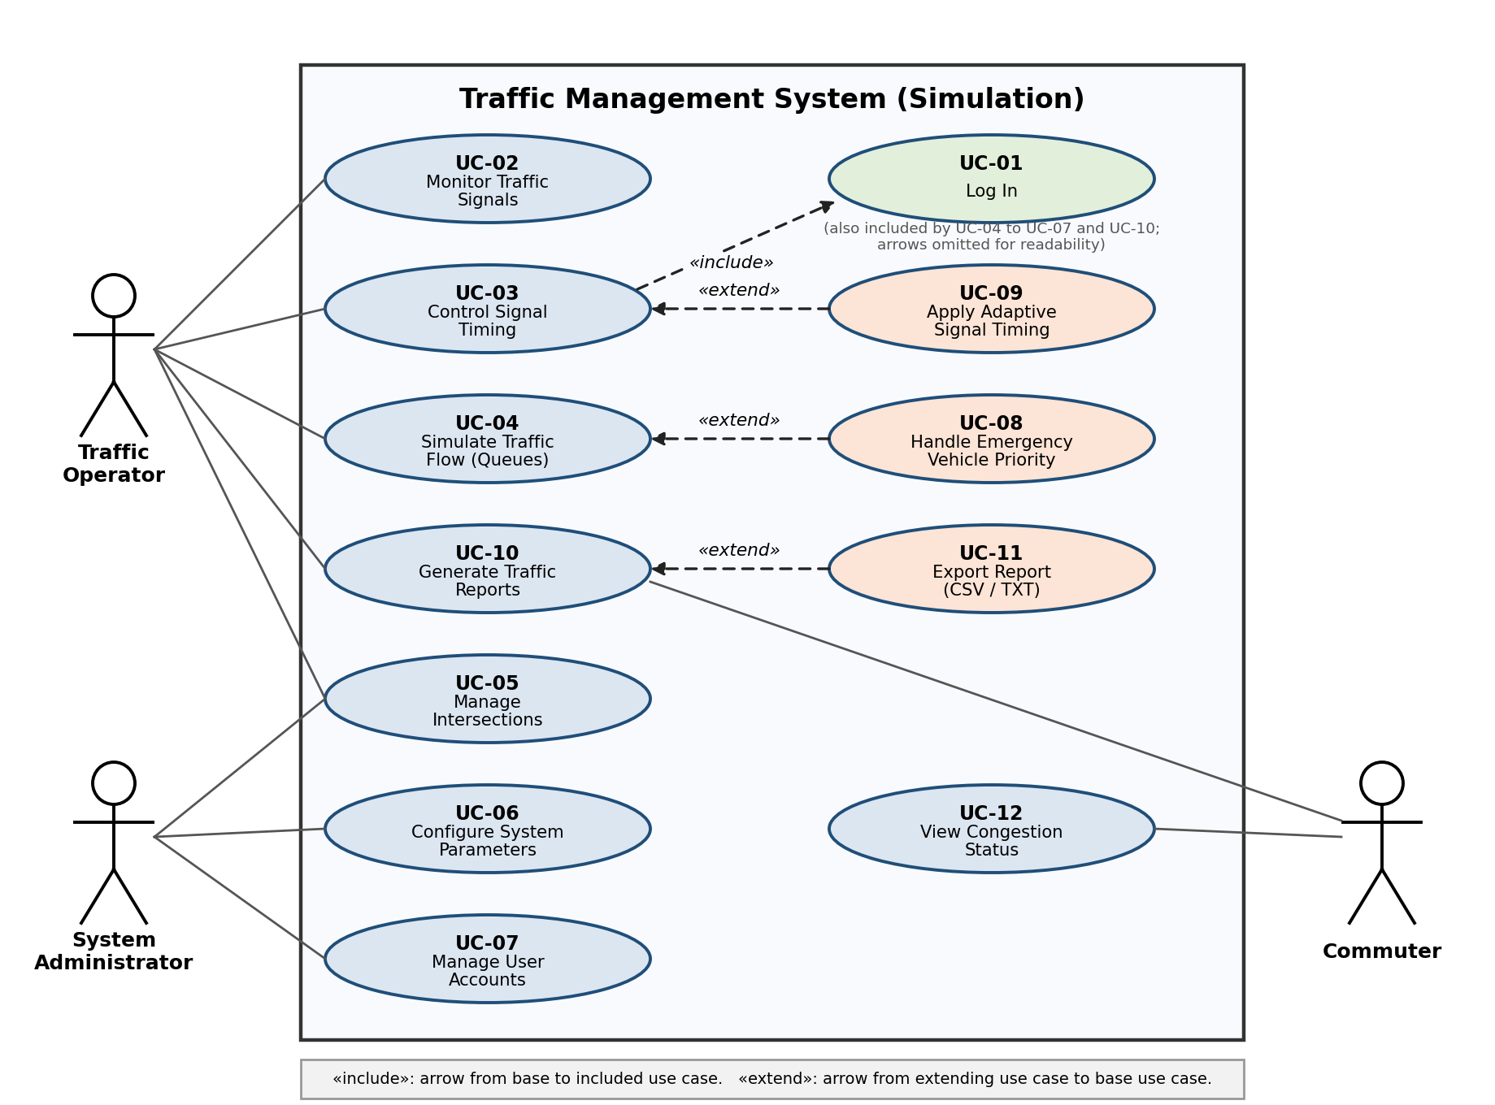
Figure 1 – UML use case diagram (extends the Phase 1 diagram with Log In, Adaptive Timing, Export Report and include/extend relationships)
Use case | Actor(s) | Description
UC-01 Log In | Operator, Admin | Authenticate with username and password. Included by every Operator/Admin use case.
UC-02 Monitor Traffic Signals | Operator | View live signal states and timers.
UC-03 Control Signal Timing | Operator | Set green duration per intersection; extended by UC-09.
UC-04 Simulate Traffic Flow (Queues) | Operator | Start, pause, stop the queue-based simulation; extended by UC-08.
UC-05 Manage Intersections | Operator, Admin | Add, edit, delete intersections and lane parameters.
UC-06 Configure System Parameters | Admin | Set seed, thresholds, session timeout, tick speed.
UC-07 Manage User Accounts | Admin | Create, deactivate, delete users and roles.
UC-08 Handle Emergency Vehicle Priority | (extends UC-04) | Preempt signals for an emergency vehicle.
UC-09 Apply Adaptive Signal Timing | (extends UC-03) | Automatically extend green for long queues.
UC-10 Generate Traffic Reports | Operator, Commuter (view) | Compute throughput, wait time, congestion; extended by UC-11.
UC-11 Export Report | (extends UC-10) | Save report as CSV or TXT.
UC-12 View Congestion Status | Commuter | Read-only congestion view without login.

3.3 Functional Requirements
Each requirement is one testable 'shall' statement with numeric limits where applicable.
ID | Requirement | Priority | Verification
FR-01 | The system shall simulate vehicle arrivals per lane using one FIFO queue per lane, generating arrivals at the configured rate (1–60 vehicles/min per lane) from a seeded random generator, and shall dequeue at most one vehicle per 2 simulated seconds per lane while that lane's signal is green. | M | T
FR-02 | The system shall allow a logged-in Operator to set the green duration (5–120 s) of each intersection's signal, with yellow fixed at 3 s; a new value shall apply from the start of the next cycle and be shown on the dashboard within 1 s. | M | T
FR-03 | The system shall display, for every lane and intersection, the signal state (Red/Yellow/Green), queue length and congestion level (Low < 5, Moderate 5–14, High ≥ 15 vehicles), refreshed at least once per simulated second. | M | T
FR-04 | The system shall detect an emergency vehicle within 1 tick of its entering a lane queue and shall give that lane a green signal within 5 simulated seconds of detection (after a 3 s yellow to conflicting lanes), hold it until the vehicle departs, then resume the normal cycle; simultaneous emergencies shall be served in order of arrival. | M | T
FR-05 | The system shall allow an Administrator to configure system-wide parameters: random seed (0–2³¹−1), congestion thresholds, session timeout (1–60 min) and simulation speed (1×, 10×, 60×). | M | T
FR-06 | The system shall generate a traffic report containing throughput (vehicles/min), average wait time (s), maximum queue length and percentage of time at High congestion, and shall export it as CSV or TXT within 3 s for a one-simulated-hour run. | M | T
FR-07 | The system shall allow an Administrator to create, deactivate and delete user accounts with role Operator or Administrator (unique username of 4–20 characters) and shall authenticate users by username and password. | M | T
FR-08 | The system shall allow an Operator or Administrator to add, edit and delete intersections (maximum 10) with 1–8 lanes each, an arrival rate per lane and a signal cycle. | M | T
FR-09 | When adaptive mode is enabled, the system shall extend the green of a lane whose queue is High by up to 20 s (in 5 s steps) while every opposing queue is below Moderate, never exceeding a total green of 140 s. | S | T
FR-10 | The system shall provide a Commuter view without login that shows only congestion status (FR-03) and completed reports (FR-06) and offers no function that modifies data. | M | T/D

3.4 Non-Functional Requirements
ID | Requirement | Priority | Verification
NFR-01 | Performance – 95% of operator commands shall be processed and reflected on screen within 1 second while simulating 10 intersections with 8 lanes each. | M | T
NFR-02 | Performance – In fast mode the engine shall process at least 1,000 ticks per second at the maximum configuration (one simulated hour in ≤ 4 s). | S | T
NFR-03 | Reliability – The simulation shall run 24 simulated hours (86,400 ticks) at maximum configuration without crash, hang or memory growth above 10%, verified with AddressSanitizer/Valgrind. | M | T
NFR-04 | Usability – At least 4 of 5 first-time testers shall start a simulation and read a lane's congestion status within 5 minutes using only on-screen help; menus shall be at most 3 levels deep. | S | T
NFR-05 | Maintainability – Each module shall be a separate header/source pair; no function shall exceed cyclomatic complexity 10; unit-test line coverage shall be ≥ 70%. | S | I/T
NFR-06 | Robustness – 100% of invalid inputs (non-numeric, out-of-range, empty, longer than 256 characters) shall be rejected with a message naming the field and the allowed range, without crashing or changing state. | M | T
NFR-07 | Portability – The code shall compile with zero warnings under g++ -Wall -Wextra -std=c++17 on Ubuntu 22.04 and on Windows 11 with MinGW-w64. | S | T/I
NFR-08 | Repeatability – Two runs with the same seed and configuration shall produce identical reports (100% match). | S | T

3.5 Security Requirements
3.5.1 Security Objectives
ID | Objective | Rationale
SO-1 | Confidentiality of credentials | User passwords must never be recoverable from stored data or logs.
SO-2 | Integrity of code paths and data | Prevent memory-safety flaws (buffer overflows) and tampering with configuration or reports; C/C++ makes this essential.
SO-3 | Availability and stability | Malformed input or repeated failed logins must not crash or lock out the whole system.
SO-4 | Access control and accountability | Only authorised roles perform privileged actions, and every security-relevant action is traceable to a user.

3.5.2 Security Requirements
ID | Requirement | Objective | Verification
SEC-01 | Every Operator and Administrator function shall require successful login; unauthenticated users shall be limited to the read-only Commuter view. | SO-4 | T
SEC-02 | Passwords shall be at least 8 characters with a letter and a digit and shall be stored only as salted hashes (16-byte random salt, SHA-256 with ≥ 10,000 iterations or Argon2id); plaintext passwords shall never be stored or logged. | SO-1 | T/I
SEC-03 | After 3 consecutive failed logins for a username, the account shall be locked for 60 seconds. | SO-3, SO-4 | T
SEC-04 | An authenticated session shall end automatically after the configured inactivity timeout (default 10 minutes). | SO-4 | T
SEC-05 | Role-based access control shall be enforced on every command: user management and system parameters for Administrator only; simulation control for Operator and Administrator; a denied command shall change nothing. | SO-4 | T
SEC-06 | All user input shall be length-limited (≤ 256 characters) and range-checked; the code shall not use unbounded C functions (gets, strcpy, sprintf, scanf with %s), shall build with -fstack-protector-strong -D_FORTIFY_SOURCE=2, and cppcheck shall report zero high-severity findings. | SO-2, SO-3 | T/I
SEC-07 | The system shall append an audit record (timestamp, user, action, result) for every login success or failure, lockout, user or parameter change, emergency override and report export; the application shall provide no function to edit or delete audit records. | SO-4 | T
SEC-08 | users.dat and audit.log shall be readable and writable only by the owning OS user (mode 0600 on Linux); exported report names shall reject path separators and '..' to prevent path traversal. | SO-1, SO-2 | T/I

4 Traceability

4.1 Phase 1 Requirements → This SRS
Phase 1 | Phase 1 description | Refined in this SRS
R1 / FR1 | Simulate arrival/departure with queues | FR-01
R2 / FR2 | Control signal timing | FR-02, FR-09
R3 / FR3 | Monitor congestion | FR-03, FR-10
R4 / FR4 | Emergency vehicle priority | FR-04
R5 / FR5 | Configure parameters | FR-05, FR-08
R6 / FR6 | Traffic reports | FR-06
R7 / FR7 | User accounts | FR-07
R8 / NFR1, NFR2 | Response time and stability | NFR-01, NFR-02, NFR-03
R9 / NFR6 | Input validation | NFR-06, SEC-06
R10 / NFR3 | Authenticated access | SEC-01 to SEC-05
NFR4, NFR5 | Usability, modularity | NFR-04, NFR-05

4.2 Requirements → Use Cases
Use case | Requirements
UC-01 Log In | FR-07, SEC-01 to SEC-04
UC-02 Monitor Traffic Signals | FR-03
UC-03 Control Signal Timing | FR-02
UC-04 Simulate Traffic Flow | FR-01, NFR-01 to NFR-03, NFR-08
UC-05 Manage Intersections | FR-08, NFR-06
UC-06 Configure System Parameters | FR-05, SEC-05
UC-07 Manage User Accounts | FR-07, SEC-02, SEC-05
UC-08 Handle Emergency Priority | FR-04
UC-09 Adaptive Signal Timing | FR-09
UC-10 / UC-11 Reports | FR-06, SEC-08
UC-12 View Congestion Status | FR-03, FR-10
All use cases | SEC-06, SEC-07, NFR-05, NFR-07
Requirements are traced to test cases in the Test Plan (§11) and to components in the Architecture & Design Specification (§3.5).

