PES University, Bengaluru · Software Engineering Mini-Project
Team E16 – Section E
Traffic Management System (Simulation)
Software Architecture & Design Specification (IEEE 42010 / 1016)
Document ID | SADS-TMS-1.0
Version / Date | 1.0 / 29 September 2026
Deliverable | Mini-Project Part 1
Builds on | Phase 1 SRS (Team-E16)
Traces to | SRS-TMS-1.0, TP-TMS-1.0
Team Members
Name | SRN
Likhith T Bommisetty | PES1UG24CS249
Devashruth M | PES1UG24CS251
Manish Bala | PES1UG24CS263
Manoj PS | PES1UG24CS265
Contents

Prepared in the structure of IEEE Std 42010 (architecture) and IEEE Std 1016 (design description).

1 Introduction
Purpose: describe the architecture and detailed design that realise SRS-TMS-1.0. Scope: all modules of the Traffic Management System (Simulation) v1.0. Audience: team members, instructor, testers. Architectural drivers: (1) queue-based simulation using core data structures in C++; (2) real-time responsiveness (NFR-01); (3) memory safety and secure input handling in C++ (SEC-06); (4) modularity for Phases 2–5 (NFR-05); (5) repeatable, testable behaviour (NFR-08).
Area | Choice | Reason
Language / standard | C++17, g++ 11+ | Phase 1 decision; RAII, std::optional, std::string reduce memory errors
Build / test | CMake or make; Catch2 or GoogleTest | Portable builds, unit tests
Persistence | Local text/binary files (users.dat, config.ini, audit.log, reports/) | No database server needed (SRS §2.5)
Security tooling | -fstack-protector-strong, -D_FORTIFY_SOURCE=2, ASan/UBSan, cppcheck | SEC-06, NFR-03

2 Architecture

2.1 Architectural Pattern
Primary pattern: Layered architecture (Presentation → Application/Domain → Infrastructure) packaged as a modular monolith – one process, with each module in its own header/source pair and reachable only through a defined interface. The simulation core is a time-stepped (tick-based) discrete simulation loop. A layered design keeps console handling, business rules and file access separate, allows each module to be unit-tested (NFR-05), and gives one place (the Command Dispatcher) to enforce authentication, RBAC and input limits.
Supporting pattern | Where used | Benefit
State | Signal Controller: Red, Green, Yellow, EmergencyGreen states | Clear transition rules; easy to test timing (FR-02, FR-04)
Strategy | Timing policy: FixedTiming vs AdaptiveTiming | Adaptive mode added without changing the engine (FR-09)
Observer | Congestion Monitor notified each tick; Dashboard subscribes | Live display within 1 s (FR-03, NFR-01)
Command | Menu actions as command objects with required permission | Uniform RBAC and audit hook (SEC-05, SEC-07)
RAII / Result<T> | Files, sessions, errors | No leaks or unchecked errors (NFR-03, §3.4)
Alternatives considered: a client–server or multi-threaded design was rejected (no networking requirement, more risk of races); a pure procedural design was rejected because it would not separate security checks from logic.

2.2 Component Diagram
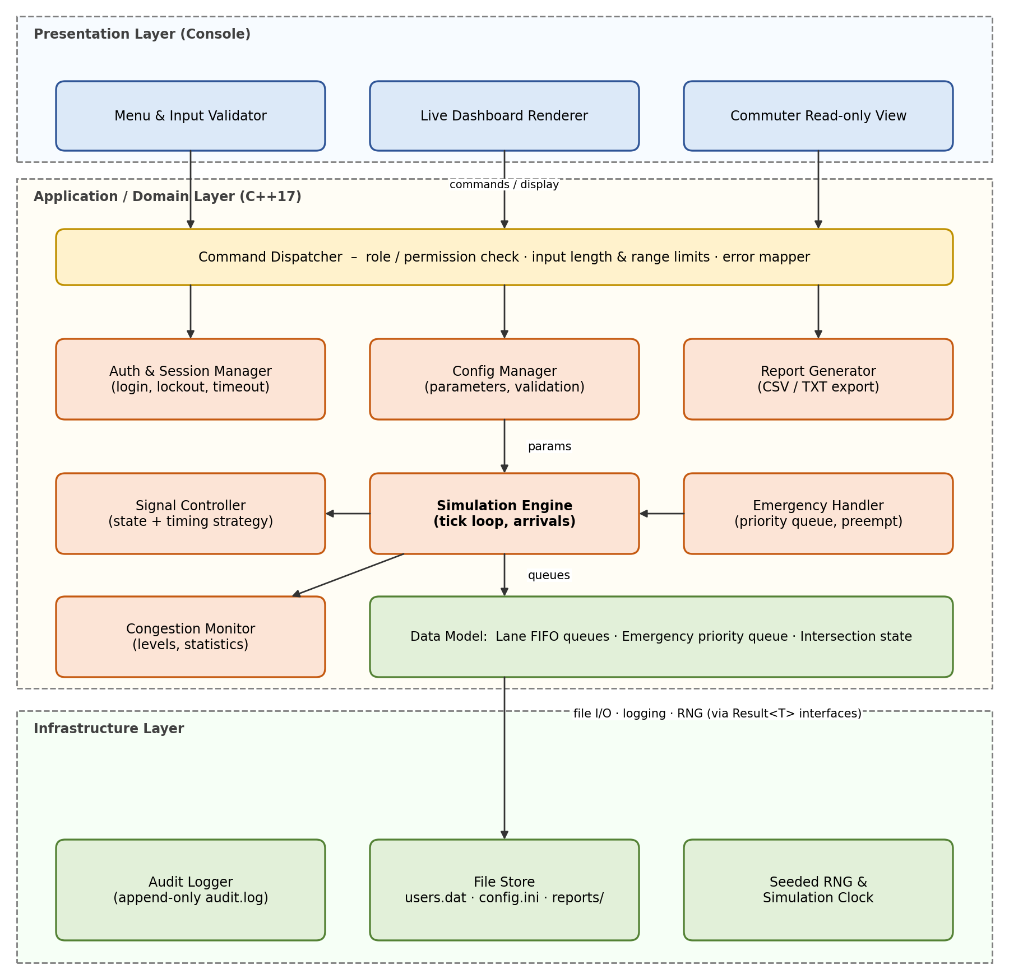
Figure 2 – Component diagram of the Traffic Management System

2.3 Component Descriptions
Component | Responsibility | Key interface
Menu & Input Validator | Reads console input, enforces length ≤ 256 and type/range checks before anything else sees it. | readField(name, type, range)
Live Dashboard Renderer | Draws signal state, queue length, congestion level each tick. | render(snapshot)
Commuter Read-only View | Shows congestion and completed reports; contains no modifying calls. | showCongestion(), showReport()
Command Dispatcher | Maps a command to its module, checks session and role, converts errors to messages. | dispatch(cmd, session)
Auth & Session Manager | Login, salted-hash verification, lockout, inactivity timeout, roles, user CRUD. | login(), logout(), hasPermission(), createUser()
Config Manager | Loads/validates/saves system parameters and intersection definitions. | get(), set(), addIntersection()
Simulation Engine | Owns the tick loop; generates arrivals from seeded RNG; enqueues/dequeues vehicles; coordinates other modules. | start(), pause(), stop(), tick()
Signal Controller | State machine per intersection; applies timing strategy; executes preemption. | setGreen(), preempt(), tick()
Emergency Handler | Scans lanes for emergency vehicles; keeps them in a priority queue ordered by arrival. | scan(), next()
Congestion Monitor | Computes levels and accumulates statistics (wait, throughput, max queue). | update(), statistics()
Report Generator | Builds and exports CSV/TXT reports from statistics. | generate(format, name)
Audit Logger | Appends audit records; exposes no edit/delete. | log(event)
File Store | Reads/writes users.dat, config.ini, reports; enforces 0600 mode and safe paths. | load(), save(), createReport()
Seeded RNG & Clock | Deterministic random numbers and simulated/real time. | next(), now()

2.4 Data Structures (core of the simulation)
Structure | Type | Purpose
Lane queue | FIFO queue of Vehicle{id, type, arrivalTick} | Waiting vehicles per lane (FR-01)
Emergency queue | Priority queue keyed by arrivalTick | Serve emergencies in arrival order (FR-04)
Intersection | struct{id, name, lanes[1..8], signalState, greenSeconds, cycle} | Holds live state (FR-08)
Statistics | struct{departed, totalWait, maxQueue, highTicks} | Report figures (FR-06)
User record | struct{username, role, salt, hash, failedCount, lockUntil} | Authentication (FR-07, SEC-02, SEC-03)

2.5 Deployment View
One executable (tms) on the operator's machine. Working directory contains config.ini, users.dat (mode 0600), audit.log (mode 0600) and reports/. No network ports are opened.

2.6 Traceability of Architecture to Requirements
Requirement(s) | Realised by | Design element / tactic
FR-01 | Simulation Engine, Data Model, Seeded RNG | Per-lane FIFO queues; 2 s per departure; seeded arrivals
FR-02, FR-09 | Signal Controller, Config Manager | State + Strategy patterns; range check 5–120 s; adaptive limits
FR-03, FR-10 | Congestion Monitor, Dashboard, Commuter View | Observer notification each tick; read-only view has no write calls
FR-04 | Emergency Handler, Signal Controller | Priority queue; EmergencyGreen state after 3 s yellow
FR-05, FR-08 | Config Manager | Validated parameters; capacity limits 10 intersections, 8 lanes
FR-06, SEC-08 | Report Generator, File Store | Statistics-based export; safe file names; create-new only
FR-07, SEC-01 – SEC-05 | Auth & Session Manager, Command Dispatcher | Salted hash, lockout, timeout, role table, central permission check
NFR-01, NFR-02 | Simulation Engine, Dashboard | Single-threaded O(lanes) tick; lightweight rendering
NFR-03 | All modules | RAII, bounds-checked containers, top-level exception handler, ASan runs
NFR-04 | Menu & Input Validator | ≤ 3 menu levels; on-screen help
NFR-05, NFR-07 | Module structure, build | Header/source pairs; warnings-as-errors builds
NFR-06, SEC-06 | Menu & Input Validator, Command Dispatcher | Central validation; banned unsafe functions
NFR-08 | Seeded RNG & Clock | Deterministic generator; no hidden randomness
SEC-07 | Audit Logger | Append-only API called from Dispatcher and modules

2.7 Security Architecture
Trust boundary. The only entry point is console input, which is untrusted. Everything crosses the Menu & Input Validator and Command Dispatcher before reaching modules. Files are trusted only if owned by the application user.
Control | Mechanism | Requirement
Authentication | Salted hash (16-byte salt, ≥ 10,000 iterations); constant-time compare; lockout after 3 failures for 60 s | SEC-02, SEC-03
Session management | Session object with role and expiry; inactivity timeout (default 10 min) | SEC-04
Authorisation | Permission table (role → command) checked in Command Dispatcher for every command | SEC-01, SEC-05
Input validation | All input into std::string with 256-char limit, then type/range parse; no unsafe C functions | SEC-06, NFR-06
Memory-safety hardening | Stack protector, FORTIFY_SOURCE, ASan/UBSan in CI, smart pointers, no raw new/delete | SEC-06, NFR-03
Audit | Append-only audit.log; Audit Logger has no delete/edit API | SEC-07
File protection | Mode 0600 for users.dat and audit.log; report names sanitised and confined to reports/ | SEC-08
Read-only public view | Commuter View links only to read functions | SEC-01, FR-10

Threat (STRIDE) | Example | Mitigation
Spoofing | Password guessing at the console | Lockout, hashing, audit
Tampering | Editing config.ini or reports with out-of-range values | Validation on load (E-CFG-001 → defaults); file modes
Repudiation | Admin denies deleting a user | Audit log with user and time
Information disclosure | Reading password hashes; error text revealing internals | 0600 files; generic messages
Denial of service | Malformed input crashing the program; lockout abuse | Central validation; per-account 60 s lock only
Elevation of privilege | Operator running admin commands; path traversal on export | RBAC on every command; safe file names

3 Design

3.1 UML Sequence Diagrams
Sequence 1 – Login with lockout and audit (FR-07, SEC-01 to SEC-04, SEC-07).
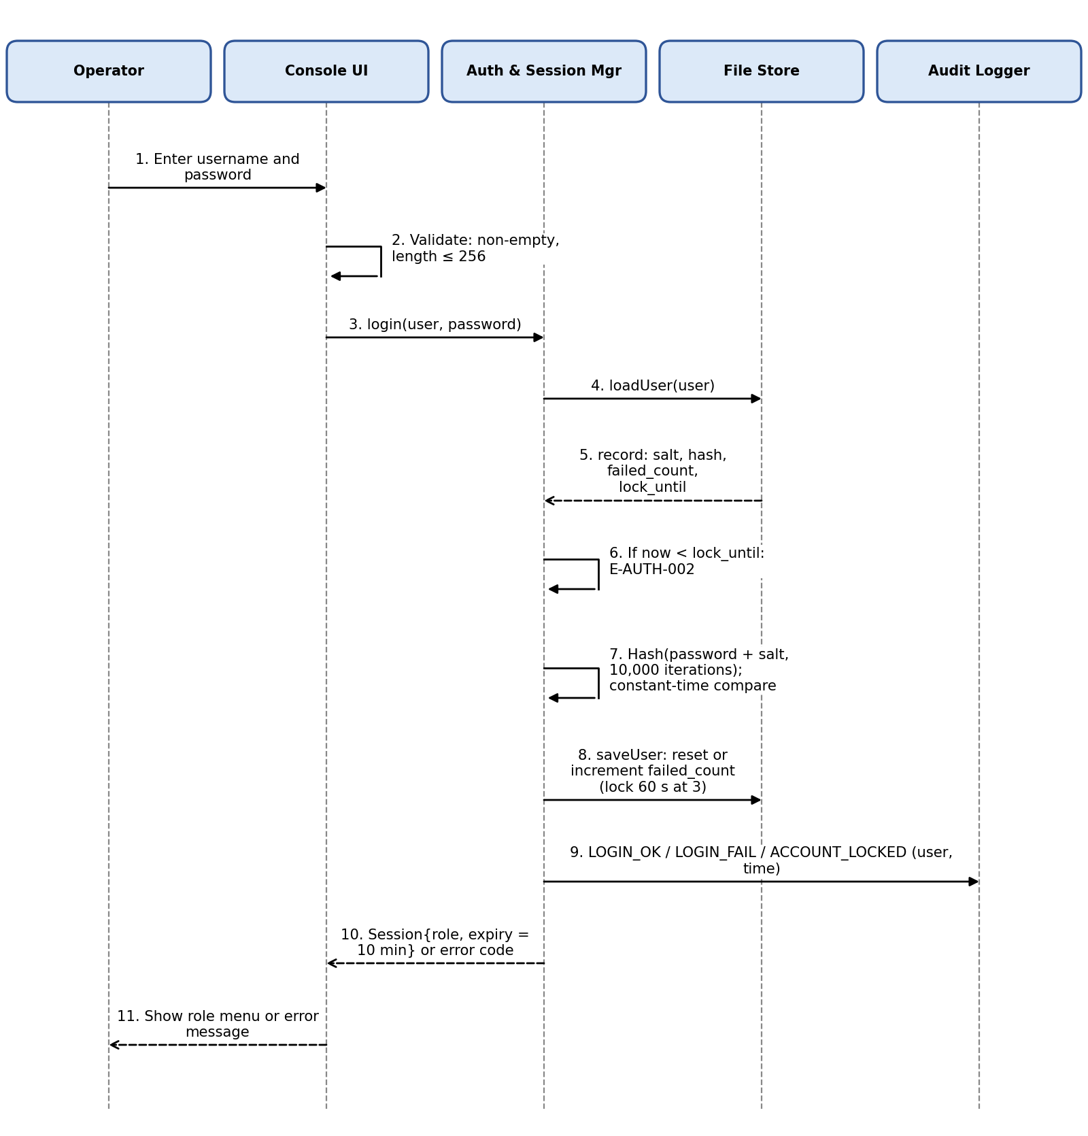
Figure 3 – Sequence diagram: user login
Sequence 2 – Simulation tick with emergency vehicle preemption (FR-01, FR-03, FR-04).
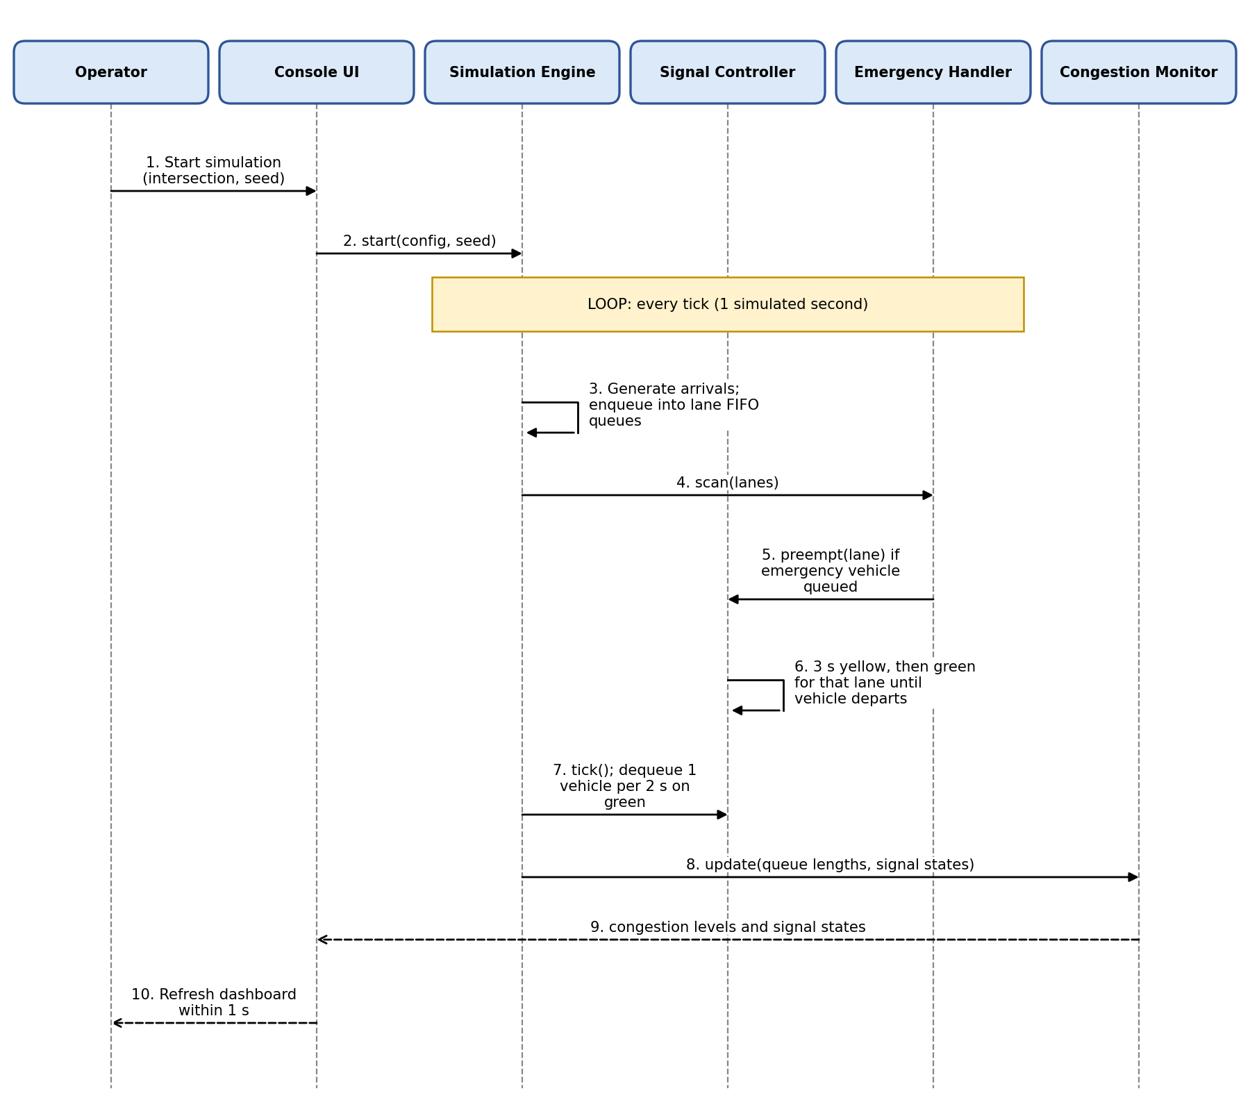
Figure 4 – Sequence diagram: simulation tick and emergency preemption
Sequence 3 – Generate and export a report with safe file handling (FR-06, SEC-07, SEC-08).
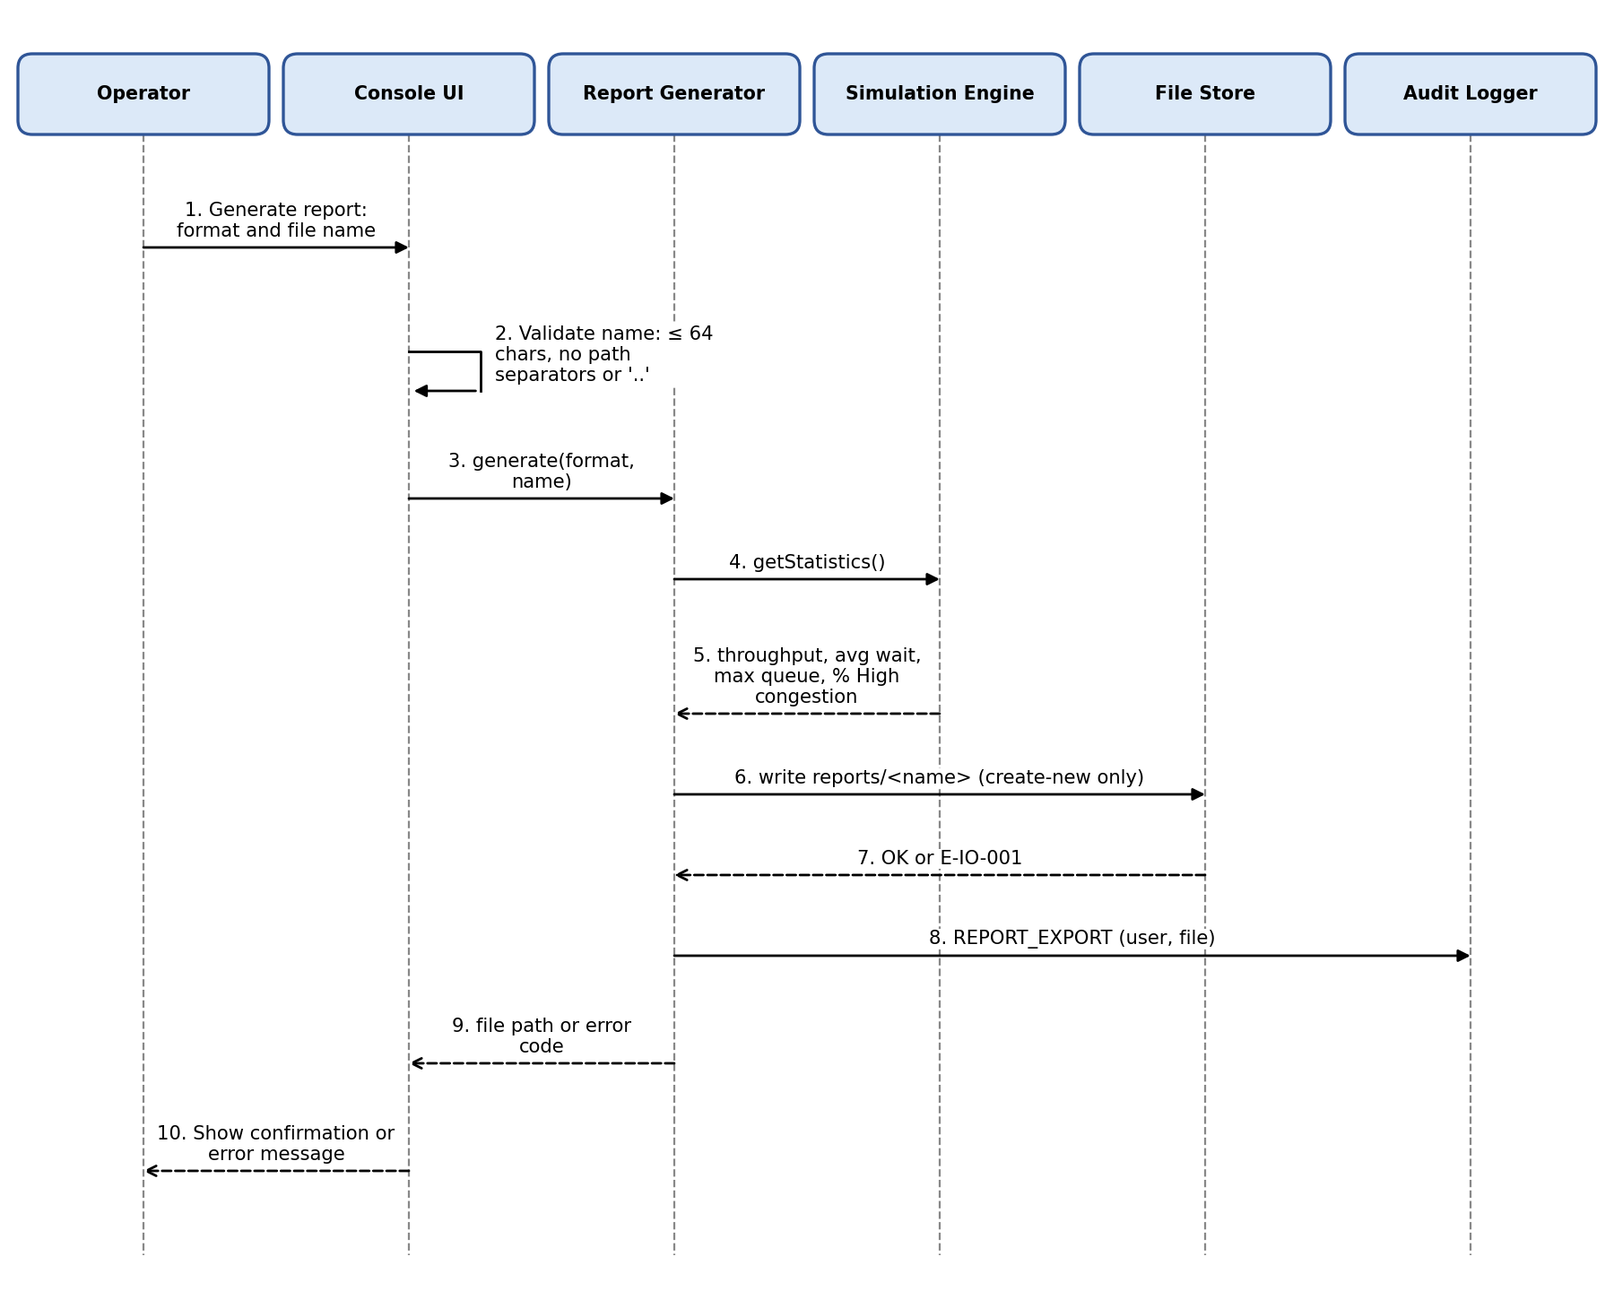
Figure 5 – Sequence diagram: report export

3.2 API Design (module interfaces and console commands)
The system has no network API. Its API is the set of C++ module interfaces below, plus the console command set exposed by the Command Dispatcher. Every operation that can fail returns Result<T> (a value or an ErrorCode) instead of throwing.
Module.method | Inputs → Output | Pre-conditions | Errors
Auth.login(user, pw) | strings → Session | Fields valid (≤ 256) | E-AUTH-001, -002
Auth.hasPermission(session, cmd) | Session, Command → bool | Session not expired | E-AUTH-003
Auth.createUser(session, user, pw, role) | … → void | Admin; username 4–20 unique; password policy | E-AUTH-004, E-VAL-001
Config.set(session, key, value) | … → void | Admin; value in range | E-AUTH-004, E-VAL-001/002
Config.addIntersection(session, def) | IntersectionDef → id | ≤ 10 intersections; lanes 1–8 | E-SIM-002, E-VAL-001
Engine.start(seed) / pause() / stop() | … → void | Session valid; ≥ 1 intersection | E-SIM-001
Signal.setGreen(session, id, seconds) | … → void | Operator/Admin; 5–120 s | E-VAL-001
Emergency.inject(session, lane) | … → void | Simulation running | E-SIM-001
Monitor.snapshot() | → CongestionSnapshot | None (used by Commuter View) | —
Report.generate(session, fmt, name) | … → path | Name ≤ 64, no '/', '\\', '..' | E-IO-001, E-IO-002
Console command set: login, logout, sim start|pause|stop, signal set, adaptive on|off, emergency inject, intersection add|edit|delete, config set, user add|deactivate|delete, report csv|txt, view congestion, help, exit. The Commuter view accepts only: view congestion, view report, help, exit.
Example interface (excerpt):
enum class ErrorCode { Ok, AuthInvalid, AuthLocked, SessionExpired, PermissionDenied,
OutOfRange, NotNumeric, BadLength, ConfigCorrupt,
IoFailure, BadFileName, NotRunning, CapacityExceeded, Internal };
template<class T> struct Result { std::optional<T> value; ErrorCode error{ErrorCode::Ok}; };

class IAuthService {
public:
virtual Result<Session> login(const std::string& user, const std::string& password) = 0;
virtual bool hasPermission(const Session&, Command) const = 0;
virtual Result<void> createUser(const Session&, const NewUser&) = 0;
};

3.3 Data Design (files)
File | Content | Protection
users.dat | username, role, active flag, salt, hash, failedCount, lockUntil | Mode 0600; never logged
config.ini | Seed, thresholds, timeout, speed, intersection definitions | Validated on load
audit.log | timestamp | user | action | result (append-only) | Mode 0600
reports/<name>.csv|txt | Throughput, average wait, max queue, % High congestion, run parameters | Name sanitised, create-new only

3.4 Error Handling
Strategy. (1) Validate at the boundary (Menu & Input Validator, Dispatcher). (2) Expected failures are returned as ErrorCode inside Result<T>; exceptions are reserved for unexpected faults. (3) The Dispatcher maps each ErrorCode to a fixed user message that names the field and allowed range and never reveals paths, hashes or internals. (4) A top-level try/catch in main logs E-SYS-001, closes files (RAII) and returns to the login screen in a safe state. (5) A corrupt config.ini falls back to defaults with a warning and is not overwritten.
Code | Cause | System behaviour
E-AUTH-001 | Wrong username or password | Reject; increment failed count; audit LOGIN_FAIL
E-AUTH-002 | Account locked (3 failures) | Reject for 60 s; audit ACCOUNT_LOCKED
E-AUTH-003 | Session expired (inactivity) | Discard session; return to login
E-AUTH-004 | Role lacks permission | Refuse command; no change; audit
E-VAL-001 | Value out of range (e.g., green 121 s) | Reject; message names field and range 5–120
E-VAL-002 | Not numeric where number required | Reject; ask again
E-VAL-003 | Empty or longer than 256 characters | Reject; input discarded safely
E-CFG-001 | config.ini corrupt or out of range | Use defaults; warn; keep original file
E-IO-001 | File cannot be opened/written | Report failure; no partial file left; audit
E-IO-002 | Unsafe file name (path separator or '..') | Reject; nothing written; audit
E-SIM-001 | Command needs a running simulation | Refuse; state unchanged
E-SIM-002 | Capacity exceeded (> 10 intersections) | Refuse; state unchanged
E-SYS-001 | Unexpected exception | Log, safe state, generic message

3.5 Key Design Decisions
- Single-threaded tick loop – removes data races and makes runs repeatable with a fixed seed (NFR-08); performance target is met by O(lanes) work per tick.
- Central permission check in the Command Dispatcher so no module can be reached without an RBAC decision (SEC-05).
- Emergency Handler as a priority queue ordered by arrival tick, so simultaneous emergencies are served predictably (FR-04).
- std::string and containers instead of raw arrays to eliminate buffer-overflow classes (SEC-06).
- Result<T> for expected errors so the compiler and reviews highlight unhandled failures.

3.6 User Interface Design (overview)
Console screens: (1) Start screen – Login or Commuter view; (2) Main menu by role (max 3 levels); (3) Dashboard – per intersection a table of lanes with queue length, signal state and congestion level, refreshed every tick; (4) Forms for configuration with inline range hints; (5) Report screen. Every screen shows a help line with valid commands (NFR-04).

