The World of Yayoi Kusama

Sinead Rafferty

BIS 471 A

3-4-19

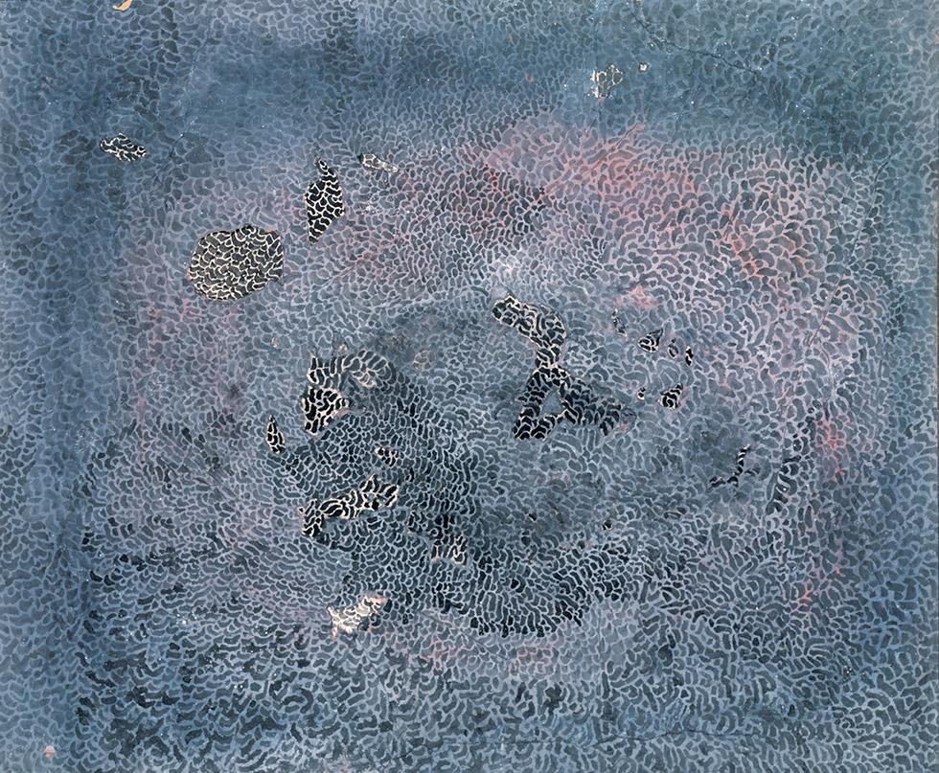

Pacific Ocean

Yayoi Kusama; 1959

Oil on Canvas

Pacific Ocean

Seeking to connect with other modern and contemporary artists after having her art be turned away Japanese traditionalists Yayoi Kusama traveled to the United States to pursue her art career. When first entering the art world Kusama was heavily influenced by the works of Georgia O'keeffe who she wrote to after discovering her art in a magazine in Japan[1]. O'keefe responded to Yayoi’s letter and she soon became a mentor for the upcoming artist which gave her the courage to travel to the United States. After arriving to the United States and facing hardship she managed claim a few solo exhibitions in New York and Kasuma hoped she would be successful considering her visa had expired so gaining notoriety was her only option[2]. One of her first exhibitions titled *Infinity Nets* debuted her work to international viewers and became her official debut which featured herPacific ocean[3].

Kusama took great interest in illusions and dream like illustrations just like O'keefe so when she flew from Japan to the United States over the pacific ocean the waves reminded her of webs later influencing this piece and her *Infinity Nets* exhibition[4]. Using precise patterns and placement the mishshapped dots create a swirling motion traveling inward to imitate the simulation of waves. The piece contains a range of different shades of blue and uses gold to highlight darker colors within the piece. Many critics like Leslie Ahlander were amazed by her placement of detail saying “the artist has moved from pastels which are delicate interpretations of nature to her present group of large abstractions, based entirely on the repetition of a simple, circular brush-stroke”[5]. This piece would be a stepping towards many of her other works which would be influenced by the method of repetition.

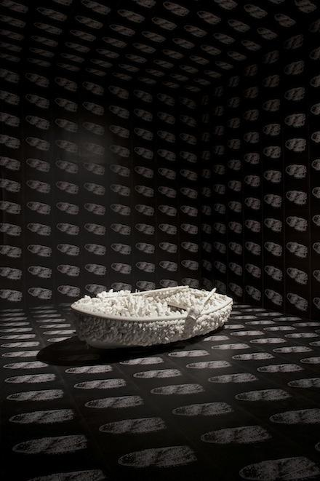

Aggregation: One Thousand Boats Show

Yayoi Kusama; 1963

Stuffed cloth sewn to boat

Aggregation: One Thousand Boats Show

Yayoi expanded her artistic mindset to sculptures when she stated that “the nets I was painting had continued to proliferate until they had spread beyond the canvas to cover the tables, the floor, the chairs and the walls”[6]. She became an environmental sculptor and started pursuing what she called obsessional art. Although Yayoi had experimented using soft sculptures before *Aggregation: One Thousand Boats Show* would become her first installation piece that three dimensionally explored the concept of obsessional art. This focus on obsessional art was a result of her psychological hallucinations from when she was a child being abused by her mother that carried on into her adult years[7]. This would later be an integral influence in many of her other pieces.

The repetition of phallic like objects is placed over a common place object which in Kusama’s piece *Aggregation: One Thousand Boats Show* is a rowboat. Covering the ceiling, walls, and floors of the installation was “ 999 black-and-white poster size photos of it… [and] when stood in this room, the thousand boats would begin to spin around you, leaving you seasick and hallucinating”[8]. Almost like the design of *Pacific Ocean* where the similarly colored dots combine to make a hallucinating web design the repetition of the black and white boat images create the same illusion. The soft phallic culmination of phallus is a space that viewers can interact with so Kasuma wanted the experience the be as immersive and disorienting as possible. The presence of phallic objects covering the boat consumes the object and anyone who interacts with it which was Kasuama’s approach to commenting male power and oppression but desiring to control it[9]. As the host desires to control male oppression it can lead to what kasuma refers to as ‘self obliteration’. This was defined as expressing “an unbridled impulse to impose her will on her environment”[10].

Infinity Room - Phalli's Field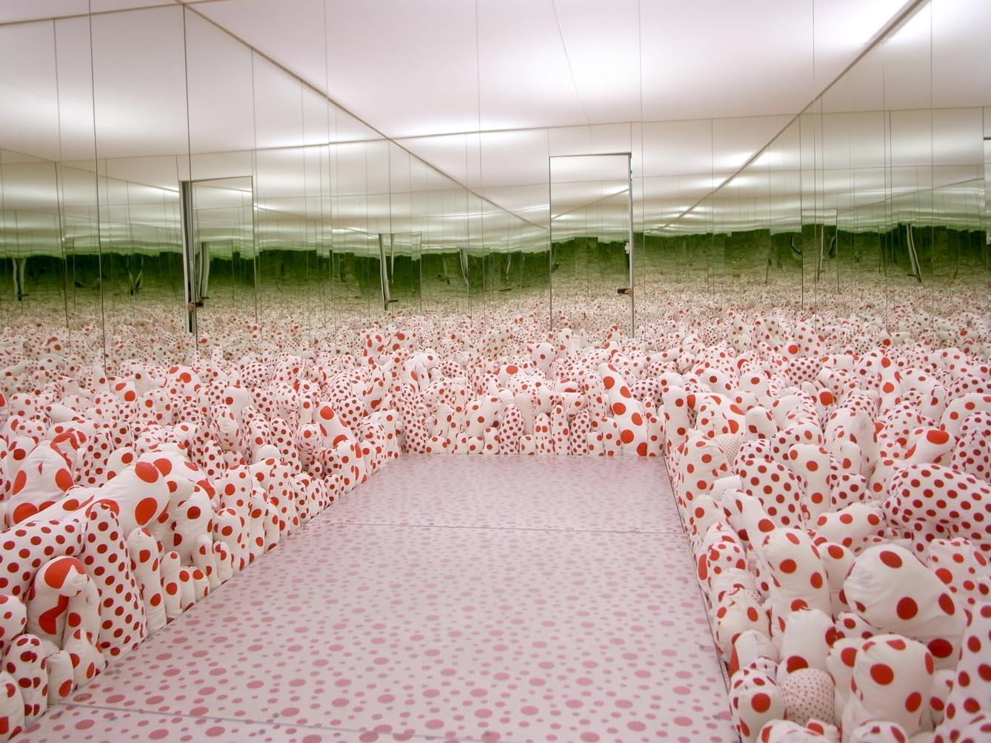

Yayoi Kusama; 1965

Mirror, iron, wood, plaster, styrofoam, acrylic paint, and cloth

Infinity Room - Phalli's Field

Seeking to explore the use of three dimensional space and the subconscious mind Kasuma started developing many more installations based off her success with her first installation *Aggregation: One Thousand Boats Show* delving deeper into the concept of ‘self obliteration’. In this piece she had just started to analyze the concepts of her fears towards sex but when making *Infinity Room - Phalli's Field* Kasuma directly analyzed the meaning behind creating phallic shaped objects despite her fears towards them[11]. As she began to create more phallic object installations her artwork became more self reflective and hallucinogenic. Her fear of sex and phallic objects is directly the cause of the society she had grown up in as a child, traditionalist Japan, where she taught to be ashamed of sex yet her mother would send her as a spy to see if her father was cheating[12]. These childhood experiences would directly influence many of Kusama's future pieces.

The installation *Infinity Room - Phalli's Field* uses mirrors to distort the viewer's perception and make them feel like they are in a secluded world. When looking closely at the phallic shapes it’s apparent that the red polka dots are either large and spacious or small and close together. Not to mention their sizes vary in shape creating a “ ‘phallic field” figured as a tumbling riot of tumescent forms, ranging from the short and dumpy to the long and spindly”[13]. Using a varying array of shaped objects it makes it easier for the viewer to become enveloped in their environment and slowly getting dissolved with the addition of the mirrors. Although playful looking the installation reflects Kusama's experience with her own delusions being used as self therapy. The placement of dots and sized phallic objects is intentional in order to create these effects gaining her much notoriety in the avante garde world.



Anti-War Naked Happening

Yayoi Kusama; 1968

Black and white photo

Anti-War Naked Happening

Slowly rising to the top of the avant garde world Kasuma decided to take her art into the streets during the peak of America’s political stress involving their involvement in the Vietnam war. Kasuma held many public stages that involved artistic performances using the naked body which provoked outcry against her studio where she faced threatening phone calls by people around the country. Her idea for the public display of nudity as art for protest came from her childhood experiences where “ at night[she] would assemble [her] aunts and cousins in one corner of the parlour and dance naked before them” while singing lyrics she had written (infinity net). She did this despite the abuse she received from her mother when she found about the events almost beating her unconcious[14]. Kasuma used these experiences to perfect her performance directing technique in New York.

Kasuma had many of her friends join her in her public displays of nudity with many of them being hippies or part of the gay community. All of the participants are holding up a sign saying ‘Kusama - Self Obliteration’ as Kusama paints dots their naked bodies on a heavy foot traffic New York City bridge. She uses their bodies as a canvas for her work as if a moving installation where the “textures composed by these dots, stretching and crossing, represent the flow of life”[15]. This gives even more meaning considering these are the lives of these outcasted members of society who are not recognized by the society. In comparison to Kusama's previous piece *Infinity Room - Phalli's Field* where she uses mirrors to create an immense amount of polka dots here she uses polka dots in motion to create hallucinations and distort reality. This compiled with the slow progression of painting the polka dots creates a much slower progression of hallucination unlike *Infinity Room - Phalli's Field* where the viewer is immediately met with thousands of polka dots.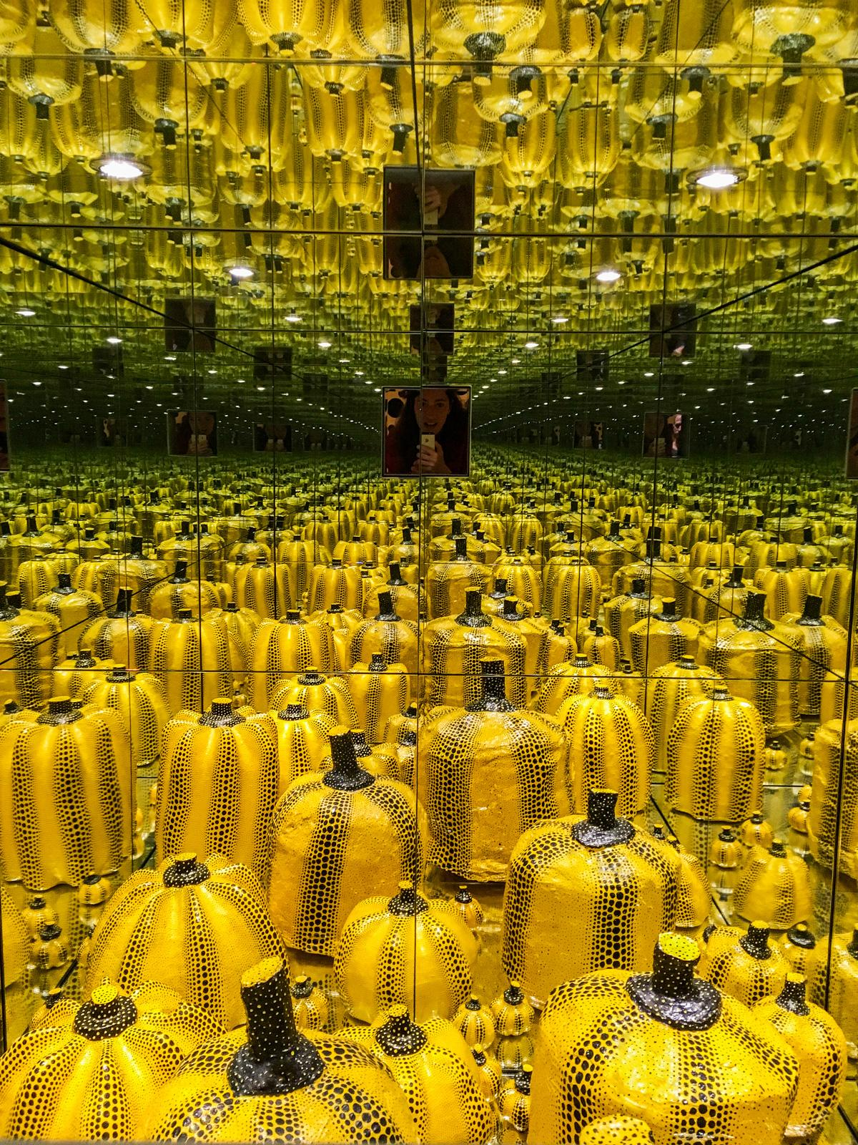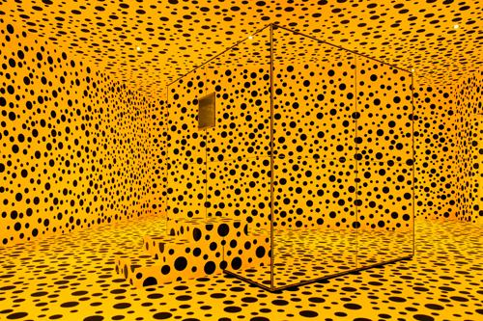

Mirror Room (Pumpkin)

Yayoi Kusama; 1991

Mirror, iron, wood, plaster, styrofoam, and acrylic paint

Mirror Room (Pumpkin)

Seen in Kusama's previous pieces she was always influenced by her hallucinations and distortions of reality that started occurring when she was just a child and carried into her adulthood. However, in 1973 when she decided to temporarily visit Japan her hallucinations became even more extreme which lead her to self admit herself to a mental health hospital located in the city of Shinjuku in 1977 after seeing a therapist[16]. During this time the avant garde art world in the United States forgot about her for sometime. This was until the late 1980’s where she started writing her own novels and showing her work in exhibits again in the United States all while remaining at the mental hospital (infinity net). As she started to rise back into noderity *Mirror Room (Pumpkin)* was one of her many pieces that helped her do just that.

Taking influence from Kusama’s previous piece *Infinity Room - Phalli's Field* there is a mirror reflecting the designs of Kusma but instead the mirror room is showcased within another room filled with black spots on a yellow background. The mirrored box also does not have a door but rather a small hole the viewer can view into. Although Kusama finally had a diagnosis on her mental state, being diagnosed with “‘atypical psychosis’, which resulted in schizophrenia and irritability” that didn’t change her style or her motivations to create[17]. She still created her art for the sake of her self healing but in *Mirror Room (Pumpkin)* she forces more interaction from the viewer by making them looking through a single hole one at a time if they want to see the entirety of the installation. This makes the viewer feel even more lost among the sculptures of pumpkins that have much more intricate designs in comparison to the Phallic objects seen in her previous pieces. However, the pumpkins stand as a symbol for phallic objects as well for the stem is almost phallic.

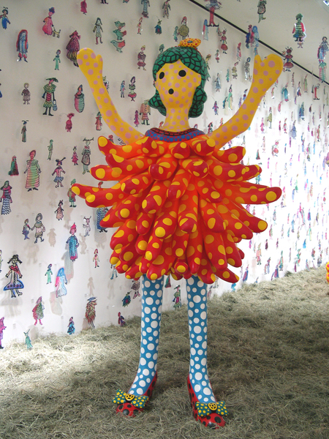

Hi, Konichiwa (Hello!) Yayoi-chan

Yayoi Kusama; 2004

Mixed media

Hi, Konichiwa (Hello!) Yayoi-chan

Kusama was known for her alternative fashion sense as far back as when she started experimenting with the three dimensional realm with sculpture and polka dots. In one of her photo’s of a live performance demonstration *Anti-War Naked Happening* she is wearing very non-confirmative western clothing with polka dot tights and a Japanese inspired designed kimono. Because of this Kusama was very interesting in fashion and design so in her ‘Hi Konichiwa exhibition she “invited fashion-design students to create costumes based on the figures for a fashion show” while still remaining in a mental hospital[18]. Kusama wanted to create a piece that was peak of cuteness of innocence and cuteness in contrast to her painful childhood so having designers with those experiences created a convincing portrayal of what society defines as cute.

Even Though the figures had the features of cute dolls with their bright colors and round edges Kusama saw that “cuteness is not a stable entity in the hands of these women, there is always an underlying of darkness and destruction”[19]. Although not directly apparent the dolls show the same theme of obliteration seen in *Mirror Room (Pumpkin)* where the polka dots obliterate everything but in this case the doll is being obliterated. They’re not just “trapped in decay, they are its very essence”[20]. Not to mention, yayoi nicknames this doll after herself which could be because this doll has the most shocked or scared pose out of the rest of the dolls featured in the exhibit. The dolls on the two dimensional wall seem more crudely drawn but as a result they look more content than the three dimensional doll. The contrast against the hay on the floor is also intentional considering dolls are seen as pristine and perfect but it may be that Kusama wants to make the dolls look out of their environment.

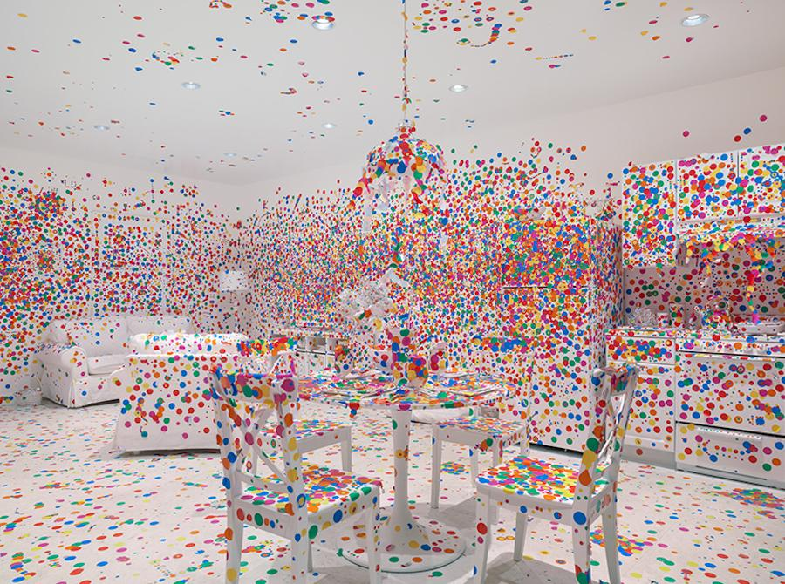

Obliteration Room

Yayoi Kusama; 2018

Canvas paint, furniture, and multi color stickers

Obliteration room

Even Though Kusama has remained committed to a mental hospital since 1975 she has remained committed to developing new artworks and installations. As of recent years she has been seen as the most influential Japanese female artist of this century. She has become known worldwide for her obliteration art but she still incorporates experiments with new forms of interactivity. The *Obliteration Room* was on display for approximately five weeks like most of her art work but this installation had a great emphasis on the distortion of time and space. Viewers were given a sticker upon entering the one level house that was fully furnished but painted completely white[21]. They were allowed to stick the sticker wherever they pleased in the exhibit meaning stickers could overlap and be placed on any surface. This interactive component mixed with the distortion of minimalism created a ever changing piece of art. During this time Kusama is still living in the mental institution she admitted herself to in 1975 so maybe the white walls are related to the bleakness that is the institution she lives in.

Just like in Kusama’s *Anti-War Naked Happening* the polka dots are steadily applied over time and viewers may only see certain phases of the piece depending on how long they choose to stay and view it. However, instead of having polka dots move and stretch on the naked human form the polka dots are placed on objects that can be moved by the viewers as they please. This time the viewers become the participants while “entire rooms and their furnishings, various mannequins and live occupants, including the artist herself, became engulfed in a dazzling array of colored dots”[22]. The viewers are now taking part in the obliteration of the space that was once present and their own bodies inside the space. Each polka dot has an intentional purpose for being placed and has sentimental meaning behind it.

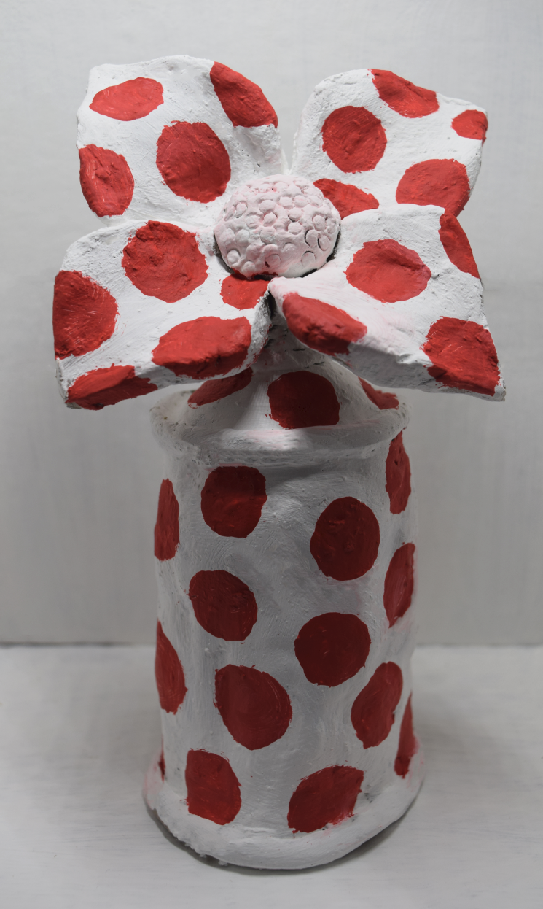

Spotted Creation

Sinead Rafferty; 2018

Acrylic paint on air dry clay

Spotted Creation

Originally planning on doing a digital painting I decided to use some left over clay I had from a previous class to make a miniature installation because I was inspired by Kusama’s creativity in her multiple installations from her early pieces. I molded a spray paint can figure out of clay and molded a flower coming out of the top of the spray paint can. These specific items were chosen because they hold significance in m life and I use them as everyday items. The spray paint can resembles my love of art and how I’ve recently been creating spray paint art with stencils. On the other hand, the flower is a representation of my love for gardening and creating. I thought it would be natural to combine these two items since they both follow the theme of creation and growth for me.

I was inspired by Kusama’s *Obliteration Room* because it had an assortment of items familiar to every person whether it be a chair or a television. Then these items were obliterated by polka dots making the items indistinguishable as more polka dots were added. I wanted to create an object that was a combination of two items I see and use often and then obliterate them with the placement of solid red polka dots. The white of the sculpture almost blends with the background but the spots make the outline of the sculpture more indistinguishable. These red polka dots were all about the same size and placed evenly apart from one another. The background was also left white to allow for all attention to be solely on the red polka dots that are overtaking the object. The red polka dots bring a pattern of unity but ultimately obliterate the meaning and definition of the object it is on. Polka dots redefine the object and give it a new contextual purpose whether it arise a feeling of fear, happiness, or distraught for the viewer.

Bibliography:

* Applin, Jo. *Yayoi Kusama: Infinity Mirror Room - Phalli's Field*. Afterall, 2012.
* Guo, Q. (2019). Mirror Room (Pumpkin)—Yayoi Kusama’s Psychological Space. Art and Design Review, 7, 22-28. https://doi.org/10.4236/adr.2019.71003
* Kusama, Yayoi, and Lynn Zelevansky. *Love Forever: Yayoi Kusama, 1958-1968*. Los Angeles County Museum of Art, 1999.
* Kusama, Yayoi. *Yayoi Kusama: Give Me Love*. David Zwirner Books, 2016.
* “The Self and the World: Negotiating the Art of Yayoi Kusama, Ana Mendieta, and Francesca Woodman.” *Mirror Images: Women, Surrealism and Self-Representation*, by Dawn Ades and Whitney Chadwick, MIT, 1998, pp. 159–163.
* Kusama, Yayoi, and Ralph F. McCarthy. *Infinity Net: the Autobiography of Yayoi Kusama*. The University of Chicago Press, 2011.
* “Yayoi Kusama .” *Drop Dead Cute the New Generation of Women Artists in Japan*, by Ivan Vartanian, Chronicle Books, 2005, pp. 130–143.

<https://eastofborneo.org/wp-content/uploads/2017/11/momacatalogue216300025595.pdf>

<https://ebookcentral-proquest-com.offcampus.lib.washington.edu/lib/washington/reader.action?docID=3339526> room

( infinity room <https://hirshhorn.si.edu/kusama/infinity-rooms/> )

Another online reading:

<https://www-jstor-org.offcampus.lib.washington.edu/stable/40425916?seq=7#metadata_info_tab_contents>

Info about mental illness (<https://psychnews.psychiatryonline.org/doi/full/10.1176/appi.pn.2017.9a21>)

Pummmppkinnss:

<https://file.scirp.org/pdf/ADR_2018122814154998.pdf>

1. Kusama, Yayoi, and Ralph F. McCarthy. *Infinity Net: the Autobiography of Yayoi Kusama*. The University of Chicago Press, 2011.
2. Kusama, Yayoi, and Ralph F. McCarthy. *Infinity Net: the Autobiography of Yayoi Kusama*. The University of Chicago Press, 2011.
3. Kusama, Yayoi, and Ralph F. McCarthy. *Infinity Net: the Autobiography of Yayoi Kusama*. The University of Chicago Press, 2011.
4. Kusama, Yayoi, and Ralph F. McCarthy. *Infinity Net: the Autobiography of Yayoi Kusama*. The University of Chicago Press, 2011.
5. Kusama, Yayoi, and Ralph F. McCarthy. *Infinity Net: the Autobiography of Yayoi Kusama*. The University of Chicago Press, 2011.
6. Kusama, Yayoi, and Ralph F. McCarthy. *Infinity Net: the Autobiography of Yayoi Kusama*. The University of Chicago Press, 2011.
7. “The Self and the World: Negotiating the Art of Yayoi Kusama, Ana Mendieta, and Francesca Woodman.” *Mirror Images: Women, Surrealism and Self-Representation*, by Dawn Ades and Whitney Chadwick, MIT, 1998, pp. 159–163.
8. Kusama, Yayoi, and Ralph F. McCarthy. *Infinity Net: the Autobiography of Yayoi Kusama*. The University of Chicago Press, 2011.
9. “The Self and the World: Negotiating the Art of Yayoi Kusama, Ana Mendieta, and Francesca Woodman.” *Mirror Images: Women, Surrealism and Self-Representation*, by Dawn Ades and Whitney Chadwick, MIT, 1998, pp. 159–163.
10. “The Self and the World: Negotiating the Art of Yayoi Kusama, Ana Mendieta, and Francesca Woodman.” *Mirror Images: Women, Surrealism and Self-Representation*, by Dawn Ades and Whitney Chadwick, MIT, 1998, pp. 159–163.
11. Kusama, Yayoi, and Ralph F. McCarthy. *Infinity Net: the Autobiography of Yayoi Kusama*. The University of Chicago Press, 2011.
12. Kusama, Yayoi, and Ralph F. McCarthy. *Infinity Net: the Autobiography of Yayoi Kusama*. The University of Chicago Press, 2011.
13. Applin, Jo. *Yayoi Kusama: Infinity Mirror Room - Phalli's Field*. Afterall, 2012.
14. Kusama, Yayoi, and Ralph F. McCarthy. *Infinity Net: the Autobiography of Yayoi Kusama*. The University of Chicago Press, 2011.
15. Guo, Q. (2019). Mirror Room (Pumpkin)—Yayoi Kusama’s Psychological Space. Art and Design Review, 7, 22-28. https://doi.org/10.4236/adr.2019.71003
16. Kusama, Yayoi, and Ralph F. McCarthy. *Infinity Net: the Autobiography of Yayoi Kusama*. The University of Chicago Press, 2011.
17. Guo, Q. (2019). Mirror Room (Pumpkin)—Yayoi Kusama’s Psychological Space. Art and Design Review, 7, 22-28. https://doi.org/10.4236/adr.2019.71003
18. “Yayoi Kusama .” *Drop Dead Cute the New Generation of Women Artists in Japan*, by Ivan Vartanian, Chronicle Books, 2005, pp. 130–143.
19. “Yayoi Kusama .” *Drop Dead Cute the New Generation of Women Artists in Japan*, by Ivan Vartanian, Chronicle Books, 2005, pp. 130–143.
20. Guo, Q. (2019). Mirror Room (Pumpkin)—Yayoi Kusama’s Psychological Space. Art and Design Review, 7, 22-28. https://doi.org/10.4236/adr.2019.71003
21. Kusama, Yayoi. *Yayoi Kusama: Give Me Love*. David Zwirner Books, 2016.
22. “The Self and the World: Negotiating the Art of Yayoi Kusama, Ana Mendieta, and Francesca Woodman.” *Mirror Images: Women, Surrealism and Self-Representation*, by Dawn Ades and Whitney Chadwick, MIT, 1998, pp. 159–163.