



**Module Code & Title**

CS6P05 Final Year Project MAD

**FitGuide Pro** –Mobile App

**Assessment Weightage & Type**

60% Final Coursework

**Module Leader By**

Mr. Subin Chitrakar

**Student Details**

Name: Sita Ram Thing

London Met Id: 22015892

College Id: NP01MA4S220003

Islington College, Kathmandu

17 Jan 2024

**Figma:** https://www.figma.com/file/PjjW3Pp8AsMEoduqnlcQnQ/Interaction-Design?type=design&node-id=0%3A1&mode=design&t=8NcKNZYPM5QQbJ2w-1

**FigJam:** https://www.figma.com/file/VqDnF8hpYm37PbQqmMXF2E/Empathy-Map?type=whiteboard&node-id=0%3A1&t=peXHtqLUmH6cGEQU-1

1. **Introduction**

HFE stands at the forefront of fitness education, recognized as a leading provider of Fitness Courses, Training, and Qualifications in the United Kingdom. Our commitment to excellence is evident in the comprehensive programs we offer, covering various disciplines such as personal training, group exercise instruction, yoga, Pilates, nutrition, and more. With a rich history of delivering high-quality education, HFE has become synonymous with excellence in the dynamic field of fitness. Operating in the UK, HFE is dedicated to shaping the future of fitness professionals and enthusiasts alike. Our industry-recognized qualifications are a testament to the standards we uphold, ensuring that individuals are well-equipped for success in the ever-evolving fitness industry.

HFE takes pride in offering a comprehensive range of fitness courses, training programs, and industry-recognized qualifications. Whether you aspire to become a certified fitness instructor or personal trainer or wish to specialize in areas like yoga or nutrition, HFE provides the knowledge, skills, and accreditation necessary for success in the dynamic fitness industry. HFE is a genuine and reputable company operating in the United Kingdom. Our track record speaks for itself, as we consistently deliver high-quality fitness education and training to individuals across the country. With a steadfast commitment to excellence, HFE is recognized as a trustworthy resource for those seeking professional qualifications in the fitness sector.

In the age of digital convenience, HFE has taken the initiative to enhance your learning experience through a user-friendly mobile application. This app serves as an invaluable companion, providing on-the-go access to course materials, study resources, and interactive tools. From engaging video tutorials and insightful quizzes to progress tracking and seamless communication with tutors, our app is designed to enrich and streamline your fitness education journey with HFE.

1. **Empathies**
   1. **Identify Users**

Empathizing with users is crucial for the success of a fitness app. Understanding the diverse needs and preferences of users allows the app to provide a more personalized and engaging experience. Here are some key user segments to consider:

* + 1. Fitness Beginners

Users who are new to fitness and need guidance on getting started. Tailor content to include beginner-friendly workouts and educational resources to build foundational knowledge.

* + 1. Advanced Enthusiasts

Users with a higher fitness level seek challenging workouts and advanced training programs. Provide advanced exercises, specialized training routines, and opportunities to set and achieve ambitious fitness goals.

* + 1. Time-Conscious Individuals

Users with busy schedules looking for quick and effective workout routines.

Offer short and focused workout sessions that can easily fit into their daily routines.

* + 1. Health-Conscious Users

Users with specific health goals, such as weight management or stress reduction. Incorporate nutrition tracking, mindfulness exercises, and content focused on holistic well-being.

* + 1. Community Seekers

Users who thrive on social interaction and group activities. Integrate social features, challenges, and forums to foster a sense of community and support.

* + 1. Tech-Savvy Users

Users who appreciate cutting-edge technology and integration with wearables. Ensure compatibility with fitness trackers, smartwatches, and other tech gadgets to enhance their experience.

* + 1. Goal-Oriented Users

Users with specific fitness goals, such as weight loss, muscle gain, or flexibility improvement. Offer personalized workout plans and progress-tracking features to help them stay focused on their objectives.

By identifying and empathizing with these user segments, a fitness app can tailor its features and content to better meet the diverse needs and preferences of its audience, ultimately enhancing user satisfaction and engagement.

* 1. **Interview/Survey**
     1. Interview No 1 (Sangam Shrestha)

The Sangam is a person who works in the TI company as a QA.

1. What's a typical day like at your home? Are there physical activities involved?

* A typical day at home involves regular chores like cooking and cleaning. Sometimes I do some light exercises or go for a walk in the evening.

1. Have you tried making your daily tasks simpler or more efficient?

* Yes, I try to find easier ways to finish my tasks faster, like organizing my schedule or using helpful social media.

1. How do you usually spend your free time or holidays?

* During my free time or holidays, I enjoy relaxing with family, watching movies, playing badminton, or reading books.

1. What are the major challenges in your job, and how do you manage your time to handle them?

* In my job, meeting deadlines and many times some things testing can be challenging. I manage time by prioritising tasks and staying organised.

1. Do you do anything specific to stay healthy during busy periods? How do you relax and clear your mind?

* I try to eat well and take short breaks to stretch or meditate during busy periods. Relaxing music helps me unwind.

1. What do you think about your health? Do you have any concerns, and why?

* I think I'm healthy, but I sometimes worry about maintaining a balanced lifestyle.

1. How do you feel about new technologies or innovations for health?

* New technologies and innovations are exciting, especially if they simplify daily life or enhance productivity but have no ideas for any health-related information.

1. What do you look for in physical activities that you find helpful or enjoyable?

* I prefer physical activities that are fun yet beneficial, like cycling or playing sports.

1. Can you remember a recent time when it was hard to maintain a healthy lifestyle?

* There was a time when work demanded a lot, making it tough to stick to a healthy routine.

1. Do you have any wish existed to make health-related tasks easier for you?

* It would be great to have an app that suggests quick and healthy meal options based on a busy schedule.

1. What do you want to need for physical feeds on your health?

* For my physical health, I need nutritious meals and some form of exercise regularly to stay active and fit.
  + 1. Interview No 2 (Pradesh Sapkota)

The Pradesh Sapkota is a person who works in Food delivery.

1. How do you manage the work and exercise during your free day, and how many times walking or run for at least minutes per day?

* On Saturday I have full free time but on other days morning time I physically exercise then in the evening time join the gym training center for 2 hours where walking and running for around 45 minutes per day.

1. How many hours of sleep are you getting on average each night?

* I sleep around 7 hours from 11 PM to 6 AM.

1. Do you consume a balanced diet with a variety of fruits, vegetables, lean proteins, and whole grains?

* Yes, I maintain a balanced diet by including a variety of fresh fruits and different food items daily.

1. Are you staying every day feeling physically healthy by doing enough of your work throughout the day?

* No, I often feel fatigued from my work and recognize the importance of incorporating rest and better time management into my daily routine to maintain physical well-being.

1. Do you take breaks from sedentary activities, such as working at a desk or watching TV, managing stress through techniques like mindfulness, meditation, or relaxation exercises, and performing flexibility exercises, such as stretching or yoga or anything more?

* Yes, I do take breaks from sedentary activities and incorporate stress management techniques and flexibility exercises. However, I lack sufficient knowledge about how to maintain physical fitness.

1. Would you consider joining a training or fitness-related knowledge application to enhance your physical fitness, based on your current priorities and time management for exercise in your daily or weekly schedule?

* Yes, considering my current priorities and time constraints, joining a training or fitness-related knowledge seems like a practical choice to enhance my physical fitness.

1. What do you need for your physical fitness to maintain a healthy life?

* I need effective food-eating management, entertainment, and adherence to fitness guidelines, Yoga, or other physical activity.

**2.3. Empathy Map**

**2.4. User Persona**

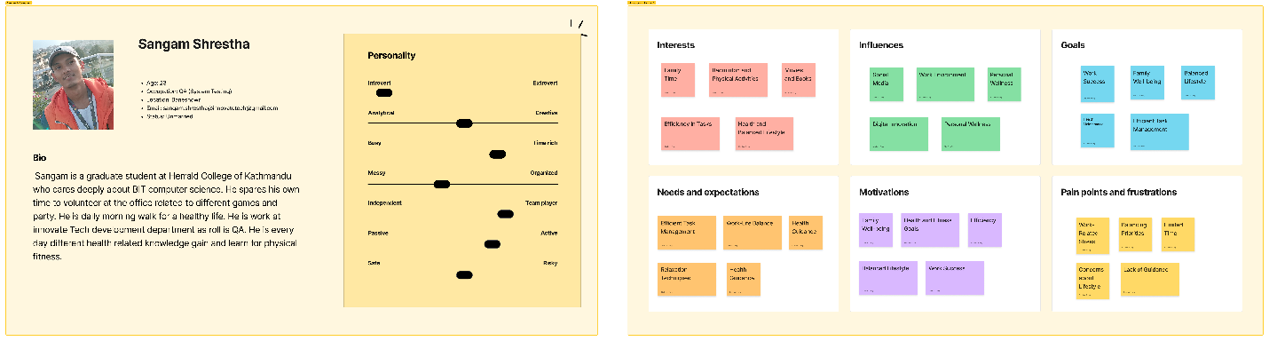

Figure : User persona Sangam Shrestha

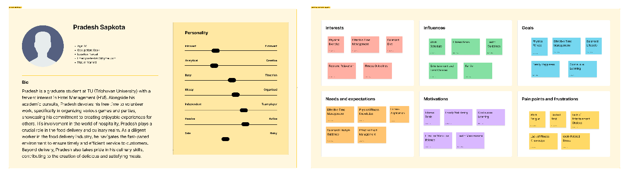

Figure : User persona Pradesh Sapkota

**2.5. User Journey Map**

**2.6. Problem Identification**

1. **Define**  
   - Define problem statement  
   - Define problem needs  
   - Define scope of Project  
    Functional Specification  
    Content Specification  
   - User Goals and Objectives

**3.1. User Goals and Objectives**

The main aim is to empower users with a holistic approach to health by providing personalized fitness plans, balanced nutrition guidance, diverse workout videos, and mindfulness activities for improved physical and mental well-being.

The objective of the FitGuide Por application features is given below:

* Users should be able to set and track personalized fitness goals, such as weight loss, muscle gain, or cardiovascular improvement.
* Provide a variety of workout routines that cater to different fitness levels and can be performed at home or in a gym, ensuring flexibility and convenience.
* Allow users to input their fitness levels, preferences, and any health restrictions to generate customized workout plans that align with their goals.
* Implement features for users to log their daily activities, track workout performance, monitor nutrition, and visualize progress over time through charts and graphs.
* Integrate motivational features, such as achievement badges, personalized challenges, and reminders to keep users engaged and committed to their fitness routines.
* Enable seamless integration with popular fitness trackers and wearables to automatically sync data, such as steps taken, heart rate, and sleep patterns, for a more comprehensive view of users' overall health.
* Offer informative articles, videos, and tutorials on fitness, nutrition, and general well-being to empower users with knowledge that can enhance their understanding of healthy living.
* Design for an easy-to-navigate user interface that accommodates users of all technological proficiency levels, making the app accessible and enjoyable for a broad audience.
* Continuously improve the by providing regular updates, incorporating user feedback, and introducing new features to keep the platform dynamic and in line with evolving fitness trends and technologies.

**5. Ideate**  
**5.1. Competition Review**

One similar app in the fitness landscape is "FitWell Plus", “Fresh Tri”. FitWell Plus to provide a comprehensive solution for users seeking physical fitness and mental well-being. The app offers a variety of workout routines, nutrition tracking, and mindfulness exercises. Users can customize their fitness plans based on personal preferences and health goals, and the app provides real-time progress tracking to keep users motivated.

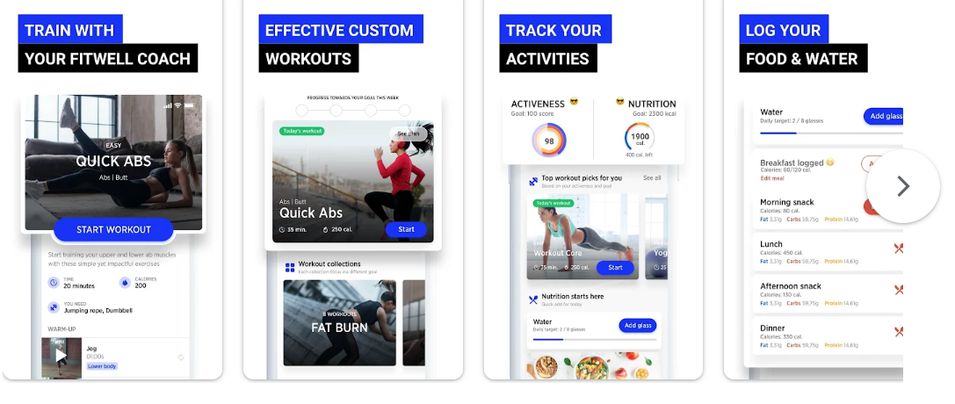

Figure 3: FitWell Plus

FitGuide Pro and FitWell Plus share similarities in their offerings, FitGuide Pro distinguishes itself in a few key aspects. FitGuide Pro places a strong emphasis on a user-centric design process, incorporating in-depth research, including user interviews, empathy mapping, and persona development. This ensures that the app is finely tuned to meet the specific needs and preferences of its users. FitGuide Pro stands out with its integration of real-time collaboration features through FigJam. This facilitates effective teamwork and seamless brainstorming sessions during the design phase, contributing to a more dynamic and engaging user experience. Furthermore, FitGuide Pro sets itself apart by providing a more extensive educational component. In addition to guiding users through workouts, the app offers a wealth of fitness knowledge, nutritional guidance, and mental well-being practices. This educational focus distinguishes FitGuide Pro as a holistic resource for users looking to not only improve their physical fitness but also enhance their overall health and well-being.

5.2. Storyboard (User flow) (how to play your ap in user image design)

**6. Prototype**  
6.1. Wireframe  
6.2. Low fidelity

6.3. High-fidelity

**7. Test**  
 Review prototypes with the User

**8. Conclusion**

The "FitGuide Pro" fitness app, meticulously designed on Figma and FigJam, embodies a comprehensive and user-centric solution dedicated to promoting holistic well-being. Commencing with extensive research into physical fitness, involving user interviews, empathy mapping, and user persona development, the project prioritized understanding user needs and preferences. The subsequent design process systematically advanced through wireframing, low-fidelity prototypes, and high-fidelity prototypes, with each stage thoroughly tested and refined based on valuable user feedback. Real-time collaboration features in FigJam facilitated effective teamwork and seamless brainstorming sessions during the design phase.

Beyond offering a visually appealing and user-friendly interface, the fitness application integrates a wealth of content covering fitness knowledge, physical exercises, mental well-being practices, and educational resources. Guided by a user journey map, it ensures a cohesive and intuitive user experience from the initial research phase to the final prototype testing. Embodying a user-centric design philosophy, the app prioritizes user needs and preferences, guiding users not only through their physical fitness journey but also nurturing their mental well-being. This commitment promotes a holistic and sustainable approach to a healthier lifestyle, providing users with an accessible and informative gateway to the world of fitness.

The app's development began with a deep dive into research, user interviews, empathy mapping, and user persona development to understand and prioritize user needs. The user-centric design process then unfolded through wireframing, low-fidelity and high-fidelity prototypes, allowing for rigorous testing and refinement. With an intuitive interface, the application delivers valuable content encompassing fitness knowledge, physical exercises, mental well-being practices, and educational resources. Supported by a user journey map, the app ensures a cohesive and enjoyable experience, fostering a holistic approach to health and encouraging sustainable lifestyle changes. The FitGuide Pro fitness app gives a successful fusion of thoughtful design, user engagement, and a commitment to enhancing users' overall well-being.

**9. References and Bibliography**

**Introduction**  
- Introduction about your company  
- What do they do  
- Is it real or not  
- What does your app do.

**Empathise**  
- Identify Users  
- Interview/Survey  
- Empathy Map  
- User Persona  
- User Journey Map  
- Problem Identification

**Define**  
- Define problem statement  
- Define problem needs  
- Define scope of Project  
- Functional Specification  
- Content Specification  
- User Goals and Objectives

**Ideate**  
- Competition Review  
- Storyboard (User flow)

**Prototype**  
- Wireframe  
- Low-fidelity  
- High-fidelity

**Test**  
- Review prototypes with User

**Conclusion**

**References and Biblography**