3 main components in Redux :

1. Store
2. Reducer
3. Action

* Action triggers change in store and has to return :Payload with [Type, description]
* Store handle all data in one Object
* Reducer that handles changes on store and return new store
* To avoid redendence in action name we make actionTypes file and put in it all action type in string format

1. USE @REDUXTOOLKIT :

When use redux toolkit we import createAction and createReducer

And about store we import configureStoreZ

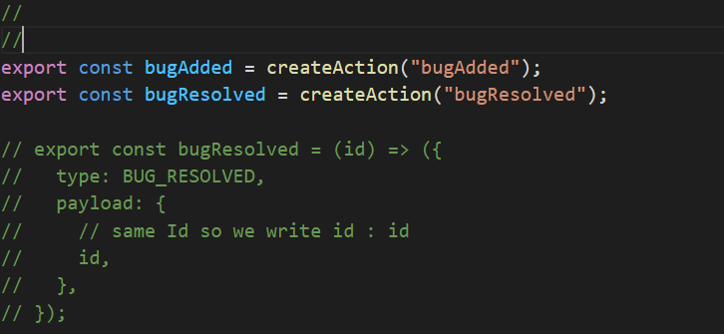

And about reducer:

