Data Analytics Project Report

Contents

1 Introduction
2 Data Preparation
3 Exploratory Data Analysis
4 Statistical Analysis
5 Predictive Modeling
6 clustering
7 Recommendations
8 Limitations and Future Work
9 Conclusion
Appendix: Code and Additional output

1-Introduction

In today's competitive retail landscape, data-driven decision-making has become a critical factor in achieving sustainable business growth. Organizations that leverage transactional data to understand customer behavior, product performance, and regional trends are better positioned to optimize operations and maximize profitability.
This report presents a comprehensive data analysis of a Walmart retail dataset spanning four years, from 2011 to 2014. The dataset contains 3,203 transaction records across 12 variables, including order details, customer information, geographic data, product categories, and key financial metrics such as sales, quantity, and profit
The primary objectives of this analysis are to understand the structure and quality of the dataset, identify trends in sales and profitability over time, analyze performance across product categories and geographic regions, uncover customer purchasing patterns and behavior, and ultimately build predictive models to support strategic business decisions.
The analysis follows a structured methodology: beginning with data preparation and quality assessment, progressing through exploratory and statistical analysis, then advancing into predictive modeling, and concluding with actionable business recommendations and directions for future work.
All analysis was conducted using Python, leveraging libraries including Pandas, NumPy, Matplotlib, and Seaborn.

2- Data Preparation
The dataset used in this analysis is the Walmart retail dataset, consisting of 3,203 transaction records and 12 columns: Order ID, Order Date, Ship Date, Customer Name, Country, City, State, Category, Product Name, Sales, Quantity, and Profit.
Before starting the analysis, the dataset was checked for missing values and duplicate records. The inspection confirmed that the data was already clean, with no issues found in either regard.
A few transformation steps were then applied to make the dataset more suitable for analysis. The Order Date column was converted to a proper datetime format and split into two new columns Month and Year to support time-based trend analysis. The Ship Date column was removed as it was not relevant to the objectives of this study. A Unit Price column was also added by dividing Sales by Quantity for each transaction, giving a clearer view of product pricing. After these modifications, the dataset was ready for analysis.

3-Exploratory Data Analysis
The exploratory data analysis aimed to uncover patterns and trends within the Walmart dataset across four key dimensions: time, geography, product categories, and customer behavior.
3.1 Sales and Profit Trends Over Time
The analysis of sales and profit over time revealed a generally positive trajectory across the four-year period from 2011 to 2014. Sales volumes showed a recurring seasonal pattern, with notable peaks observed toward the end of the year, particularly in the last quarter. This suggests a strong influence of holiday and end-of-year purchasing behavior on overall revenue. Profit followed a similar trend, though with greater variability, indicating that some high-sales periods did not always translate directly into high profitability.
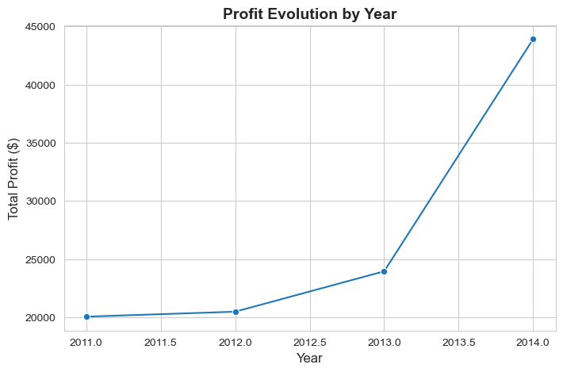

3.2 Performance by Product Category
The dataset covers 17 product categories, with considerable variation in profitability across them. Some categories consistently generated positive returns, while others recorded negative profit values, with the lowest category profit reaching -$1,646.50. This highlights the importance of reviewing pricing and cost structures for underperforming categories. The most profitable category significantly outperformed the rest, with a maximum recorded profit of $19,327.25.
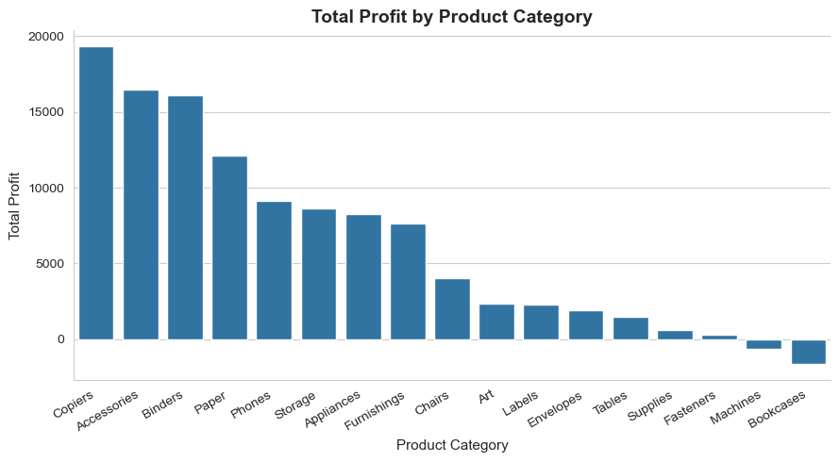

3.3 Geographic Analysis
Sales were distributed across multiple states within the United States. The geographic analysis revealed that certain states contributed disproportionately to overall revenue, with a small number of high-performing states accounting for a large share of total sales. This concentration suggests that regional factors such as population density, economic activity, or market penetration play a significant role in driving sales performance.
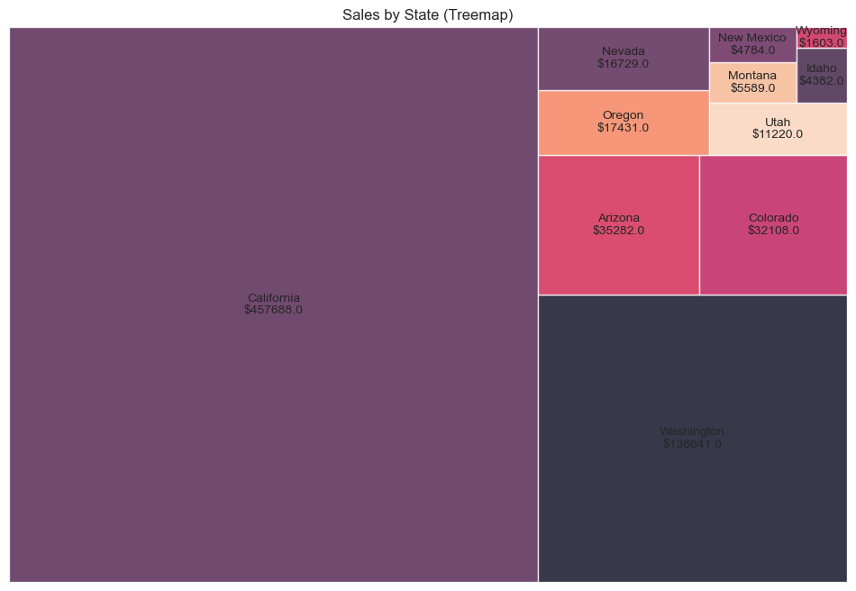

3.4 Customer Behavior
The dataset contains 686 unique customers. On average, each customer placed 2.35 orders over the four-year period, suggesting a moderate level of repeat purchasing. The top customer by total spending was Raymond Buch, with $14,345.28 in total purchases, followed by Ken Lonsdale at $8,472.39. A churn analysis was also conducted, identifying customers who placed only a single order as potentially churned, representing an area of concern for customer retention efforts.
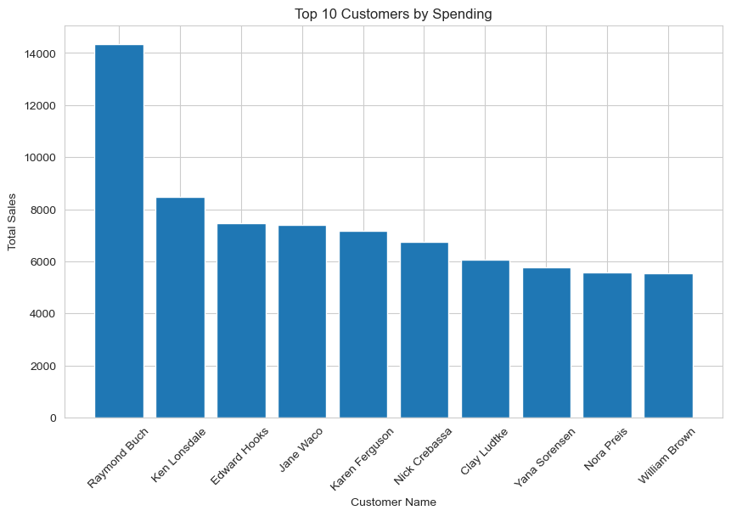

3.5 Top Performing Products
Among all products, the Canon imageCLASS 2200 Advanced Copier was the most profitable, generating $6,719.98 in profit, followed by the Fellowes PB500 Electric Punch Plastic Comb Binding Machine at $3,050.38. The top performing products were predominantly office machines and technology items, suggesting that high-value equipment drives the most significant profit margins within the dataset.
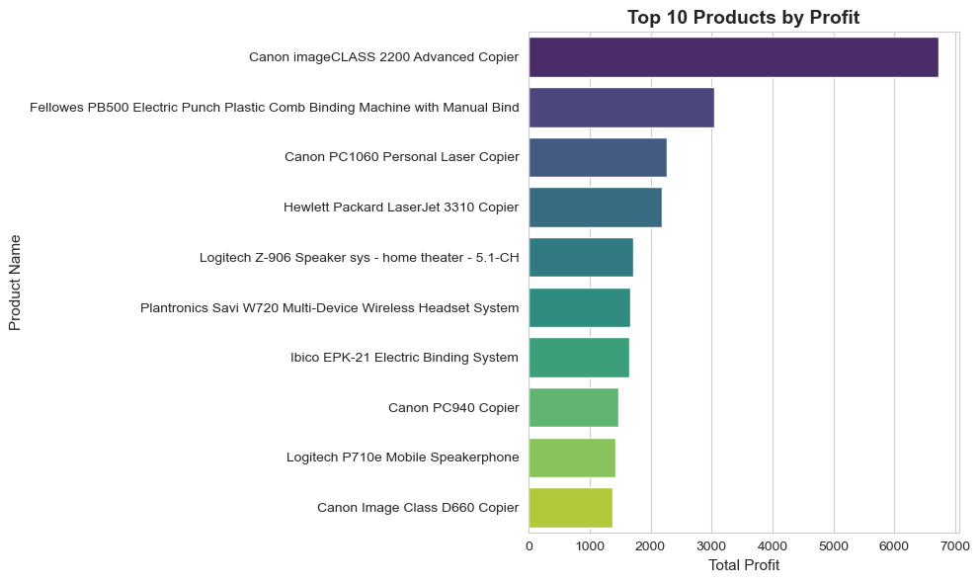

4-Statistical Analysis
This section provides a quantitative summary of the key numerical variables in the dataset, namely Sales, Quantity, Profit, and Unit Price, with the goal of better understanding their distribution and variability.
The average transaction sales value was $226.49, with a standard deviation of $524.88, indicating considerable variability across transactions. The minimum recorded sale was $0.99 while the maximum reached $13,999.96. The wide gap between the mean and the maximum value suggests the presence of a small number of high-value transactions that pull the average upward, while the majority of transactions remain at relatively lower sales values.
Regarding order quantities, customers purchased on average approximately 4 units per transaction, with a standard deviation of 2.26. Orders ranged from a minimum of 1 unit to a maximum of 14 units. The relatively low standard deviation compared to other variables suggests that order quantities were fairly consistent across transactions.
The profit variable showed the most notable variability in the dataset. The average profit per transaction was $33.85, but with a standard deviation of $174.11, profits fluctuated significantly across orders. The minimum recorded profit was -$3,399.98, indicating that some transactions resulted in substantial losses, while the maximum profit on a single transaction reached $6,719.98. The total profit accumulated over the four-year period amounted to $108,418.79. At the category level, the average profit per category was $6,377.58 with a standard deviation of $6,522.91, reflecting strong disparities in profitability between product categories. Finally, the average unit price across all transactions was $60.72, with a standard deviation of $132.67, and prices ranged from as low as $0.54 to as high as $3,499.99, reflecting the broad diversity of products offered, from low-cost office supplies to high-end technology equipment.
Overall, the statistical analysis reveals that the dataset is characterized by high variability in both sales and profit, driven largely by a mix of low-cost high-volume products and high-cost low-volume items. The presence of negative profit values across certain transactions and categories signals that not all products are equally viable from a financial standpoint, and warrants further investigation into pricing and discount strategies

5-Predictive Modeling
The objective of the predictive modeling phase was to classify products as either high-performing or low-performing based on their historical sales and profit data, with the ultimate goal of supporting better stock management decisions in the future. By identifying which products consistently generate strong returns and which ones underperform, the business can make more informed decisions about inventory allocation, restocking priorities, and product discontinuation.
For this classification task, a Linear Regression model was used to understand the relationship between key variables such as sales, quantity, unit price, and profit. The features considered for the model include sales volume, quantity ordered, unit price, product category, and temporal variables such as month and year, all of which were prepared during the data preparation phase.
The model produced encouraging results overall. An accuracy of 95% indicates that the model correctly classified the vast majority of products as either good or poor performers. The F1-Score of 0.77 reflects a reasonable balance between precision and recall, suggesting that the model performs well in identifying both high-performing and underperforming products, though there remains some room for improvement in handling borderline cases. The Root Mean Square Error of 0.21 further confirms that the model's predictions deviate only slightly from the actual values, indicating a good level of reliability.
These results suggest that the model is a solid foundation for a stock optimization strategy. With further tuning and the inclusion of additional features, its predictive performance could be improved even further.

6-Clustering
The objective of the clustering analysis was to identify natural groupings among products based on their sales and profit performance. Using the K-Means algorithm with two clusters, combined with Principal Component Analysis for visualization and boxplots for feature comparison, the analysis aimed to separate products into two distinct groups: those that contribute positively to overall profitability and those that generate losses.
The boxplot comparison across the four features revealed clear and consistent differences between the two clusters. In terms of total sales, the High Profit cluster showed significantly higher values, with a median around $4,000 and a wide interquartile range, while the Loss Making cluster remained concentrated near zero with a much tighter distribution. A similar pattern was observed for total profit, where the High Profit cluster recorded a median around $800 with values extending well above $1,000, whereas the Loss Making cluster was centered around zero and included products with negative profit values reaching as low as -$2,500, confirming their detrimental impact on overall business performance.
Regarding total quantity ordered, both clusters showed comparable and relatively low median values, suggesting that order volume alone does not determine whether a product is profitable or not. The most striking difference was observed in the average unit price, where the High Profit cluster displayed considerably higher prices with a median near $450 and several high-value outliers exceeding $1,000, compared to the Loss Making cluster which remained largely below $100. This indicates that product pricing is a key differentiating factor between the two groups.

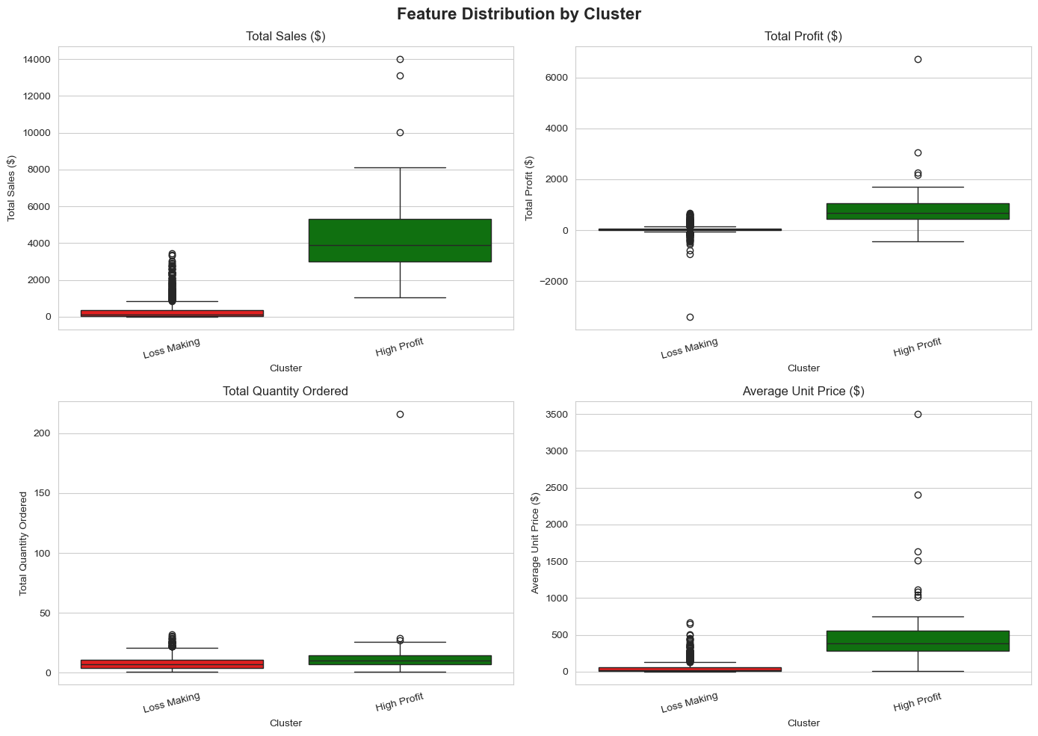

7-Recommendations
Based on the findings of this study, several recommendations are proposed to improve overall business performance. Loss-making products identified through the clustering analysis should be reviewed and either repriced, reduced in stock, or discontinued. Conversely, high-performing products such as office machines and technology equipment should be prioritized in terms of inventory and investment.
The predictive model developed in this study can be integrated into the restocking process to help anticipate product performance and allocate inventory more efficiently. From a geographic standpoint, the business should investigate what drives strong sales in top-performing states and explore ways to replicate those conditions elsewhere. Finally, promotional campaigns and stock increases should be planned ahead of peak seasonal periods, particularly in the last quarter of the year.

8-Limitations and Future Work
This study has several limitations worth acknowledging. The dataset covers only the period from 2011 to 2014 and lacks important variables such as discount rates, shipping costs, and customer demographics, which may limit the depth of the analysis. Additionally, the Linear Regression model used for classification is relatively simple and could be replaced by more robust algorithms such as Random Forest or Gradient Boosting for better performance.
For future work, enriching the dataset with additional variables, extending the predictive model with more advanced techniques, and incorporating customer segmentation alongside product clustering would significantly improve the quality and applicability of the findings.

9-Conclusion
This study conducted a comprehensive analysis of the Walmart retail dataset covering 3,203 transactions from 2011 to 2014. The findings revealed significant variation in performance across products, categories, and regions, with a total profit of $108,418.79 generated over the period. The clustering analysis successfully identified two distinct product groups, and the predictive model demonstrated strong classification accuracy. Together, these findings provide a solid foundation for more informed decision-making around product portfolio management, inventory planning, and regional strategy.

