INTELLIGENT DOCUMENT
ANOMALY & INCONSISTENCY
DETECTION SYSTEM
Project Documentation
AI • NLP • OCR • Unsupervised Machine Learning • Explainable AI
Project Type | Artificial Intelligence / Machine Learning
Primary Use Case | Business Invoice Anomaly Detection
Core Model | Isolation Forest
Dataset | Synthetic historical invoice dataset — 120 records
Technology | Python, Pandas, NumPy, Scikit-learn, Streamlit, OCR/NLP stack

1. Executive Summary
The Intelligent Document Anomaly & Inconsistency Detection System is an AI-based solution designed to analyze business documents such as invoices, reports, applications, and contracts and identify suspicious inconsistencies. The system combines deterministic validation rules, feature engineering, natural language processing, embeddings, optical character recognition (OCR), and unsupervised machine learning.
The first implementation focuses on business invoices. It validates dates and financial totals, detects duplicate invoice identifiers, creates numerical features from historical transactions, and uses an Isolation Forest model to identify records that differ significantly from normal patterns. The system is designed to provide an explanation alongside an anomaly score.

2. Problem Statement
Organizations process large volumes of documents containing dates, names, amounts, terms, and identifiers. Manual verification is time-consuming and can miss subtle inconsistencies. A document may contain a duplicated invoice number, an incorrect total, an impossible date relationship, or a value far outside normal historical patterns.
The objective is to automate the first level of document verification and highlight suspicious records for human review.

3. Objectives
- Extract useful information from digital and scanned business documents.
- Identify missing, duplicated, conflicting, or inconsistent information.
- Validate relationships between fields such as invoice date and due date.
- Detect unusual numerical values using historical transaction patterns.
- Use unsupervised machine learning when labeled anomaly data is unavailable.
- Provide understandable reasons for detected anomalies.
- Provide a foundation for a web-based document analysis dashboard.

4. Scope of Current Version
Phase 1 focuses on invoices because they provide clear fields and measurable relationships. The design can later be extended to reports, applications, contracts, and other business documents.
- Invoice identifier validation
- Vendor field validation
- Invoice date and due date consistency
- Subtotal, tax, discount, and total validation
- Duplicate invoice number detection
- Historical numerical feature analysis
- Isolation Forest anomaly detection
- Preparation for OCR, NLP, embeddings, and Streamlit UI

5. System Architecture
Document Upload → OCR/PDF Extraction → Information Extraction → Feature Engineering → Rule Engine + NLP/Embeddings + ML Anomaly Detection → Risk Score → Explanation Engine → Dashboard

6. Technologies Used
Technology | Purpose | Status
Python | Core programming language | Current
Pandas | Data preprocessing | Current
NumPy | Numerical operations | Current
Scikit-learn | Isolation Forest / ML | Current
Joblib | Model persistence | Current
PyMuPDF | PDF extraction | Planned
Tesseract / OCR | Scanned document extraction | Planned
Sentence Transformers | Semantic embeddings | Planned
Streamlit | Interactive web application | Planned

7. Dataset Description
A synthetic dataset containing 120 invoice records has been created for development and testing. It contains realistic invoice attributes and deliberately inserted anomalous records so that the detection pipeline can be evaluated before connecting it to real documents.
Field | Description
invoice_id | Unique invoice identifier
vendor | Vendor or supplier name
invoice_date | Invoice issue date
due_date | Expected payment due date
subtotal | Pre-tax, pre-discount amount
tax | Tax amount
discount | Discount applied
total | Final invoice amount
num_items | Number of items

8. Feature Engineering
Feature engineering transforms raw invoice fields into numerical variables suitable for anomaly detection.
- days_to_due = due_date − invoice_date
- tax_rate = tax / subtotal
- discount_rate = discount / subtotal
- subtotal, tax, discount, total, and number of items as numerical features
These features allow the unsupervised model to learn normal invoice patterns without requiring a manually labeled anomaly class.

9. Rule-Based Anomaly Detection
- Date rule: due date should not occur before invoice date.
- Total rule: total should equal subtotal + tax − discount within a small tolerance.
- Duplicate rule: the same invoice identifier should not occur multiple times.
- Required-field rule: important fields such as vendor and invoice identifier should not be empty.

10. Unsupervised Anomaly Detection
Isolation Forest is the initial unsupervised anomaly detection algorithm. It is appropriate when confirmed anomaly labels are limited because it learns patterns in historical records and identifies observations that are unusually easy to isolate.
The model uses subtotal, tax, discount, total, number of items, days to due date, tax rate, and discount rate. The trained model is saved as models/anomaly_model.pkl.

11. NLP, Embeddings, and OCR — Planned Extension
- OCR converts scanned document images into machine-readable text.
- NLP identifies entities and fields such as vendor names, dates, amounts, and terms.
- Sentence embeddings convert text into numerical representations.
- Semantic similarity can compare statements and identify potentially conflicting terms.
- Extracted fields are passed to the same validation and anomaly-detection pipeline.

12. Explainable AI
The system should not only state that a document is anomalous; it should explain the signals behind the decision. The final application will combine rule violations and model signals into a risk assessment.
Example:
Risk Score: 87/100
Status: ANOMALY DETECTED
Reasons:
• Due date occurs before invoice date.
• Invoice amount is significantly higher than the historical vendor pattern.
• Invoice number is duplicated.
• Reported total does not match the calculated total.

13. Project Workflow
- User uploads a PDF or image.
- System determines direct PDF extraction or OCR path.
- Text and relevant fields are extracted.
- Required fields are checked.
- Consistency rules are executed.
- Numerical features are generated.
- Isolation Forest calculates an anomaly signal.
- NLP and semantic comparison are applied in the extended version.
- Signals are combined into a risk score.
- Explanation engine generates human-readable reasons.
- Dashboard presents the final analysis.

14. Project Folder Structure
Intelligent_Document_Anomaly_Detection/
├── data/
│ ├── invoices.csv
│ └── documents/
├── models/
│ └── anomaly_model.pkl
├── src/
│ ├── data_preprocessing.py
│ ├── feature_engineering.py
│ ├── anomaly_detection.py
│ ├── rule_engine.py
│ ├── document_parser.py
│ └── explanation.py
├── templates/
├── app.py
├── train_model.py
├── requirements.txt
└── README.md

15. Installation and Execution
Install dependencies from the project root:
pip install -r requirements.txt
Train the initial anomaly model:
python train_model.py
The trained model is written to models/anomaly_model.pkl.

16. Testing Strategy
- Test valid invoices to verify normal records are not unnecessarily flagged.
- Test due dates earlier than invoice dates.
- Test invoices with incorrect totals.
- Test duplicate invoice identifiers.
- Test unusually large transaction amounts.
- Test missing vendor or identifier fields.
- Compare rule-based and Isolation Forest results.
- Verify explanations accurately describe detected issues.

17. Expected Output
The final application will provide a document-level result containing a risk score, overall status, detected anomaly categories, supporting values, and plain-language explanations. A human reviewer can then decide whether the document requires manual verification.

18. Advantages
- Combines deterministic business rules with machine learning.
- Works without requiring a fully labeled anomaly dataset.
- Can process structured and unstructured document information.
- Produces explanations rather than only predictions.
- Can be extended to multiple document types.
- Suitable for an AI/ML internship demonstration.

19. Limitations
- The current dataset is synthetic and is not real financial data.
- Isolation Forest detects statistical unusualness, not fraud by itself.
- OCR accuracy can vary with document quality and layout.
- Semantic conflict detection requires domain-specific validation.
- Production use would require stronger security, audit logging, access control, and extensive validation.

20. Future Enhancements
- Support invoices, contracts, reports, applications, and purchase orders.
- Add layout-aware document understanding.
- Add vendor-specific historical baselines.
- Use advanced transformer-based document models.
- Add a database for historical documents.
- Add document-to-document comparison.
- Add configurable business rules.
- Add confidence scores and reviewer feedback loops.
- Deploy as a secure cloud service.

21. Images

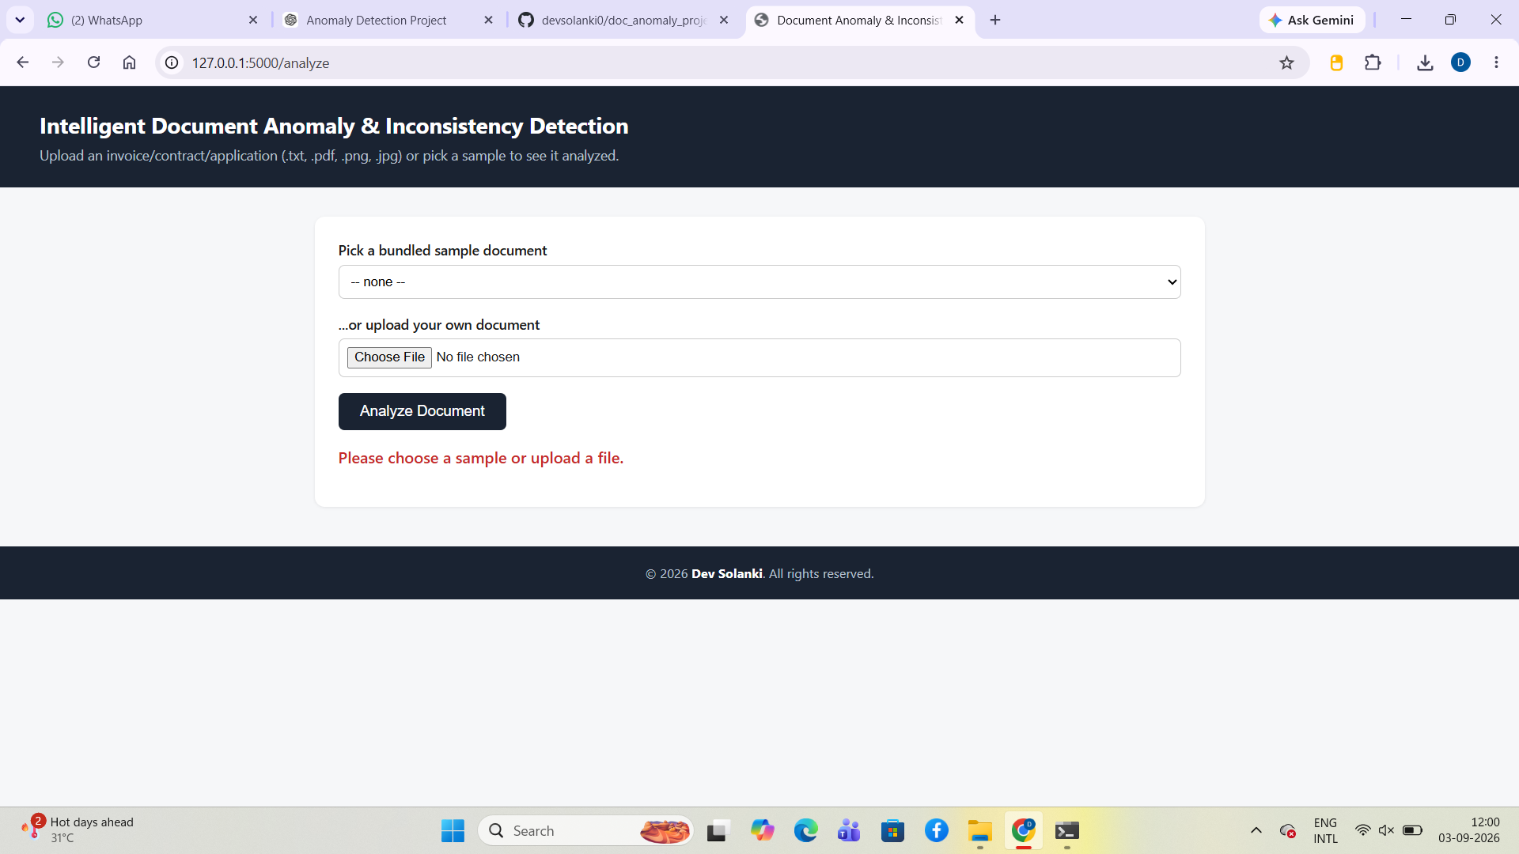

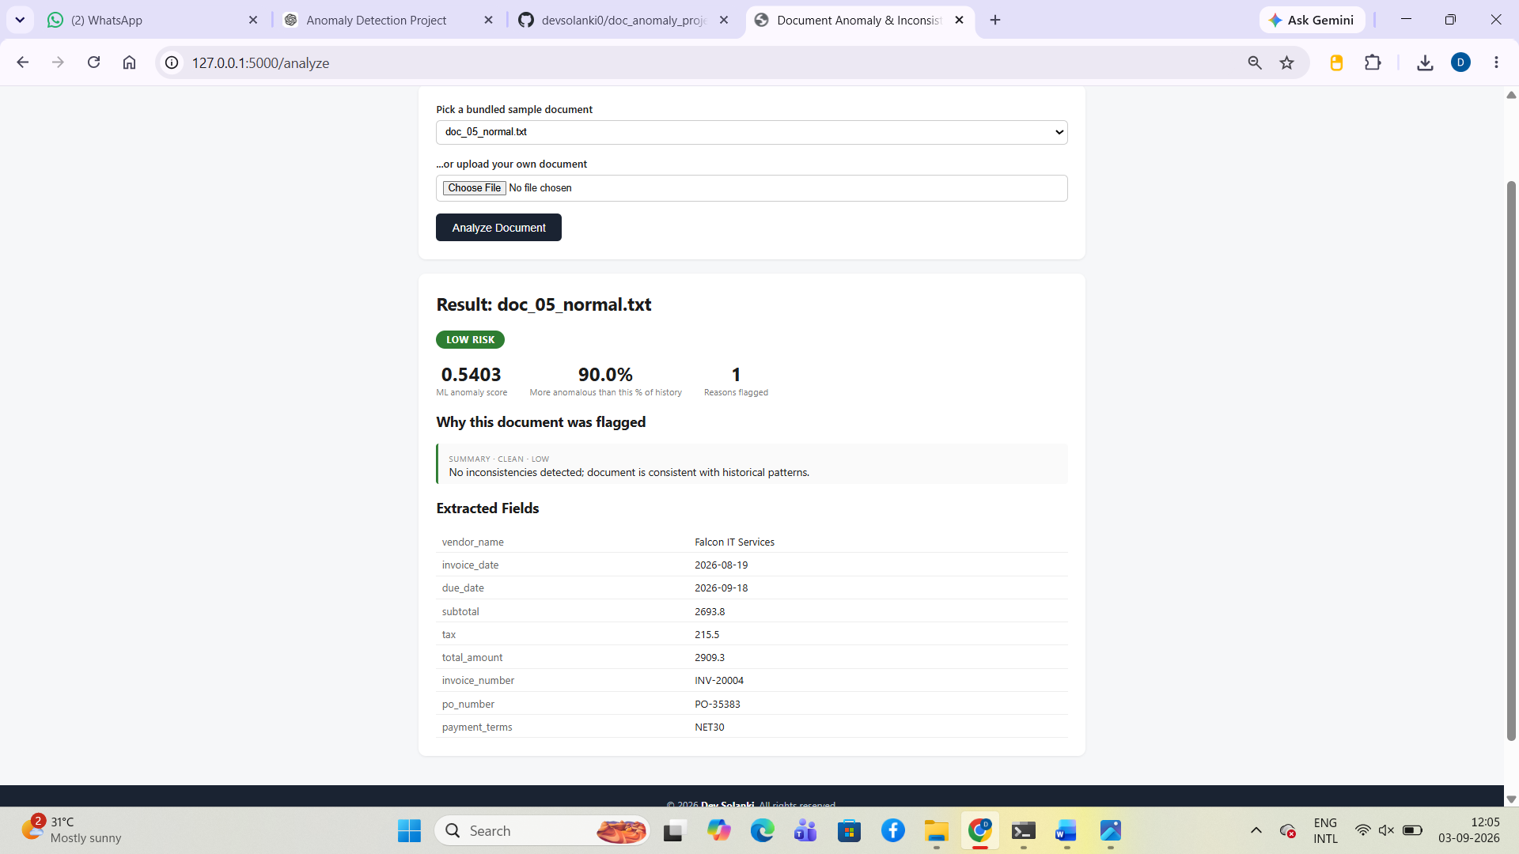

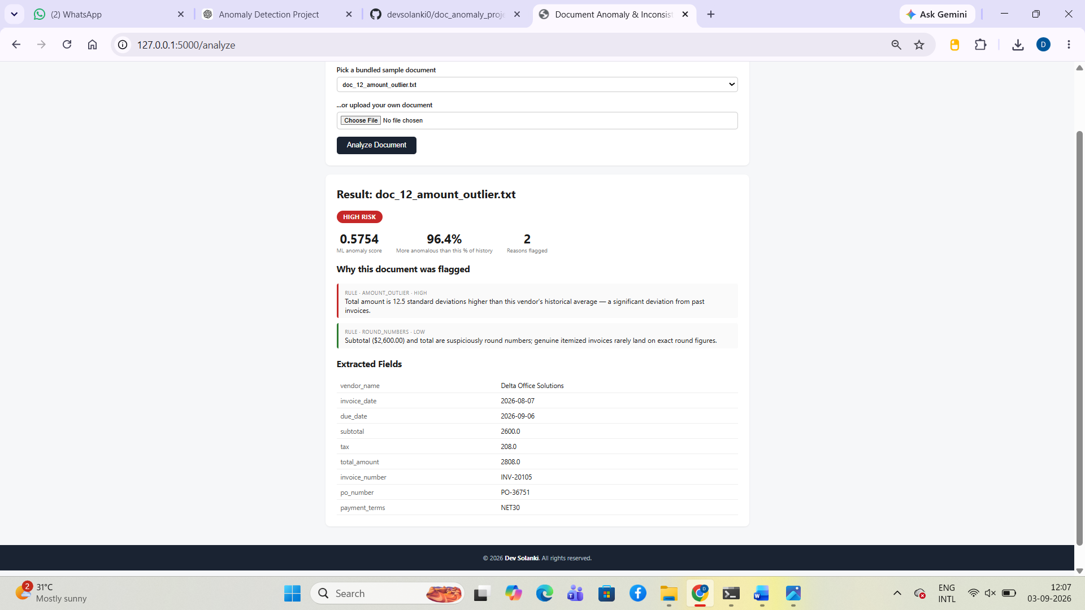

22. Conclusion
The Intelligent Document Anomaly & Inconsistency Detection System provides a practical foundation for automated business-document verification. Phase 1 establishes the dataset, preprocessing pipeline, feature engineering, rule engine, and unsupervised anomaly detection model. Subsequent phases will connect real document uploads, OCR, NLP, embeddings, explainable results, and an interactive dashboard, creating a strong practical AI/ML portfolio project.

