Backdrop & Display
1. Curved Wooden Backdrops
2. Fabric Light Wall Display Stands
3. Media Wall Backdrops
4. Party Backdrops
5. Straight Fabric Tension Backdrops
6. Flex Banner
7. Lama Stand
8. Spring A Board
9. Totem Display Stand
Custom Signage
1.3D Vertical Signage Signboard
2. Office Door Signage
3. Soft LED Screen Display
Exhibition & Stands
1.Standard Exhibition Booths
Vehicle Branding
1.Container Branding
Banner Printing
1.Backlit Banner Printing
2. Blockout (Double-Sided) Banner Printing
3. Building Wrap Banner Printing
4. Fabric Banner Printing
5. Popup Banners
6. Rollup Banners
7. Tarpaulin Eco Banner Printing

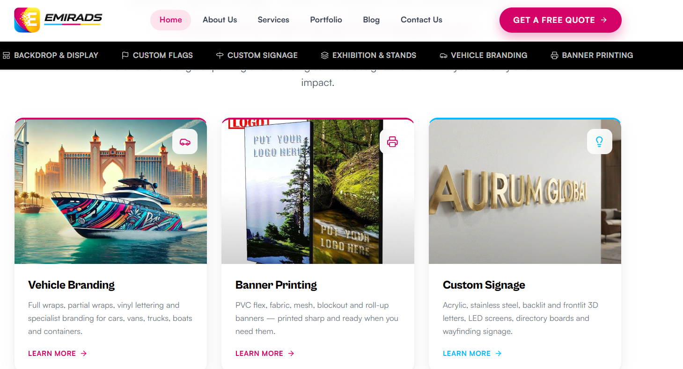
Change Home page images
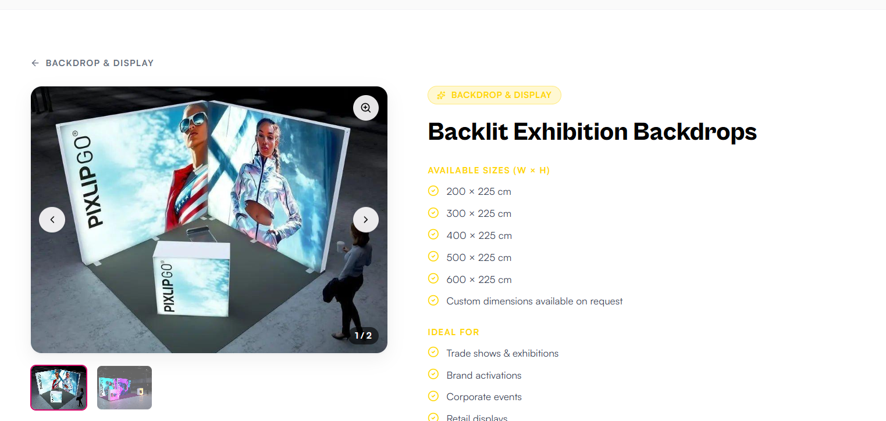
Change the title color only Backdrop & Display page

