### **Mongodb - PG Made Eazy - Web Application AGGREGATIONS**

### **Users**

### **1.Count users by role**

db.users.aggregate([

{ $group: { _id: "$role", count: { $sum: 1 } } }

])

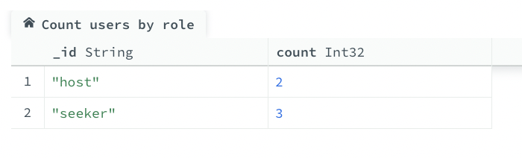

**2.Count users by gender**

[

{

$group: {

_id: "$gender",

count: { $sum: 1 }

}

}

]

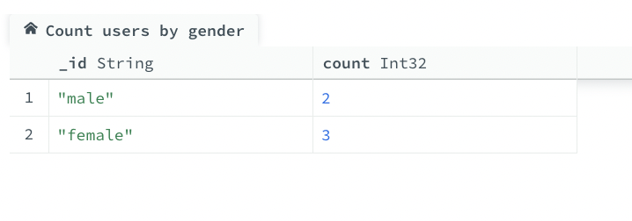

**3.List all seekers with Gmail addresses**

[

{ "$match": { "role": "seeker", "email": { "$regex": "gmail\\.com$" } } }

]

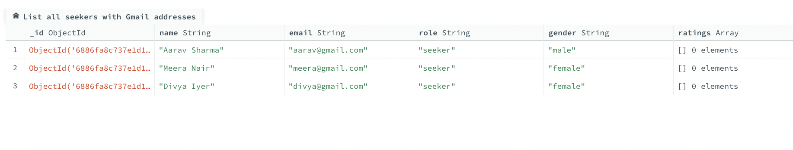

**4.Add custom field "hasRated" if user has left any ratings**

[

{

$addFields: {

hasRated: {

$cond: {

if: { $gt: [{ $size: "$ratings" }, 0] },

then: true,

else: false

}

}

}

}

]

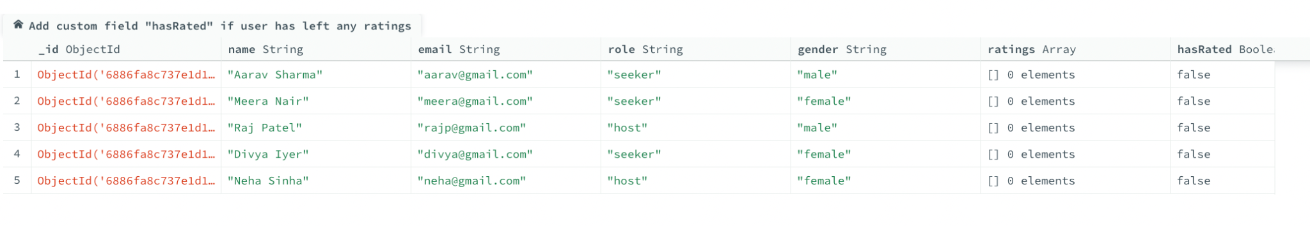

**5.Count seekers vs hosts ratio**

[

{

$group: {

_id: "$role",

count: { $sum: 1 }

}

}

]

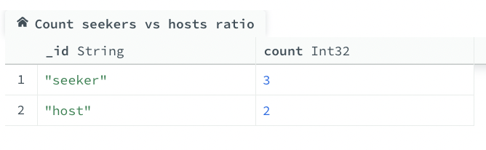

### **Properties**

**1. Average price by city**

[

{

"$group": {

"_id": "$location",

"averagePrice": { "$avg": "$price" }

}

}

]

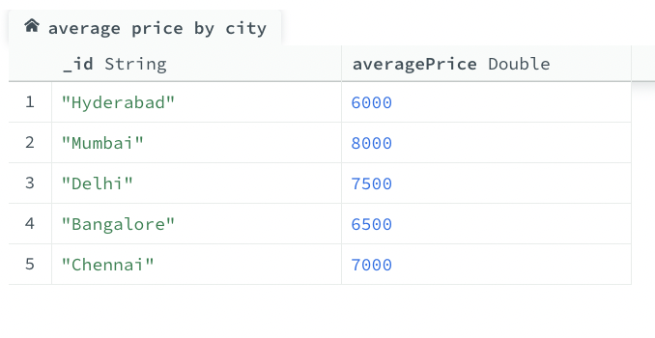

**2. Properties with more than 2 available rooms**

[

{ "$match": { "available_rooms": { "$gt": 2 } } }

]

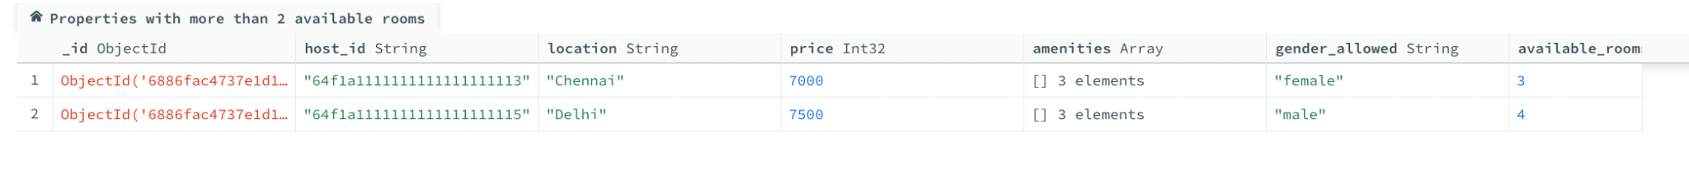

**3. Count properties by gender restriction**

[

{

$group: {

_id: "$gender_allowed",

count: { $sum: 1 }

}

}

]

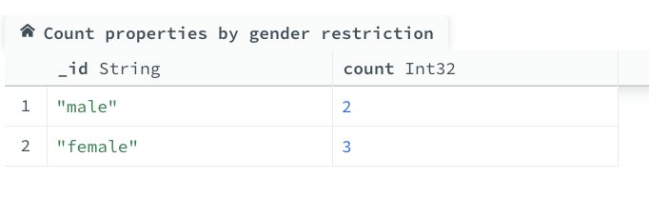

**4. Count of properties with WiFi**

[

{"$match": {"amenities": "WiFi"}},

{"$count": "wifi_properties_count"}

]

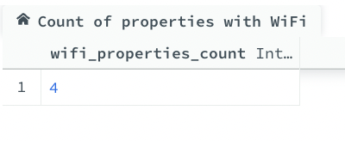

**5. Average rating for each property**

[

{

$project: {

_id: 1,

average_rating: {

$avg: "$reviews.rating"

}

}

}

]

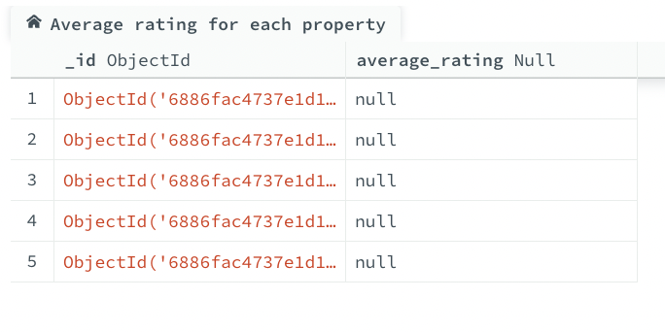

**Bookings**

**1. Total bookings per property**

[

{

$group: {

_id: "$property_id",

totalBookings: { $sum: 1 }

}

}

]

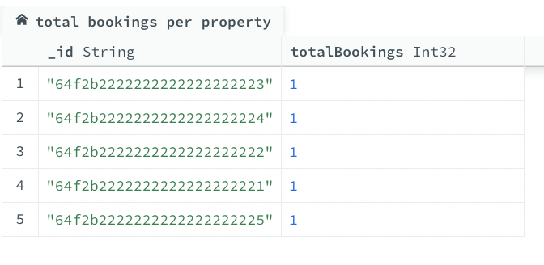

**2. Monthly revenue**

[

{

$match: {

"payment.status": "completed"

}

},

{

$addFields: {

booking_year_month: {

$substr: ["$booking_date", 0, 7]

}

}

},

{

$group: {

_id: "$booking_year_month",

total_revenue: {

$sum: "$payment.amount"

}

}

},

{

$project: {

month: "$_id",

total_revenue: 1,

_id: 0

}

},

{

$sort: {

month: 1

}

}

]

**3. Booking status breakdown**

[

{

$group: {

_id: "$status",

count: { $sum: 1 }

}

},

{

$sort: { count: -1 }

}

]

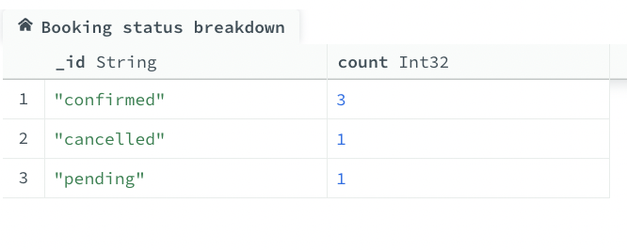

**4. Average booking amount by status**

[{ $group: { _id: "$status", averageAmount: { $avg: "$payment.amount" } } }]

**5. User-wise total amount spent**

[

{

$group: {

_id: "$user_id",

totalAmountSpent: { $sum: "$payment.amount" }

}

}

]

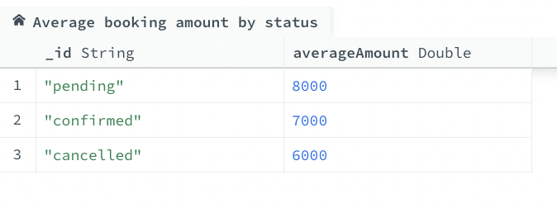

**Reports**

**1. Number of reports per type**

[

{

"$group": {

"_id": "$report_type",

"count": { "$sum": 1 }

}

}

]

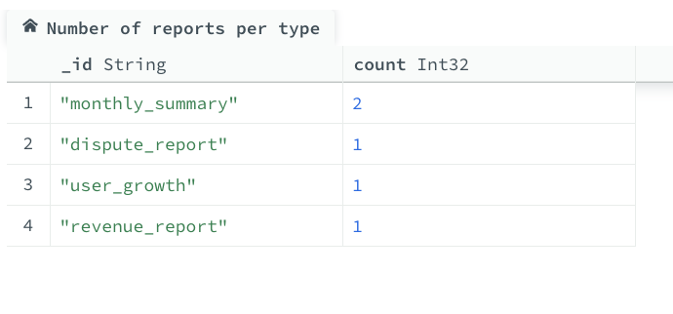

**2. Monthly average disputes resolved**

[

{

$match: {

report_type: "monthly"

}

},

{

$group: {

_id: {

year: { $year: { $dateFromString: { dateString: "$generated_on" }}},

month: { $month: { $dateFromString: { dateString: "$generated_on" }}}

},

avg_disputes_resolved: { $avg: "$disputes_resolved" }

}

}

]

**3. Highest booking count in reports**

[

{

"$sort": {

"total_bookings": -1

}

},

{

"$limit": 1

}

]



**4. Reports with more than 400 users**

[

{ $match: { total_users: { $gt: 400 } } }

]



**5. Total disputes resolved across all reports**

[

{

$group: {

_id: null,

totalDisputesResolved: { $sum: "$disputes_resolved" }

}

}

]

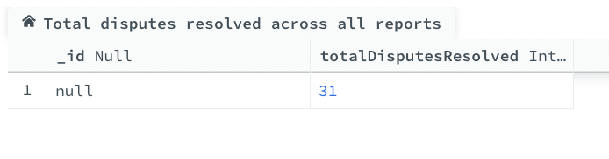

**Reviews**

**1. Average rating per property**

[

{ $group: { _id: "$property_id", averageRating: { $avg: "$rating" } } }

]

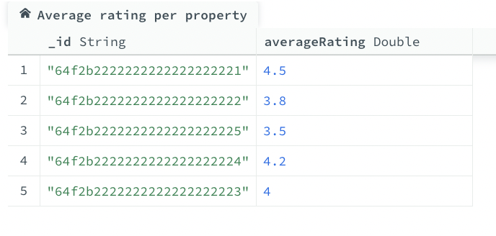

**2. Total reviews per user**

[

{ $group: { _id: "$user_id", totalReviews: { $sum: 1 } } }

]

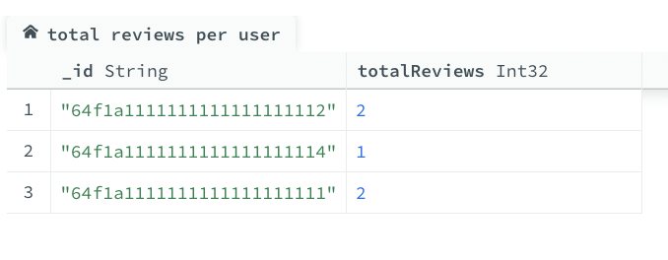

**3. Count of reviews with rating < 4**

[

{

$match: { rating: { $lt: 4 } }

},

{

$count: "low_rating_reviews_count"

}

]

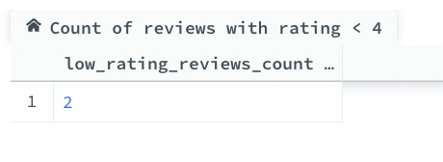

**4. Most recent reviews**

[

{

"$sort": {

"created_at": -1

}

}

]

**5. Properties with average rating ≥ 4**

[

{

"$group": {

"_id": "$property_id",

"averageRating": { "$avg": "$rating" }

}

},

{

"$match": {

"averageRating": { "$gte": 4 }

}

}

]

