**1. USERS COLLECTION**

**CREATE (Insert)**

db.users.insertMany([

{ name: "Aarav Sharma", email: "aarav@gmail.com", role: "seeker", gender: "male", ratings: [] },

{ name: "Meera Nair", email: "meera@gmail.com", role: "seeker", gender: "female", ratings: [] },

{ name: "Raj Patel", email: "rajp@gmail.com", role: "host", gender: "male", ratings: [] }

])

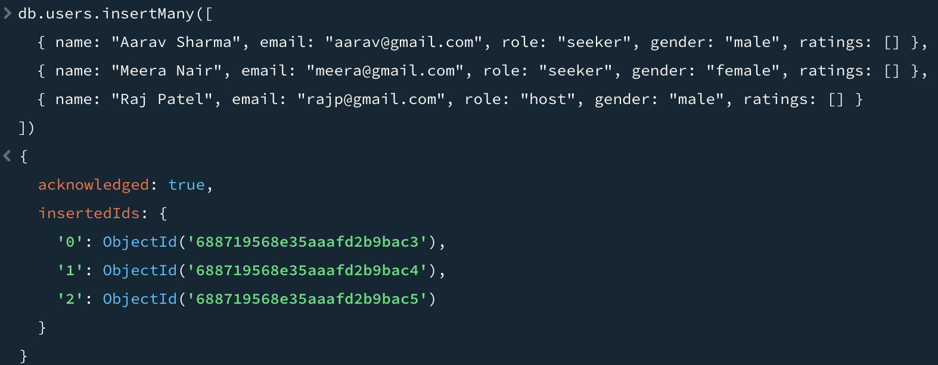

**READ**

db.users.find()

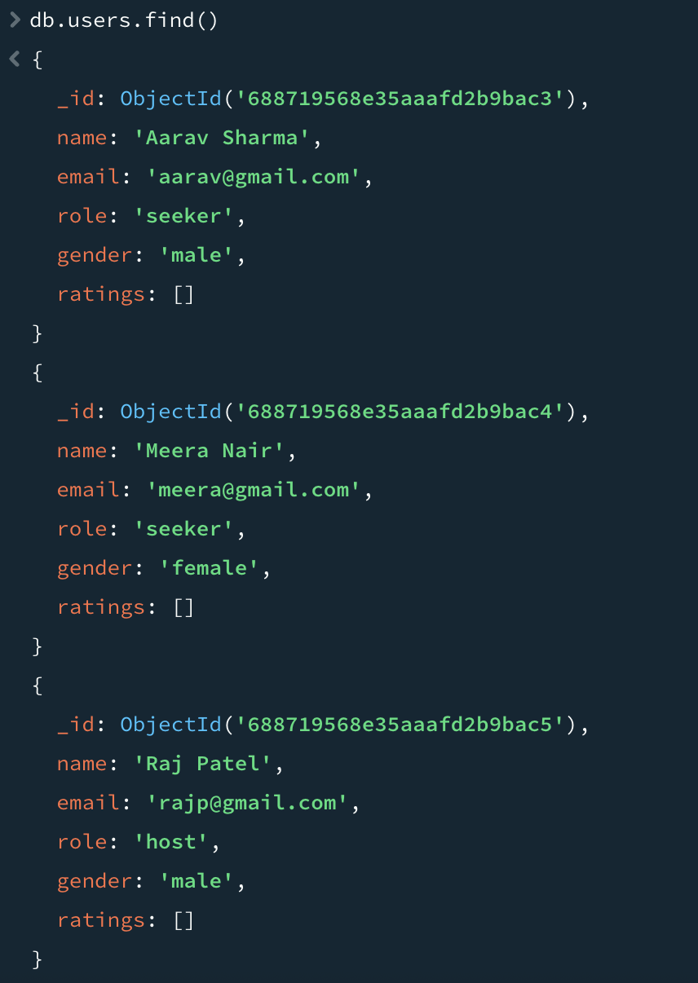

**UPDATE**

db.users.updateOne(

{ name: "Aarav Sharma" },

{ $set: { email: "aarav_updated@gmail.com" } }

)

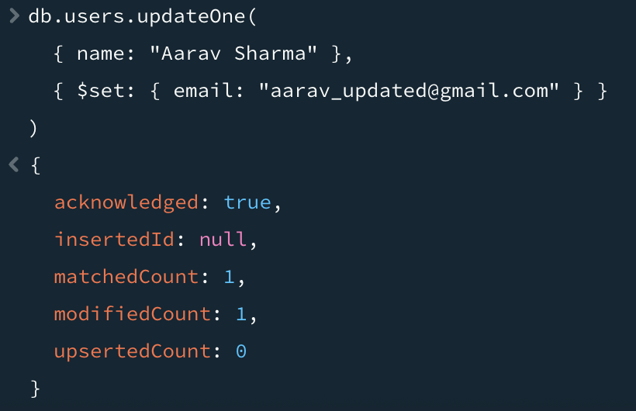

**DELETE**

db.users.deleteOne({ name: "Raj Patel" })

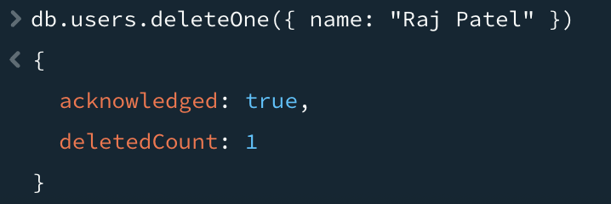

**2. REVIEWS COLLECTION**

**CREATE**

db.reviews.insertOne({

user_id: ObjectId(), // placeholder

property_id: ObjectId(),

rating: 4.5,

comment: "Great place",

created_at: new Date()

})

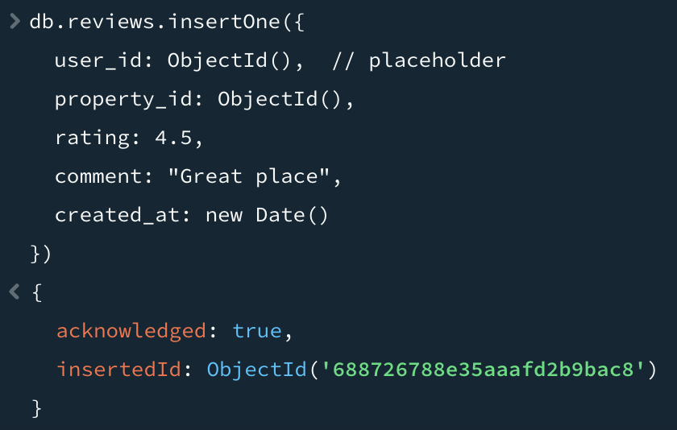

**READ**

db.reviews.find()

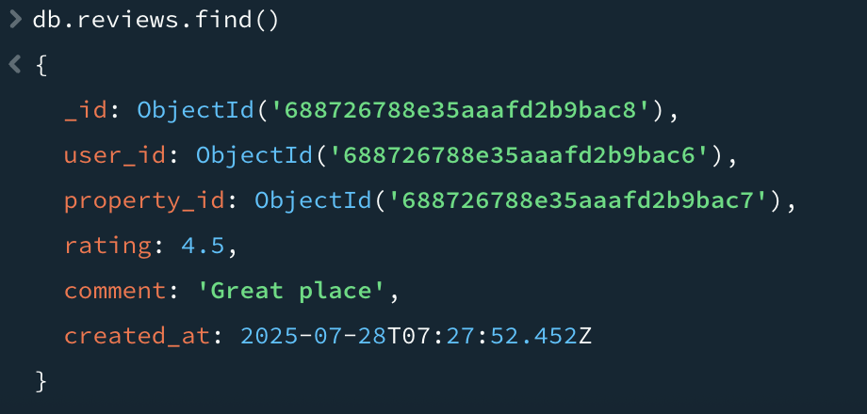

**UPDATE**

db.reviews.updateOne(

{ rating: 4.5 },

{ $set: { comment: "Very clean and calm place" } }

)

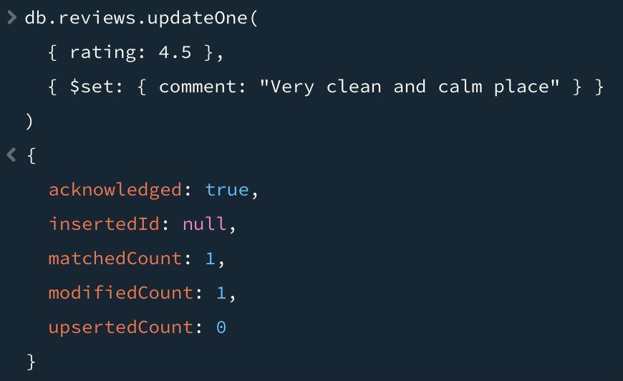

**DELETE**

db.reviews.deleteOne({ rating: 4.5 })

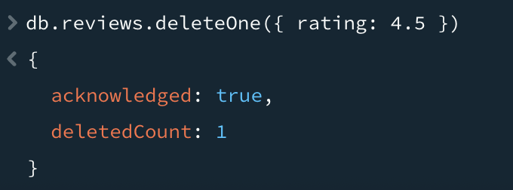

**3. PROPERTIES COLLECTION**

**CREATE**

db.properties.insertOne({

host_id: ObjectId(),

location: "Chennai",

price: 7000,

amenities: ["WiFi", "Food"],

gender_allowed: "female",

available_rooms: 2,

reviews: []

})

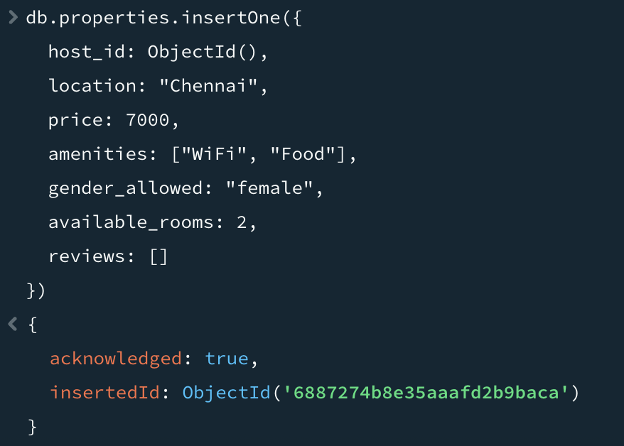

**READ**

db.properties.find()

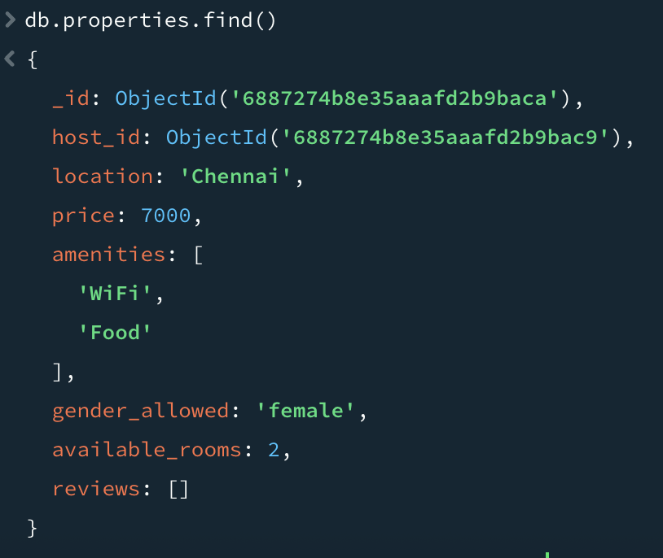

**UPDATE**

db.properties.updateOne(

{ location: "Chennai" },

{ $set: { available_rooms: 3 } }

)

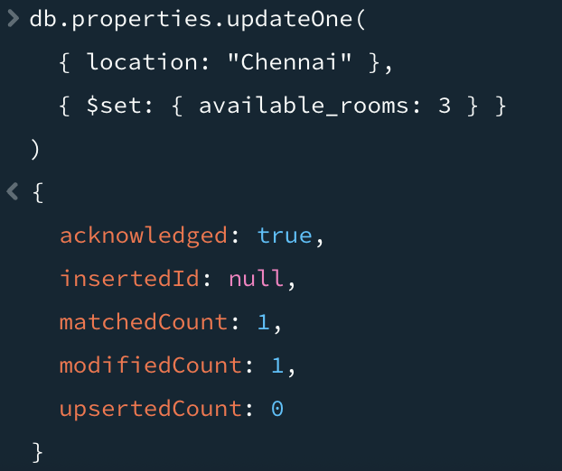

**DELETE**

db.properties.deleteOne({ location: "Chennai" })

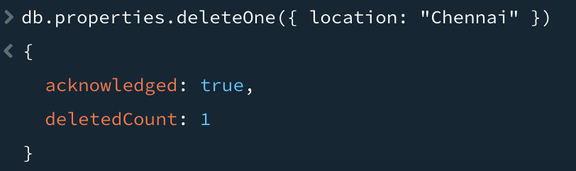

**4. BOOKINGS COLLECTION**

**CREATE**

db.bookings.insertOne({

user_id: ObjectId(),

property_id: ObjectId(),

status: "confirmed",

booking_date: new Date(),

checkin: ISODate("2025-08-01"),

checkout: ISODate("2025-08-30"),

payment: {

amount: 7500,

status: "paid"

}

})

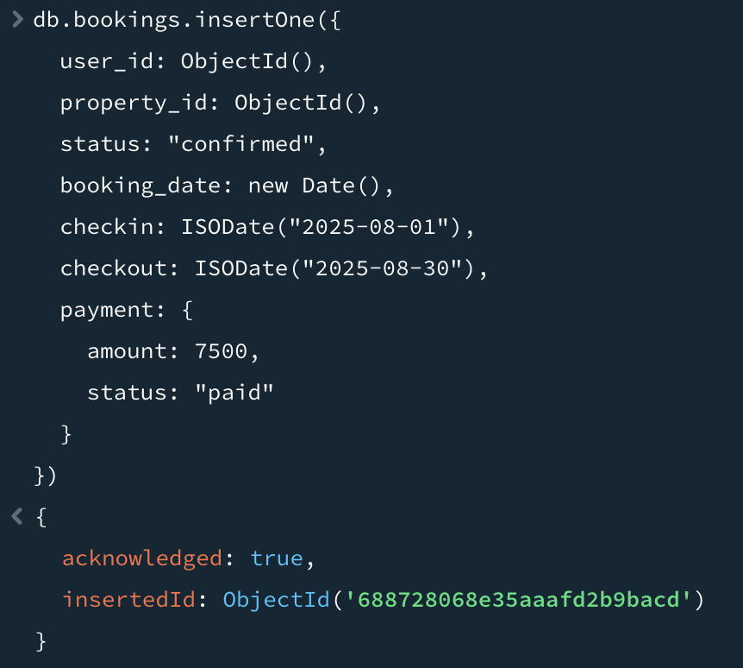

**READ**

db.bookings.find()

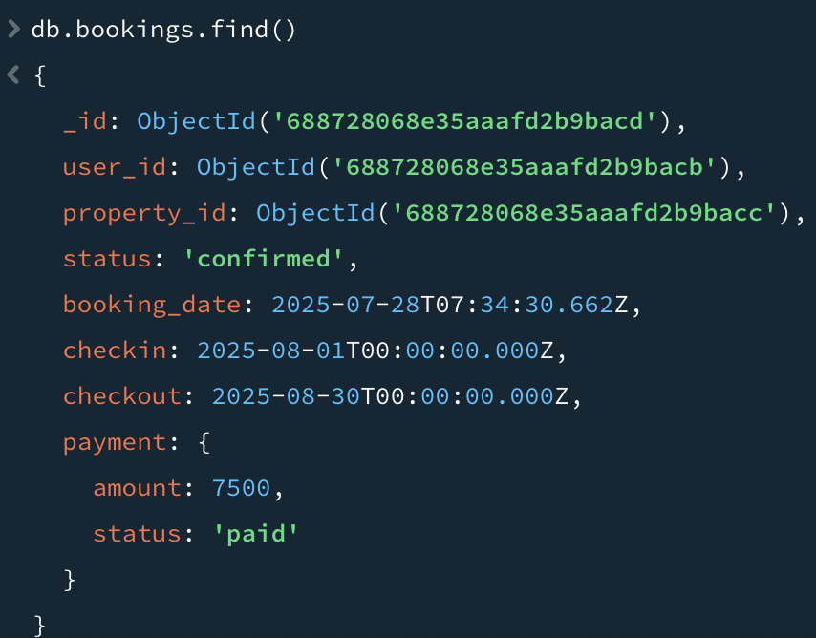

**UPDATE**

db.bookings.updateOne(

{ status: "confirmed" },

{ $set: { status: "cancelled" } }

)

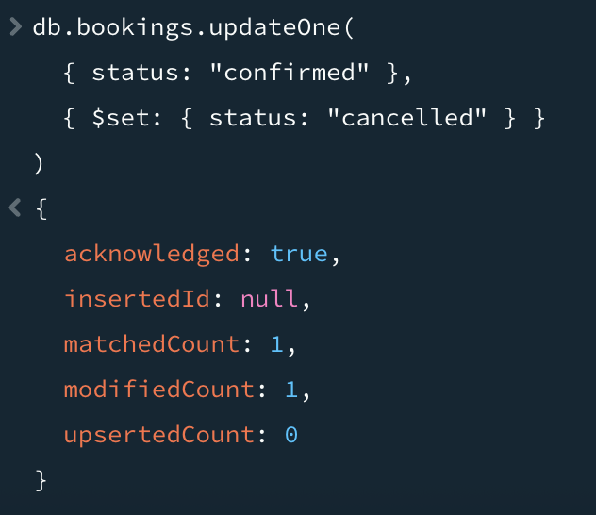

**DELETE**

db.bookings.deleteOne({ status: "cancelled" })

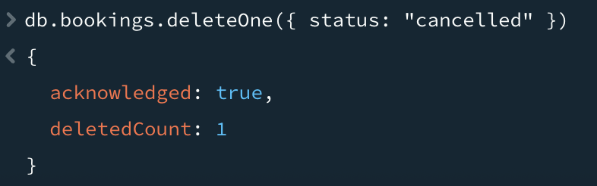

**5. REPORTS COLLECTION**

**CREATE**

db.reports.insertOne({

report_type: "monthly_summary",

generated_on: new Date(),

total_bookings: 100,

total_users: 400,

disputes_resolved: 8

})

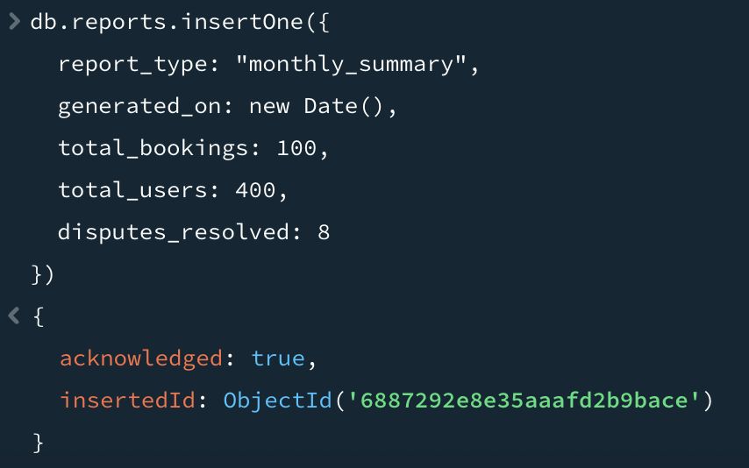

**READ**

db.reports.find()

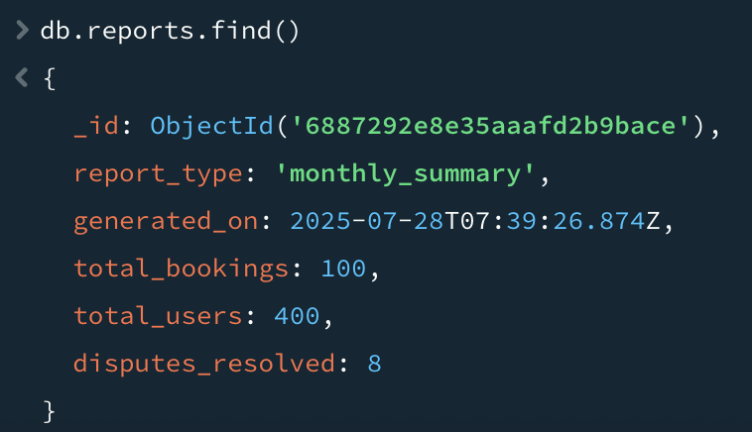

**UPDATE**

db.reports.updateOne(

{ report_type: "monthly_summary" },

{ $set: { total_users: 420 } }

)

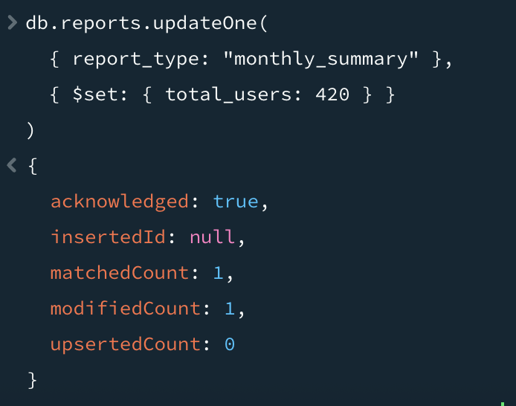

**DELETE**

db.reports.deleteOne({ report_type: "monthly_summary" })

