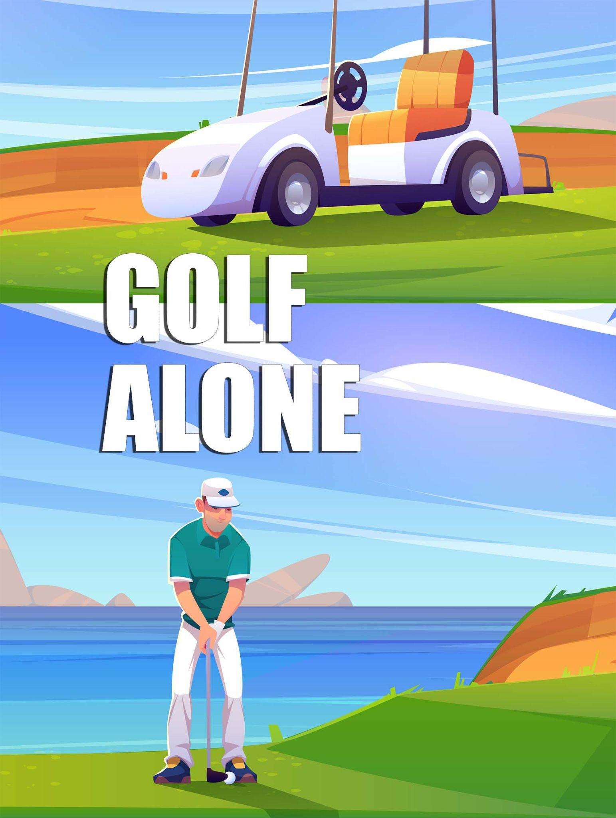

**Contents**

|  |  |
| --- | --- |
| Game Overview . . . . . . . . . . . . . . . . . . . . . . . . . . . . . . . . . . . .  High Concept . . . . . . . . . . . . . . . . . . . . . . . . . . . . . . . . . . . . . .  Unique Selling Points . . . . . . . . . . . . . . . . . . . . . . . . . . . . . . . .  Platform Minimum Requirements . . . . . . . . . . . . . . . . . . . . . . .  Competitor/Similar Titles. . . . . . . . . . . . . . . . . . . . . . . . . . . . . . . Synopsis . . . . . . . . . . . . . . . . . . . . . . . . . . . . . . . . . . . . . . . .  Game Objectives . . . . . . . . . . . . . . . . . . . . . . . . . . . . . . . . .  Game Rules . . . . . . . . . . . . . . . . . . . . . . . . . . . . . . . . . . . . .  Game Structure . . . . . . . . . . . . . . . . . . . . . . . . . . . . . . . . . .  Gameplay . . . . . . . . . . . . . . . . . . . . . . . . . . . . . . . . . . . . . . . . . . . .  Game Controls . . . . . . . . . . . . . . . . . . . . . . . . . . . . . . . . .  Game Camera . . . . . . . . . . . . . . . . . . . . . . . . . . . . . . . . .  HUD . . . . . . . . . . . . . . . . . . . . . . . . . . . . . . . . . . . . . . . . .  Player . . . . . . . . . . . . . . . . . . . . . . . . . . . . . . . . . . . . . . . . . . . . . . . .  Player Characters . . . . . . . . . . . . . . . . . . . . . . . . . . . . . . . . . .  Player Metrics . . . . . . . . . . . . . . . . . . . . . . . . . . . . . . . . . . .  Player States . . . . . . . . . . . . . . . . . . . . . . . . . . . . . . . . . . . . .  Player Weapons . . . . . . . . . . . . . . . . . . . . . . . . . . . . . . . . . . .  Art . . . . . . . . . . . . . . . . . . . . . . . . . . . . . . . . . . . . . . . . . . . . . . . . . . . .  Setting . . . . . . . . . . . . . . . . . . . . . . . . . . . . . . . . . . . . . . . . . . .  Level Design . . . . . . . . . . . . . . . . . . . . . . . . . . . . . . . . . . . . . . .  Audio . . . . . . . . . . . . . . . . . . . . . . . . . . . . . . . . . . . . . . . . . . . . .  MVP (Minimum Viable Product) . . . . . . . . . . . . . . . . . . . . .  Wishlist . . . . . . . . . . . . . . . . . . . . . . . . . . . . . . . . . . . . . . . . .  Bibliography . . . . . . . . . . . . . . . . . . . . . . . . . . . . . . . . . . . . . . | Game Development Team Members  **Tamer Elsawaf**  **Matthew Herron**  **Matthew Schuitema**  **John CrutchField**    PRODUCER  Tamer Elsawaf/Matthew Herron/Matthew Schuiteman/ John CrutchField    PRODUCTION MANAGER  Tamer Elsawaf/Matthew Herron/Matthew Schuiteman/ John CrutchField    PRODUCTION COORDINATOR  Tamer Elsawaf/Matthew Herron/Matthew Schuiteman/ John CrutchField  GAME DESIGNERS  Tamer Elsawaf/Matthew Herron/Matthew Schuiteman/ John CrutchField  SYSTEMS/IT COORDINATOR  Tamer Elsawaf/Matthew Herron/Matthew Schuiteman/ John CrutchField  PROGRAMMERS  Tamer Elsawaf/Matthew Herron/Matthew Schuiteman/ John CrutchField  TECHNICAL ARTISTS  Tamer Elsawaf/Matthew Herron/Matthew Schuiteman/ John CrutchField  AUDIO ENGINEERS  Tamer Elsawaf/Matthew Herron/Matthew Schuiteman/ John CrutchField  UX TESTERS  Tamer Elsawaf/Matthew Herron/Matthew Schuiteman/ John CrutchField |

**Game Overview**

Title: Golf Alone

Platform: PC Standalone

Genre: 3D, Single Player, Sports Simulator

Rating: (5+) ESRB

Target: Casual gamer (aging from 5 - 65)

Release date: December 2021

Publisher: CS583 Team09

Golf Alone is a 3D single player golf simulator game. It allows users to experience the thrill of playing on the PGA golf tour with the nostalgia of Wii Golf.

# High Concept

3D golf simulator that allows players to select the golf ball of their choice and simulates stroking the golf ball. There will be a power meter to symbolize the strength in the swing and accuracy is done via aiming left, right (QEAD) to guide the ball. You can also select your club for accurate hitting results!

# Unique Selling Points

* Realistic simulation of golf
* Fun mechanics to play around with
* A fun time to be had for all

# Platform Minimum Requirements

PC, MAC AND LINUX STANDALONE OS: Windows XP SP2+, Mac OS X 10.8+, Ubuntu 12.04+

# Competitors / Similar Titles

* Wii Golf
* Golf Game (<https://arfel.itch.io/golf>)
* Simple Golf Game (<https://show50726.itch.io/simple-golf-game>)
* Golf (prototype) ( <https://26k.itch.io/golf>)

# Synopsis

Like real-life golf, the goal is to get the golf ball into the hole in as little strokes as possible.

# Game Objectives

Complete each hole with the lowest score, par for reference at each hole and remaining strokes.

# Game Rules

Select Your Difficulty, if Hard then you start with 7 strokes and must restart if you don’t complete the level by the end of your remaining strokes. Normal allows the player to become more comfortable with the courses and starts you off with 15 strokes per hole. Try not to fly off the edge!

# Game Structure

Each game ‘level’ is a real-life golf hole. When the ball gets into the hole, you start the next level (hole). Make sure you don’t fly off the map!

# Game Play

#### Game Controls

A & D will be used to aim detailed left or right, this should be used when you need a precise shot. Please use C to change clubs. You will use the mouse click to start your swing and end it. Your first click will initialize the swing meter and your second one will mark how powerful your swing was.

E & D allows the user to major aim to left and right to readjust the frame, this is helpful in the brush, or if you get stuck amongst the trees.

#### Game Camera

When getting ready to swing the camera will be behind the golf club and ball.

During flight it will be stationed at strategic locations that capture the flying ball from trigger point to trigger point. This will follow the ball in the middle of the screen until it comes to a stop.

#### HUD

SWING STRENGTH: Indicates the amount of power in the swing

CURRENT CLUB: shows current club and allows player to alternate clubs

REMAINING STROKES: remaining strokes

PLAYER NICKNAME: displays name player enters on input player selection screen

Player

Golf Ball



Golf Clubs: Driver, Three Wood, Five Iron, Seven Iron, Wedge, Putter

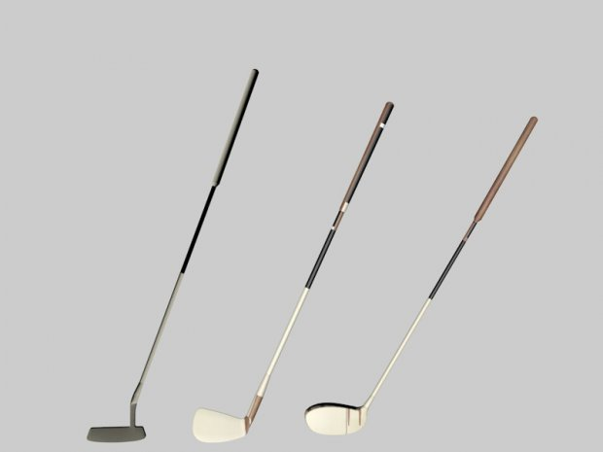

# Art

Setting: 3 Holes

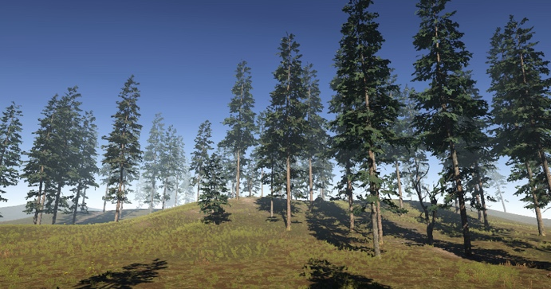 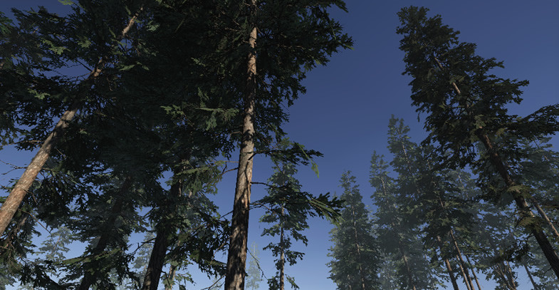

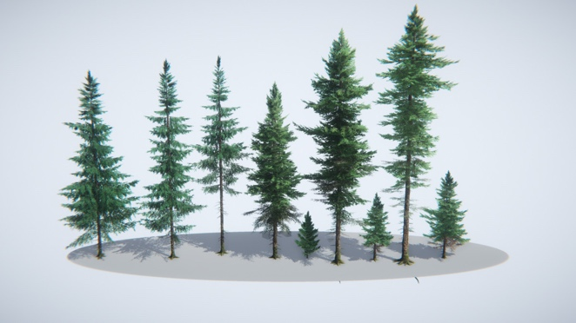

Level Design

Different holes will be different environments with their own variations of terrain, wind speed, and environment. This allows the player to get a feel for different textures and playing fields, avoid the large sets of trees, sand traps, and fall off the edge!



# Audio

Sound of driver, putter, irons, wedge, and wood hitting ball.

<https://www.bensound.com/royalty-free-music/track/jazzy-frenchy>

# Minimum Viable Product (MPV)

# <https://rijeka.sdsu.edu/cs583_21ft_team09/f21_proj_3a_golfalone>

# Wish List

* Wind Movements in Trees (**ADDED**)
* Sounds for impact and traveling
* Realistic ball physics (**ADDED**)
* Sandtraps

## Bibliography

**Assets:**

|  |  |
| --- | --- |
| Reason - Author | artwork - Upklyak - Freepik.com |
| item | https://www.freepik.com/free-vector/golf-course-on-lake-shore-with-man-and-cart_17681127.html |

|  |  |
| --- | --- |
| Reason - Author | Minigolf field sprites – Kennys.nl free assets |
| item | https://www.kenney.nl/assets/minigolf-kit |

|  |  |
| --- | --- |
| Reason - Author | game assets – cloth animation-based flags |
| item | https://assetstore.unity.com/packages/3d/props/exterior/cloth-animation-based-flag-65842 |

|  |  |
| --- | --- |
| Reason - Author | Menu artwork – freepik liscense |
| item | https://www.freepik.com/free-vector/flat-golf-swing-collection_1794122.htm |

|  |  |
| --- | --- |
| Reason - Author | Conifers – background and tree rendering |
| item | https://assetstore.unity.com/packages/3d/vegetation/trees/conifers-botd-142076 |

|  |  |
| --- | --- |
| Reason - Author | Grass flowers pack – unity store |
| item | https://assetstore.unity.com/packages/2d/textures-materials/nature/grass-flowers-pack-free-138810 |

|  |  |
| --- | --- |
| Reason - Author | Menu artwork – freepik liscense |
| item | https://www.freepik.com/free-vector/flat-golf-swing-collection_1794122.htm |

|  |  |
| --- | --- |
| Reason - Author | music – background music |
| item | https://www.bensound.com/royalty-free-music/jazz |

**Tutorials Used:**

|  |  |
| --- | --- |
| Reason - Author | Dynamics of Unity 3d game |
| item | https://www.youtube.com/watch?v=fvlakpubZQk |

|  |  |
| --- | --- |
| Reason - Author | Colliders and triggers |
| item | https://www.youtube.com/watch?v=6C4KfuW2q8Y |

|  |  |
| --- | --- |
| Reason - Author | How to make a Hole Game in Unity |
| item | https://www.youtube.com/watch?v=5qGE2PL9wwU&t=171s |