

Balkumari, Lalitpur

A

Minor Project Proposal

On

“**Discount Recommendation System Using K-NN Algorithm**”

**Project Members**

Biru Nayak (KIC076BCT010)

Dev Narayan Tajpuriya (KIC076BCT013)

Dibya Ghimire (KIC076BCT015)

Prabidhi Shrestha (KIC076BCT022)

**DEPARTMENT OF COMPUTER AND ELECTRONICS &**

**COMMUNICATION ENGINEERING**

**LALITPUR, NEPAL**

**August 2022**

**Abstract**

The document is to present a proposal for a bachelor’s project which seeks to display discount offer collection, provided by different companies, and different online businesses. Nowadays, the customer has to visit different websites for the different types of discounts offered by the different platforms. Therefore, the motivation behind this website is to provide a platform for users to get the discount offers announced by different companies or platforms. Our website is focused on those people who prefer online shopping. Our website is also focused on those people who like discounts the most. Not only this but our website is also focused on those people who want to buy more products and also want to save money and time. Our aim is to arrange available discounts in the market, and e-commerce, provided by the companies, etc. in a systematic way on one website. And, for the development of our website, we use HTML, CSS, Python, and Java script.

**Table of Contents**

Abstract………………………………………………………....…. 2

Table of Contents………………………………...………………... 3

List of Figures…………………………...……………………….... 4

List of Abbreviations…………………………...…………………. 4

1 Introduction…………………………...………………………… 5

1.1 Background.…………………………...……………….5

1.2 Problem Statement………………………….………….5

1.3 Objectives……………………………………………... 5

2 Literature Review…………………………...……………………6

3 Feasibility Study.…………………………...……………………7

3.1 Technical Feasibility …………………………...……...7

3.2 Financial Feasibility …………………………...………7

3.3 Schedule Feasibility …………………………...………7

3.4 Operational Feasibility …………………………...……7

4 Project Methodology…………………………...………………...8

4.1 Block Diagram………………………………………….8

4.2 Development Model…………………………...……....10

4.3 Use-case diagram………………………………………11

5 Implementation Plan …………………………...……………….11

5.1 Schedule …………………………...………………….11

5.2 Software Requirements…………………………...…...12

6 Expected Outcomes …………………………...………………...12

References…………………………...……………………………..13

**List Of Figures**

Figure 4.1 Block Diagram..........................................................................8

Figure 4.2 Modified Water Fall Model ………….....………...………...10

Figure 4.3 Use-case Diagram …………………………………………..11

Figure 5.1 Gantt Chart ………………………………………………… 11

**List of Abbreviations**

HTML Hypertext Markup Language

CSS Cascading Style Sheet

VS Code Visual Studio Code

K-NN K-Nearest Neighbour

**1. Introduction**

**1.1 Background**

As we know, discounts are very attractive to customers and may not only bring new clients but can also bring back previous customers. So, our website collects all the discount offers announced by the different platforms and provides them easily to the users and also recommends them. So, the users can easily get all the discount offers in one place. So it helps to save time and money for the users. The discount given in different categories like food items, stationery items, home appliances, fashion items, electronic gadgets, etc. by the different restaurants, dealers, etc. is also included on our website.

Our website is beneficial for both customers and sellers (like companies). The customer can easily get all the discounts announced in the market. And the number of customers of the companies also increases. Therefore, our website helps to increase the sales of different companies.

**1.2 Problem Statement**

It is hardly possible to visit the different websites of different companies, online business, e-commerce, etc. for getting a suitable discount offer which are available in the market. We cannot remember all the domains of the websites which are mentioned above or install all the applications where discount offers are available.

**1.3 Objectives**

To design and implement a website to manage and recommend all the discounts available in the market.

**2. Literature Review**

As technology has evolved, it has made the life of every individual easier. Nowadays, people have options and they try to choose the best one. So, we researched about the discount offers providing platform and some of the related projects.

Some of the related services available in Nepal like Daraz, eswa, foodmandu, khalti. All of these services were providing discounts in their individual platform. But as the technology is growing, people need more ease and features all at the same place. So our website is based on collecting all the discount available in the market.

Previous studies in marketing have shown that price discounts have both positive and negative effects on consumers’ buying behavior. It was identified that there are three routes of promotional effects: (a) economic, (b) informational and (c) affective. The final effect of a price promotion on purchasing decision is a combination of positive and negative economic, informational, affective influences[1].

According to Xia and Monroe (2009), their study resulted that consumers with a shopping goal are more responsive towards discount messages such as “pay less” and “discount” while consumers without shopping goal are responsive towards promotional messages such as “save more” and “free gift”. Xia and Monroe (2009, p.691) cited from (Monroe, 2003) that price promotion have several benefits such as to increase demand, adjust fluctuations in supply and demand, and increasing consumers’ purchasing over time [3].

The study of So, Wong and Sculli (2005) resulted that when there is the presence of discount offers, consumers will have higher intention to purchase in web-shopping; purchasing decisions and choice making from alternative evaluations can be made easily when there is the presence of discount offers[2].

**3. Feasibility Study**

**3.1 Technical Feasibility**

Our project is technically feasible as we use the latest programming language (python). Our website provides good service to both users and companies (who provide a discount to the public). The system, which is being developed in the latest web technology available, can efficiently use the resources available and maximize output.

**3.2 Financial Feasibility**

Our project is economically feasible as it uses low cost for development. As our project is totally based on software development (i.e. no use of hardware component). So, minimum cost is required for development of our website. We use different programming language (like python, html, etc.) which are the free source language. Therefore, we have not to pay the money for it. Thus, our project is financially feasible.

**3.3 Schedule Feasibility**

* Analysis
* Feasibility analysis- about 10 days
* Requirements specification-about 15 days
* Design- about 25 days
* Coding– about 128 days
* Testing and implementation – about 30 days
* Documentation-about 208 days

**3.4 Operational Feasibility**

The project once completed shall be useful to the company. The general difficulty level of the project has been kept low so as to ensure ease of operation. Our final project will be a web application and a user will need a computer/phone with an internet connection to utilize it

**4. Project Methodology**

**4.1 Block Diagram**

User

User

product

Figure 4.1: Block Diagram

We will be using KNN algorithm for recommendation system of our project.

**K-Nearest Neighbour** is one of the simplest Machine Learning algorithms based on Supervised Learning technique. This algorithm assumes the similarity between the new case/data and available cases and put the new case into the category that is most similar to the available categories. This algorithm stores all the available data and classifies a new data point based on the similarity. This means when new data appears then it can be easily classified into a well suite category by using K- NN algorithm.

K-NN algorithm works as shown in flowchart:

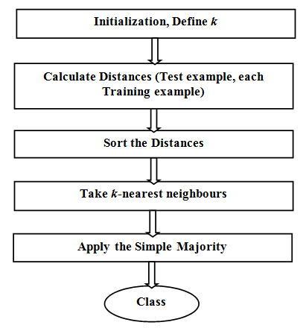

**Recommendation System using KNN**

A common task of recommender systems is to improve customer experience through personalized recommendations based on prior implicit(suggested) feedback. These systems passively track different sorts of user behavior, such as purchase history, watching habits and browsing activity, in order to model user preferences. Unlike the much more extensively researched explicit feedback, we do not have any direct input from the users regarding their preferences.

**Content-based Filtering Recommendation System**

One popular technique of recommendation systems is content-based filtering. Content here refers to the content or *attributes* of the products you like. So, the idea in content-based filtering is to tag products using certain keywords, understand what the user likes, look up those keywords in the database and recommend different products with the same attributes. It is based on the idea of recommending the item to user K which is similar to previous item *highly rated* by K.

Content-based algorithms are given user preferences for items and recommend similar items based on a *domain-specific* notion of item content. This approach also extends naturally to cases where item metadata is available (e.g., movie stars, book authors, and music genres).

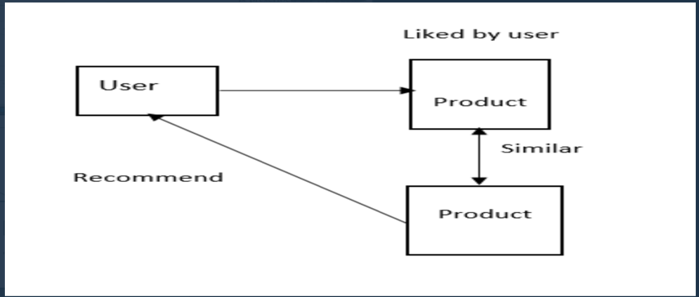

**4.2 Development Model**

# **Our project follows the modified waterfall model**

* **THE MODIFIED WATERFALL MODEL**

The steps of the typical waterfall model are:

1. Requirement Gathering
2. Design
3. Implementation
4. Testing
5. Operation and maintenance

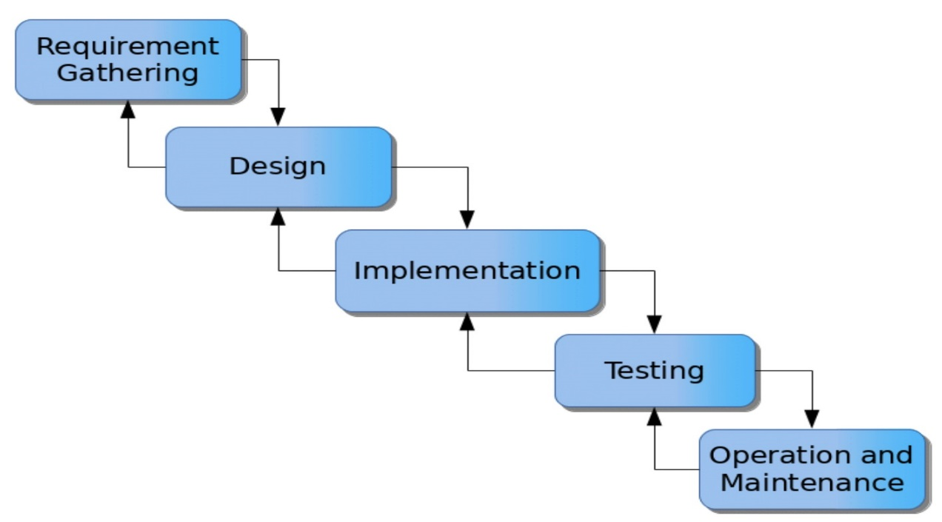

**[FIG 4.1: - MODIFIED WATERFALL MODEL [4]**

Waterfall model is a software development model, which was the first process model to be introduce by Dr. Winston W. Royce in a paper published in 1970. Above mentioned stages once completed cannot be jumped back to previous step in classical waterfall model.

So, to overcome this drawback, we are using modified water fall model to add a feedback system between stages. So that if any problem is found at one phase can cause remedial action to take at the previous step.

**4.3 Use-case Diagram**

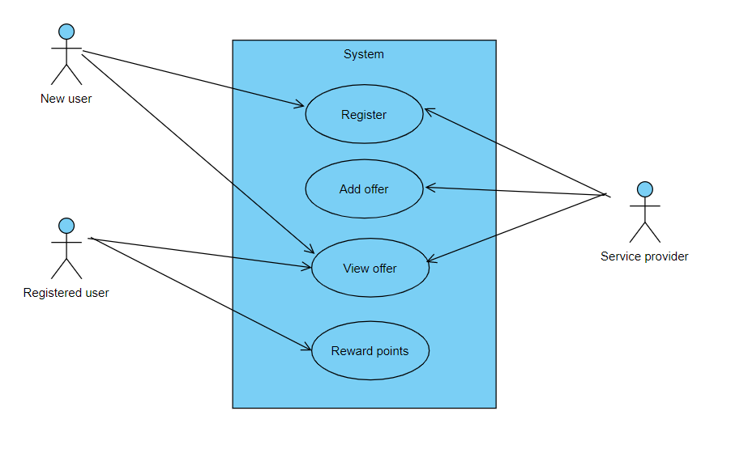

Figure 4.3 Use-case Diagram

**5. Implementation Plan**

**5.1 Schedule**

**Figure 5.1 Gantt Chart**

**5.2 Software Requirements**

* Python
* HTML
* CSS
* JAVASCRIPT
* VS code

**6. Expected Outcomes**

The following outcomes have been presumed for this project:

* A website provides all discount list available in the market and recommend to the user according to their preferences.
* The user-friendly environment to know about the discount.

**References**

[1] Shekhawat, Kanchan.4 April 2020.INTERNATIONAL JOURNAL OF CREATIVE RESEARCH THOUGHTS. Retrieved from﻿[https://ijcrt.org/papers/IJCRT2004117.pdf]

[2] Engel.Blackwell.21st september 2021.Literature Review on Online Shopping. Retrieved [https://www.ukessays.com/essays/marketing/literature-review-of-online-purchase-intention-marketing-essay.php]

[3] https://www.ukessays.com/essays/marketing/literature-review-of-online-purchase-intention-marketing-essay.php

[4] Reference Swami Sachchidanand Polytechnic College