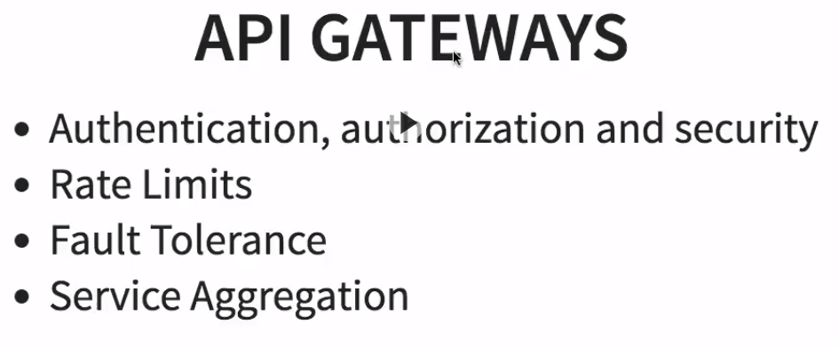

<http://localhost:9000/currency-exchange/from/USD/to/INR>

<http://localhost:8765/currency-exchange-service/currency-exchange/from/USD/to/INR>

<http://localhost:9100/currency-converter-feign/from/USD/to/INR/quantity/180>

<http://localhost:8765/currency-conversion-service/currency-converter-feign/from/USD/to/INR/quantity/180>