


AGILE COACHING
THE GAME


Version 1.0
August 14, 2016

Aim of the game
"Agile Coaching - the game is fun and encourages leaders (lateral, agile, becoming agile) and agile coaches to enter into conversation. The aim is to expand your own skills in agile systems through the exchange of experience and inspiration.
On the basis of examples, the players discuss options for action in different systems and evaluate them. The options for action should be worked out as specifically as possible.

Course of the Game
The game is played in five phases:
- Preparing the Game Table
- Describing the Company
- Selecting the Company
- Clarifying Function
- Reacting to Events
- Giving Feedback

Preparing the Game Table
The game is played with a minimum of three and a maximum of eight participants.
If more than four people are playing, some of them are playing in pairs, so that a total of four parties are playing. Single players and pairs are now referred to as subgroups.
Each subgroup receives the following material:
- 1 game block
- 1 pen
- Game Pieces of one color:
  - 1 rocket
  - 1 fish
  - 1 game piece (round) for each player

In the middle of the table, all the cards are placed as piles face-down. This is also where you put the PostIt block.

Selecting the Company

Defining the Company
Reveal a Selection card and an Organization card. Read these out loud. The task now is, to construct a company that is as coherent as possible and that fits well with the transition task described by the Selection card.
Next, turn over two Mission cards. Read these cards aloud as well. Now use your round game piece to select the mission that best matches the Organization and Selection card. If there is a tie, turn over another Mission card, read it out and choose between the three cards. The card with the most votes will lead to the description of your company.
Repeat the voting process with two method cards. Choose the method card that best matches the set of organization and mission card.
Finish your company selection with a choice between two Culture cards. The same voting rules apply as for the Mission cards. Choose the card that matches best the Organization, Selection, Mission and Method cards.

Describing the Company
You have now put together a company. Tell each other exactly what it's like in this company.
- What are typical sayings?
- How do employees often act?
- What would be a total break in corporate culture?
Note your comments on the A4 sheet in the middle of the game table. This will serve as a reminder for subsequent events.


Reacting to Events
You play a total of five events in the company.

Choose a Role in the Company
Draw the top card from the "Role" deck and place it next to the description cards. Your role in the company is now set for this round.
Place the function card next to it. You start with the side "You coach the role".
You read the role out loud. If necessary, explain to each other which tasks are performed by this role in the chosen company. You can make a note of this on the A4 sheet.

Events in the Company

Reading out the Event
Draw the top event card and read it out loud. If necessary, clarify how the event card is to be interpreted for the company created.

Developing Options for Action with the Greatest Leverage
Describe an option for action with the greatest leverage for you in the named function (coach or role). An action option can contain several measures. These must be formulated coherently.
You summarize this option in writing (in bullet points) on your rating pad.
The longest serving game group (on average) is first to present its biggest leverage. Questions are allowed in order to understand the proposed measures. Then all other groups follow in descending order of seniority.
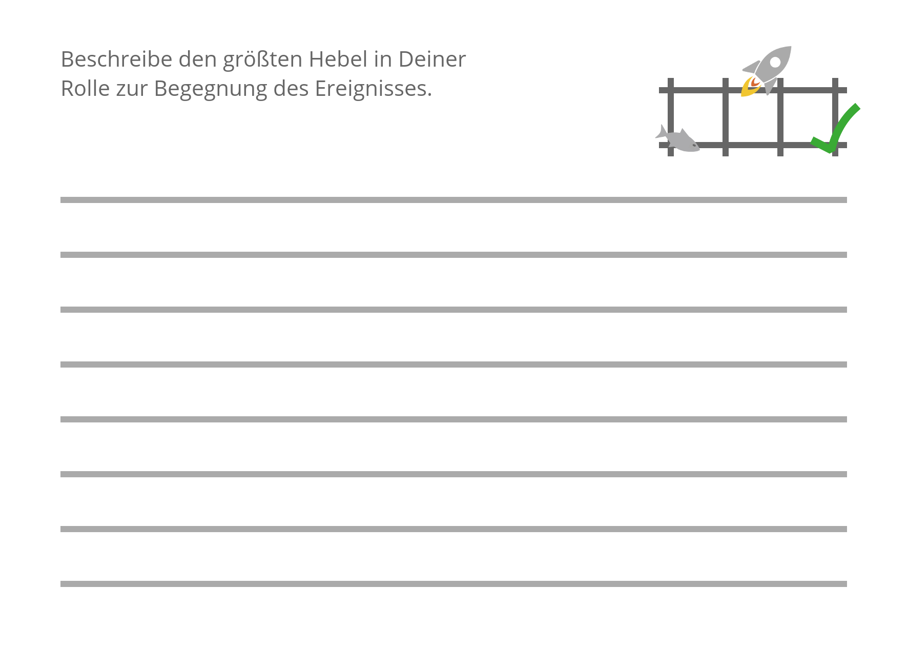

After all options for action have been presented, you rate them according to the following pattern:
- Place your rocket on the action option that you consider to have the greatest leverage in response to the event.
- Place the fish on the action option that most reminds you of an action you have already experienced.
All subgroups note the number of pieces they have received on their rating pad.

Explaining the Ratings
Explain to each other why you have made the ratings (rocket, fish).

Optional: Giving Feedback
Cross the square with the hook on the rating pad to note if you have had any special insights as a result of the developed options for action or the explanations of the assessments.
Share these insights in the group (or thank the initiator / Pulse generator).

Determining the Next Event
You decide by consensus in the group whether you want to draw a new role card or a new event card. You can also decide by consensus whether you would like to act in the role drawn or as an agile coach for the next round. Turn the function card over accordingly.
Discard the corresponding old card and draw a new one. The game begins with V.1. or V.2.

Feedback
At the end of the fifthevent, you can use the room to give feedback to all your fellow players - for example, feedback on the contributions and any "aha" moments you had.

License
This game is licensed under Creative Commense License
CC-BY-NC-SA by Judith Andresen (judithandresen.com).

You are free to:
- Share - copy and redistribute the material in any medium or format
- Adapt - remix, transform, and build upon the material for any purpose, even commercially.
The licensor cannot revoke these freedoms as long as you follow the license terms.

Under the following terms:
- Attribution - You must give appropriate credit, provide a link to the license, and indicate if changes were made. You may do so in any reasonable manner, but not in any way that suggests the licensor endorses you or your use.
- ShareAlike - If you remix, transform, or build upon the material, you must distribute your contributions under the same license as the original.
- No additional restrictions - You may not apply legal terms or technological measures that legally restrict others from doing anything the license permits.

