Fundamentals of Databases

Entity-relationship diagram exercises

Group members:

Piotr Kaźmierski (217847)

Piotr Kocik (217848)

Kacper Kubicki (217849)

Michał Kuśmidrowicz (217850)

IT IFE

Monday, 12:15

# Exercise 1

Design database schema for a hotel network with the following assumptions:

1. Hotels are located in different cities.
2. In some cities there may be located several hotels of that network.
3. Each employee of the network has got a particular job title and is employed in a particular city.
4. The customer books a room in a particular hotel for a certain number of people and a certain number of days from the date stated.

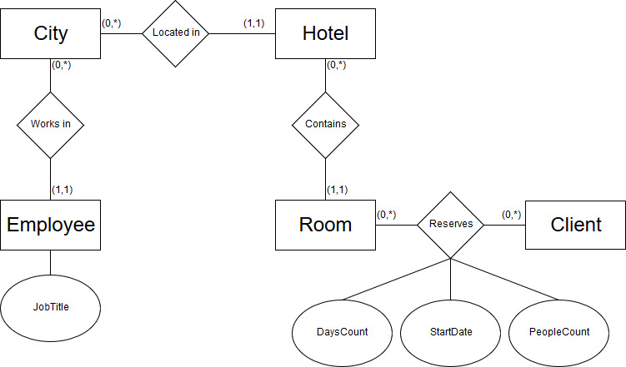

# Exercise 2

Design a database schema for a language school with the following assumptions:

1. The school leads courses in several languages at different levels.
2. School teachers can teach in different languages.
3. The group has got a defined schedule of classes defined by the number of days and start times.
4. Number of hours and their frequency is defined for the level (e.g. advanced level 3 x 2h).
5. The days on which classes are held, are assigned to a given language group.
6. The group is assigned to one teacher.

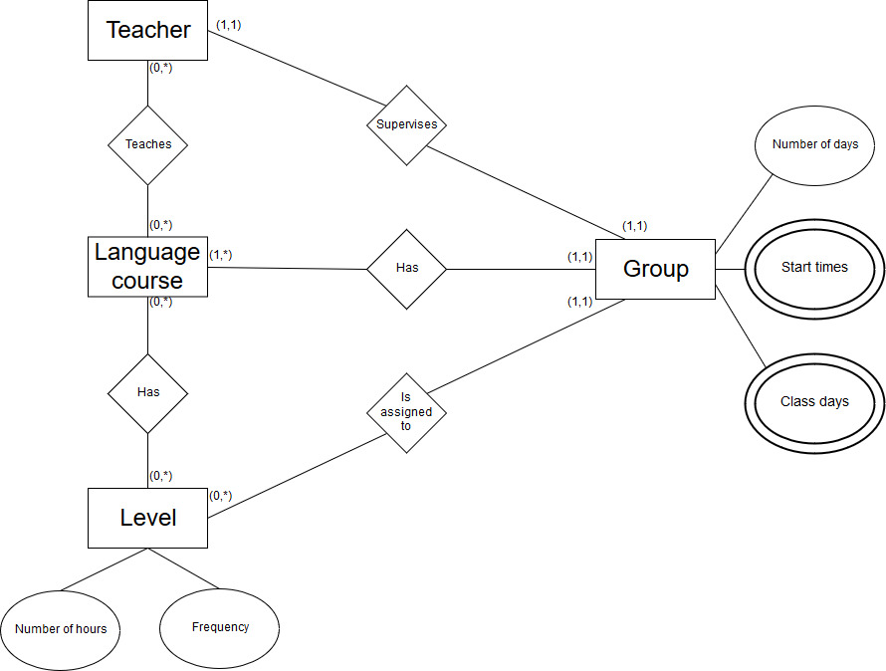

# Exercise 3

Design a database schema for a health center with the following assumptions:

1. The doctors have got different specialties - every doctor has a particular specialty.
2. The patient is assigned to a particular GP (general practitioner / family doctor is one of the specialties).
3. The patient can make an appointment to any doctor for a particular day and time.
4. Within each specialty the patient has set up a patient card on which course of treatment is recorded: dates of visits and recommendations.

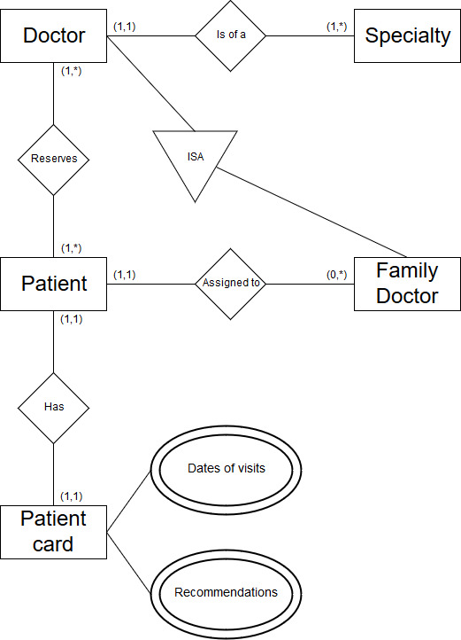

In this example each patient should be assigned to one family doctor, so we decided to apply “ISA” block to determine which doctor possesses such specialty.

# Exercise 4

Design a database schema for a housing association with the following assumptions:

1. There are many associated residential buildings .
2. There are many apartments in each building
3. A particular number of registered tenants occupies a particular apartment. One of tenants is a member of the association /
4. cooperative.
5. There are charges for apartments regularly paid. the date and size of the impact are to be stored.
6. Tenants are also charged for additional services associated with the apartments: a garage, a basement room, a parking space, etc.

# 

In this task we assumed that there is one association member per apartment, so we applied “ISA” block (to determine which tenant is a member) and relation one-to-one between the member and the apartment. Another “ISA” block is used to differentiate regular and additional charges.

# Exercise 5

Design a database schema for cookery book with the following assumptions:

1. Dishes are prepared with specified ingredients in specified amounts.
2. Dishes have got well-defined categories (e.g. soups, appetizers, etc.)
3. Meals have a certain degree of difficulty and preparation time.
4. You can specify the occasion on which food is selected as appropriate (e.g. Christmas dinner, dinner for two, a party for children, etc.)

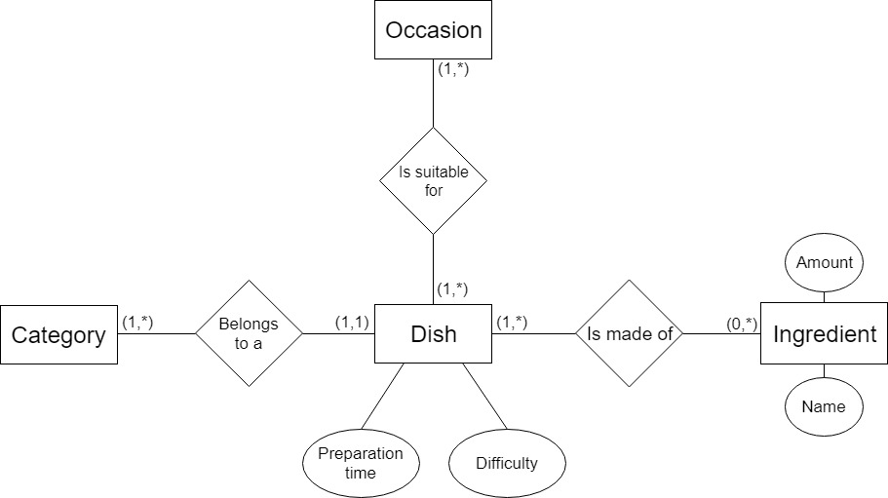

# Exercise 6

Design a database schema for the zoo with the following assumptions:

1. Animals at the zoo are located in cages.
2. There can be more than one animal one particular species in one cage.
3. Animals are distinguished - each of them has a name and date of birth.
4. Zoo employees take care of several cages.
5. Animals of particular species have a defined graphic of operations defined by the time of its execution and the name.

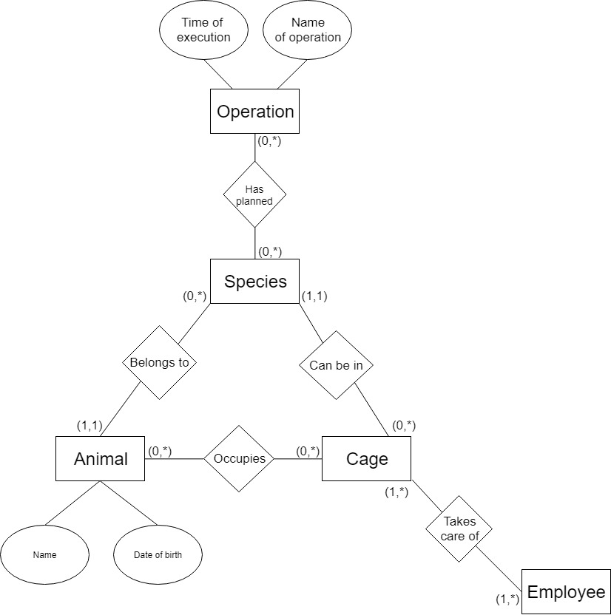

# Exercise 7

Design a database schema for a dating agency with the following assumptions:

1. Information about registered people (name, surname, address, color of eyes, height, etc.) is stored in the database.
2. Clients have got different traits determining their character. These traits are described by a number in a scale of 10 degrees.
3. Clients have got different interests / hobbies chosen from the available list.
4. Further interests and character traits can be added.
5. The database stores the information about a pair matchmaking: who, with whom, the date of the meeting, the status (e.g. "before the date, " "success" "failure")

# 

In this example we decide to present matchmaking as a recursive one-to-many relation, because dating portals are constructed in such way, that each client is able to find many potential partners.

# Exercise 8

Design a database schema for a company storing information on the employment with the following assumptions:

1. Each employee has got one particular job at any given time.
2. The salary is associated with the job. Employees get their payments once a month - the system stores data about the date and
3. amount paid.
4. The employee may change the job. The system stores all the jobs taken by the employee.
5. There are duties defined in the database, which are related to jobs.

# 

In this task there is one relation describing current and past jobs of each employee. We introduced starting and ending time of each job as a relation argument, so as to distinguish them (in this case current job can be also easily distinguished, because it simply does not have ending time).

# Exercise 9

Design a database schema for rent apartments agency with the following assumptions:

1. The names of clients (owners and renters) and the renting time (the start date and the end date) are to be stored.
2. Each apartment has got a particular rental price , which can change in time. I
3. There are additional costs the renter has to pay for: water used, electricity, gas, etc. They are calculated on consumption.

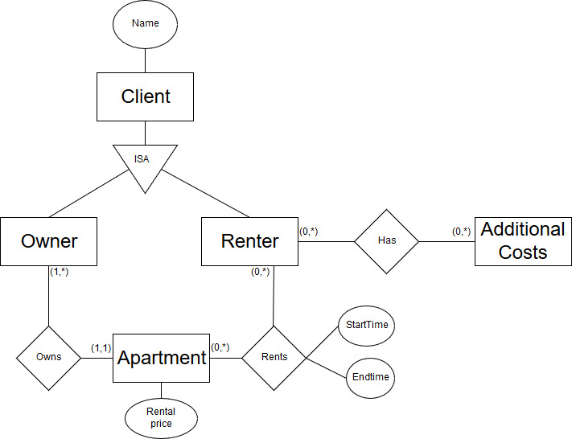

# Exercise 10

Design a database schema for employment agency with the following assumptions:

1. The clients of the agency are either employers or unemployed (job seekers).
2. A person, who is looking for a job, gives his / her data (gender, age, education) and preferences: job name, the minimum
3. salary.
4. The employer shall provide the company name and address and information about the offer: job name, salary, required
5. education, age, gender, ...
6. The information about matchmaking (who and where) is to be stored in the database.

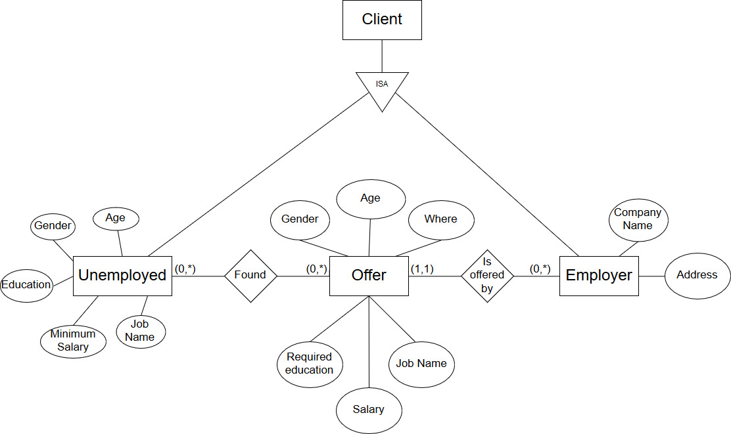

In this example there is no direct relation between unemployed and employer. Employer is able to ‘spawn’ entities of offers with desired requirements which can be found by unemployed.

# Exercise 11

Design a database schema for recording the presence of students with the following assumptions:

1. The student is to attend classes in specific courses.
2. There are many laboratory groups within a given subject (the student belongs to one of them).
3. The classes for students are conducted by university staff - each employee can conduct classes in various courses.
4. The presence of students is recorded for each class of the course.

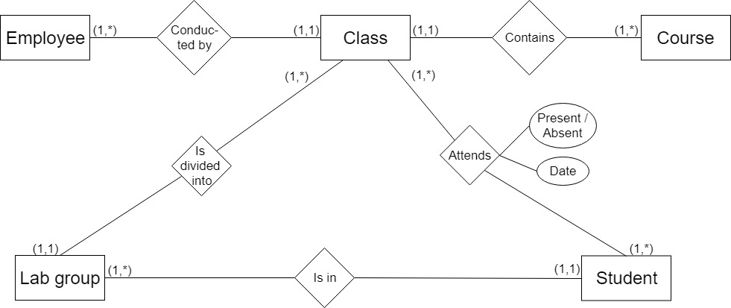

# Exercise 12

Design a database schema for drugstore with the following assumptions:

1. Drugs (medicines) belong to different categories (antibiotics, analgesics, vitamins, etc.) - a drug may belong to several different categories.
2. Medicines are linked to the diseases (a cold, headache, hypertension, etc.).
3. Each drug has a specific active substance - the specific substance can occur in many medicines.
4. The drug has a manufacturer, but it may happen that the same drug may produce several manufacturers.
5. Some medicines require a prescription - information about prescription drugs must be included in the database.

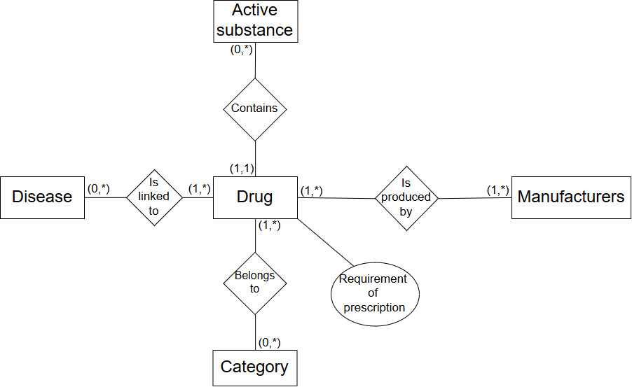

# Exercise 13

Design a database schema for a library with the following assumptions:

1. Library lends different titles (books). There may be many copies of the same title - each has its own unique number.
2. Books are written by authors - some books have a few of them.
3. Books can be borrowed for a particular period (2 weeks, month, ...)
4. The reader can borrow several books. All the books can be returned at the same, but they can be returned separately.

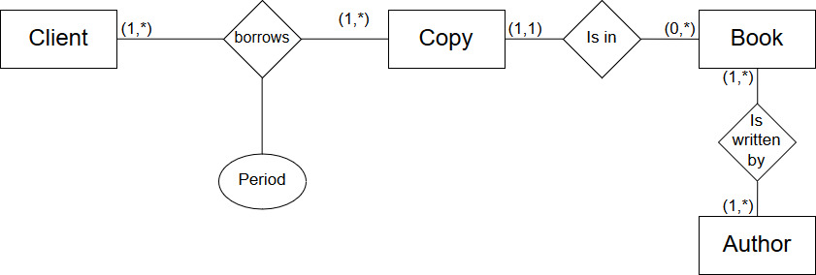

# Exercise 14

Design a database schema for cinema (multiplex) with the following assumptions:

1. Movies are divided into categories - the movie can belong to several categories simultaneously (e.g. family / comedy)
2. Movies are displayed in different rooms of multiplex cinemas. A movie can have many sessions in different rooms.

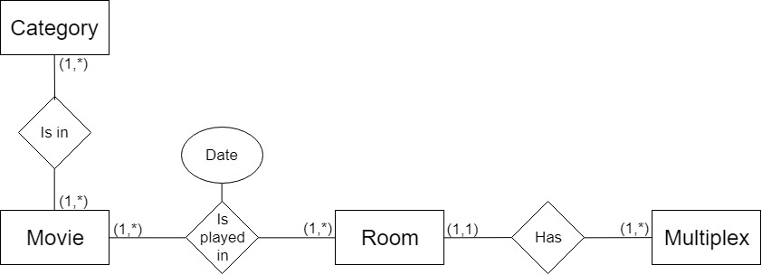

# Exercise 15

Design a database schema for hospital patients registration with the following assumptions:

1. Patients are registered for a specified time and for a particular hospital ward.
2. Doctors are assigned to the ward. One of the doctors is the head of his division (ward).
3. The patient is assigned to a particular doctor.

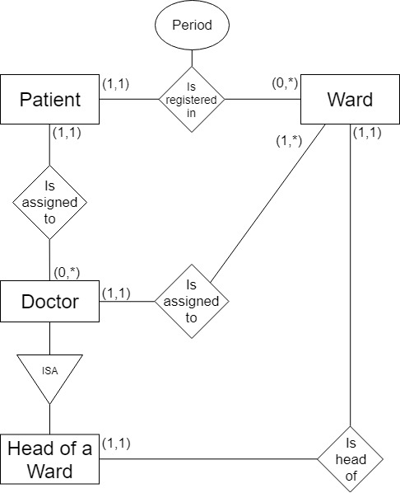

In this task there should be one head of ward per ward, so we applied “ISA” block (to determine which doctor is a head of ward) and relation one-to-one between the head of ward and the ward.

# Exercise 16

Design a database schema for movies with the following assumptions:

1. The movie is assigned to a director.
2. Different actors plays in a particular movie.
3. The movie is based on a script / a book. Several movies may be based on the same source.

