CREATE DATABASE test_f9;

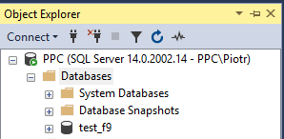

USE test_f9;

CREATE TABLE BANDS (

band_id INTEGER PRIMARY KEY,

name VARCHAR(40),

origin_country VARCHAR(50),

formed_year INTEGER

);

SELECT COUNT(*);



INSERT INTO BANDS (band_id, name, origin_country, formed_year)

VALUES (1, 'The Beatles', 'England', 1960);

SELECT * FROM BANDS;

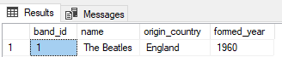

SELECT COUNT(*);



CREATE TABLE MEMBERS (

member_id INTEGER PRIMARY KEY IDENTITY(100, 1),

band_id INTEGER,

surname VARCHAR(60),

name VARCHAR(50),

);

ALTER TABLE MEMBERS ADD

CONSTRAINT fk_members_bands FOREIGN KEY (band_id) REFERENCES BANDS(band_id)

DECLARE @band INT;

SELECT @band = band_id

FROM BANDS

WHERE name = 'The Beatles';

INSERT INTO MEMBERS (band_id, surname, name)

VALUES (@band, 'Lennon', 'John');

INSERT INTO MEMBERS (band_id, surname, name)

VALUES (@band, 'McCartney', 'Paul');

INSERT INTO BANDS (band_id, name, origin_country, formed_year)

VALUES (2, 'Queen', 'Great Britain', 1971);

DECLARE @band INT;

SELECT @band = band_id

FROM BANDS

WHERE name = 'Queen';

INSERT INTO MEMBERS (band_id, surname, name)

VALUES (@band, 'Mercury', 'Freddie');

ALTER TABLE BANDS ADD CHECK (formed_year >= 1920);

INSERT INTO BANDS (band_id, name, origin_country, formed_year)

VALUES (3, 'Louisiana Five', 'United States', 1917);

Msg 547, Level 16, State 0, Line 1

The INSERT statement conflicted with the CHECK constraint "CK__BANDS__formed_ye__3D5E1FD2". The conflict occurred in database "test_f9", table "dbo.BANDS", column 'formed_year'.

The statement has been terminated.