1. Use test_empl schema: Run test_empl_schema.sql script to create the database and tables. Then run test_empl_data.sql to populate this database with data.

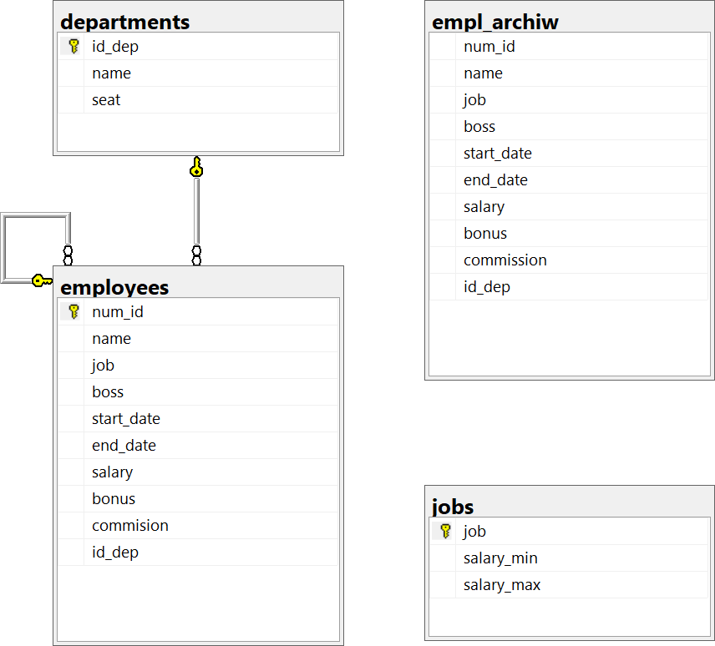

1. Get names and salaries of employees.

SELECT name, salary

FROM employees;

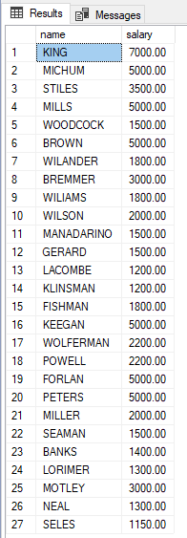

1. Get names and daily salaries of employees.

SELECT name, salary/30

FROM employees;

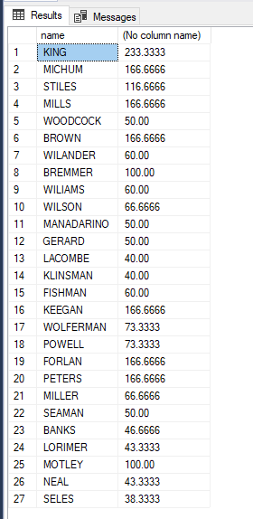

1. Get names and yearly salaries of employees.

SELECT name, salary*12

FROM employees;

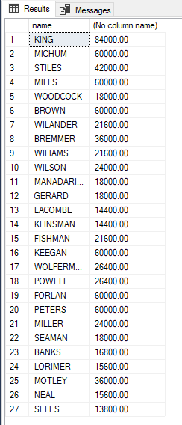

1. Get the minimal salary in the table employees.

SELECT MIN(salary)

FROM employees;

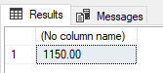

1. Get the name, job, and salary of the employee with the smallest salary.

SELECT name, job, salary

FROM employees

WHERE salary = (

SELECT MIN(salary)

FROM employees

);

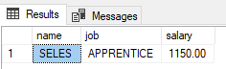

1. Get names, jobs and salaries of employees who earn less than the average salary in the enterprise.

SELECT name, job, salary

FROM employees

WHERE salary < (

SELECT AVG(salary)

FROM employees

);

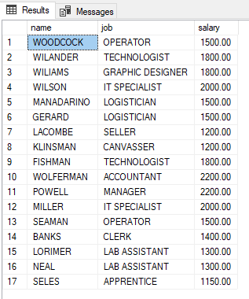

1. For each department get the number of employees.

SELECT id_dep, COUNT(*)

FROM employees

GROUP BY id_dep;

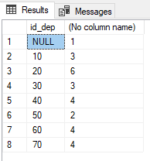

1. For each department and for each job get the number of employees. ORDER BY is optional here, but makes the results easier to read.

SELECT id_dep, job, COUNT(*)

FROM employees

GROUP BY id_dep, job

ORDER BY id_dep;

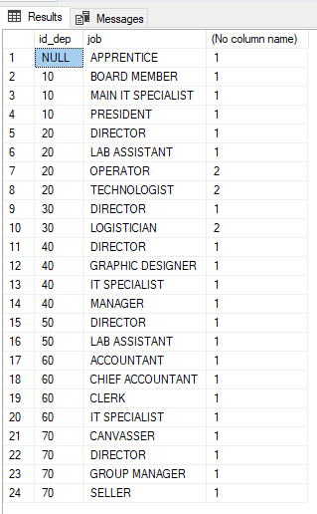

1. Get names and salaries of employees who earn more than any employee working in department 30.

SELECT name, salary

FROM employees

WHERE salary > (

SELECT MAX(salary)

FROM employees

WHERE id_dep = 30

);

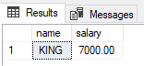

1. For every employee get his name, salary and the difference between his salary and the average salary in the enterprise.

SELECT name, salary, salary - (

SELECT AVG(salary)

FROM employees

)

FROM employees;

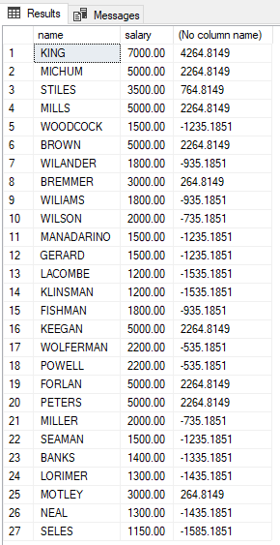

1. For every department get its name and the average salary
2. Get the name, id_dep and salary of employees who earn more than the average salary in their departments
3. Get the names of employees who have subordinate employees
4. Get the identifier and the name of the department without employees
5. Insert a new employee with the following attributes: (num_id -9781, Name -Hurst, job - ACCOUNTANT, boss - 9235, start_date - today, salary 1150, id_dep – 70)
6. Insert a new employee with the following attributes: (num_id -9781, Name -Cooper, job - LOGISTICIAN, boss - 9332, start_date - today+12 days, salary 1200)
7. Change the job operators to sellers in department 20 and increase their salary by 10%
8. For all employees who have subordinate employees increase the bonus by 10% of the smallest salary
9. Delete the logistician with the shortest period of employment