**Use Case Description**

|  |  |  |
| --- | --- | --- |
| **Use Case** | **Actor** | **Action** |
| Search for products | Buyer | Searches for products by category or keyword. |
| View product information | Buyer | Views detailed information about the products. |
| Buy products | Buyer | Initiates purchase transactions for desired products. |
| Comment on products | Buyer | Leaves comments on product pages. |
| Contact seller | Buyer | Contacts the seller for more information about the product. |
| Rate products | Buyer | Rates the products based on their experience. |
| Respond to transactions | Buyer | Responds to transaction updates from sellers. |
| Sell products | Seller | Posts product information and manages listings. |
| Manage posts | Seller | Edits or removes their own product listings. |
| View transaction history | Seller | Views the history of transactions made. |
| Manage transaction status | Seller | Updates the status of transactions. |
| Manage system | Administrator | Oversees and manages the entire application system. |
| Review products | Moderator | Reviews product listings for compliance with guidelines. |
| Review violation reports | Moderator | Reviews reports of violations submitted by users. |
| Ban violators | Moderator | Bans users who violate the application’s terms after successful review. |

**Use Case Diagram**

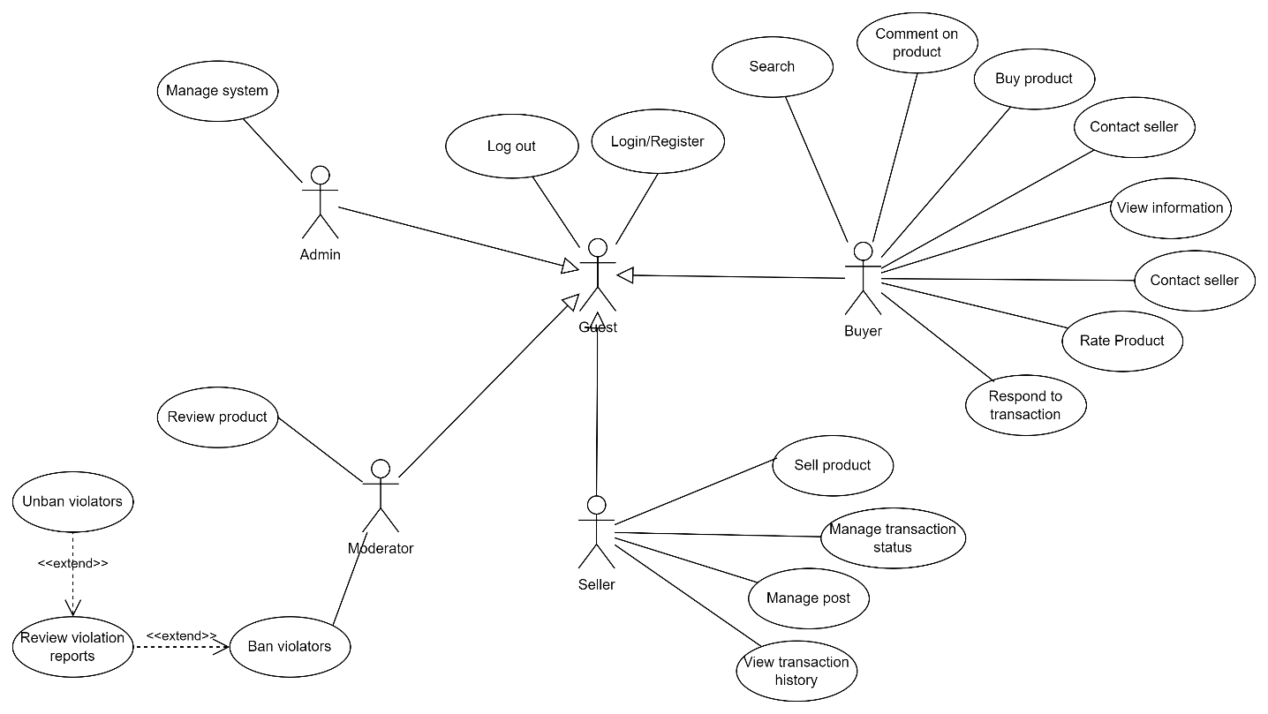

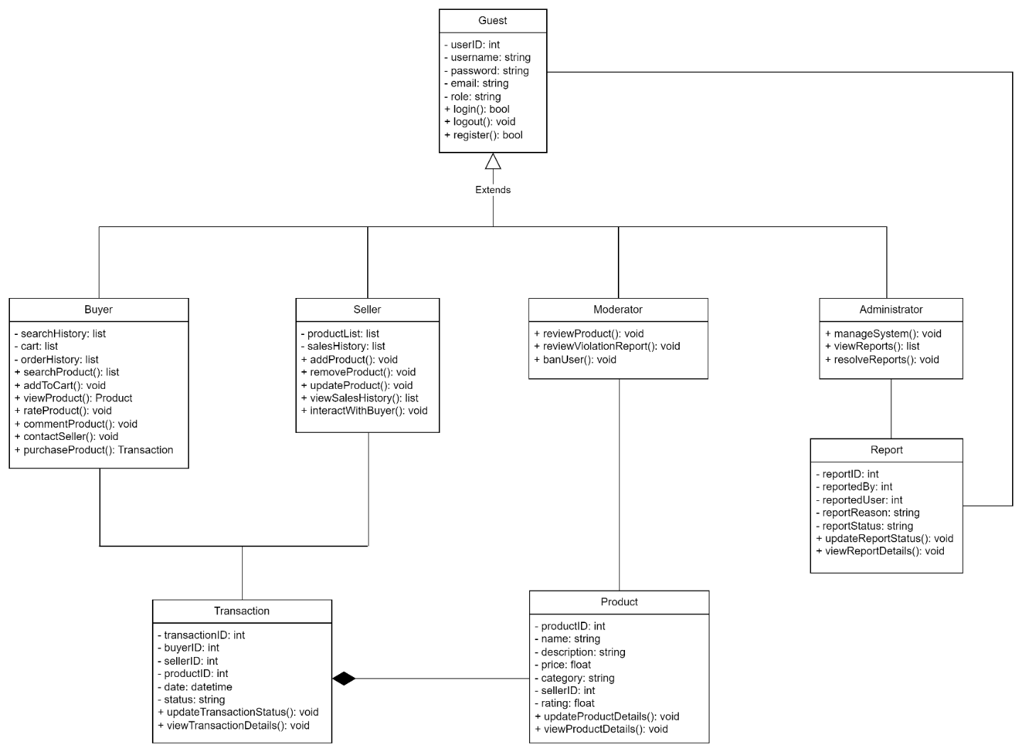**Class Diagram**