1. What is software? What is software engineering?

* Software

Software is set of instruction , data or programs used to operate computers and execute specific tasks.

It is just another term for a computer programme and a programme is a set of instructions that tells the device how to perform.

Examples: MS word,excel,power point ,spread sheets,etc.

* Software engineering

Software engineering is the brach of computer science that deles with the design, development, testing and maintenance of software applications.

Software engineering is typically used for large and intricate software systems rather than single application or programs.

Example: Network control systems, operation systems.

2. Explain types of software

1.**System** Software

* Operating System
* Language Processor
* Device Driver

2.**Application** Software

* General Purpose Software
* Customize Software
* Utility Software

**1.System Software**

System software is software that directly operates the computer hardware and provides the basic functionality to the users as well as to the other software to operate smoothly.

**Types of System Software**

**Operating System:**

It is the main program of a computer system. When the computer system ON it is the first software that loads into the computer’s memory.

Examples of operating systems are Linux, Apple macOS, Microsoft Windows, etc.

**Language Processor:**

As we know that system software converts the human-readable language into a machine language and vice versa.

**Device Driver**:

A device driver is a program or software that controls a device and helps that device to perform its functions.

**2.Application Software**

Software that performs special functions or provides functions that are much more than the basic operation of the computer is known as application software.

**Types of Application Software**

**General Purpose Software**:

This type of application software is used for a variety of tasks and it is not limited to performing a specific task only.

For example, MS-Word, MS-Excel, PowerPoint, etc.

**Customized Software:**

This type of application software is used or designed to perform specific tasks or functions or designed for specific organizations.

**Device Driver:**

A device driver is a program or software that controls a device and helps that device to perform its functions.

3. What is SDLC? Explain each phase of SDLC

* SDLC stands for Software Development Life Cycle

SDLC is the cost-effective and time-efficient process that development teams use to design and build high-quality software.

Saven phases of SDLC

* Planning
* Analysis
* Design
* Development
* Testing
* Implementation
* Maintenance

**Planning**: The organization identifies the need for a new system and defines its objectives and scope during this stage. A feasibility study is carried out to determine whether or not the project is feasible and the resources required.

**Analysis**: During this stage, the organization collects and analyses the system requirements. Gathering requirements from stakeholders and developing a detailed system specification are part of this stage.

**Design**: The system design is created during this stage, which includes the software and hardware architecture, database design, user interfaces, and system security.

**Development**: This stage entails the actual coding and development of the system based on the previous stage's design. Developers design, develop, debug, and test the system.

**Integration** & **Testing**: The system is tested during this stage to ensure that it meets the requirements and functions as expected. To validate the system, various types of testing are performed, including unit testing, integration testing, and acceptance testing.

**Implementation**: The system is installed and deployed in a live environment for end-users to use at this stage. The system is deployed in a production environment and used by customers and end users.

**Maintenance**: After the system has been deployed, this stage entails providing support for it. The system may require maintenance and bug fixes, as well as the addition of new features based on customer feedback.

4. What is DFD ? Create a DFD diagram on Flipkart

DFD stands for Data Flow Diagram

DFD maps out the flow of information for any process or system.

It uses defined symbols like rectangles, circles and arrows, plus short text labels, to show data inputs, outputs, storage point and the routes between each destination.

Diagram:

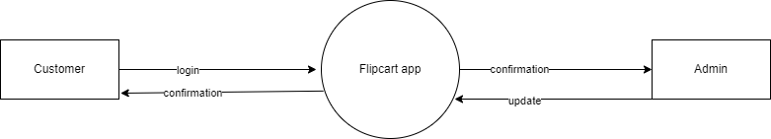

[ fig: Flipkart DFD level-0]

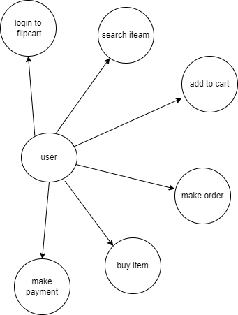

[fig: Flipkart DFD level-1]

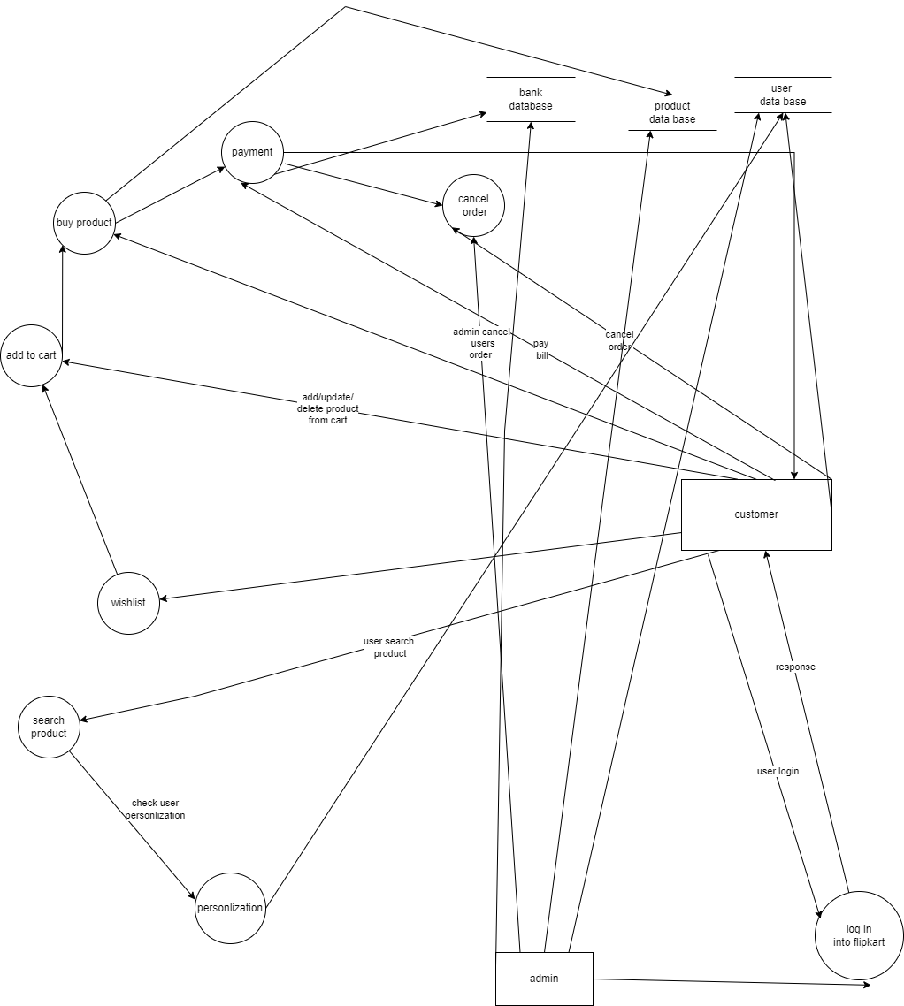

[fig: Flipkart DFD level-2]

5. What is Flow chart? Create a flowchart to make addition of two numbers.

A flow chart is a type of diagram that represents a workflow or process.

A flowchart can also an algorithm a step by step approach to solving a task.

They are used to understand, analyze and optimize processes in a range of industries, including software development, engineering ,business and education.

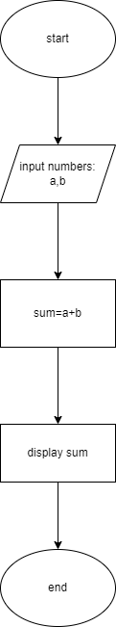

[ fig: flowchart for add two numbers ]

6.what is use case diagram? Create a use case on bill payment on paytm.

Use case diagrams describe the high level function and scope of a system.

The use case and actors in use case diagrams describe what the system does and how the actors use it, but not how the system operates internally.

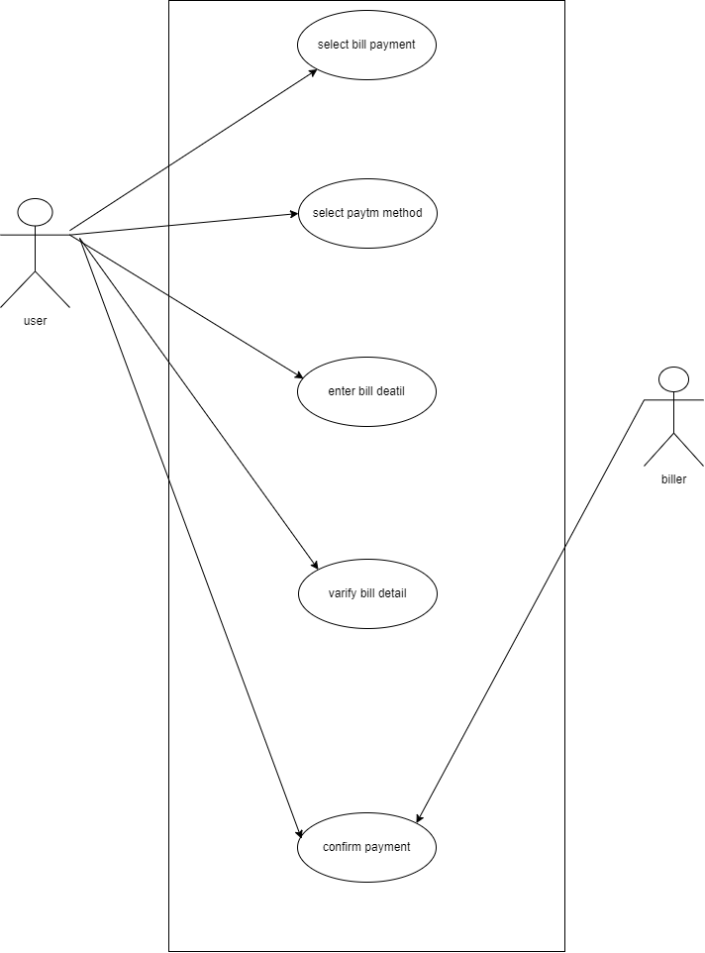

[ fig: use case diagram on bill payment on paytm ]