Micro Project Report
---------------------------------------------------------------------------------------------------------------------------------------------------

Mobile Phone Shop
Management System
---------------------------------------------------------------------------------------------------------------------------------------------------
Submitted by:
Angel Joseph
Roll No: 13
Integrated MCA S3

Under Supervision of:
Jobin T. J
Subject teacher


DEPARTMENT OF COMPUTER APPLICATIONS
AJCE
Overview
This Mobile Shop Management System in C Language is a consoled based application created using c programming language. It is a part of the mini project going in the Computer Applications Department (S2, Integrated MCA), AJCE.

Purpose
The Mobile Store Management System was created specifically for the purpose of entering records for mobile phones in mobile showrooms. The user can conveniently save mobile records according to their brands in this system. At any time, the user can add, update, or view a mobile’s record. Records are organized in a logical manner, with their availability status, quantity, and prices indicated. The program is useful for those who are dealing with managing a mobile phone shop by providing most accurate and relevant details

Objective
The final goal of the project was twofold.
- Easy assess of all the records of the management.
- Save time of the administration.
Functionalities Used
- Add Mobile – For the add mobile, the user can add new mobile information.
- Display Mobile – For the display mobile, the user can view their mobile added.
- Search Mobile – For the search mobile, the user can search the mobile name.
- Delete Contents-For the deletion of the information of the mobile added.

- Customer Information -For adding and displaying the purchase details of a customer .
- Exit – For the exit, the user can also exit in the system.
Source code
#include<string.h>
#include<stdio.h>
#include<stdlib.h>
#include<windows.h>
struct node
{
int Id;
char Model[100];
char Color[100];
char Processor[100];
char kp[100];
float Price;
long long int pho;
struct node *next;

}* Mobile;
struct node * head;
struct node * temp;

int main()
{

system("color 3");
char l;

int f,n,choice,m;
int r;
start:
system("cls");
printf("\n\n\t\t\t\t\t\t \xB2\xB2\xB2\xB2\xB2\xB2\xB2\xB2\xB2\xB2\xB2\xB2\xB2\xB2\xB2\xB2\xB2\xB2\xB2\xB2\xB2\xB2\xB2\xB2\xB2\xB2\n");
printf("\n\t\t\t\t\t\t WELCOME TO MOBILE PARADISE");
printf("\n\n\t\t\t\t\t\t \xB2\xB2\xB2\xB2\xB2\xB2\xB2\xB2\xB2\xB2\xB2\xB2\xB2\xB2\xB2\xB2\xB2\xB2\xB2\xB2\xB2\xB2\xB2\xB2\xB2\xB2\n");

printf("\n\n\n\n\t\t\t1.Admin Login");
printf("\t\t\t2.Customer Login");
printf("\t\t\t3.Exit");
printf("\n\n\n\n\n\n\t\t\t\t\t\tChoose option : ");
scanf("%d",&n);

switch(n)
{
case 1:
system("color f2");
printf("\n\n\tEnter username : ");
scanf("%d",&r);
printf("\n\tEnter Password : ");
scanf("%d",&f);
if(r==1234 &&f==1234)
{
char k;
system("cls");

// Car = NULL;

do
{ system("color f5");
int choice;
printf("\n\n\n\n\t\t\t\t\t1. Add Content");
printf("\n\n\t\t\t\t\t2. Display Content");
printf("\n\n\t\t\t\t\t3. Search Content");
printf("\n\n\t\t\t\t\t4. Delete Content");
printf("\n\n\t\t\t\t\t5. Customer details");
printf("\n\n\t\t\t\t\t6. Exit");
printf("\n\n\t\t\t\t\t\tEnter Choice: ");
scanf("%d", &choice);
switch (choice)
{
case 1:
add();
break;
case 2:
printf("\n\n\n\t>\tId\t\tModel\t\tColor\t\tProcessor\t\tPrice ");
display();
break;
case 3:
search();
break;
case 4:
deletee();
break;
case 5:
customer_();
break;
case 6:
goto start;
break;
case 7:
exit(0);

}
//printf("press any key to continue or 7 to exit");
}
while(choice!=5);
}
else
system("color 4");
printf("\n\tIncorrect username or password..!!!\n\n");

break;

case 2:
do
{
system("color f3");
printf("\n\n\n\t\t\t1.Display Mobile");
printf("\n\n\t\t\t2.Search Mobile");
printf("\n\n\t\t\t3.To buy a mobile");
printf("\n\n\t\t\t4.Exit");
printf("\n\n\n\t\t\t\t\tEnter the choice:");
scanf("%d",&m);
switch(m)
{
case 1:
display();
break;
case 2:
search();
break;
case 3:
buy();
break;
case 4:
goto start;
}
}
while(m!=5);

break;

case 3:
printf("\n\n\t\t\t\t\tThank You For visiting MOBILE PARADISE...!!!\n\n\n");
break;

default:
system("color 4");
printf("\n\n\t\t\tInvalid Input...!!!\n");
break;
}

}

void add()
{
int choice;
char Model[100];
char Color[100];
char Processor[100];
int Id;
float Price;
struct node * ptr;
ptr=(struct node*)malloc(sizeof (struct node));
printf("\n\n\t\tEnter Id : ");
scanf("%d", &Id);
ptr->Id=Id;
printf("\n\t\tEnter Model : ");
fflush(stdin);
gets(Model);
strcpy(ptr->Model,Model);
// ptr->Model=Model;
printf("\n\t\tEnter Color : ");
// scanf("%s[^\n]",&Color);
fflush(stdin);
gets(Color);
strcpy(ptr->Color,Color);
printf("\n\t\tEnter processor : ");
fflush(stdin);
gets(Processor);
strcpy(ptr->Processor,Processor);
printf("\n\t\tEnter Price : ");
scanf("%f", &Price);
ptr->Price=Price;
printf("\n\n\t\t\tNew Mobile Information is Added Successfully...");
if(head==NULL)
{

head=ptr;
ptr->next=NULL;
}
else
{
temp=head;
while(temp->Id!=Id&&temp->next!=NULL)
{

temp=temp->next;
}
if(temp->Id==Id)
{
int u;
printf("\n\n\t\tProduct with same ID exist...!!!");
printf("\n\n\tPress 8 to add product details again or press 6 to go to main menu or press any key to exit");
scanf("%s",&u);
if(u=='8')
{
add();
}
else if(u=='6')
{
main();
}
else
{
exit(0);
}
// break;

}
else
{
ptr->next=head;
head=ptr;
}

}
}

void display()
{int i;
struct node *temp;
temp=head;
if(temp==NULL)
{
printf("\n\n\t\t\tNo information is available...!!!");
}
while(temp!=NULL)
{

printf("\n\n\t\t%d\t\t%s\t\t%s\t\t%s\t\t%f",temp->Id,temp->Model,temp->Color,temp->Processor,temp->Price);
for(i=1;i<=1;i++)
{
printf("\n\t---------------------------------------------------------------------------------------------\n");
}
temp=temp->next;
}
}
void search()
{
int f=0;
char k;
long long int j;
struct node *temp;
struct node *save;
printf("\n\n\tEnter the Mobile ID to search : ");
scanf("%lld",&j);
temp=head;
if(temp==NULL)
{
printf("\n\n\t\t\tNo information is available...!!!");
}
else if(temp!=NULL)
{
while(temp->Id!=j &&temp->next!=NULL)
{
temp=temp->next;
}
if(temp->Id==j)
{ int i;
printf("\n\n\n\t>\tId\t\tModel\t\tColor\t\tProcessor\t\tPrice ");
printf("\n\n\n\t\t%d\t\t%s\t\t%s\t\t%s\t\t%f",temp->Id,temp->Model,temp->Color,temp->Processor,temp->Price);
for(i=1;i<=1;i++)
{
printf("\n\t------------------------------------------------------------------------------\n");
}
temp=temp->next;
}

}
else

{
printf("\tInvalid product number...!!!");
}
}

void deletee()
{
struct node *save;
struct node *temp;
int j,f=0;
printf("\n\nEnter the Mobile ID : ");
scanf("%d",&j);
if(head==NULL)
{
printf("\n\n\t\tNo information is available...!!!");
}
else
{
temp=head;
while(temp->Id!=j&&temp->next!=NULL)
{
f++;
save=temp;
temp=temp->next;
}
if(f==0)
{
if(head->Id==j)
{
head=head->next;
printf("\n\tProduct has been Deleted...!!!\n");
}
else
{
printf("\n\tInvalid product number...!!!");
}
}
else if(temp->Id==j)
{
printf("\n\tProduct has been Deleted...!!!\n");
save->next=temp->next;
free(temp);
}

else
{
printf("\n\tInvalid product number...!!!");
}
}
}
buy()
{
struct node *ptr;
struct node *temp;
char name[50];
ptr=(struct node*)malloc(sizeof (struct node));
long long int phone;
char mail[40];
char buy[50];
printf("\n\n\t\t\tTo Buy a Mobile fill up the following....\n\n");
printf("\n\t\tName of the customer : ");
fflush(stdin);
gets(name);
strcpy(ptr->Model,name);
printf("\n\t\tCustomer phone number : ");
scanf("%lld",&phone);
ptr->pho=phone;
printf("\n\t\tCustomer Email id : ");
fflush(stdin);
gets(mail);
strcpy(ptr->Color,mail);
printf("\n\t\tModel of the mobile : ");
scanf("%s", &buy);
strcpy(ptr->kp,buy);
printf("\n\n\t\t\t\t\tThank You For visiting MOBILE PARADISE...!!!\n\n\n");
if(head==NULL)
{
head=ptr;
ptr->next=NULL;
}
else
{
ptr->next=head;
head=ptr;
}
}

void customer_()
{
temp=head;
while(temp!=NULL)
{
printf("\n\n\t>\tCustomer Name : %s",temp->Model);
printf("\n\n\t\tCustomer Email id : %s",temp->Color);
printf("\n\n\t\tCustomer phone number : %lld",temp->pho);
printf("\n\n\t\tMobile Model : %s",temp->kp);
temp=temp->next;
}
}

Output
- Open interface – Shows the 2 basic functionalities. Under which four sub functionalities are shown.
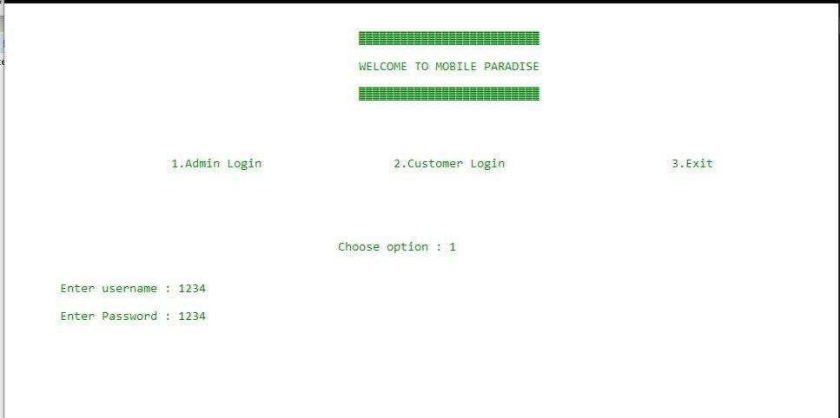Under the admin login you have to enter the username and password to login Select the option 1(Admin Login)
Under the admin login there are four sub functionalities

- Add content
- Display content
- Search content
- Delete content
- Customer information
- Exit
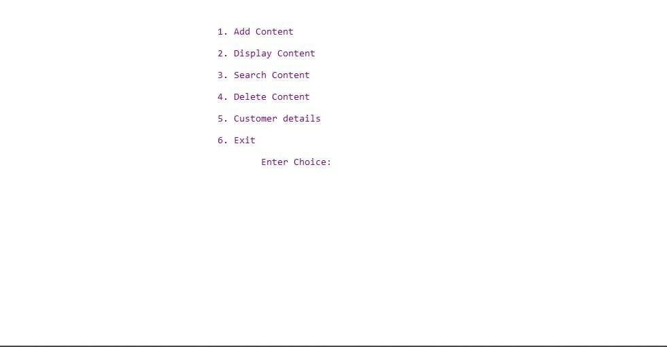
- Enter the choice 1(Add content)
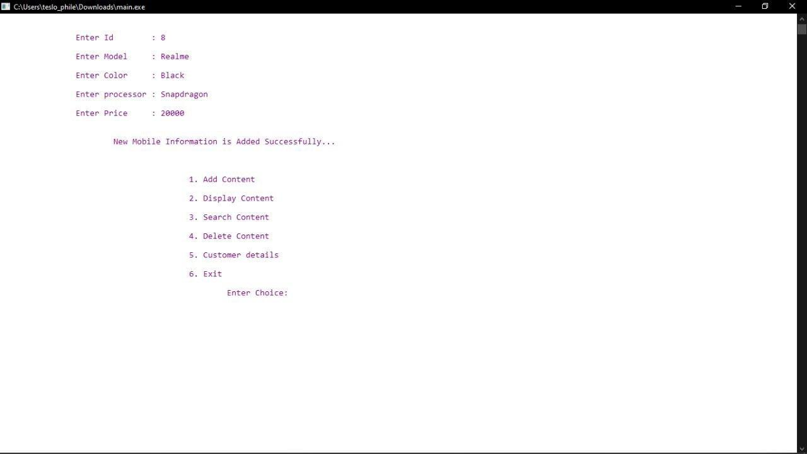
Enter the details of the mobile you want to add.

Enter the choice:2(Display content)
The details of the mobiles will be displayed on the screen.
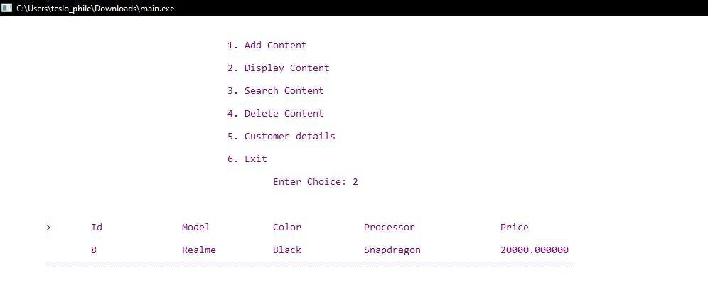

Enter the choice :3(Search content)
Enter the mobile ID that you want to search and the details of the searched mobile model will be displayed on the screen.
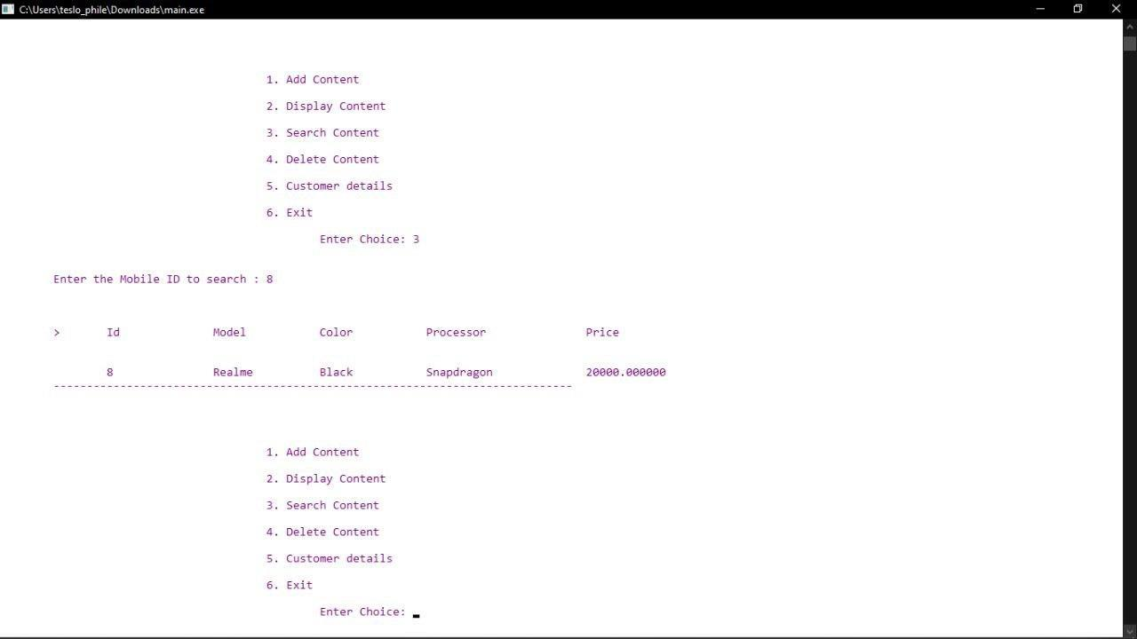
Enter the choice :4(Delete content)
Enter the mobile ID that you want to delete and then the selected mobile details will be deleted.
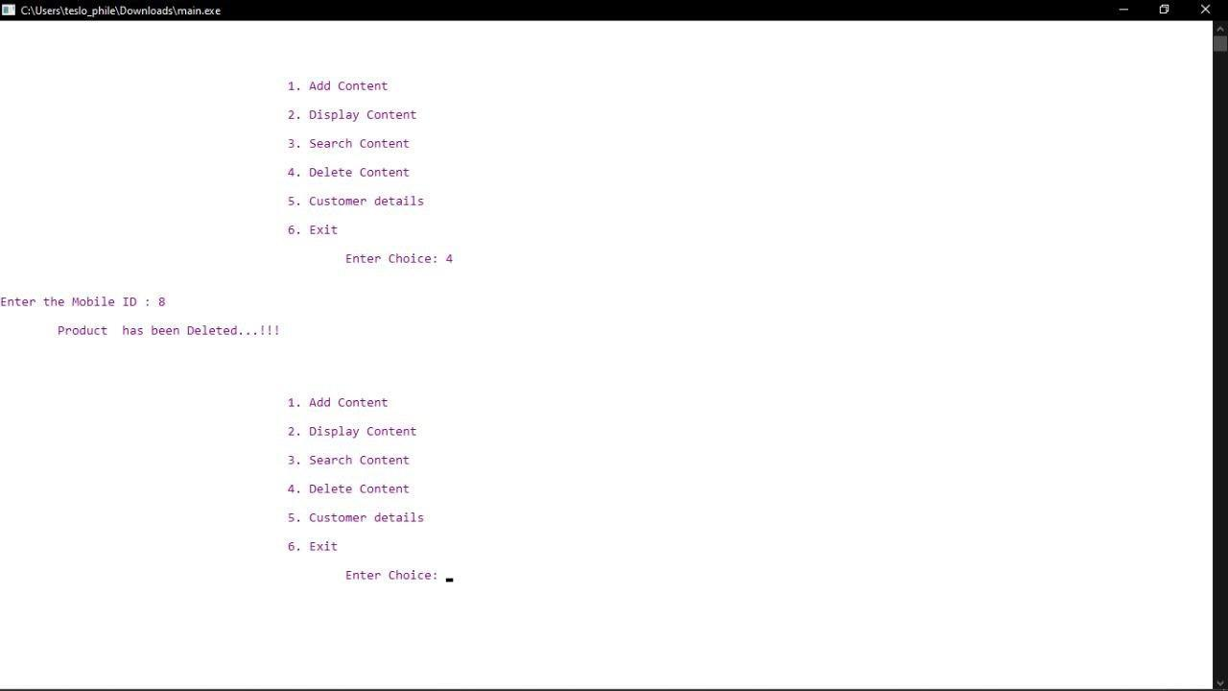
Enter the choice :5(Customer Information )
Displays the details of the purchases from the shop by the customers.
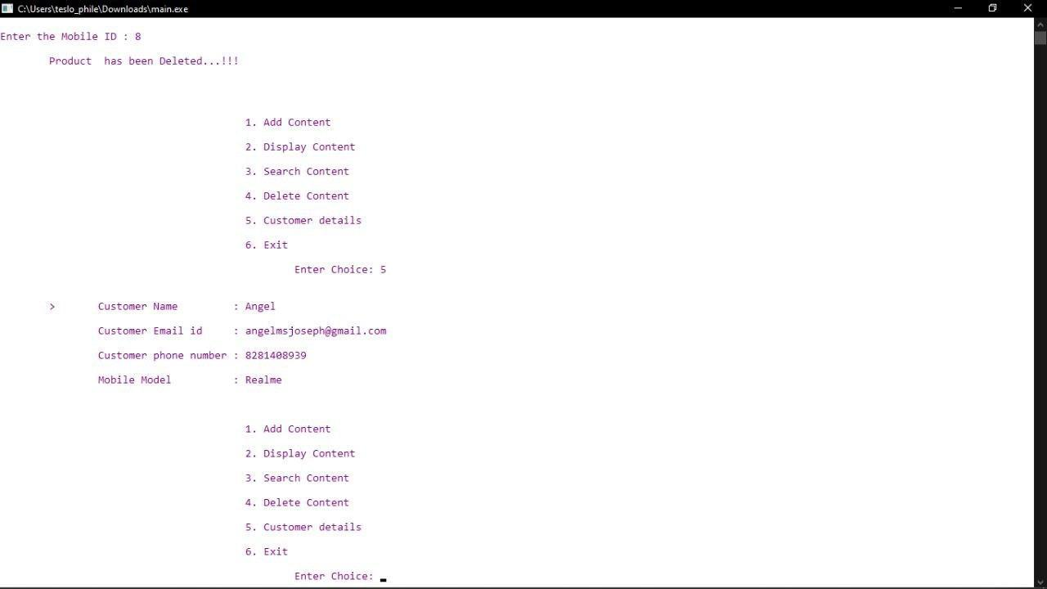
Enter the choice:6(Exit)
To exit from the admin login and go to the open interface.
Select the option 2(Customer Login)
From the open interface choose the option 2 to enter the customer login.
- Under customer login there is four sub functionalities:
- To search a mobile and find its details.
- Display mobile details.
- To buy a mobile
- Exit
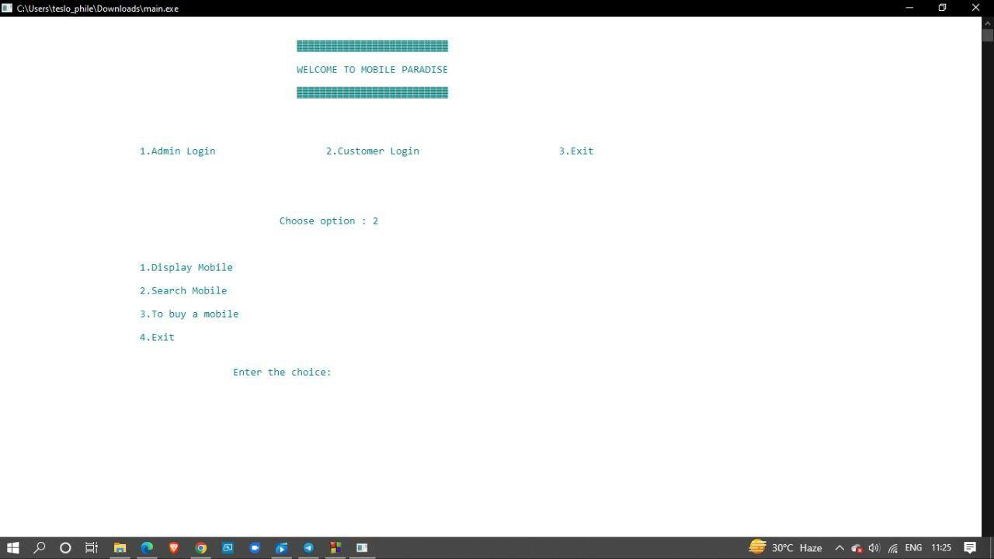

Enter the choice:1(To search a mobile and find its details)
Enter the mobile model you want to search and the details of the mobile will be displayed on the screen.
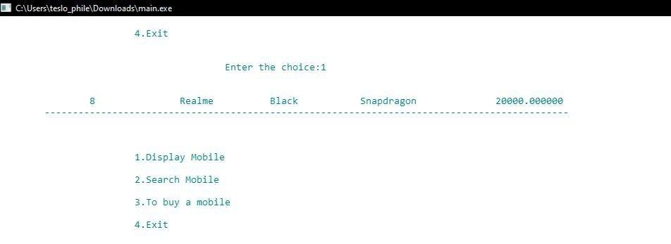

- Enter the choice:2(Display mobile details)
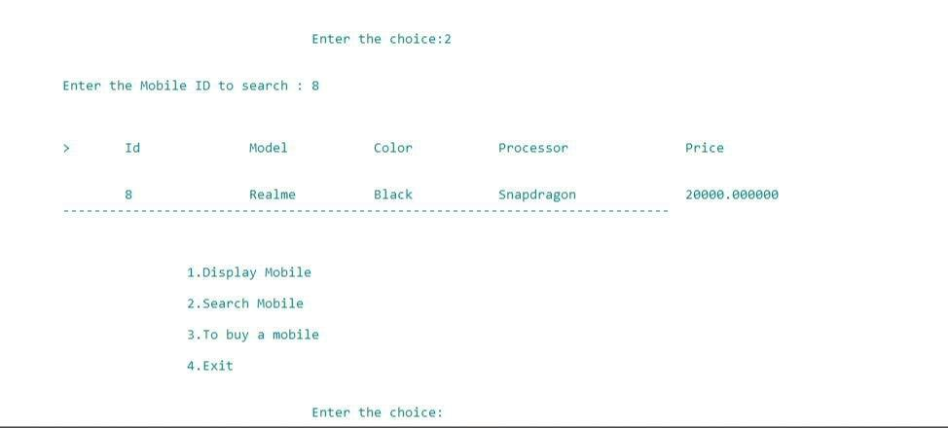
The details of the mobiles will be displayed on the screen.
- Enter the choice:3(To buy a mobile)
Enter the details of the owner and the details of the mobile that was bought by the owner. Details of this are displayed on the screen.
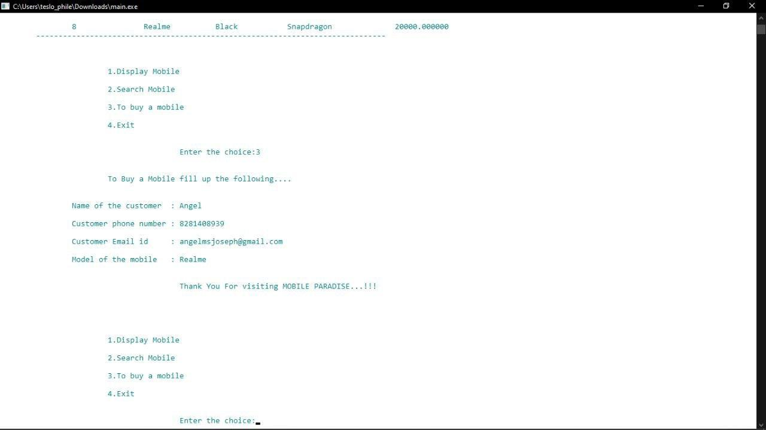
- Enter the choice:4(Exit):To exit from the customer login.
- Enter the choice:3(Exit)
To exit from the management login.
