WhatsApp-Based Smart Medication Adherence System with Caregiver Alerts and Adherence Analytics
- Abstract
Taking medicines, the right way is important. This helps treat chronic or acute conditions significantly. However, most patients forget to take their medicines or just become too busy. Such an issue affects the elderly or patients taking long-term medication the most. Conventional methods of reminders through alarms or applications may not always be helpful as not all patients will have equal access to them; moreover, the interface may not be pleasant, and patients might have to download another program. Now, there is the WhatsApp-Based Smart Medication Adherence System. The innovation leverages what is already known to many of us, which is the popularity of WhatsApp. It is like a robocall to adhere to medicines on time. You simply send text messages to schedule your medication. Then, depending on your schedule, automated messages alert you, after which you simply send a report if it is taken or if it is missed. In case of a missed dose, it immediately informs a registered caregiver. The system also records every medication instance and develops medication adherence analytics in the form of daily and weekly reports. Such reports help patients and their caregivers detect patterns of medication adherence over time. It is intended to be very usable and highly accessible by avoiding the need for developing another mobile app—relying on a very popular messaging service that scales very easily. In a nutshell, this strategy presents a very effective mechanism to improve medication adherence and caregiver participation.
- Objectives
The proposed idea intends to develop a reminder system for taking medicines by tracking when the medicines are taken by patients, also sending reminders automatically through the WhatsApp messaging platform. It also plans to identify when medicines are missed by patients, sending alerts immediately to the care giver, along with generating reports daily and weekly. Thus, making use of the WhatsApp platform for interaction makes it more accessible for the reminder system.
- Framework / Architecture
Technology Framework
- Frontend Interface: WhatsApp Messaging Platform
- Backend Server: Python with Flask Framework
- Messaging API: Twilio WhatsApp API
- Scheduler: APScheduler
- Database: SQLite
Three-tier architecture is followed by this system. Input, Processing, and Output tier levels are included here. This system aims to provide real-time interaction, scheduling, monitoring, and notifications to caregivers via WhatsApp.
The service is relied upon by users for medication information to be shared with the application. The backend server is responsible for medication reminders and report generation based on user-provided medication consumption details. Caregivers get notifications when a medication is missed.
Layer-wise Explanation
1. Input Layer
The input layer represents user interaction with the system. Patients provide medication-related inputs through WhatsApp messages using simple text commands. This layer ensures ease of use, especially for elderly users, by eliminating the need for specialized applications.
Inputs include:
- Medication name and time
- Intake confirmation (Taken / Missed)
- Report requests
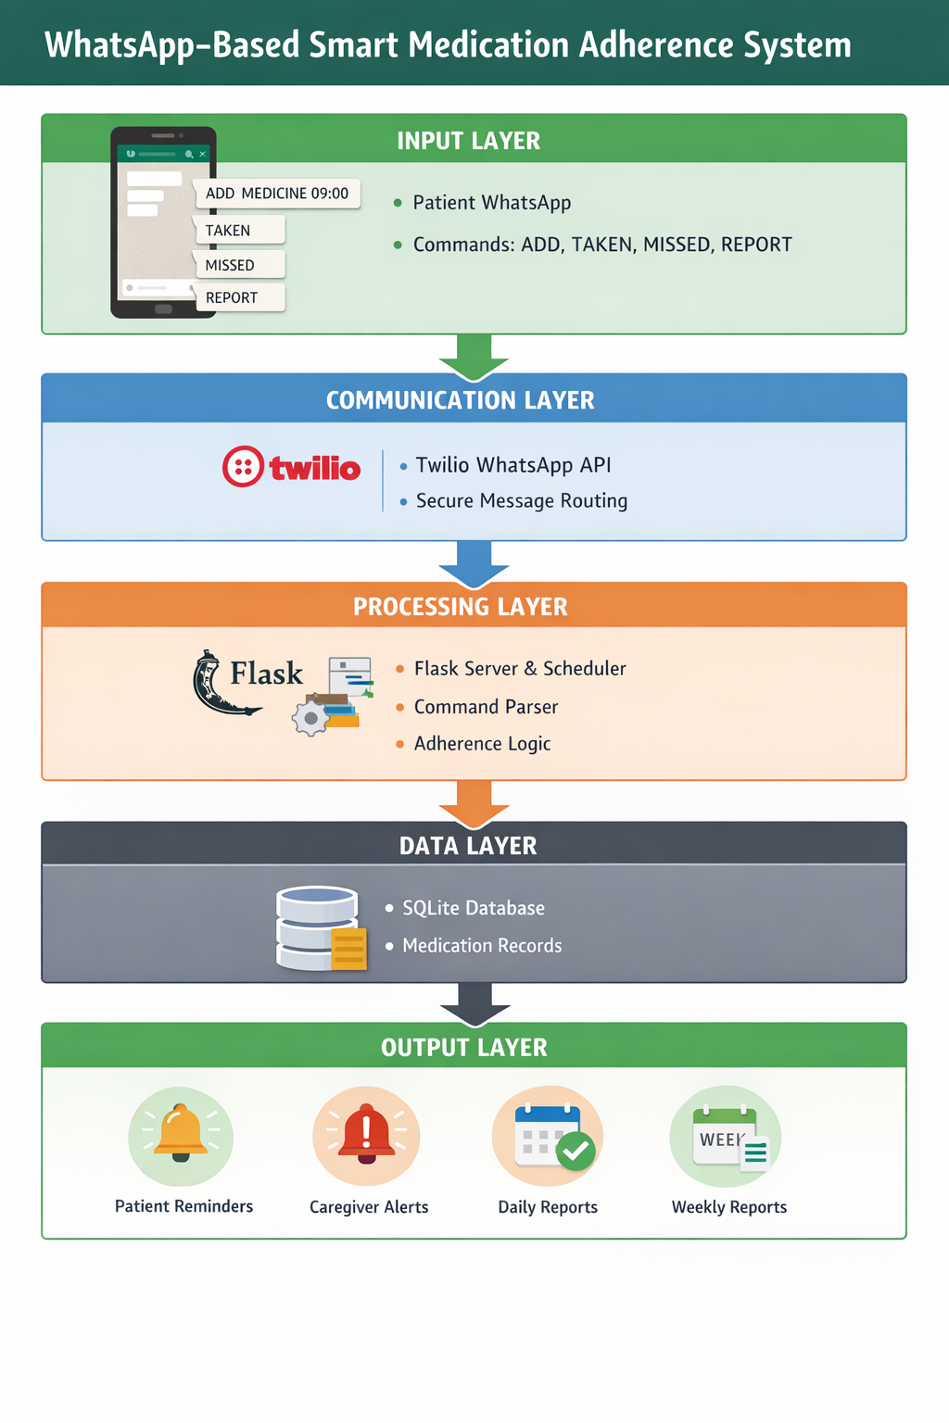
Fig 3.1: architecture of the proposed system
2. Communication Layer
The communication layer is the bridge that joins WhatsApp with the back-end system. The Twilio WhatsApp API securely relays messages received from the users to the back-end server and sends notifications back to WhatsApp.

3. Processing Layer
This represents the core layer of this system, in which all logics occur. The backend server deals with commands from users, error validation, reminders, adherence, and notifications for caregivers, depending on when they have to happen.
Key components include:
- Command parsing module
- Time-based scheduling engine
- Adherence monitoring logic
- Report generation module
4. Data Layer
The data layer stores all real-time medication data generated by users. A lightweight SQLite database is used to maintain medication schedules, intake status, and timestamps. This data supports adherence analytics and report generation.
5. Output Layer
The output layer delivers results back to users and caregivers. Patients receive reminders and confirmations, while caregivers receive alerts for missed doses. The system also provides adherence reports for monitoring purposes.
Architecture Significance
- Ensures real-time communication
- Supports scalability and modularity
- Enables caregiver intervention
- Requires no mobile application installation
- Designed for healthcare accessibility

- Methodology / Algorithm(s)
Methodology
The WhatsApp-Based Smart Medication Adherence System proposed in this study adopts a well-structured approach to properly track medications, alert caregivers, and monitor adherence.
Step 1: User Interaction and Input Acquisition
In this process, the patient interacts with the system through the WhatsApp application using commands that include the name of the medicine, time scheduled, confirmation of intake, or reporting, all of which are in text form. There is no inconvenience of downloading applications.
Step 2: Message Reception via WhatsApp API
All the incoming messages are channelled through the secured Twilio WhatsApp API. The API proceeds to deliver the messages to the backend server via the webhook feature, which enables the real-time connection between the WhatsApp and the system.
Step 3: Command Parsing and Validation
The parsing and validation but, It receives and interprets the received message from the other end and then breaks it into a line by line format. It also checks for valid commands entered for their appropriate format, time, and command.
Step 4: Medication Scheduling
For appropriate input for medicines, there is an reminders schedule that is generated using a time-based scheduling engine. A unique reminder for every medicine is ensured to avoid overwriting, thus enabling handling for multiple medicines simultaneously.

Step 5: Reminder Notification
At this point in time, the reminder for medications will be sent to the patient through the WhatsApp service. The reminder will require confirmation of intake in response to the confirmation message.
Step 6: Intake Monitoring
The patient will answer to confirm whether the drug has been followed and/or missed. The system will record the answer.
Step 7: Caregiver Alert Mechanism
If the dose is recorded as missed, the system automatically creates a reminder that is instantly sent to the caregiver’s WhatsApp number.
Step 8: Data Storage
Data All events related to drug administration, such as dosage scheduling, administration of medication, and missed doses, are recorded in a structured database. The measurement of compliance is basically based upon this.
Step 9: Adherence Analytics and Reporting
The system has the capability of measuring the levels of compliance and generates a report. The system generates a daily report and a weekly report. The weekly report has data on the levels of compliance.
Step 10: Continuous Operation
The Continuing The process runs 24/7 in order to process new data and plan notifications in advance as well.
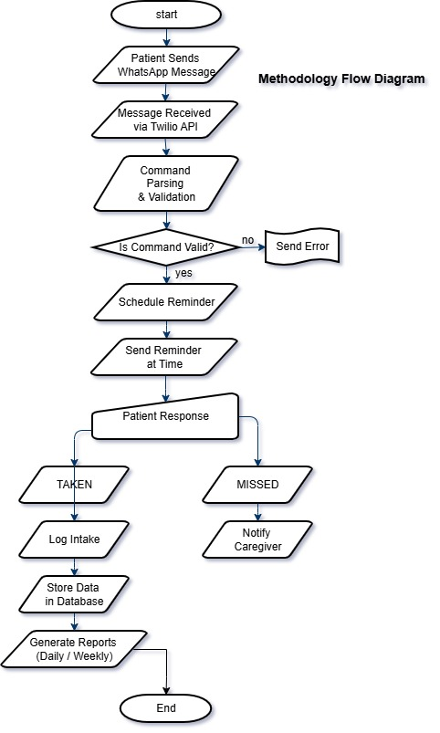
Fig 4.1: Methodology Flow Diagram
Algorithms Used
Algorithm 1: Medication Scheduling Algorithm
Functionality: Providing timely reminders for taking medication.
Steps:
- Accept medication name and time from user.
- Convert input time into system timestamp.
- If the time has elapsed, then reschedule for the next day.
- Job Identification Number: The field shall contain an.
- Recording a Reminder to a Scheduler.
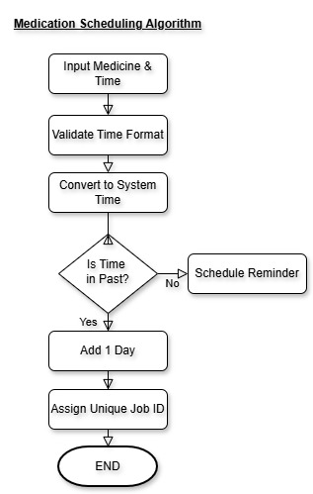
Fig 4.2: Medication Scheduling Algorithm flowchart
Algorithm 2: Medication Intake Tracking Algorithm
Function: To track whether medications are being taken or missed.
Steps:
- Receive patient response.
- Identify response type (Taken / Missed).
- Update medication status in database.
- Trigger caregiver alert if missed.
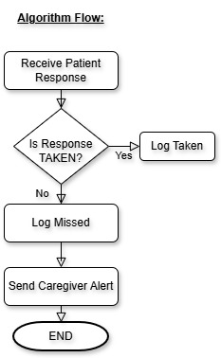
Fig 4.3: Medication Intake Tracking Algorithm flowchart
Algorithm 3: Adherence Calculation Algorithm
Purpose: To calculate medication adherence percentage.
Steps:
- Get medication history records from database.
- Count total doses and taken doses.
- Calculate adherence percentage.
- Generate report.
Formula:
Adherence (%) = (Number of Doses Taken / Total Doses) × 100
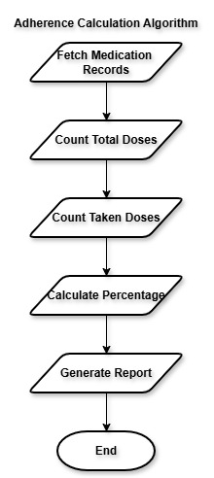
Fig 4.4: Adherence Calculation Algorithm flowchart
- Implementation
1. Development Environment Setup
Software Requirements
- Operating System: Windows / Linux
- Programming Language: Python 3.x
- Framework: Flask
- Messaging API: Twilio WhatsApp API
- Database: SQLite
- Scheduler: APScheduler
- Tunneling Tool: ngrok

Python Libraries Used
- flask
- twilio
- apscheduler
- sqlite3
- datetime
2. Project Folder Structure
whatsapp_medication_bot/
│
├── app.py # Main application file
├── database.db # SQLite database (auto-generated)
├── requirements.txt # Dependency list
3. Backend Server Implementation
The backend server is developed using the Flask framework. It handles incoming WhatsApp messages, processes commands, schedules reminders, logs medication data, and sends notifications.
Core Responsibilities
- Receive WhatsApp messages via webhook
- Parse and validate user commands
- Schedule medication reminders
- Track medication intake
- Notify caregivers on missed doses
- Generate adherence reports

4. WhatsApp Integration
This system employs the Twilio WhatsApp API in order to facilitate communication between the user and the server.
Process of Integration
- Patient and caregiver sign up to Twilio WhatsApp sandbox.
- The incoming messages from Twilio are routed to the Flask web-hook.
- Processing of the message happens through the Flask message system, with Twilio transmitting the response messages.
This will provide a safe and instantaneous messaging system without necessarily developing a custom mobile application.
5. Medication Scheduling Implementation
A time-based scheduler is provided by using APScheduler library.
Scheduling Logic
- User enters medication name & time.
- The time is proven and synchronized as the system timestamp.
- If the time has elapsed, the reminder is set for the following day.
- Each reminder is assigned a unique job ID to avoid overwriting.
This way, it’s possible to schedule a number of medications at the same time
6. Medication Intake Tracking
Patients respond to reminders using predefined commands:
- TAKEN
- MISSED
Each response is logged in the database with a timestamp. This data forms the basis for adherence analysis.

7. Caregiver Alert Implementation
When a patient reports a missed dose:
- The system immediately sends an alert message to the registered caregiver’s WhatsApp number.
- The alert includes patient identification and dose status.
This enables timely caregiver intervention.
8. Database Implementation
A lightweight SQLite database is used to store:
- Patient phone number
- Medication name
- Scheduled time
- Intake status
- Date of event
The database is created automatically when the application starts and is updated dynamically based on user interactions.
9. Adherence Analytics and Report Generation
The system computes medication adherence using stored data.
Reports Supported
- STATUS – Overall adherence percentage
- REPORT DAILY – Daily medication adherence
- REPORT WEEKLY – Weekly medication adherence
Adherence Formula
Adherence (%) = (Number of Doses Taken / Total Doses) × 100
Reports are delivered directly through WhatsApp.
10. Complete System Flow
- User sends command via WhatsApp.
- Twilio forwards message to Flask server.
- Backend parses and validates command.
- Scheduler handles reminders.
- Patient confirms intake.
- Caregiver is notified on missed dose.
- Data is stored and analyzed.
- Reports are generated on request.
11. Execution and Deployment
Run the Application
python app.py
Expose Server
ngrok http 5000
The generated HTTPS URL is configured as the webhook in the Twilio console.
App.py
from flask import Flask, request
from twilio.twiml.messaging_response import MessagingResponse
from twilio.rest import Client
from apscheduler.schedulers.background import BackgroundScheduler
import sqlite3
from datetime import datetime, timedelta

# ================== APP SETUP ==================
app = Flask(__name__)
scheduler = BackgroundScheduler()
scheduler.start()

# ================== TWILIO CONFIG ==================
# ⚠️ USE YOUR REAL TWILIO CREDENTIALS
TWILIO_SID = "ACbe3c4e53ebf6e84a6babef58c122f71c"
TWILIO_AUTH = "ba2a8cb27670edf104aa5ab5ab30b195"
FROM_WHATSAPP = "whatsapp:+14155238886" # Twilio sandbox number

# ================== CAREGIVER CONFIG ==================
CARE_GIVER_NUMBER = "+919390401050" # Caregiver WhatsApp number

client = Client(TWILIO_SID, TWILIO_AUTH)

# ================== DATABASE ==================
def init_db():
conn = sqlite3.connect("database.db")
c = conn.cursor()
c.execute("""
CREATE TABLE IF NOT EXISTS medications (
phone TEXT,
medicine TEXT,
time TEXT,
status TEXT,
date TEXT
)
""")
conn.commit()
conn.close()

init_db()

def insert_record(phone, medicine, time, status):
conn = sqlite3.connect("database.db")
c = conn.cursor()
c.execute(
"INSERT INTO medications VALUES (?, ?, ?, ?, ?)",
(phone, medicine, time, status, datetime.now().date())
)
conn.commit()
conn.close()

# ================== SEND REMINDER ==================
def send_reminder(phone, medicine):
try:
client.messages.create(
from_=FROM_WHATSAPP,
to=f"whatsapp:{phone}",
body=f"⏰ Reminder: Take your medicine *{medicine}*.\nReply TAKEN or MISSED."
)
print(f"Reminder sent for {medicine}")
except Exception as e:
print("Twilio Error:", e)

# ================== WHATSAPP WEBHOOK ==================
@app.route("/whatsapp", methods=["POST"])
def whatsapp():
raw_msg = request.values.get("Body", "")
lines = raw_msg.strip().upper().splitlines()
phone = request.values.get("From").replace("whatsapp:", "")
response = MessagingResponse()

for msg in lines:

# ---------- ADD MEDICINE ----------
if msg.startswith("ADD"):
parts = msg.split()

if len(parts) != 3:
response.message(
f"❌ Format error in:\n{msg}\nUse: ADD <MEDICINE> <HH:MM>"
)
continue

medicine = parts[1]
time_str = parts[2]

try:
now = datetime.now()
reminder_time = datetime.strptime(time_str, "%H:%M")
reminder_time = reminder_time.replace(
year=now.year,
month=now.month,
day=now.day,
second=0
)

# If time already passed → schedule next day
if reminder_time <= now:
reminder_time += timedelta(days=1)

# UNIQUE JOB ID (prevents overwrite)
job_id = f"{phone}_{medicine}_{time_str}_{now.timestamp()}"

scheduler.add_job(
send_reminder,
'date',
run_date=reminder_time,
args=[phone, medicine],
id=job_id,
replace_existing=False
)

insert_record(phone, medicine, time_str, "SCHEDULED")
response.message(f"✅ {medicine} scheduled at {time_str}")

except ValueError:
response.message(
f"❌ Invalid time in:\n{msg}\nUse HH:MM (24-hour)"
)

# ---------- TAKEN ----------
elif msg == "TAKEN":
insert_record(phone, "Unknown", "", "TAKEN")
response.message("✔ Dose recorded as TAKEN")

# ---------- MISSED (WITH CAREGIVER ALERT) ----------
elif msg == "MISSED":
insert_record(phone, "Unknown", "", "MISSED")

# Notify caregiver
try:
client.messages.create(
from_=FROM_WHATSAPP,
to=f"whatsapp:{CARE_GIVER_NUMBER}",
body=(
"🚨 Medication Alert!\n"
f"Patient: {phone}\n"
"Status: MISSED DOSE"
)
)
except Exception as e:
print("Caregiver alert error:", e)

response.message("⚠ Dose MISSED. Caregiver notified")

# ---------- STATUS ----------
elif msg == "STATUS":
conn = sqlite3.connect("database.db")
c = conn.cursor()

c.execute(
"SELECT COUNT(*) FROM medications WHERE phone=? AND status='TAKEN'",
(phone,)
)
taken = c.fetchone()[0]

c.execute(
"SELECT COUNT(*) FROM medications WHERE phone=? AND status!='SCHEDULED'",
(phone,)
)
total = c.fetchone()[0]
conn.close()

if total > 0:
adherence = int((taken / total) * 100)
response.message(f"📊 Adherence: {adherence}%")
else:
response.message("No medication history found")

# ---------- DAILY REPORT ----------
elif msg == "REPORT DAILY":
today = datetime.now().date()

conn = sqlite3.connect("database.db")
c = conn.cursor()

c.execute(
"SELECT COUNT(*) FROM medications WHERE phone=? AND date=?",
(phone, today)
)
total = c.fetchone()[0]

c.execute(
"SELECT COUNT(*) FROM medications WHERE phone=? AND status='TAKEN' AND date=?",
(phone, today)
)
taken = c.fetchone()[0]
conn.close()

if total > 0:
adherence = int((taken / total) * 100)
response.message(
f"📅 Daily Report ({today})\n"
f"Taken: {taken}\n"
f"Total: {total}\n"
f"Adherence: {adherence}%"
)
else:
response.message("No medication data for today")

# ---------- WEEKLY REPORT ----------
elif msg == "REPORT WEEKLY":
today = datetime.now().date()
week_start = today - timedelta(days=7)

conn = sqlite3.connect("database.db")
c = conn.cursor()

c.execute(
"SELECT COUNT(*) FROM medications WHERE phone=? AND date>=?",
(phone, week_start)
)
total = c.fetchone()[0]

c.execute(
"SELECT COUNT(*) FROM medications WHERE phone=? AND status='TAKEN' AND date>=?",
(phone, week_start)
)
taken = c.fetchone()[0]
conn.close()

if total > 0:
adherence = int((taken / total) * 100)
response.message(
"📆 Weekly Report (Last 7 Days)\n"
f"Taken: {taken}\n"
f"Total: {total}\n"
f"Adherence: {adherence}%"
)
else:
response.message("No medication data for this week")

# ---------- HELP ----------
else:
response.message(
"🤖 Commands:\n"
"ADD <MEDICINE> <HH:MM>\n"
"TAKEN\n"
"MISSED\n"
"STATUS\n"
"REPORT DAILY\n"
"REPORT WEEKLY"
)

return str(response)

# ================== RUN SERVER ==================
if __name__ == "__main__":
app.run(port=5000)

12. Key Implementation Highlights
- No mobile application installation required
- Supports single and multiple medication inputs
- Handles multiple reminders reliably
- Real-time caregiver alerts
- Lightweight and scalable design
- Suitable for elderly and non-technical users
13. Screenshots
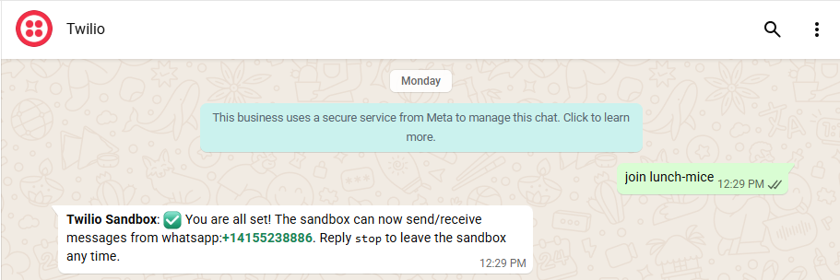
Fig 13.1 Welcome and connection screen
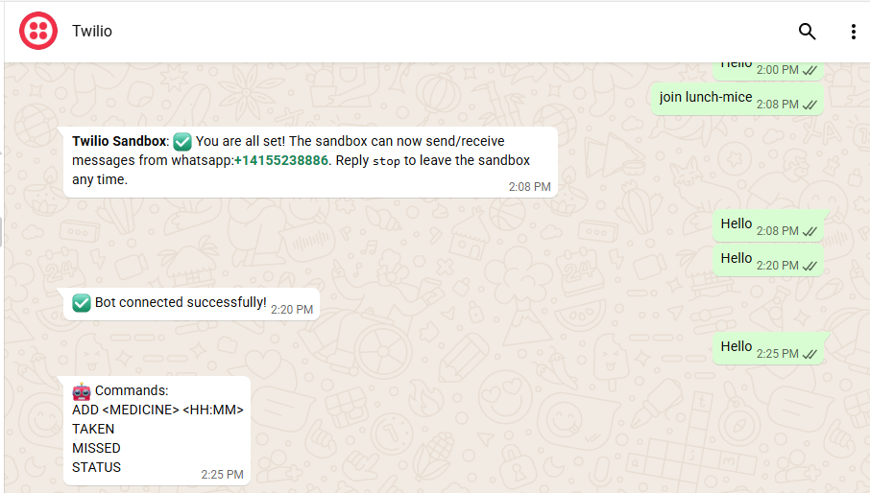
Fig 13.2 connected to bot and getting inputs from the bot
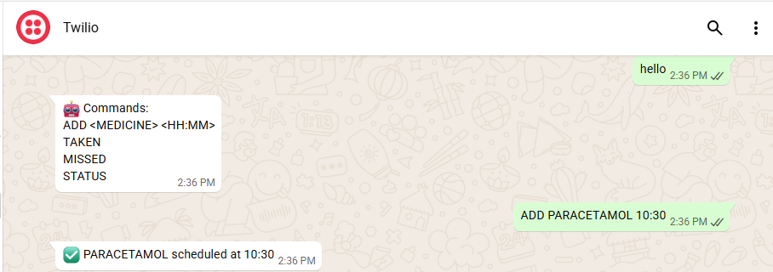
Fig 13.3 giving input to the bot and scheduling the single medicine
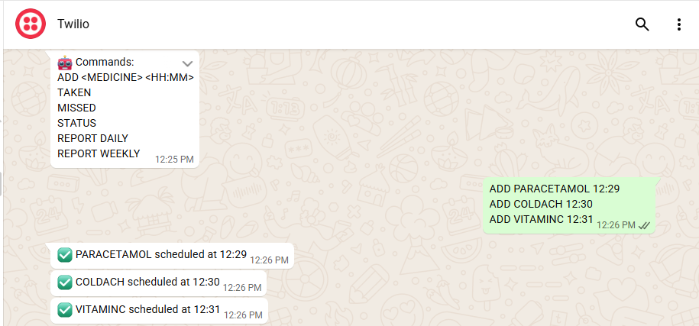
Fig 13.4 giving multiple inputs and scheduling multiple medications in one input
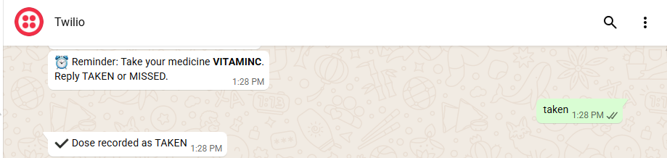
Fig 13.5 getting notify and bot will ask that weather medicine taken or missed
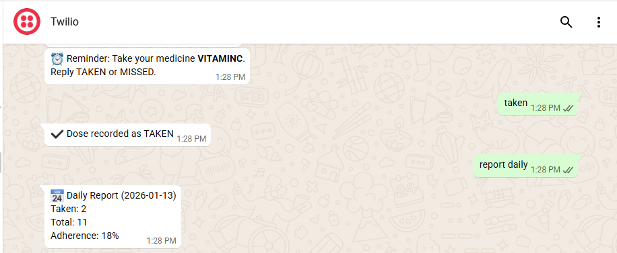
Fig 13.6 getting daily reports of medication
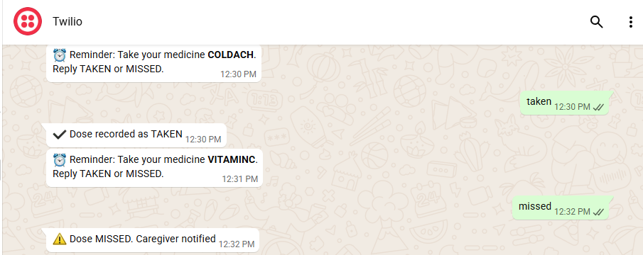
Fig 13.7 medicine missed and get notified for caregiver
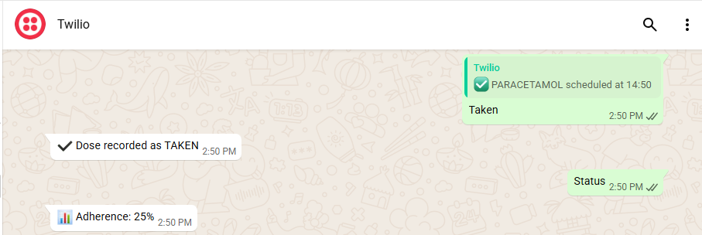
Fig 13.8 getting Adherence status of the medication
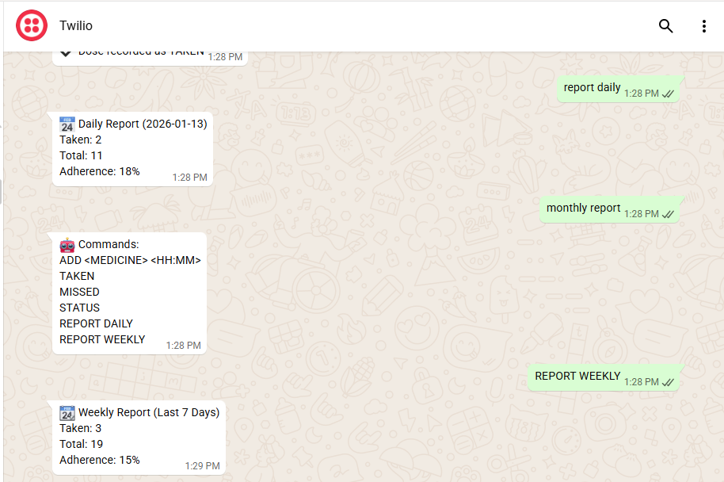
Fig 13.9 getting weekly reports and analysis of the medication

- Conclusion
The project has been able to successfully design and implement a WhatsApp-Based Smart Medication Adherence System with Caregiver Alerts and Adherence Analytics. The proposed system has been designed to address the global problem of medication non-adherence by sending reminders and notifications through a popular messaging service.
In that it removes the need for the development of mobile applications, the system ensures high levels of accessibility and usability, especially among the elderly patients and those who lack technical expertise. The addition of alerts for caregivers improves the safety of patients by enabling the intervention of caregivers in the case of missed doses. The analytics for adherence also give information on patient compliance.
The system is scalable, reliable, and flexible to the real-world environment of the healthcare industry. Future work may include the addition of support for multiple caregivers, cloud-based data storage, support for electronic health records, and support for multiple languages. In conclusion, the proposed solution offers an effective and practical approach to enhance patient medication compliance through existing digital communication infrastructure.

