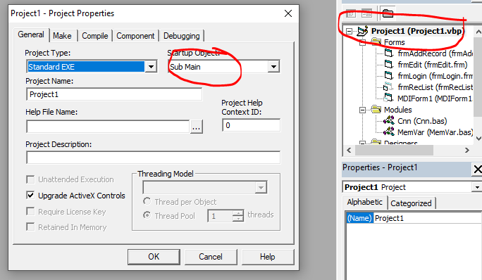

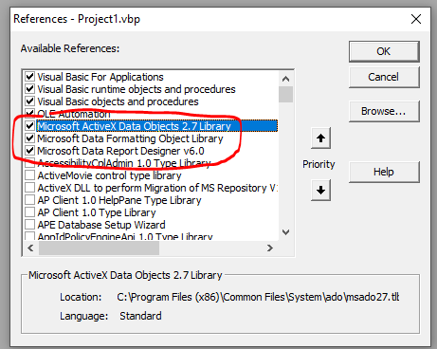

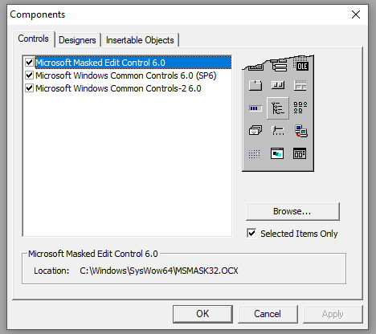

**Module: Cnn.bas**

Public CN As New ADODB.Connection

Public RS As New ADODB.Recordset

Public Sub Main()

On Error GoTo Err:

CN.Provider = "MICROSOFT.ACE.OLEDB.12.0;"

CN.Open App.Path & "\Dbase\dbmain.mdb"

frmLogin.Show

Exit Sub

Err:

MsgBox Err.Description, vbCritical

End

End Sub

Public Sub CloseRS()

If RS.State = adStateOpen Then RS.Close

End Sub

Public Sub ResetErrIn(frm As Form)

CN.Close

CN.Open App.Path & "\Dbase\dbmain.mdb"

MsgBox Err.Description, vbExclamation

Err.Clear

End Sub

**Form: frmLogin.frm**

Option Explicit

Public LoginSucceeded As Boolean

Dim invalidpw As Integer

Private Sub CmdCancel_Click()

LoginSucceeded = False

Unload Me

End Sub

Private Sub cmdOK_Click()

If txtUserName = "" Then

MsgBox "Please Enter your Username, try again!", , "Login"

txtUserName.SetFocus

ElseIf txtPassword = "" Then

MsgBox "Please Enter your Password, try again!", , "Login"

txtPassword.SetFocus

Else

RS.Open "SELECT * FROM tbl_user WHERE Trim(username) = '" & Trim(txtUserName.Text) & _

"' AND Trim(password) = '" & Trim(txtPassword.Text) & "'", CN, adOpenKeyset, adLockReadOnly

If RS.RecordCount = 0 Then

invalidpw = invalidpw + 1

If invalidpw = 1 Then

MsgBox "Invalid Username and Password, try again!", , "Login 1st Attempt"

RS.Close

txtUserName.SetFocus

ElseIf invalidpw = 2 Then

MsgBox "Invalid Username and Password, try again!", , "Login 2nd Attempt"

RS.Close

txtUserName.SetFocus

ElseIf invalidpw = 3 Then

MsgBox "Invalid Username and Password, try again!", , "Login Last Attempt"

RS.Close

Unload Me

Else

MsgBox "Invalid Username and Password, try again!", , "Login"

RS.Close

txtUserName.SetFocus

End If

Else

MsgBox "Access Granted.", vbInformation + vbOKOnly, "System message"

Screen.MousePointer = vbNormal

LoginSucceeded = True

RS.Close

Unload Me

MDIForm1.Show

End If

End If

End Sub

Private Sub Form_Load()

invalidpw = 0

End Sub

**Form: frmRecord.frm**

Dim Item As ListItem

Dim PreviewPrint As Integer

Public Sub LoadRecord()

Me.ListView1.ListItems.Clear

CloseRS

RS.Open "SELECT * FROM tbl_record", CN, adOpenKeyset, adLockReadOnly

If RS.RecordCount = 0 Then Exit Sub

While Not RS.EOF

Set lst = Me.ListView1.ListItems.Add(, , RS("id"))

lst.SubItems(1) = RS("xtext")

lst.SubItems(2) = RS("xnumber")

lst.SubItems(3) = RS("xdate")

lst.SubItems(4) = RS("xtime")

RS.MoveNext

Wend

RS.Close

Me.ListView1.Refresh

End Sub

Private Sub DeleteRecord()

If Me.ListView1.ListItems.Count = 0 Then Exit Sub

If MsgBox("Delete Record No.:" & Me.ListView1.SelectedItem.Text & " - " & Me.ListView1.SelectedItem.ListSubItems(1).Text, vbQuestion + vbYesNo, "Record List") = vbYes Then

CN.Execute "DELETE * FROM tbl_record WHERE Trim(id) = '" & Trim(Me.ListView1.SelectedItem.Text) & "'"

MsgBox "Successfully Deleted", vbExclamation, "Record List"

Call LoadRecord

End If

End Sub

Private Sub RecordTop()

On Error Resume Next

ListView1.SetFocus

ListView1.ListItems(1).Selected = True

ListView1.ListItems(1).EnsureVisible

Toolbar1.Buttons(7).Enabled = False

Toolbar1.Buttons(8).Enabled = False

Toolbar1.Buttons(9).Enabled = True

Toolbar1.Buttons(10).Enabled = True

End Sub

Private Sub RecordPrevious()

On Error Resume Next

ListView1.SetFocus

If ListView1.SelectedItem.Index <> 1 Then

ListView1.ListItems(ListView1.SelectedItem.Index - 1).Selected = True

ListView1.ListItems(ListView1.SelectedItem.Index - 1).EnsureVisible

Toolbar1.Buttons(7).Enabled = True

Toolbar1.Buttons(8).Enabled = True

Toolbar1.Buttons(9).Enabled = True

Toolbar1.Buttons(10).Enabled = True

Else

ListView1.ListItems(1).Selected = True

ListView1.ListItems(1).EnsureVisible

Toolbar1.Buttons(7).Enabled = False

Toolbar1.Buttons(8).Enabled = False

Toolbar1.Buttons(9).Enabled = True

Toolbar1.Buttons(10).Enabled = True

End If

End Sub

Private Sub RecordNext()

On Error Resume Next

ListView1.SetFocus

If ListView1.SelectedItem.Index <> ListView1.ListItems.Count Then

ListView1.ListItems(ListView1.SelectedItem.Index + 1).Selected = True

ListView1.ListItems(ListView1.SelectedItem.Index + 1).EnsureVisible

Toolbar1.Buttons(7).Enabled = True

Toolbar1.Buttons(8).Enabled = True

Toolbar1.Buttons(9).Enabled = True

Toolbar1.Buttons(10).Enabled = True

Else

ListView1.ListItems(ListView1.ListItems.Count).Selected = True

ListView1.ListItems(ListView1.ListItems.Count).EnsureVisible

Toolbar1.Buttons(7).Enabled = True

Toolbar1.Buttons(8).Enabled = True

Toolbar1.Buttons(9).Enabled = False

Toolbar1.Buttons(10).Enabled = False

End If

End Sub

Private Sub RecordBottom()

On Error Resume Next

ListView1.SetFocus

ListView1.ListItems(ListView1.ListItems.Count).Selected = True

ListView1.ListItems(ListView1.ListItems.Count).EnsureVisible

Toolbar1.Buttons(7).Enabled = True

Toolbar1.Buttons(8).Enabled = True

Toolbar1.Buttons(9).Enabled = False

Toolbar1.Buttons(10).Enabled = False

End Sub

Private Sub SearchID()

Me.ListView1.ListItems.Clear

CloseRS

RS.Open "SELECT * FROM tbl_record WHERE Trim(id) = '" & Trim(Me.txtID.Text) & "'", CN, adOpenKeyset, adLockReadOnly

If RS.RecordCount = 0 Then Exit Sub

While Not RS.EOF

Set lst = Me.ListView1.ListItems.Add(, , RS("id"))

lst.SubItems(1) = RS("xtext")

lst.SubItems(2) = RS("xnumber")

lst.SubItems(3) = RS("xdate")

lst.SubItems(4) = RS("xtime")

RS.MoveNext

Wend

RS.Close

Me.ListView1.Refresh

End Sub

Private Sub FilterText()

Me.ListView1.ListItems.Clear

CloseRS

RS.Open "SELECT * FROM tbl_record WHERE Trim(xtext) LIKE '%" & Trim(Me.txtText.Text) & "%'", CN, adOpenKeyset, adLockReadOnly

If RS.RecordCount = 0 Then Exit Sub

While Not RS.EOF

Set lst = Me.ListView1.ListItems.Add(, , RS("id"))

lst.SubItems(1) = RS("xtext")

lst.SubItems(2) = RS("xnumber")

lst.SubItems(3) = RS("xdate")

lst.SubItems(4) = RS("xtime")

RS.MoveNext

Wend

RS.Close

Me.ListView1.Refresh

End Sub

Private Sub RecordReport()

CloseRS

RS.Open "SELECT * FROM tbl_record WHERE Trim(id) = '" & Trim(Me.ListView1.SelectedItem.Text) & "'", CN, adOpenKeyset, adLockReadOnly

If RS.RecordCount = 0 Then Exit Sub

Set rprtInfo.DataSource = RS

If PreviewPrint = 1 Then

rprtInfo.PrintReport

PreviewPrint = 0

ElseIf PreviewPrint = 2 Then

rprtInfo.Show

PreviewPrint = 0

Else

Exit Sub

End If

End Sub

Private Sub Form_Resize()

On Error Resume Next

With ListView1

.Width = Me.Width - 540

.Height = Me.Height - 2300

End With

End Sub

Private Sub Toolbar1_ButtonClick(ByVal Button As MSComctlLib.Button)

Select Case Button.Index

Case 1: frmAddRecord.Show 1

Case 2: Call EditRecord

Case 3: Call DeleteRecord

Case 5: Call LoadRecord

Case 7: Call RecordTop

Case 8: Call RecordPrevious

Case 9: Call RecordNext

Case 10: Call RecordBottom

Case 12: Call RecordReport

PreviewPrint = 1

Case 13: Call RecordReport

PreviewPrint = 2

Case 14: Unload Me

End Select

End Sub

**Form: frmAddRecord.frm**

Private Sub CmdSave_Click()

If txtText.Text = "" Or _

txtNumber.Text = "" Or _

txtDate.Value = "" Or _

txtTime.Text = "" Then

MsgBox "Please fill-up the form properly", vbExclamation

Else

RS.Open "SELECT * FROM tbl_record WHERE Trim(xtext) = '" & Trim(txtText.Text) & "'", CN, adOpenKeyset, adLockReadOnly

If RS.RecordCount = 0 Then

RS.Close

RS.Open "SELECT * FROM tbl_record", CN, adOpenStatic, adLockOptimistic

With RS

.AddNew

.Fields("xtext") = (Me.txtText.Text)

.Fields("xnumber") = (Me.txtNumber.Text)

.Fields("xdate") = (Me.txtDate.Value)

.Fields("xtime") = (Me.txtTime.Text)

.Update

End With

MsgBox "Saved Successfully", vbExclamation

Unload Me

Else

MsgBox "Record Already Exist", vbExclamation

RS.Close

End If

End If

End Sub

**Form: frmEditRecord.frm**

Private Sub LoadInfo()

On Error GoTo Err_380_InvalidPropVal

CloseRS

RS.Open "SELECT * FROM tbl_record WHERE Trim(id) = '" & Trim(frmRecList.ListView1.SelectedItem.Text) & "'", CN, adOpenKeyset, adLockReadOnly

If RS.RecordCount = 0 Then Exit Sub

With RS

Me.txtText.Text = .Fields("xtext")

Me.txtNumber = .Fields("xnumber")

Me.txtDate.Value = .Fields("xdate")

Me.txtTime.Text = .Fields("xtime")

.Close

End With

Err_380_InvalidPropVal:

Select Case Err.Number

Case -380

MsgBox "The value on your date/time is invalid. Contact the Administrator", vbCritical, "Oooops!"

Exit Sub

End Select

End Sub

Private Sub UpdateInfo()

CloseRS

RS.Open "SELECT * FROM tbl_record WHERE Trim(id) = '" & Trim(frmRecList.ListView1.SelectedItem.Text) & "'", CN, adOpenStatic, adLockOptimistic

If RS.RecordCount = 0 Then Exit Sub

With RS

.Fields("xtext") = (Me.txtText.Text)

.Fields("xnumber") = (Me.txtNumber.Text)

.Fields("xdate") = (Me.txtDate.Value)

.Fields("xtime") = (Me.txtTime.Text)

.Update

End With

MsgBox "Update Successfully", vbExclamation

Unload Me

End Sub

**Report: rprtInfo.Dsr**

