TRADE POLICIES AND PRACTICES BY MEASURE

Measures Directly Affecting Imports

Customs procedures
          - U.S. Customs and Border Protection (CBP), an agency of the Department of Homeland Security is responsible for matters relating to customs and importation, and enforcement of U.S. trade laws. Since 1993, with the implementation of the Customs Modernization Act, there has been an increased sharing of responsibility for compliance with customs rules between CBP and the importing community. Pursuant to this "informed compliance" approach, i.e. the shared responsibility between CBP and the import community, importers are expected to apply "reasonable care" in their importing operations. They are expected to exercise reasonable care to classify, value, and determine origin of goods so that CBP can apply the necessary import rules, assess duty rates, and collect statistics. CBP also makes available a significant amount of information to importers, through its informed compliance publications and through various rulings.
          - Beyond the basic importing topics of classification, valuation, and origin and marking, CBP is responsible for a number of initiatives to facilitate trade, better secure U.S. borders, and enforce U.S. laws and regulations. These include:
C-TPAT, is a voluntary public-private partnership operated in conjunction with over 10,000 partners in order to develop and adopt measures to improve security while at the same time not hindering trade. In addition to importers, the programme covers carriers, brokers, consolidators, and certain manufacturers who agree to work to help protect the supply chain and implement security measures and best practices. C-TPAT is working towards signing mutual recognition arrangements with a number of foreign governments in order to link international industry partnerships together globally. Through the C-TPAT partnership more than 50% of U.S. imports are covered by C-TPAT partnership trade.
Automated Commercial Environment (ACE), the electronic commercial trade processing system being developed to facilitate trade while strengthening border security. ACE will provide a single centralized portal and access point for the trade community to interact with CBP. Currently, ACE is being implemented in phases and already includes provisions for individual account management, periodic payment capabilities, e-manifests, entry summary filing, and trade data sharing. More than 17,000 ACE accounts were in operation in 2011.
Container Security Initiative (CSI), launched in the aftermath of the 9/11 terrorist attacks in order to address the threat to border security posed by the use of maritime container shipments. As more than 11 million cargo containers arrive at U.S. ports every year, CBP has developed a pre-screening process to assess risk and, if necessary, containers are inspected abroad before being shipped to the United States. CSI is now in operation in 58 ports world-wide and pre-screens over 80% of maritime container cargo destined for the United States.
Secure Freight Initiative (SFI), initiated in response to the Security and Accountability for Every (SAFE) Port Act to evaluate the feasibility of requiring 100% scanning of maritime cargo containers. The SAFE Port Act, as amended, requires 100% scanning of all maritime containers shipped to the United States by 1 July 2012. On 2 May 2012, in accordance with the statute, DHS Secretary submitted to Congress her intent to extend the deadline by two years. New proposed legislation to extend or eliminate the statutory deadline has not been passed into law. Complimentary rules and procedures for ensuring security of air cargo on passenger aircraft were enacted (Implementing Recommendations of the 9/11 Commission Act) and the law is under the purview of the Transportation Security Administration (TSA), another agency of the Department of Homeland Security. The law required 100% cargo scanning on international U.S. inbound flights, originally by 31 December 2011. However, the TSA postponed this deadline and instituted a new deadline of 3 December 2012 for implementation.
          - CBP is also responsible for supervision or oversight of certain import processes or provisions. For example, CBP regulations allow for the "in-bond process", which provides that imported goods may be transported in-bond to another port of entry and entered there under the same conditions as at the port of arrival. CBP recently proposed new rules or procedures for the in-bond process, but final rules have not yet been issued. CBP also oversees "Foreign Trade Zones" (FTZs) which are located at or near CBP ports of entry and allow merchandise to enter and be further processed before entering the customs territory of the United States or being re-exported. Although CBP oversees the FTZs, the establishment of FTZs, and their rules and regulations are under the purview of the Foreign-Trade Zones Board. The FTZ Board recently revised the regulations pursuant to the Foreign-Trade Zones Act in order to improve flexibility and enhance clarity for U.S.-based operations, address compliance for uniform treatment in a zone, and simplify the procedures to gain authority to undertake an activity in a FTZ.
          - In addition, CBP is responsible for the rules pertaining to customs brokers, through its regulations. While there are no specific rules or restrictions on importing by an owner or purchaser of imported goods, U.S. laws only allow licensed customs brokers to transact customs business on behalf of others (i.e. importers, purchasers). There are approximately 11,000 licensed customs brokers in the United States. CBP regulations prescribe eligibility requirements (age, citizenship, etc.) and qualifications (licence exam, fees, and approval by CBP) to become a licensed customs broker. In 2010, CBP adopted new eligibility requirements, which slightly modified the rules for taking the licence exam. CBP is also working on another important initiative with respect to customs brokers. The Role of the Broker Initiative will examine with a view to redesigning and modernizing broker regulations and clarifying brokers' responsibilities, as well as encouraging brokers to be force multipliers for CBP trade facilitation efforts.

Customs valuation
          - Since 1980 when the United States implemented the Tokyo Round Customs Valuation Agreement, the primary method of determining the value of imported merchandise has been the "transaction value". There have been no legislative changes to the basic valuation method, as prescribed by the GATT/WTO Customs Valuation Agreement, since its establishment by title II of the Trade Agreements Act of 1979. In 1996, the United States notified that its legislation previously notified remained valid, and no further notifications have been made since that time. The United States assesses customs duties on an f.o.b. basis.
          - In 2008, the U.S. Department of Homeland Security, Bureau of Customs and Border Protection, proposed a new interpretation of the phrase "sold for exportation to the United States" for the purposes of applying the transaction value method in a series-of-sales importation scenario. This proposal reflected the conclusions of the WCO Technical Committee on Customs Valuation, as set out in Commentary 22.1, in which the majority of WTO Members already used the price paid in the last sale occurring prior to import. Thereafter, Congress enacted the Food, Conservation, and Energy Act, in 2008, and Section 15422 created a one-year importer-declaration requirement to collect data and information on the valuation of certain goods in a multiple sale scenario situation. This provision was included in order to help Congress better understand the impact of the proposed new interpretation, which would have reversed a long-standing judicial and administrative interpretation of the expression "sold for exportation to the United States". The legislation also indicated that Customs and Border Protection should not implement a change of interpretation of the expression before 1 January 2011. On 29 September 2010, Customs and Border Protection officially withdrew its proposal, thus retaining its long-standing position of using the "first (or earlier) sale" interpretation.

Rules of origin

Non-preferential rules of origin
          - In July 2008, the CBP proposed new uniform rules of origin, based on the NAFTA tariff-shift methodology, that would apply to all imports (non-preferential trade). Based on the experience with the NAFTA origin rules, the CBP stated that the proposed rules "have proven to be more objective and transparent and provide greater predictability in determining the country of origin of imported merchandise than the system of case-by-case adjudication they would replace. The proposed change also will aid an importer's exercise of reasonable care." However, after receiving comments, many of which opposed the new rules, the CBP officially withdrew the proposal on 2 September 2011. Thus, the non-preferential rules of origin remain unchanged (Chart III.1). CBP continues to determine origin on a case-by-case basis, often relying on a number of court decisions, regulations, and agency interpretations to confer origin. For example, according to the CBP's Customs Rulings Online Search System (CROSS), there were approximately 100 country of origin and/or marking rulings in 2011 (nearly 200 in 2010).
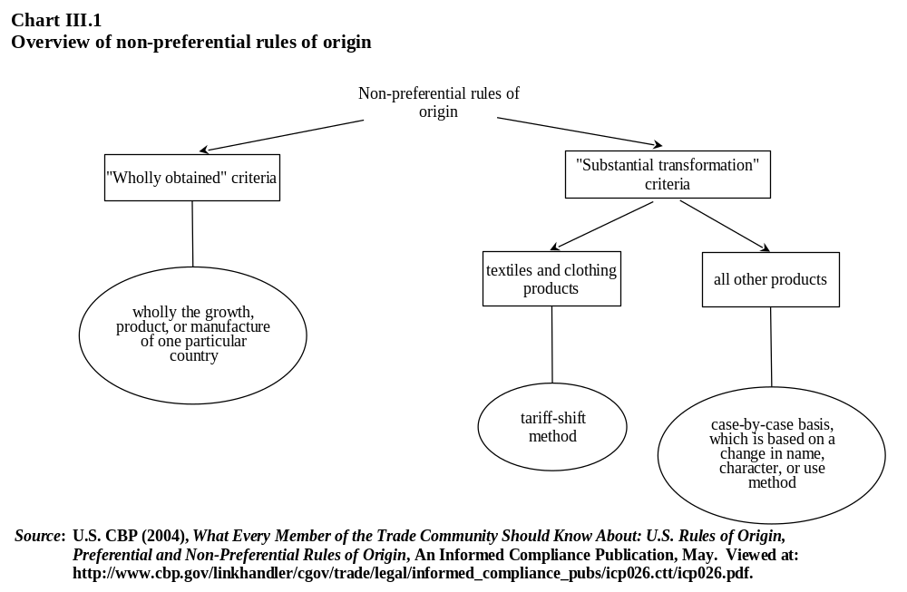

Preferential rules of origin
          - The increasing number of FTAs the United States has entered into with trading partners has had an impact on the growth of U.S. preferential origin regimes. Each agreement has unique rules of origin, specifically negotiated between the trading partners, and results in more pages of differing rules. The preferential rules used for non-reciprocal trade preference programmes rely largely on the "wholly obtained" criteria, or undergo a substantial transformation, determined by using a required minimum local value content of an appraised value. In contrast, U.S. FTA rules of origin have been modelled after the NAFTA rules, which principally utilize product-specific rules, largely based on a tariff-shift methodology and/or regional value content formula. Product-specific rules are based on the HS nomenclature and can be extensive since there are specific rules for each HS Chapter, heading, or subheading. NAFTA, CAFTA-DR, Australia, Chile, Peru, and Singapore FTAs mostly use changes in tariff classification to determine the origin of a good with components from more than once country (Table III.1). Furthermore, within the same FTA there are often significant differences in the origin rules applied across HS chapters or across industries. The case of textiles and clothing is one important example, with its "yarn forward" rule for many products, which essentially requires three levels or steps of origin-confirming processes for the yarn, fabric, and clothing in order to confer origin or allow for regional value content calculation. Other industry sectors often require a simple one-step change in tariff heading or subheading to confer origin. The role of U.S. industry has been noted as having a very influential impact on the varying product-by-product outcome of preferential rules of origin negotiations. This proliferation of differing rules of origin, their complexity, and lack of transparency continues to be of concern for some.
Table III.1
Overview of preferential rules of origin criteria, 2012
Preferential programme | Citationª | Brief overview of origin rules^{b}
AGOA | GN 16; 19 U.S.C. 3701; 19 CFR 10.178a, 10.211 | Imported directly from a beneficiary country and the sum of the cost or value of the materials produced in one or more designated beneficiary countries, plus the direct costs of processing operations is at least 35% of the appraised value of the article. Up to 15% of the 35% local value content requirement may be attributable to the cost or value of materials produced in the United States
ATPA/  ATPDEA | GN 11; 19 U.S.C. 3201; 19 CFR 10.201, 10.241, 251 | Imported directly from a beneficiary country and the sum of the cost or value of the materials produced in one or more Andean beneficiary countries or one or more Caribbean Basin beneficiary countries, plus the direct costs of processing operations is at least 35% of the appraised value of the article. Up to 15% of the 35% local value content requirement may be attributable to the cost or value of materials produced in the United States
CBERA | GN; 19 CFR 10.191; 19 U.S.C. 2701 | Imported directly from a beneficiary country and the sum of the cost or value of the materials produced in one or more designated beneficiary countries, plus the direct costs of processing operations is at least 35% of the appraised value of the article. Up to 15% of the 35% local value content requirement may be attributable to the cost or value of materials produced in the United States
CBTPA | GN 17; 19 U.S.C. 2701; 19 CFR 10.221, 10.231 | Imported directly from a beneficiary country and meets the NAFTA rules of origin
GSP | GN 4; 19 CFR 10.171; 19 U.S.C. 2461 | Imported directly from a beneficiary country and the sum of the cost or value of the materials produced in a designated beneficiary country or in one or more members treated as an association of countries, plus the direct costs of processing operations is at least 35% of the appraised value of the article
NAFTA | Article 401 of NAFTA; GN 12; 19 CFR Part 181; 19 U.S.C. 3332 | The rules of origin for goods that are not wholly obtained from the NAFTA region are based on a tariff shift method and/or regional value content method
Chile | GN 26; 19 U.S.C. 3805 | The rules of origin for goods that are not wholly obtained from the United States or Chile are based on a tariff shift method and/or regional value content method
Israel | GNs 3(a)(v) and 8; 19 U.S.C. 2112 | Imported directly from Israel, West Bank, Gaza Strip, or a Qualifying Industrial Zone and the sum of the cost or value of materials produced in Israel, West Bank, Gaza Strip, or a Qualifying Industrial Zone, plus the direct costs of processing operations, is at least 35% of the appraised value of the article. Up to 15% of the 35% local value content requirement may be attributable to the cost or value of materials produced in the United States
Jordan | GN 18; 19 U.S.C. 2112 | Imported directly from Jordan and that is wholly the growth, product or manufacture of Jordan or a new or different article of commerce that has been grown, produced or manufactured in Jordan and the sum of the cost or value of the materials produced in Jordan, plus the direct costs of processing operations is not less than 35% of the appraised value of such article. Up to 15% of the 35% local value content requirement may be attributable to the cost or value of materials produced in the United States
Singapore | GN 25; 19 U.S.C. 3805 | The rules of origin for goods that are not wholly obtained from the United States or Singapore are based on a tariff-shift method and/or regional value-content method
Australia | GN 28, P.L 108-286 | The rules of origin for goods that are not wholly obtained from the United States or Australia are based on a tariff-shift method and/or regional value-content method
Morocco | GN 27, P.L 108-302 | The rules of origin for goods that are not wholly obtained from the United States or Morocco are based on a tariff-shift method or the sum of the value of each material produced in the territory of Morocco or of the United States, or both, and the direct costs of processing operations performed in the territory of Morocco or of the United States, or both, is not less than 35% of the appraised value of the good
CAFTA-DR | GN 29, P.L 109-53 | The rules of origin for goods that are not wholly obtained from the United States or the CAFTA-DR region are based on a tariff-shift method and/or regional value-content method
Bahrain | GN 30, P.L 109-169 | The rules of origin for goods that are not wholly obtained from the United States or Bahrain are based on a tariff-shift method or the sum of the value of each material produced in the territory of Bahrain or of the United States, or both, and the direct costs of processing operations performed in the territory of Bahrain or of the United States, or both, is not less than 35% of the appraised value of the good
Table III.1 (cont'd)
Oman | GN 31, P.L 109-283 | The rules of origin for goods that are not wholly obtained from the United States or Oman are based on a tariff-shift method or the sum of the value of each material produced in the territory of Oman or of the United States, or both, and the direct costs of processing operations performed in the territory of Oman or of the United States, or both, is not less than 35% of the appraised value of the good
Peru | GN 32, P.L 110-138 | The rules of origin for goods that are not wholly obtained from the United States or Peru are based on a tariff-shift method and/or regional value content method
Korea, Rep. of | GN 32, P.L 110-138 | The rules of origin for goods that are not wholly obtained from the United States or Korea, Rep. of, are based on a tariff-shift method and/or regional value content method
Colombia | GN 34, P.L. 112-42 | The rules of origin for goods that are not wholly obtained from the United States or Colombia are based on a tariff-shift method and/or regional value content method
a "GN" refers to General Note of the HTSUS.
b For non-textile items. For textile items, different rules apply.
Source: U.S. Customs and Border Protection (2004), What Every Member of the Trade Community Should Know About: U.S. Rules of Origin: Preferential and Non-Preferential Rules of Origin, May. Viewed at: http://www.cbp.gov/
linkhandler/cgov/trade/legal/informed_compliance_pubs/icp026.ctt/icp026.pdf; and Committee on Ways and Means, U.S. House of Representatives (2010), Overview and Compilation of U.S. Trade Statutes, December. Viewed at: http://www.gpo.gov/fdsys/pkg/CPRT-111WPRT63130/pdf/CPRT-111WPRT63130.pdf.
          - The U.S. preferential rules of origin have not been notified to the WTO Committee on Rules of Origin since 1997. The preferential rules are contained in the HTSUS, mainly in the General Notes, accounting for approximately 670 pages of text. Additional preferential origin criteria, outside the General Notes, are in Chapter 98 and 99 provisions. An importer would need to determine which preferential rules might apply to the product concerned, and then find the appropriate section of the HTSUS to determine the applicable origin criteria. Furthermore, the nomenclature-specific tariff shift information has not been updated to reflect HS2012 changes introduced in the tariff, which would have to be negotiated between trading partners for FTAs.

Country-of-origin marking
          - U.S. legislation dating back to 1890 requires that articles of foreign manufacture contain a mark or label indicating the country where the good originated. The law has been amended numerous times but, as originally enacted, covered "all articles of foreign manufacture". Different rules apply for domestic products, for example in order to be labelled as "Made in the U.S.A.". The principle legislation for imported products is in section 304 of the Tariff Act of 1930 and is administered by CBP at the border. Pursuant to marking legislation and its judicial interpretation over many years, goods are considered to originate from the country in which they were grown, produced or manufactured. The rules of "substantial transformation" may be applied to determine the last country in which the article was transformed by having a new name, character, or use.
          - Other product-specific marking/labelling requirements, at the federal or state level, follow other rules or regulations. Specific labelling requirements, outside of section 304, include the American Automobile Labeling Act, the Fur Products Labelling Act, the Omnibus Trade and Competitiveness Act for Native American style jewellery, and various other Acts or Codes relating to agricultural products such as meat, eggs, mushrooms, etc. In addition to product-specific marking requirements, different marking requirements exist, outside section 304, for products subject to FTAs such as NAFTA.
          - Section 304 of the Tariff Act of 1930, as amended, provides that all imported articles, unless exempted (Table III.2), must be marked at the time of importation so that the "ultimate purchaser" knows where the imported article was manufactured. If imported articles are not marked or if they are inadequately marked, penalties or fines may be applied, and the products may be retained by Customs. Provisions of certain FTAs allow exemptions from the fines and penalties for beneficiary countries under certain conditions.
          - The U.S. marking rules regime may be considered as one of the more detailed, compared with other countries. Specific rules for U.S. imported products, differ from those applied to domestic products, which differ from FTA preferential origin rules, and these are likely to differ for U.S. products exported (subject to foreign countries marking or origin requirements). For example, under some preference programmes, such as GSP, an imported article must be substantially transformed in the beneficiary country and must include at least 35% local value content. Failure to meet the 35% local value content makes the article ineligible for GSP treatment even if it is substantially transformed. However, for marking and other purposes, the article would be "originating" in that beneficiary country because of the substantial transformation. Furthermore, as U.S. domestic product marking rules follow a different set of rules and jurisprudence of the Federal Trade Commission, the product would have to be made solely of domestic content and of U.S. labour in order to be marked as "Made in the U.S.A."; the concept of substantial transformation does not apply. Thus, the same or similar products could have different origin determinations depending on which rules were being applied for which purpose.
Table III.2
Exemptions to the section 304 marking requirement
Article is incapable of being marked
Article cannot be marked without injury to the item
Article cannot be marked prior to shipment to the United States, except at an expense economically prohibitive of its importation
Marking of the container of the article will reasonably indicate the origin of the article
The article is a crude substance
Such article is imported for use by the importer and not intended for sale in its imported or any other form
Such article is to be processed in the United States by the importer or for his account otherwise than for the purpose of concealing the origin of such article and in such a manner that any mark contemplated by this section would necessarily be obliterated, destroyed, or permanently concealed
An ultimate purchaser, by reason of the character of such article or by reasons of the circumstances of its importation, must necessarily know the country of origin of such article even though it is not marked
Such article was produced more than 20 years prior to its importation
U.S. Treasury J-List of exempted products
Such article cannot be marked after importation except at an expense which is economically prohibitive, and the failure to mark the article before importation was not due to any purpose of the importer, producer, seller, or shipper to avoid compliance with marking
Products of American fisheries
Products of U.S. possessions
Products of U.S. origin that have been exported and returned
Articles entered for immediate transhipment and exportation
Articles entering duty-free valued at US$1 or less
Bona fide gifts valued at less than US$10
Certain teas, coffees, and spices
Source: USITC (1996), Country-of-Origin Marking: Review of Laws, Regulations, and Practices, Investigation No. 332-366, Publication 2975, July. Viewed at: http://www.usitc.gov/publications/332/pub2975.pdf; and Committee on Ways and Means, U.S. House of Representatives (2010), Overview and Compilation of U.S. Trade Statutes, December. Viewed at: http://www.gpo.gov/fdsys/pkg/CPRT-111WPRT63130/pdf/CPRT-111WPRT
63130.pdf.

Changes to U.S. origin and marking rules
          - The United States continues to make changes to its rules of origin regimes (Table III.3). It appears that the majority of the changes were a result of aligning the origin rules to the intent of the agreements, a result of legal jurisprudence, and to harmonize certain provisions among the various FTAs.
Table III.3
Changes or developments in U.S. preferential rules of origin, January 2010-June 2012
ROO | Effective dateª | Citation | Issue/subject
NAFTA FTA | 3 October 2009 | Presidential proclamation 8536 | Technical corrections for certain chemicals and brake linings
Singapore FTA | 8 February 2009 | Presidential proclamation 8536 | Technical corrections for certain machinery
Chile FTA | 8 February 2009 | Presidential proclamation 8536 | Technical corrections for certain machinery
Truth in Fur Labeling Act | 18 March 2011 | P.L. 111-113 | Made changes to the Fur Products Labelling Act to require labelling of all fur products regardless of value
ROO for textiles and apparel products | 17 March 2011 | 76 FR 14575 | Final rule to revise, update, and consolidate the CBP regulations relating to the country of origin of textile and apparel products. The primary regulatory change consists of the elimination of the requirement that a textile declaration be submitted for all importations of textile and apparel products. In addition, to improve the quality of reporting of the identity of the manufacturer of imported textile and apparel products, it adopts as a final rule an amendment requiring importers to identify the manufacturer of such products through a manufacturer identification code ("MID'')
NAFTA FTA | 3 October 2011 | 76 FR 54691 | Pipe fittings and flanges, greeting cards, glass optical fiber, rice preparations, and certain textile and apparel products
Chile FTA | 1 November 2011 | Presidential proclamation 8742 | Chemicals, certain dried vegetables, coffee, spices, cocoa, rubber products, certain machines of ch. 84, lamps, and certain instruments and apparatus
Table III.3 (cont'd)
Singapore FTA | 7 February 2008 / 24 May 2011 | Presidential proclamation 8682 | Certain instruments and apparatus, and certain clothing and apparel items
Peru FTA | 1 January 2011 | Presidential proclamation 8682 | Certain amendments to chapter 99
NAFTA FTA | 2 October 2009 | Presidential proclamation 8682 | Chemicals
a Changes were sometimes issued with retroactive effect, thus the effective date may precede the date of the legislation or proclamation.
Source: WTO Secretariat.

Tariffs
          - The Harmonized Tariff Schedule of the United States (HTSUS) provides tariff levels, classification, general rules for importation, and rules of origin information for imported products entering the United States. While it is cited in the Code of Federal Regulations, it remains a publication of the USITC so that it can be kept current and updated regularly. The USITC maintains a custodial role over the HTSUS as key elements are legislated by Congress, proclaimed by the President through limited authority and oversight, and/or directly through the provisions of the international nomenclature. The HTSUS may be updated frequently to reflect new provisions in rates, nomenclature or other trade rules. For example, the HTSUS has been updated four times in 2012 to incorporate changes to implement WCO changes, the FTAs with Korea and Colombia, and changes related to the U.S. Generalized System of Preferences.

Tariff nomenclature
          - The United States' tariff nomenclature is published as the Harmonized Tariff Schedule of the United States, which is based upon the internationally adopted Harmonized System. In addition to adopting the international nomenclature to the six-digit level, the United States further delineates the nomenclature to the eight-digit tariff-rate legal level, and to the ten-digit statistical reporting level. Thus, for importers reporting purposes, the ten-digit level is recorded for entries. The United States also expands the nomenclature with the use of chapters 98 and 99 of the tariff, which are unique national provisions. Chapter 98 pertains to special classification provisions, and chapter 99 to temporary legislation, temporary modifications, and additional import restrictions. The use of chapter 99 has increased significantly in recent years as it is typically used to implement certain temporary provisions, especially as pertains to FTA tariff reductions.
          - By presidential proclamation, the United States implemented the HS2012 nomenclature changes to its tariff schedule in early 2012. The changes implemented comprise 219 of the 220 sets of changes as prescribed by the WCO Harmonised System Convention in order to keep the HS updated and current to reflect changes in technology and patterns in international trade. The United States did not implement one set of changes affecting three six-digit tariff codes of certain photographic films of chapter 37. The United States has been included in the WTO waiver decision of 30 November 2011, "Introduction of Harmonized System Changes into WTO Schedules of Tariff Concessions", to waive certain WTO obligations in order to implement the nomenclature changes. To date (noting the deadline of 30 September 2012), the United States had not yet submitted its documentation to the WTO in order to make the necessary changes to its WTO tariff schedule.
          - During the period under review, the United States implemented other nomenclature changes to its tariff schedule (HTSUS) by presidential proclamation. There were 11 sets of changes involving the footwear sector (i.e. footwear with textile outersoles). The United States has not notified these changes as a rectification or modification to its tariff schedule, thus the nomenclature of the HTSUS and the U.S. WTO schedule differ for these 11 sets of footwear changes.

MFN applied tariffs
          - The HTSUS contains seven columns of information and two of these pertain to rates of duty. Column 1, subdivided into "General" and "Special", is for those countries having normal trade relations (NTR), i.e. MFN status; and column 2 for those countries that do not have NTR. Currently only two countries are designated as column 2 countries, Cuba and North Korea. Column 1 "General" is the normal duty rate applied, while "Special" is used to designate special duty provisions or programmes such as FTA rates, preferential rates, and special programmes that cover trade in civil aircraft or pharmaceuticals for example. Thus, even if a WTO commitment is recorded on an MFN basis, the United States may apply this through the "General" or "Special" columns. The United States generally uses ad valorem, specific, or compound duty rates.
          - The 2012 HTSUS contains 10,711 tariff lines at the eight-digit tariff level. According to the HTSUS, the United States maintains TRQs on 200 tariff lines of agricultural products, which correspond to 199 out-of-quota tariff lines. These include beef, dairy, sugar, cotton, tobacco, and peanuts (see also Chapter IV(1)(iii)(a)). The following analysis excludes the in-quota lines, and is based on 10,511 tariff lines (Table III.4).
Table III.4
Structure of the tariff schedule, selected yearsª
(%)
 |  | 2002 | 2004 | 2007 | 2009 | 2012
1. | Total number of tariff lines | 10,297 | 10,304 | 10,253 | 10,253 | 10,511
2. | Bound tariff lines (% of all tariff lines)^{b} | 100.0 | 100.0 | 100.0 | 100.0 | 100.0
3. | Duty free tariff lines (% of all tariff lines) | 31.2 | 37.7 | 36.5 | 36.3 | 37.0
4. | Simple average tariff (%) | 5.1 | 4.9 | 4.8 | 4.8 | 4.7
5. | WTO agriculture | 9.8 | 9.7 | 8.9 | 8.9 | 8.5
6. | WTO non-agriculture (including petroleum) | 4.2 | 4.0 | 4.0 | 4.0 | 4.0
7. | Agriculture, hunting, forestry, and fishing (ISIC 1) | 5.6 | 5.7 | 5.5 | 5.7 | 5.6
8. | Mining and quarrying (ISIC 2) | 0.4 | 0.4 | 0.3 | 0.4 | 0.4
9. | Manufacturing (ISIC 3) | 5.1 | 4.9 | 4.8 | 4.8 | 4.7
10. | First stage of processing | 3.8 | 3.7 | 3.7 | 3.7 | 3.7
11. | Semi-processed products | 4.7 | 4.3 | 4.2 | 4.2 | 4.2
12. | Fully processed products | 5.5 | 5.4 | 5.3 | 5.3 | 5.2
13. | Dutiable lines tariff average rate (%) | 7.4 | 7.8 | 7.6 | 7.6 | 7.5
14. | Non-ad valorem tariffs (% of all tariff lines) | 12.2 | 10.6 | 10.7 | 10.7 | 10.9
15. | Non-ad valorem with no AVEs (% of all tariff lines) | 0.0 | 0.0 | 0.0 | 0.0 | 0.0
16. | Lines subject to tariff quotas (% of all tariff lines) | 1.9 | 1.9 | 1.9 | 1.9 | 1.9
17. | Domestic tariff "peaks" (% of all tariff lines)^{c} | 5.6 | 7.1 | 6.9 | 6.7 | 6.7
18. | International tariff "peaks" (% of all tariff lines)^{d} | 6.6 | 5.5 | 5.2 | 5.3 | 5.0
19. | Overall standard deviation | 12.3 | 12.6 | 11.9 | 11.8 | 11.9
a The tariff is provided at the eight-digit level. Averages exclude in-quota rates and lines. Calculations include ad valorem equivalents (AVEs) for non-ad valorem duties that were calculated by the U.S. authorities using import price data.
b Two lines applying to crude petroleum are not bound.
c Domestic tariff peaks are defined as those exceeding three times the overall average applied rate.
d International tariff peaks are defined as those exceeding 15%.
Source: WTO Secretariat calculations, based on data provided by the U.S. authorities and notifications.
          - U.S. tariff rates have remained relatively unchanged for several years. The United States assesses duties on an f.o.b. basis (not c.i.f. like most other countries) which may have a bearing on tariff rates. The 2012 simple average tariff level remains relatively low, at 4.7%, however the tariff structure is quite dispersed. A significant proportion (37%) of tariff lines are duty free, while approximately 7% of tariff lines are considered to have peaks, some as high as 350% (tobacco) (Chart III.2) The vast majority of peaks (around 50%) are in the textile and apparel sector, followed by agricultural products (35%), and footwear (7%). Commodities that are subject to TRQs generally have peak tariffs in the out-of-quota tariff line and many tariffs that are non-ad valorem are also peak tariffs. Duty-free tariffs are highly concentrated in the machinery and electronics sector, mainly due to the products covered by the ITA, and in the chemicals, steel, and paper subsectors, due to the U.S. participation in the Uruguay Round zero-for-zero sectoral initiatives (Table AIII.1).
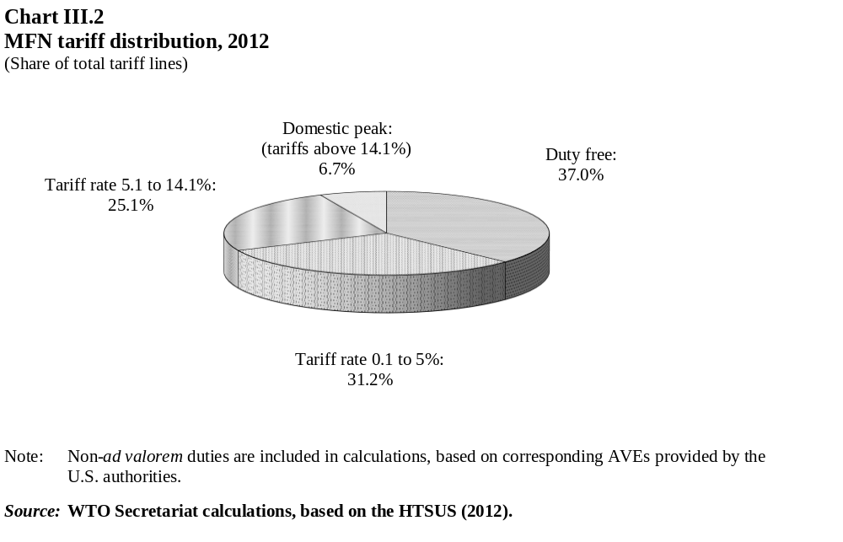
          - The United States made a few changes to its MFN applied rates during the period under review. The U.S. Manufacturing Enhancement Act of 2010 was passed by Congress and signed into law by the President in August 2010. This legislation grouped several hundreds of tariff duty suspensions and reductions into one law, thereby providing new or extended temporary duty relief for certain products until 31 December 2012. According to a statement released by the Office of the President, the legislation would reduce or eliminate some tariffs, which in turn would significantly lower costs for American manufacturing companies, including cars, chemicals, medical devices, and sporting goods. These specific duty reductions are not accounted for in the analysis above as they are implemented through special Chapter 99 temporary tariff reductions.
          - On 1 January 2011, the United States implemented additional duty-free concessions on pharmaceutical products pursuant to its participation in the WTO initiative on pharmaceutical products. A total of 718 new pharmaceutical products were added in the 4th review cycle in order to receive duty-free treatment. To date, the United States were notified these changes to its WTO schedule of concessions; the notification of the third review of pharmaceutical products also remains outstanding.

WTO bindings
          - The United States' WTO tariff schedule (Schedule XX) contains concessions mainly from the Uruguay Round, although subsequent rectifications or modifications reflect the HS nomenclature changes from 1996 and 2002, and certain other trade liberalizing initiatives such as the ITA, distilled spirits, certain pharmaceutical products, etc. The WTO tariff bindings do not yet reflect HS changes from 2007 and 2012, as is the case with most Members, or some other changes that the United States has made domestically but has not yet notified. Moreover, while the HS96 and HS02 nomenclature changes have been implemented for the tariff lines concerned, the Chapter notes have not been updated, and they remain as implemented at the time of the Uruguay Round. One Uruguay Round concession remains conditional, i.e. subject to obtaining adequate coverage in the area of Government Procurement, and therefore remains outstanding. Furthermore, the legal change to amend certain tobacco tariffs, pursuant to Article XXVIII renegotiations, has not been implemented at the WTO, while it appears the United States proceeded domestically with these changes long ago.
          - U.S. Schedule XX statistically results in 100% binding coverage, however two lines remain unbound, those pertaining to crude petroleum. A comparison of the bound and applied rates was performed using the bound tariff schedule that currently exists in the HS2002 nomenclature and no discrepancies were found.
          - The United States bound most "other duties and charges" at zero during the Uruguay Round. However, seven tariff lines have "other duties and charges" bound at higher levels, i.e. US¢ 5.99 or US¢ 14.27 per litre for fuel mixtures containing ethyl alcohol and for ETBE.

Preferential tariffs and duty-free initiatives
          - Tariff commitments under the FTA with Korea entered into force on 15 March 2012 (Table AIII.2). As of 30 June 2012, the simple average tariff for Korean products entering the United States is 1.7%, compared with 4.7% for MFN countries. Tariffs were reduced to zero for petroleum, minerals, and pulp and paper immediately upon implementation. Significant tariff reductions, i.e. greater than a 2% reduction, occurred in the fruit and vegetable, textiles, leather and footwear, chemicals and photographic supplies, and electric machinery.
          - Upon implementation of the Colombia FTA on 15 May 2012, tariff reductions went into effect giving a simple average tariff of 0.8% for all products (Table AIII.2). Over half of all imports from Colombia already benefited from duty-free access due to preferences or MFN-duty free rates (Chapter II(3)(i)(a)). Most sectors were liberalized immediately upon implementation; the HS sections in which tariffs remain and are being staged more gradually are in agriculture and footwear.
          - Pursuant to preferential trade relations under FTAs, the United States maintains tariff-rate quotas on some imports from certain FTA partners. A number of products across sectors are involved, but in particular to textiles and apparel, where Tariff Preference Levels (TPLs) are created in which duty-free treatment is provided to non-originating goods up to agreed quantity restrictions. This allows products to enter under the preferential rates when the item does not meet the preferential rule of origin. For textiles and apparel, the item is converted to "square meter equivalents", and thereafter measured against the quota category to determine the available quota or quota fill rate.
          - Certain watches, watch movements, and jewellery enter the United States duty free from U.S. insular possessions through special annual import allocations. Watch producers in the U.S. insular possessions may ship watches and watch movements, up to their exemption limits, free of duty into the customs territory of the United States. In addition, producers of watches and jewellery in the U.S. insular possessions receive a duty refund certificate, based on the amount of wages and fringe benefits (health insurance, life insurance, and pension benefits) they paid their workers during the previous calendar year, entitling them to refunds of duties paid on goods imported into the United States.
          - The United States applied certain other special programmes that provide duty-free or preferential rates for certain products. Under the Florence Agreement programme, certain scientific instruments apparatus qualify for duty-free entry if the Department of Commerce determines that an equivalent instrument is not being manufactured in the United States. The United States also adheres to the Nairobi Protocol, which allows for duty-free treatment of articles for physically handicapped persons.

Other charges affecting imports

Customs user fees

Merchandise Processing Fee
          - Since 1985 the United States has imposed fees for the processing of commercial merchandise. Several revisions to the law or new laws that have modified the fees, changed how they are assessed, and created exemptions. The Merchandise Processing Fee (MPF) was created in 1986, and since 1990 has been applied differently depending on whether the import is an informal or formal entry. For informal entries, the MPFs are: US$2 for automated entries, US$6 for manual entries not prepared by CBP, and US$9 for manual entries prepared by CBP. For formal entries there is an ad valorem fee with caps for minimum (US$25) and maximum (US$485) rates. Currently, the informal entry limit for merchandise is US$2,000, but there is a proposed rule by the Department of Homeland Security and the Department of Treasury to raise the limit to US$2,500. The final rule is expected to be issued in the second half of 2012.
          - Following the enactment of the NAFTA, the merchandise processing fee has not been applied to imports from Canada since 1 January 1994 and from Mexico since 30 June 1999. Successive FTAs have exempted most from this fee, with the exception of Morocco and Jordan. Certain other preference programme recipients are also exempt (Table III.5).
Table III.5
MPF exemptions, 2012
MPF exemption | Citation | Notes
Australia | Article 2.12 of the AFTA | TPL goodsª are not exempt
Bahrain | 19 CFR 24.23(c)(8) | TPL goods are not exempt
Chile | 19 CFR 24.23(c)(7) | TPL goods are not exempt
CAFTA-DR | 19 CFR 24.23(c) | TPL goods are not exempt
Colombia | 19 USC 58c(b)(20)
Israel | 19 CFR 24.23(c)(5) | Products of Israel are exempt irrespective of whether ILFTA is claimed
Korea, Rep. of | Sec. 203
NAFTA | 19 CFR 24.23(c)(3) | TPL goods are not exempt. E criterion goods (Annex 308.1) are not exempt unless eligible to be marked as products of Canada or Mexico
Oman | 19 CFR 24.23(c)
Panama | Sec. 204
Peru | 19 CFR 24.23(c)
Singapore | 19 CFR 24.23(c)(6) | Integrated Sourcing Initiative (ISI) goods also originate, so also exempt. TPL goods are not exempt
AGOA | 19 CFR 24.23(c)(1)(iv)  19 CFR 24.23(c)(1)(i) | Exempt only when products of an LDBDC or when entered under HTS 9819
ATPDEA | 19 CFR 24.23(c)(1)(i) | Exempt only when HTS 9821 is claimed
CBERA | 19 CFR 24.23(c)(1)(iii) | Exempt irrespective of whether CBERA is claimed
CBTPA | 19 CFR 24.23(c)(1)(iii) | Exempt irrespective of whether CBTPA is claimed because they are a subset of CBERA
DCMAO (DCASR)^{b} | 19 CFR 24.23(c)(1)(i)
GSP | 19 CFR 24.23(c)(1)(iv) | Although products of a GSP country are not exempt, products of an LDBDC (a subset) are exempt, irrespective of whether GSP is claimed
Insular possessions^{c} | 19 CFR 24.23(c)(1)(ii) | Products of insular possessions are exempt irrespective of whether preference is claimed
a TPL = Tariff Preference Level goods. These goods are restricted by quantity and are administered like a quota by CBP. They concern textile and apparel products. See section (vii)(a) for more details on TPL.
b Defense Contract Management Area Office (Defense Contract Administration Service Representative.
c U.S. Virgin Islands, Guam, American Samoa, and Northern Mariana Islands.
Source: U.S. Customs and Border Protection online information, "Trade: Trade Programs: Trade Agreements: MPF and Duty Preference Programs". Viewed at: http://www.cbp.gov/xp/cgov/trade/trade_programs/international_
agreements/merchandise_fee/; and United States-Korea Free Trade Agreement Implementation Act, Public Law 112–41, 21 October 2011.
          - New legislation raised the MPF ad valorem rate for formal entries from 0.21% to 0.3464% as of 1 October 2011; however the minimum and maximum rates remained unchanged at US$25 and US$485, respectively. The rates for informal entries remain unchanged.

COBRA fees
          - The United States charges fees to recover processing costs in ensuring carriers, passengers, and their personal effects entering the U.S. are compliant with customs laws. The law, established in 1985 as the Consolidated Omnibus Budget Reconciliation Act (COBRA), has been modified over the years and is essentially a flat-rate fee system for inspection services on a per arrival basis for commercial vessels, trucks, railroad cars, private aircraft and boats, and certain passengers arriving on commercial vessels or aircraft (Table III.6).
Table III.6
Consolidated Omnibus Budget Reconciliation Act fees
Fee | Citation | Fee rate/annual decal/cap/user fee | Notes
Commercial vessel | 19 CFR 24.22(b)(1) | US$437/ US$5,955 (cap)
Commercial vehicle | 19 CFR 24.22(c) | US$5.50/US$100 (annual cap)
Rail cars | 19 CFR 24.22(d) | US$8.25/ US$100 (prepay)
Private aircraft/vessel | 19 CFR 24.22(e) | US$27.50 (annual decal)
Air/sea passenger | 19 CFR 24.22(g) | US$5.50 | Exemption for Canada, Mexico, and U.S. territories, possessions or adjacent islands
Cruise vessel and ferry passenger travel from Canada, Mexico, and U.S. territories, possessions or adjacent islands | 19 CFR 24.22(g)(ii) | US$1.93
Dutiable mail | 19 CFR 24.22(f) | US$5.50
Customs broker | 19 CFR 24.22(c) | US$138 (annual fee)
Barge/bulk carriers from Canada and Mexico | 19 CFR 24.22(b)(2)(i) | US$110/US$1,500 (cap)
Source: CBP (undated), User Fees FAQs. Viewed at: http://www.cbp.gov/linkhandler/cgov/travel/inspections_carriers_
facilities/advisory_committee/user_fees_faqs.ctt/user_fees_faqs.doc.

Harbor Maintenance Tax
          - Since 1986, the United States has charged a fee on certain merchandise arriving by vessel in order to maintain the navigation channels. The ad valorem fee of 0.125% is assessed on the declared value for commercial cargo entering the United States. The fee is remitted by CBP to the Harbor Maintenance Trust Fund, and the U.S. Congress makes appropriations for harbour dredging or other purposes. The fund has maintained a significant surplus for many years. Data from 2005 suggests that most of the expenditures from the fund in recent years have been concentrated in Louisiana, while the highest revenue ports are located elsewhere. In essence, the tax generates a pool of funds and is distributed without regard to which ports collected the tax. A number of changes to the Harbor Maintenance Tax, including the tax rate and how to spend the revenues, have been proposed in recent year in Congress, however none has been passed into law.

Agriculture fees
          - Fees charged by Customs at the border for the inspection and/or quarantine of agricultural goods, often known as "AQI", are jointly administered by APHIS and the Department of Homeland Security's Customs and Border Protection. The fees vary by type of carrier (Table III.7). The Food, Agriculture, Conservation and Trade (FACT) Act of 1990 authorised these fees, which have been adjusted and amended by subsequent legislation. For fiscal year 2011, AQI fees collected amounted to US$534.7 million.
Table III.7
Agriculture fees, 2012
Fee | Citation | Fee rate/annual decal/cap/prepay
Air passenger | 7 CFR 354.3(f) | US$5
Commercial aircraft clearance | 7 CFR 354.3(e) | US$70.75
Commercial truck | 7 CFR 354.3(c) | US$5.25/US$105 (annual decal)
Commercial vessel | 7 CFR 354.3(b) | US$496/7,410 (cap)
Commercial railroad car | 7 CFR 354.3(d) | US$7.75/155 (prepay)
Source: CBP (undated), User Fees FAQs. Viewed at: http://www.cbp.gov/linkhandler/cgov/travel/inspections_carriers_
facilities/advisory_committee/user_fees_faqs.ctt/user_fees_faqs.doc; and U.S. Department of Agriculture online information, "Agricultural Quarantine and Inspection: User Fees". Viewed at: http://www.aphis.usda.gov/
userfees/aqi_rates.shtml.

Excise taxes
          - The United States maintains over 100 excise taxes at the federal level on various products and services. A number of these have been discussed in previous TPRs of the United States. The Internal Revenue Code establishes the excise taxes, which are assessed and collected on different bases and exist in two basic forms: general fund and trust fund excise taxes. The trust funds have been established by the federal government, often for many social reasons, and are financed with dedicated excise receipts; other, general fund, excise taxes are used for general purpose expenditures.
          - For fiscal year 2010, the United States collected US$74.7 billion in federal excise taxes. Over one third (US$25.1 billion) was on gasoline motor fuels, followed by tobacco products (US$15.5 billion), diesel motor fuel (US$8.6 billion), beverage alcohol (US$7.6 billion), and transportation of persons by air (US$7.6 billion) (Chart III.3).
          - Federal excise taxes are collected and reported by: the Internal Revenue Service for retail, manufacturers, service, environmental, transportation, and insurance activities; or by the CBP (for imports), and the Alcohol and Tobacco Tax and Trade Bureau (TTB) (for domestic products), for spirits, wine, beer, tobacco products; and by the Bureau of Alcohol, Tobacco, Firearms and Explosives for firearms. As reported in previous TPRs, there are differences regarding the collection of excise taxes for some categories of beer and wine.
          - In addition to federal excise taxes, the 50 states and local governments charge excise taxes. Products affected by state and local excise taxes include fuels, tobacco products, cigarettes, spirits, wine, and beer.

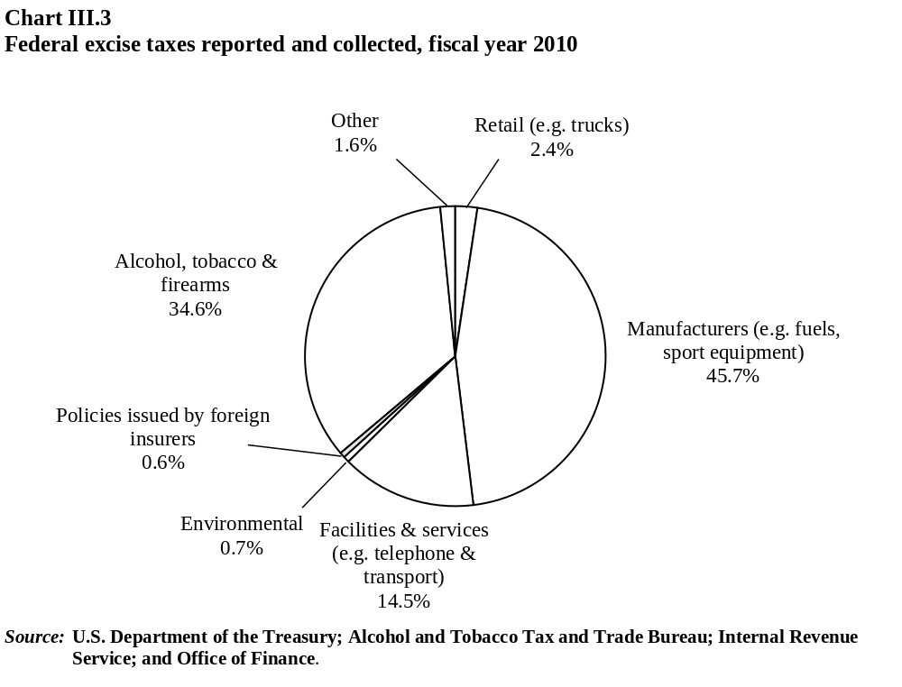

Contingency measures

Anti-dumping and countervailing measures
          - Anti-dumping (AD) and countervailing duty (CVD) legislation is contained in title 19 of the U.S. Code (sections 1671-77). Regulations are included in title 19 of the Code of Federal Regulations. The U.S. Department of Commerce and the U.S. International Trade Commission (USITC) are responsible for the administration of AD and CVD legislation.
          - The initiation of anti-dumping investigations increased in 2011 after only a few initiations in 2010. In 2008-10, over 90% of the AD investigations initiated resulted in final AD measures being imposed, but this percentage dropped in 2011, with half of the initiated investigations resulting in the imposition of final AD measures through June 2012 (Table III.8). From 2008 to June 2012, AD investigations were initiated on 0.15% of total imports.
          - The majority of AD investigations in recent years were on imports from Asia, and in particular, China. Over the past five years, Asia has accounted for 83% of the AD investigations initiated, with the Americas accounting for 10%, and the Middle East for 5% (Chart III.4).

Table III.8
Anti-dumping investigations, 2008-12
 | 2008 | 2009 | 2010 | 2011 | 2012ª
Investigation initiations | 16 | 20 | 3 | 15 | 9
Of the investigations initiated, the following determinations have been made^{b}
Preliminary injury determinations, negative | n.a. | 2 | n.a. | .. | ..
Final injury determinations, affirmative | 15 | 17 | 3 | 4 | ..
Final injury determinations, negative | 1 | 1 | n.a. | 5 | ..
Final dumping determinations, affirmative | 15 | 18 | 3 | 9 | ..
Final dumping determinations, negative | n.a. | n.a. | n.a. | .. | ..
Termination, suspension or withdrawal | 1 | n.a. | 1 | .. | ..
By per cent
Final dumping determinations, affirmative | 94 | 90 | 100 | .. | ..
Final dumping determinations, negative | n.a. | n.a. | n.a. | .. | ..
Imports subject to investigation initiations (US$ million)^{c} | 984 | 5,614 | 753 | 5,659 | 1,555
As a % of total imports | 0.05 | 0.27 | 0.05 | 0.30 | 0.07
n.a. Not applicable.
.. Not available.
a Up to June 2012.
b Data based on calendar year when relevant investigation was initiated, regardless of when a given action actually occurred.
c Import value data based on calendar year prior to initiation date.
Note: All figures refer to calendar year.
Source: WTO Secretariat, based on Import Administration online information, "Antidumping and Countervailing Duty Investigations Initiated After January 01, 2000". Viewed at: http://ia.ita.doc.gov/stats/inv-initiations-2000-current.html; USITC (2010), Import Injury Investigations Case Statistics (FY 1980-2008), February. Viewed at: http://www.usitc.gov/trade_remedy/documents/historical_case_stats.pdf; and USITC online information, " Trade Remedy Investigations: Completed Investigations". Viewed at: http://www.usitc.gov/trade_remedy/731_ad_
701_cvd/investigations/completed/index.htm.
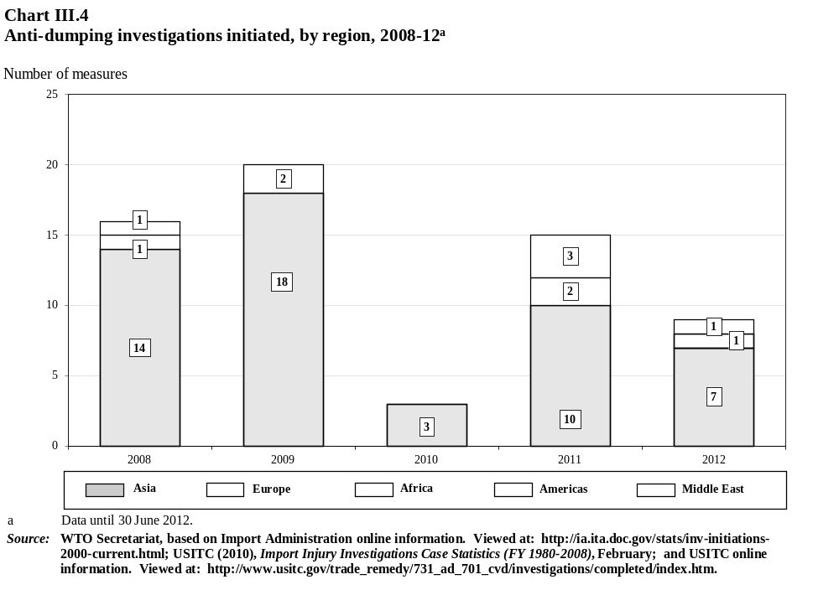
          - In terms of sectors affected by AD investigations, the metals industry accounted for 41% of all investigations, followed by chemicals and plastics with 21%, and machinery and electrical equipment with 13% (Chart III.5).
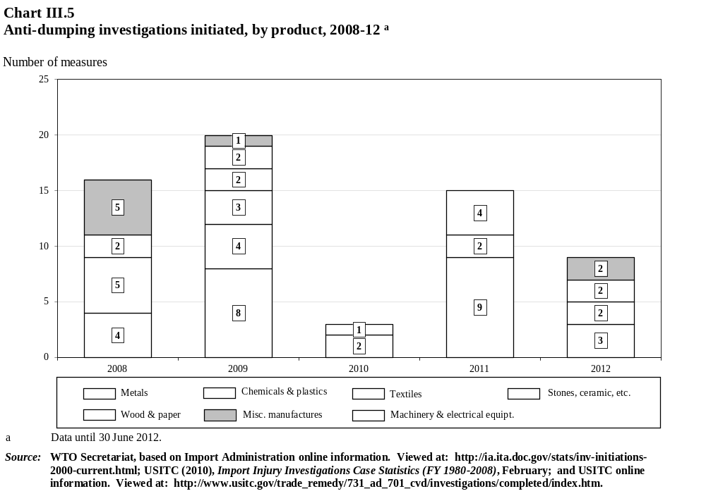
          - At the end of 2011, the United States had 237 AD measures in force; the number remained relatively stable during 2008-11 with an average of 241 measures. In 2011, China was the subject of the most AD orders with 38%, followed by the EU countries with 10%, and Chinese Taipei, 7%. The number of AD orders relating to imports from China has increased steadily, in line with increased imports from China; while the number relating to imports from EU member States has fallen. The other six countries/customs territories (Chinese Taipei, India, Japan, the Republic of Korea, Brazil, and Mexico) accounting for the next highest numbers of AD orders imposed have generally seen their number of orders remain stable over the past four years (Table III.9). Many of these developing countries are also generally the ones that have become larger users of AD measures themselves in recent years.
          - Pursuant to commitments undertaken in the Uruguay Round, the United States began reviewing outstanding AD orders in force starting in July 1998. The two agencies involved – the Department of Commerce and the USITC – had conducted 738 reviews at end 2011 under the "sunset" review procedure. The sunset review process has resulted in about 58% of orders being maintained (i.e. not revoked), and 37% of orders being revoked (Table III.10).
          - The United States abandoned the use of zeroing when calculating margins in original investigations based on weighted average to weighted average comparisons in 2006. However, in February 2012, after publishing a proposed modification, receiving public comments, and consulting with Congress, the U.S. Department of Commerce modified its methodology to address the issue of zeroing in administrative, new shipper, expedited, and sunset reviews. In administrative reviews, "except where the Department determines that application of a different comparison method is more appropriate, the Department will compare monthly weighted average export prices with monthly weighted average normal values, and will grant an offset" where the export price exceeds the normal value. Further, in sunset reviews "it will not rely on weighted average dumping margins that were calculated using the methodology determined by the Appellate Body to be WTO-inconsistent." The new rules apply to all reviews pending before the Department for which preliminary results were issued after 16 April 2012.
Table III.9
Anti-dumping measures, by country, 2008-11
 | 2008 | 2009 | 2010 | 2011
Trading partner/region
China | 72 | 82 | 88 | 91
EU countries (27) | 32 | 32 | 31 | 23
Chinese Taipei | 16 | 16 | 16 | 16
India | 14 | 16 | 16 | 15
Japan | 20 | 20 | 16 | 14
Korea, Rep. of | 14 | 15 | 13 | 11
Brazil | 11 | 11 | 11 | 10
Mexico | 7 | 6 | 8 | 6
Other America | 6 | 6 | 6 | 6
Other Asia (including Australia) | 22 | 22 | 25 | 25
Other Europe | 17 | 17 | 17 | 17
Africa | 3 | 3 | 3 | 3
Total | 234 | 246 | 250 | 237
Source: WTO Secretariat, based on USITC (2011), Antidumping and Countervailing Duty Orders in place as of 11 October 2011; USITC (2010), Import Injury Investigations Case Statistics (FY 1980-2008), February. Viewed at: http://www.usitc.gov/trade_remedy/documents/historical_case_stats.pdf; and Department of Commerce, Import Administration online information.
Table III.10
Overview of five-year sunset investigations initiated, as of year-end 2011
 | Number of cases | Distribution of cases (%)
Cases instituted | 738
Final disposition – order revoked | 271 | 36.7
Final disposition – order not revoked | 427 | 57.9
Terminated | 2 | 0.3
Suspended | 3 | 0.4
Pending | 35 | 4.7
Source: WTO Secretariat, based on USITC (2010), Import Injury Investigations Case Statistics (FY 1980-2008), February. Viewed at: http://www.usitc.gov/trade_remedy/documents/historical_case_stats.pdf; USITC Sunset Review online database. Viewed at: http://pubapps2.usitc.gov/sunset/caseProf/list?sort=caseTitle&order=asc; and USITC online information, "Trade Remedy Investigations: Active Investigations". Viewed at http://www.usitc.gov/
trade_remedy/731_ad_701_cvd/investigations/active/index.htm#reviews.
          - As of August 2011, the Department of Commerce implemented changes in its regulations governing the submission of information in AD and CVD proceedings. These amendments incorporated changes resulting from the first phase of the Department’s implementation of an electronic filing system, known as IA ACCESS (Import Administration Antidumping and Countervailing Duty Centralized Electronic Service System). When the remaining two phases are fully implemented (2012-13), all public documents will be available in IA ACCESS.
          - During the review period, the United States has adopted or proposed several modifications to its methodology for the calculation of dumping margins for non-market economies. In June 2012, after receiving public comments, the U.S. Department of Commerce announced a methodological change under which it will now reduce the export price or constructed export price by the amount of any export tax, duty or other charge in proceedings involving China and Viet Nam. Although this reduction is standard in transactions involving market economies, the U.S. Department of Commerce previously considered that such reductions were not appropriate in the case of non-market economies.
          - More recently, the U.S. Department of Commerce proposed to modify its regulations concerning the use of market economy input prices in non-market economy proceedings. Under the proposed modification, where a non-market economy producer purchases an input from a market economy supplier, the U.S. Department of Commerce would treat the price paid to the market economy supplier as the price for all of the input used only if "substantially all" of the input (greater than 85%) was purchased from the market economy supplier. In other cases, it would use a surrogate price for the portion of the input not purchased from a market economy supplier. Currently, it presumptively uses the price paid to the market economy supplier as the price for all of the input used where the share of the input purchased from market economy suppliers exceeds 33% of the total volume of the input purchased. This proposed modification was opened for public comments, to be received by 30 July 2012.
          - From 2008 to 2010, 91% of CVD investigations resulted in final affirmative CVD determinations. From 2008 to June 2012, CVD investigations were initiated on 0.10% of total imports (Table III.11).
          - The majority of CVD investigations initiated during the past five years involved imports from Asian countries (92%) (Chart III.6), in particular China. This reflects a decision of the Department of Commerce, noted in the Secretariat's previous review Report, to apply CVD measures to non-market economy countries (NMEs). This decision, and consequent decisions regarding the simultaneous application of CVD measures alongside AD measures based upon dumping margins calculated using an NME methodology, have resulted in litigation both at the WTO, and in domestic courts. While the U.S. Court of Appeals for the Federal Circuit held in December 2011 that under U.S. law CVD measures cannot be applied to NMEs, Congress in March 2012 enacted legislation effectively reversing that ruling retroactively. The new legislation, which also contains provisions intended to address WTO rulings by preventing "double counting", is currently facing challenges on Constitutional grounds.
Table III.11
Countervailing duty investigations initiated, 2008-12
 | 2008 | 2009 | 2010 | 2011 | 2012ª
Investigation initiations | 6 | 14 | 3 | 9 | 4
Of the investigations initiated, the following determinations have been made^{b}
Preliminary determinations, negative | n.a. | 1 | n.a.
Final injury determinations, affirmative | 6 | 10 | 3 | 1 | ..
Final injury determinations, negative | n.a. | 3 | n.a. | .. | ..
Final CVD determinations, affirmative | 6 | 12 | 3 | .. | ..
Final CVD determinations, negative | n.a. | 1 | n.a. | .. | ..
Termination, suspension or withdrawal |  |  |  | ..
By per cent
Final CVD determinations, affirmative | 100 | 86 | 100 | .. | ..
Final CVD determinations, negative | n.a. | 7 | n.a. | .. | ..
Imports subject to investigation initiations (US$ million)^{c} | 511 | 4,475 | 752 | 2,713 | 941
As a of total imports | 0.03 | 0.21 | 0.05 | 0.14 | 0.04
n.a. Not applicable.
.. Not available.
a Data as of June 2012.
b Data based on calendar year when relevant investigation was initiated, regardless of when a given action actually occurred.
c Import value data based on calendar year prior to initiation date.
Note: All figures refer to calendar year.
Source: WTO Secretariat, based on Import Administration online information, "Antidumping and Countervailing Duty Investigations Initiated After January 01, 2000". Viewed at: http://ia.ita.doc.gov/stats/inv-initiations-2000-current.html; USITC (2010), Import Injury Investigations Case Statistics (FY 1980-2008), February. Viewed at: http://www.usitc.gov/trade_remedy/documents/historical_case_stats.pdf; and USITC online information, " Trade Remedy Investigations: Completed Investigations". Viewed at: http://www.usitc.gov/trade_remedy/731_ad_
701_cvd/investigations/completed/index.htm.
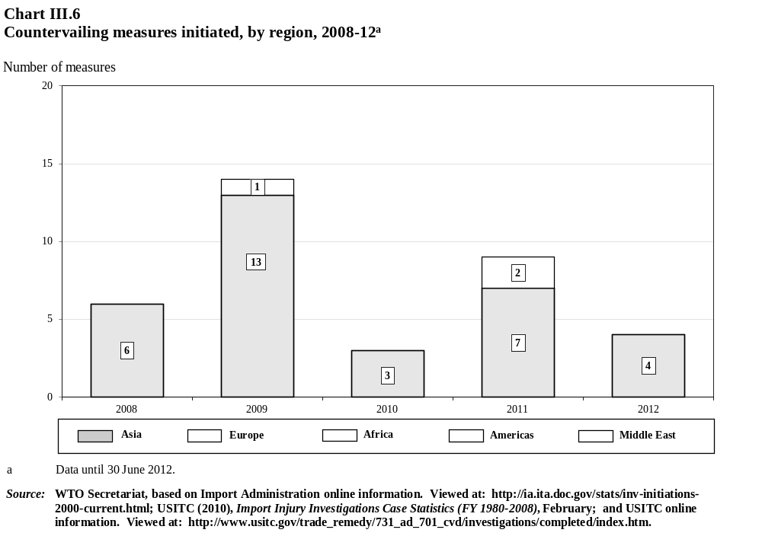
          - CVD measures have been concentrated in the metals sector since 2008 with 20 cases (Chart III.7).
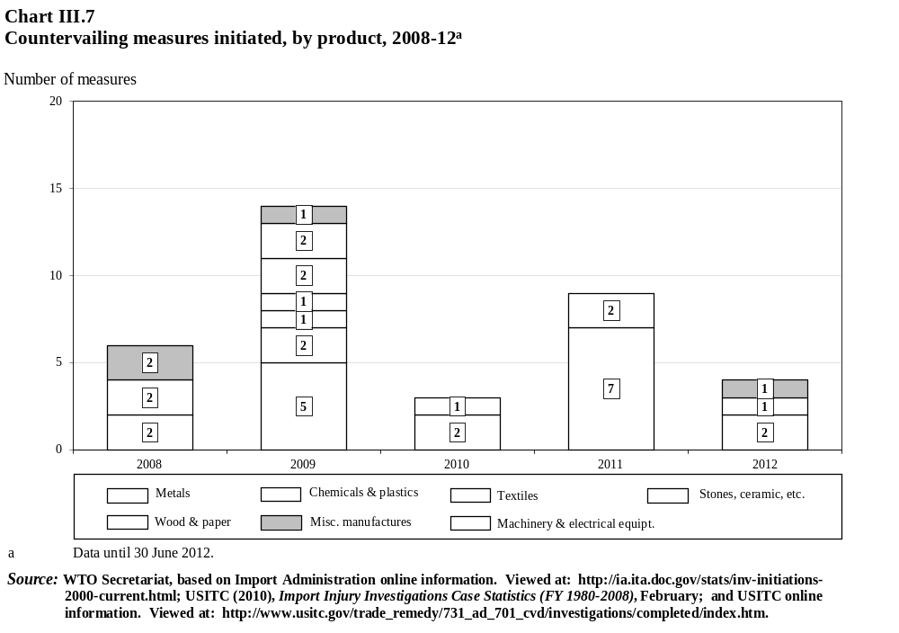
          - Under the "Sunset" review procedures initiated to date, approximately half (48%) of the 125 cases have resulted in the final CVD duty being lifted (revoked) and the other half (49%) being maintained (not revoked) (Table III.12).
Table III.12
Overview of five-year sunset reviews initiated, as of year-end 2011
 | Number of cases | Distribution of cases (%)
Cases instituted | 125 | 100.0
Final disposition – order revoked | 60 | 48.0
Final disposition – order not revoked | 61 | 48.8
Terminated | 0 | 0.0
Suspended | 0 | 0.0
Pending | 4 | 3.2
Source: WTO Secretariat, based on USITC (2010), Import Injury Investigations Case Statistics (FY 1980-2008), February. Viewed at: http://www.usitc.gov/trade_remedy/documents/historical_case_stats.pdf; USITC Sunset Review online database. Viewed at: http://pubapps2.usitc.gov/sunset/caseProf/list?sort=caseTitle&order=asc; and USITC online information, "Trade Remedy Investigations: Active Investigations". Viewed at http://www.usitc.gov/
trade_remedy/731_ad_701_cvd/investigations/active/index.htm#reviews.

Safeguards
          - The U.S. has several statutes in place relating to safeguards. The global safeguard provisions, 19 U.S.C. 2251-2254, are generally referred to as Sections 201-204 of the Trade Act of 1974, as amended. There is also safeguard legislation specific to communist countries under 19 U.S.C. 2436 (Section 406), and to China under 19 U.S.C. 2451-2451b (Sections 421-423), as well as safeguard provisions in many of the U.S. FTAs (Table III.13).
Table III.13
U.S. FTA safeguard implementation legislation, as of 2012
Agreement | Section of the Act | U.S.C. reference
United States-Australia Free Trade Agreement Implementation Act | 311(b) | 19 U.S.C. 3805 note
United States-Bahrain Free Trade Agreement Implementation Act | 311(b) | 19 U.S.C. 3805 note
United States-Chile Free Trade Agreement Implementation Act | 311(b) | 19 U.S.C. 3805 note
United States-Colombia Trade Promotion Agreement Implementation Act | 311(b) | 19 U.S.C. 3805 note
Dominican Republic-Central America-United States Free Trade Agreement Implementation Act | 311(b) | 19 U.S.C. 4061(b)
United States-Jordan Free Trade Area Implementation Act | 211(b) | 19 U.S.C. 2112 note
United States-Korea Free Trade Agreement Implementation Act | 311(b) | 19 U.S.C. 3805 note
United States-Morocco Free Trade Agreement Implementation Act | 311(b) | 19 U.S.C. 3805 note
NAFTA Implementation Act | 302(b) | 19 U.S.C. 3352(b)
United States-Oman Free Trade Agreement Implementation Act | 311(b) | 19 U.S.C. 3805 note
United States-Panama Trade Promotion Agreement Implementation Act | 311(b) | 19 U.S.C. 3805 note
United States-Peru Trade Promotion Agreement Implementation Act | 311(b) | 19 U.S.C. 3805 note
United States-Singapore Free Trade Agreement Implementation Act | 311(b) | 19 U.S.C. 3805 note
Source: 77 FR 3922.
          - There were no changes to U.S. safeguard laws during the period under review. However, there were two changes with respect to practice and procedure. The first involved a rule of general application regarding procedural changes at the USITC with respect to the electronic filing of documents, which became effective on 7 November 2011. On 26 January 2012, the USITC published notice of an interim rule as part of its Rules of Practice and Procedure to amend its rules relating to the conduct of investigations under legislation implementing safeguard provisions in free trade agreements. In essence, these rules expand upon the current rules for bilateral safeguard investigations under the NAFTA and make them applicable to other FTAs with similar procedures. On 25 June 2012, the interim rule was adopted as a final rule.
          - The U.S. last applied a safeguard measure in 2009, with respect to China, under the provisions of Section 421. This measure, "Certain Passenger Vehicle and Light Truck Tires From China," was challenged by China under the DSU. China brought a complaint and subsequently requested establishment of a panel to review the matter; it appealed the Panel's findings to the Appellate Body. The findings upheld the safeguard measure. The other U.S. safeguard laws have been little utilized in recent times. A case under Sections 201-202 was last initiated in 2001 with a review of that case (Sections 203-204) in 2005, and Section 406 was last utilized in 1993.

Special safeguard provisions under Article 5 of the Agreement on Agriculture
          - The United States has certain scheduled rights in its WTO tariff schedule relating to the possible invocation of the agriculture special safeguard (SSG) (see Chapter IV(1)).

Quantitative trade measures, restrictions, controls, and licensing

Quantitative restrictions, including prohibitions
          - The United States has various laws or provisions that allow for quantitative restrictions or prohibitions on imported products. These are often maintained to protect the security or economy of the United States, or safeguard the health or well-being of plant or animal life. For example, the Marine Mammal Protection Act, Endangered Species Act, the Fishermen's Protective Act, the Lacey Act, and the Tariff Act of 1930 Section 305 for obscene materials, and Section 308 pertaining to dog and cat fur products all have provisions to prohibit imports of certain products. CBP has enforcement authority and may restrict goods (on behalf of other agencies) that do not conform to U.S. laws or regulations such as standards or consumer protection regulations.
          - The United States also maintains quotas or quantitative restrictions on products outside of the agriculture TRQs. For industrial products, there are TRQs on certain tariff lines of tuna fish and for broomcorn brooms. Quotas on textile and apparel products were eliminated in line with the expiry of the ATC in 2005.
          - The United States last notified quantitative restrictions in 1999, and cross-referenced three notifications in the areas of safeguards, import licensing, and textiles. According to the authorities, a new notification is under preparation.

Import licensing
          - The United States requires an import licence, either automatic or non-automatic for 15 categories of products (Table III.14). The licensing requirements are required by six different U.S. executive Departments, under various statutes, and for various purposes. Generally, it is necessary to contact the focal point at the Department or Agency concerned in order to obtain the necessary licence, which is subsequently enforced at the border by CBP. In general, all persons, firms, and institutions are eligible to apply for licences. For certain products additional criteria may apply, i.e. being a resident in the United States, a registered user, a manufacturer or refiner, etc.
Table III.14
Products subject to U.S. import licensing procedures, 2011
Product / Legal reference | Stated purpose | Procedure
Animals and animal products
Title 9 C.F.R., Parts 92, 94.7, 94.16, 95.4, 95.18, 95.19, 95.20 through 98, 104 and 122; and in the following laws as codified: 21 U.S.C–102 to 105, 111, 134, 135, 151-159 and 19 U.S.C–1306 | Not used to restrict the quantity or value of imports, but only to protect domestic agriculture from the introduction or entry of animal diseases or disease vectors | The amount of time in advance of importation within which a permit must be applied for is not specified in the regulations. A permit cannot be granted immediately upon request. Prior review of the application is required. There are no limitations as to the period of the year during which permit applications may be made. Permit applications are processed and effected by one office
Table III.14 (cont'd)
Certain dairy products
The licensing system is not a statutory requirement. The authority to make such allocations was delegated to the Secretary of Agriculture by Presidential Proclamation 3019 of 8 June 1953 | Administrative tool that governs the importation of certain dairy products subject to TRQs resulting from entry into force of the Uruguay Round Agreement. Dairy articles subject to licensing cannot enter at the in-quota rate unless accompanied by a licence | The procedures for submitting licence applications, eligibility criteria, licence use requirements, and other provisions of the regulation are codified in 7 CFR 6.20-6.37
Controlled substances and listed chemicals
Title 21, Code of Federal Regulations, Section 1312.13 poses additional limitations on the imports of narcotic raw materials | To restrict the quantity of imports of controlled substances and listed chemicals and maintain a monitoring system | Annual notice of publication of aggregate production quotas for total U.S. needs (through domestic manufacture or importation) for all Schedule I and II controlled substances and the listed chemicals ephedrine, pseudoephedrine, and phenylpropanolamine, are published in the Federal Register on or about 1 July of the year prior to that to which the quota applies. Additional notice of regulations is published in Title 21, Code of Federal Regulations, Part 1300 to End
Defence articles
Arms Export Control Act of 1976; 22 U.S.C. 2778; 27 CFR Part 447; and Executive Order 11958 (42 FR 4311), as amended by Executive Order 13284 (68 FR 4075) | In part, to regulate the permanent importation of certain defence articles under the Arms Export Control Act | Bureau of Alcohol, Tobacco, Firearms and Explosives (ATF) administers the permanent importation provisions of the Arms Export Control Act with respect to defence articles. ATF is guided by the Department of State on matters affecting world peace and the external security and foreign policy of the United States
Distilled spirits or alcohol for industrial use (incl. alcohol for fuel use)
26 U.S.C. 5171 and 27 CFR Part 19 | To prevent tax fraud | An importer of distilled spirits or alcohol for industrial use (including alcohol for fuel use) secures a permit from the Alcohol and Tobacco Tax and Trade Bureau
Distilled spirits (beverages); wine, and malt beverages
Federal Alcohol Administration Act (FAA Act), 27 U.S.C. 201 et seq. | To provide an enforcement mechanism to ensure that importers comply with all requirements of Federal law relating to alcohol | An importer of alcohol beverages secures a permit from the Alcohol and Tobacco Tax and Trade Bureau
Explosives
18 U.S.C. Chapter 40 and 27 CFR Part 555 | To protect commerce against interference and interruption by reducing the hazard to persons and property arising from misuse and unsafe or insecure storage of explosive materials | Consideration of licence applications is effected by a single administrative organ (ATF)
Firearms and ammunition
18 U.S.C., Chapter 44 and 27 CFR Part 478  26 U.S.C., Chapter 53 and 27 CFR Part 479 | To provide support to Federal, State, and local law enforcement officials in their fight against crime and violence without placing any undue or unnecessary Federal restrictions or burdens on law-abiding citizens with respect to the acquisition, possession, or use of firearms appropriate to the purpose of hunting, trapshooting, target shooting, personal protection, or any other lawful activity . In part, generally to prevent statutorily prohibited persons in the United States from shipping, transporting, possessing, or receiving any firearm or ammunition. Certain firearms, including non-sporting firearms, machine guns, and destructive devices, are generally not importable into the United States except as provided in the statutes. Firearms under the National Firearms Act are generally subject to registration and taxation | Only a licensed importer may import firearms or ammunition. A Federal Firearms Licence is issued within 60 days after receipt of a properly completed application. Any person who wishes to permanently import a firearm, firearm barrel, or ammunition into the United States must first file with the Bureau of Alcohol, Tobacco, Firearms and Explosives (ATF) and obtain an approved ATF Form 6 – Application and Permit for Importation of Firearms, Ammunition and Implements of War
Table III.14 (cont'd)
Fish and wildlife (incl. endangered species)
50 CFR 14.91 93. Exceptions to the licence requirement are found at 50 CFR 14.92 | To identify commercial importers and exporters of wildlife, require records which fully and correctly disclose each importation or exportation of wildlife and the subsequent disposition of the wildlife by the importer or exporter. To allow the Service to inspect records required to be kept and inventories of imported wildlife or wildlife to be exported. To remove repeat wildlife law violators from commercial wildlife trade. To improve communications between the Service and commercial wildlife importers and exporters. To assist the Service in its effort to conserve endangered and threatened species and identify species which may be threatened or endangered | No time limit is set for receiving an application in advance of importation, however the Service has 60 days to process a licence application, which must be issued prior to an importation or exportation. Applications are submitted to and processed by Service law enforcement regional offices. The Special Agent in Charge, Office of Law Enforcement, of each office has been delegated authority to issue licences
Natural gas
Section 3 of the Natural Gas Act (NGA) (15 U.S.C. 717b) | Not intended to restrict the quantity or value of natural gas imports | DOE regulations (10 C.F.R. Part 590) specify that an applicant for a natural gas import authorization should apply 90 days prior to the anticipated date for start up of the import. Licensing applications are considered by a single administrative organ, the Office of Fossil Energy, U.S. Department of Energy
Nuclear facilities and materials
10 CFR Part 110 pursuant to the Atomic Energy Act of 1954, as amended, and the Energy Reorganization Act of 1974, as amended | Not to restrict quantities or values of items imported; it is to protect public health and safety and the environment, and maintain the common defence and security of the United States, by exercising prudent controls over the possession, use, distribution, and transport of such items | For imports under NRC’s import authority that are not authorized by the general licence in 10 CFR 110.27, an application must be submitted for review and a licence must be issued before the importation occurs
Plants and plant products
Section 412 of the Plant Protection Act, 7 U.S.C. 7712 | To protect against the entry of plant pests and diseases, and to protect endangered plant species | Permit applications are effected by one office, U.S. Department of Agriculture, Permit Section. Most applications are not passed on to other offices for visas, note or approval. The exceptions to this are permit applications for soil and for plants required to be grown in post-entry quarantine
Steel
The final rule extending the system until 21 March 2013 was published on 18 March 2009, in the Federal Register (74 FR 11474); it is possible to renew and extend the program pending Administrative review and approval | Not intended to restrict the quantity or value of imports. It is designed to provide fast and reliable statistical information on steel imports to both the government and the public | Steel import licences may be applied for up to 60 days prior to the expected date of importation and until the date of filing of the entry summary documents, or in the case of FTZ entries, the filing of Customs and Border Protection (CBP) Form 214. The licence is valid for 75 days
Sugar
15 CFR 2011, Sub part A. Certificates for specialty sugar are issued pursuant to 15 CFR 2011, Sub part B. The regulations governing licenses for the importation of sugar exempt from quota are under 7 CFR 1530. Authority exists to suspend each of these systems whenever it is determined that such action is appropriate. Notice of such suspension shall be published in the Federal Register | To provide exporters access to the U.S. domestic market at the low tier tariff. The purpose of the certificate for specialty sugar is to allow entry of certain refined sugars not widely available in the United States. These refined sugars fulfil demand in niche markets, such as the ethnic, organic and gourmet markets. Licenses for quota exempt sugar are intended to increase the utilization of excess domestic refining capacity and improve employment in refining and related industries | The U.S. Department of Agriculture administers the licensing and certificate systems
Tobacco products
26 U.S.C. 5713 and 26 U.S.C. 5702 | Does not restrict the quantity or value of imported tobacco products. To provide an enforcement mechanism to ensure that importers comply with all requirements of the Internal Revenue Code relating to tobacco | The Alcohol and Tobacco Tax and Trade Bureau has sole authority to issue the permit required under 26 U.S.C. 5713
Source: WTO document G/LIC/N/3/USA/8, 10 October 2011; and information provided by the U.S. authorities.

Sanctions, controls, or special procedures
          - The United States imposes sanctions against a number of countries, some of which restrict imports and/or exports to/from the United States. In addition to restraints on trade in goods, many of the sanctions involve controls on financial services, restrictions on monetary flows or remittances, and transfer of property. Full or partial trade sanctions are in place with respect to two WTO Members, Cuba and Myanmar, and a number of non-WTO Members, i.e. Syria, Iran, North Korea, and Sudan.
          - The Clean Diamond Trade Act of 2003 implements the Kimberley Process Certification Scheme, an international initiative aimed at curbing the trade in conflict diamonds. The importation and exportation of rough diamonds into and out of the United States requires a Kimberley Process Certificate and a tamper-resistant container. The United States is currently covered under a WTO waiver for the Kimberley process.
          - Under the Currency and Foreign Transactions Reporting Act persons transporting monetary instruments (e.g. coins, currency, checks, money orders, securities or stocks in bearer form, etc.) in excess of US$10,000 across U.S. borders are required to file and report this movement of monetary instruments to the CBP. According to the authorities, this reporting requirement has no impact on legitimate trade.

New legislation or rules enacted during the review period
          - The Asian Carp Prevention and Control Act of 2010 amends the Lacey Act to add the bighead carp of the species Hypophthalmichthys nobilis to the list of injurious species that are prohibited from being shipped or imported to the United States.
          - A new law pertaining to conflict minerals was contained in the Dodd–Frank Wall Street Reform and Consumer Protection Act, which entered into effect on 21 July 2010. The law foresees reporting and disclosing the source of four minerals, some of which are mainly used in the electronic industry. Reporting would be required by companies listed in the U.S. stock exchanges or those that raise capital in the United States. Draft rules and regulations implementing the law were issued by the SEC in 2010 for comment, and final rules were expected in 2011, but have so far not been issued (1 July 2012). Thus, the actual reporting requirements and their impact are not known at this time. The State of California has adopted a similar law pertaining to conflict minerals, which will be implemented when the Dodd-Frank rules are finalized. Maryland has also enacted a law on conflict minerals.
          - A new rule by the Agricultural Department amends the historical licence-reduction provisions of the Dairy TRQ licensing programme, by suspending the provisions on the reduction of historical licences based on surrenders of unused quantities until 2016.

Technical regulations and standards
          - Title IV of the Trade Agreements Act of 1979, as amended, is the legal basis for implementing the TBT Agreement in the United States. The Trade Agreements Act designates the Office of the USTR as the lead agency within the federal Government for coordinating and developing international trade policy on standards-related activities and in discussions and negotiations with foreign countries on standards-related matters. The Trade Agreements Act requires the USTR to inform and consult with federal agencies with expertise in the matters under discussion and negotiation. The United States submitted a notification on the implementation and administration of the TBT Agreement in February 1996. The enquiry point and notification authority under the Agreement is the National Institute of Standards and Technology (NIST) of the Department of Commerce.
          - Between 1 January 2010 and 30 June 2012, the United States made 520 notifications to the WTO Committee on Technical Barriers to Trade of which, 337 were addenda or corrigenda. The notifications were made on behalf of a number of government agencies for a variety of reasons, including: the Environmental Protection Agency for environmental protection; the Consumer Product Safety Commission on product safety; and the Food and Drug Administration for human health and food safety standards. Over the period, the U.S. authorities recognized the need to make improvements in their internal procedures for sub-federal notifications, and initiated a temporary hiatus in notifications in order to make corrections. Therefore, in contrast with the last review period, when 83 sub-federal measures were notified, 16 notifications on sub-federal measures have been made since 1 January 2010, 15 of which have been notified since August 2012.
          - WTO Members have used the TBT Committee to raise a number of concerns about TBT measures taken by the United States, and three dispute settlement proceedings in the WTO were taken against the United States under the TBT Agreement during the period under review. The United States has also used the TBT Committee to raise concerns on TBT measures taken or proposed by other Members and, since 2010, has published an annual report on measures considered to represent barriers to trade in other countries in the form of standards, conformity assessment, and technical regulations.
          - The United States is a member of the International Organization for Standardization (ISO) and the International Electrotechnical Commission, where it is represented by the American National Standards Institute (ANSI), a private sector body. It is also a member of the International Telecommunication Union (where it is represented by the Department of State, the Department of Commerce, and the Federal Communications Commission), and the Codex Alimentarius Commission (where it is represented by the U.S. Codex Office, the Food and Drug Administration, and the Department of Agriculture). In addition, the United States is a member of the International Maritime Organization (IMO), and the International Civil Aviation Organization (ICAO), participating in the respective standards-development activities of these organizations.
          - The United States is also a member of several regional organizations, such as the Pacific Area Standards Congress (PASC), the Pan American Standards Commission (COPANT), and the Council for Harmonization of Electrotechnical Standards of the Nations in the Americas (CANENA). PASC and COPANT coordinate regional input for international standardization organizations while CANENA is a forum for regional harmonization of standards in North America.
          - With a few exceptions, such as Executive Order 13563 of 18 January 2011 on improving regulation and regulatory review and Executive Order 13609 of 1 May 2011 on promoting international regulatory cooperation (see below), the procedures for developing technical regulations and conformity assessment procedures have not changed over the past few years and they are set out in a number of laws, regulations, and guidelines (Table III.15).
Table III.15
Laws, regulations and guidelines on developing technical regulations and conformity assessment procedures
Law/Regulation/Guideline | Description
Administrative Procedures Act of 1946 | Covers the notice and comment process for rule making, including the development of technical regulations, and generally requires that members of the public be given the opportunity to comment on regulatory proposals before new rules can be issued or existing ones changed. Proposed and final technical regulations or conformity assessment procedures must be published in the Federal Register
Regulatory Flexibility Act | Requires Government agencies to publish biennial agenda, which included proposed new rules that are likely to have significant economic impact
Consumer Product Safety Act as amended (including the Consumer Products Safety Improvement Act (CPSIA) in 2008) and associated regulations, | Established the Consumer Product Safety Commission with the power to develop safety standards and pursue product recalls (see below). The CPSIA was again amended in 2011, with provisions intended to reduce the cost of third-party testing requirements with a proposed rule published in November of that yearª
National Technology Transfer and Advancement Act | Requires government agencies to use voluntary consensus standards developed by private-sector standards development organizations except where inconsistent with law or otherwise impractical
Executive Order 12866 on Regulatory Planning and Review | States that government agencies should only promulgate regulations as required by law, necessary to interpret the law, or as required by compelling public need. Agencies proposing regulations, including technical regulations or sanitary or phytosanitary measures at the federal level, must identify the nature and significance of the problem to be addressed through regulation, identify and assess the costs and benefits of alternatives, and ensure that the benefits of regulations justify their costs
Circular OMB A-119 of 10 February 1998 on Federal participation in the development and use of voluntary consensus standards and in conformity assessment activities | Requires federal agencies to use "voluntary consensus standards"^{b} in procurement and regulatory activities, and for federal employees to participate in the standard development activities
Circular OMB A-4 of 17 September 2003 on regulatory analysis | Encourages the use of voluntary standards over technical regulations for goods and services; and a focus on performance rather than design standards (that is the outcome rather than the means to achieve it)
Executive Order 13563 on Improving Regulation and Regulatory Review which reaffirmed Executive Order 12866, | Stresses the importance of public participation in the rulemaking process, and seeks to improve rulemaking by requiring the use of the Internet and a period of 60 days to enable public comment on regulatory proposals
Executive Order 13609 on Promoting International Regulatory Co-operation | Provides a framework for promoting efforts to eliminate unnecessary regulatory differences and related costs, burdens and delays associated with U.S. regulatory approaches. The Order also requires agencies to provide the public with a summary, in advance, of their international regulatory cooperation activities that are reasonably anticipated to lead to significant regulations
a Federal Register, "Application of Third Party Testing Requirements; Reducing Third Party Testing Burdens", 11 August 2011. Viewed at: https://www.federalregister.gov/articles/2011/11/08/2011-27676/application-of-third-party-testing-requirements-reducing-third-party-testing-burdens [May 2012].
b "Voluntary consensus standards" are defined as standards developed or adopted by "voluntary consensus standards bodies" which are defined as domestic or international organizations which plan, develop, establish, or coordinate voluntary consensus standards using agreed-upon procedures.
Source: WTO Secretariat.
          - Institutional responsibility for implementing technical regulations has not changed over the past few years. The Office of Management and Budget (OMB) in the Executive Office of the President is responsible for overseeing and coordinating regulatory policy in the federal government. New regulations, including those that incorporate technical regulations and conformity assessment procedures, must be published in the Federal Register in both proposed and final form and must be cleared by the OMB before publication if they have a significant effect. The Regulatory Information Service Center, a component of the U.S. General Services Administration, compiles the semi-annual Unified Agenda of Federal Regulatory and Deregulatory Actions with the Office of Management and Budget's Office of Information and Regulatory Affairs and the 60 Cabinet, Executive, and independent agencies, government wide. Each edition of the Unified Agenda includes regulatory agendas from all federal entities that currently have regulations under development or review.
          - The agency or agencies responsible for developing technical regulations depend on the product in question and include: the National Highway Traffic Safety Administration for on-road vehicles and tyres; the U.S. Coast Guard for boats; the Alcohol and Tobacco, Tax and Trade Bureau for alcohol and tobacco; the Food and Drug Administration for food, drugs, cosmetics, and medical devices; the Food Safety Inspection Service (FSIS) of the Department of Agriculture for meat, poultry, and egg products; the Environmental Protection Agency (EPA); and the Consumer Product Safety Commission (CPSC) for consumer products not under other agencies' jurisdictions. The National Institute for Standards and Technology (NIST) is the federal agency that coordinates standards activities among federal government agencies with private sector standards-development organizations.
          - The CPSC is an independent agency set up in 1972 under the Consumer Product Safety Act with general responsibility for ensuring consumer product safety by encouraging the development of effective standards, developing technical regulations where needed, and enforcing compliance with product safety laws and regulations, including the overarching requirement that no product may present an unreasonable risk of injury or death. Although the official preference is to rely on industry's use of voluntary standards, the CPSC and other agencies with responsibility for product and service regulations may develop technical regulations when voluntary standards are not considered adequate or when compliance with voluntary standards is considered unlikely. The government agencies may also be required by law to develop or adopt technical regulations, for example, the Consumer Products Safety Improvement Act required the CPSC to develop technical regulations for toys and all-terrain vehicles. About 200 products are currently subject to technical regulations developed by the CPSC.
          - The American National Standards Institute (ANSI) coordinates and administers the private sector voluntary standards system in the United States. There are about 225 ANSI accredited standards developing organizations (SDOs) in the United States, 20 of which (e.g. Underwriters Laboratories Inc. (UL), ASTM International, and the American Society of Mechanical Engineers (ASME)) develop approximately 80% of the standards produced by ANSI-accredited SDOs.
          - Although compliance with voluntary consumer product safety standards is not a legal obligation, non-compliance may indicate the existence of a hazard. The CSPC and other agencies may take corrective action if their analysis shows that the product could pose a substantial hazard, in which case it will take action to withdraw the product from the market. The number of product recalls has fallen over the past few years, from over 628 in 2008 to 413 in 2011 (Table III.16). According to the GAO, the CPSC focused much of its surveillance and compliance work on imported products which represented about 80% of recalls for 2008-11.
Table III.16
Recalls by the Consumer Product Safety Commission, FY 2007-11
Year | Number of recalls of regulated products | Number of recalls of unregulated products
2007 | 92 | 385
2008 | 169 | 449
2009 | 46 | 452
2010 | 60 | 416
2011 | 30 | 383
Note: These recalls were tabulated from CPSC data for regulated and unregulated products. Unregulated products may include those covered by voluntary standards. According to CPSC officials, recalls of unregulated products are not necessarily associated with violations of voluntary standards; on some occasions the recall could be associated with issues in manufacturing or assembly of the product.
Source: CPSC as quoted by GAO (2012), Consumer Product Safety Commission, A More Active Role in Voluntary Standards Development Should Be Considered, GAO-12-582, p. 22, May. Viewed at: http://gao.gov/assets/
600/590990.pdf.

Sanitary and phytosanitary measures
          - At the federal level, institutional responsibility for SPS matters continues to be shared among several government agencies depending on the product and type of risk, while at the state level the authorities may develop their own measures, subject to federal laws and regulations. At the federal level, numerous statues, along with their implementing regulations, impose SPS requirements in the U.S. market. These statutes include: the Federal Food, Drug, and Cosmetic Act, the Federal Meat Inspection Act; the Plant Protection Act; and the Federal Insecticide, Fungicide, and Rodenticide Act. In addition, the Food and Drug Administration (FDA) Food Safety Modernization Act (which amended the Federal Food, Drug, and Cosmetic Act) became law on 4 January 2010 (Box III.1). In general, many SPS measures are subject to the same administrative rulemaking procedures as technical regulations (see above). However, according to the GAO, "[t]he safety and quality of the U.S. food supply is governed by a highly complex system stemming from at least 30 laws related to food safety that are collectively administered by 15 agencies."
          - The United States is a member of the Codex Alimentarius Commission and the World Organization for Animal Health (OIE), and a contracting party to the International Plant Protection Convention (IPPC). The contact points are in the Food Safety and Inspection Service of USDA for Codex, and the Animal and Plant Health Inspection Services of the USDA for both the OIE and the IPPC.
Box III.1: The FDA Food Safety Modernization Act (FSMA)
The FDA Food Safety Modernization Act, became law in January 2011. It is a major reform of legislation on food safety under the responsibility of the FDA, and applies to all FDA-regulated food (i.e. it does not apply to meat poultry, and processed egg products to the extent that they are under the jurisdiction of the FSIS in the Department of Agriculture).
Registration: Under Section 102 of the FSMA, food facilities are required to renew their registration with the FDA (required under Section 415 of the Federal Food, Drug, and Cosmetic Act (FD&C Act)) every two years. "Food facilities" include places that manufacture, process, pack, or hold food for consumption in the United States, including foreign facilities. This biennial registration renewal requirement which must be submitted between 1 October and 31 December, begins in 2012. The FDA may suspend registration if there is reasonable probability that food manufactured, processed, packed, received, or held by the facility could have serious adverse effect on human or animal health. Food from a facility that must register, but that does not have a valid registration must not be brought into the United States.
Preventive Controls: Under Section 418 of the FD&C Act, a registered facility is required to evaluate the hazards that could affect the food it manufactures, processes, packs or holds. The facility is required to prepare a written plan that includes: the identification of potential hazards; and the preventive controls to minimize or prevent these hazards (which could include a recall plan and/or verification of supplier activities related to food safety). The effectiveness of these controls must be monitored and procedures established for corrective actions for circumstances where they are not properly implemented or are ineffective. Each facility is required to keep records, for at least two years, documenting the monitoring of the preventive controls, instances of non-conformance, test results, verification, and corrective actions taken. The food safety plan must be re-analysed at least once every three years.
Some food facilities are exempt in whole or in part from the requirements of Section 418, including:
- facilities that comply with the FDA's existing seafood or juice hazard analysis and critical control point (HACCP) regulations;
- facilities that comply with the FDA's existing low-acid canned food regulations (only for microbiological hazards, addressed by those regulations; for other hazards facilities must comply with the FSMA);
- qualified facilities (defined as very small business or a small business with total annual food sales of less than US$500,000, at least half of which was sold directly to the final consumers, to restaurants, or to retail food establishments in the same State or within 275 miles). These qualified facilities must provide documentation including: showing potential hazards have been identified, and preventive controls are being implemented and monitored; or showing the facility is complying with all State, local, or other applicable non-federal food safety laws. (Proposed rules not yet issued.)
Produce Safety Standards: Under Section 419 of the FD&C Act, the FDA is required to establish science-based minimum standards for the safe production and harvesting of fruits and vegetables that are raw agricultural commodities for which the FDA determines that such standards minimize the risk of serious adverse health consequences or death. The FDA has the discretion to decide whether to include small and very small businesses that produce low-risk raw agricultural commodities in this rulemaking and, when included, smaller businesses have extended compliance dates. (Proposed rule not yet issued.)
Safety of imported food: Section 301 of the FD&C Act now provides that U.S. importers are to be required to verify that imported food is produced in compliance with processes and procedures that provide the same level of public health protection as Section 418 (preventive controls) or Section 419 (produce safety standards) and to verify that the food is not adulterated and is not misbranded with regard to food allergen labelling requirements. (Proposed rules not yet issued.) The Voluntary Qualified Importer Program is intended to expedite the review and imports by importers that meet certain requirements, including that the facility must have been certified by an accredited third-party auditor. (Programme not yet established.)
Intentional Adulteration: Section 420 of the FD&C Act requires the FDA, in coordination with the DHS and in consultation with USDA, to issue regulations to protect against the intentional adulteration of food. The regulations will be limited to food for which there is a high risk of intentional contamination and are to specify how a person is to assess whether mitigation measures are required and to specify appropriate science-based mitigation measures or strategies. In addition, In consultation with DHS and USDA, the FDA is directed to issue guidance documents on protection against intentional adulteration. (Proposed rule and guidance to industry not yet issued.)
Box III.1 (cont'd)
Fees: The FSMA provides the FDA with the authority to collect certain fees related to food safety. Section 743 of the FD&C Act now provides for the collection of fees from domestic facilities and the U.S. agents of foreign facilities to cover costs related to reinspections (i.e., costs incurred for inspections conducted after an earlier inspection uncovered instances of non-compliance related to a food safety requirement of the FD&C Act), for non-compliance with recall orders, from each importer subject to a reinspection, to cover reinspection-related costs, and from importers participating in the voluntary qualified importer program (see below). A Fee Notice was issued in August 2011 and a Guidance to Industry was issued in September 2011. In addition, Section 808 of the FD&C Act provides FDA with the authority to collect fees to cover the costs of establishing and administering the third party accreditation system (see below).
Inspections: The FSMA sets out inspection frequencies for high risk food facilities of once in the first five years after the FSMA was enacted and every three years thereafter. For non-high-risk facilities, FSMA mandates a minimum inspection frequency of once in the first seven years following enactment and once every five years thereafter. Under the statute, at least 600 foreign facilities are to be inspected in the first year of enactment and FDA is directed to double the number of foreign facilities inspected each year thereafter for five years. Under section 807 of the FD&C Act, if a foreign factory, warehouse, or other establishment refuses an inspection (defined as not permitting an inspection within 24 hours of a request or such other time period as agreed upon) food from the establishment is subject to refusal of admission into the United States.
Laboratory and Third-Party Accreditation: Section 422 of the FD&C Act requires the FDA to implement a programme for the accreditation of laboratories (including foreign laboratories) and to work with accreditation bodies to increase the number of accredited laboratories. Under Section 307 of the FD&C Act, the FDA is also required to establish a programme for the recognition of accreditation bodies that, in turn, may accredit third-party auditors to certify eligible foreign facilities and food shipments as meeting FDA requirements. (Proposed rules not yet issued.)
Traceability, records: Section 204 of the FSMA directs the Secretary of Health and Human Services to develop a product tracing system to improve the ability of FDA to track and trace food in the United States or offered for import into the United States. Section 204 also requires the FDA to develop regulations for records that must be kept by facilities involved with high-risk foods. The FSMA updates requirements for responsible parties for food facilities to report additional consumer-orientated information to the FDA in instances where food it has dealt with has a reasonable probability of causing adverse health consequences to humans or animals (a "reportable food") for subsequent notification to grocery and retail stores. (A traceability pilot project is in progress, record-keeping requirements for high-risk foods proposed rule not yet issued, reportable food Registry improvements not yet issued.)
Mandatory recall authority: Under Section 206 of the FSMA, if the FDA determines that there is a reasonable probability that an article of food is adulterated or misbranded and that it will cause serious adverse health consequences or death for humans or animals, the FDA may order a party to cease distribution and recall the food, after first giving the party an opportunity to do so voluntarily. (Authority in effect.)
Source: The FDA Food Modernization Act, 21 USC 2201 note. Viewed at: http://www.fda.gov/food/
foodsafety/fsma/default.htm [May 2012].
          - The U.S. enquiry point and national notification authority under the SPS Agreement is the International Regulations and Standards Division in the Foreign Agricultural Service of the USDA. The United States has continued to make notifications of SPS measures it proposes to take or has taken to the WTO Committee on Sanitary and Phytosanitary Measures (Table III.17) and to use the Committee to raise concerns about measures other Members have taken.
Table III.17
Notifications by the United States, 1 January 2010 to 30 June 2012
Objective/rationale | Total | Addenda/corrigenda | Emergency | Regular
Food safety | 398 | 31 | 0 | 367
Zoonoses | 6 | 2 | 1 | 3
Plant protection | 114 | 51 | 11 | 52
Animal health | 29 | 15 | 2 | 12
Territory protection | 16 | 2 | 13 | 1
Total | 537 | 92 | 13 | 432
Note: A notification may have more than one rationale.
Source: WTO documents in the series G/SPS/N/USA/.
          - In the WTO Committee on Sanitary and Phytosanitary Measures, since 1 January 2010 the United States has raised concerns on measures taken by several Members, including the EU, Turkey, Viet Nam, the Philippines, Indonesia, and India, and it has supported others in their statements about measures taken by Chinese Taipei, Albania, Croatia, China, Malaysia, and the EU. Other Members have also used the SPS Committee to raise concerns with measures taken or proposed by the United States, including: Costa Rica on measures affecting imports of flowers and plants; Argentina on foot-and-mouth disease and imports of queen bees; and India on maximum residue limits on basmati rice imports. A particular concern of several Members has been the FDA Food Safety Modernization Act and its implementing regulations. This issue was raised by India, China, Mexico, Costa Rica, Pakistan, and the Philippines, and the United States responded that the law had not been implemented yet and that trading partners would be able to participate in the process of developing implementing regulations for the Act through the WTO notification process.
          - The SPS Agreement was also cited in a dispute settlement cases taken against the United States on poultry.,
          - As stated above, a number of different agencies are involved in developing, implementing, and enforcing SPS measures. Among the main agencies are:
- the Animal and Plant Health Inspection Service (APHIS) in the Department of Agriculture, whose responsibilities include the regulation of imports of live plants, grain, oilseed and horticultural products, animals, including those embryos, semen, ova, and live animals intended for research and development;
- the Food Safety and Inspection Service (FSIS) in the Department of Agriculture, which is responsible for the safety of meat, poultry, and processed egg products, including imports, and the recognition of establishments in other countries that meet U.S. regulatory standards for these commodities and may export to the United States;
- the Food and Drug Administration (FDA), whose responsibilities include the regulation of: human and veterinary drugs; food (except meat, poultry, and processed eggs), including food additives; cosmetics; and dietary supplements; and
- the Environmental Protection Agency (EPA), whose responsibilities include registering pesticides (including herbicides and fungicides) for use in the United States, and establishing maximum residue limits (MRLs) for pesticides on food.
          - Other agencies involved in SPS issues, include the Agricultural Marketing Service, the Agricultural Research Service, and the National Institute of Food and Agriculture in USDA, the Centers for Disease Control and Prevention in the Department of Health and Human Services, the National Marine Fisheries Service in the Department of Commerce, Customs and Border Protection in the Department of Homeland Security, and the Alcohol and Tobacco Tax and Trade Bureau in the Department of the Treasury.
          - The Food Safety Working Group, an interagency group set up in March 2009 by the President to advise him on how to strengthen the food safety system has continued to work to improve coordination throughout the Government. The Working Group has been credited with improving cooperation between agencies and, as a result, improving food safety. However, it has also been noted that it has not developed a government-wide performance plan for food safety. Although the FDA Food Safety Modernization Act was recognized as strengthening a major part of the food safety system, "it does not apply to the federal food safety system as a whole or create a new risk-based food safety structure" (Box III.1).

Measures Directly Affecting Exports

Customs procedures and documentation
          - Since the elimination of the Shipper's Export Declaration in 2008, information on exports must be filed electronically through the Automated Export System (AES), which is used to collect data for statistical purposes as well as to support export controls. The information must be filed by the U.S. principal party in interest (USPPI) or an authorized agent. An Internal Transaction Number (ITN), which is generated by the AES, is assigned to a shipment confirming that the export information was accepted and is on file in the AES. The ITN is sent electronically to the filer of the information as proof of filing citation. This citation, or the applicable Electronic Export Information (EEI) filing exemption, must be submitted to the exporting carrier on the bill of lading, air waybill, export shipping instructions, or other commercial loading documents. The carrier is responsible for collecting the ITN or EEI filing exemption before loading the merchandise for export. Other documents may be required depending on the product and its destination. Enforcement of export controls and other export-related measures requires certification and notification requirements that depend on the product, the destination, and the use the product will be put to.
          - According to the World Bank, on average four documents are needed for exports (a customs export declaration, a bill of lading, a certificate of origin, and a commercial invoice), and exporting a container costs about US$1,050 and takes six days, including two days to prepare documents and one day for customs clearance and technical control. However, the authorities pointed out that that they do not require a commercial invoice or certificate of origin to be submitted for export, and export data are filed electronically only with no document involved.

Export taxes and fees
          - The U.S. Constitution's Export Clause bars Congress from imposing taxes on exports. Thus, taxes contingent on exports, such as the Harbour Maintenance Tax, which do not represent compensation for services rendered, may not be applied. However, fees may be applied for government supplied services, facilities, or benefits, such as user fees for providing certification for the exportation of plant and plant products under the Plant Protection Act, and fees for export certificates for human and animal drugs and devices under the Federal Food Drug and Cosmetic Act. In these cases, the fees relate to certificates or other documents required by the importing country rather than for export from the United States.

Prohibitions, restrictions, and licensing
          - The United States maintains export restrictions and controls for national security and foreign policy reasons, including addressing shortages of scarce materials. Export controls may be based on domestic legislation, policy decisions, UN Security Council Resolutions or international agreements (such as the Convention on International Trade in Endangered Species of Wild Fauna and Flora (CITES), and the Chemical Weapons Convention) as well as U.S. participation in non-binding arrangements such as:
- Wassenaar Arrangement on transfers of conventional arms and dual-use goods and technologies;
- Missile Technology Control Regime (MTCR), which seeks to coordinate national export licensing efforts on the non-proliferation of unmanned delivery systems capable of delivering weapons of mass destruction;
- Treaty on the Non-Proliferation of Nuclear Weapons (NPT), and the Exporters Committee (Zangger Committee), which seeks to harmonize implementation of the Treaty's requirements to apply International Atomic Energy Agency safeguards to nuclear exports;
- Nuclear Suppliers Group (NSG) on the non-proliferation of nuclear weapons through the implementation of guidelines for nuclear exports and nuclear-related exports; and
- Australia Group (AG), an informal forum of countries which, through the harmonization of export controls, seeks to ensure that exports do not contribute to the development of chemical or biological weapons.
          - Trade sanctions may be applied by the Department of the Treasury under the authority of, inter alia, the International Emergency Economic Powers Act (IEEPA), the Trading with the Enemy Act, and the United Nations Participation Act. The Department of the Treasury's Office of Foreign Assets Control (OFAC) administers economic and trade sanctions under these laws, and may, in this capacity, restrict exports to foreign countries and regimes and persons (entities and individuals) that are subject to such sanctions.
          - Export licences are actually required for only a small percentage of total exports. However, it is up to the exporter to determine whether a product and/or its destination require a licence and to research the end-use of the product. The law on export controls is contained in several different pieces of legislation and responsibility for implementation is divided among different government agencies.

Arms Export Control Act
          - Under the Arms Export Control Act (AECA) and the International Traffic in Arms Regulations (ITAR), all manufacturers, exporters, and brokers of items on the U.S. Munitions List (USML) must register with the Directorate of Defense Trade Controls (DDTC) in the Department of State, and often must obtain an export licence or other authorization for the export of any item on the USML. An exporter may make a self-determination, based on the USML, as to whether the item is controlled on the USML. However, should the exporter prefer a formal government opinion, it may request a Commodity Jurisdiction (CJ) determination. An appeal of a CJ determination may be made to the Managing Director of the DDTC for a final determination.
          - An exporter may also ask for a review of a decision by the DDTC concerning refusal, revocation or amendment of an export licence, in which case the Under Secretary for Arms Control and International Security has the authority to make a final decision. However, out of a total of over 82,000 applications for export licences or authorization in 2011, less than 1% were refused and there were no appeals of these decisions.
          - U.S. Immigration and Customs Enforcement, Homeland Security Investigations (HSI), in the Department of Homeland Security is responsible for investigating violations and attempted violations of the AECA and ITAR, as well as other potential violations involving exports, such as smuggling, pursuant to 18 U.S.C. Section 554. HSI works with the U.S. Department of Justice to prosecute criminal cases.
          - Civil penalties that may be imposed on an enterprise for violations of the AECA include a fine and a Consent Agreement that outlines the measures required to improve compliance within the enterprise. In 2010 and 2011, four Consent Agreements were imposed.
          - For commodities controlled by the International Traffic in Arms Regulations (ITAR), a destination control statement appears on the commercial invoice, and bill of lading, which indicates to the carrier and all foreign parties that the item may be exported only to certain destinations.

Export Administration Regulations
          - Exports and re-exports of certain goods, technology, and software that have commercial and military or proliferation applications ("dual-use" items) are controlled through the Export Administration Act (EAA) and the Export Administration Regulations (EAR), which is administered by the Bureau of Industry and Security (BIS) in the Department of Commerce. The EAR includes a list of products, the Commerce Control List (CCL), which may require a licence from the BIS before they may be exported or re-exported. The rules are frequently updated and changes posted on the BIS website. The need for a licence depends on the item, the country of destination, its end-use, and the end-user and it is up to the exporter to find out if a licence is needed (unless informed directly by the BIS).
          - The Bureau of Industry and Security is also responsible for licensing products that are determined to be in short supply under the EAA.
          - In 2010, U.S. companies exported US$3.7 billion in licensed items (of which 5% were exported under a special comprehensive licence), and US$16.1 billion under a licence exception, representing 0.3% and 1.3%, respectively, of overall U.S. goods exported.
          - The Export Administration (EA) in the Bureau of Industry and Security is responsible for analysing applications for export licences, classification of items, and development of proposals for the control or decontrol of items covered by the Wassenaar Arrangement, the Nuclear Suppliers Group, the Australia Group, and the Missile Technology Control Regime. All applications for export licences are reviewed under the timeframes set out in Executive Order 12981. Applicants denied an export licence application may appeal to the Under Secretary for Industry and Security. In the past two years, the BIS has received between 10 and 15 appeals. In FY 2011, the BIS processed 25,093 export licence applications valued at approximately US$89.6 billion up from 21,660 applications processed in FY 2010.
          - The Office of Export Enforcement (OEE) in the Bureau of Industry and Security and U.S. Immigration and Customs Enforcement, Homeland Security Investigations (HSI) are responsible for investigating potential criminal violations of the dual-use export control laws. HIS and the OEE work with the Department of Justice to prosecute criminal cases, and the Office of Chief Counsel for Industry and Security to impose civil fines and deny export privileges.
          - A licence is required for exports or re-exports to Cuba of all commodities, technology, and software subject to the EAR, with a few exceptions. The Bureau generally denies such applications, although applications for certain products are reviewed on a case-by-case basis. Similarly, the EAR imposes varying degrees of strict controls on exports or re-exports to the Islamic Republic of Iran, the Democratic Peoples' Republic of Korea, the Republic of Sudan, and the Syrian Arab Republic.

Atomic Energy Act
          - The Nuclear Regulatory Commission (NRC), established as an independent government agency under the Energy Reorganization Act, is responsible for administering export controls on source, special nuclear, and by-product material, and nuclear facilities and equipment. The Department of Energy is responsible for the re-export of such nuclear material and equipment and the export of nuclear technology. An exporter must submit an application to the NRC and decisions may be appealed to the federal courts of appeal.

Export Control Reform Initiative
          - In August 2009, the President directed that an inter-agency process to review the export control system be launched. This review found that the current system was overly complicated, contained too many redundancies, and reduced the focus on the most critical national security priorities. As a result, the Administration launched the Export Control Reform Initiative (ECR Initiative), which is being implemented in three phases: the first two phases are focused on establishing harmonized control lists and processes among the Departments of Commerce, State, and the Treasury; and the third phase is the establishment of a single control list, a single licensing agency, an information technology system, and a single enforcement coordination agency. A November 2010 GAO report noted that some progress had been made in addressing weaknesses in the export control system and that the export control initiatives have the potential to address others, if fully implemented.
          - A number of proposed and final rules have been published under the ECR Initiative, with a focus on rebuilding the U.S. export control lists. These rulemakings are being made in a two-step process of publishing proposed and final rules to ensure that public input is included before issuing final rules. All proposed and final rules, as well as all other measures taken as part of the Initiative, are made available to the public in a single location. As examples of rules that have been proposed and then published in final, in May 2011, the Department of State amended ITAR by simplifying licence procedures for approved end-users to allow access to items on the USML by dual and third-country nationals employed by the end-user. In June 2011, the Bureau of Industry and Security published a final rule on the Strategic Trade Authorization Licence Exception which amends the EAR. Under the rule, export licences will no longer be required for exports, re-exports, and transfers in the country of destination of some items on the CCL for destinations that "pose relatively low risk that those items will be used for a purpose that licence requirements are designed to prevent." Eligibility for the exception depends on the parties to a transaction providing notifications giving assurances against diversion of imports to other destinations.
          - The Export Enforcement Coordination Center (E2C2) was opened in March 2012. The Center is administered by the Department of Homeland Security (DHS) and coordinates with the Department of Commerce, the Department of State, the Department of Defense, the Department of Energy, the Department of Justice, the Department of Treasury, and the Office of the Director of National Intelligence. The aim of the E2C2 is to coordinate and improve criminal, administrative, and related export enforcement activities, and to protect national security through greater export enforcement and intelligence exchange. On the same day, the multi-agency Information Triage Unit (ITU) was also opened in the Department of Commerce. The ITU is responsible for gathering information on exports that require licences and disseminating this information among the agencies responsible for making decisions on export licences.

Official support and related fiscal measures

Export subsidies and drawbacks
          - Under the Agreement on Agriculture, the United States has the right to provide export subsidies for 14 agricultural products, subject to limits on the quantities that may be exported with subsidies in any year, and limits to the budgetary outlay for exports of each of these products. The notifications to the Committee show that, since 2007, export subsidies have been used for exports of some dairy products (Chapter IV(1)(iii)(a)).
          - A number of different types of drawback of duties, taxes, and fees paid on imported products remain in operation. The drawback schemes cover a variety of imported goods, including import duties, taxes, and fees on: goods imported into the United States that are re-exported; goods used in the manufacture of products (including packaging) that are exported; imports of goods that are "commercially interchangeable" with domestically produced products that are exported; imports of salt used to cure fish or meat; imported material used to construct and equip vessels built for foreign account and ownership; and imported material used to repair jet aircraft engines that are exported.

National Export Initiative
          - Under Executive Order 13534 of 11 March 2010, the President set out the National Export Initiative (NEI) with the goal of doubling exports over five years by "helping firms – especially small businesses – overcome the hurdles to entering new export markets, by assisting with financing, and in general by pursuing a Government-wide approach to export advocacy abroad, among other steps". The NEI addresses several issues intended to increase exports, including: developing programmes that improve information and other technical assistance to first-time exporters, and assist current exporters in identifying new export opportunities in international markets; promoting existing federal resources for export assistance; increasing the availability of export credits to SMEs; promoting exports of goods and services through trade missions and commercial advocacy; improving market access by actively opening new markets; reducing significant barriers to trade, and enforcing trade agreements; and promoting balanced growth in the global economy.

Finance, insurance, and guarantees
          - The Export-Import Bank of the United States (Ex-Im Bank) is the official export credit agency of the United States with the mission of assisting in financing exports to international markets by "assuming credit and country risks that the private sector is unable or unwilling to accept" and "matching the financing that other governments provide to their exporters." The Ex-Im Bank has been an independent executive agency since 1934 and funds both programme and administrative costs from receipts, which are also used to fund reserves to cover future claims. Since 9 September 2001, the Bank has operated under the Federal Credit Reform Act, which is subject to periodic extensions granted by Congress, most recently in May 2012, with the next reauthorization scheduled for September 2014. In addition, Ex-Im Bank's overall exposure limit was raised to US$140 billion by 2014.
          - Ex-Im Bank provides export financing through various programmes including:
- direct loans to foreign buyers of exports from the United States, normally for capital-intensive goods such as commercial aircraft, heavy equipment, and project finance;
- medium and long-term guarantees for financial institutions lending to foreign buyers of U.S. exports;
- working capital guarantees for lenders (normally commercial banks) on secured, short-term working capital loans to finance the production of goods for export by U.S. companies, particularly small businesses;
- short and medium-term export credit insurance to exporters and lenders against the risk of default on debt obligations used to finance export contracts; and
- special financing programmes such as aircraft finance, project finance, and supply chain finance.
          - Ex-Im Bank operates in 186 countries around the world and has identified nine key markets (Brazil, Colombia, India, Indonesia, Mexico, Nigeria, South Africa, Turkey, and Viet Nam).
          - To the extent necessary, Ex-Im borrows from the U.S. Treasury to finance medium- and long-term loans. However, in the past five years, Ex-Im Bank has generated US$1.9billion in excess revenues over its costs of operations. According to the authorities, the Ex-Im Bank's fees are set in accordance with the OECD Arrangement on Officially Supported Export Credits. The Bank typically covers up to 85% of the value of eligible goods and services in a U.S. supply contract or all of the U.S. content of eligible goods and services in that contract. Certain ocean-borne cargoes financed by Ex-Im Bank direct loans and long-term guarantees exceeding US$20 million or with a repayment period of more than seven years must be transported on U.S. flag vessels, unless a waiver is obtained from the U.S. Maritime Administration. According to MARAD, 10 waivers were granted in 2010 and 16 in 2011.
          - The "efforts at Ex-Im Bank are focused on supporting President Obama's National Export Initiative (NEI) and the goal of doubling U.S. exports by 2015." Since 2008, the Bank has greatly increased its export financing through loans, guarantees, and export credit insurance (Table III.18) with the increased activity primarily attributed to greater demand driven by a lack of private-sector liquidity. Under the NEI, the Bank has increased its efforts to provide export financing for small businesses, through the Small Business (Global Access) initiative, launched in 2011, and the development of new products, such as express insurance and an online application process.
Table III.18
Ex-Im Bank authorizations, 2008-11
 | 2008 |  | 2009 |  | 2010 |  | 2011
 | Number | US$ million | Number | US$ million | Number | US$ million | Number | US$ million
Loans | 2 | 356.0 | 16 | 3,033.3 | 15 | 4,260.6 | 18 | 6,322.9
Long-term | 2 | 356.0 | 16 | 3,025.5 | 14 | 4,255.5 | 17 | 6,315.0
Medium-term/  tied aid | 0 | 0 | 0 | 7.8 | 1 | 5.1 | 1 | 7.9
Guarantees | 673 | 10,179.4 | 619 | 11,474.7 | 719 | 13,105.9 | 784 | 19,400.4
Long-term | 79 | 8,101.5 | 57 | 9,628.4 | 67 | 10,224.9 | 97 | 15,479.4
Medium-term | 135 | 697.0 | 89 | 315.3 | 95 | 702.5 | 81 | 693.0
Working capital | 459 | 1,380.9 | 473 | 1,531.0 | 557 | 2,178.5 | 606 | 3,228.0
Credit Insurance | 2,029 | 3,863.5 | 2,256 | 6,513.1 | 2,798 | 7,101.3 | 2.949 | 7,003.8
Short-term | 1,879 | 3,635.5 | 2,153 | 6,275.8 | 2648 | 6,788.4 | 2,836 | 6,765.0
Medium-term | 150 | 228.0 | 103 | 237.3 | 150 | 312.9 | 113 | 238.8
Source: Ex-Im Bank (several issues), Annual Reports.
          - At the end of FY 2011 (30 September 2011), the Bank had over US$60 billion in outstanding guarantees, loans, insurance, and claims with an additional US$29 billion undisbursed, giving a total exposure of US$89 billion, up from US$68 billion in FY 2009. The largest exposure is in the air transportation sector, which accounted for nearly half of total exposure in FY 2011. Geographically, the Bank's greatest exposure is to Mexico (US$8.3 billion), India (US$7.0 billion), Ireland (US$4.3 billion), Turkey (US$3.8 billion), and Colombia (US$3.8 billion).

Other Measures Affecting Investment and Trade

Business framework and business investment incentives
          - The U.S. business climate is one of encouraging private enterprise and fostering competition based on free-market economic principles. The United States also uses a number of tools and policies to encourage private-sector growth, investment, job creation, and small business development.
          - Following the economic downturn the U.S. Government has turned to a number of fiscal incentives to help spur the economic recovery. In particular a number of tax incentives to businesses have been adopted in the last few years:
- the American Recovery and Reinvestment Act (ARRA) extended the temporary bonus depreciation incentive originally contained in the Economic Stimulus Act;
- the Hiring Incentives to Restore Employment (HIRE) Act of 2010 included an employment tax credit; and
- the Tax Relief, Unemployment Insurance Reauthorization, and Job Creation Act (TRUIRJCA) of 2010, reduced the workers' payroll taxes by 2%. It also included a provision to encourage investment through the 100% business expensing provision, which allows for bonus depreciation in the first year, allowing for 100% deductions.
          - More recently, the President proposed a new framework for business tax reform in February 2012. The proposed reforms include provisions to: (a) eliminate dozens of tax loopholes and subsides, broaden the base and cut the corporate tax rate to spur growth in America; (b) strengthen American manufacturing and innovation; (c) strengthen the international tax system, including establishing a new minimum tax on foreign earnings, to encourage domestic investment; (d) simplify and cut taxes for America's small businesses; and (e) restore fiscal responsibility and "not add a dime to the deficit". To date, these reforms are only a proposal from the Administration, however, the U.S. Congress is also holding hearings on possible business tax reform.
          - The United States also has a significant number of state, local, and regional economic development organizations that aim to facilitate business investment attraction. The newly created SelectUSA initiative further coordinates and builds upon this by partnering with economic development organizations, providing a single entry point for information, and serving as a national advocate for business investment in the United States. The U.S. Economic Development Administration is also involved in promoting collaborative regional innovation, public/private partnerships, and global competitiveness.
          - The growth of small businesses has been a priority for economic growth in the United States as small businesses account for approximately half of private-sector non-farm employment. Through the Small Business Administration (SBA), loans, loan guarantees, procurement opportunities, contracts, counselling sessions, and other forms of assistance are offered to small businesses. The SBA is involved in a number of initiatives, alone or in conjunction with other agencies to help promote businesses, trade, and investment. For example, the SBA is part of the Advanced Manufacturing Jobs and Innovation Accelerator Challenge, which aims to foster innovation-fueled job creation through public-private partnerships. It aims to promote regional-driven economic development that supports cluster-based development and advanced manufacturing. SBA was appropriated USD$30 million a year for two years (2010 and 2011 fiscal years), under the Small Business Jobs Act of 2010, to provide grants to states to promote small business exports. The grants are made on a competitive basis to states that have submitted proposals for their own custom-designed programmes.

State trading enterprises, government corporations, and government enterprises
          - The United States has a number of entities that contain elements of governmental and corporate organization. These entities vary considerably in structure, finance, and management.
          - One type, known as Government Sponsored Enterprises (GSEs), exists and operates by virtue of federal law. Some GSEs have private equity shareholders. The GSEs are characterized by private-sector ownership, limited competition, activities limited by Congressional charter, and chartered privileges that create an inferred federal guarantee of obligations. There are currently five GSEs in operation (Table III.19).
Table III.19
Government sponsored enterprises
GSE | Area of operation
Federal National Mortgage Association (Fannie Mae)ª | Residential and multi-family mortgages
Federal Home Loan Mortgage Corporation (Freddie Mac)ª | Residential and multi-family mortgages
Federal Agricultural Mortgage Corporation (Farmer Mac) | Creates a secondary market for agricultural, rural housing, and rural utility loans
Federal Home Loan Bank System | Provides funding to member banks so the banks can provide community development credit
Farm Credit System^{b} | Guarantees payments as to principal and interest on securities issues by member banks
a Currently in conservatorship.
b The Farm Credit System now encompasses the roles of the Federal Intermediate Credit Banks, Federal Land Banks, and the Regional Banks for Cooperatives.
Source: Kosar, K. (2007), Government-Sponsored Enterprises (GSEs): An Institutional Overview, CRS Publication RS21663, 23 April. Viewed at: http://www.fas.org/sgp/crs/misc/RS21663.pdf; and information provided by U.S. authorities.
          - A second category comprises government agencies established by Congress as corporations. There is no single definition of a government corporation, therefore they are often enumerated differently depending on their purpose. The use of a corporate structure for a government agency may arise for several reasons. These agencies for the most part do not operate commercially but serve governmental or public policy functions. Some have special privileges and receive budgetary allocations. In most cases, a corporate structure also allows these agencies to be self-sustaining. A corporate structure also allows Congress, as the agency authorizer, to clearly define its role. Many government agencies structured as corporations have limited mandates as defined by their legal charters. This prevents the agencies from taking on roles outside of their defined mandates. A corporate structure may provide (usually also includes) a clearly defined management structure through the use of a board of directors or similar governing body (Table III.20).
Table III.20
Government corporations, 2011
Government corporation | Legal reference | Area of operation
Commodity Credit Corporation | 15 U.S.C. 714 | Commodity credit financing
Export-Import Bank | 12 U.S.C. 635 | Export financing
Federal Crop Insurance Corporation | 7 U.S.C. 1501 | Agricultural insurance
Federal Deposit Insurance Corporation | 12 U.S.C. 1811 | Bank resolution and deposit insurance
Federal Financing Bank | 12 U.S.C. 2281 | Financing
Federal Prison Industries (UNICOR) | 18 U.S.C. 4121 | Prison services
Financing Corporationª | 12 U.S.C. 1441 | Financing
Government National Mortgage Corporation | 12 U.S.C. 1717 | Mortgagees
National Railroad Passenger Corporation (AMTRAK) | 49 U.S.C. 241 | Passenger rail services
Overseas Private Investment Corporation | 22 U.S.C. 2191 | International investment and financing
Pension Benefit Guaranty Corporation | 29 U.S.C. 1301 | Pensions
Presidio Trust of San Francisco | 16 U.S.C. 460bb | Park and recreation
Resolution Funding Corporation | 12 U.S.C. 1441(b) | Financing and bonds for debt created by the former Resolution Trust Corporation
St. Lawrence Seaway Development Corporation | 33 U.S.C. 981 | Marine transport
Tennessee Valley Authority | 16 U.S.C. 831 | Navigation, flood control, electricity, certain manufacturing and economic development
U.S. Postal Service^{b} | 39 U.S.C. 101 | Mail services
Valles Caldera Trust | 16 U.S.C. 698-v4 | Historical preservation
Federal Home Loan Banks | 12 U.S.C. Ch. 11 | Banking
Table III.20 (cont'd)
National Credit Union Administration Central Liquidity Facility | 12 U.S.C. 1795b | Credit Unions
Community Development Financial Institutions Fund | 12 U.S.C. 4701 | Banking
Corporation for National and Community Service | 42 U.S.C. 12651 | National and communities services
Government National Mortgage Association | 12 U.S.C. 1717 | Mortgages
Millennium Challenge Corporation | 22 U.S.C. 7703 | Foreign assistance
International Clean Energy Foundation | 42 U.S.C. Part B | Foreign assistance for green house gas reduction
a No longer writing new business; current outstanding obligations expire by 2019.
b Only partially a government corporation.
Source: Kosar, K. (2011), Federal Government Corporations: An Overview, CRS Publication RL30365, 8 June. Viewed at: http://www.fas.org/sgp/crs/misc/RL30365.pdf; Government Corporation Control Act, 31 U.S.C. 9101; and information provided by U.S. authorities.
          - The United States has also identified certain government entities as state-trading enterprises pursuant to the provisions of GATT Article XVII. According to a 2010 notification to the WTO, the United States maintains four state-trading enterprises (Table III.21).
Table III.21
State-trading enterprises, 2010
Enterprise | Products affected | Purpose
Commodity Credit Corporation | Non-fat dry milk (0402), butter (0405), cheese (0406), honey (0409), dry beans (0713), wheat (1001), rye (1002), barley (1003), oats (1004), corn (1005), rice (1006), sorghum (1007), soybeans (1201), peanuts (1202), flaxseed (1204), Sunflower seeds (1206), sugar (1212), cotton (5201), mohair (5102), wool (4102), and pulses (0708) | The Commodity Credit Corporation (CCC) is a government-owned and operated entity within the U.S. Department of Agriculture (USDA). CCC was created to stabilize, support, and protect farm income and prices. CCC also helps maintain balanced and adequate supplies of agricultural commodities, and aids in their orderly distribution
Isotopes Production and Distribution Fund | Isotopes under Harmonized Tariff System headings 2844 and 2845 | The Department of Energy provides radioactive and stable isotope products and associated services. The IP&D produces and sells radioactive and stable isotopes, byproducts, surplus materials, and related isotope services. These products and services are sold worldwide and are used for a variety of research, development, biomedical, and industrial applications. The programme's objectives are to produce and distribute isotopes for research and development, medical diagnostics and therapy, and other applications that are in the national interest
Power Administrations | Electrical energy, Harmonized Tariff System Number 2716 | The Power Marketing Administrations (PMAs) market wholesale electricity generated at hydroelectric dams owned and managed by the United States Army Corps of Engineers (Corps) and the United States Bureau of Reclamation (Reclamation). Bonneville also markets electricity generated by a nuclear plant owned and operated by Energy Northwest, and by a non-federally owned and operated hydro project. Western also markets about 400 MW of capacity generated by the Navajo coal-fired plant in Arizona. The Federal Government began to market electricity after Congress authorized the construction of the dams and established major water projects by the Corps and Reclamation, primarily in the 1930s through the 1960s. The Corps and Reclamation operate these projects to provide or manage water for such multiple purposes as irrigation, flood control, navigation, recreation, water supply, and environmental enhancement. These agencies also generate electricity at hydropower plants located at federal water projects. The PMAs sell the power that is not used for project purposes to cooperatives and public bodies, such as municipal utilities, irrigation districts, military installations, and to other utilities, and any power surplus to those needs to other power purchasing entities
Strategic Petroleum Reserve | Crude petroleum, Harmonized Tariff System Number 2709 | The Strategic Petroleum Reserve (SPR) is a crude oil stockpile, managed by the Department of Energy (DOE). The SPR mission is to reduce vulnerability to economic, national security, and foreign policy consequences of supply interruptions
Source: WTO document G/STR/N/13/USA, 22 July 2010.

Government procurement

Overview of U.S. Federal Procurement
          - For fiscal year 2010, U.S. spending on federal procurement contracts amounted to US$517 billion, approximately 16% of 2010 federal government expenditures. The Department of Defense accounted for the most significant share with 64%, and all non-defense agencies with the remaining 36%. The Departments of Energy and of Veterans Affairs accounted for 5% and 4.5%, respectively (Chart III.8). In terms of distribution of federal procurement among the states, California and Virginia each accounted for approximately 11% of all federal procurement.
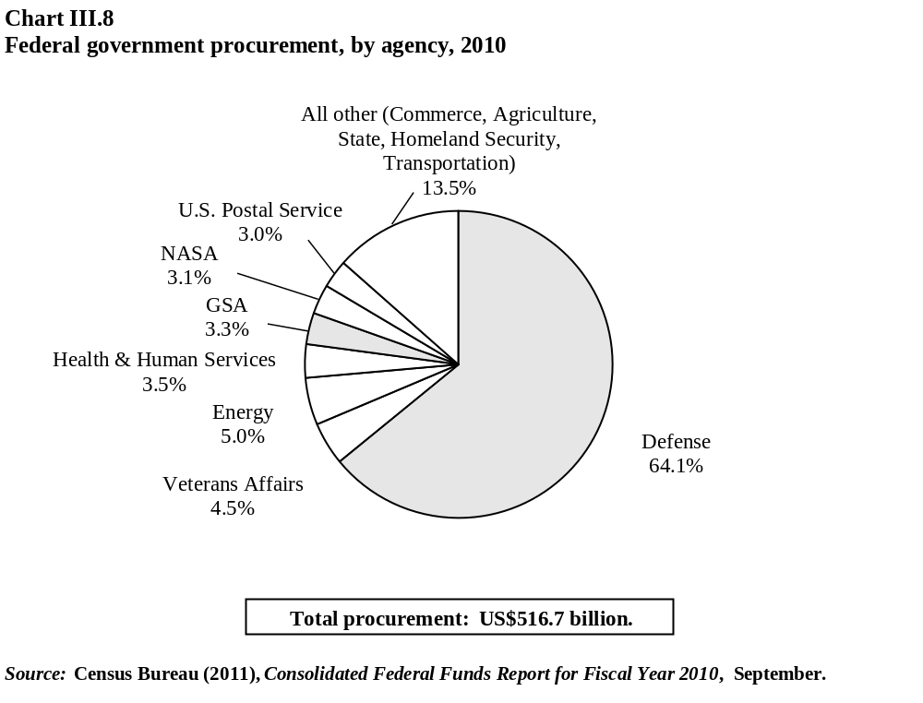

U.S. procurement legislation
          - The first major U.S. government procurement legislation enacted, and still operating after 80 years, is the Buy American Act, which requires the U.S. Federal Government to purchase domestic goods. Title III of the Trade Agreements Act of 1979 allows the President to waive the discriminatory purchasing requirements with respect to purchases covered by the GPA and FTAs, for the signatories of those agreements, as well as for least developed countries. However, the Buy American Act applies to purchases below the GPA and FTAs thresholds and to non-covered entities. Exceptions under the Buy American Act apply when: (i) it is deemed inconsistent with the public interest; (ii) the cost is considered unreasonable; (iii) the products are for use outside of the United States; (iv) the products are not produced or manufactured in the United States in sufficient quantities or of satisfactory quality; and (v) the procurement is for less than US$2,500.
          - An agency is allowed to use a foreign supplier if the price of the domestic product is "unreasonable". The threshold for determining "unreasonable" is generally 6%. However, if the contract involves a small business or labour surplus area, a differential of 12% is applied, and for the Department of Defense, a threshold of 50% is applied.
          - U.S. procurement legislation also has specific rules on what qualifies as an American good, i.e. specific origin rules that differ from rules of origin and marking for importation purposes. Non-manufactures are considered U.S. products if mined or produced in the United States. Manufactures are considered U.S. products if manufactured in the United States and the cost of U.S. components is more than 50% of the overall cost of all components. In addition, special rules apply for construction contracts: origin is not based on the nationality of the contractor or similar, but on the origin of the articles, materials, and supplies used by the contractor in constructing or repairing the building or work.
          - The second major procurement law is the Office of Federal Procurement Policy Act of 1974 (OFPP Act). This legislation provided overall direction for government-wide procurement policies, regulations, and procedures. In order to promote standard processes, the OFPP Act provided for the creation of the Federal Acquisition Regulation (FAR). The FAR establishes the rules and regulations for federal procurement of goods and services through the acquisition process. It is codified in Title 48 of the Code of Federal Regulations. Nearly all federal agencies are required to comply with the FAR, but certain agencies are exempt. The Competition in Contracting Act (CICA) was enacted in 1984 and its implementation required revisions to the FAR. The CICA introduced more competition through full and open competition in the awarding of government contracts, with the goal of reducing the costs of procurement.
          - In January 2011, the U.S. Congress passed new legislation relating to the reorganization of public contracts as Title 41 of the United States Code, "Public Contracts". This legislation revises and restates certain laws relating to public contracts and re-enacts them as Title 41, U.S.C. The new law consolidates various provisions that had been enacted separately over many years, reorganizing them, conforming style and terminology, modernizing obsolete language, and correcting drafting errors. The changes were to restate existing law without substantive effect.
          - Under U.S. laws and rules, agencies may reserve contracts exclusively for certain designated groups. These provisions are known as set-asides. There are five set-aside categories: (i) small business; (ii) woman-owned small business; (iii) disabled veteran-owned small business; (iv) historically under-utilized small business zones (HUBZones); and (v) a minority small business development programme that utilizes set-asides. The Small Business Act sets a government-wide small business contracting goal of 23% of all federal procurement dollars to be awarded to small business. The Small Business Administration (SBA) negotiates individual small business goals with each federal agency. Included in the 23% goal are individual goals for woman-owned small business (5%), small disadvantaged business (5%), disabled veteran-owned small business (3%), and HUBZone small business (3%). The Department of Veterans Administration (DVA) is responsible for two DVA contract award specific set-asides, one for veteran-owned small business and one for service-disabled veteran-owned business. In addition, the Department of Commerce administers a contracting and grants programme for minority business enterprise.
          - In August 2010, the United States notified the final Regulation implementing the "buy American" provision in the American Recovery and Reinvestment Act of 2009 (ARRA) pursuant to Article XXIV:5(b). The rule applied only with respect to contracts funded with ARRA funds to ensure compliance with U.S. obligations under international agreements when undertaking construction covered by such agreements.

New WTO government procurement commitments
          - WTO GPA Members recently reached consensus on a revision of the GPA and re-negotiation of the specific commitments contained in the annexes pertaining to each Member. The U.S. commitments, undertaken in the 1994 GPA, remain virtually the same. While the thresholds for procurement did not change, the number of central government covered entities has increased by 12. Commitments for sub-central government entities (i.e. states) and other entities (i.e. government corporations) remain unchanged, except for the increased transparency with the listing for several states of the executive branch entities that they cover. In addition, the United States covered telecommunications projects funded by the U.S. Rural Utilities Service under Annex 3.

Special provisions, exceptions, etc.
          - The United States passed new legislation in late 2010 to create a federal excise tax on foreign entities receiving payments for goods and services. When the law goes into effect, an amount of 2% is applied to foreign entities not party to an international procurement agreement. This is understood to apply to countries that are not members of the GPA or do not have a free-trade agreement with the United States. The regulatory changes to implement the law have not been finalized; the changes will follow the FAR rulemaking procedures before entering into effect.
          - Procurement at the sub-central (i.e. state) level is a matter of state law. Various state procurement rules may have similar "buy American" provisions that can be seen as restrictive or discriminate on the basis of origin or similar requirements. For example, several states have restrictions on the public procurement of American flags, requiring them to be manufactured in the United States. In Minnesota, law officials' uniforms are required to be of U.S. origin.
          - The United States also has special provisions regarding procurement under legislation relating to sanctions on certain countries. This not only results in direct restrictions on the country concerned, but also indirectly on firms that do certain types of business with that country. The Comprehensive Iran Sanctions, Accountability, and Divestment Act of 2010 (CISADA), prohibits U.S. executive agencies from entering into or renewing a contract, for goods or services, with an entity that exports sensitive technology, as defined in section 6 of CISADA, to Iran. Regulations requiring government contractors to self-certify regarding this issue became effective on 2 November 2011.

Subsidies and other government assistance
          - Subsidies, as defined and notified under GATT Article XVI:1 and Article 25 of the Agreement on Subsides and Countervailing Duties are reported to the WTO by Members including the United States. According to the latest notification in October 2011, the United States reported 50 federal programmes, and over 500 sub-federal programs (Table III.22).
Table III.22
Federal subsidy programmes, 2011 (fiscal year 2010)
(US$ million)
Federal programmes | Amount reported (US$ million)
Agriculture | 14,424
Dairy Export Incentive Program (DEIP) | 2ª
Agriculture Income Support and Marketing Assistance for Covered Commodities | 13,532^{b}
Expensing of Multi-period Livestock and Crop Production Costs | 140^{c}
Treatment of Loans Forgiven Solvent Farmers as if Insolvent | 20^{c}
Capital Gains Treatment of Certain Agricultural Income | 490^{c}
Exemption from Excise Tax for Tobacco Products Supplied to Their Employees by Tobacco Product Producers | Per unit amount only
Five-year Recovery Period for Certain Farming Business Machinery or Equipment | 240^{c}
Energy and fuels | 18,099
Energy Supply – Renewable Energy Resources | 815^{d}
Energy Conservation Programs – Transportation Sector | 304^{d}
Energy Conservation Programs – Building Technologies | 219^{d}
Energy Conservation – Industry Sector | 94^{d}
Fossil Energy Research and Development | 477^{d}
Expensing of Exploration and Development (E&D) Costs for Oil, Gas and other Fuels | 400^{c}
Excess of Percentage over Cost Depletion for Oil, Gas and Other Fuels | 980^{c}
Alternative Fuel Production Credit | 170^{c}
Capital Gains Treatment of Royalties on Coal | 50^{c}
Energy Efficient Appliance Credit | 150^{c}
Alcohol Fuel Credit | 8,570^{c}
Biodiesel and Renewable Diesel Credit | 510^{c}
Alternative Fuels Credit | 3,960^{c}
Tax Credit for Refined Coal and Indian Coal | Less than 50^{c}
Credits for Investment in Advanced Coal Facilities and Advanced Gasification Facilities | 240^{c}
Advanced Energy Property Credit | 180^{c}
Credit for Production of Low-Sulfur Diesel and Deduction for Investment in Low-Sulfur Diesel Refineries | Under 10^{c}
Deduction for Investment in Increased Refinery Capacity | 760^{c}
Amortization of Geological and Geophysical Expenditures | 150^{c}
Deduction for Tertiary Injectants | Less than 10^{c}
Fisheries | 112
Fisheries Finance Program (FFP) | 69e
Saltonstall-Kennedy Grant Program: Fisheries Research and Development | 8
Sea Grant | 9^{d}
Columbia River Hatcheries | 26^{d}
Lumber and timber | 380
Capital Gains Treatment of Certain Timber Income | 50^{c}
Expensing of Multi-period Timber Growing Costs | 230^{c}
Expensing and Seven-Year Amortization for Reforestation Expenditures | 50^{c}
Reduced Corporate Capital Gains Tax Rate for Qualified Timber Gain | 50^{c}
Medical | 489
Orphan Drug Tax Credit | 470^{c}
The Office of Isotopes for Medicine and Science | 19ª
Metals, minerals, and extraction (non-fuel) | 900
Excess of Percentage over Cost Depletion for Non-fuel Minerals | 770^{c}
Expensing of Exploration and Development Costs for Non-fuel Minerals | 110^{c}
Table III.22 (cont'd)
Capital Gains Treatment of Iron Ore | Less than 10^{c}
Special Rules for Mining Reclamation Reserves | Less than 10^{c}
Shipyards | 15
Assistance to Small Shipyards Grant Program | 15^{d}
Textiles | 1
Textile/Clothing Technology Corporation Program (TC2) | 1^{d}
Timepieces and jewellery | 3
Insular Possessions Watch and Jewellery Programs | 3
Other | 2,030
Empowerment Zones and Renewal Communities | 730^{c}
New Markets Tax Credit | 720^{c}
New York Liberty Zone | 20^{c}
Gulf Opportunity Zone | 360^{c}
Kansas Disaster Area | 100^{c, f}
Midwestern Disaster Area | 100^{c}
a Budgetary outlay basis.
b Includes some fiscal year 2009 data.
c Revenue loss basis.
d Appropriations basis.
e Loan basis.
f 2009 fiscal year.
Note: Subtotals are approximate. Sub-federal entities are not included as they are too numerous (see WTO document G/SCM/N/220/USA, 19 October 2011 for details).
Source: WTO document G/SCM/N/220/USA, 19 October 2011.
          - As illustrated through the WTO notification, the agriculture and energy and fuel sectors are the largest recipients of government assistance and have grown in recent years. One of the major contributors to the growth in this sector is interest in biofuels, or using incentives to find alternatives to fossil fuels. This has gained further momentum in recent years due to the high energy prices and the negative contribution to the current account caused by substantial petroleum imports (Chapter I). Biofuel incentives are also important as they could have a direct or indirect impact on certain aspects of global trade, due to diversion of food products to fuel, commodity price fluctuations, and with respect to agricultural policies. There are a number of programmes, grants, tax credits, and other incentives related to energy biofuels (Table III.23).
          - As examined during the last Review, the United States implemented a number of fiscal stimulus measures or government assistance to mitigate the impact of the financial crisis. While some of these programmes are winding down, some still play an important role in the ongoing recovery and have an impact on the current economic and business climate, including the Authoritative Resources on the American Recovery and Reinvestment Act of 2009 (ARRA) and the Troubled Asset Relief Program (TARP, as contained in the Emergency Economic Stabilization Act (EESA). The recently re-authorized Trade Adjustment Assistance (TAA) also provides support for workers and firms, and is an important aspect of U.S. trade policy.
          - The TARP provided government support to AIG, the automotive industry, banks, and financial institutions. On 31 May 2012, the lifetime cost of TARP was estimated at US$63 billion. While many of the TARP programmes are winding down, significant assets remain under government control or ownership and a number of programmes remain active, especially in the housing market. The United States has articulated broad principles for exiting TARP, including exiting TARP programmes as soon as practicable and seeking to maximize taxpayer returns. As concerns the Automotive Industry Financing Program, TARP has received US$40 billion of its approximately US$80 billion investment. Chrysler exited the programme in July 2011, but GM and Ally Financial (former GMAC financing) remain included, as US$37.2 billion of reimbursement remains outstanding. Likewise, AIG is still covered under TARP and is expected to have a lifetime cost of US$18.7 billion.
Table III.23
Federal programmes on biofuels, 2011
Federal programmes | Legal citation | Description
Renewable Fuel Standard | P.L. 109-58 §1501 | Mandated use of renewable fuel in gasoline: 4 billion gallons in 2006, increasing to 36 billion gallons in 2022
Volumetric Ethanol Excise Tax Creditª | P.L. 108-357 §301 | Gasoline suppliers who blend ethanol with gasoline are eligible for a tax credit of US$0.45 per gallon of ethanol
Small Ethanol Producer Creditª | P.L. 101-508 | An ethanol producer with less than 60 million gallons per year in production capacity may claim a credit of US$0.10 per gallon on the first 15 million gallons produced in a year
Biodiesel Tax Creditª | P.L. 108-357 | Producers of biodiesel or diesel/biodiesel blends may claim a tax credit of US$1.00 per gallon of biodiesel
Small Agri-Biodiesel Producer Creditª | P.L. 109-58 | An agri-biodiesel (produced from virgin agricultural products) producer with less than 60 million gallons per year in production capacity may claim a credit of US$0.10 per gallon on the first 15 million gallons produced in a year
Renewable Diesel Tax Creditª | P.L. 109-58 | Producers of renewable diesel (similar to biodiesel, but produced through a different process) may claim a tax credit of US$1.00 per gallon of renewable diesel
Credit for Production of Cellulosic Biofuel | P.L. 110-246 | Producers of cellulosic biofuel may claim a tax credit of US$1.01 per gallon. For cellulosic ethanol producers, the value of the production tax credit is reduced by the value of the volumetric ethanol excise tax credit and the small ethanol producer credit – the credit is currently valued at US$0.46 per gallon. The credit applies to fuel produced after 31 December 2008
Special Depreciation Allowance for Cellulosic Biofuel Plant Property | P.L. 109-432 | Plants producing cellulosic biofuels may take a 50% depreciation allowance in the first year of operation, subject to certain restrictions
Alternative Fueling Station Creditª | P.L. 109-58 §1342 | A credit of up to $30,000 is available for the installation of alternative fuel infrastructure, including E85 (85% ethanol and 15% gasoline) pumps
Biorefinery Assistance | P.L. 110-246 §9001 | Loan guarantees and grants for the construction and retrofitting of biorefineries to produce advanced biofuels
Repowering Assistance | P.L. 110-246 §9001 | Grants to biorefineries that use renewable biomass to reduce or eliminate fossil fuel use
Bioenergy Program for Advanced Biofuels | P.L. 110-246 §9001 | Provides payments to producers to support and expand production of advanced biofuels
Feedstock Flexibility Program for Producers of Biofuels (Sugar) | P.L. 110-246 §9001 | Authorizes the use of CCC funds to purchase surplus sugar, to be resold as a biomass feedstock to produce bioenergy
Biomass Crop Assistance Program (BCAP) | P.L. 110-246 §9001 | For biomass crop establishment costs and annual payments for biomass production; also provides payments to assist with costs for biomass collection, harvest, storage, and transportation
Rural Energy for America Program (REAP) | P.L. 110-246 §9001 | Loan guarantees and grants for a wide range of rural energy projects, including biofuels
Biomass Research and Development | P.L. 106-224 | Grants for biomass research, development, and demonstration projects
Biorefinery Project Grants | Various statutes | Funds cooperative R&D on biomass for fuels, power, chemicals, and other products
Loan Guarantees for Ethanol and Commercial Byproducts from Various Feedstocks | P.L. 109-58 §§1510, 1511, and 1516 | Several programs of loan guarantees to construct facilities that produce ethanol and other commercial products from cellulosic material, municipal solid waste, and/or sugarcane
DOE Loan Guarantee Program | P.L. 109-58 Title XVII | Loan guarantees for energy projects that reduce air pollutant and greenhouse gas emissions, including biofuels projects
Cellulosic Ethanol Reserve Auction | P.L. 109-58 §942 | Authorizes DOE to provide per-gallon payments to cellulosic biofuel producers
Import Duty for Fuel Ethanolª | P.L. 96-499 | All imported ethanol is subject to a 2.5% ad valorem tariff; fuel ethanol is also subject to a most-favored nation added duty of US$0.54 per gallon (with some exceptions)
Flexible Fuel Vehicle Production Incentive | P.L. 94-163 | Automakers subject to Corporate Average Fuel Economy (CAFE) standards may accrue credits under that program for the production and sale of alternative fuel vehicles, including ethanol/gasoline flexible fuel vehicles (FFVs)
a Expired at the end of 2011.
Source: Yacobucci, B.D. (2011), Biofuels Incentives: A Summary of Federal Programs", CRS Publication R40110, 1 July. Viewed at: http://fpc.state.gov/documents/organization/168094.pdf.
          - ARRA has current expected outlays of US$840 billion, up from US$787 billion, since its inception in 2009. It continues to provide money for three main categories aimed at economic recovery: tax cuts, entitlement programmes, and federal contracts, grants, and loans (Chart III.9). In the category of federal contracts, grants, and loans, the majority of funding is for education, followed by transportation, infrastructure, and energy/environment. Most of the funding for tax cuts goes to individual tax credits, and most of the entitlement funding is for Medicaid/Medicare and unemployment insurance. There is no legislative expiry for ARRA, although many of the individual provisions are limited in time and have deadlines associated with the appropriations (budget).
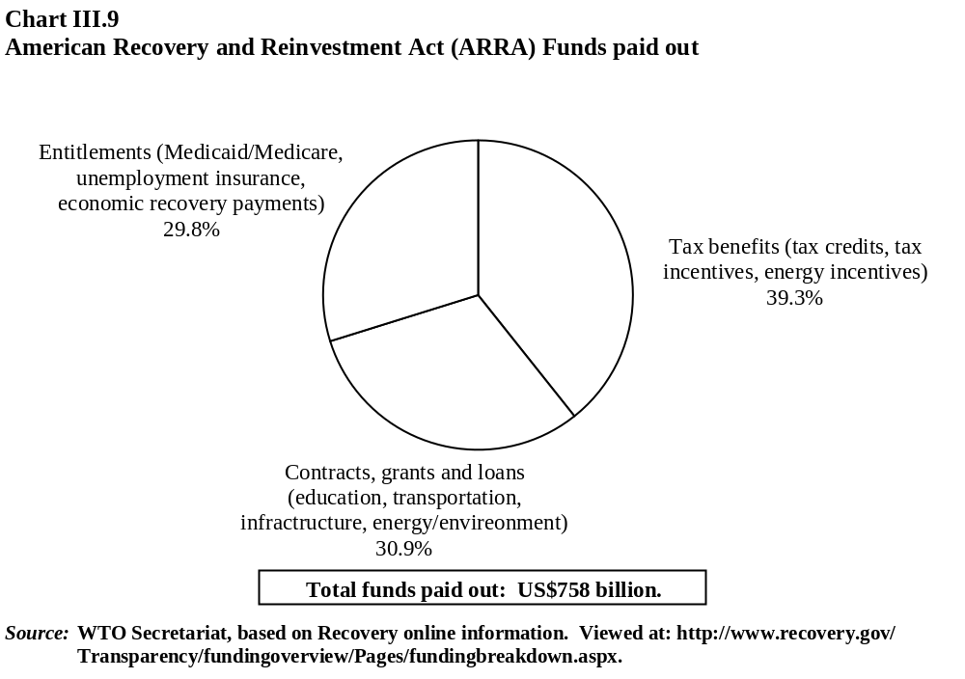
          - TAA has been an important aspect of U.S. trade policy for over half a century, helping firms and workers adjust to trade liberalization. In particular, it helps with worker retraining, financial assistance, and benefits; and for firms it provides technical assistance to develop recovery plans. As a result of proceeding with three new FTAs in October 2011, the President pushed for re-authorization of the TAA in order to improve or modify a number of its provisions. Among the other important changes, the re-authorization extended the worker, firm, and farmer programmes until 31 December 2013; discontinued TAA for communities; restored and enhanced funding levels for many of the programmes; discontinued eligibility for public-sector workers; and made provisions retroactive to the expiry of the previous enhancements.

Competition policy
          - U.S. federal legislation on competition policy, or antitrust, has been in existence for 112 years and is constituted by three core laws or pillars. The Sherman Act, passed in 1890, is a comprehensive law aimed at preserving free and unfettered competition. It outlaws restraint of trade and monopolization. The Federal Trade Commission Act of 1914 prohibits unfair methods of competition and unfair or deceptive acts or practices. The Clayton Act prohibits mergers and acquisitions where the result would lessen competition. The Robinson-Patman Act and the Hart-Scott-Rodino Antitrust Improvement Act amended the Clayton Act to ban certain discriminatory prices and to require advance notification of mergers and acquisitions. The U.S. antitrust laws often have severe penalties or fines for violations, including imprisonment. The Federal Trade Commission (FTC) and the Antitrust Division of the Department of Justice (DOJ) enforce the federal antitrust laws. In addition to the main federal laws, most states have antitrust laws, often modelled after the federal laws.
          - There have been no major changes to the core antitrust laws for many years. Contrary to most aspects of U.S. trade policy that occur through new laws or actions by Congress and the Executive branch, U.S. competition policy is generally developed through interpretation by the Judicial branch, and through administrative proceedings at the FTC. The DOJ or the FTC initiate many cases each year pursuant to the relevant antitrust laws (Tables III.24 and III.25).
Table III.24
DOJ investigations initiated pursuant to antitrust laws, 2008-11
Total investigations initiated, by primary type of conduct | 2008 | 2009 | 2010 | 2011
Sherman §1 – Restraint of trade | 66 | 70 | 46 | 47
Sherman §2 – Monopoly | 0 | 4 | 2 | 2
Clayton §7 – Mergers | 84 | 68 | 64 | 90
Others | 22 | 22 | 7 | 3
Source: Department of Justice, statistics.
Table III.25
FTC investigations initiated pursuant to antitrust laws, 2008-11
 | 2008 | 2009 | 2010 | 2011
Merger investigations opened | 224 | 135 | 186 | 222
Non-merger investigations opened | 39 | 31 | 32 | 23
Abuse of dominance (monopolization) investigations openedª | 11 | 8 | 18 | 7
a The number of "abuse of dominance investigations opened" is as reported in the Global Competition Review survey, and is a subset of non-merger investigations opened.
Source: Federal Trade Commission, statistics.
          - While the three pillars of antitrust legislation provide the basic structure, there are other U.S. laws or regulations that could facilitate anticompetitive practices. In the area of international trade: the Agricultural Marketing Agreement Act of 1937 allows the Secretary of Agriculture to enter into marketing agreements with producers and processors of agricultural commodities, and these are specifically exempt from the antitrust laws; the Export Trading Company Act of 1982 provides certain antitrust immunity for export trade and export trade activities; and the Webb-Pomerene Act provides immunity for associations of otherwise competing businesses to engage in collective export sales.
          - In 2011, the Federal Trade Commission amended the Hart-Scott-Rodino Pre-merger notification rules and the form for reporting the proposed merger. The new rules, effective 18 August 2011, include significant changes. Additionally in 2010, the Department of Justice and the FTC amended the Horizontal Merger Guidelines. The amendments retained the core elements of the previous guidelines but contain a number of important clarifications concerning market definition, and expand the discussion on assessing unilateral effects.

Trade-related intellectual property rights

Introduction
          - Intellectual property (IP) has a central place in the domestic economy and the international trade profile of the United States. The United States is one of the most well established and mature IP jurisdictions, however, the legal, economic, and trade policy context of IP continued to evolve significantly during the review period, notably through:
- major legislative developments (e.g., the Leahy-Smith America Invents Act) and continuing reform of IP administration (such as improvement in patent quality and pendency reduction in the patent examination process);
- significant judicial decisions on central issues of patentability particularly as regards patent-eligible subject matter;
- regulatory legislation with significance for IP protection, for instance an abbreviated process for approving "biosimilar" generic versions of innovative biological medicines;
- strengthened domestic enforcement, including through the work of the Office of the U.S. Intellectual Property Enforcement Coordinator, and efforts to build stronger enforcement in foreign markets;
- a policy focus on the role of IP in promoting domestic economic growth and creation of high-value jobs, and in strengthening the U.S. position in international trade. IP protection has been stressed in the implementation of the National Export Initiative (NEI), which aims at doubling U.S. exports within five years; and
- consolidation of a trend towards development of markets in IP as such, ranging from the rapid expansion of markets in digital products to major transactions in patent portfolios in the IT sector.

Economic policy context
          - Policymakers continued to emphasize the central importance of IP for the trade, economic and employment position of the United States, and – in line with international developments – sought to base IP policy on a firm empirical foundation. A 2012 report, jointly prepared by the Economics and Statistics Administration and the U.S. Patent and Trademark Office, assessed that U.S. industries that protect their works through patents, trademarks or copyrights supported 27.1 million jobs, or close to 19% of all employment in the United States in 2010, and indirectly supported a further 12.9 million jobs. A substantial share of this IP-intensive employment was in trademark-intensive industries, which sustained 22.6 million jobs, while patent-intensive industries accounted for 3.9 million jobs, and copyright-intensive industries for 5.1 million jobs. IP-intensive industries contributed just over US$5 trillion in value added, or almost 35% of U.S. GDP in 2010.
          - IP was integral to trade policy concerns to boost high-value exports of goods and services. The same report estimated that merchandise exports of IP-intensive industries accounted for close to 61% of total U.S. merchandise exports in 2010, and merchandise imports of IP-intensive industries for almost 70% of total U.S. merchandise imports. That same year, manufacturing industries were responsible for 99% and 79% of IP-intensive merchandise exports and imports, respectively. The report estimated that exports of IP-intensive service-providing industries accounted for about 19% of total U.S. private services exports. Exports of software publishers were the largest group of IP-intensive service-providing industries in 2007, followed by the motion picture and video industry, financial investment activities, and scientific research and development.
          - The IP component of trade in technology, know-how, creative expressions, brands, and other types of IP is difficult to measure precisely since these often take the form of intangibles embedded in services and physical goods. However, trade in IP is also undertaken as specific IP licences, and the value of this trade may be estimated from balance-of-payments statistics, distinctly from figures for trade in goods that incorporate IP or for IP-related services. In the case of the United States, a comprehensive assessment of IP licence trade is made possible by the detailed statistics available on international payments and receipts of royalties and licence fees. This shows that the United States has traditionally posted a large balance-of-payments surplus in IP licence trade. The surplus declined in 2009 but recovered to reach an all-time record of US$84 billion in 2011 (Chart III.10).
          - The IP licence surplus was the result of U.S. residents having collected almost US$121 billion in royalties and licence fees in 2011, while paying nearly US$37 billion to foreign residents (preliminary data). Both receipts (exports) and payments (imports) increased considerably between 2009 and 2011 (by 24.1% and 22.6% in nominal terms), to reach historical peaks, which is in line with the overall expansion of U.S. exports and imports of goods and services. In monetary terms, IP licence exports are as significant as U.S. exports of agricultural food products, and larger than those of mining or automotive products (see Chapter I(3)). IP licence exports and imports contributed 5.7% and 1.4% to total exports and imports of goods and services in 2011.
          - The United States is by far the world's single largest IP licence exporter, collecting about half of world royalties and licence fees in 2010 (last year available). The United States paid approximately 15% of world royalties and licence fees in the same year, which made it the second single largest IP importer. As noted by the U.S. authorities, IP-related imports provide benefits for U.S. consumers and producers by increasing market competition and thus lowering prices, and by supplying intermediate inputs for U.S. industries that make these industries' finished products more competitive.
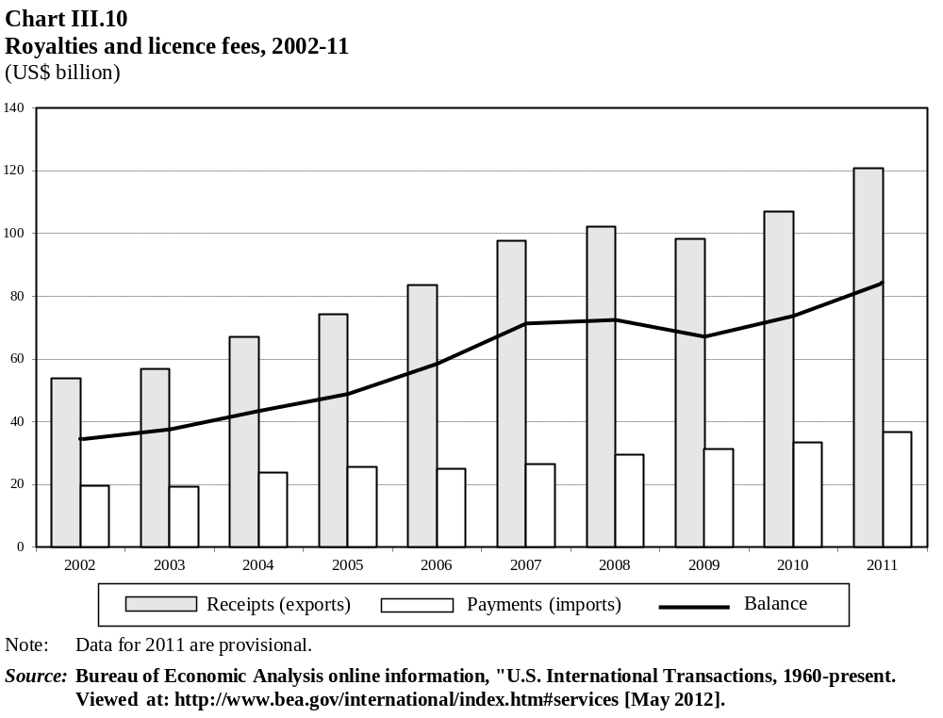
          - The large two-way trade in IP licences between the United States and its partners reflects the fact that U.S. residents control a significant proportion of IP rights (IPRs) worldwide, while foreign residents account for a considerable share of IPRs in the United States. For example, U.S. residents own some 8%-9% of the patents in force worldwide (excluding the United States), while foreign residents account for about 48% of the patents in force in the United States. This suggests that the United States' large market and well developed IP regime offer an attractive environment for both U.S. and foreign IP right holders.
          - The combined value of IP licence receipts and payments was US$139 billion in 2010 (the most recent year available) (Chart III.11. See also Table AIII.3). This trade is geographically concentrated, with only three U.S. trading partners – Canada, the European Union, and Japan – accounting for 61% in 2010. However, trade with developing countries has been more dynamic, and the highest rates of growth in U.S. IP licence trade between 2006 and 2010 was with Argentina, Brazil, Chile, China, Chinese Taipei, and India. In these markets, except for Chinese Taipei, receipts and payments associated with film and television tape distribution expanded particularly strongly.
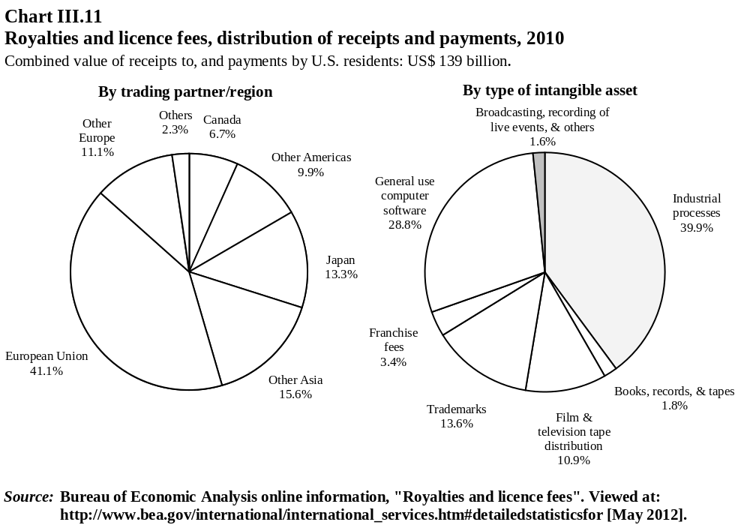
          - Industrial processes generated 40% of U.S. IP licence trade, followed by computer software, with almost 30%, and trademarks with close to 14% (Chart III.11). The fastest growing IP types were computer software and trademarks, which expanded 56% and 53% between 2006 and 2010. Ireland and, far behind, Japan made the largest contribution to computer software expansion, and Japan and Switzerland to trademark growth. Payments for rights related to industrial processes have been less dynamic, possibly reflecting the subdued performance of the manufacturing sector, although improving over the past two years.
          - Most U.S. IP licence trade takes place within multinational companies that serve foreign markets through affiliates located in those markets. The value of receipts and payments within U.S. multinational companies (affiliated transactions) represented about 65% of the total value of IP licence transactions in 2010 (Table AIII.3). This was slightly lower than the share in 2006 (67%), as affiliated transactions have tended to expand at a slower pace than those involving unaffiliated firms. On the other hand, affiliated transactions have shown greater stability during the recent years of economic turmoil. This resilience has been attributed to the nature of long-term contracts, the reliance on inputs from affiliated parties in the integrated operations of multinational companies, and cost-sharing arrangements within these companies.
          - Some of the most dynamic recent developments in domestic and international trade in IP licences has been at the consumer level, with the rapid growth in markets for content in the form of digital downloads, notably software applications for mobile platforms, e-books, and audio and audiovisual works. A publishing industry report recorded a 332.6% increase in export revenues from e-books in 2011, lifting the share of e-books in publishing exports from 1.5% in 2010 to over 6%. Digital downloads of music reportedly rose 17% in 2011 to reach US$2.6 billion, offsetting a decline in shipments of physical media in a year when digital shipments exceeded conventional music media for the first time. One online music store, operated by U.S. corporation Apple Inc., confirmed its status in the review period as the world's largest music retailer, exporting to over 120 countries; it also reported over 30 billion downloads of software applications in under four years, with payments of over US$5 billion to software developers.
          - The significance for the United States of trade in IP licences and in IP-intensive goods and services is mirrored by the high level of expenditures on R&D, which OECD data set at 2.9% of GDP, by far the largest such outlay within the OECD. Some 30% of R&D expenditures are estimated to be government-financed. The 2012 U.S. Budget provided US$148 billion for R&D overall, a slight nominal increase (0.5%) over actual 2010 expenditures. Government assistance to R&D activities takes different forms including, in addition to IPR protection, direct grants and "tax expenditures" (see section (iv)). Against a background of policy focus on the continuing competitiveness of the U.S. economy and the need for high value jobs, the impact of such assistance would be assessed to the extent that it is commensurate with the positive externalities generated, and to the extent that the balance between assistance and externalities avoids distortions to the incentives framework for R&D activities, not just domestically but also internationally.

Institutional framework
          - Several agencies are responsible for various administrative and enforcement aspects involving intellectual property in the United States. The United States Patent and Trademark Office (USPTO) plays a key role in strengthening and facilitating IP protection. Beyond its administrative and statutory functions, USPTO provides advice on IP policy issues, gives assistance to foreign governments and international organizations, and conducts programmes and studies to strengthen the effectiveness of IP protection domestically and throughout the world.
          - The USPTO established the Office of Chief Economist in March 2010 to provide advice on the economic implications of policies affecting the U.S. IP system. USPTO's Economic Research Agenda covers matters such as the relationship between IP and economic growth, the economic impact of trademark examination on relative grounds, managing IP in the context of technology standards, and facilitating more efficient markets for technology and knowledge. The USPTO also conducts training and education programmes, including through the Global Intellectual Property Academy, which offers courses designed for foreign government officials and other stakeholders. Moreover, it has developed the Intellectual Property Awareness Assessment Tool, a web-based system designed to assess IP knowledge and provide training resources for small and medium-sized enterprises and inventors.
          - The United States Copyright Office (USCO) is charged by Congress with administering the Copyright Act; it is an office of public record, where claims to copyright are registered and where documents relating to copyright may be recorded when the requirements of the copyright law are met. The USCO also provides advice to Congress on the development of national and international copyright policy, drafts legislation, and prepares technical studies on copyright-related matters. Like the USPTO, the Copyright Office works with other U.S. government agencies and international organizations to promote adequate and effective protection of U.S. copyright works internationally.
          - A number of other agencies work to promote effective intellectual property protection both in the United States and aboard; these include the Department of State, the Department of Commerce, and USTR.
          - The mission of the USTR includes "to support and implement the Administration’s commitment to aggressively protect American IP overseas", in view of the impact of IPR infringements in foreign markets on U.S. businesses and on key U.S. comparative advantages in innovation and creativity. USTR's Office of Intellectual Property and Innovation uses a range of tools to promote strong IP laws and effective enforcement worldwide (see below).

Participation in WTO and international initiatives
          - The United States aims to use Trade Policy Reviews of its trading partners to seek constructive engagement on TRIPS implementation. The reviews of its own trade policies regularly cover IP issues, with the most recent covering patents, copyright, broadcast signals, circumvention of technological measures, trademarks and geographical indications, as well as enforcement activities, including annual and out-of-cycle Special 301 Reports and Section 337 investigations. The United States also responded to questions on its implementation of DSB recommendations concerning two of the four IP-related cases in which the United States had taken part as respondent, i.e. Section 110(5) of U.S. Copyright Act, and Section 211 Omnibus Appropriations Act of 1998. Acknowledging that in those two cases its implementation had not been completed, the United States noted that it had been working actively towards compliance in furtherance of the purpose of the dispute settlement system, and engaged to continue to work to implement the relevant DSB recommendations and rulings.
          - With respect to the 110(5) matter, the U.S. Administration continues to work closely with the U.S. Congress, and will continue to confer with the European Union, in order to reach a mutually satisfactory resolution of this matter. With respect to the Section 211, the U.S. Administration will continue to work on a solution that would resolve this matter.
          - The United States was not active in any TRIPS-related dispute settlement cases during the review period (see Chapter II(2)). However, in the course of one case covering also a wide range of non-IP measures, Measures Affecting Trade in Large Civil Aircraft, the panel considered measures on the allocation of IP rights under government contracts, and did not determine them to be covered by the SCM Agreement.
          - The United States continued its active role in the TRIPS Council during period under review, in particular introducing material concerning IP enforcement, and communicating (with several other Members) the text of the Anti-Counterfeiting Trade Agreement (ACTA; see section below). USTR views the TRIPS Council as an opportunity for sharing experiences to ensure effective implementation of IP enforcement obligations.
          - During the review period, several updates were made on IP laws notified to the TRIPS Council. Table III.26 lists the United States' main IP laws currently in force, and summarizes the protection they provide; Table AIII.4 lists all laws notified under the TRIPS Agreement. The United States updated the Council on its implementation of Article 66.2 of the TRIPS Agreement, its programmes on TRIPS-related technical assistance and capacity building, and notified the Deputy Assistant USTR for IP and Innovation as its contact point both for TRIPS-related technical cooperation and for cooperation on enforcement under Article 69 of the TRIPS Agreement.
Table III.26
Summary of intellectual property protection in the United States, May 2012
Form | Main legislation | Coverage | Duration
Copyright and related rights | Copyright Law of the United States, Title 17 of the U.S. Code | Authors' rights in the artistic, literary and scientific domains; to enjoy copyright protection a work must be an original creation | Life of author plus 70 years for works created on or after 1 January 1978. Anonymous works, pseudonymous works, and works made for hire protected for 95 years after publication or 120 years after creation, whichever is the shorter
Patents | Patent Law of the United States, as incorporated in Title 35 of the U.S. Code | Any inventions that are new, useful, and non-obvious. Apply to process, machine, manufacture or composition of matter, or improvements thereof | 20 years from filing date
Industrial designs | Patent Law of the United States, as incorporated in Title 35 of the US Code | The ornamental design of a product is entitled to the protection afforded to designs, provided it is new | 14 years from date of grant
Trademarks | The Lanham Act of 1946, as amended (15 U.S.C. 1051 et seq.) | Any sign used to identify and distinguish goods or services from one enterprise from those of another enterprise | 10 years from registration date; renewable indefinitely as long as the trademark is in use in commerce that is lawfully regulated by Congress
Geographical indications | The Lanham Act of 1946, as amended (15 U.S.C. 1051 et seq.), and Federal Alcohol Administration Act of 1935 | Protection against misuse of geographic signs and names of viticultural significance | Unlimited
New plant varieties | Plant Variety Protection Act Amendments of 1994 (7 U.S.C. 2321 et seq.) | New plant varieties: not previously sold for purposes of exploitation of the variety, in the United States, more than 1 year prior to the date of filing; or in any area outside of the United States more than 4 years prior to the date of filing, or, in the case of a tree or vine, more than 6 years prior to the date of filing | 20 years from the date of issue of the certificate in the United States
Layout designs of integrated circuits | Semiconductor Chip Protection Act of 1984 | Topography of microelectronic semiconductor products provided it is original (the result of its creator's own intellectual effort) and is not staple, commonplace or familiar in the industry at the time of its creation | 10 years from filing date (or, if earlier, from first use)
Undisclosed Information | Economic Espionage Act of 1996 and state laws | Any information, including a formula, pattern, compilation, program device, method, technique, or process, not generally known to the relevant portion of the public, that provides an economic benefit to its holder, and is the subject of reasonable efforts to maintain its secrecy | Indefinite
Note: In some cases common law may control aspects of IPR protection.
Source: WTO document WT/TPR/S/235/Rev.1, 29 October 2010 – updated by the WTO Secretariat.
          - Multilateral, bilateral, and regional institutions all play a part in U.S. trade policy efforts to enhance IP protection and enforcement. WTO accession negotiations are viewed as an opportunity to improve IP standards, in view of concerns about infringement in several accession countries. Thus, with the exception of LDCs, the United States requires full implementation of TRIPS obligations as a condition of entry into the WTO.
          - All but one of the 14 RTAs entered into by the United States and included in the WTO's RTA Information System contain substantive IP provisions (see also Chapter II(3)). These provisions vary somewhat across RTAs, but generally cover enforcement procedures, including border measures, and substantive standards across the full category of IP, broadly requiring a level of protection similar to that in the United States, although flexibilities were introduced by the "New Trade Policy for America". WTO non-discrimination principles mean that these additional IP standards have a systematic reach and impact beyond the original parties to bilateral agreements.
          - Bilateral talks under Trade and Investment Framework Agreements (TIFAs) also cover IP protection and enforcement; the United States has signed 22 bilateral agreements or memoranda of understanding specifically covering IP, which are considered important for furthering the protection and enforcement of IPRs. The United States has also sought to enhance IPR protection in foreign countries by conducting regular reviews of their enforcement efforts (see below).

Patent law
          - The Leahy-Smith America Invents Act entered into effect in 2011, representing the most significant reform of U.S. patent law in the past 50 years. Key features of this complex legislation include:
- changing the rule of entitlement to an invention as between competing inventors from "first-to-invent" to "first-to-file", which brings U.S. law in this regard into alignment with the practice in other national and regional patent systems. The Act continues existing U.S. practice in providing a one-year, pre-filing "grace period" whereby disclosures of the invention by the applicant within the one year window do not affect patentability;
- replacement of "first-to-invent"-based interference proceedings for resolving conflicting claims of entitlement to a patent for the same invention with "first-to-file"-based derivation proceedings that can be used to determine whether an inventor named in an earlier application derived the claimed invention from the inventor named in a later application;
- measures to provide cost-effective alternatives to litigation, measures that are expected to improve patent quality and reduce litigation by expanding third-party review of patents through pre-issuance submissions, inter partes review, and post grant review; and
- establishment of a prior user rights regime consistent with similar regimes provided for in the laws of major trading partners.
          - The Act also provides that while disclosure of best mode continues to be a requirement for obtaining a patent in the first instance, failure to disclose the best mode cannot be raised as a ground for invalidating, cancelling, or otherwise holding unenforceable any claim in a granted patent. The Act further codifies long-standing USPTO policy that claims directed to or encompassing human organisms are not patent-eligible subject matter.
          - The Act established several mechanisms aimed at boosting competitiveness of U.S. markets and at supporting innovative firms, particularly small businesses. For example, it establishes a new category of applicant known as a "micro entity", in recognition of the substantial contributions made by small businesses and independent inventors that are resource-challenged to economic growth and innovation, and accordingly, grants them a 75% discount of certain fees.
          - The Act also includes provisions for the establishment of a prioritized examination process, whereby examination of an application may be expedited upon payment of a fee. In addition, Congress required the USPTO to produce a study on how USPTO can best help small businesses with patent protection overseas, such as whether a loan or grant programme should be established to help small businesses cover the costs of application, maintenance, and enforcement fees or related technical assistance.
          - During the review period, a number of landmark judicial decisions were made on patent law, shedding light on how the core principles of patentability are applied in current U.S. law. In Bilski v. Kappos (2010), the Supreme Court provided guidance for determining when a claimed process is directed to patent-eligible subject matter or to an ineligible abstract idea. In Mayo v. Prometheus (2012), the Court addressed the difference between claims directed to patent-eligible applications of natural laws and claims directed to the natural laws themselves.
          - Timeliness and quality of patent examination continued to be a key focus for the USPTO. Timeliness of patent procedures was measured by total pendency, i.e. the average number of months from filing date to final disposition of an application (issued as a patent or abandoned). Against a goal of reducing this period to 20 months by 2015, pendency in the review period varied between 33.5 and 33.9 months. The USPTO also undertook a range of initiatives during the review period to further improve quality and timeliness, including through international cooperation. Among those activities were:
- worksharing initiatives with other patent offices on patent examination, notably the Patent Prosecution Highway, which speeds up patent examination and reduces costs by allowing examiners to reuse search and examination results for corresponding applications filed in other participating countries. There was a significant increase in the number of international partners during the review period, and the petition fee for use of this pathway was eliminated;
- the Green Technology Pilot Program, which ran from December 2009 to December 2011, enabling applicants to request accelerated examination for patents on green technologies. Of 5,550 petitions under the programme, 3,533 were granted, leading (as at April 2012) to 1,062 issued patents;
- the Cooperative Patent Classification (CPC) Project, a partnership with the European Patent Office aimed at harmonizing the existing classification systems (ECLA and USPC, respectively) and migrating towards a common classification scheme;
- a second pilot programme under the Peer to Patent project, enabling public participation in the patent examination process;
- patent examination quality initiatives, including the development of new metrics for patent quality; and
- Patents for Humanity, a voluntary pilot programme to recognize patent owners who apply their patented technology to address humanitarian needs.

Data protection
          - The Patient Protection and Affordable Care Act (Affordable Care Act), signed into law on 23 March 2010, amended the Public Health Service Act (PHS Act) to create an abbreviated pathway, through the Biologics Price Competition and Innovation Act (BPCI Act), for approval of biological products that are shown to be "biosimilar" to or "interchangeable" with a biological product already licensed by the FDA. The Affordable Care Act provided for a 12 year period of data exclusivity from the time of FDA approval of the original product, after which follow-on biologics would be able to rely on data provided for the original approval, together with data demonstrating the similarity of the generic product.

Trademarks and geographical indications
          - The Trademark Technical and Conforming Amendments took effect on 8 November 2011, and amended the Rules of Practice in Trademark Cases to implement the Trademark Technical and Conforming Amendment Act of 2010. The Act became law on 17 March 2010, and made small technical and conforming corrections to the Lanham Act, as well as more significant changes regarding filing Affidavits or Declarations of Use or Excusable Nonuse to maintain a registration. Specifically, the legislation gave Madrid Protocol registrants the benefit of six-month grace periods immediately following the statutory time periods for filing their trademark registration maintenance documents under Section 71, 15 U.S.C. 1141k.
          - "Changes in Requirements for Specimens and for Affidavits or Declarations of Continued Use or Excusable Nonuse in Trademark Cases" took effect on 21 June 2012. The rule was promulgated to help access and to ensure the accuracy of the trademark register, by allowing the USPTO to require any additional specimens, information, exhibits, and affidavits or declarations deemed reasonably necessary to examine a post-registration affidavit or declaration of continued use or excusable nonuse in trademark cases; to conduct a two-year pilot programme to assess the accuracy and integrity of the register; and, upon request, to require more than one specimen in connection with a use-based trademark application, an allegation of use, or an amendment to a registered mark.

Copyright
          - The increasing availability of digitized material online sparked litigation with significant implications for the publishing industry, including foreign holders of copyright. Associations of publishers and artists had brought separate lawsuits against Google, Inc. for copyright infringement in relation to the Google Book Search project, an initiative to digitize books in libraries and make them searchable on the Internet. A proposed settlement sparked international debate over how to facilitate access to orphan works, as well as on the compatibility of the settlement with international copyright law, as the terms of the settlement would have affected the rights of rights owners from around the world. In March 2011, the Southern District Court of New York rejected the proposed settlement agreement, citing, inter alia, concerns over copyright law, antitrust law, and international law, as well as the adequacy of class representation. A particular concern was that the settlement would have released Google from future acts that were not covered by the claims of the law suits, which the court felt should be left to the legislature, and forced right holders to opt out of the settlement agreement if they did not want to be covered.
          - Following the Court's settlement rejection, the Authors Guild filed their fourth amended class action complaint in October 2011, and in November 2011 the American Society of Media Photographers, et al., filed their first amended class action complaint against Google, Inc. The members of the Authors Guild then filed a motion to be declared a class, for the purposes of suing Google, Inc. as a class, and to be a plaintiff alongside the Authors Guild as co-plaintiffs. Google, Inc. filed a motion to have the plaintiff associations in both cases dismissed and to require the individual members join the case individually. In May 2012, the Judge issued a single opinion on both motions. The order granted class action status to the individual members of the Authors Guild and denied Google's motion to remove the plaintiff associations as named plaintiffs from the renewed case brought by the Authors Guild and the case brought by several associations including the American Society of Media Photographers, the Graphic Artists Guild, the Picture Archive Council of America, the North American Nature Photography Association, and Professional Photographers of America.
          - On 18 January 2012, in the case of Golan v. Holder, the Supreme Court upheld the constitutionality (under the Copyright Clause) of the restoration of copyright protection to foreign works that had previously fallen into the public domain, through the operation of the Uruguay Round Agreements Act (which included provisions to implement U.S. obligations under the TRIPS Agreement).
          - Congress has asked the Copyright Office to undertake various studies, three of particular note. First, with a view to reviewing the scope of federal protection for recordings, as directed by Congress, the Copyright Office undertook a study on "the desirability and means of bringing sound recordings fixed before 15 February 1972, under Federal jurisdiction"; these recordings are currently "protected under a patchwork of State statutory and common laws from their date of creation until 2067". Its report recommended that the term of protection for sound recordings fixed prior to 15 February 1972 be 95 years from publication or, if the work was not published prior to the effective date of legislation federalizing protection, 120 years from fixation. Such protection would not continue past 2067, and for such recordings where these terms expired before 2067, protection could be extended if the recording had been available to the public at a reasonable price. At the time of writing, this recommendation had not been developed into legislation.
          - Second, a study entitled "The Satellite Television Extension and Localism Act (STELA)," was prepared by the Copyright Office and delivered to Congress on 29 August 2012. As directed by Congress under Section 302 of the Satellite Television Extension and Localism Act of 2010, the Report considers the repeal of statutory licensing provisions in Sections 111, 119, and 122 of the Copyright Act, which currently govern the retransmission of distant and local television broadcast signals by cable operators and satellite carriers. The Report provides recommendations for commencing and carrying out such repeal responsibly and on a reasonable schedule, and addresses possible methods and mechanisms for the possible phase-out of these licenses. Third, on 31 October 2011, the Office published "Legal Issues in Mass Digitization: A Preliminary Analysis and Discussion Document", which addressed issues raised by the intersection between copyright law and the mass digitization of books. The purpose of this discussion document is to facilitate further discussions among the affected parties and the public (such as voluntary initiatives, legislative options, or both) and to identify questions to consider in determining an appropriate policy for the mass digitization of books.

Enforcement
          - Several initiatives to improve the coordination and effectiveness of domestic mechanisms to enforce IP rights matured during the review period. In recognition of the need for more effective coordination and a stronger information base for enforcement of IP rights, the Prioritizing Resources and Organization for Intellectual Property (PRO-IP) Act of 2008 created a new position of Intellectual Property Enforcement Coordinator (IPEC). This position was filled following Senate confirmation in 2009. The PRO-IP Act required the IPEC to coordinate the development of a joint strategic plan against counterfeiting and infringement. The plan was issued in 2010, containing 33 enforcement strategy action items within six categories: (i) leading by example; (ii) increasing transparency; (iii) ensuring efficiency and coordination; (iv) enforcing rights internationally; (v) securing the supply chain; and (vi) building a data-driven government.
          - In June 2012, on the second anniversary of the Joint Strategic Plan on Intellectual Property Enforcement, the IPEC reported on progress under the plan, highlighting growth in enforcement activities between 2009 and 2011, customs seizures in that period rising 67% to 24,792, including increases of 183% in counterfeit consumer-safety and critical-technology merchandise, and nearly 600% in counterfeit pharmaceuticals. The report stressed the significant impact of voluntary approaches to combating online infringement, such as voluntary agreements to quarantine sites engaged in counterfeiting and piracy through cooperation with credit card companies, domain name registrars, and online advertisers. Among legislative recommendations made in the 2011 White Paper on Intellectual Property Enforcement, two entered law as part of the National Defense Authorization Act of 2012, concerning penalties for counterfeit goods or services sold to or for use by the military or national security applications, and granting explicit authority to U.S. Customs and Border Protection to share information to help determine whether suspected counterfeit semiconductors, electronics, or other products are genuine. The report also emphasized greater efficiency and inter-agency coordination; for instance, in FY 2010 a 5% increase in funding for IP enforcement, reportedly yielded a 33% rise in seizures of counterfeit and pirated goods.
          - Section 337 investigations conducted by the U.S. International Trade Commission, may result in exclusion orders directing U.S. Customs to prevent IP-infringing imports from entering the United States. During the review period, the Commission conducted a survey on the effectiveness of exclusion orders. Its results reflected the continuing challenges of enforcement: 39% of survey responders believed that infringing goods covered by an exclusion order had not been imported since issuance of the order compared with 35% in a similar survey in 2005; those believing that infringing goods had since been imported rose from 48% to 51%.
          - Effective IP enforcement in foreign markets remains a strong priority for U.S. authorities. The Joint Strategy included the goal of working collectively to strengthen enforcement of IP rights internationally, including through: (i) combating foreign-based and foreign-controlled websites that infringe American IP rights, as a "growing problem that undermines … national security, particularly … national economic security"; (ii) enhancing foreign law enforcement cooperation to combat piracy and counterfeiting; and (iii) promoting enforcement of U.S. IP rights through trade policy tools, including bilateral trade dialogues and problem-solving, communicating U.S. concerns clearly through reports such as the Special 301 Report, committing trading partners to protect American IP through trade agreements such as the ACTA and the Trans-Pacific Partnership (TPP), and, when necessary, asserting rights through WTO dispute settlement processes. The policy is adopted of conducting these efforts in a manner consistent with the balance found in U.S. law and the legal traditions of its trading partners.
          - The IPEC Second Anniversary report noted that administration officials at the most senior levels had repeatedly pressed foreign trading partners to improve IP enforcement, and had adopted, in the Statement by G-8 Leaders on the Global Economy in May 2012, a statement affirming "the significance of high standards for IPR protection and enforcement, including through international legal instruments and mutual assistance agreements, as well as through government procurement processes, private-sector voluntary codes of best practices, and enhanced customs cooperation, while promoting the free flow of information". The statement also committed, in the interests of public health and consumer safety, to exchange information on rogue internet pharmacy sites in accordance with national law, and to share best practices on combating counterfeit medical products.
          - The United States and seven other WTO Members signed the ACTA on 1 October 2011. The ACTA aims to strengthen the international legal framework for combating commercial-scale counterfeiting and piracy. It calls for stronger legal frameworks, deeper international cooperation, and better enforcement practices. The U.S. authorities consider that the ACTA will help defend U.S. jobs in innovative and creative industries against IP theft. The U.S. authorities have noted that the ACTA is consistent with existing U.S. law and does not require the enactment of implementing legislation. The TRIPS Council discussed the ACTA at some of its recent meetings, when questions, answers, and divergent views were presented by Members: the United States commented that "the effective enforcement of IPRs was critical to sustaining economic growth across all industries and globally."
          - The annual Special 301 Reports issued by the USTR in 2011 and 2012 continued to monitor developments concerning IP protection in U.S. trading partners, and cited the significance of IP protection for U.S. jobs and export performance. In both years, 77 trading partners were reviewed, and 42 (in 2011) and 40 (in 2012) were placed on one of the Special 301 lists (Priority Watch List, Watch List, or Section 306 monitoring list). Areas of particular concern included online copyright piracy, internet trading in physical counterfeit goods, test data protection, infringing goods sent by regular courier services, separate shipping of labels for counterfeit products, collection of royalties for performance of musical works, trade secret protection and "enforced technology transfer", government use of illegitimate software, and unauthorized registration of trademarks under country code top level domain name (ccTLD) extensions. The Special 301 process also focused on specific websites and physical markets concerns, which are considered particularly relevant for enforcement action. While USTR had identified such "notorious markets" in Special 301 Reports since 2006, in 2010 it announced that the Notorious Markets List would be published separately from the Special 301 Report, in order to increase public awareness and guide related trade enforcement actions. Such lists of notorious markets were published in February and December 2011. Special 301 Reports also described positive trends in a number of countries, outlined international cooperation and capacity building on enforcement, and identified international best practices among trading partners.

Public Law 103-182.
Mutual recognition arrangements (non-binding) have been completed with New Zealand, Canada, Republic of Korea, Japan, Jordan, and the European Union.
CBP online information, "C-TPAT: Program Overview". Viewed at: http://www.cbp.gov/ linkhandler/cgov/trade/cargo_security/ctpat/ctpat_program_information/what_is_ctpat/ctpat_overview.ctt/ctpat_overview.pdf.
CBP online information, "ACE at a Glance Fact Sheet". Viewed at http://www.cbp.gov/xp/ cgov/newsroom/fact_sheets/trade/ace_factsheets/ace_glance_sheet.xml.
CBP online information, "CSI In Brief", viewed at: http://www.cbp.gov/xp/cgov/trade/cargo_ security/csi/csi_in_brief.xml.
Public Law 109-347.
S.832.
TSA Press Release, "TSA Sets Cargo Screening Deadline for International Inbound Passenger Aircraft", 16 May 2012. Viewed at: http://www.tsa.gov/press/releases/2012/0516.shtm.
77 FR 10622.
77 FR 12112.
19 CFR part 111.
19 U.S.C. 1641.
9 CFR part 111.
Customs and Border Protection online information, "CBP Begins Public Outreach to Update Broker Regulations". Viewed at: http://www.cbp.gov/xp/cgov/trade/trade_transformation/brokerregs.xml.
19 U.S.C. 1401a.
43 FR 45135.
WTO document G/VAL/N/1/USA/1, 1 April 1996.
73 FR 4254.
Committee on Ways and Means, U.S. House of Representatives (2010), p. 71.
Committee on Ways and Means, U.S. House of Representatives (2010), p. 71.
75 FR 60134.
73 FR 43385.
76 FR 54691.
Jones and Martin (2012).
CBP CROSS database. Viewed at: http://rulings.cbp.gov/index.asp.
Jones and Martin (2012).
At the last TPR of the United States, certain Members requested information on preferential rules of origin, and the United States indicated that it intended to submit an updated notification within months (WTO document, WT/TPR/M/235/Add.1, 1 November 2010, p. 194). To date, no notification has been received by the Secretariat. The last notification concerning preferential rules of origin was in WTO document G/RO/N/18, 3 November 1997, concerning the Israel FTA.
The HTSUS 2012 (Supplement 1) contains approximately 3,400 pages and includes the General Notes in addition to the sections outlining the specific tariff rates.
Tariff Act of 1890 and Tariff Act of 1930, 19 U.S.C. 1304.
USITC (1996).
Legislation and implementing regulations governing rules of origin in U.S. non-preferential schemes may be found as follows: Government Procurement (19 U.S.C. § 2511 et seq. (Specifically § 2518(4)(B)) and 19 CFR §177.21); Marking Rules of Origin (19 U.S.C. §1304 for marking requirement, 19 CFR Part 134, and 19 CFR §102.0); Most-Favored-Nation or Normal-Trade-Relations Duty Assessment(General Note 3 to the HTSUS (19 U.S.C. §1202)); Textile and Textile Products (7 U.S.C. §1854, 19 U.S.C. § 3592, and 19 CFR §§ 12.130, 102.21); Other Marking Statutes (15 U.S.C. 69, 49 U.S.C. 32304).
Legislation and implementing regulations governing rules of origin in U.S. non-preferential schemes may be found as follows: Government Procurement (19 U.S.C. § 2511 et seq. (Specifically § 2518(4)(B)) and 19 CFR §177.21); Marking Rules of Origin (19 U.S.C. §1304 for marking requirement, 19 CFR Part 134, and 19 CFR §102.0); Most-Favored-Nation or Normal-Trade-Relations Duty Assessment(General Note 3 to the HTSUS (19 U.S.C. §1202)); Textile and Textile Products (7 U.S.C. §1854, 19 U.S.C. § 3592, and 19 CFR §§ 12.130, 102.21); Other Marking Statutes (15 U.S.C. 69, 49 U.S.C. 32304).
Paragraph 1 of Annex 311 of the NAFTA provides that the NAFTA parties shall establish "Marking Rules" to determine when a good is a good of a NAFTA country. The Marking Rules established by the United States are set out in 19 CFR Part 102, and are used to determine the country of origin. The Marking Rules are distinct from the rules of origin that are used to determine whether a good is originating under Article 401 of the Agreement.
Imported goods that are not properly marked may be subject to a 10% ad valorem marking duty penalty, and persons involved in intentional alternation or removal of country-of-origin markings may also be subject to fines of US$100,000 or one-year prison term for the first offence and US$250,000 for subsequent offences (Committee on Ways and Means, U.S. House of Representatives, 2010).
USITC (1996).
The Harmonised Commodity Description and Coding System.
Proclamation 8771, 29 December 2011, 77 FR 413.
The change concerns the deletion of subheadings 3702.91 to 3702.95, and the insertion of new subheadings 3702.96, 3702.97, and 3702.98 (World Customs Organization, 2011b).
WTO document WT/L/834, 8 November 2007.
Presidential Proclamation 8771.
Presidential Proclamation 8742.
H.R. 4380 (111th Congress), enacted after signature by the President on 11 August 2010.
The White House Blog online information, "Another Step for American Manufacturing". Viewed at http://www.whitehouse.gov/blog/2010/08/11/another-step-american-manufacturing.
Presidential Proclamation 8618.
WTO document G/MA/W/102, 2 August 2010.
These have been noted above or in other parts of this Report.
Additional Note 12 to Chapter 85, pertaining to ex 8518.90.10.
G/SECRET/2, 8 March 1995 has not been approved or certified. Tobacco changes implemented by Presidential Proclamation 6821.
HTSUS 2709.00.10 and 2709.00.20.
Customs and Border Protection (2012).
Import Administration online information, "The Insular Possessions Watch and Jewellery Program". Viewed at: http://ia.ita.doc.gov/sips/sipswap.html.
76 FR 66875.
The proposed rule would also remove the requirement for certain products, i.e. textiles and apparel, to be imported as a formal entry. The CBP notes that requirement of formal entry is no longer necessary as these products are no longer subject to quota under the ATC, which has expired (see 76 FR 66875).
19 USC 58c note, Public Law 112-40.
Water Resources Development Act of 1986, P.L. 99-662. A Supreme Court case in 1998 challenged its assessment on exports, and the fee has been applied only to imports since then.
The fee is also assessed on passengers based on the price of their ticket (Government Accountability Office, 2008).
"While the top ten ports account for nearly 70% of the total value of foreign goods shipped through U.S. ports, these ports have received about 16% of total HMTF expenditures over the last decade" (Frittelli, 2011).
Frittelli (2011).
21 U.S.C. 136a/Pub. L. No. 101-624, as amended by Pub. L. No. 101-508, Pub. L. No. 102-237, Pub. L. No. 104-127, and Pub. L. No. 107-171.
Department of Agriculture online information, "Agricultural Quarantine and Inspection: User Fees". Viewed at: http://www.aphis.usda.gov/userfees/aqi_rates.shtml.
For a full detailed description of the taxes and their details, see Joint Committee on Taxation (2011).
See WTO documents WT/TPR/M/200/Add.1, 9 September 2008; and WT/TPR/S/235/Rev.1, 29 October 2010.
Internal Revenue Service online information, "IRS online information, "SOI Bulletin Historical Table 20: Federal Excise Taxes Reported to or Collected By the Internal Revenue Service, Alcohol and Tobacco Tax and Trade Bureau, and Customs Service, By Type of Excise Tax, Fiscal Years 1999–2010". Viewed at: http://www.irs.gov/taxstats/article/0,,id=175900,00.html.
Federal Register, "Antidumping Proceedings: Calculation of the Weighted Average Dumping Margin and Assessment Rate in Certain Anti-Dumping Proceedings: Final Modification", Vol. 77, No. 30, p. 8101, 14 February 2012. Viewed at: http://www.gpo.gov/fdsys/pkg/FR-2012-02-14/html/2012-3290.htm.
Federal Register, "Antidumping Proceedings: Calculation of the Weighted Average Dumping Margin and Assessment Rate in Certain Anti-Dumping Proceedings: Final Modification", Vol. 77, No. 30, p. 8102, 14 February 2012. Viewed at: http://www.gpo.gov/fdsys/pkg/FR-2012-02-14/html/2012-3290.htm.
Federal Register, "Antidumping Proceedings: Calculation of the Weighted Average Dumping Margin and Assessment Rate in Certain Anti-Dumping Proceedings: Final Modification", Vol. 77, No. 30, p. 8103, 14 February 2012. Viewed at: http://www.gpo.gov/fdsys/pkg/FR-2012-02-14/html/2012-3290.htm.
International Trade Administration online information. Viewed at: http://iaaccess.trade.gov.
WTO document WT/TPR/S/235/Rev.1/, 29 October 2010, p. 32.
WTO document WT/DS379/AB/R, United States - Definitive Anti-Dumping and Countervailing Duties on Certain Products from China.
GPX International Tire Corp. v. United States, 666 F3d 732 (Fed. Cir. 2011).
Application of Countervailing Duty Provisions to Nonmarket Economy Countries, Pub. L. No. 112-99, 126 Stat. 265 (2012)(to be codified at 19 U.S.C. Secs. 1671, 1677f-1).
GPX International Tire Corp. v. United States, 2011-1107, -1108, -1109, 9 May 2012 (Fed. Cir. 2012).
76 FR 39750 and 76 FR 61937.
77 FR 3922.
77 FR 37804.
For details, see WTO documents WT/DS/399/R, 13 December 2010, and WT/DS/399/AB/R, 5 September 2011.
USITC (2010); and USITC online information, "Trade Remedy Investigations: Completed Investigations". Viewed at: http://www.usitc.gov/trade_remedy/731_ad_701_cvd/investigations/completed/ index.htm.
Quantity for certain tuna is limited to 4.8% of apparent U.S. consumption for a lower duty rate of 6%. Quantity limit for whiskbrooms of 61,655 dozen per year, and other brooms of 121,478 dozen per year for brooms valued at less than US$0.96 may enter at duty rate of 8% (HTSUS 2012).
WTO document G/MA/NTM/QR/1/Add.6, 20 September 1999.
WTO document G/LIC/N/3/USA/8, 10 October 2011.
Customs and Border Protection (2006).
Department of Treasury, "Sanctions Programs and Country Information". Viewed at: http://www.treasury.gov/resource-center/sanctions/Programs/Pages/Programs.aspx.
Public Law 108-19.
WTO document WT/L/676, 19 December 2006.
31 U.S.C. 5311.
Public Law 111-307
Public Law 111-203.
75 FR 80948.
Bill SB 861 was approved by both California assembly and senate and subsequently approved by the Governor in October 2011.
75 FR 762530.
19 USC, Section 2531 et seq.
WTO document G/TBT/2/Add.2, 19 February 1996.
WTO document G/TBT/2/Add.2, 19 February 1996.
US-Clove Cigarettes (DS406), US-Country of Origin Labelling (COOL) (DS386 and DS384), and US-Tuna II (DS381).
WTO TBT Information Management System. Viewed at: http://tbtims.wto.org/Default.aspx? Lang=0 [May 2012].
USTR (2012c).
WTO document WT/TPR/S/235/Rev.1, 29 October 2010, pp. 34-40.
Economically significant regulations are those that have an effect on the economy of US$100 million or more in any one year.
For the Annual Unified Agenda and Regulatory Plan, see the Office of Information and Regulatory Affairs online information. Viewed at: http://www.reginfo.gov/public/do/eAgendaMain.
Government Accountability Office (2012a), p. 4.
Government Accountability Office (2012a), p. 22.
WTO document WT/TPR/S/235/Rev.1, 29 October 2010, pp. 40-46.
21 USC, Section 301 et seq.
21 USC Chapter 12, Section 601-624, 641-645, 661, 671-680, 691-695.
7 USC Section 7701 et seq.
7 USC Section 136 et seq.
Government Accountability Office (2011), p. 3.
WTO documents G/SPS/ENQ/21/Add.1, 22 June 2007, and G/SPS/NNA/11/Add.1, 22 June 2007.
WTO SPS Information Management System database. Viewed at: http://www.wto.org/ english/tratop_e/sps_e/sps_e.htm [May 2012]; and WTO documents G/SPS/R/66, 23 May 2012; G/SPS/R/64, 17 January 2012; G/SPS/R/63, 12 September 2011; and G/SPS/R/62, 27 May 2011.
DS392 United States – Certain Measures Affecting Imports of Poultry from China.
The SPS Agreement was also cited in the request for consultations in another case on clove cigarettes (DS406 United States-Measures Affecting the Production and Sale of Clove Cigarettes), but the Panel noted that "no analysis or request for findings was made in respect to [the] conditional SPS claims"(WT/DS406/R para. 7.9) and they were not examined.
WTO document WT/TPR/S/235/Rev.1, 29 October 2010, pp. 44-45.
For more details, see WTO document WT/TPR/S/235/Rev.1, 29 October 2010, pp. 41-45.
Government Accountability Office (2011).
World Bank (2011).
Constitution of the United States, Article I, Section 9: "No Tax or Duty shall be laid on Articles exported from any State".
Onecle online information, "Duties on Exports from States". Viewed at: http://law.onecle.com/ constitution/article-1/54-duties-on-exports-from-states.html [May 2012].
7 USC, Chapter 104, Subchapter III, Section 7759(f)(2).
21 USC, Chapter VIII Section, 381(e)(4)(B).
Wassenaar Arrangement on Export Controls for Conventional Arms and Dual-Use Goods and Technologies online information. Viewed at: http://www.wassenaar.org/introduction/index.html [May 2012].
Missile Technology Control Regime online information. Viewed at: http://www.mtcr.info/english/ index.html [May 2012].
Zangger Committee online information. Viewed at: http://www.zanggercommittee.org/ Seiten/default.aspx [May 2012].
Nuclear Suppliers Group online information. Viewed at: http://www.nuclearsuppliersgroup.org/ Leng/default.htm [May 2012].
The Australia Group online information. Viewed at: http://www.australiagroup.net/en/index.html [May 2012].
50 USC Chapter 35.
50 USC Appendix, Chapter 106, 40 Stat.411.
22 USC Chapter 7, Subchapter XVI.
WTO document WT/TPR/S/235/Rev.1, 29 October 2010, pp. 48-50.
22 USC Chapter 39.
22 CFR Sections 120-130.
22 CFR Section 128.13.
Department of State online information, "Consent Agreements". Viewed at: http://www.pmddtc.state.gov/compliance/consent_agreements.html [May 2012].
Since August 21, 2001, the EAA has been in lapse but under Executive Order 13222 of 17 August 2001 (3 CFR, 2001 Comp. 783 (2002)) and Presidential Notices (the most recent being that of 15 August 2012 (77 FR 49699 of 16 August 2012)), the EAR has continued in effect under the International Emergency Economic Powers Act (50 USC Sections 1701 et seq.).
15 CFR Chapter VII, subchapter C.
15 CFR Chapter VII, subchapter C, Section 774.
BIS online information. Viewed at: http://www.bis.doc.gov/index.htm.
60 FR 62981 (8 December 1995).
The commodities under the NRC's export licensing authority are set out in 10 CFR Sections 110.8 and 110.9.
White House Press Release, "Statement of the Press Secretary", 13 August 2009. Viewed at: http://www.whitehouse.gov/the_press_office/Statement-of-the-Press-Secretary/ [April 2010].
Government Accountability Office (2010).
See Export.gov online information, "President's Export Control Reform Initiative". Viewed at: http://www.export.gov/ecr.
22 CFR Parts 120, 124, and 126. See Federal Register, Vol. 76, No. 94, 16 May 2011. Viewed at: http://export.gov/static/2011-05-16%20Dual%20Nationals%20Final_Latest_eg_main_030527.pdf.
15 CFR Parts 732, 738, 740, 743, and 774. See Federal Register, Vol. 76, No. 116, 16 June 2011. Viewed at: http://www.gpo.gov/fdsys/pkg/FR-2011-06-16/pdf/2011-14705.pdf [May 2012].
White House Press Release, "Fact Sheet: Latest Steps to Implement the President's Export Control Reform Initiative", 7 March 2012. Viewed at: http://www.whitehouse.gov/the-press-office/2012/03/07/fact-sheet-latest-steps-implement-presidents-export-control-reform-initi.
WTO document WT/TPR/S/235/Rev.1, 29 October 2010, p. 51.
19 USC 1313.
Executive Order 13534 – National Export Initiative, 11 March 2010. Viewed at: http://www.whitehouse.gov/the-press-office/executive-order-national-export-initiative [May 2012].
Ex-Im Bank online information, "Mission". Viewed at: http://www.exim.gov/about/mission.cfm [May 2012].
Ex-Im Bank Press Release, "U.S. Exports in April Hit $182.9 Billion", 8 June 2012. Viewed at: http://www.exim.gov/pressrelease.cfm/09F38661-098E-3C86-337C6EF4D8E519CB/ [June 2012].
Public Resolution No. 17 of the 73rd Congress. This Public Resolution is implemented by the Ex-Im Bank under regulations contained in 12 CFR 402.3.
Ex-Im Bank (2011), p. 5.
Ex-Im Bank (2011), p. 37.
Public Law 110-185 and Public Law 111-5.
Public Law 111-147.
Public Law 111-312.
White House and Department of the Treasury (2012).
White House (2012b).
SBA Press Release, "Obama Administration Launches $26 Million Multi-Agency Competition to Strengthen Advanced Manufacturing Clusters Across the Nation", 29 May 2012. Viewed at: http://www.sba.gov/about-sba-services/7367/148601.
Kosar (2007).
WTO document G/STR/N/13/USA, 22 July 2010.
Census Bureau (2011).
41 U.S.C. Chapter 83.
Luckey (2009).
Luckey (2009).
For example, U.S. Postal Service and CIA are exempt.
Public Law 111-350.
Set-asides for small business are in respect of all federal government contracts, but may vary on the size of the contract. For small contracts (less than US$150,000), set-asides are automatic, and for large contracts (US$500,000), a sub-contracting plan is often necessary (SBA online information, "Goaling Program". Viewed at: http://www.sba.gov/about-sba-services/2636).
WTO document GPA/98/Add.2, 6 September 2010.
WTO document WT/Let/844, 9 January 2012.
WTO document GPA/113, 2 April 2012.
Public Law 111-347.
Public Law 111-195.
Department of Treasury (2012).
Recovery online information. Viewed at: www.recovery.gov.
Hornbeck and Rover (2011).
15 U.S.C. 1-7.
15 U.S.C. 12-27.
7 U.S.C. 601-627.
15 U.S.C. 4001-4003.
15 U.S.C. 61-66.
Varney (2011).
Executive Order 13534, 11 March 2010.
Economics and Statistics Administration and U.S. Patent and Trademark Office (2012).
Total IP-intensive industry employment is less than the sum of patent, trademark, and copyright-intensive industry employment because several industries intensively use both patents and trademarks or copyrights and trademarks.
Royalties and licence fees cover transactions with non–residents that involve intangible assets – including patents, trade secrets, and other proprietary rights – that are used in connection with the production of goods; copyrights; trademarks; franchises; rights to reproduce or distribute motion pictures and television recordings; rights to broadcast live events; software licensing fees; and other IPRs. The term royalties generally refers to payments for the utilization of copyrights or trademarks, and the term licence fees to payments for the use of patents or industrial processes.
WTO Secretariat estimates, based on World Bank online information, "Indicators: Science and Technology: Royalties and License Fees". Viewed at: http://data.worldbank.org/indicator?display=default [May 2012].
Economics and Statistics Administration and U.S. Patent and Trademark Office (2012).
WTO Secretariat estimates, based on WIPO online information, "Statistics on Patents". Viewed at: http://www.wipo.int/ipstats/en/statistics/patents/ [May 2012].
WTO Secretariat estimates, based on Bureau of Economic Analysis online information, "Royalties and license fees". Viewed at: http://www.bea.gov/international/international_services.htm#detailedstatisticsfor [May 2012].
Koncz-Bruner and Flatness (2011).
Association of American Publishers online information, "US Publishers See Rapid Sales Growth Worldwide". Viewed at: http://www.publishers.org/press/68/.
Recording Industry Association of America (2012).
Apple Press Release, "Apple's App Store Downloads Top 25 Billion", 5 March 2012. Viewed at: http://www.apple.com/pr/library/2012/03/05Apples-App-Store-Downloads-Top-25-Billion.html; and International Federation of the Phonographic Industry (2012).
Apple online information, "iTunes Support". Viewed at: http://www.apple.com/support/ itunes/ww/.
OECD online information, "OECD.Stat Extracts: Indicator on Gross Domestic Expenditure on R&D". Viewed at: http://stats.oecd.org/BrandedView.aspx?oecd_bv_id=strd-data-en&doi=data-00182-en [May 2012].
WTO Secretariat estimates, based on OECD online information, "Gross domestic expenditure on R-D by sector of performance and source of funds". Viewed at: http://www.oecd-ilibrary.org/science-and-technology/data/oecd-science-technology-and-r-d-statistics/gross-domestic-expenditure-on-r-d-by-sector-of-performance-and-source-of-funds_data-00189-en?isPartOf=/content/datacollection/strd-data-en [May 2012].
White House, Office of Science and Technology Policy (2011).
For example, a recent report from the Office of Tax Policy, U.S. Department of the Treasury, estimated that the Research and Experimentation Tax Credit produces approximately a dollar-for-dollar increase in current research spending, while supporting a large number of well paid, highly skilled jobs as some 70% of research costs that qualify for the credit are labour costs. On the cost side, the same report estimated that close to US$9 billion in research credits were claimed in FY2008 (Department of the Treasury, 2011).
American Inventors Protection Act of 1999 (Public Law 106-113).
For details, see USPTO online information, "Office of Chief Economist". Viewed at: http://www.uspto.gov/ip/officechiefecon/index.jsp [May 2012].
USPTO online information, "IP Awareness Assessment". Viewed at: http://www.uspto.gov/ inventors/assessment [May 2012].
17 U.S.C. section 701; see also USCO Circular 1a. Viewed at http://www.copyright.gov/ circs/circ1a.
USTR (2012a).
USTR (2012a).
WTO document WT/TPR/M/235/Add.1, 1 November 2010.
As respondent, the United States has taken part in the following IPR-related cases: DS160, DS176, DS186, and DS224. For details, see WTO (2010), Table III.12.
WTO documents WT/DS160/R, 15 June 2000; and WT/DS176/R, 6 August 2001.
WTO document WT/TPR/M/235/Add.1, 1 November 2010.
WTO document WT/DS353/R, 31 March 2011.
WTO document IP/C/W/563, 7 October 2011.
USTR (2012a).
Article 63.2 requires Members to notify their IPR-related laws and regulations. Since 2010, the United States has notified the following statutes (WTO document between parentheses): Trademark Technical and Conforming Amendment Act of 2010 (IP/N/1/USA/2, 8 June 2010); Leahy-Smith America Invents Act (IP/N/1/USA/3, 21 October 2011); and Appendix R – Consolidated Patent Rules – Title 37 – Code of Federal Regulations Patents, Trademarks, and Copyrights; U.S. Trademark Law – Rules of Practice and Federal Statutes; and U.S. Trademark Technical and Conforming Amendments ( IP/N/1/USA/4, 22 February 2012).
Article 66.2 requires developed country Members to provide incentives to promote technology transfer to LDCs. See WTO documents IP/C/W/551/Add.5, 25 October 2010, and IP/C/W/558/Add.6, 20 October 2011.
WTO documents IP/C/W/550/Add.5, 25 October 2010, and IP/C/W/560/Add.6, 21 October 2011.
WTO documents IP/N/7/Rev.3, 17 February 2010, and IP/N/3/Rev.11, 4 February 2010. Article 69 requires Members to establish and notify contact points to exchange information on trade in counterfeit and pirated goods.
USPTO online information, "Office of the Administrator for Policy and External Affairs: WTO Accessions". Viewed at: http://www.uspto.gov/ip/global/trade/ir_trade_wtoaccessions.jsp [May 2012].
The exception is the US-Israel FTA, which is the earliest U.S. RTA included in the WTO RTA Information System online information. Viewed at: http://rtais.wto.org/UI/PublicMaintainRTAHome.aspx [May 2012].
USPTO online information, "Office of the Administrator for Policy and External Affairs: Trade: Free Trade Agreements (FTAs)". Viewed at: http://www.uspto.gov/ip/global/trade/ir_trade_fta.jsp [May 2012]. The Trade Promotion Authority Act of 2002, as a negotiating objective, to promote IP rules that "… reflect a standard of protection similar to that found in United States law". Viewed at: http://www.bilaterals.org/ IMG/pdf/TPAA_2002.pdf.
Unlike in the case of goods and services, no general derogation from the MFN principle is available for IP under multilateral rules. For a detailed discussion of the costs and benefits of harmonizing national policies across jurisdictions in the context of RTAs, see WTO (2011).
The United States has signed TIFAs with 45 countries or trading groups. Viewed at: http://www.ustr.gov/trade-agreements/trade-investment-framework-agreements.
With the Bahamas, Bulgaria, Cambodia, China, Chinese Taipei, Ecuador, Hungary, Jamaica, Japan, Korea (Rep. of), Latvia, Nicaragua, Paraguay, Peru, the Philippines, Sri Lanka, Trinidad and Tobago, and Viet Nam (Trade Compliance Center online information. Viewed at: http://tcc.export.gov/Trade_Agreements/ All_Trade_Agreements/ [May 2012]).
H.R. 1249, An Act to amend title 35, United States Code, to provide for patent reform. Viewed at: http://www.gpo.gov/fdsys/pkg/BILLS-112hr1249eh/pdf/BILLS-112hr1249eh.pdf.
Authors Guild v. Google, Inc., 770 F. Supp. 2d 666 (S.D.N.Y. 2011).
Authors Guild, et al, v. Google, Inc. American Society of Media Photographers, et al, v. Google, Inc., no. 05 Civ. 9136, 10 Civ. 2977 (S.D.N.Y. May 31, 2012).
565 U. S. ____, 132 S. Ct. 873 (2012).
Federal Register, "Protection of Sound Recordings Fixed Before February 15, 1972", Vol. 75, No. 212, 3 November 2010. For the docket of this study, including public comments, related documents and the final report issued on 28 December 2011, a U.S Copyright Office Study on the Desirability and Means for Bringing Sound Recordings Fixed Before February 15 1972 (U.S. Copyright Office online information, "A Study on the Desirability of and Means for Bringing Sound Recordings Fixed Before February 15, 1972, Under Federal Jurisdiction", see: http://www.copyright.gov/docs/sound/).
The text of the Copyright Office report on STELA (also sometimes referred to as the "Section 302 Report") is viewed at U.S. Copyright Office (2011a).
See Public Law No. III-175, 124 Stat. 1218 (2010).
For the text of the Copyright Office report on Mass Digitization, see U.S. Copyright Office online information, "Legal Issues in Mass Digitization: A Preliminary Analysis and Discussion Document". Viewed at: http://www.copyright.gov/docs/massdigitization/; and for the full report see U.S. Copyright Office (2011b).
White House (2012a).
White House (2010).
White House Press Release, "Statement by G-8 Leaders on the Global Economy", 19 May 2012. Viewed at: http://www.whitehouse.gov/the-press-office/2012/05/19/statement-g-8-leaders-global-economy.
The ACTA was signed in Tokyo by Australia, Canada, Korea (Rep. of), Japan, New Zealand, Morocco, Singapore, and the United States.
USTR online information, "Anti-Counterfeiting Trade Agreement (ACTA)". Viewed at: http://www.ustr.gov/acta [May 2012].
USTR online information, "ACTA: Meeting U.S. Objectives". Viewed at: http://www.ustr.gov/ about-us/press-office/fact-sheets/2011/september/acta-meeting-us-objectives [May 2012].
WTO documents series IP/C/M/.
For details of the process, see USTR (2012a), Annex 1: Statutory Background on Special 301.
USTR (2011).

