

Air Force Life Cycle Management Center (AFLCMC)
Standard Process
for
Should Cost Management (SCM)

Process Owner: AFLCMC/AQ
Date: 7 Mar 2017
Version: 3.0

Record of Changes:
Record of Changes
Version | Effective Date | Summary
1.0 | 28 Oct 2013 | Basic Process, S&P Board approved on 17 Oct 2013
1.1 | 14 Apr 2015 | Updated Links, Added BBP 3.0 link
2.0 | 30 October 2015 | 1. Updated SC policy documentation references  2. Updated SC reporting based on CCaR database updates (Cost Avoidance).  3.Updated SCI development applicability to additional program types  4. Updated available training forums, specifically including Air Force SC Fundamentals (AFIT SYS 190)  5. General clean-up
2.1 | 1 March 2016 | Incorporated metric measurement table to paragraph 5.0
3.0 | 7 Mar 2017 | Changes to align with update release of SAF/AQ Should Cost Management (SCM) Business Rules, dtd 19 Aug 2016

Should Cost Management Process
- Description
  - Should Cost Initiatives (SCIs) are discrete actions taken within the framework of a continuous approach to controlling program costs throughout the product lifecycle of a defense acquisition program. This framework, known as Should Cost Management (SCM), is discussed in the OSD/AT&L Better Buying Power (BBP) 3.0 document in the section titled, “Achieve Dominant Capabilities While Controlling Lifecycle Costs”:
“This continuing core BBP initiative <Should Cost> requires programs to actively manage costs through the careful assessment of the contributing drivers of cost across a program, identification of goals for cost reduction (should cost goals), and implementation of specific efforts designed to achieve those cost reductions.”This guidance is further refined by AT&L’s Should Cost Management in Defense Acquisition memo dated 06 Aug 13 which states:
“…Program Executive Officers (PEOs) will ensure Program Managers (PMs) implement should cost management in all Acquisition Category (ACAT) I, IA, II, and III programs, including related services, regardless of life-cycle phase.”2
Currently, the fundamental Should Cost data and reporting requirement is for program managers to establish a minimum of one SCI unless they have an approved waiver. Furthermore, program managers should strive to establish SCIs throughout all phases of the program lifecycle.
  - The August 2016 SAF/AQ guide “Should Cost Management (SCM) Guidance and Business Rules” states: “With the exception of programs that have a Service Acquisition Executive (SAE) approved waiver, all ACAT I, II, and III programs that are at or beyond MS A, to include throughout the O&S phase, shall conduct SCM .”3 Foreign Military Sales (FMS), Enterprise Sustainment, and other non-ACAT programs are currently not required to report SC savings; however, FMS PMs are highly encouraged to incorporate an SCM philosophy into their program activities. Foreign partners understand and expect the US Air Force will apply the same acquisition discipline and expertise to FMS programs as it would for its own programs.
  - SAE-approved waiver criteria applies to the following defense acquisition activities: Low Cost Modifications*, Service Bulletins, Urgent Operational Needs, Joint Urgent Operational Needs, Joint Emergent Operational Needs, and Quick Reaction Capability.
* An exact dollar level threshold has not yet been defined for “Low Cost Modification”, and further coordination with SAF/AQ may be needed to clarify waiverability.
  - To sum up SC intent, the SAF/AQ 2016 business rules capture the following USD(AT&L) language:
“As an element of BBP, SC urges program managers to scrutinize every element of program cost, assess whether each element can be reduced relative to the year before, challenge learning curves, dissect overheads and indirect costs, and target cost reduction with profit incentive – in short, execute to what the program should cost.”4

- Purpose
  - This AFLCMC Standard Process enables IPTs to develop and document discrete SCIs. This document is intended to provide program managers a high-level approach and methodology to conduct SC planning, and to document SCIs; it is not intended to be a prescriptive checklist that will result in producing specific SCIs for specific kinds of programs.
  - Although not every SCI will result in savings, the cumulative savings of all SCIs (in terms both Cost Avoidance and Budget Savings) will indicate the degree of IPT success in applying Should Cost Management across a program’s life-cycle.

- Entry/Exit Criteria
  - Entry: SCIs can begin at any time within the acquisition life cycle once a Will Cost Estimate (WCE) is developed. PMs and PEOs should routinely analyze all elements of cost and consider reasonable measures to reduce those costs, taking into account any associated risks per WBS 1.1 (Attachment 1) . The focus should not be only on cost efforts within their immediate span of control, but should also apprise leadership of life cycle SC opportunities that require Higher Headquarters (HHQ) approval or involvement.
  - Exit: When the action or decision required for the SCI is executed and the reinvestment of realized or planned savings is coordinated and approved per WBS 1.7 and 1.8. Note that for O&M savings (3400 money), a re-investment plan is not required since this money will be distributed by the Centralized Asset Management (CAM) office. The PM will then update the SC Initiative and designate it as closed in the Comprehensive Cost and Requirement System (CCaR). If the SCI did not realize savings (Cost Avoidance or Budget Savings), the PM will document the initiative as unsuccessful when closing it in CCaR.

- Process Workflow and Activities
  - Suppliers, Inputs, Process, Outputs and Customers (SIPOC)
Suppliers | Inputs | Process | Outputs | Customers
(providers of the required resources) | Resources required to execute process | Description of activity | Deliverables from the process | Anyone receiving output of process
FM | Will-Cost baseline(s), Data for SC Estimate | Cost Estimating, CCaR data entry | SC Estimate | PEO, SAF/AQ, MAJCOM
PM | Previous SCIs, Unfunded Reqt’s, Program Risks | SCI Development | Reinvestment Plan for realized and/or planned savings | PEO, SAF/AQ, MAJCOM, user
EN | Technical Risks | Risk Management | SCI Risk Assessment | PM, PEO
T&E  (Test and Evaluation) | Test and Evaluation Master Plan | Test Management | SCI Risk Assessment | PM, PEO
PK | Contract details (type, financing, value, deliverables, etc) | Contract Award | Contract Mod with SC-identified savings | PM, PEO
LG | POE, Product Support Strategy, Production, and O&S Cost Estimates – all funding categories | Development Planning, LHA, LCSP, BCA, provisioning, cataloging, DSORs, reliability assessments | SC Initiative Sustainment Assessment | PM, PEO, MAJCOM
Contractor | Contractor-based efficiency ideas, actual costs | Developing contract-based savings ideas | SC Estimate | PM, PEO, SAF/AQ, MAJCOM
CM/DM | Contract data & documentation, CDRLs | Assess required contract data for reduction | Reduced contract data and/or documentation | PM, PEO
DCMA, DCAA | Contract | Evaluation of contractor processes, services, products | Reduced or more cost-efficient contractor products/services | PM, PEO, MAJCOM
Using MAJCOM(S) | Requirements | Requirements level evaluation | Additional / improved capability | Operators
Table 1: Should Cost SIPOC
It should be emphasized that all IPT functionals, and members external to the IPT including the contractor, can be responsible for contributing ideas for Should Cost savings.

  - Work Breakdown Structure (WBS) The AFLCMC Should Cost Initiative process is structured in a WBS format, with additional details for each step shown in the process flow chart below in Figure 1. The WBS is provided as an Excel attachment to this document (Attachment 1).

  - Process Flow Chart Figure 1 on the next page depicts the process for SCI implementation. All AFLCMC product and service programs warrant consideration for should cost management and SCIs to control program costs. Given the varations in complexity and scope among the AFLCMC portfolio of programs, there are no standard timelines shown associated with SCI development and execution. Regardless of the duration, the basic process remains as follows: (1) gather cost, contract, and programmatic data; (2) analyze the data and business practices to find efficiencies through the possible use of SC tools and training; (3) propose SCI plans to PEO; (4) execute SCIs; and (5) report status of savings and proposed reinvestment in CCaR.
Should Cost
(
SC
)
Process Flow
Program Office
PEO
SAF
/
AQ
ACAT Program
prep for MDA
Evaluate SC
applicability
1
.
1
SC
Applicable
?
Submit Waiver
To SAF
/
AQ
1
.
9
NO
Upload
Waiver in
CCaRs
1
.
9
.
1
Initiate Assessment
1
.
2
YES
Prepare Data
(
program
data
&
lessons learned from
similar programs
)
1
.
2
.
1
Scope Level of
Effort
1
.
2
.
2
Follow SC analysis
Methodology &
Identify SCIs
1
.
3
Develop SCI Plan
(
actions
,
milestones
,
measurable targets
)
&
present to PEO
1
.
4
Execute SCI
Activity Plan
1
.
5
Report SCI
Activities in
CCaR
1
.
6
Savings
Realized
?
NO
Develop
Reinvestment
Strategy
1
.
7
YES
PEO Approves
Activity Plan
?
PEO Approves
Reinvestment
Strategy
?
PEO Submits
Reinvestment
Strategy to SAF
/
AQ
1
.
8
YES
Waiver
Approved
?
SAF
/
AQ Makes
Determination on
Reinvestment
Strategy
Update
/
Close
SC Initiative
YES
YES
NO
NO
NO
NO
YES
Figure 1: Should Cost Process Flowchart

  - Risk / Opportunity Assessment with Should Cost One useful approach for identifying and assessing a program’s Should Cost initiatives is to include it in the “Active Risk Management” process. Comparing program Risks /Opportunities with SCIs creates a sense of priority among all the SCIs relative to each other, thereby establishing which ones are the more important to focus on and execute. Programs may also identify additional SCIs through this process. The product of this process is called the Probability Impact Diagram (PID) and can be presented as a summary for management review. A general example of a PID is shown below in Figure 2:
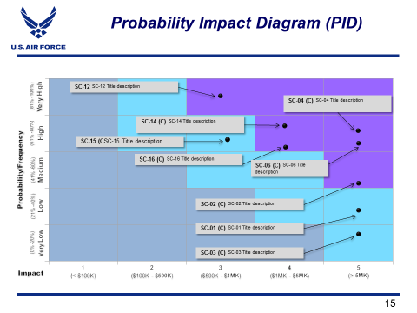
Figure 2: Probability Impact Diagram
Reference to further guidance on associating Should Cost considerations wih opportunity management can be found in: “Department of Defense Risk, Issue, and Opportunity management Guide for Defense Acquistiion Programs”, Chaper 4: Opportunity Management, at http://go.usa.gov/x9SCU.

- Measurement: As with all AFLCMC Standard Processes and metrics, the Should Cost Description Table below summarizes the metric associated with the standard process:
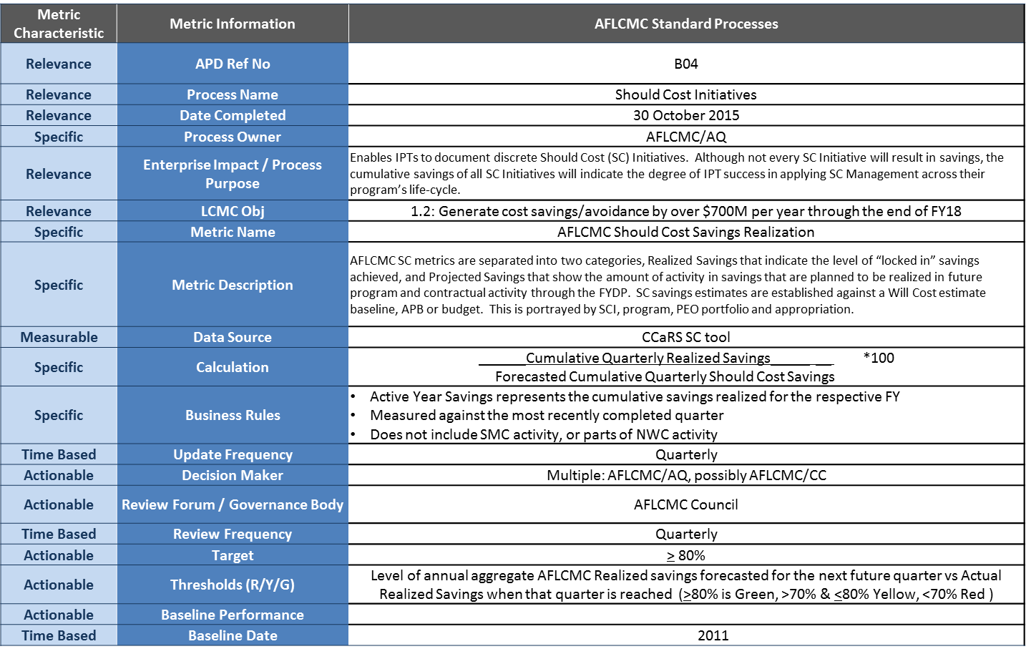
Table 2: Should Cost Metric Measurement Table
  - SC metrics are aligned into two categories, implementation metrics that are short-term indicators of the adoption of SC Management in the AFLCMC culture, and enduring metrics that focus on the results of SC Management:
    - Implementation Metrics: Number of programs with approved SCIs.
    - Enduring Metrics: SC savings from a SC estimate against a Will Cost estimate baseline, APB or budget. The SC estimate is broken down by amount of savings per year, as well as whether the savings are Projected or Realized. This estimate is portrayed by program, PEO portfolio and appropriation.
  - Reporting. SC reporting metrics will be generated from the CCaR SC tool. The PM/PEO will use both the primary CCaR tool and Executive CCaR.

- Roles and Responsibilities
  - Program Executive Officers (PEO) PEOs are ultimately responsible for implementing SCM with the Service Acquisition Executive. This includes reviewing and approving SCIs, monitoring and reporting progress and recommending allocation of realized or planned cost savings to SAF/AQ and the MAJCOM Core Function Lead Integrator (CFLI). Per SAF/AQ direction, “PEOs, or a designated representative, will review SCIs according to criteria listed, not less than once a year.” In addition, “PEOs have the authority to delegate SCI approval authority to best fit their organizational structure and program portfolio.”
  - Program Manager (PM) The PM has the overall responsibility to ensure SCIs are identified, executed and properly documented in CCaR. This includes SC acquisition planning, and development of the SC acquisition strategy, while ensuring all key functionals and external agencies participate in identifying and developing SCIs as needed.
  - Contracting (PK) When developing a SC Initiative, the contracting officer helps decide which elements of the contractor’s operation have the greatest potential for cost savings. Coordination with other program functionals on this such as EN and FM is vital to validating contract cost saving ideas. Contracting is then responsible for incorporating identified SC savings opportunities into contract negotiations and ultimately contract award. In addition, contracting plays a critical role in the review of business processes, and is integral to the determination of appropriate contractor incentives to empower contractors to develop economical and efficient operations.
  - Financial Management (FM) FM will be responsible for developing and supporting the Will Cost Estimate (WCE) for the program or project. FM will also be a member of the program team that analyzes SCIs and translates the effort into a SC Estimate.
  - Engineering (EN) As an SCI, by definition, does not involve requirement revisions of any kind toward saving costs, the Lead System Engineer (LSE) will support and assist the PM in identifying SCIs that will not jeopardize the program’s overall system technical performance, general requirements, or key performance parameters (KPPs). The LSE will facilitate a risk assessment for SCIs to determine the overall program risks and trade-offs. The LSE will provide the assessment results and a recommendation for consideration to the PM.
  - Logistics (LG) The Product Support Manager (PSM) will support the PM in identifying SCIs and data requirements to accomplish the SC estimate and work initiatives. The PSM will work with FM on R&D, Production and O&S cost estimates and the POE as a baseline Will Cost estimate for SCIs in all phases. The PSM will also facilitate information flow with AFSC offices as required and ensure that the assumptions for the SC Initiative reflect the approved Product Support Strategy as documented in the Life Cycle Sustainment Plan.
  - Test and Evaluation The Chief Developmental Tester (CDT)/Test Manager (TM) will support and assist the PM in identifying SCIs that may result from DT&E/OT&E test strategy planning based on program requirements and test business case analysis. The CDT/TM will provide any assessment results with a recommendation for consideration to the PM.
  - External Agency Program Members: Other organizations that have a role in a given program may include the defense contractor, the using command (customer), the Defense Contract Management Agency (DCMA), and the Defense Contract Audit Agency (DCAA). These organizations can have a unique perspective of the program that may lend to saving program funds that other members of the program may not be able to consider.
  - AFLCMC/AQ The SC Initiative Standard Process is executed entirely within PEO execution channels; however, as the process owner, AFLCMC/AQ will keep this Standard Process current, and update and report CCaR AFLCMC metrics resulting from this process. For the overview of how all functionals described above work together to execute the Should cost process as a whole, refer to the chart above titled “Should Cost Process Flow”.

- Tools
  - Comprehensive Cost and Requirement System (CCaR). Per SAF/AQ SC Management Guidance and Business Rules, CCaR will be used to track and report SCIs. More information on CCaR can be found http://www.webccar.com/. Also available is Executive CCaR which provides a broader reporting perspective. Executive CCaR will also display SC at the PEO and higher levels. More information on Executive CCaR is located at https://execccar.altess.army.mil/executiveccar/
  - BBP Tool is at: https://cs.eis.afmc.af.mil/sites/ASCACE/shouldcost/Tools/BBP_Tool.pptx . Despite the fact that the latest BBP document is designated as BBP 3.0, this latest BBP tool is still identified as BBP 2.0. This tool was created to aid government acquisition personnel in understanding and implementing the concept of BBP and the Department of Defense (DoD) BBP initiatives primarily related to contract formation. It contains 11 fundamental BBP Practices and over 80 associated techniques. SC is covered by BBP practices menu item one, Management Affordability/Efficiency Throughout Life Cycle, and menu item eight, Conduct a Rigorous Cost/Price Analysis. Access of the BBP 3.0 Implementation Guidance memorandum is possible through the link: https://cs.eis.afmc.af.mil/sites/ASCACE/shouldcost/Policy/Forms/AllItems.aspx

- Training
  - Training Curriculum Outline. AFLCMC/AQ teams with SAF/AQX and AFIT to provide SC training in three categories:
    - SC Policy – Foundation for why SC Management should be performed, and how it fits with other policy directives.
    - SC Methodologies – Techniques and approaches to finding savings and efficiencies.
    - SC Execution – Business rules and how to use the CCaR SC tool. Recurring CCAR SC tool classes are available via DCO.
  - A foundational Should Cost Management Computer Based Training (CBT) course is available to all military and civilian government personnel via Air University Blackboard. This web-based and self-paced Air Force Institute of Technology (AFIT) course, SYS 190 – Air Force Should Cost Fundamentals, includes award of 6 Continuous Learning Points, provides individual knowledge, and serves as an informal prerequisite for participation on a program team during SCI development. Support contractors may enroll in the SYS 190 CBT for a fee, to be provided by their employer.
  - A formal Should Cost workshop is also available to support programs requiring specialized assistance. This two-day forum is facilitated by members of AFIT, and the SYS 190 CBT referenced above is a pre-requisite to the workshop. The output goal of this training is to have each team develop at least one candidate SCI to be further developed at their office, approved, and entered into CCaR.
  - AFLCMC/AQPB is the AFLCMC focal point for other SC training forums such as AFLCMC Focus Week, Program Manager Journeyman Level Training, and other ad hoc training opportunities. AFLCMC/AQP will release training dates throughout the year as they become available.

- Definitions, Guiding Principles or Ground Rules and Assumptions.
  - Definitions or Glossary of Terms. Please view the SAF/AQ SC Guidance and Business Rules document, dated 19 Aug 2016, for SC terms and definitions.

- References to Law, Policy, Instructions, or Guidance
  - SAF/AQX homepage for BBP memos: https://www.my.af.mil/gcss-af/USAF/ep/browse.do?categoryId=p0ECF2BB845754CE6014598CC5A350370&channelPageId=s6925EC13430A0FB5E044080020E329A9
  - DoDI 5000.02 (7 Jan 2015, incorporating Change 1, effective 26 Jan 2017), SAF/AQ Should Cost Management Guidance and Business Rules (19 Aug 2016) https://cs.eis.afmc.af.mil/sites/ASCACE/shouldcost/Policy/Forms/AllItems.aspx

  - Additional References
    - (FAR 15.407-4): http://farsite.hill.af.mil/vffara.htm
    - (DFARS PGI 215.407-4): http://farsite.hill.af.mil/reghtml/regs/far2afmcfars/fardfars/dfars/PGI%20215_4.htm
    - AFIT Now Training Course website which includes access to the AFIT SYS 190: https://www.atrrs.army.mil/channels/afitnow/

Attachment 1: WBS
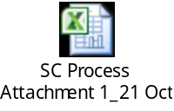

Implementation Directive for Better Buying Power 3.0 – Achieving Dominant Capabilities through Technical Excellence and Innovation (9 Apr 15), Atch2, p.2
2 Should Cost Management in Defense Acquisition, (6 Aug 2013)
3 SAF/AQ Should Cost Management (SCM) Guidance and Businss Rules, (19 Aug 2016), p.8
4 USD (AT&L), Better Buying Power, Guidance for Obtaining Greater Efficiency and Productivity in Defense September 14, 2010, p.3
SAF/AQ Should Cost Management (SCM) Guidance and Businss Rules, (19 Aug 2016), p.14
SAF/AQ Should Cost Management (SCM) Guidance and Businss Rules, (19 Aug 2016), p.11

