LESSON ACTIVITIES FOR
Introduction, Block 1: Problem Solving & Programming and Block 2: Data representation
Lesson 1 activities
Activity 1.1
Write a program to print out “Hello World”.
Activity 1.2
Write a program that writes your name on the screen.
Activity 1.3
- Copy and run this program.
print("hello " * 10)
- Write a program that prints your name six times.
Lesson 2 activities
Activity 2.1
Are the following statements true or false?
Python was released in 2010 | True or false?
Python was named after the TV series “Monty Python’s Flying Circus” | True or false?
Python is proprietary software which is expensive to buy | True or false?
Python was written by Bill Gates | True or false?
YouTube is written in Python | True or false?
Activity 2.2
Make a note of what these useful keyboard shortcuts do.
Keyboard shortcut | What does the keyboard shortcut do?
Control c
Control v
Control a
Control x
Control f
Control n
Control p
Control s
Control z

Activity 2.3
- Copy and run this program:
print("This is the end")
print("Hold your breath and count to ten”)
print("Feel the earth move and then”)
print("Hear my heart burst again”)

- Write a program that writes four lines of the lyrics of your favourite song on the screen.
Activity 2.4
- Copy and run this program.
print("the rain falls","from the sky")

- Now answer these questions:
  - What happens?
  - What effect does the ”,“ have?
Activity 2.5
Escape sequences can be used to alter how the information is displayed on the screen. An escape sequence is a back slash “\”.
Experiment with these escape sequences and complete the table.
print("\tQuestion what goes woof\t\tdogs\t\t\trabbits")
print("\n\nwhat kind of snake is good at maths?\n\nAn adder\n\n")
print("\n\nGoodbye\n\n")

Hint: Use alt p to display the last command entered in the IDLE shell.
Escape sequence | Effect
\t
\n
\\
\’
\”
Activity 2.6
Print this text using just one line of code.
Help, I need somebody
Help, not just anybody
Help, you know, I need someone
Activity 2.7
Write a program using print commands to display your initials five characters high on the screen.
X x x x
Xx x x X
X x x Xxxxxx
X xx x x
X x x x
Activity 2.8
An algorithm is a sequence of steps needed to perform a particular task. Algorithms can be represented in different ways.
Match the words to the representations.
flowchart pseudocode structured English
written description program code
A
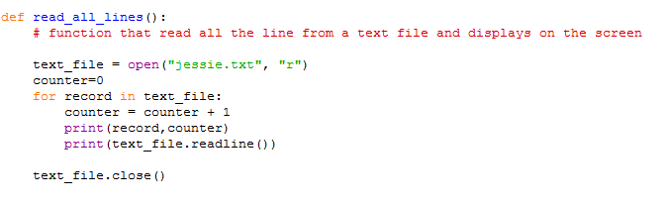

B
RECEIVE myName FROM (STRING) KEYBOARD
RECEIVE myAge FROM (INTEGER) KEYBOARD
SET AgeInTen TOmyAge + 10
SEND myName “will be” AgeInTen “in 10 years time” TO DISPLAY

C
Write a program that prompts the user to enter their name and age. The program then adds 10 onto the age and displays the text “<name entered> will be <age + 10> in ten years time.”
D
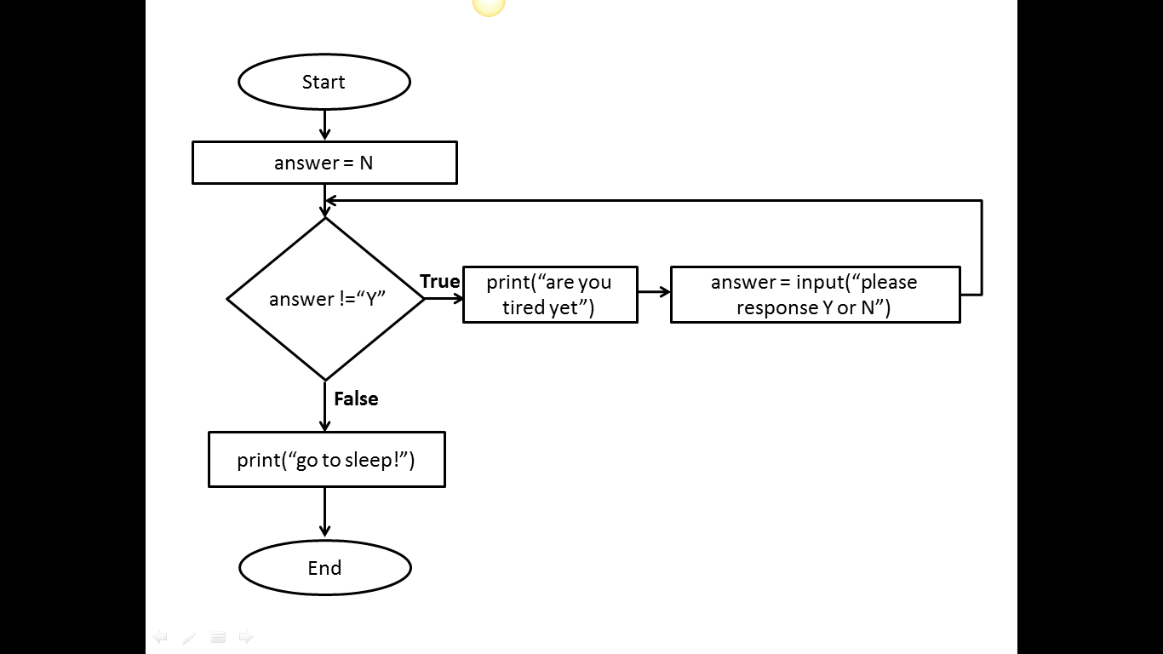

E
If animal has 4 legs then
If animal has a tail then
If animal answers to “puss” then
animal = cat
endif
endif
endif

Activity 2.9
Explore ASCII art (Wikipedia) and write a Python program to display your ASCII art creation.
.--. /\ ____
'--' /__\ (^._.^)~ <(o.o)>

Lesson 3 activities
Activity 3.1
Copy and run these lines of code. Complete the table to explain what the mathematical operators do.
>>> 60/5
>>> 987+34
>>> 564*89
>>> 2**5
>>> 43-5
>>> 11//2
>>> 11%2

Mathematical operator symbol | Operation
/
+
*
**
-
//
%

Activity 3.2
Make up some mathematical calculations of your own and add an example to the table for each mathematical operator.
Mathematical operator symbol | Operation | Example | Answer
/ | divide
+ | add
* | multiply
** | exponential
- | subtract
// | integer division
% | modulus (remainder after the division)
Activity 3.3
- Write a program to display this text on the screen and fill in the missing number.
8 cats have 4 legs each
The cats have ___ legs in total

- Write a program to display this text on the screen and fill in the missing number.
A farmer with 1089 sheep sells 56 of them
The farmer has _____ sheep left

- Write a program to display this text on the screen and fill in the missing number.
4 children pick 56 flowers each
The children each have ____ flowers
Activity 3.4
Copy and run these lines of code. What effect do the parentheses () have?
>>> 5 * 3 / 6 + 4
>>>(5 * 3) / (6 + 4)
Activity 3.5
- Predict what you think will be displayed on the screen when this line of code is executed.
15 / 2 * 3 + 2
- Now copy and run the code. Explain the answer you get. Is it what you predicted?
Activity 3.6
- Make up some multiple-choice questions on precedence. Each question must have four possible answers, one of which is correct.
Here are two examples:
What is the correct answer to the following expression?
>>> 7 + 4 * 5

- 55
- 27
- 16
- 33
What is the correct answer to the following expression?
>>> 6 -2 / 2 + 5

- 0.57
- 10
- 7
- 11

  - Check your answers are correct by using the interactive Python shell.
  - Try your questions out on other people. You must be able to explain to them why the answers are correct.
Activity 3.7
Devise your own mnemonic for remembering the order of precedence.
Python order of precedence | Mnemonic
Parenthesis (brackets)
Exponential
Division and multiplication
Addition and subtraction
Lesson 4 activities
Activity 4.1
Copy and run this code and explain the result.
>>>print hello world
Activity 4.2
Copy and run this code and explain the result.
>>>print("hello world")
Activity 4.3
- Python produces different types of error. Match up the type of error with its description.
Type of error
TypeError
RuntimeError
NameError
ZeroDivisionError
KeyBoardInterrupt

Description of the error
Dividing a number by zero.
When a program is interrupted from the keyboard by pressing control+c.
When a name is used that is not known about (often a variable name that is misspelt).
When an operation is attempt that is invalid for that type of data.
An error occurs when the program is running.

- Experiment with Python to see if you can create each type of error.
Hint: A full list of Python errors can be found here: http://www.tutorialspoint.com/python/standard_exceptions.htm
Activity 4.4
Copy and run this code and explain the result.
# Programmer Amy Smith 6th September 2013
Activity 4.5
- Use file/new window to open a script file in the IDLE.
- Copy this code into the file.
print("So long and thanks for all the fish")
print("The answer is",6*7)

- Save the file using file/save. Always give the filename an extension of .py. Use a meaningful filename and store in a suitable folder.
- Run the commands by using run/run module
- Close Python and then restart Python, open the file and run the program again.
Activity 4.6
Following the same steps as in Activity 4.5, write a program that displays your name and then your age.
Hint: Use file/new window and save the file using file/save. Don’t forget to use a meaningful filename.
Activity 4.7
Using the Python IDLE
Write your own summary sheet to describe how to run Python programs, including how to save and open .py files. Include any other commands that you have found useful.
Using the Python IDLE
How to open a new window
How to save a file
How to open a file
How to run a program
Useful tips
alt p | Displays the last line you entered
Commands in the file are not colour coded | Save as a .py file
Lesson 5 activities
Activity 5.1
Where does the name ‘Boolean’ come from?
Boolean variables are named after George Boole who invented the mathematics of digital logic. Find a picture of George Boole and insert it here. When was he born?
Activity 5.2
Data types
Use the “type” function to find out the data types for these values.
>>>type("Fred")
>>>type(198)
>>>type(88.9)
>>>type(True)
>>>type(False)

Hint: Remember that True and False must start with a capital letter.
Activity 5.3
The type function returns the data type of an expression.
For each of these expressions, first predict the data type then use the type command to see if your prediction was correct.
Expression | Predicted data type | Type command | Result
“hello world” |  | type("hello world")
False |  | type(False)
15 |  | type(15)
35.6 |  | type(35.6)
-999 |  | type(-999)
“15” |  | type(“15”)
“False” |  | type(“False”)
True |  | type(True)
0.001 |  | type(0.001)

Activity 5.4
The interactive shell is a useful place to explore variables.
- Copy and run this code in the interactive shell.
myName="Fred Smith"
myAge=14
print(myName,myAge)

- Create a variable called myName and assign it to your name.
- Create a variable called myAge and assign it to your age
- Create a variable called myEyes and assign it to your eye colour.
- Create a variable called myHeight and assign it to your height.
- Write the commands to display on the screen your name, age, eye colour and height.
Hint: Remember that a single ‘=’ is used to assign a value to a variable.
Activity 5.5
Variable names
A programmer is trying to decide on a valid name for a variable that represents a house number.
- Which of the following variable assignments are valid? Why are the others not valid?
 | Valid or invalid variable name? | Reason why not valid
8HouseNumber = 288
houseNumber = 288
house Number = 288
house_number = 288
import = 288

- What type of error do you get when using an invalid variable name?
Activity 5.6
- Copy and run this code and explain the result.
# Programmer Amy Jones 12/8/2013
# adds two numbers
numberOne=15
numberTwo=23
answer=numberOne + numberTwo
print("The answer is “,answer)

- Amend the program to add another variable called numberThree. Assign the value 76 to this variable. The program should all up all three numbers and print the result.
Activity 5.7
Data types in Python
Complete this table to describe the four data types.
Data type | Python abbreviation | Explanation | Example
integer | int
string | str
float | float
boolean | bool

Hint: Quotation marks are used to show the start and end point of a string, e.g. “this is a string”.
Lesson 6 activities
Activity 6.1
Input function
The input function allows the user to input a value and assign it to a variable.
- Copy and run this program.
myAnswer=input("Please enter your name: ")
print(myAnswer)

- Re-run the program several times, entering different names each time.

- Write a program that asks the user for their name and favourite food and displays these on the screen.
Activity 6.2
Int function
- Copy and run this program.
age=input("Please enter your age: ")
agePlusTen = age + 10
print("You will be",agePlusTen,"in 10 years")

- Explain why it does not work.
- Correct the program.
Activity 6.3
Write a program that asks you to enter a number then displays the number doubled.
Activity 6.4
String formatting
The string method .format gives you more control over the formatting of your output than printing using space-separated values. The string formatting commands are given in curly brackets {}.

- Copy and run these lines of code:

>>>foodOne="fish"
>>>foodTwo="chips"
>>>print("{0} and {1}".format(foodOne,foodTwo))
fish and chips

>>>print("{1} and {0}".format(foodOne,foodTwo))
chips and fish

>>>print("{1} {1} {1} and {0} {0} {0}".format(foodOne,foodTwo))
chipschipschips and fishfishfish

- Create these variables:
one = “cheese”
two =”onion”

- Use the .formatcommand to display:

My favourite crisps are cheese and onion. I love them!
cheese and onion and cheese and onion and cheese and onion
cheesecheesecheese and oniononiononion
You guessed it. The best crisps are onion and … cheese.

- Try altering the flavours assigned to the variables to your favourite flavour! Enjoy.
Activity 6.5
Formatting numbers
You can use the .format method to format the number of decimal places.

- Copy and run these lines of code:

>>>number = 98.1468297645
>>>print("The answer is {0:.5f}".format(number))
The answer is 98.14683

>>>print("The answer is {0:.4f}".format(number))
The answer is 98.1468

>>>print("The answer is {0:.3f}".format(number))
The answer is 98.147

>>>print("The answer is {0:.1f}".format(number))
The answer is 98.1

>>>print("The answer is {0:.0f}".format(number))
The answer is 98

- Assign the number 765.87641987 to a variable and display the number with 5, 2 and no decimal places using the .format command.
Activity 6.6
- Write a program that asks how much your bill is at a restaurant and then asks you to enter the % you want to give in a tip. The program should display the amount of tip to give to the waiter.

- Amend the program so that it also displays the total cost of the meal including the tip.
Activity 6.7
- Write a program that displays the square of a number.
- Write a program that prompts for a number and then displays the cube of a number.
- Write a program to find the perimeter of a square.
- Write a program to find the perimeter of a rectangle.
- Write a program that finds the area of a square.
- Write a program that finds the area of a cube.
- Write a program to convert from pounds to euros.

Hint: All these programs should prompt for the input information and display the result appropriately.

Lesson 7 activities
Activity 7.1
Relational operators
Password checking is an example of a relational operator. If the password entered is the same as the password stored then the condition is true. The operator is ‘is equal to’.
Brainstorm other examples of condition statements and decide what the operator is.
Relation statement | Operator
Activity 7.2
- Complete this table of the Python relational operators. Give an example of each and say whether it will evaluate to true or false.
Relational operator | Operator | Example | Evaluates to
Equal to
Not equal to
Greater than
Greater than or equal to
Less than
Less than or equal to

- Try out your expressions by typing them into the Python interactive shell.
Activity 7.3
Greater than and less than
Find a way that works for you of remembering the difference between “less than” < and “greater than” >.
Hint: As there are only two options you only need to learn one!
Operator | > | <
Operator meaning | Greater than | Less than
How I remember this
Activity 7.4
This program asks if it is snowing and if so tells you to take a sledge otherwise to have a good day. The condition is missing.

Copy and complete the condition to make the program work correctly.
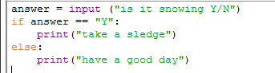

Activity 7.5
What condition is needed in this program to display ‘pass’ if the exam mark is 40 or more?
Copy and complete the condition to make the program work correctly.
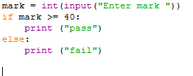

Activity 7.6
Write a program that asks you to enter the colour of the light at a pedestrian crossing. If the light is green it tells you it is safe to cross, otherwise it tells you to stop.
Activity 7.7
Write a program that asks you for your password. It then asks you to re-enter your password. If they are the same the message “access granted” is displayed. If the passwords are not the same the message “access denied” is displayed.
Lesson 8 activities
Activity 8.1
Using elif
This program simulates a fortune cookie. A random number is used to decide your ‘fortune’.
- Copy and run this program.
# a random number is given by the randint() function
import random
answer= random.randint(1,6)
if answer == 1:
print("You will make a new friend this week")
elif answer == 2:
print("You will do well in your GCSEs")
elif answer == 3:
print("You will find something you thought you’d lost")

- The program is not yet complete. Include your own ‘fortunes’ for the numbers 4, 5 and 6.

Note: random.randint(1,6) is a function that returns a random number between 1 and 6. The ‘import random’ command allows the program to access the random.randint() function.
Activity 8.2
Writing readable code: a style guide
Program code is read more often that it is written. Here are some guidelines on how to write Python code so that it is easy to read.
A style guide for Python code
- Indent by four spaces for each indentation level.
- Use blank lines to separate different parts of the program.
- Use two blank lines to separate functions.
- Choose meaningful names for variables, using CamelCase or with words separated by underscores.
- Put imports at the top of the file.
- Include one space around each side of an assignment and other operators.
- Use complete sentences with the first word capitalised for comments.
- Write comments that add clarity and explain what the program does. Do not simply repeat what the code already says.
- Write function names in lowercase, with words separated by underscores.
- Use meaningful function names which describe the purpose of the function.
- Write constants in CAPITAL_LETTERS.
- Use meaningful constant names, which describe the purpose of the constant.

Note: Functions are subprograms which start with the “deffunction_name():. Constants are variables whose value never changes. You will be covering functions in later lessons.
For more detail see http://www.python.org/dev/peps/pep-0008/
Apply the rules in the style guide above for this Python code.
def a(s):
if s<50:
print("You have lost")
else:
print("You have won")
Activity 8.3
Select some of your programs and make them more readable using the rules in the style guide.
Lesson 9 activities
Activity 9.1
Flowcharts
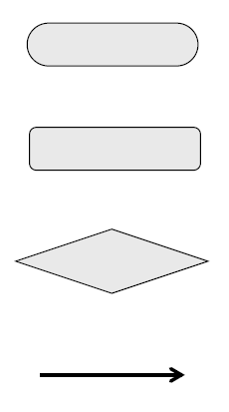
Flowcharts can be used to represent algorithms. Identify the flowchart symbols below.
Activity 9.2
Study this program.

# password checking
password=input("Please enter password: ")
newPassword=input("Please re-enter password: ")
if password == newPassword:
print("Access granted")
else:
print("Access denied")

Draw the flowchart for this program.

Activity 9.3
Study the flowchart.
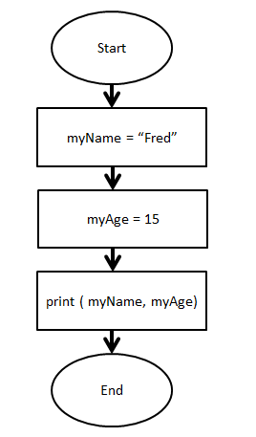
Write a program to implement this flowchart.

Activity 9.4
Study the flowchart.
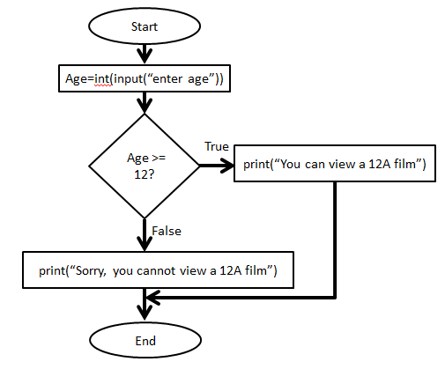
- What does this flowchart do?
- Write the program to implement this flowchart.

Extension: Can you extend the program to display whether they can watch 15 films or 18 films?

Activity 9.5
Boolean Operators
Complete the table using the logical (Boolean) operators AND, OR and NOT.
Symbol | Description
 | Returns true if both conditions are true.
 | Returns true if any of the conditions are true.
 | Reverses the outcome of the expression; true becomes false, false becomes true.

Activity 9.6
Predict the answer to the conditions and then use the interactive shell to test your answer.
Condition | Your prediction  (true or false?) | Result
(78 == 10) or (6 == 7)
(78 == 10) or (6 == 6)
(78 == 10) and (6 == 6)
(1 < 10) and (2 < 10)
(1 < 10) or (2 < 10)
not ( 5 ==5)
not (6 < 4)

Hint: Try asking yourself the questions:
Is condition_1 true OR condition_2 true – if YES then the answer is true.
Is condition_1 true AND condition_2 true – if YES then the answer is true.
Activity 9.7
- Make up some Boolean operator questions of your own and check your answers are correct by using the interactive Python shell.
Here is an example question:
>>>answer = 50
>>> (answer<40) or (answer >80)
True or False?

- Try them out on other people. Make sure you can explain the right answer to them if they need you to.
Activity 9.8
A truth table lists all the possible combinations of true and false outcomes for each condition.
Complete the truth tables for AND and OR operators.

Truth table showing true and false AND conditions
Condition 1 | Condition 2 | Output
false | false
true | false
false | true
true | true

Truth table showing true and false OR conditions
Condition 1 | Condition 2 | Output
false | false
true | false
false | true
true | true

Activity 9.9
Write a program that asks the user to enter a year group and tells them which key stage that year group is in.
Key stage | Year group
Key stage 1 | Years 1 and 2
Key stage 2 | Years 3, 4, 5 and 6
Key stage 3 | Years 7, 8 and 9
Key stage 4 | Years 10 and 11

Extension: What happens if the year group entered is greater than 11? Can you improve your program to cope with this?

Activity 9.10
Python commands colour coding
The Python language is colour coded.
Complete this table.
Colour coding | What does it show | Example
green
purple
black
orange
red
Lesson 10 activities
Activity 10.1
Strings
- Write the index position for each character in the string.
H | e | l | l | o |  | w | o | r | l | d | !

- What character is at index 3?
- What character is at index 5?
- What character is at index 0?
- What character is at index 11?
- How many characters are there in this string?
Activity 10.2
Use the interactive shell to explore how strings can be concatenated.
- Make a variable called FirstName and set its value to the string “Fred”
- Make a variable called SecondName and set its value to the string “Smith”
- Make a variable called FullName and set its value to the value of the variables FirstName plus SecondName
- Print the value of the variable FullName

Activity 10.3
Slicing strings
Parts of a string can be extracted (or sliced) by giving the index location in the format:
[start position: end position]

Start position is the index at which the slice starts (remember that indexing starts at zero). End position is the index AFTER the last index required.

Use the interactive shell to explore how strings can be sliced.

- Make a variable called word and set its value to the string “PIZZA”.

>>>word="PIZZA"

P | I | Z | Z | A
0 | 1 | 2 | 3 | 4

- What do these commands do?

  - >>>word[2:5]
  - >>>word[1:2]
  - >>>word[0:3]
  - >>>word[0:5]

Hint: Remember that the index starts at zero not one.
Activity 10.4
A variable has been created and assigned the string “watch #bbcclick today”

myVariable = “watch #bbcclick today”

w | a | t | c | h |  | # | b | b | c | c | l | i | c | k |  | t | o | d | a | y
0 | 1 | 2 | 3 | 4 | 5 | 6 | 7 | 8 | 9 | 10 | 11 | 12 | 13 | 14 | 15 | 16 | 17 | 18 | 19 | 20

- What command would you use to extract the following slices?

  - #bbcclick
  - watch
  - today

- Check your answers using the interactive shell.
Activity 10.5
Using string methods
Any variable with a string assigned is a member of the class called string. String methods can be used to manipulate that string.
Explore string methods by working through these commands in the interactive shell and describing what happens.

- >>>myVariable="There's a starman waiting in the sky"
- >>>myVariable.upper()
- >>>myVariable.replace("a","x")
- >>>myVariable.title()
- >>>myVariable.swapcase()
Activity 10.6
The string .format method revisited: using the string .format method to format output
There are two ways to output information to the screen. Using the print() function or by giving the expression.

Try these now:
>>>myName="David Bowie"
>>>print(myName)
David Bowie

>>>myName
'David Bowie'

The string .format is used to give more control over formatting.

It allows you to use placeholders and then specify the variable you want to print in the string. The placeholders are shown using {}.

>>>first="David"
>>>second="Bowie"
>>>print("The best music is from {0} {1}!".format(first,second))

The best music is from David Bowie!

It also allows you to choose how to format the output.
Lesson 11 activities
Activity 11.1
Lists (arrays)
Complete this table to summarise the list commands.
Things to do with lists | Commands
Create a list
Reference an item in a list
Delete an item in a list
Append an item to the end of a list
Activity 11.2
Lists (arrays)
A list is a data structure that stores a set of elements. Lists are assigned to a name using square brackets.

>>>mylist=["apple","oranges","lemon","pear","lime"]

apples | oranges | lemon | pear | lime
0 | 1 | 2 | 3 | 4

Each element in a list has an index location. The first element of the list is in position zero (0).

Elements of a list are referenced using their index location (an integer number).
List name[index]

A range of elements can be displayed using
[start index: end index]

Start index is the position to start at (remember that indexing starts at zero). End position is the index AFTER the index required.

- Make this list and experiment with the list commands.
>>>mylist=["apple","orange","lemon","pear","lime"]

- What does mylist[1] display?
- What does mylist[1:3] display?
- What does mylist[-1] display?
- What command will display just apple?
- What command will display lemon and pear?

- Make a new list called myfood containing your five favourite foods.
- Display the whole list.
- Display the food item at index position 3.
- Display the food item at index position 0.
- Display the food items at index position 1 to 4.
Activity 11.3
Using lists
- Make the list that contains the class marks for Amy Jones.

Marks = ['Amy', 'Jones', 'English', 67, 'Maths', 76, 'Computer Science', 96]

- The English teacher has entered Amy’s mark incorrectly; it should be 72 not 67. Alter this item in the list.
- Add the mark for Physics to the end of the list. “Physics”, 65
- Remove “Maths” and the score 76 from the list.
- Write a program to find the average score for the three subjects (English, Computer Science and Physics).
Activity 11.4
Using Python docs help
- Select help/python docs then select the Python tutorial and go to 3.1.4 Lists.
- Read through the discussion of lists and try out the examples. Make a note of three more facts about lists to share in the next lesson.
Python is a very powerful programming language which is used in universities and commercial organisations. You do not need to know all the details provided in the Python docs but, with practice, you should be able to find information about Python that can be very useful.
Lesson 12 activities
Activity 12.1
For loops
- Copy and run this program.
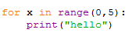
- Write a program that prints out “I like Kate Bush” 10 times.
Activity 12.2
- Copy and run this program:

for number in range(10):
print(number)

- Explain what this program does.

- Write a program that prints the numbers from 1 to 15.
- Write a program that prints the numbers from 1 to 8, with the square of each number, both on the same line.
- Write a program that prints out the 9 times table (up to 20 x 9).
- Write a program that asks the user which times table they want and then displays that table.
- Write a program that asks for a start value and an end value and then counts in fives between those numbers. Hint: range(start value, end value, step)

Activity 12.3
- Copy this program into a file and run the program.
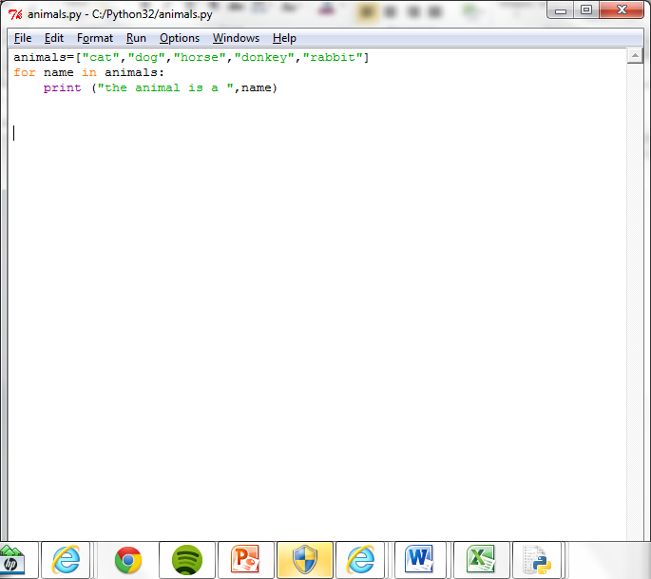
- Explain the purpose of the ‘name’ variable.
- Write a program that creates a list of things you would take to a desert island. The program should then display each item in the list a line at a time.
Activity 12.4
Re-arrange the program statements to write a program that will print out the names of the animals that begin with the character ‘c’.
print(next)
if next[0] == "c" :
myList=["cat","dog","cow","donkey","rabbit","canary"]
for next in myList:
Activity 12.5
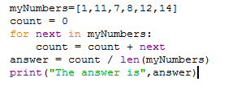
- Study this program.
- What will the program do?
- Explain what the variable next is used for?
- Explain what the variable count is used for?
- What does len(myNumbers) do?
- What happens if you add or append more numbers in the list?
- If a print statement was added to the for loop, as shown below, what would be displayed?
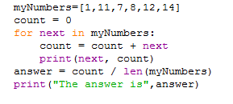
Activity 12.6
Write a program that finds the largest number in this list.
myNumbers=[19,6,7,9,2,25,16]
Lesson 13 activities
Activity 13.1
While command
- What does this while command do?
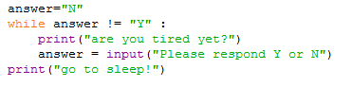
- What is the condition that is being tested and how does it change?
Activity 13.2
Write a program that asks the user if they are hungry. While they reply ‘N’ the program repeats the question, showing how many times they have replied ‘N’.
When they reply ‘Y’, the program tells them to get something to eat.
Activity 13.3
- What does this program do?
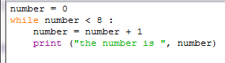
- What is the ‘sentry’ variable?
- What is the condition?
Activity 13.4
Flowcharts and while command
Flowcharts can be used to represent programs. Complete the flow chart for this program.
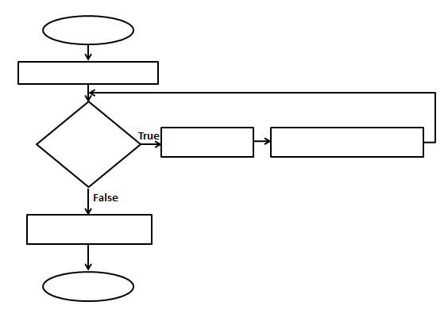
Lesson 14 activities
Activity 14.1
Pseudocode
Pseudocode, or ‘mock’ code, is another way of describing a program. You will need a copy of the pseudocode used in this course (Appendix B of the specification) to answer these questions.

- What does this pseudocode do?
RECEIVE myName FROM (STRING) KEYBOARD
RECEIVE myAge FROM (INTEGER) KEYBOARD
SET AgeInTen TOmyAge + 10
SEND myName “will be” AgeInTen “in 10 years’ time” TO DISPLAY

- Write the Python code for this program.
Activity 14.2
- What does this pseudocode do?
SET score TO 119
IF score < 50 THEN SEND “You have lost” TO DISPLAY
ELSE SEND “You have won” TO DISPLAY
END IF

- Write the Python code for this program.
Activity 14.3
random() function
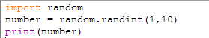
- Copy and run this program code:

- Run the program a few times. What does it do?
- What is meant by ‘import random’?
- What happens if you alter the values to 1, 100?
Activity 14.4
Write a program that acts like a dice. After each ‘throw’ of the dice it should ask if the player wishes to continue and stop when they enter ‘Y’.
Activity 14.5
Write a program that gives the user 10 chances to guess a number between 1 and 10. It then compares their answer with a randomly generated number and stops the program when the number generated matches the number guessed or when the user is out of guesses.
Lesson 15 activities
Activity 15.1
Lists and for loops revisited

- What does this command do?
>>>countries= ["Japan","Germany","USA","China","Austria","Turkey","Mexico"]
- How would you display all the values in countries?
- How would you display “China”?
- How would you display “Japan”
- How would you address the third item in the list?

- Copy and run this program. Explain how it works.
for name in countries:
print(“This is one of my favourite countries “, name)

- Copy and run this program, which uses list comprehension. Explain how it works.
length=10
myList= [43 for number in range(length)]
print(myList)

- Write a program that creates a list with each element initialised to 0?

Activity 15.2
Battleships: a game using two-dimensional array addressing (lists)
How to set up the game
Each player decides at which index locations in the two dimensional array [row, column] to place their ships.
They have five ships:
- A battle ship that takes up five index spaces
- A cruiser that takes up four index spaces
- A submarine that takes up three index spaces
- A destroyer that takes up two index space
- Four spy ships, disguised as fishing boats, that each take up one index space.
None of the ships may be placed diagonally; they must all be placed in straight lines either horizontally or vertically. It is legal (but not required) for two or more ships to be next to each other. The ships are marked by blocking in the appropriate spaces.
How to play the game
Players take turns taking shots at each other’s ships. A shot is taken by calling out the index locations on the 8 x 8 two-dimensional array. The array index locations are given [row, column] e.g. [2, 6].
Each player takes one shot at a time.
If the player calls the coordinates of an index location where a ship is located, their opponent tells them so by saying ‘hit’. If they miss, their opponent says ‘miss’.
Players mark the shots they take on their ‘Opponent’ array, and whether each shot was a hit or a miss to keep track of their shots. Players may also mark the ‘Self’ array to show the shots taken by their opponent.
A ship is sunk when all of its index locations have been hit. When this happens, the player whose ship was sunk says, for example, ‘You sank my spy ship’.
The winner is the play who manages to sink all their opponent’s ships.

Battleships: My battle ships
[0,0] | [0,1] | [0,2] | [0,3] | [0,4] | [0,5] | [0,6] | [0,7]
[1,0] | [1,1] | [1,2] | [1,3] | [1,4] | [1,5] | [1,6] | [1,7]
[2,0] | [2,1] | [2,2] | [2,3] | [2,4] | [2,5] | [2,6] | [2,7]
[3,0] | [3,1] | [3,2] | [3,3] | [3,4] | [3,5] | [3,6] | [3,7]
[4,0] | [4,1] | [4,2] | [4,3] | [4,4] | [4,5] | [4,6] | [4,7]
[5,0] | [5,1] | [5,2] | [5,3] | [5,4] | [4,5] | [5,6] | [5,7]
[6,0] | [6,1] | [6,2] | [6,3] | [6,4] | [6,5] | [6,6] | [6,7]
[7,0] | [7,1] | [7,2] | [7,3] | [7,4] | [7,5] | [7,6] | [7,7]
[8,0] | [8,1] | [8,2] | [8,3] | [8,4] | [8,5] | [8,6] | [8,7]
Battleships: My opponent’s battle ships
[0,0] | [0,1] | [0,2] | [0,3] | [0,4] | [0,5] | [0,6] | [0,7]
[1,0] | [1,1] | [1,2] | [1,3] | [1,4] | [1,5] | [1,6] | [1,7]
[2,0] | [2,1] | [2,2] | [2,3] | [2,4] | [2,5] | [2,6] | [2,7]
[3,0] | [3,1] | [3,2] | [3,3] | [3,4] | [3,5] | [3,6] | [3,7]
[4,0] | [4,1] | [4,2] | [4,3] | [4,4] | [4,5] | [4,6] | [4,7]
[5,0] | [5,1] | [5,2] | [5,3] | [5,4] | [4,5] | [5,6] | [5,7]
[6,0] | [6,1] | [6,2] | [6,3] | [6,4] | [6,5] | [6,6] | [6,7]
[7,0] | [7,1] | [7,2] | [7,3] | [7,4] | [7,5] | [7,6] | [7,7]
[8,0] | [8,1] | [8,2] | [8,3] | [8,4] | [8,5] | [8,6] | [8,7]

Activity 15.3
Two-dimensional arrays (using nested lists)
In Python, two-dimensional arrays are represented as nested lists (a list of lists) so the addresses are given as [row] [column] rather than [row,column]
- Copy and run this program. What happens and why?
rowLength=4
columnLength=6
myArray=[[0 for row in range(rowLength)] for column in range(columnLength)]
print(myArray)

- Change the value ‘0’ to ‘86’ and run the program again. What happens and why?
- Change the value back to 0 and change rowLength to 9 and columnLength to 5. Run the program. What happens?
- Add these lines to the program as shown to assign values within the array. Run the program. What happens and why?
myArray[0][4] = 99
myArray[2][3] = 74
print(myArray)

- Add these rows to the program so that it prints out the array a row at a time. Explain how it works.
# print out a row at a time
for row in range(rowLength):
print(myArray[row])
Activity 15.4

How to use two-dimensional arrays in Python (nested lists which start from zero)
Task | Example
How to initialise a two-dimensional array
How to address an array element
How to assign values in a two-dimensional array
How to print a two-dimensional array
Activity 15.5
Write a program that fills up a two-dimensional grid with the results of the multiplication table 10 x 10 and prints out the result.
Activity 15.6
Write a program to implement a “one player” Battleships game. Use randint() to initialise the location of the ships. The player enters the index locations for their shots. The player scores one point for every direct hit on a ship. The player is allowed 10 “goes” to hit as many ships as possible. The score is displayed at the end of the game.
Lesson 16 activities
Activity 16.1
Validation
Validation is the automatic checking of entered data by a computer program. Validation cannot check that the data entered is correct only that it is a reasonable value.
Complete the first column of this table using the words listed below, to match the validation type with the correct description. Then give an example of each type in the third column.
presence range length type look-up

Type of validation | Description | Example
 | Checks the data entered is not too short or too long.
 | Checks that data has been entered.
 | Checks that the value entered falls within a given range.
 | Checks that the value entered is of the expected type.
 | Checks the entered value is a value that is expected. Checks value against a look up list or string.
Activity 16.2
Validation – length check
Write a program that asks the user to input a password and then uses a length check to make sure the password is at least eight characters long. If it is shorter than eight characters the user is asked to enter a different password.
Hint: Use the len() function.
Activity 16.3
Validation – presence check
Write a program that asks the user to enter a name and uses a presence check to make sure that an answer has been entered. If nothing has been entered the user is prompted again to enter a name.
Extension: The program should output an appropriate message when the user fails to enter any characters.
Activity 16.4
Validation – type check
Write a program that asks the user to enter their age and checks that they have entered an integer. It should display a message asking them to enter a number if they have not done so.
Hint: Use the ‘try except else’ command.
Activity 16.5
Validation – presence check
Write a program that asks the user to enter an email address and then checks the string entered to make sure it contains an ‘@’. If it does not, the user is prompted again to enter an email address.
Activity 16.6
Validation – range check
Write a program that asks the user to enter a % of charge left in their mobile phone. Use a range check to make sure the value is less 100% or more than 0%. The program must ask the user to re-enter the value if it is outside the range.
Extension: Alter the program so it only allows integer numbers to be entered.
Activity 16.7
Try command: divide by zero error check
Write a program that asks the user for two numbers, then divides the numbers and displays the answer. If the program generates a divide by zero error, display a message to explain they entered a zero as the second number.
Activity 16.8
Write a program that asks the user to enter their name, age and email address using validation to ensure the data contains reasonable values. It should then display the data and ask the user if it is correct.
Use validation to make sure the user can reply ‘Y’, ‘y’ or ‘Yes’ and ‘N’, ‘n’, or ‘No’. The user should be allowed to re-enter the data if it is incorrect.
Lesson 17 activities
Activity 17.1
Test data
Give examples of valid, invalid and extreme data for these data.

An A grade is given to marks between 70 and 80.
Invalid | Extreme (still valid) | Valid | Extreme (still valid) | Invalid

The amount of battery charge is given as a percentage between 0% and 100%.
Invalid | Extreme (still valid) | Valid | Extreme (still valid) | Invalid

Age range for people allowed to view a 15 film.
Invalid | Extreme (still valid) | Valid | Extreme (still valid) | Invalid

Activity 17.2
Test plans
Choose one of your programs and write a test plan for it.
Test number | Description of test | Test data | Expected result | Actual result | Pass/Fail
Lesson 18 activities
Activity 18.1
Default parameter values
- Copy and run the program below.
def myFunction(name = “Fred”, surname = “Bloggs”, age = 21):
print("My name is {0} {1} and I am {2}".format(name, surname, age))

- Explain what happens when these function calls are executed:
myFunction("George","Wales","0")
myFunction("Amelia","Jones")
myFunction("Vicky")
myFunction()
Activity 18.2
Subprograms in Python – writing a function
- Copy this program into a Python window. Save the file as ‘testing_functions.py’ and run.
def function_one(myName):
print("Hello",myName)

This is a subprogram that is expecting one parameter “myName”.

- Run this program from the IDLE shell by entering
function_one(“Edward”)

This will run function_one and pass the argument “Edward” into the subprogram.
- Run the function a few times passing different names into the file.
Remember that it is the name of the function that is used to run the function not the name of the file in which you saved the function.
Activity 18.3
- Create a .py file called testing_functions.py.
- Write a function called name_age in your testing_functions.py file. Use parameters to pass a name and age into the function. The function should display this information appropriately on the screen. Run the function several times passing different names and ages.
Activity 18.4
Write a function called square in your testing_functions.py file. Use a parameter to pass into the function the length of a side and it should display the area of the square. Run the function several times passing different sizes of box.
Activity 18.5
Write a function called numbers in your testing_functions.py file. Use parameters to pass two numbers into the function. The function should then count from the first number to the second number.
Activity 18.6
- Copy and run this program
# outputs a number
def display(number,answer,type):
print("This number {0} has been {2} the answer is {1}".format(number,answer,type))

# squares a number
def square(number):
answer = number * number
return(answer)

# main program
amount = int (input("Please enter number : "))
for next in range(1,amount):
ans = square(next)
display(next,ans,"squared")

- Explain what this program does. Add appropriate comments to the program.
- Colour code the programming constructs: subprograms, return statement, parameters, arguments.
- Explain why the two functions are called in different ways.
- Amend the program to include another function that calculates the cube of the number and displays it.
Activity 18.7
Advantages of subprograms
What do you think are the advantages of using sub-programs?

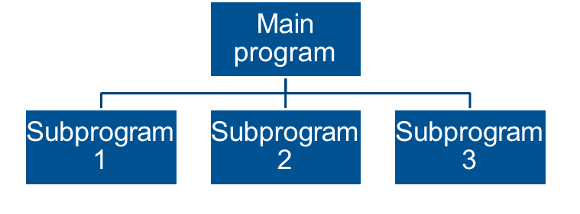
Lesson 19 activities
Activity 19.1
Local and global variables
Variables can be ‘seen’ in different parts of a program. If a variable is defined inside a function then it usually cannot be seen outside that function and is called a local variable. If a variable is declared as being global then it can be ‘seen’ everywhere. This is sometimes called the ‘scope’ of the variable.
- Copy and run this function.
def myFunction():
globalvariableOne
variableOne = 45
variableTwo = 2

- Run the commands at the prompt and explain the result.
>>>myFunction()
>>>print(variableOne)
45

>>>print(variableTwo)

Activity 19.2
Identify which are the local and global variables in this program. You may wish to copy and run the program.
deffunctionOne():
global answer
number1 = 90
number2 = 78
answer = number1 * number2

deffunctionTwo():
global answer
number1 = 65
number2 = 3
answer = number1 / number2

The problem with using a global variable is that it can take different values in different functions. This makes it difficult to keep track of its correct value. Use global variables with care.
Lesson 20 activities
Activity 20.1
Types of errors
Identify the error type from the description given. Choose from the words below. Then, give an example of each type of error from your own experience.
logic syntax runtime
Type of error | Description | Example from your programming experience
 | Errors detected during the program execution often from mistakes in the algorithm used or type of data used.
 | Errors that occur when the program statements cannot be understood because they do not follow the rules of the programming language.
 | Errors in the design of the program such as the use of the wrong programming control structures or the wrong logic in condition statements. This type of error may not produce error messages just the wrong answer.

Activity 20.2
Trace tables
Complete the trace table for the following program.
for next in range(1,10,2):
number1 = next
number2 = next * next
number3 = next / 2

next | number1 | number2 | number3

Activity 20.3
Exploring the IDLE debugger
- Open Python IDLE with an existing program file.
- Start the IDLE debugger using Debug/Debugger. The IDLE shell will display [DEBUG ON] to show you are in debug mode. To turn off this mode select Debug/Debugger.
- Start running your program. The Debug Control window will be displayed:
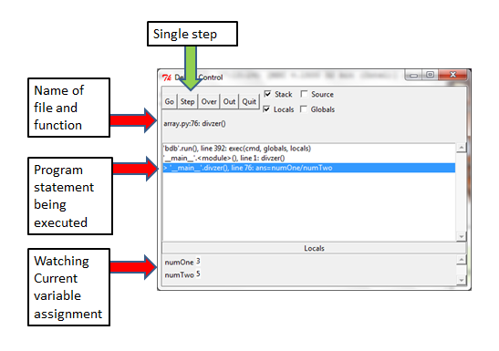

- Step through the program by clicking on ‘step’. The current command being executed and the current values of the variables will be displayed. Predict what you expect these to be.
Once the debugger has been switched on break points can be set by right clicking in the program and selecting

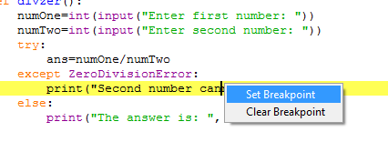

When you run the program it will stop at the break point and allow you to view the variable values at this point. You can set more than one break point in a program.
- Use the Python IDLE debugger to explore some of your existing programs.
- Use the Python IDLE debugger to help you debug errors in your programs.
Lesson 21 activities
Activity 21.1
Web browser module in Python 3
This module allows Python to open web pages from programs. More details can be found at http://docs.python.org/2/library/webbrowser.html.

webbrowser.open(URL) opens a web page given a URL as a string in your default web browser.
>>>webbrowser.open("http://www.bbc.co.uk")

- Copy and run this program:

def webpage():
importwebbrowser
web1 ="http://www.bbc.co.uk/"
web2="http://en.wikipedia.org/wiki/Main_Page"
web3= “http://www.nasa.gov/”
answer = input (input("""
1 To open BBC
2 To open Wikipedia
3 To open NASA
"""))
if answer ==1:
webbrowser.open(web1)
elif answer == 2:
webbrowser.open(web2)
else:
webbrowser.open(web3)

- Amend the program to open other web pages.
Activity 21.2
winsound module in Python 3
This module allows Python to play sounds on Windows computers. Try out the commands below to explore the winsound module.

winsound.Beep(frequency,duration) makes a sound at the frequency given for the amount of time given in duration. Frequency is in hertz from 32 to 32,767. Duration is in milliseconds.
>>>winsound.Beep(1000,500)

- Experiment with different values of frequency and duration.

- Copy and run this program. Explain what it does.
def sound():
importwinsound
frequency = 100
duration = 200
number = 40
fori in range (40):
winsound.Beep(frequency,200)
frequency = frequency + 50

- Experiment inputting different frequency and duration values.

winsound.PlaySound(filename, flags) plays the sound file specified by the filename. This can be used to play the Windows sound files (for Windows operating systems only), which have been set up by the operating system.
>>>importwinsound
>>>winsound.PlaySound("SystemExit", winsound.SND_ALIAS)

- This plays the “SystemExit” sound. Other sounds are available – experiment to find out what sounds these filenames give.

'SystemAsterisk'
'SystemExclamation'
'SystemExit'
'SystemHand'
'SystemQuestion'

- Write a program that plays a different note depending on a number in the range 1 to 10 which is entered by the user.
Activity 21.3
math module in Python 3
Try out the commands below to explore the math module. A full explanation is given here: http://docs.python.org/2/library/math.html

- Import the math module and list the directory of mathematical functions:
>>>import math
>>>dir(math)

['__doc__', '__name__', '__package__', 'acos', 'acosh', 'asin', 'asinh', 'atan', 'atan2', 'atanh', 'ceil', 'copysign', 'cos', 'cosh', 'degrees', 'e', 'erf', 'erfc', 'exp', 'expm1', 'fabs', 'factorial', 'floor', 'fmod', 'frexp', 'fsum', 'gamma', 'hypot', 'isfinite', 'isinf', 'isnan', 'ldexp', 'lgamma', 'log', 'log10', 'log1p', 'modf', 'pi', 'pow', 'radians', 'sin', 'sinh', 'sqrt', 'tan', 'tanh', 'trunc']

- Use mathematical constants such as pi.
>>>math.pi

3.141592653589793
A factorial is the sum of all the integers less than or equal to the number.

- Raise a number to a power. The first number is the number and the second is the power.
>>>ans=math.pow(2,3)
>>>ans
8.0

- Find the square root of a number.
>>>ans=math.sqrt(1024)
>>>ans
32.0

Challenges using the math module
- Find the area of circle with a radius of 19.7.
- Find the square root of 1048576.
- Find the value of 5 to the power 4.
- A right-angled triangle has sides of 5 and 6. Find the length of the other side.
- Find examples of other math functions that you may find useful.

Lesson 22 activities
Activity 22.1
Turtle graphics in Python (programming using x,y Cartesian coordinates)
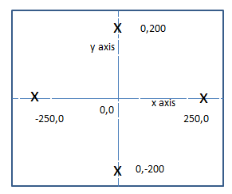
Cartesian co-ordinates is a way of specifying an exact point using two values (x,y).
Turtle graphics allows a robotic turtle to be programmed to move around in an x,y plane “playground” graphic canvas. The turtle starts at x,y co-ordinates (0,0) in the centre of the graphics canvas. The turtle holds a pen which can be placed up or down. When down the pen ‘draws’ on the canvas. By changing the direction and moving the turtle around, you can draw shapes and pictures.
Turtle graphics is an example of object oriented programming. Each turtle is an object which has properties such as turtle position (x,y) turtle heading (a bearing in degrees), turtle shape (turtle, arrow, circle, etc.), pen (up or down), pen colour (‘colour’), pen width. There can be more than one turtle on the canvas.

Exploring turtle graphics
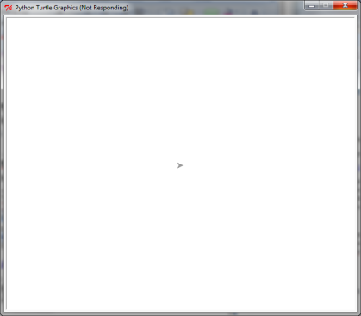
- Create a turtle object using the commands:
>>>import turtle
>>>t = turtle.Pen()

Where t is the name of the variable that refers to the turtle.
This should display the graphic canvas with the turtle at position (0,0). (The turtle is the arrow shape in the middle of the screen.)
To alter the turtle use:
Turtle_name=turtle.command() e.g. t=turtle.forward(50)

To view a property of the turtle use
Turtle_name.function() e.g. t.position()

- Explore these commands:

  - To change the shape to a turtle
>>>t= turtle.shape("turtle")

  - To change the colour of the turtle
>>>t=turtle.color("blue")

  - To move turtle
t=turtle.forward(50)

  - To turn turtle
>>>t=turtle.right(90)

  - To put the pen down
>>>t=turtle.pendown()

  - To change the pen colour
>>>t=turtle.pencolor("red")

  - To view the position of the turtle
>>>t.position()

  - To view the heading of the turtle
>>>t.heading()

Programming challenges using turtle graphics
- Write a program that draws a square.
- Write a program that draws four squares in different colours at different locations on the canvas
- Write a program that draws a circle.
- Write a program that draws a square with a circle inside.
- Write a program that draws a square where each side is a different colour.
- Write a program that ‘stamps’ a different colour of the turtle in each of the four corners of the canvas.
- Copy and run this function. Explain the purpose of the first three lines. What does the function do?
def t2():
import turtle
t=turtle.Pen()
t.reset()
t.goto(10,10)
t.pencolor("blue")
t.width(5)
t.circle(70)
t.goto(10,10)
t.pencolor("pink")
t.circle(50)

- Draw two more circles in different colours all starting at 10,10.

- Copy and run this function. What does it do? Try altering some of the values to see what kind of pattern it will draw.
def t1():
import turtle
t=turtle.Pen()
t.reset()
for x in range(1,20):
t.forward(100)
t.left(95)

For more details on turtle graphics see http://docs.python.org/2/library/turtle.html
Lesson 24 activities
Activity 24.1
Records and files
A file is made up of records (or lines) in order. Files are sequential which means you have to read each record (or line) in order to get to the next record. A file pointer is used to keep track of which record is currently being processed.
Record 0
File pointer
Record 1
Record 2
Record 3
Record 4

A file has a file name (for example myFile.txt) and a file access mode. The file access mode indicates how you want to access the file.
File access modes | Explanation
r | Opens a file for reading. File pointer is set to 0.
w | Opens a file for writing. The file is overwritten if it exists so TAKE CARE!  If the file does not exist a new file is created.
a | Opens a file for writing by appending to the end. File pointer is set to the end of the file. If the file does not exist a new file is created.

When using files in Python you have to open the file and close the file. The close command makes sure all information is written to the file. If strange things are happening check you have closed the file.
Directory structures and files
The default file location is the Python installation directory (often c:Python32). This is where Python will expect to find files and will store files. If you want to use other directories use the path name for that directory.

- Writing a record to a file
  - Copy and run the program below which writes records to a file which is called “NewFile.txt”.
defwriteToFile():
myFile = open("NewFile.txt","w")
for each in range(1,8):
record = "This is record number {0} in the file \n".format(each)
print(record)
myFile.write(record)
myFile.close()

  - Open the file (in Notepad) and make sure it has written to the file. The newline escape code “\n” is put at the end of the line so that each line is stored as a separate record.
  - Amend the program to write your name at the end of each record.
Hint: You can only write strings to a file.

- Reading a record from a file
- Copy and run the program to read the records from the file you created above.
defreadFromFile():
myFile = open("NewFile.txt","r")
for each in range(1,8):
record = myFile.readline()
print("this is record {0} {1}".format(each, record))
myFile.close()

- Amend the program to write four lines of your favourite song lyrics to a file and read them back.
Lesson 27 activities
Activity 27.1
Use Python to experiment with how the computer handles strings, floats and bools. What is the outcome of running each of these code snippets? Why does this happen?
#Snippet 1
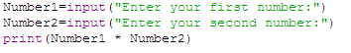
Outcome:
Why did this happen?
#Snippet 2
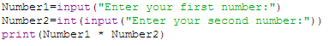
Outcome:
Why did this happen?

#Snippet 3
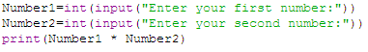
Outcome:
Why did this happen?
#Snippet 4
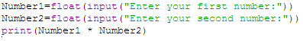
Outcome:
Why did this happen?

#Snippet 5
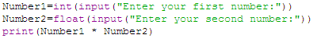
Outcome:
Why did this happen?
#Snippet 6
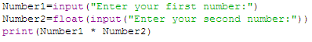
Outcome:
Why did this happen?

Activity 27.2
What are these binary numbers in denary?
Binary | Denary
0001
0010
0101
1000
1001
1100
1011
1111

What are these denary numbers in binary?
Denary | Binary
4
6
10
0
3
7
14
13

What range of numbers can be represented by 8 bits?

Underline the most significant bit in this binary number. | 1011 0011
What weighting does it have?
What is its value in denary?

Activity 27.3
Answer these questions in binary.
How many days in a week?
How many months in a year?
How many fingers (including the thumb) on one hand?
How many toes on two feet?
How many lives does a cat have?

Lesson 28 activities
Activity 28.1
Answer these questions.
How many states does a transistor have?
How many bits in a nibble?
What range of unsigned integer numbers can be represented by 8 bits?
What is the position of the most significant bit in a byte?
How many different values can be represented with 6 bits?
Activity 28.2
What comes next?
1111
0011 1111

What comes before?
1000
1111

Activity 28.3
Working in pairs, design and write a simple binary to denary conversion program that inputs a 4-bit binary number and converts it to an unsigned integer.

Extension (homework)

Produce a program that can convert a binary number of any length into denary.

Hint: you will need to use the exponential operator.

Activity 28.4
Add up these binary numbers.
Check your answers by converting them to denary.
0111 7 |  | 0101 |  | 1111 15
0100 + |  | 0110 + |  | 0111 +

0011 |  | 1011 |  | 0111
0011 + |  | 1111 + |  | 0010 +

1110 |  | 01111 |  | 01110
0111 + |  | 10101 + |  | 10111 +

10101010 |  | 10101100
00110010 + |  | 00010010 +

Activity 28.5
Subtract these binary numbers.
Check your answers by converting them to denary.
11 |  | 1111 |  | 100
10 - |  | 0110 - |  | 010 -

100 |  | 1000 |  | 0111
011 - |  | 0101 - |  | 0010 -

1110 |  | 10010 |  | 01110
0111 - |  | 01010 - |  | 00011 -

10101010 |  | 10101100
00110010 - |  | 00010010 -

Lesson 29 activities
Activity 29.1
Convert these sign and magnitude numbers into denary. The first one is done for you.
Sign and magnitude binary number | Denary
1100 1101 | -(64+8+4+1) = -77
0001 1111
1000 1010
0101 1100
1000 0000
1111 1111
0111 1111
Activity 29.2
Convert these two’s complement numbers into denary. The first one is done for you.
Two’s complement binary number | Denary
1100 1101 | -128+64+8+4+1 = 51
0001 1111
1000 1010
0101 1100
1000 0000
1111 1111
0111 1111
Hint: The most significant bit is -128.
Activity 29.3
Convert these floating point binary numbers into fractions. The first one has been done for you.
Mantissa | Exponent | Decimal
0.100 1101 | 0000 0100 | Exponent is 4 so decimal point moves 4 places to the right:  01001.101 = 8 + 1 + ½ + ⅛ = 9⅝
0.001 1111 | 0000 0011
1.000 1010 | 0000 0101
0.101 1100 | 0000 0011
1.000 0000 | 0000 0010
1.111 1110 | 0000 0011

Lesson 30 activities
ASCII binary code
Symbol | Binary | Symbol | Binary | Symbol | Binary | Symbol | Binary | Symbol | Binary
A | 0100 0001 | a | 0110 0001 | ! | 0010 0001 | @ | 0100 0000 | Space | 0010 0000
B | 0100 0010 | b | 0110 0010 | " | 0010 0010 | [ | 0101 1011
C | 0100 0011 | c | 0110 0011 | # | 0010 0011 | \ | 0101 1100
D | 0100 0100 | d | 0110 0100 | $ | 0010 0100 | ] | 0101 1101
E | 0100 0101 | e | 0110 0101 | % | 0010 0101 | ^ | 0101 1110
F | 0100 0110 | f | 0110 0110 | & | 0010 0110 | _ | 0101 1111
G | 0100 0111 | g | 0110 0111 | ' | 0010 0111 | ` | 0110 0000
H | 0100 1000 | h | 0110 1000 | ( | 0010 1000 | { | 0111 1011
I | 0100 1001 | i | 0110 1001 | ) | 0010 1001 | ¦ | 0111 1100
J | 0100 1010 | j | 0110 1010 | * | 0010 1010 | } | 0111 1101
K | 0100 1011 | k | 0110 1011 | + | 0010 1011 | ~ | 0111 1110
L | 0100 1100 | l | 0110 1100 | , | 0010 1100 | 0 | 0011 0000
M | 0100 1101 | m | 0110 1101 | - | 0010 1101 | 1 | 0011 0001
N | 0100 1110 | n | 0110 1110 | . | 0010 1110 | 2 | 0011 0010
O | 0100 1111 | o | 0110 1111 | / | 0010 1111 | 3 | 0011 0011
P | 0101 0000 | p | 0111 0000 | : | 0011 1010 | 4 | 0011 0100
Q | 0101 0001 | q | 0111 0001 | ; | 0011 1011 | 5 | 0011 0101
R | 0101 0010 | r | 0111 0010 | < | 0011 1100 | 6 | 0011 0110
S | 0101 0011 | s | 0111 0011 | = | 0011 1101 | 7 | 0011 0111
T | 0101 0100 | t | 0111 0100 | > | 0011 1110 | 8 | 0011 1000
U | 0101 0101 | u | 0111 0101 | ? | 0011 1111 | 9 | 0011 1001
V | 0101 0110 | v | 0111 0110
W | 0101 0111 | w | 0111 0111
X | 0101 1000 | x | 0111 1000
Y | 01011001 | y | 0111 1001
Z | 01011010 | z | 0111 1010
Activity 30.1
Use the table of ASCII binary codes to decode this:
ASCII binary code | Character
0110 1000
0110 0101
0110 1100
0110 1100
0110 1111

Use the table of ASCII binary codes to translate this:
Character | ASCII binary code
S
a
n
T
a
C
l
a
u
s
Hint: Don’t forget the space.

The ASCII code for a blank space is:
It is important to have a code for a blank space because…

Write your name in ASCII.
Activity 30.2
Use this text-to-ASCII converter to write a Christmas greeting to your friends.
http://www.binaryhexconverter.com/ascii-text-to-binary-converter
Activity 30.3
Use this ASCII-to-text converter to find out what this message says.
http://www.binaryhexconverter.com/binary-to-ascii-text-converter

01001000 01101111 01110000 01100101 00100000 01110100 01101111 00100000 01101101 01100101 01100101 01110100 00100000 01110101 01110000 00100000 01101100 01100001 01110100 01100101 01110010

Activity 30.4
Run these lines of code in Python.:
Explain why Python sorts the list in the way it does.
Activity 30.5
Design and write a simple text-to-ASCII conversion program that prompts the user to enter some text, converts each character into ASCII binary code and displays the code on the screen.

Hint: Use the string method .encode(ASCII) when you input the text.

Hint: Format each binart code to 8 bits by using format ‘08b’.

Extension: Produce a program that converts an ASCII binary code into a character.

Hint: Tackle this problem in two steps –
- convert the binary code into a set of integers using a version of the binary to denary conversion program you wrote in Activity 28.3 (or the homework extension)
- then use the built-in function chr() to convert each integer into a character.
Lesson 31 activities
Activity 31.1
Open a bitmap image (such as a photograph) in a graphics software package. Resize the image so that the dimensions are doubled then save it again. Compare the file sizes of the two versions.
Version 1:
Version 2:

Compare the clarity of the two images. Which is clearer?

Why do you think this is the case?

How big can you make the image before it gets blurry?

What happens if you make the original image smaller?

Reload the original image and change its colour depth. Summarise what happens as the colour depth decreases.

Activity 31.2
Complete this table.
Colour depth | Number of colours | Range
1 bit | 2 | 0 – 1
2 bits
3 bits
4 bits
8 bits
16 bits
24 bits
32 bits

0 = black and 1 = white
Fill in the grid to reveal what character this code produces.
Binary code
0000
0111
0111
0001
0111
0111
0000

0 = black and 1 = white
Produce the binary code to produce the letter G in the grid below.
Binary code

Using a colour depth of 2 bits, produce the binary code for a Christmas sprite.
Binary code:
Colour:
Activity 31.3
Use the Bitmap Activity spreadsheet and worksheet to create bitmap images.

Activity 31.4
Calculate the file size of an image with dimensions of 3 inches x 4 inches, a pixel density of 300 pixels per inch and a colour depth of 8 bits.
Give your answer in bytes.
Hint: The formula for calculating the file size of a bitmap image is (height x pixel density) x (depth x pixel density) x colour depth and there are 8 bits in a byte.

Calculate the file size of an image with dimensions of 5 inches x 7 inches, a pixel density of 400 pixels per inch and a colour depth of 3 bits.
Give your answer in bytes.

Activity 31.5
Units of measurement
Use a calculator to calculate the number of bytes
Number of bytes
1 kilobyte (KB) = 1024 bytes
1 megabyte (MB) = 1024 kilobytes
1 gigabyte (GB) = 1024 megabytes
1 terabyte(TB) = 1024 gigabytes

Answer these questions (giving all answers to 2 decimal places):
Question | Answer
What are 92,400 MB in GB?
Ann has a 750 MB file and Nicky has a 550 MB file. Will both files fit on Ann’s 2 GB pen drive?
Jo has 250 500 KB images. How much space does she need on her hard drive to store them? Give your answer in megabytes.
Nicky has 30 hours of MP3 recordings stored in the cloud. How many gigabytes of storage would she need to download them onto her phone?
Hint: MP3 audio generates approximately 1 MB of data per minute.
Ann’s video camera produces video data at the rate of 2.5 GB per hour. How big will a 20 minute recording be? Give your answer in megabytes.

Answer these questions:
Question | Answer
How much storage space is required for 50 images, each with dimensions of 3 inches x 4 inches, a bit-map density of 300 pixels per inch and a colour depth of 8 bits.
Give your answer in megabytes to 1 decimal place.
Lesson 32 activities
Activity 32.1
Draw an analogue sound wave and label:
- amplitude
- time
- analogue signal
- sampling period
Describe the process of converting analogue sound waves into digital data.

Activity 32.2
Representation of sound and other analogue data
Answer these questions:
Question | Answer
What is the difference between analogue and digital data?
What is meant by the term ‘sampling rate’?
What did Nyquist have to say about sampling rate?
What is the sampling rate for CD audio?
Give your answer in kHz.
In the context of digital sound, what is meant by the term ‘bit depth’?
How many bits per sample are used for CD audio?
What about DVD audio?
Is a high frequency sound high or low pitched?
What is the highest frequency the human ear can detect?
Why do most sound recordings have two channels?
Calculate the file size of a CD quality, stereo sound track that is 2.5 minutes long.
Give your answer in megabytes to 1 decimal place.

Calculate the bit depth of a 10.3 MB, 3 minute, stereo sound track, with a sampling rate of 30kHz.
An analogue-to-digital converter samples the temperature of a furnace every two hours. Each sample is stored as a 32-bit number. How may bytes of data are stored in a week?

