**Use case Diagram**

**Admin side**

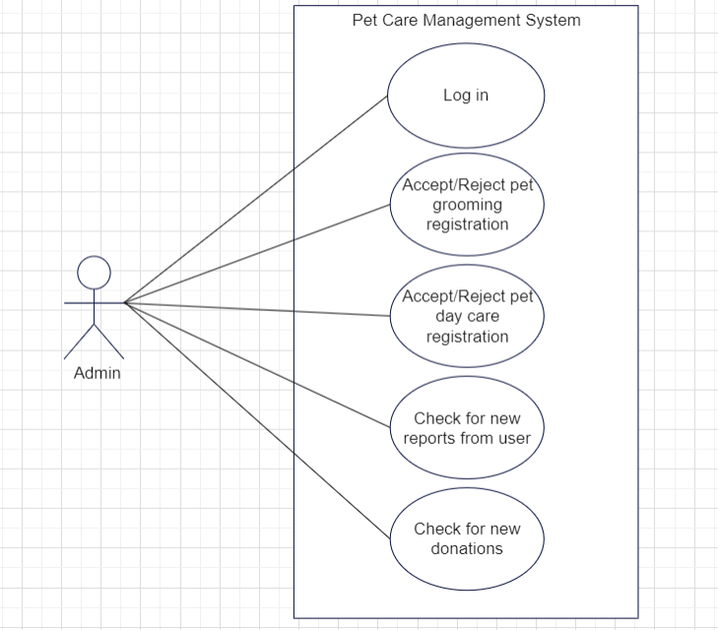

**User side**

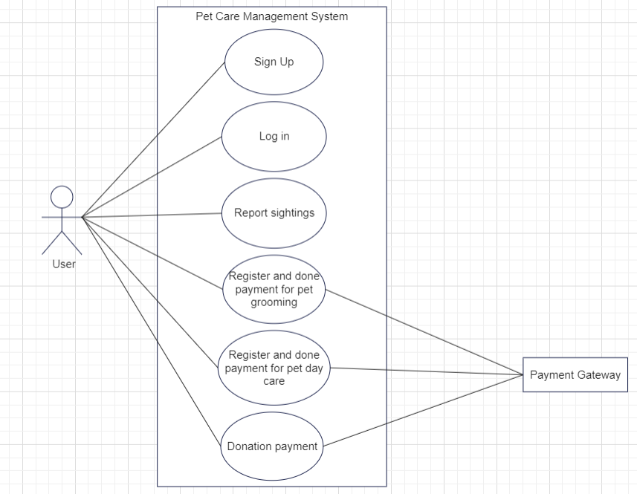

**4.7 TABLE DESIGN**

1. Table Name: login

|  |  |  |  |  |
| --- | --- | --- | --- | --- |
| **Sl.no** | **Field Name** | **Data Type** | **Constraint** | **Discription** |
| 1 | id | int | Auto_increment,  Primary Key | Admin / User id |
| 2 | f_name | varchar(50) | Not null | First name of the admin/user |
| 3 | l_name | varchar(50) | Not null | Last name of the admin/user |
| 4 | email | varchar(150) | Not null | Email id of the admin/user |
| 5 | password | varchar(50) | Not null,  unique | Password of the admin/user |
| 6 | role | int | Default | Role of the person |

2. Table Name: paid_services

|  |  |  |  |  |
| --- | --- | --- | --- | --- |
| **Sl.no** | **Field Name** | **Data Type** | **Constraint** | **Discription** |
| 1 | s_id | int | Auto_increment,  Primary Key | Service id |
| 2 | s_name | varchar(100) | Not null | Name of the service |
| 3 | amount | int | Not null | Per day amount of service |

3. Table Name: breed

|  |  |  |  |  |
| --- | --- | --- | --- | --- |
| **Sl.no** | **Field Name** | **Data Type** | **Constraint** | **Discription** |
| 1 | br_id | int | Auto_increment,  Primary Key | breed id |
| 2 | br_name | varchar(100) | Not null | Name of the breed |

4. Table Name: reports

|  |  |  |  |  |
| --- | --- | --- | --- | --- |
| **Sl.no** | **Field Name** | **Data Type** | **Constraint** | **Discription** |
| 1 | r_id | int | Primary Key,Auto increment | report id |
| 2 | u_id | int | Foreign Key  Not null | id of the user |
| 3 | r_date | date | Not null | Reporting date |
| 4 | place | varchar(150) | Not null | Place where the dog is present |
| 5 | landmark | varchar(150) | Not null | Landmark of the place |
| 6 | reason | varchar(500) | Not null | Reason for reporting |
| 7 | color | varchar(50) | Not null | Color of the dog |
| 8 | r_status | varchar(150) | Not null,  Default | Report status |
| 9 | r_discription | varchar(300) | Not null,  Default | Description of report status |
| 10 | dog_status | varchar(500) | Not null,  Default | Description of dog current status |

5. Table Name: donation

|  |  |  |  |  |
| --- | --- | --- | --- | --- |
| **Sl.no** | **Field Name** | **Data Type** | **Constraint** | **Discription** |
| 1 | don_id | int | Auto_increment,  Primary Key | donation id |
| 2 | u_id | int | Foreign Key  Not null | id of the user |
| 3 | amount | int | Not null | Donating amount |
| 4 | don_date | date | Not null | Donating date |

6. Table Name: grooming

|  |  |  |  |  |
| --- | --- | --- | --- | --- |
| **Sl.no** | **Field Name** | **Data Type** | **Constraint** | **Discription** |
| 1 | g_id | int | Auto_increment,  Primary Key | grooming id |
| 2 | u_id | int | Foreign Key  Not null | Id of the user |
| 3 | breed_id | int | Foreign Key,  Not null | id of the breed |
| 4 | g_date | date | Not null | Requested grooming date |
| 5 | g_status | varchar(50) | Not null,  Default | Request status |
| 6 | g_discription | varchar(50) | Not null,  Default | Request status discription |

7. Table Name: daycare

|  |  |  |  |  |
| --- | --- | --- | --- | --- |
| **Sl.no** | **Field Name** | **Data Type** | **Constraint** | **Discription** |
| 1 | d_id | int | Auto_increment,  Primary Key | Day care id |
| 2 | u_id | int | Foreign Key  Not null | id of the user |
| 3 | breed_id | int | Foreign Key,  Not null | id of the breed |
| 4 | d_starting_date | date | Not null | Requested date to start day care service |
| 5 | d_ending_date | date | Not null | Requested date to end day care service |
| 6 | d_status | varchar(150) | Not null,  Default | Request status |
| 7 | d_discription | varchar(250) | Not null,  Default | Request status discription |
| 8 | pet_status | varchar(500) | Not null,  Default | Updates of the pet |

8. Table Name: payments

|  |  |  |  |  |
| --- | --- | --- | --- | --- |
| **Sl.no** | **Field Name** | **Data Type** | **Constraint** | **Discription** |
| 1 | payment_id | int | Auto_increment,  Primary Key | Payment id |
| 2 | u_id | int | Foreign Key | user id |
| 3 | service_id | int | Foreign Key | Service id |
| 4 | donation_id | int | Foreign Key, Default | Donation id of the user |
| 5 | grooming_id | int | Foreign Key, Default | grooming id of the user |
| 6 | day_care_id | int | Foreign Key, Default | Donation id of the user |
| 7 | payment_date | date | Not null | Payment date |

9. Table Name: bank

|  |  |  |  |  |
| --- | --- | --- | --- | --- |
| **Sl.no** | **Field Name** | **Data Type** | **Constraint** | **Discription** |
| 1 | b_id | int | Auto_increment,  Primary Key | Bank id |
| 2 | acc_num | int | Not null | Account number of the user |
| 3 | ifsc | varchar(150) | Not null | IFSC code of the bank |
| 4 | branch | varchar(100) | Not null | Branch name of the bank |
| 5 | balance | int | Not null | Account balance of the user |
| 6 | c_num | int | Not null | Card number of the user |
| 7 | Pin | int | Not null | Pin code of the card |
| 8 | cvv | int | Not null | cvv number of the user |
| 9 | exp_date | date | Not null | Expiry date of the card |