**How to Use Motion Detection Engine**

**Brief Description**

This applications includes two parts

* Front-end (React.js)
* Back-end (Python Flask)

Backend reads video streams from IP cameras and processes each frames to detect motion, and in case of any motion detected, records videos for all the cameras connected.

Two cameras will act as triggers for motion detection.

Frontend plays the recorded videos and provides functions to add annotations for captured frames from the videos.

**How to Install (On Windows)**

1. Install Python 3.7.2 from <https://www.python.org/downloads/release/python-372/>

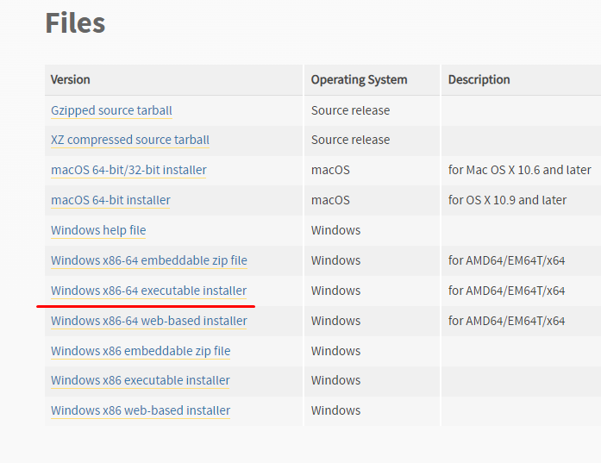

1. Install package manager – pip using command prompt.

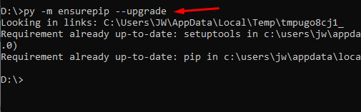

1. Install the following packages

* opencv-python==4.5.4.60

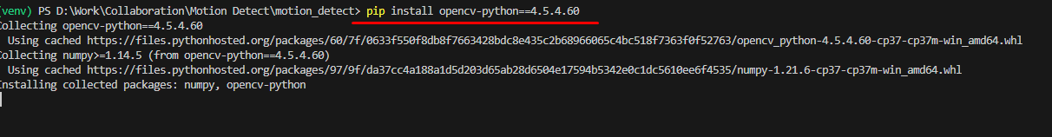

* flask==2.2.3
* flask_cors==3.0.10

1. Start the server with following command

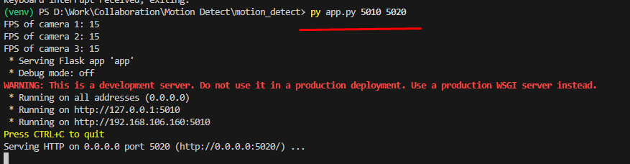

It accepts two arguments, first argument (e.g. 5010 in this case) is the port number where the client(web application) communicate with the server to get information of current state.

Second argument (e.g. 5020 in our case) is the port number where the client gets recorded videos from.

These port numbers should be matched with the web application settings.

1. Download & Install node-v18.13.0-x64 from <https://nodejs.org/dist/v18.13.0/node-v18.13.0-x64.msi>
2. Install yarn using this cli.

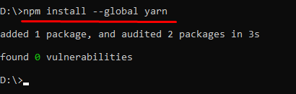

1. Go into the frontend source directory and run as following in the cli.

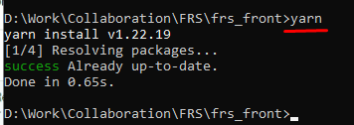

1. In the command prompt, run the following.

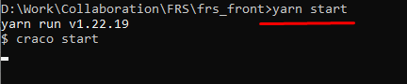

This will run the application on port 3000 as default, and if that port is being used by another application, will proceed with another port as the user agrees.

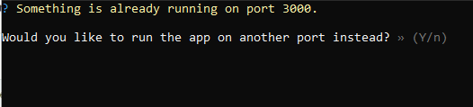

1. Open the browser, and type <http://localhost:3000/> in the address bar.

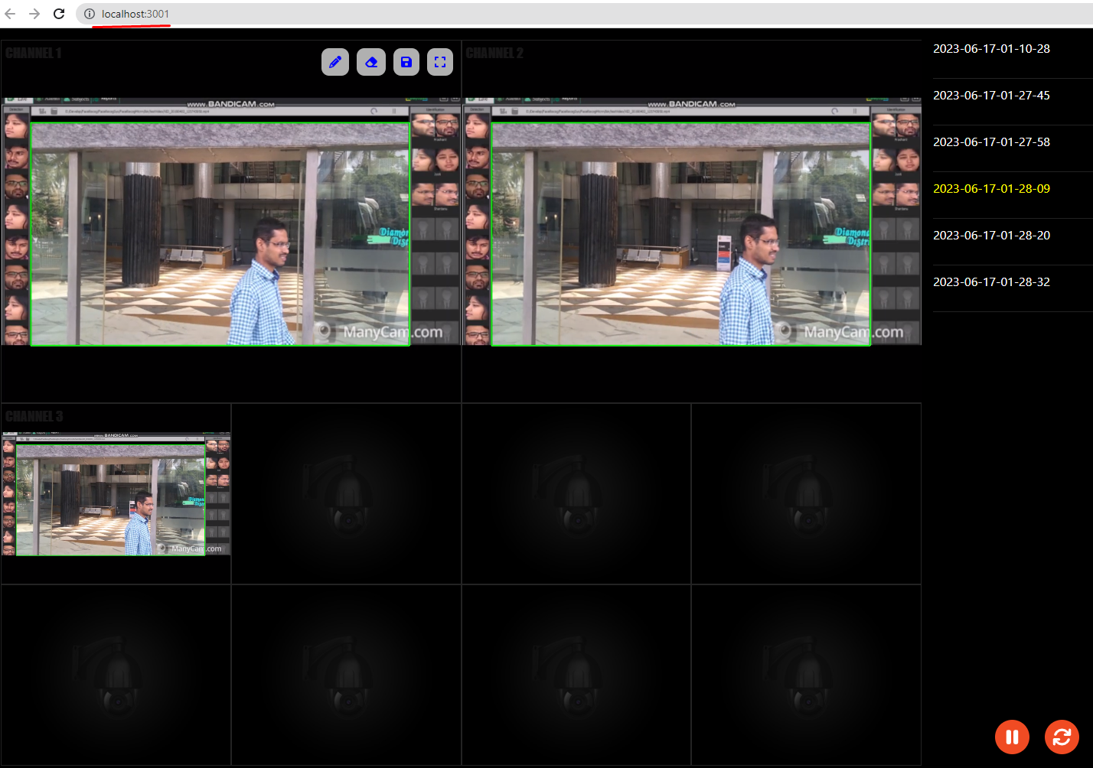

1. That’s it.

Tips:

Configurations can be found on

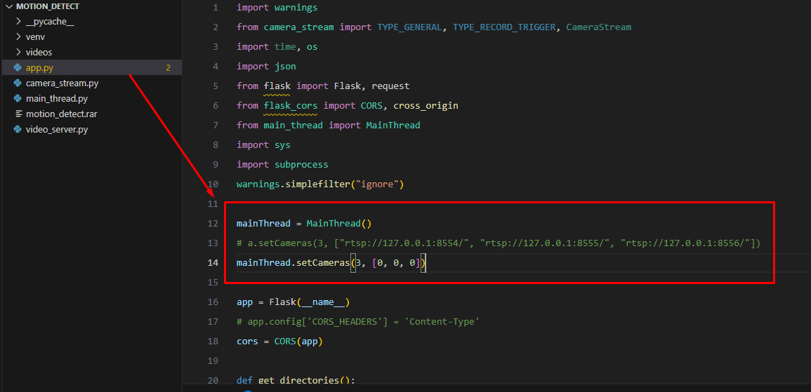

Fig. Setting number of cameras and their RTSP urls.

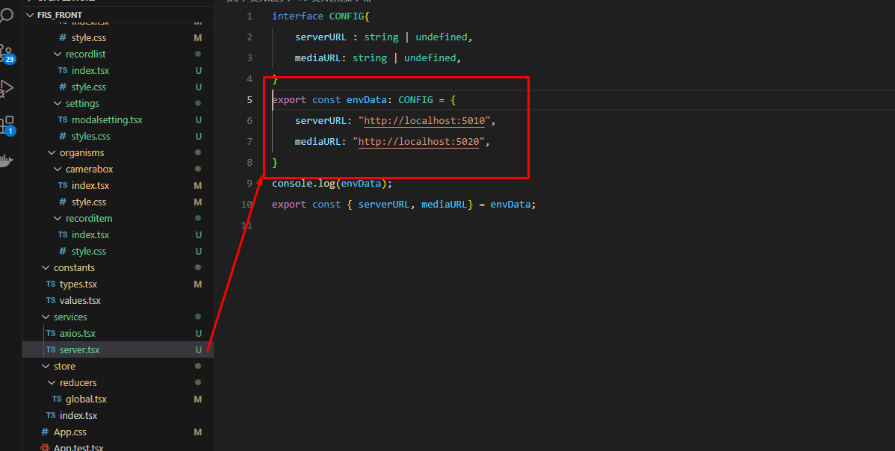

Fig. Setting server url in the frontend.

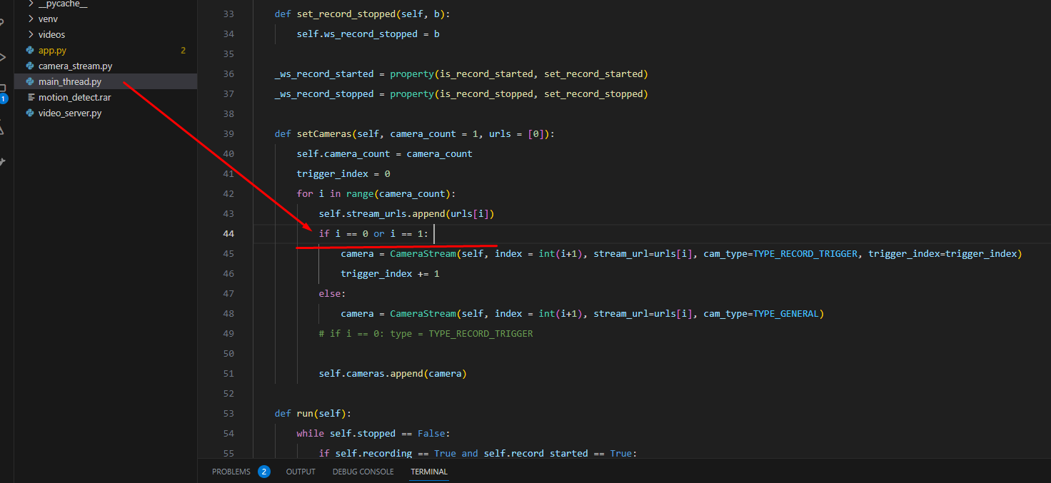

Fig. Setting Trigger Camera indices in the backend.

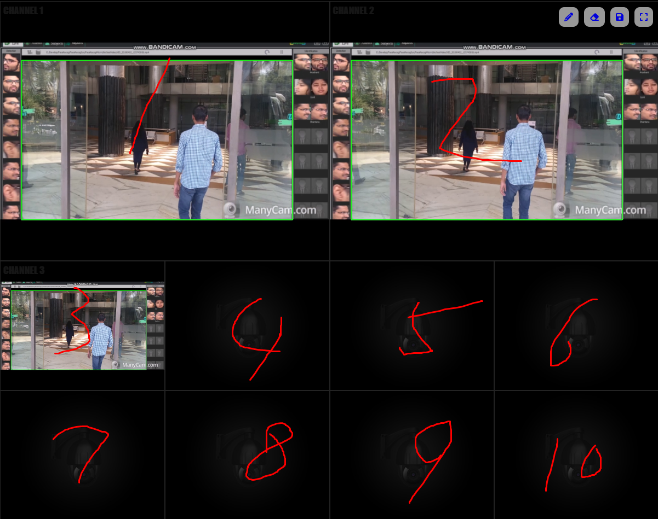

Fig. Indices of camera (Will start from 0 in the code)

These indices are used for linking each screen to the cameras and setting the cameras which act as triggers.