Figure 3.1: Gantt Chart – Phase 1: Planning, Requirements, System Design & Interim Documentation
Project Work Breakdown Structure & Schedule: 23 June 2026 – 25 September 2026 (Tasks 01 to 12)
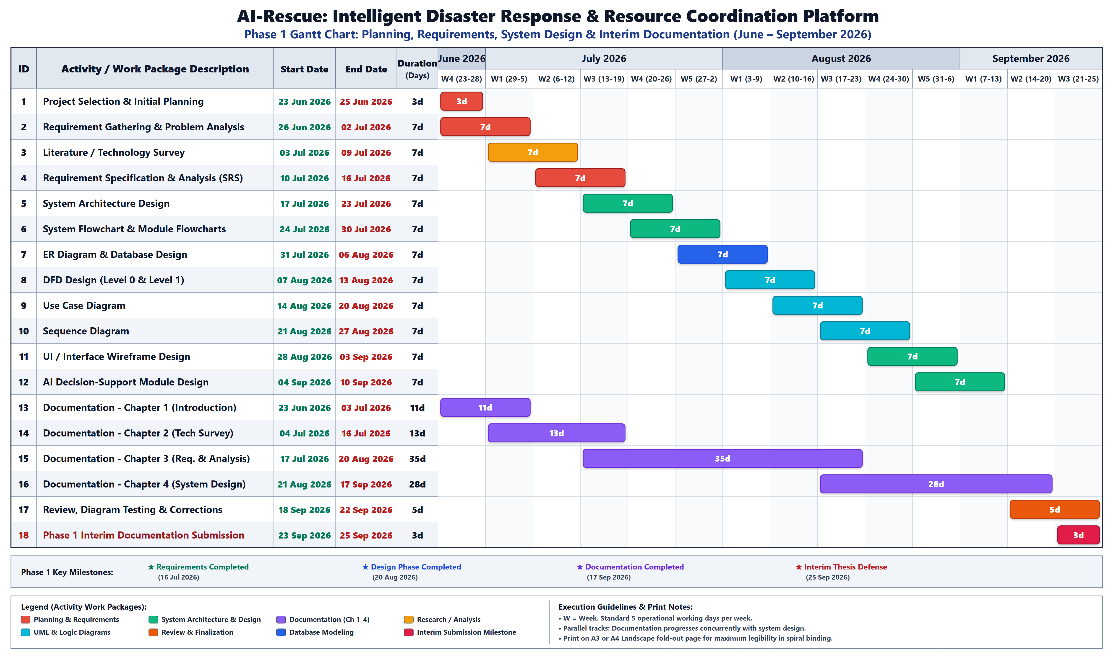
Description: Chronological timeline of Phase 1 work packages comprising project charter, requirements gathering, SRS specification, high-level architecture, master ER modeling, DFD Level 0/1 modeling, UML use case analysis, system flowcharts, wireframe design, and interim documentation leading to the 25 September 2026 interim milestone.

Figure 3.2: Gantt Chart – Phase 2: Core Full-Stack Development, AI Engine, Testing, Cloud & Final Defense
Project Work Breakdown Structure & Schedule: 26 September 2026 – 28 February 2027 (Tasks 13 to 22)
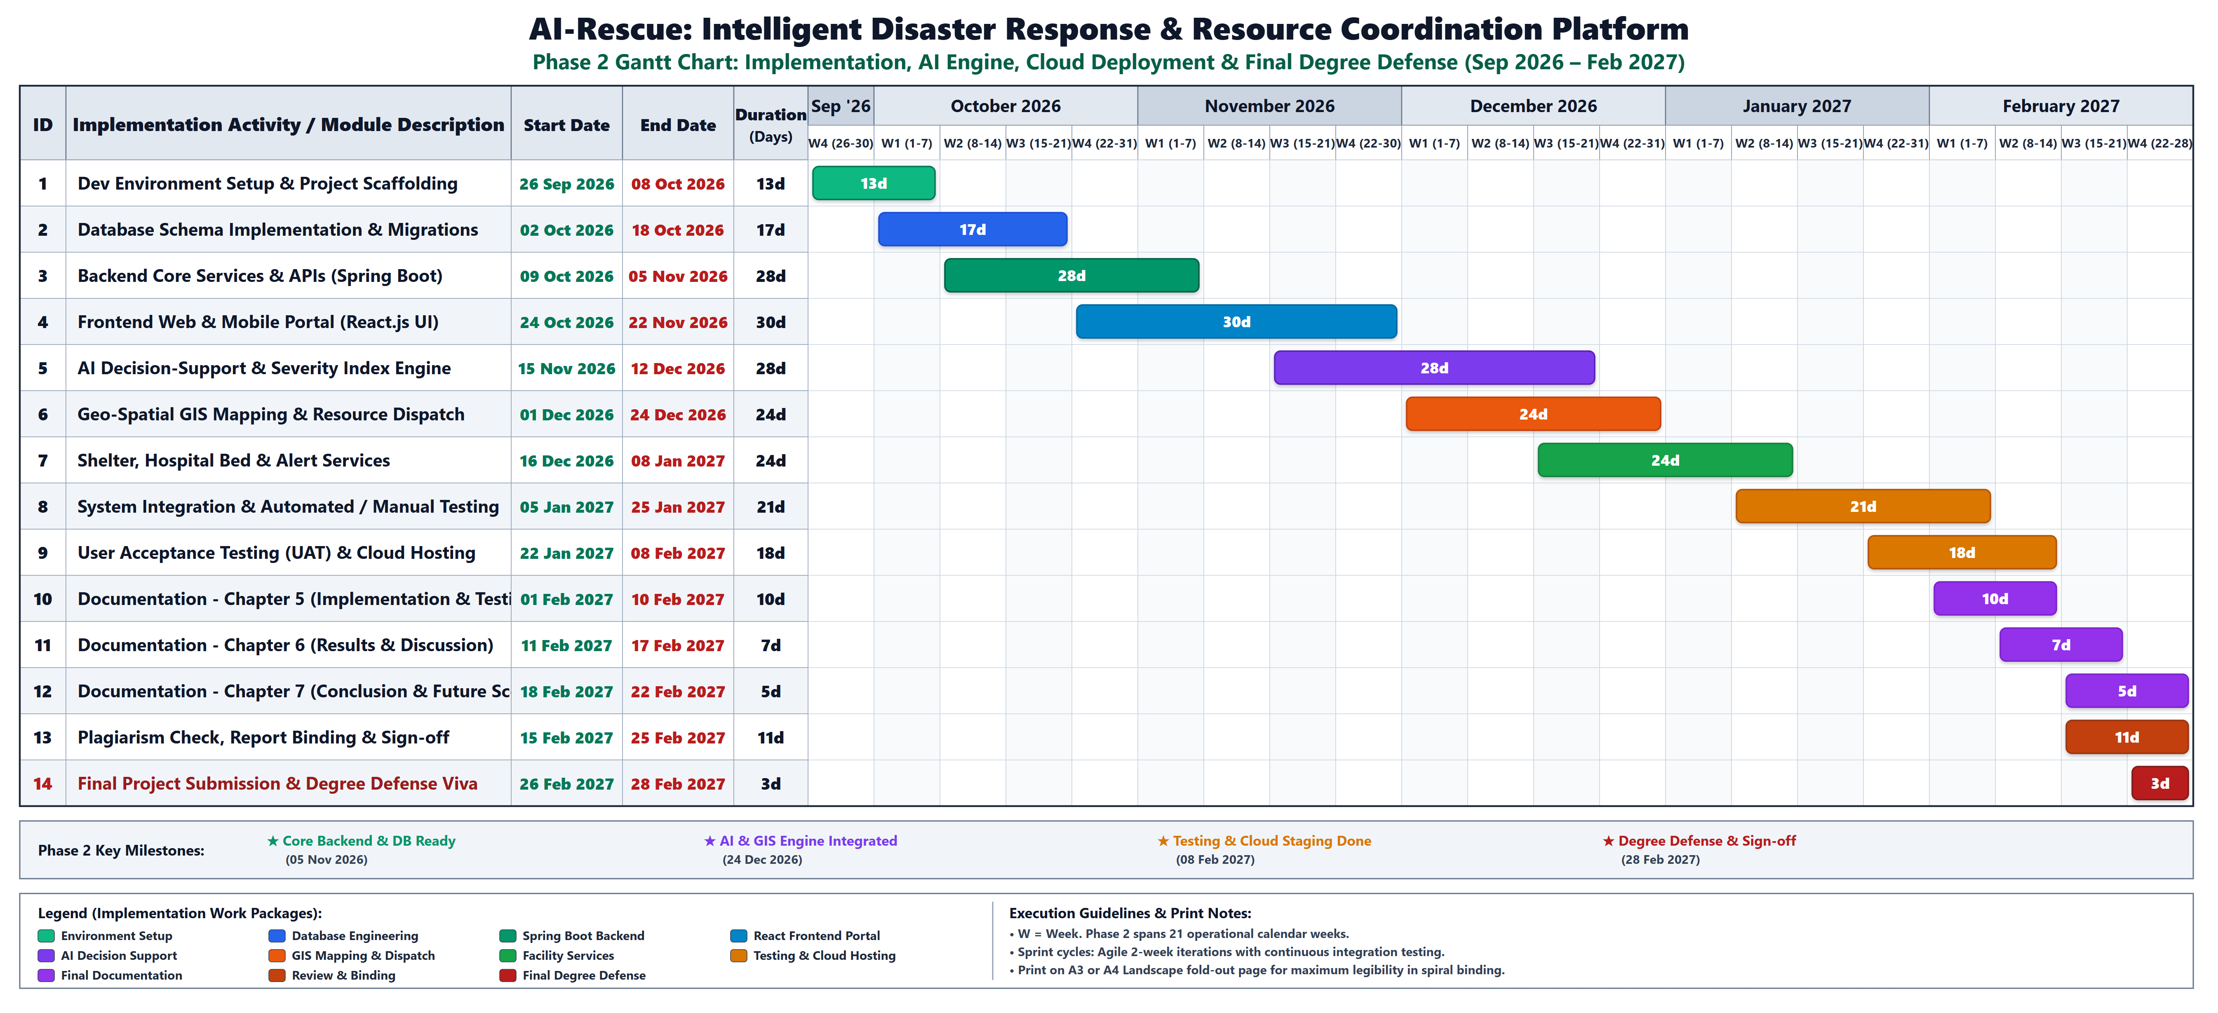
Description: Execution schedule for Phase 2 implementation covering development environment scaffolding, PostgreSQL schema migrations, Spring Boot REST APIs, React web dashboard, multi-modal AI decision-support algorithms, GIS routing, capacity tracking, end-to-end integration testing, cloud deployment, and final degree defense.

Figure 3.5: UML Use Case Diagram – AI-Rescue Platform Architecture
Functional Interaction Model Across Platform Actors (Citizen, Response Officer, System Administrator, Field Responder)
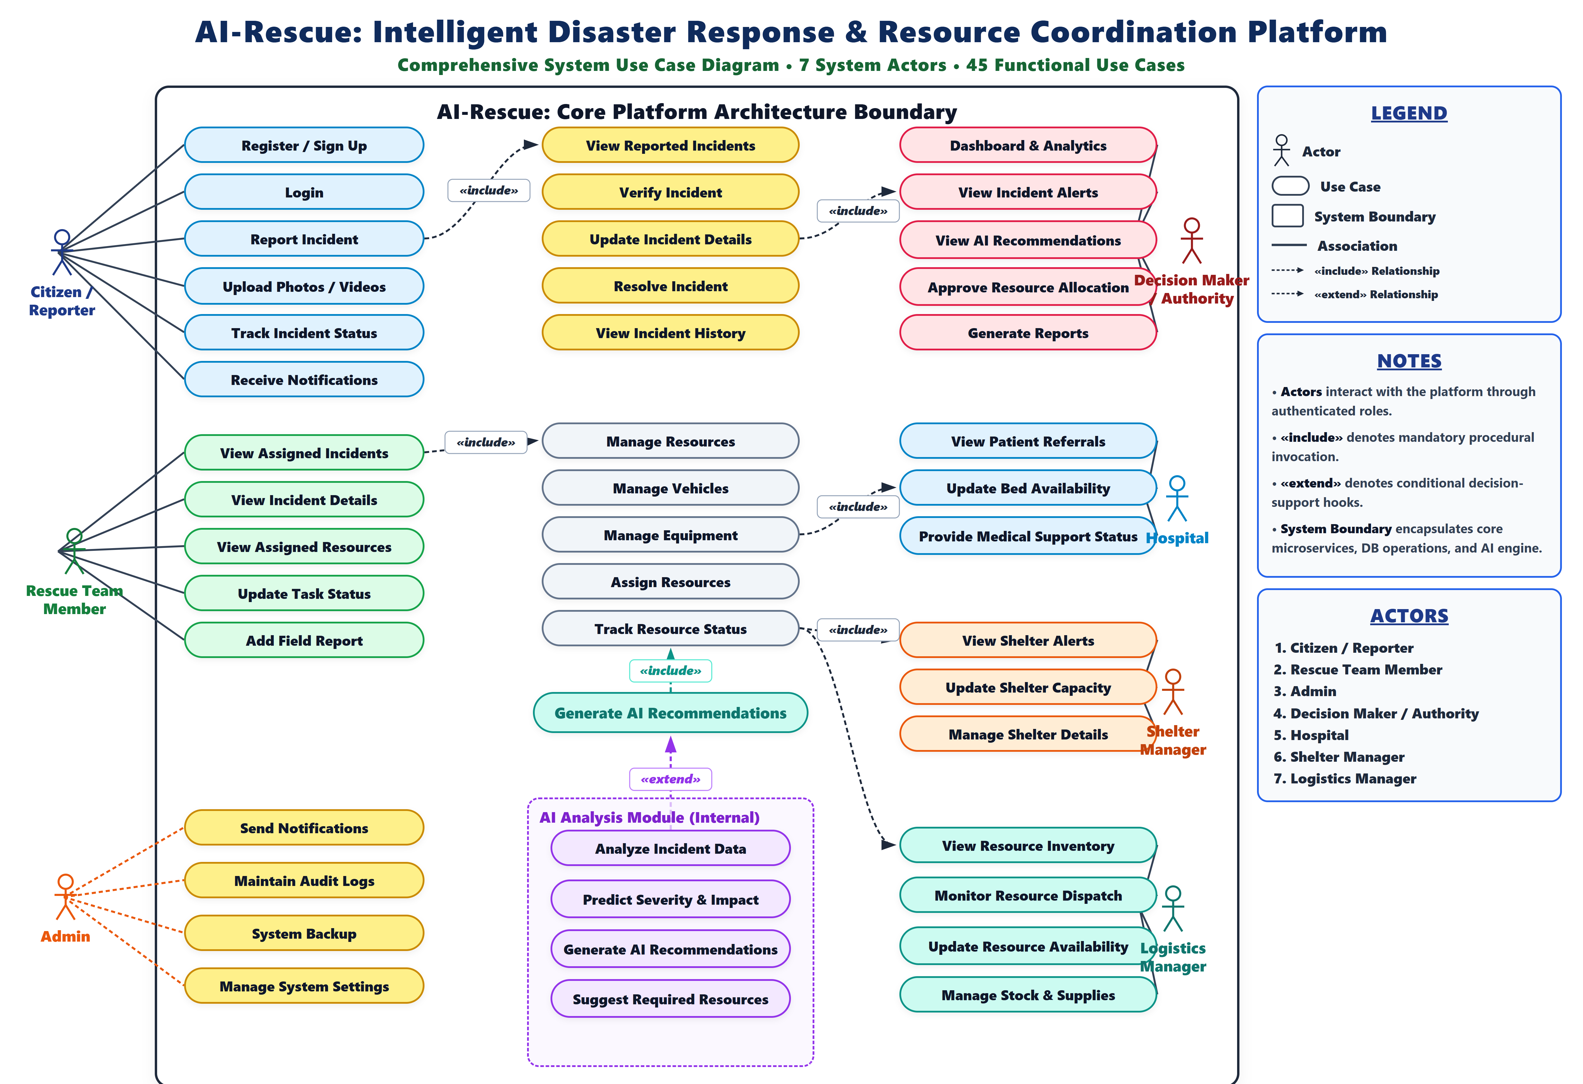
Description: Master UML Use Case Diagram depicting the complete boundary of the AI-Rescue platform across 21 discrete functional use cases and 4 specialized actors. Illustrates explicit <<include>> and <<extend>> dependencies governing incident reporting, officer verification, multi-modal AI recommendations, resource assignment, and GIS dispatch.

Figure 4.1: Entity Relationship Diagram of AI-Rescue (Master Conceptual & Logical Data Model)
Complete 16-Entity Relational Data Model with Primary/Foreign Keys and 1:N Cardinality Relationships
Description: Comprehensive Entity Relationship Diagram illustrating the 16 core entities of the production schema. Highlights foundational foreign key relationships across users, incidents, multimedia evidence, AI recommendations, physical resources, vehicles, specialized equipment, hospitals, and evacuation shelters with zero attribute truncation.

Figure 4.2: Database Design of AI-Rescue (Physical Relational Database Schema Design)
Physical MySQL / PostgreSQL Schema Architecture with Exact Field Data Types and Key Constraints
Description: Physical database schema design modeled after MySQL Workbench, representing all 16 production tables with exact PostgreSQL data types, primary keys, foreign key constraints, and default timestamp handlers. Fully details resource allocation, facility capacity indexes, and automated audit logging tables.

Figure 4.3: Overall System Flowchart – AI-Rescue Operations Workflow
Continuous Master Engineering Workflow Across All 41 Operational Nodes and 46 Transition Logic Paths
Description: Continuous end-to-end engineering flowchart mapping the entire lifecycle of emergency disaster response. Seamlessly traces user authentication, citizen disaster reporting, officer triage, AI multi-modal severity assessment, resource allocation with shortage resolution, field dispatch, status updates, and formal incident closure.

Figure 4.9: Sequence Diagram – Incident Reporting to Response Completion
Chronological Interaction Lifelines Across Actors and Platform Microservices
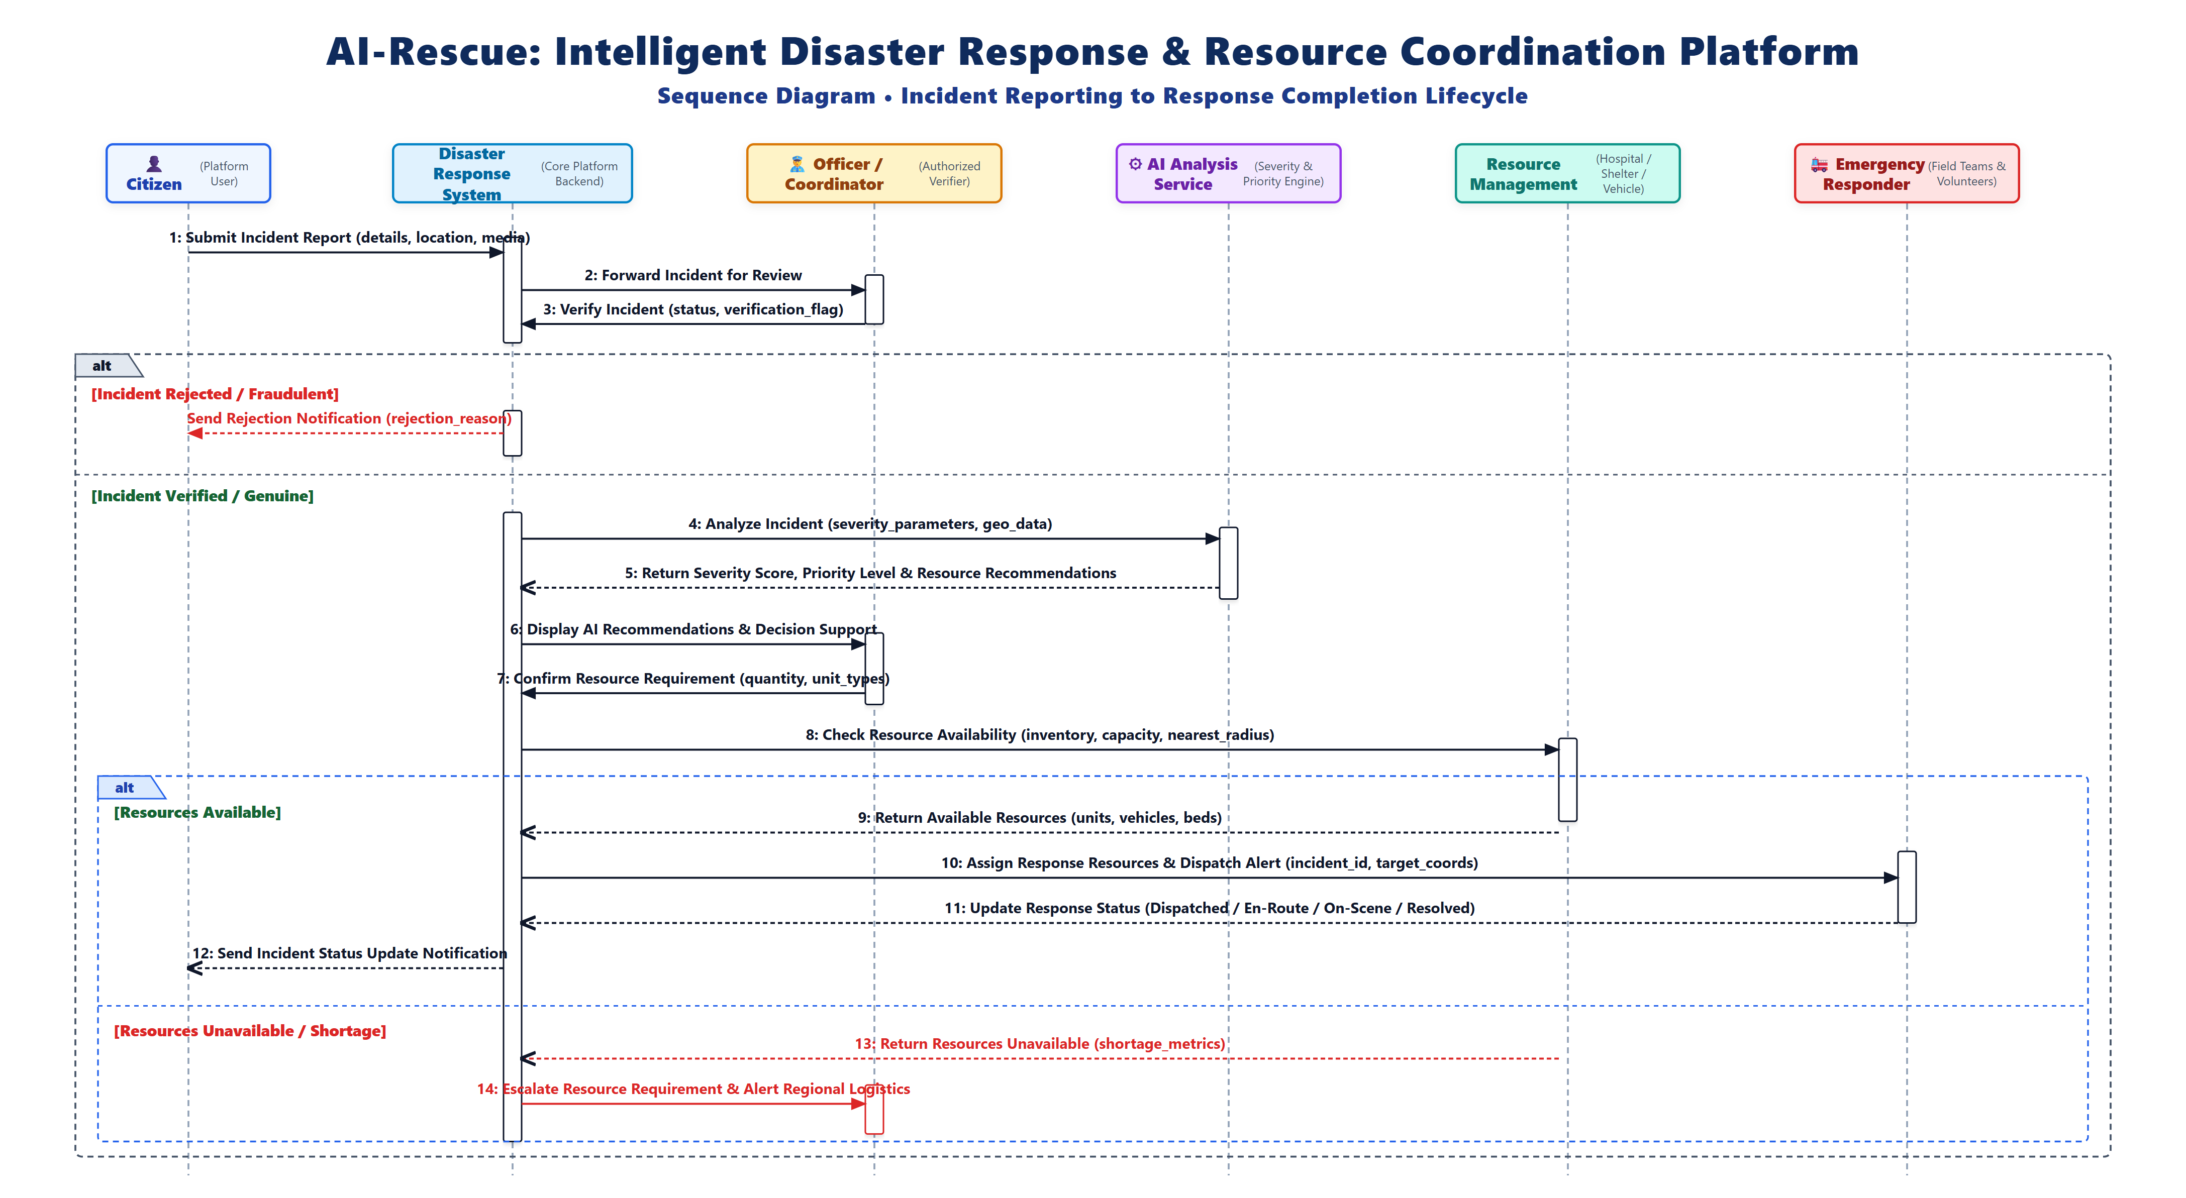
Description: High-level UML Sequence Diagram representing chronological message passing between system actors (Citizen, Response Officer, System Administrator) and backend subsystem services (Authentication, Incident Ingestion, AI Severity Engine, Resource Dispatcher, and Notification Engine) across synchronous and asynchronous events.

